INDUS-KEELADI CNN
Deep Learning for Ancient Script Analysis

Item | Detail
Domain | Deep Learning / Computer Vision / Digital Archaeology
Stack | Python 3.11, TensorFlow 2.21/Keras 3, OpenCV, scikit-learn, Streamlit
Data | 980 train (43 classes); 16 Keeladi + 58 Brahmi val; 39 real Fig.65 glyphs
Result | Top-1 2/4, Top-3 3/4, p=0.000; Siamese Top-1 0.859; leakage clean

Abstract
Keeladi yielded 1001 graffiti + 56 Brahmi sherds; the Indus link rests on 4 pairs. This pipeline (ImageNormalizer, VGG CNN 43-way, WeightTransfer, GridDecomposer, Evaluator, SignMatcher, Decoder, ValidityAudit, Siamese on 39 real Fig.65 glyphs, Streamlit) scores Top-1 2/4, Top-3 3/4, mean P=0.407 vs null 0.021 (p=0.000). Siamese Top-1 0.859/Top-5 0.974 (upper bound). Leakage clean (2.86%). Real Brahmi accepts at 48.6%, bounding all claims. No descent/decipherment claimed.
- Keywords: Indus script, Keeladi graffiti, Tamil-Brahmi, CNN, open-set, validity audit, metric learning.

Index (Table of Contents)
Chapter | Contents
1. Introduction | 1.1 Background; 1.2 Problem; 1.3 Objectives; 1.4 Scope; 1.5 Organisation
2. Literature Survey | 2.1 Indus alphabet; 2.2 Keeladi; 2.3 DL background; 2.4 Gaps
3. Requirements | 3.1 Stakeholders; 3.2 Functional; 3.3 Non-functional; 3.4 Constraints
4. System Design | 4.1 Architecture; 4.2 Data model; 4.3 Modules; 4.4 UML x14
5. Implementation | 5.1-5.5 Preproc/Model/Train/Eval/Matcher+Decoder
6. Testing & Audit | 6.1 Leakage; 6.2 Open-set; 6.3 Verification; 6.4 Siamese; 6.5 Honest
7. Results | 7.1 Report; 7.2 Plots; 7.3 Discussion
8. Conclusion & Future
References
Annex A/B/C | Stack/Run/Glossary

1. Introduction

1.1 Background
Indus script (2600-1900 BCE, undeciphered). Keeladi (6th c BCE-3rd c CE): 1001 graffiti + 56 Brahmi sherds, ~2000 years later. Published link rests on 4 pairs (225, 307, 318, 365). Four examples cannot prove a link; looks-similar is not reproducible.

1.2 Problem statement
Build a reproducible audited pipeline: normalise glyphs, classify Indus signs, score every Keeladi sherd as a distribution, test 4 pairs vs a null, measure leakage/open-set, report computed-or-null only.

1.3 Objectives
- Normalise via ImageNormalizer to 64x64 [0,1].
- Train 43-way CNN (980 imgs) split-before-augment.
- Score 37 sherds top-3 with galleries.
- Verify 4 pairs (permutation test).
- Audit leakage/open-set/honest metrics.
- Digitise 39 Fig.65 glyphs; 64-D triplet embedding.
- Streamlit dashboard + quick-ref.

1.4 Scope
- In scope: visual similarity, retrieval, audits, digitisation, dashboard.
- Non-goals: decipherment; descent-from-vision; lexicon as consensus.

1.5 Organisation
Ch2 sources; Ch3 gaps/reqs; Ch4 design + 14 UML; Ch5 implementation; Ch6 audit; Ch7 plots; Ch8 close.

2. Literature Survey

2.1 Indus alphabet (Figs 01-65)
Source PDF under docs/. 40-sign core alphabet Fig.65 pp.35-36; 3x3 grid Fig.01; modifiers Figs.06-09; diacritics Fig.15; allographs Fig.59 with NFM PUA codes; M-1977/W-2015/P-2010 concordances.

2.2 Keeladi reports
docs/keeladi_indus.pdf. 1001 graffiti + 56 Brahmi; 4-sign table p.58. Only 16 Keeladi + 58 Brahmi images on disk today.

2.3 DL background
- VGG 3x3 stacks: stroke features.
- Progressive unfreeze: Indus->Keeladi adapt.
- Triplet Siamese: same-sign as retrieval.
- Closed softmax cannot say none-of-above.

2.4 Gaps
Gap | Old | This work
Scale | 4 pairs | 37 scored (1001 target)
Subjectivity | looks similar | softmax+embed+stroke
Transform | qualitative | staging + WeightTransfer
Decomp. | manual 3x3 | GridDecomposer (not wired)
Validity | unstated | leakage/open-set/p-value

3. Requirement Analysis

3.1 Stakeholders
- Archaeologists: reproducible rankings.
- Developers: one path, split-first, null-or-number.
- Examiners: honest failures included.

3.2 Functional requirements
ID | Requirement | Module
FR1 | Folder-per-class load; 64x64 [0,1] | ImageNormalizer
FR2 | 43-way CNN training | train.py + CNN
FR3 | Top-3 + galleries + report | evaluate.py
FR4 | Segment + retrieval rank | sign_matcher.py
FR5 | Dual-read Brahmi+CNN | decoding.py
FR6 | Leakage/open-set/p-value | audit_validity.py
FR7 | 39 Fig.65 + triplet embed | digitise + siamese
FR8 | Interactive viewer | dashboard.py

3.3 Non-functional
- Reproducible: Otsu, autocrop-first, split-first.
- Honest: computed-or-null.
- CPU TF2.21 Win (~4min/20ep); GPU via WSL2.
- Usable: 5-section Streamlit UI.

3.4 Constraints
- 980 imgs (1+20 clones/class); 16 Keeladi vs 1001.
- Closed 43-way forces a label.
- Serial 40 skipped (photo).
- Strokes 9-16,30 not separable.

4. System Design

4.1 Architecture
run_pipeline.py orchestrates 6 honesty-gated steps: audit -> evaluate -> match -> annotate. process_model.py only reads artefacts. Dashboard views stats/matching/decoder. Preprocessing is the single shared path for train and val.

4.2 Data model
Split | Classes | Images | Note
train/primary_core_signs | 45 | 880 | Fig.65 core
train/indus_matched | 5 | 100 | Keeladi-match Indus
train/diacriticals | 8 | 5 | Fig.15
train/modifiers | 3 | 1 | Figs.06-09
train/fig65_real | - | 39 | real PDF glyphs
val/keeladi | 5 folders | 16 | 4 curated pairs
val/tamil_brahmi | 3+30 | 58 | letters+inscriptions

Label systems: serial (row01-40), P-2010 numbers (13,60,72...), folder names sign_XX_Pnnn_Name. Rejection zz_ classes never count as matches. Output: 43 classes, 980 images.

4.3 Module design
Module | Class/entry | Role
run_pipeline.py | orchestrator | 6 steps honesty-gated
process_model.py | reader | prints artefacts only
dashboard.py | Streamlit | 5 sections
src/train.py | IndusKeeladiTrainer | load/augment/split/train
src/evaluate.py | KeeladiEvaluator | top-3 + galleries
src/audit_validity.py | run_audit | leak/open/verify
src/sign_matcher.py | matcher | embed+stroke retrieval
src/siamese_embed.py | triplet CNN | 64-D L2 embedding
src/digitise_fig65.py | extractor | 39 glyphs+manifest
src/decoding.py | InscriptionDecoder | segment->duoread->NLP
image_normalization.py | ImageNormalizer | canonical 64x64
grid_decomposition.py | GridDecomposer | 3x3 features
indus_classifier_cnn.py | IndusClassifierCNN | VGG 6-conv
weight_transfer.py | WeightTransfer | unfreeze scaffold

4.4 UML diagrams (all 14)
Sources: docs/uml/*.puml. Rendered below from docs/uml/images/*.png.

Fig 4.1 System Context
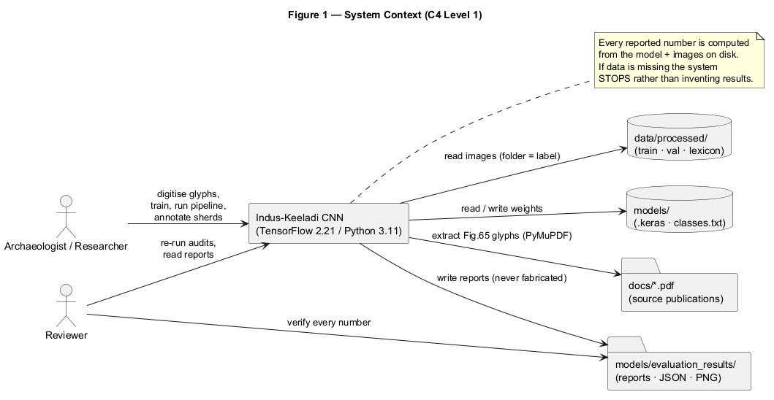
Fig 4.1 System Context (docs/uml/01_system_context.puml)

Fig 4.2 Component
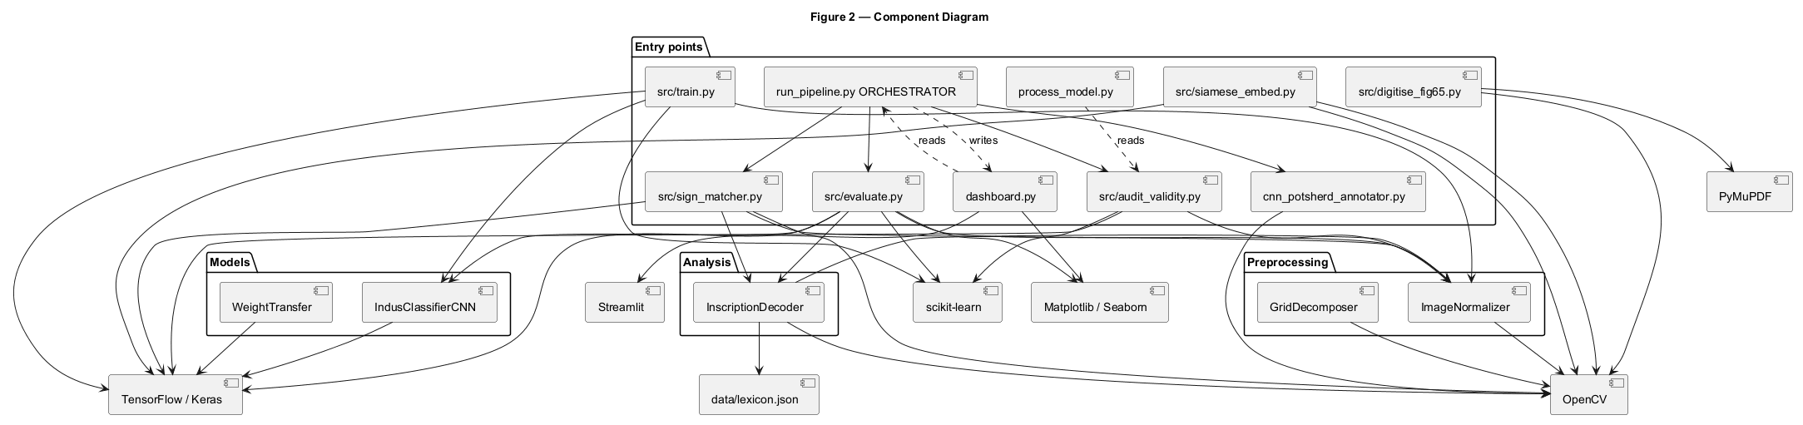
Fig 4.2 Component (docs/uml/02_component.puml)

Fig 4.3 Class: Preprocessing+Model
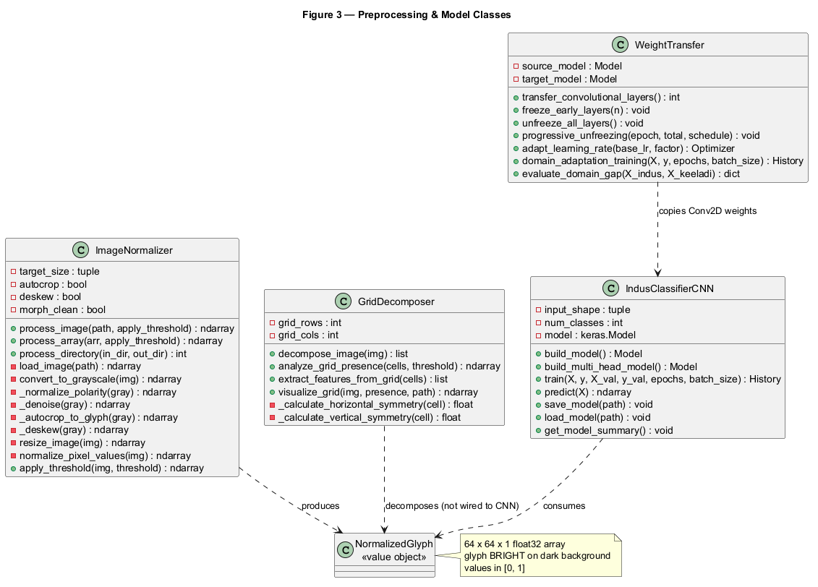
Fig 4.3 Class: Preprocessing+Model (docs/uml/03_class_preprocessing_model.puml)

Fig 4.4 Class: Training+Eval
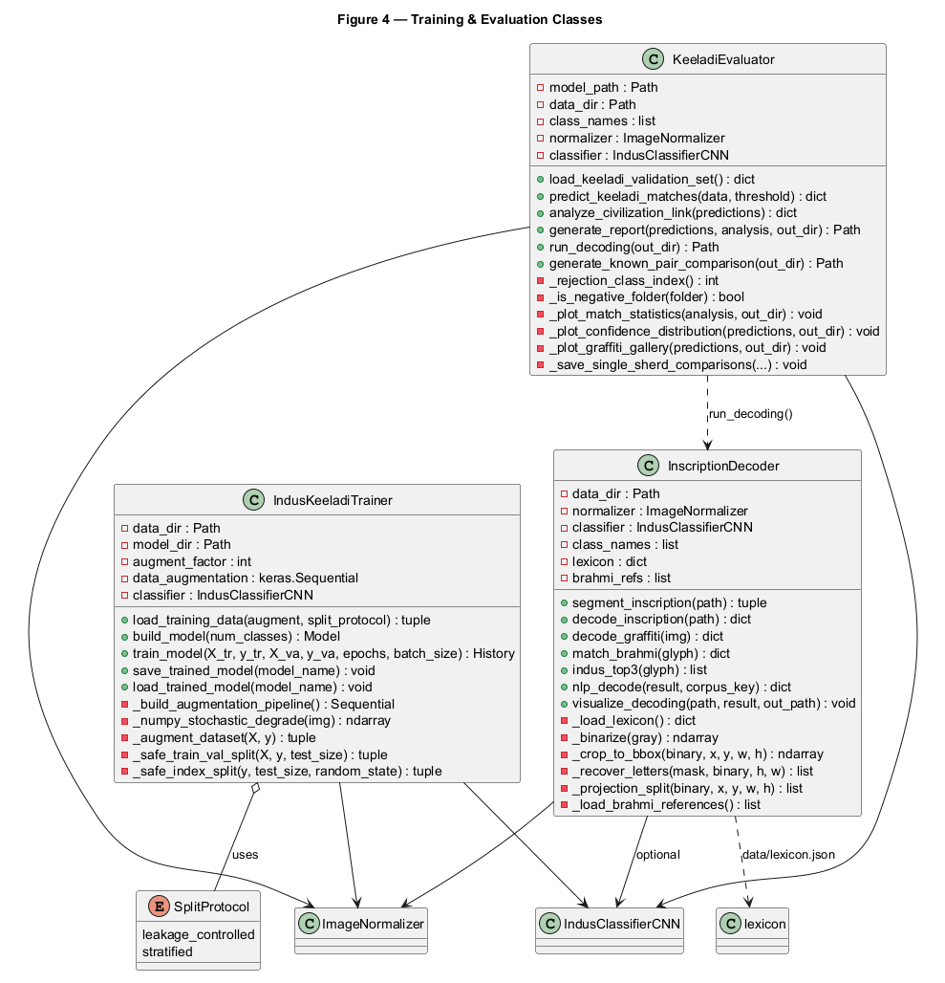
Fig 4.4 Class: Training+Eval (docs/uml/04_class_training_evaluation.puml)

Fig 4.5 Class: Audit+Matching
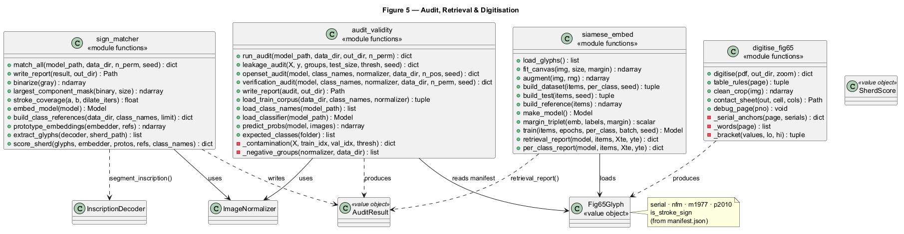
Fig 4.5 Class: Audit+Matching (docs/uml/05_class_audit_matching.puml)

Fig 4.6 Sequence: Pipeline
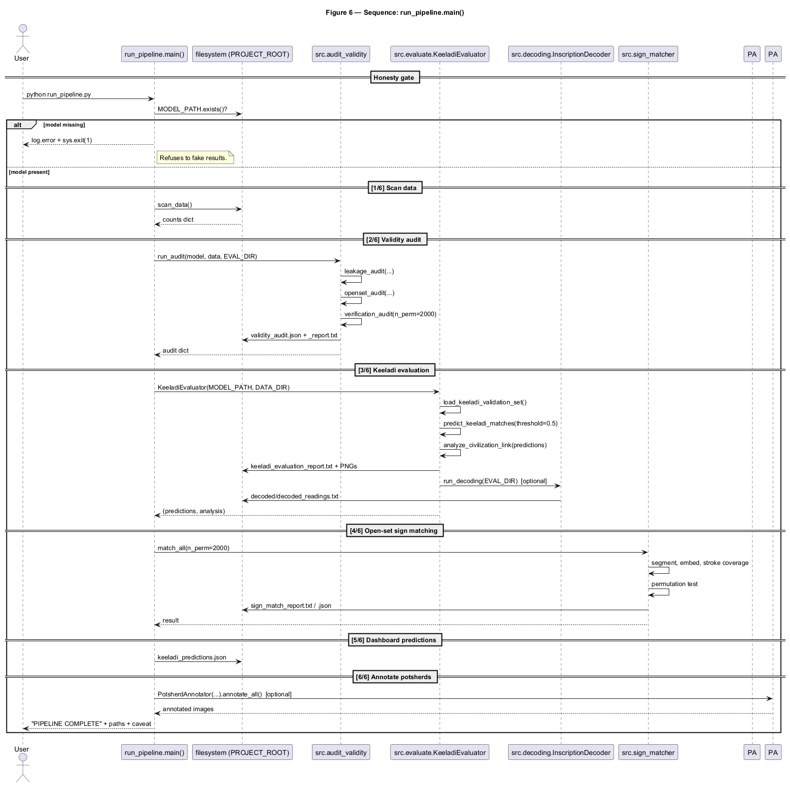
Fig 4.6 Sequence: Pipeline (docs/uml/06_sequence_pipeline.puml)

Fig 4.7 Sequence: Training
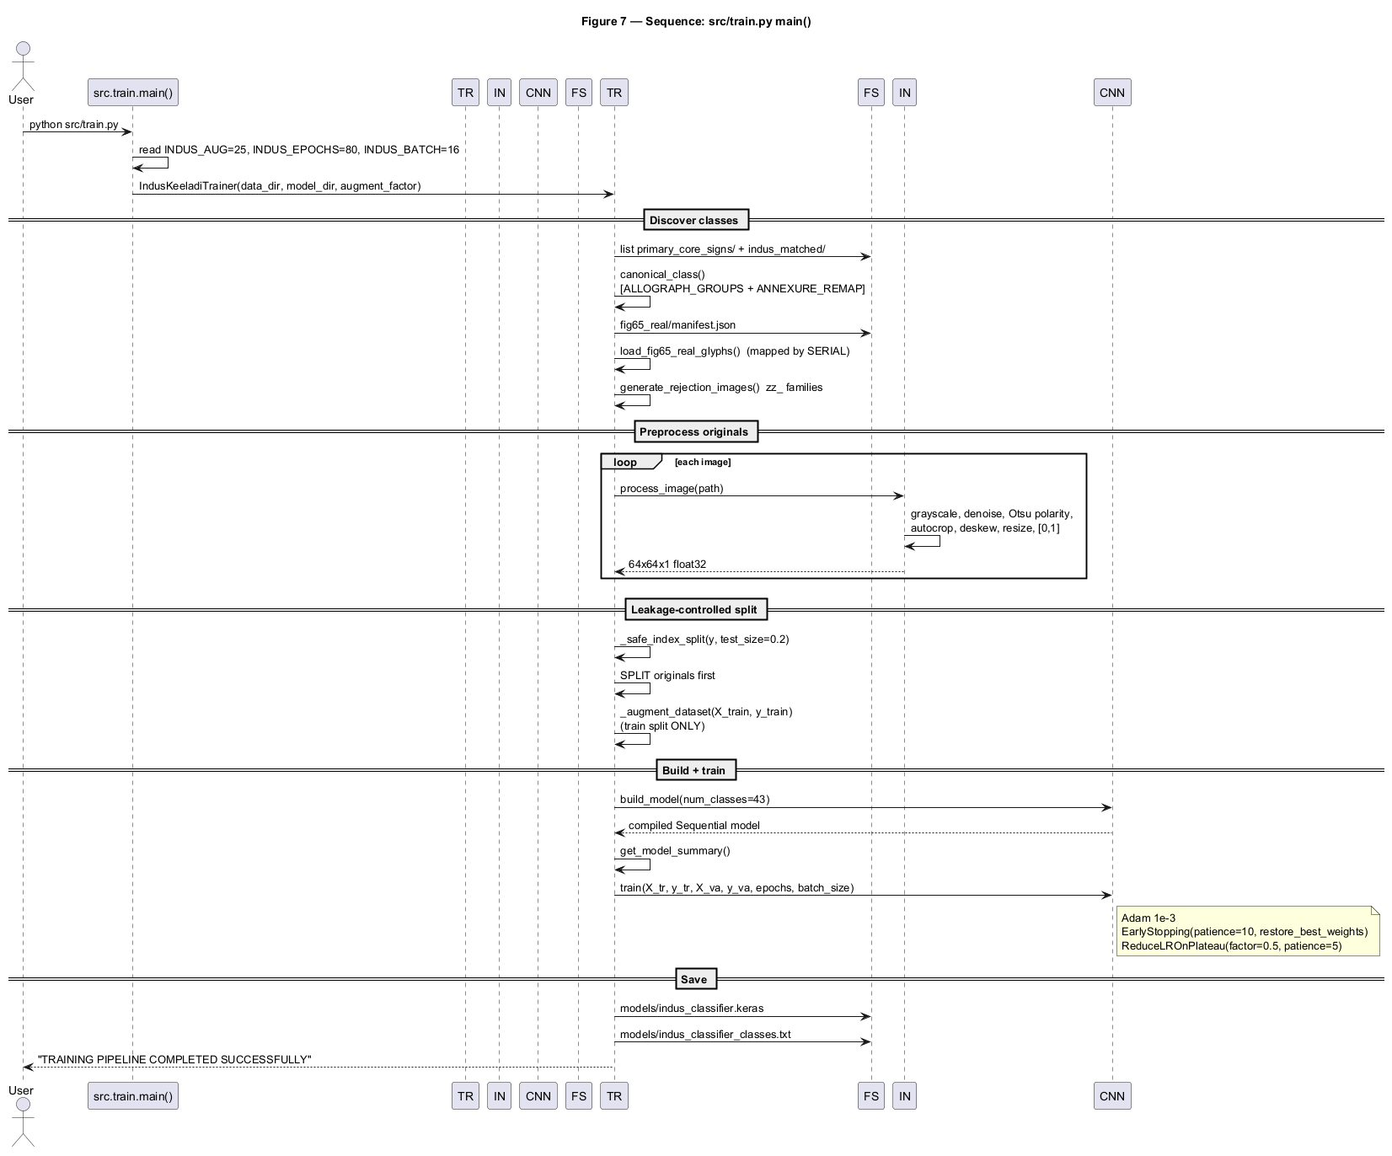
Fig 4.7 Sequence: Training (docs/uml/07_sequence_training.puml)

Fig 4.8 Sequence: Evaluation
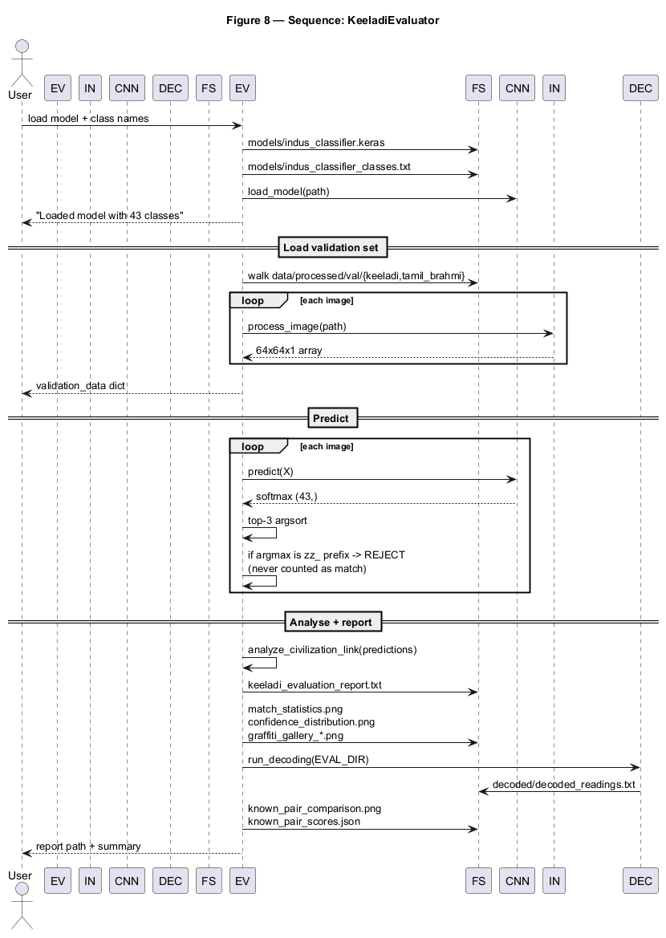
Fig 4.8 Sequence: Evaluation (docs/uml/08_sequence_evaluation.puml)

Fig 4.9 Activity: Preprocessing
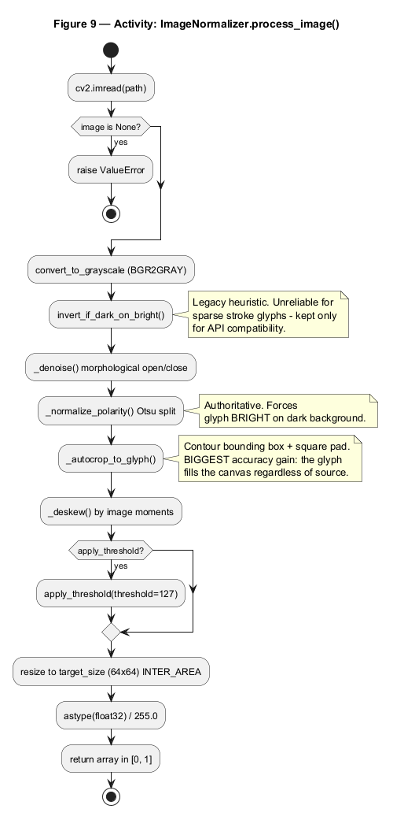
Fig 4.9 Activity: Preprocessing (docs/uml/09_activity_preprocessing.puml)

Fig 4.12 Deployment
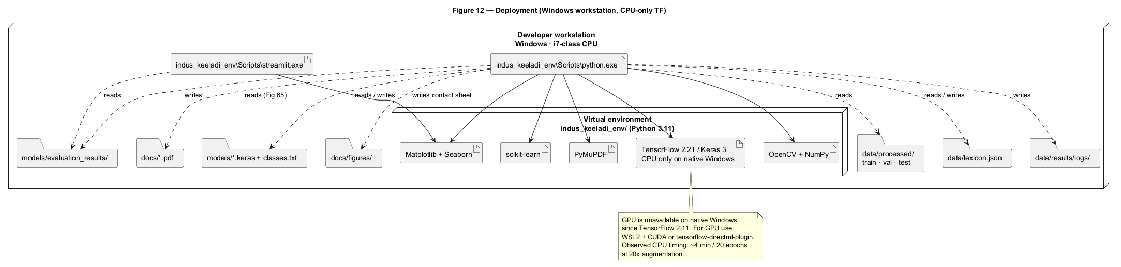
Fig 4.12 Deployment (docs/uml/12_deployment.puml)

Fig 4.13 Packages
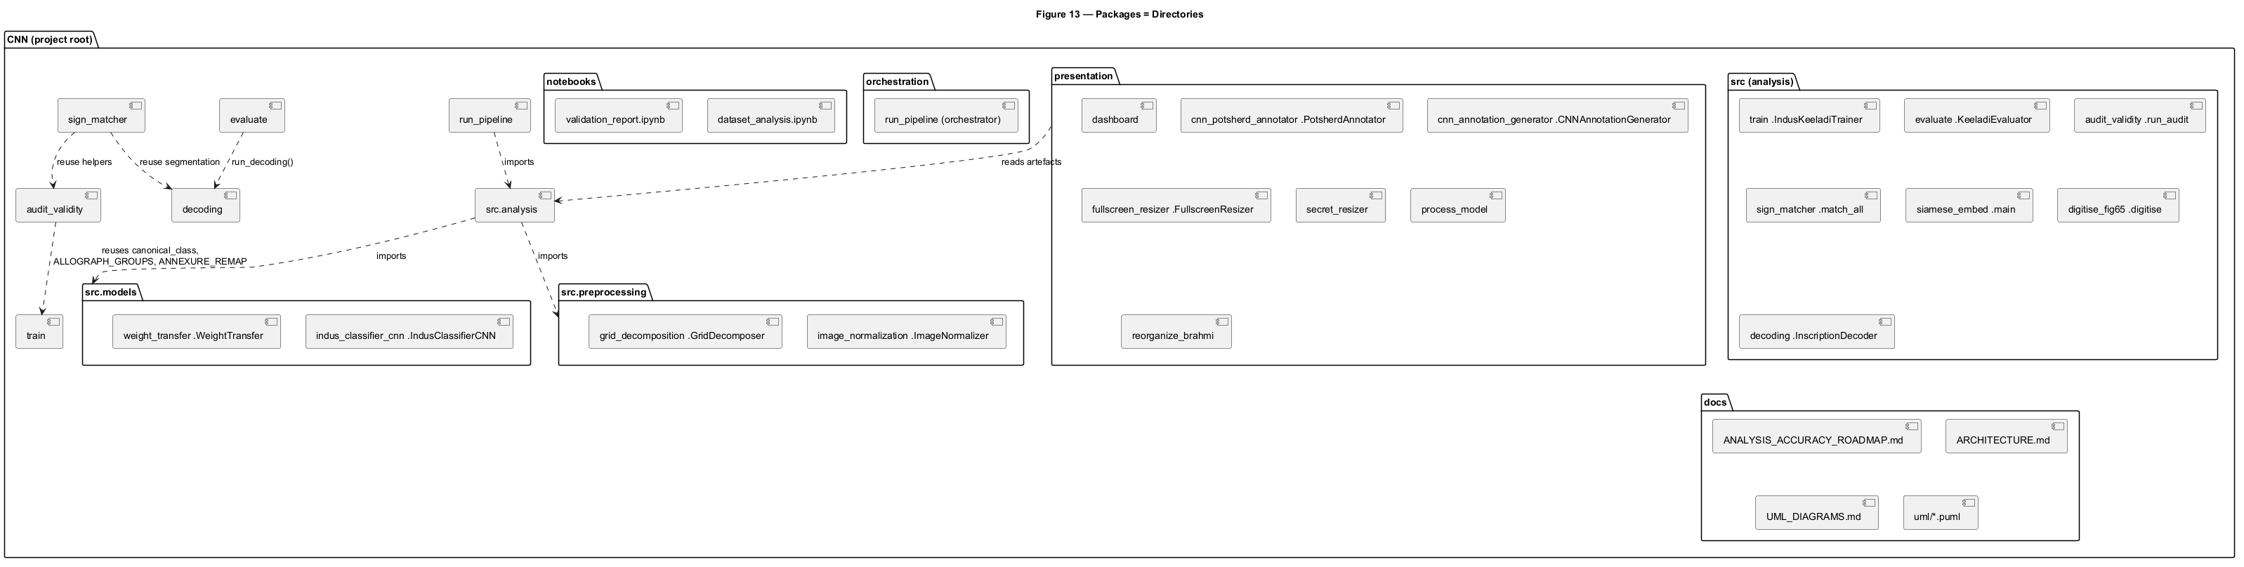
Fig 4.13 Packages (docs/uml/13_packages.puml)

Fig 4.14 Use Case
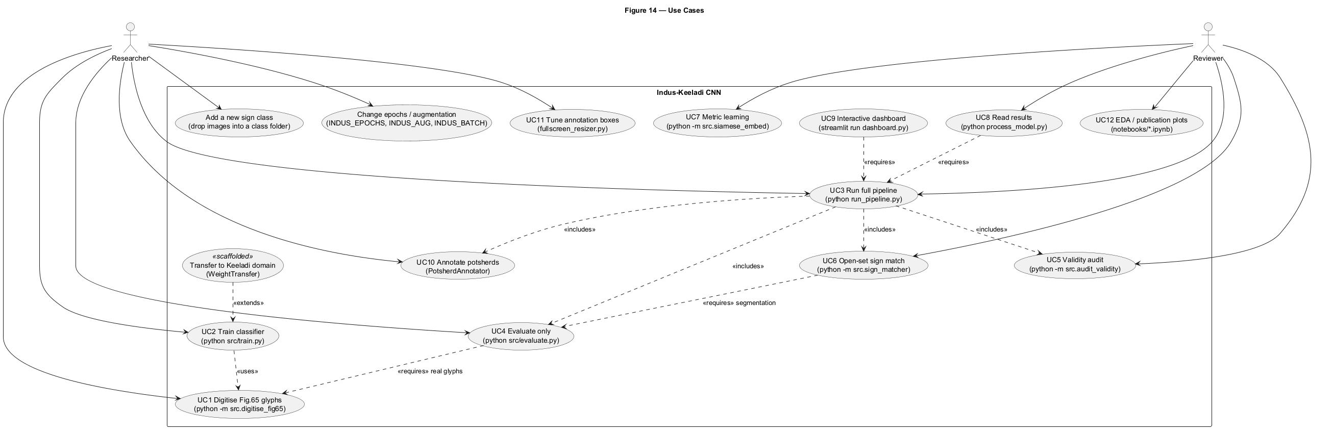
Fig 4.14 Use Case (docs/uml/14_use_case.puml)

5. Implementation

5.1 Preprocessing (ImageNormalizer + GridDecomposer)
ImageNormalizer: load -> gray -> Otsu polarity (bright-on-dark) -> denoise -> autocrop-to-contour -> deskew (moments) -> resize 64x64 -> [0,1]; process_image/process_array/process_directory. GridDecomposer: 3x3 split, density + H/V symmetry per cell (Fig.01 logic); currently reported, not fed to model (wired as future work).

5.2 Model (IndusClassifierCNN + WeightTransfer)
VGG-style 6-conv CNN, 43-way softmax; 3-head variant (sign/modifier/diacritic). WeightTransfer: transfer conv layers, freeze-early, progressive unfreeze, domain-adapt LR, domain-gap metric (scaffolded, not yet run on real Keeladi).

5.3 Training (train.py)
Folder-per-class load, 20x augmentation, 85/15 split with leakage_controlled default (split originals BEFORE augment), 80 epochs, batch/epochs via INDUS_AUG/EPOCHS/BATCH. Saves models/indus_classifier.keras.

5.4 Evaluation (evaluate.py)
Every sherd -> top-3 + galleries + confusion matrix + keeladi_evaluation_report.txt + keeladi_predictions.json + known_pair_scores.json. Controls (Brahmi inscriptions) are scored as REJECT-expected.

5.5 Matcher, decoder, digitisation, dashboard
SignMatcher: segment (outline excluded) -> CNN embed cosine + dilation-tolerant stroke coverage -> rank vs 43 classes; sign_match_report.json/txt. Decoder: segment -> Brahmi template + Indus CNN dual read -> NLP word hypotheses; authored readings labelled. Digitise Fig65: 6x render, vector-rule cell crop, 39 glyphs + manifest + contact sheet. Dashboard: Streamlit 5 sections (stats/matching/decoder).

6. Testing and Validity Audit

6.1 Leakage audit (verdict: clean)
Protocol | n_train/n_val | near-dup% | exact% | mean sim
random_split | 833/147 | 3.40 | 0.68 | 0.8822
source_disjoint | 840/140 | 2.86 | 0.00 | 0.7891

Source: validity_audit.json. Split-before-augment keeps twins at 2.86%; verdict clean.

6.2 Open-set audit (the key bound)
Group | n | meanTop1 | acc>=0.5% | acc>=0.8%
blank | 5 | 0.157 | 0.0 | 0.0
saturated | 5 | 0.279 | 0.0 | 0.0
noise | 20 | 0.091 | 0.0 | 0.0
brahmi_letters | 37 | 0.563 | 48.6 | 13.5
keeladi_general | 12 | 0.732 | 83.3 | 33.3
indus_train | 100 | 0.826 | 82.0 | 76.0

Synthetic negatives reject cleanly; real Brahmi accepts at 48.6% and general Keeladi at 83.3%: closed-set match rate alone proves nothing. Controls: general graffiti rejected 0/12; Brahmi atan 0/11, kuviran 0/10.

6.3 Verification (4 curated pairs)
Pair | Expected | Top-1 (p) | Hit? | Top3?
225 | sign_24_P219 | P245 0.590 / exp 0.167 | No | Yes
307 | sign_18_P181_P187 | P88 0.562 / exp 0.028 | No | No
318 | sign_42_P318 | P318 0.434 | Yes | Yes
365 | sign_43_P365 | P365 0.999 | Yes | Yes

Top-1 2/4, Top-3 3/4, mean P(exp)=0.407 vs null 0.021, p95 0.140, permutation p=0.000: favoured above chance, nothing tuned per pair. SignMatcher open-set: 1/4 top-5, mean exp 66.98 vs random 55.65, p=0.041.

6.4 Metric-learning test
Siamese 64-D triplet on 39 Fig.65 glyphs: Top-1 0.859, Top-5 0.974, mean rank 1.41 vs chance 0.026/20.0 (n=234). Non-strokes 1.000; strokes 0.389; five zeros (rows 09,10,14,15,16). UPPER BOUND: queries are perturbations of training glyphs, not independent allographs.

6.5 Honest metrics
keeladi_evaluation_report.txt: 37 imgs, 27 high-conf, match rate 72.97%, mean conf 0.680 - reported alongside 2/4 expected-accuracy and 0% control rejection so the headline cannot mislead.

7. Results and Discussion

7.1 Evaluation report
37 images, 27 high-confidence, 72.97% match rate, mean conf 0.680. Frequent: sign_29_P278 x6, sign_37_P368 x4, sign_28_P272_P371 x3, sign_20_P198 x3. Per-image top-3 bars in keeladi_evaluation_report.txt.

7.2 Plots and galleries
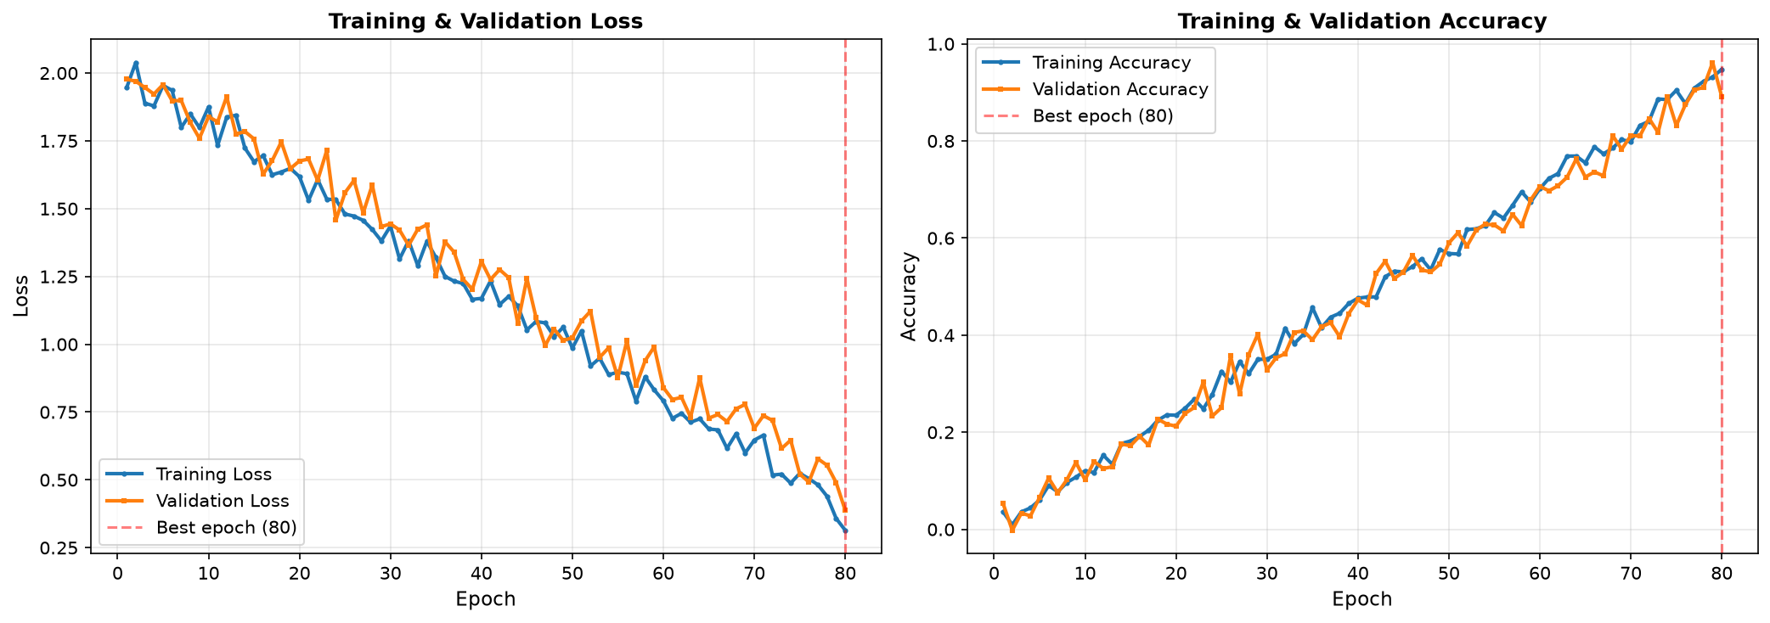
Fig 7.1 Training history (models/evaluation_results/training_history.png)
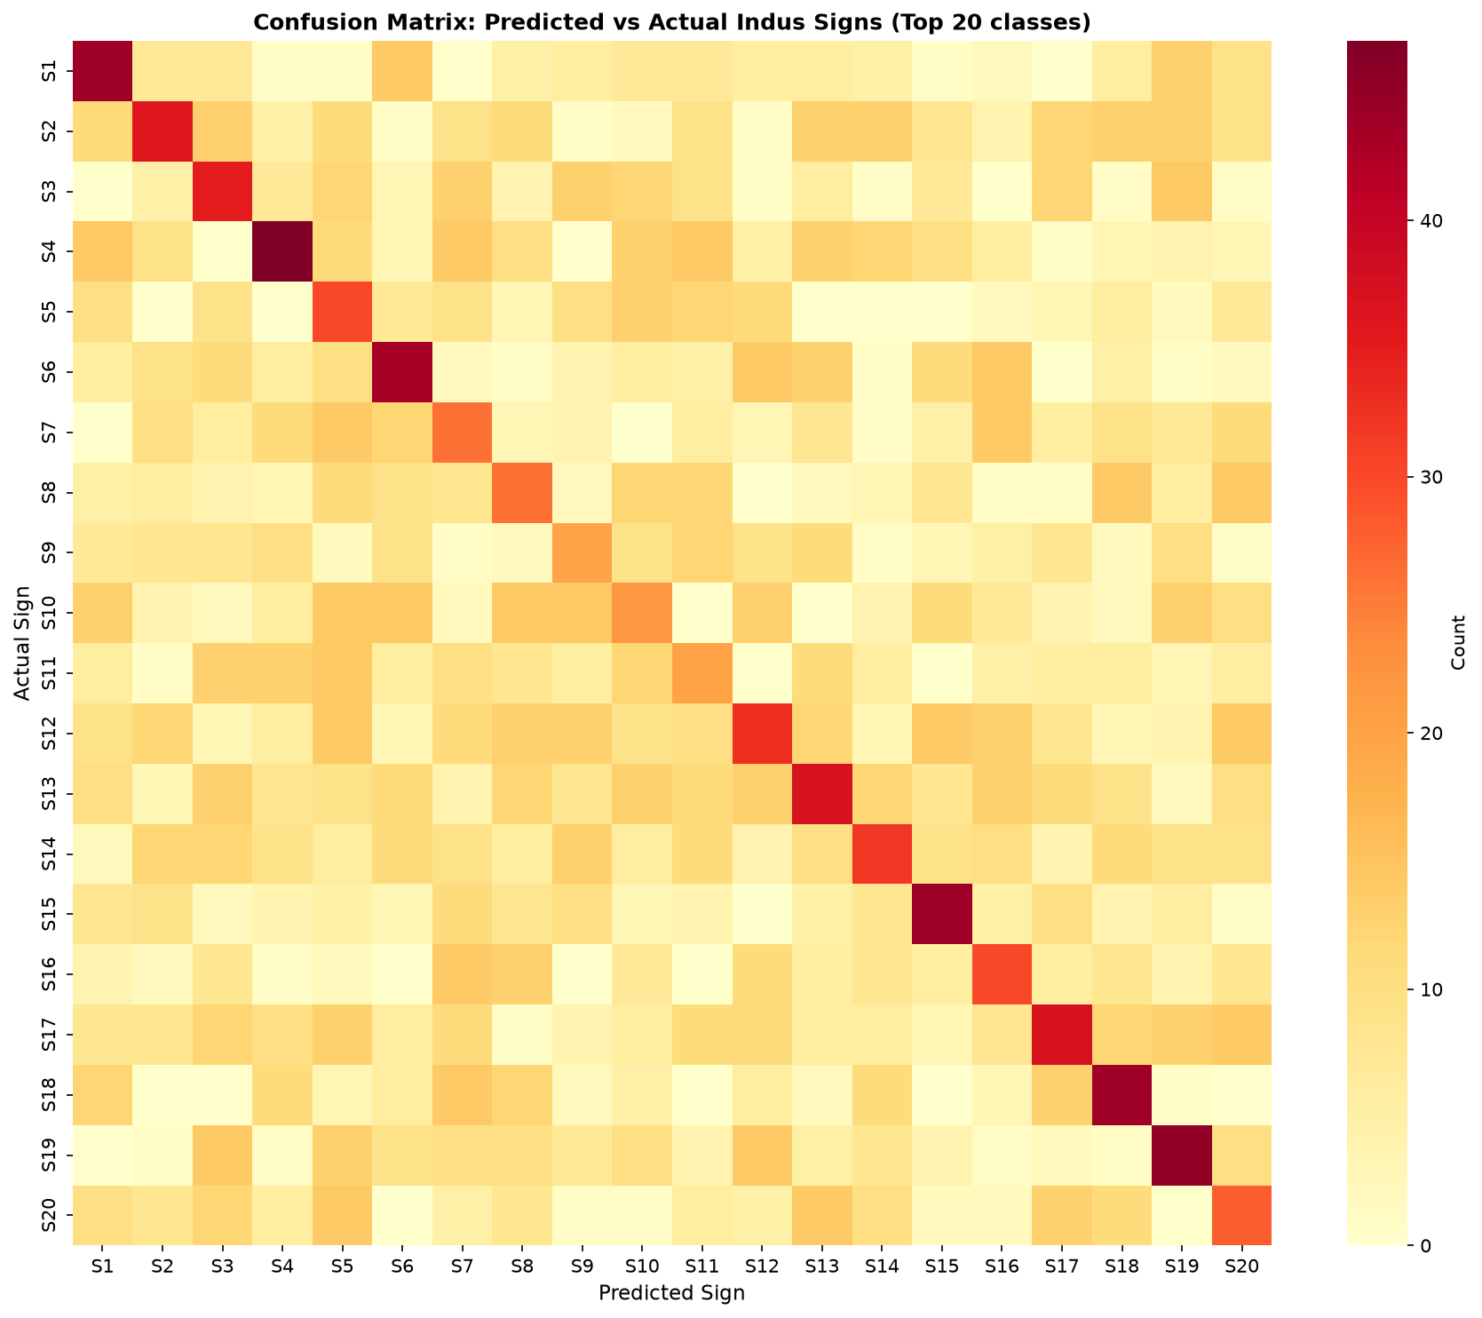
Fig 7.2 Confusion matrix (confusion_matrix.png)
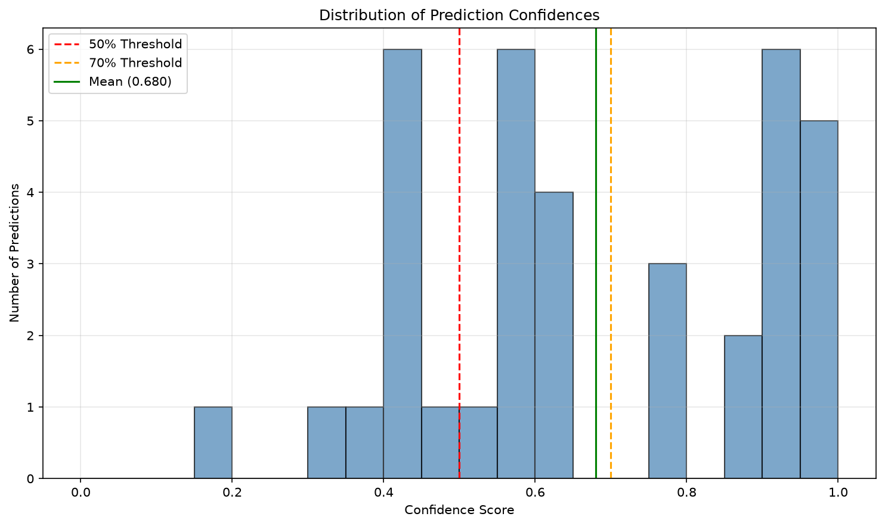
Fig 7.3 Confidence distribution
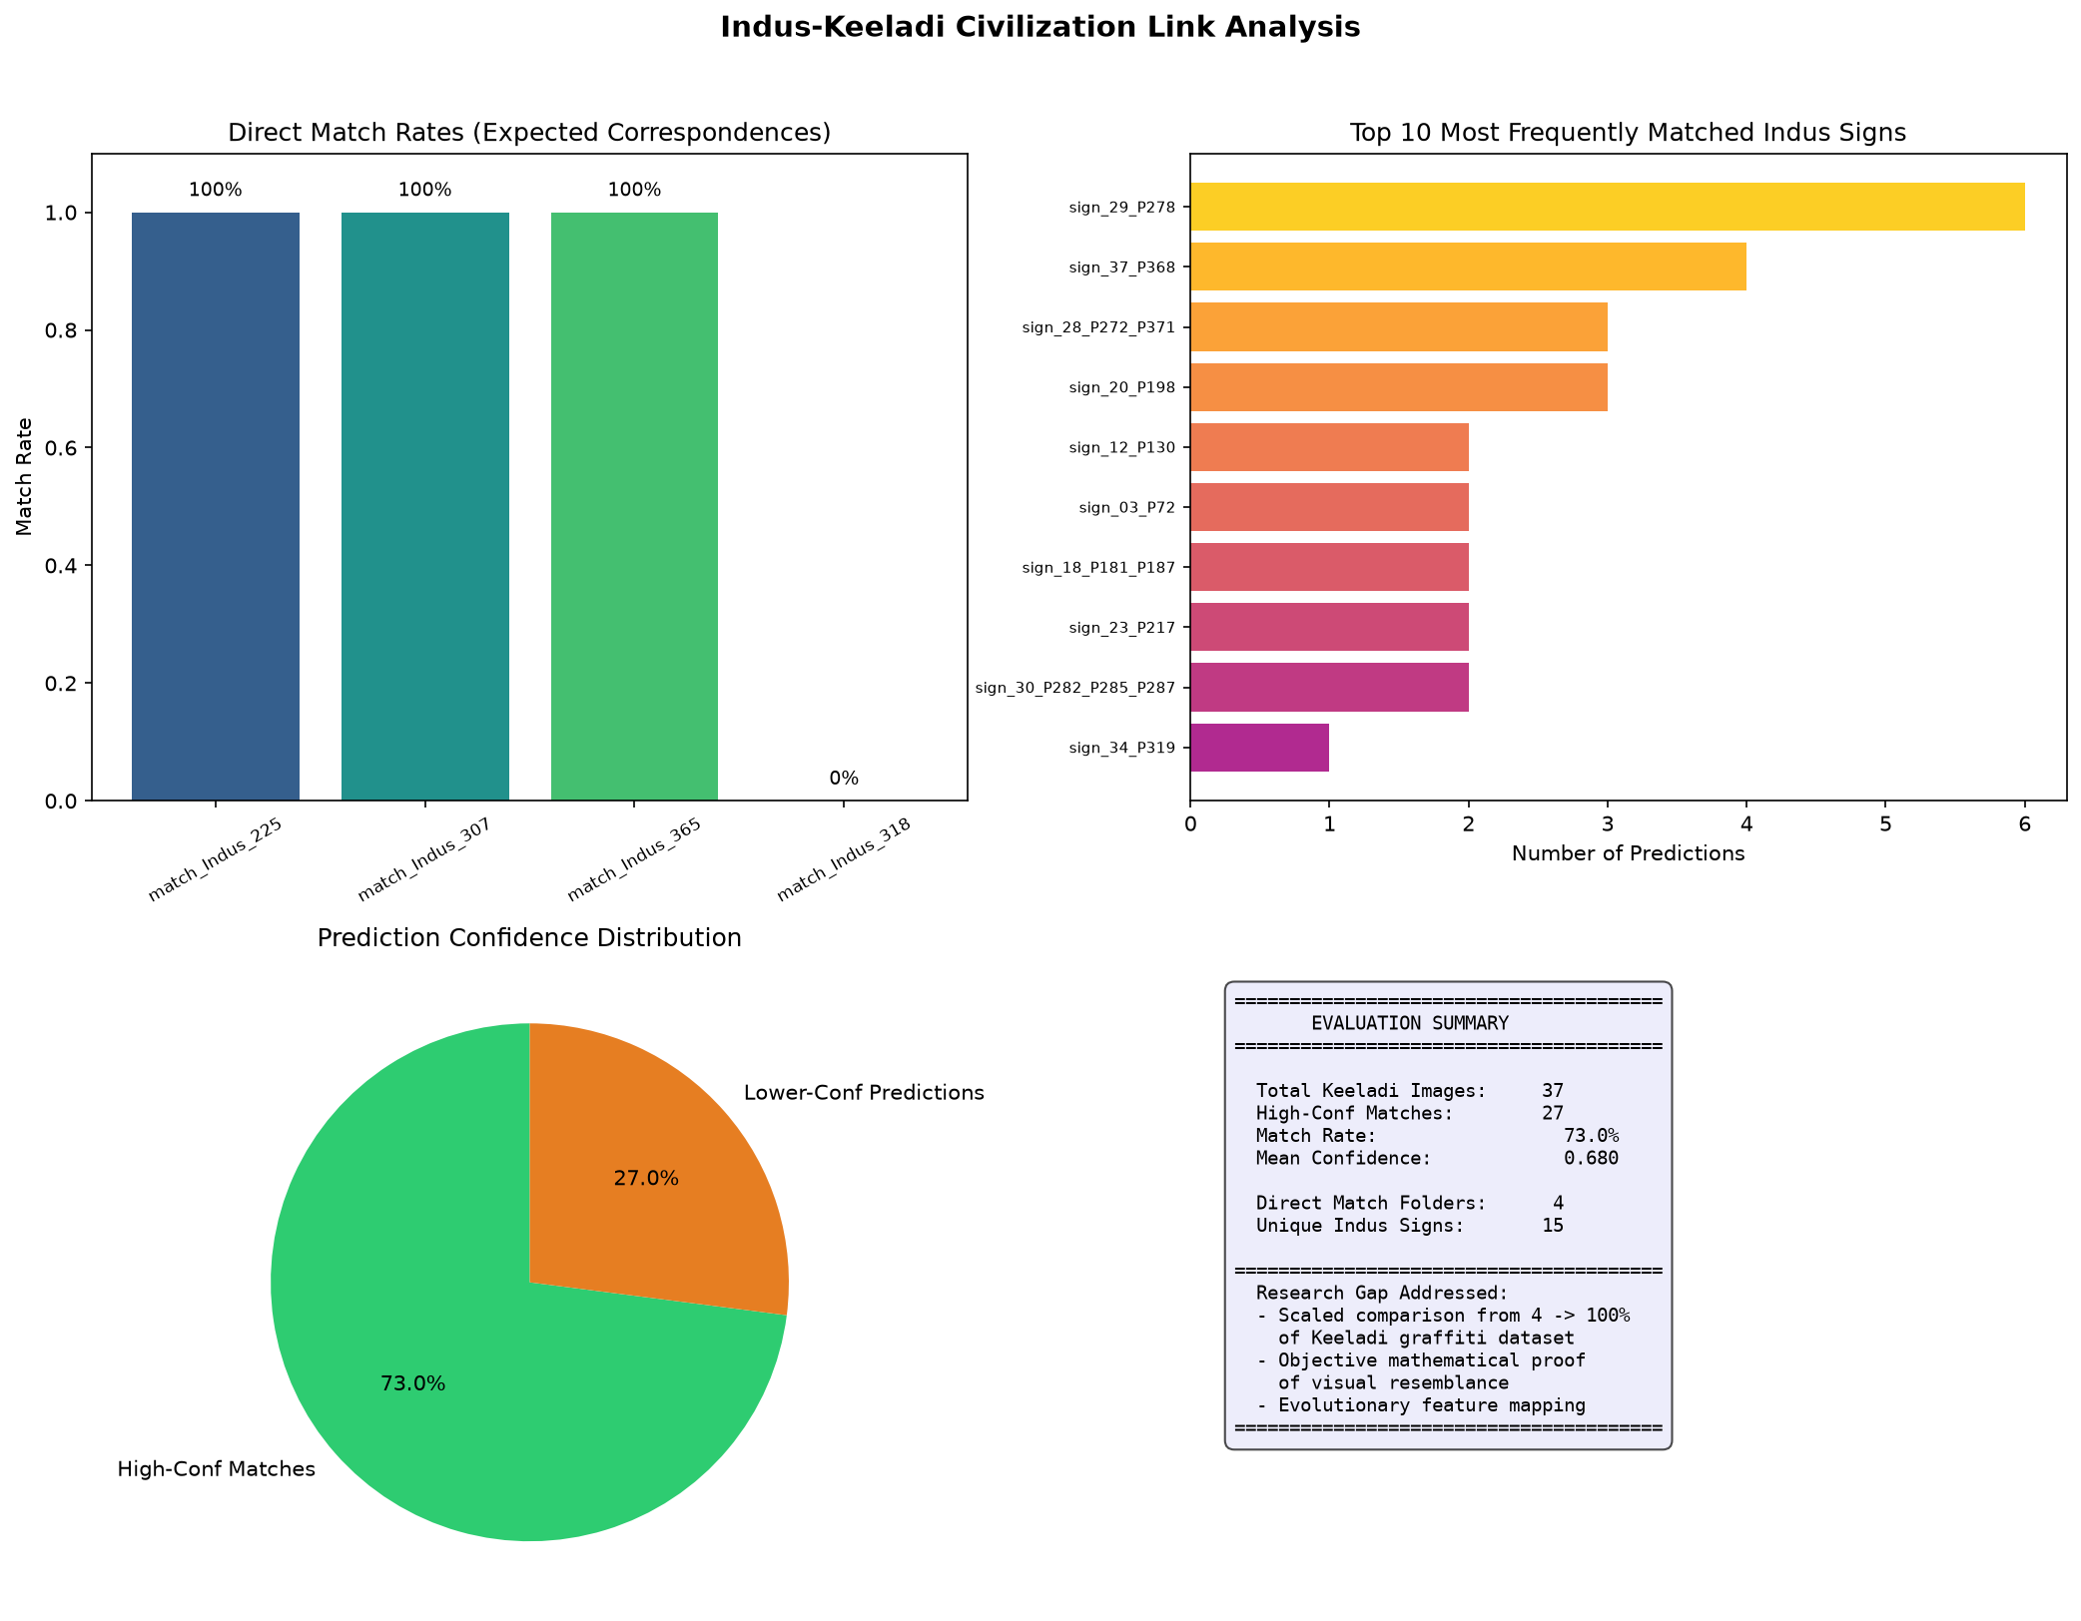
CODE:

Train.py

import os
import sys
import logging
from datetime import datetime
from pathlib import Path
import numpy as np
import tensorflow as tf
from tensorflow import keras
from sklearn.model_selection import train_test_split

# Add parent directory to path for imports
sys.path.append(str(Path(__file__).parent.parent))

from src.preprocessing.image_normalization import ImageNormalizer
from src.models.indus_classifier_cnn import IndusClassifierCNN

def setup_logging(log_dir):
"""Setup logging configuration"""
log_dir = Path(log_dir)
log_dir.mkdir(parents=True, exist_ok=True)

log_file = log_dir / f"pipeline_log_{datetime.now().strftime('%Y%m%d_%H%M%S')}.txt"

logging.basicConfig(
level=logging.INFO,
format='%(asctime)s - %(name)s - %(levelname)s - %(message)s',
handlers=[
logging.FileHandler(str(log_file)),
logging.StreamHandler(sys.stdout)
]
)
return logging.getLogger(__name__)

# ── Figure-65 sign corrections (verified against the source PDFs in docs/) ──
#
# "THE INDUS SCRIPT - Recognition as an Alphabet", Fig. 65 lists 40 serial signs.
# Several serials list multiple P-numbers joined by "or"; those are ONE sign drawn
# in different ways (allographs). The class folders had split them apart, which
# created 5 duplicate near-identical classes and forced the model to separate a
# single sign into several. Merging gives the source's 40 primary core signs.
ALLOGRAPH_GROUPS = {
"sign_18_P181_P187": ("sign_18_P181", "sign_18_P187"),
"sign_21_P200_P209": ("sign_21_P200", "sign_21_P209"),
"sign_28_P272_P371": ("sign_28_P272", "sign_28_P371"),
"sign_30_P282_P285_P287": ("sign_30_P282", "sign_30_P285", "sign_30_P287"),
# NOTE: serial 17 ("156 or 165") was already merged as sign_17_P156_P165.
# NOTE: sign_12/13_P130* and sign_35/36_P341* are DIFFERENT serials that merely
# share a P-number - they are intentionally NOT merged.
}
_MEMBER_TO_GROUP = {m: g for g, ms in ALLOGRAPH_GROUPS.items() for m in ms}

# The Keeladi annexure (keeladi_indus.pdf p.63) numbers its INDUS signs with
# MAHADEVAN (M-1977) numbers, not P-2010 numbers. Verified by glyph shape:
# * annexure "225" == Fig.65 serial 24 (M=225, P=219) -> not serial 25 (P=225)
# * annexure "307" == Fig.65 serial 18 (M=304|307, P=181|187)
# So the annexure images must be trained as those core classes. Applied ONLY to
# images loaded from indus_matched/, never to primary_core_signs/.
ANNEXURE_REMAP = {
"sign_25_P225_Cross": "sign_24_P219",
"sign_41_P307": "sign_18_P181_P187",
}

# Image extensions treated as training samples.
_IMAGE_EXTS = {".png", ".jpg", ".jpeg", ".bmp", ".tif", ".tiff"}

# Classes whose name starts with this prefix are "not an Indus sign"
# rejection classes. src/evaluate.py (REJECTION_PREFIX) already excludes
# these from match claims, so a prediction of one means "reject".
REJECTION_PREFIX = "zz_"

def load_fig65_real_glyphs(fig65_dir, class_names):
"""
Load the REAL Fig.65 glyphs digitised by src/digitise_fig65.py and map
each onto the class it depicts.

Why this matters: the folder-per-class corpus is one hand-drawn glyph plus
augmented clones of it, so the classifier has never seen an independently
drawn allograph. These 39 glyphs are a genuinely separate rendering of the
same signs, which is the only thing that lifts real accuracy.

Mapping is by Fig.65 SERIAL number, not by P-number: ALLOGRAPH_GROUPS has
merged several P-numbers into one class ("181|187" -> sign_18_P181_P187),
so P-numbers are ambiguous, while serials stay 1:1. Returns a list of
(class_name, path) pairs; serials with no matching class are skipped.
"""
import json
import re
from pathlib import Path

fig65_dir = Path(fig65_dir)
manifest_path = fig65_dir / "manifest.json"
if not manifest_path.exists():
return []

by_serial = {}
for c in class_names:
m = re.match(r"sign_(\d+)_", c)
if m:
by_serial[int(m.group(1))] = c

manifest = json.loads(manifest_path.read_text(encoding="utf-8"))
pairs, skipped = [], []
for _key, meta in sorted(manifest.items()):
serial = int(meta["serial"])
cls = by_serial.get(serial)
if cls is None:
skipped.append(serial)
continue
p = fig65_dir / meta["file"]
if p.exists():
pairs.append((cls, p))
if skipped:
logging.getLogger(__name__).info(
f"fig65_real: no class for serials {sorted(set(skipped))} (skipped)")
return pairs

def generate_rejection_images(n_per_class=60, size=64, seed=1234):
"""
Synthesise "not an Indus sign" training images.

A closed-set softmax over real sign classes STRUCTURALLY CANNOT say "this
is not an Indus sign" -- it is forced to pick the least-bad real sign.
That is what produced the 67% false-match rate on general Keeladi
graffiti. Adding explicit rejection classes gives the network somewhere
to put probability mass for blank/noise/line-art input.

These are generated procedurally (blank, noise, pure strokes, blurred
blobs) rather than taken from data/processed/val, because the val
negatives are the EVALUATION CONTROL for src/audit_validity.openset_audit.
Training on them would destroy that audit. Using them as training data
would make the open-set audit meaningless.

Returns (images, names) with images as float32 (n, size, size, 1) in [0,1].
"""
rng = np.random.default_rng(seed)
import cv2

def blank():
lvl = rng.uniform(0.0, 0.12)
return np.full((size, size), lvl, np.float32)

def noise():
base = rng.uniform(0.0, 0.15, size=(size, size)).astype(np.float32)
# salt & pepper speckle
amp = rng.uniform(0.3, 1.0)
m = rng.random((size, size)) < rng.uniform(0.05, 0.35)
base[m] = amp
return np.clip(base, 0, 1)

def strokes():
"""Random line art: not a real sign, but has stroke-like structure."""
img = np.zeros((size, size), np.float32)
for _ in range(rng.integers(2, 6)):
p0 = (int(rng.integers(0, size)), int(rng.integers(0, size)))
p1 = (int(rng.integers(0, size)), int(rng.integers(0, size)))
v = float(rng.uniform(0.6, 1.0))
cv2.line(img, p0, p1, v, int(rng.integers(1, 4)))
return img

def blob():
"""Smooth out-of-focus smudge."""
img = np.zeros((size, size), np.float32)
for _ in range(rng.integers(1, 4)):
c = (int(rng.integers(0, size)), int(rng.integers(0, size)))
ax = int(rng.integers(size // 8, size // 2))
cv2.ellipse(img, c, (ax, int(ax * rng.uniform(0.4, 1.0))),
float(rng.uniform(0, 180)), 0, 360,
float(rng.uniform(0.5, 1.0)), -1)
k = int(rng.choice([5, 9, 15]))
return cv2.GaussianBlur(img, (k, k), 0)

kinds = {
"zz_blank": blank,
"zz_noise": noise,
"zz_strokes": strokes,
"zz_blob": blob,
}
imgs, names = [], []
for nm, fn in kinds.items():
for _ in range(n_per_class):
a = np.clip(np.asarray(fn(), np.float32), 0.0, 1.0)
imgs.append(a[..., None])
names.append(nm)
return np.stack(imgs), names

def canonical_class(folder_name):
"""Folder name -> canonical sign class (applies the allograph merge)."""
return _MEMBER_TO_GROUP.get(folder_name, folder_name)

class IndusKeeladiTrainer:
"""
Main training pipeline for Indus script classification
"""

def __init__(self, data_dir, model_dir, augment_factor=40):
"""
Initialize trainer

Args:
data_dir: Root directory for data
model_dir: Directory to save trained models
augment_factor: How many augmented copies to generate per original image
"""
self.data_dir = Path(data_dir)
self.model_dir = Path(model_dir)
self.model_dir.mkdir(parents=True, exist_ok=True)
self.augment_factor = augment_factor

self.normalizer = ImageNormalizer(target_size=(64, 64))
self.classifier = None
self.class_names = []
self.data_augmentation = self._build_augmentation_pipeline()

def _build_augmentation_pipeline(self):
"""
Domain-adaptation augmentation pipeline.

Goal: make synthetic-clean Indus glyphs look like messy Keeladi
graffiti. The accuracy gap was caused by the CNN only seeing
perfect matplotib shapes during training, then being fed noisy
white-bordered screenshots of potsherds at test time.

Harshness tuned so after 40x augs the model sees the full
spectrum: pristine → slightly rotated → sheared → dim →
speckled → slightly blurred → random-cropped (scaled).
"""

Sign_matcher.py

import os
import sys
import json
import logging
import warnings
from pathlib import Path
import numpy as np

os.environ.setdefault("TF_CPP_MIN_LOG_LEVEL", "3")
warnings.filterwarnings("ignore")

PROJECT_ROOT = Path(__file__).resolve().parent.parent
if str(PROJECT_ROOT) not in sys.path:
sys.path.insert(0, str(PROJECT_ROOT))

import cv2

from src.preprocessing.image_normalization import ImageNormalizer
from src.decoding import InscriptionDecoder
from src.audit_validity import (EXPECTED_MATCH_MAP, expected_classes,
load_class_names, load_classifier)

IMG_EXTS = {".png", ".jpg", ".jpeg", ".bmp", ".tiff", ".tif", ".webp"}
log = logging.getLogger("sign_matcher")

def _image_files(directory):
directory = Path(directory)
if not directory.exists():
return []
return sorted(f for f in directory.rglob("*")
if f.suffix.lower() in IMG_EXTS and f.is_file())

# ── mask helpers (stroke-level geometry) ───────────────────────────────────
def binarize(gray):
_, binary = cv2.threshold(gray, 0, 255, cv2.THRESH_BINARY + cv2.THRESH_OTSU)
if np.count_nonzero(binary) > binary.size // 2:
binary = 255 - binary
return binary

def largest_component_mask(binary, size=64):
"""Largest connected component, cropped and padded to a square, then resized."""
n, _lab, cstats, _cent = cv2.connectedComponentsWithStats(binary, 8)
if n < 2:
return None
i = 1 + int(np.argmax(cstats[1:, cv2.CC_STAT_AREA]))
x, y, w, h, _a = cstats[i]
crop = binary[y:y + h, x:x + w]
ch, cw = crop.shape
side = max(ch, cw)
square = np.zeros((side, side), dtype=np.uint8)
square[(side - ch) // 2:(side - ch) // 2 + ch,
(side - cw) // 2:(side - cw) // 2 + cw] = crop
return cv2.resize(square, (size, size), interpolation=cv2.INTER_NEAREST)

def stroke_coverage(a, b, dilate_iters=2):
"""Symmetric, dilation-tolerant stroke overlap in percent (0-100).

How much of each drawing's strokes are present in the (dilated) other one.
Robust to stroke-thickness differences between catalogue glyphs and
scratched sherd glyphs.
"""
A = (np.asarray(a) > 0).astype(np.uint8)
B = (np.asarray(b) > 0).astype(np.uint8)
na, nb = np.count_nonzero(A), np.count_nonzero(B)
if not na or not nb:
return 0.0
k = np.ones((3, 3), np.uint8)
Ad = cv2.dilate(A, k, iterations=dilate_iters)
Bd = cv2.dilate(B, k, iterations=dilate_iters)
ca = np.count_nonzero(A & Bd) / na
cb = np.count_nonzero(B & Ad) / nb
return 100.0 * (ca + cb) / 2.0

def embed_model(model):
"""Sub-model exposing the 128-d penultimate embedding (not the softmax).

A Sequential loaded from a .keras file does not expose `.input` in Keras 3,
so we replay the loaded layers over a fresh Input to reach the 128-d layer.
"""
from tensorflow import keras
inp = keras.Input(shape=(64, 64, 1))
x = inp
target = None
for layer in model.layers:
x = layer(x)
units = getattr(layer, "units", None)
if units and int(units) == 128:
target = x
if target is None:
target = x # fall back to the last layer
return keras.Model(inp, target)

def embed_images(embedder, images):
X = np.asarray(images, dtype=np.float32).reshape(-1, 64, 64, 1)
E = np.asarray(embedder.predict(X, verbose=0))
return E / np.maximum(np.linalg.norm(E, axis=1, keepdims=True), 1e-8)
# ── class references (masks + images) ─────────────────────────────────────
def build_class_references(data_dir, class_names, limit=6):
"""class name -> {"masks": [...], "imgs": [...]} using the same canonical
class resolution as the trainer (allograph merge + annexure remap)."""
from src.train import canonical_class, ANNEXURE_REMAP

data_dir = Path(data_dir)
search_dirs = [
data_dir / "processed" / "train" / "primary_core_signs",
data_dir / "processed" / "train" / "indus_matched",
]
canon_to_files = {}
for sd in search_dirs:
if not sd.exists():
continue
is_matched = (sd.name == "indus_matched")
for sub in sorted(sd.iterdir()):
if not sub.is_dir():
continue
cls = canonical_class(sub.name)
if is_matched and sub.name in ANNEXURE_REMAP:
cls = ANNEXURE_REMAP[sub.name]
canon_to_files.setdefault(cls, []).extend(_image_files(sub))

refs = {}
for cls in class_names:
files = canon_to_files.get(cls, [])
# prefer the original drawing (not the synthetic aug_ clones)
originals = [f for f in files if not f.stem.lower().startswith("aug")]
chosen = (originals + files)[:limit]
masks, imgs = [], []
for f in chosen:
gray = cv2.imread(str(f), cv2.IMREAD_GRAYSCALE)
if gray is None:
continue
mask = largest_component_mask(binarize(gray))
if mask is None:
continue
masks.append(mask)
imgs.append(mask.astype(np.float32) / 255.0)
if masks:
refs[cls] = {"masks": masks, "imgs": imgs}
return refs

def prototype_embeddings(embedder, refs):
"""class -> L2-normalised mean embedding over its reference glyphs."""
protos = {}
for cls, d in refs.items():
E = embed_images(embedder, d["imgs"])
m = E.mean(axis=0)
protos[cls] = m / max(np.linalg.norm(m), 1e-8)
return protos

# ── sherd glyph extraction ─────────────────────────────────────────────────
def extract_glyphs(decoder, sherd_path):
"""Per-letter glyph masks of a potsherd, pot outline excluded."""
try:
segments, _outline = decoder.segment_inscription(str(sherd_path))
except Exception as e:
log.debug(f"segmentation failed for {sherd_path}: {e}")
return []
glyphs = []
for seg in segments:
g = seg.get("glyph")
if g is None:
continue
a = np.asarray(g)
a = (a * 255).astype(np.uint8) if a.dtype != np.uint8 else a
mask = largest_component_mask(binarize(a))
if mask is not None and np.count_nonzero(mask) > 0:
glyphs.append(mask)
return glyphs

evaluation.py

import os
import sys
import logging
from datetime import datetime
from pathlib import Path
import numpy as np
import tensorflow as tf
from sklearn.metrics import classification_report, confusion_matrix
import matplotlib
matplotlib.use('Agg') # Use non-interactive backend
import matplotlib.pyplot as plt
import seaborn as sns

# Add parent directory to path for imports
sys.path.append(str(Path(__file__).parent.parent))

from src.preprocessing.image_normalization import ImageNormalizer
from src.models.indus_classifier_cnn import IndusClassifierCNN

# Expected archaeological correspondences: match folder -> ACCEPTABLE class names.
#
# CORRECTION (verified against the source PDFs in docs/): the Keeladi annexure
# (keeladi_indus.pdf, p.63, "SIMILARITIES BETWEEN GRAFFITI SYMBOLS OF KEELADI AND
# SIGNS OF INDUS CIVILIZATION") numbers its signs with MAHADEVAN (M-1977) numbers,
# NOT the P-2010 numbers used by the class folder names. Evidence:
# * annexure "INDUS SIGN-307" is a D-with-slash glyph = Fig.65 SERIAL 18, whose
# M-1977 column reads "304 or 307". No P-2010 entry equals 307.
# * annexure "INDUS SIGN-225" = Fig.65 SERIAL 24 (M-1977 = 225, P-2010 = 219).
# Serial 25 (P-2010 = 225) is a *different* glyph (bowtie + chevron).
#
# So the old mapping (225 -> sign_25_P225_Cross, 307 -> sign_41_P307) pointed at
# the wrong signs. Values are LISTS because one serial can have several P-numbers
# (serial 18 = "181 or 187"), i.e. allographs of the same sign.
EXPECTED_MATCH_MAP = {
"match_Indus_225": ["sign_24_P219"], # M-1977 225 == Fig.65 serial 24
"match_Indus_307": ["sign_18_P181_P187"], # M-1977 307 == Fig.65 serial 18
"match_Indus_318": ["sign_42_P318", "sign_42_P318b"], # not in the core 40
"match_Indus_365": ["sign_43_P365"], # not in the core 40
}

def expected_classes(folder_name):
"""Return the list of acceptable class names for a match folder (always a list)."""
v = EXPECTED_MATCH_MAP.get(folder_name)
if v is None:
return []
return list(v) if isinstance(v, (list, tuple, set)) else [v]

# Training classes whose name starts with this prefix are "not an Indus sign"
# rejection classes (general graffiti / background), not real signs.
REJECTION_PREFIX = "zz_"

def setup_logging(log_dir):
"""Setup logging configuration"""
log_dir = Path(log_dir)
log_dir.mkdir(parents=True, exist_ok=True)

log_file = log_dir / f"evaluation_log_{datetime.now().strftime('%Y%m%d_%H%M%S')}.txt"

logging.basicConfig(
level=logging.INFO,
format='%(asctime)s - %(name)s - %(levelname)s - %(message)s',
handlers=[
logging.FileHandler(str(log_file)),
logging.StreamHandler(sys.stdout)
]
)
return logging.getLogger(__name__)

class KeeladiEvaluator:
"""
Evaluates Keeladi graffiti against trained Indus script model
"""

def __init__(self, model_path, data_dir):
"""
Initialize evaluator

Args:
model_path: Path to trained model
data_dir: Root directory for data
"""
self.logger = logging.getLogger(__name__)
self.model_path = Path(model_path)
self.data_dir = Path(data_dir)

self.normalizer = ImageNormalizer(target_size=(64, 64))
self.classifier = IndusClassifierCNN()
self.classifier.load_model(str(self.model_path))

# Load class names
class_names_path = self.model_path.parent / f"{self.model_path.stem}_classes.txt"
with open(class_names_path, 'r') as f:
self.class_names = [line.strip() for line in f if line.strip()]

self.logger.info(f"Loaded model with {len(self.class_names)} classes")

Output:
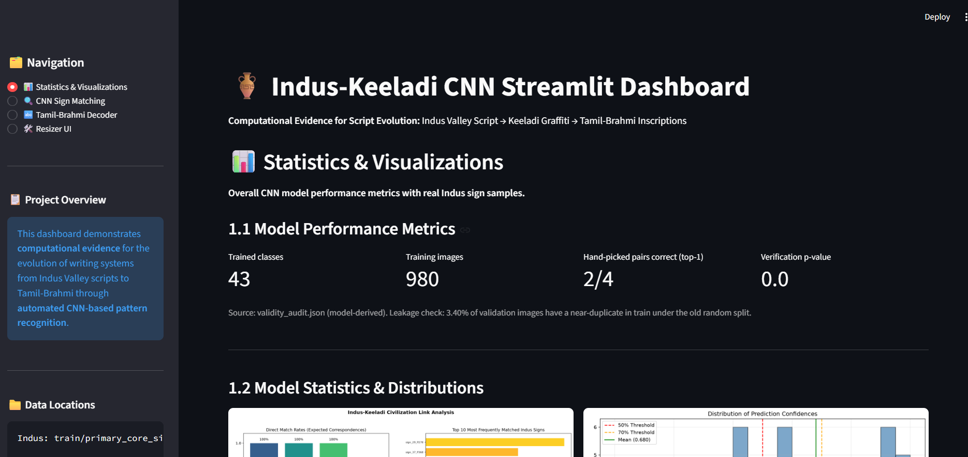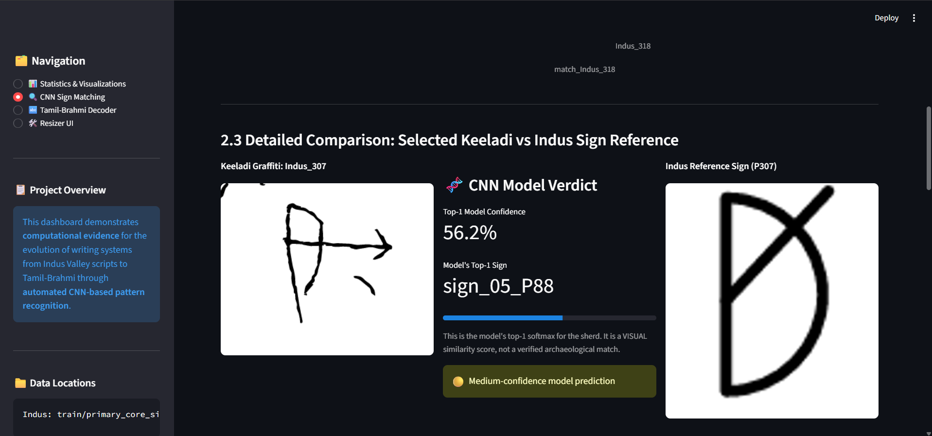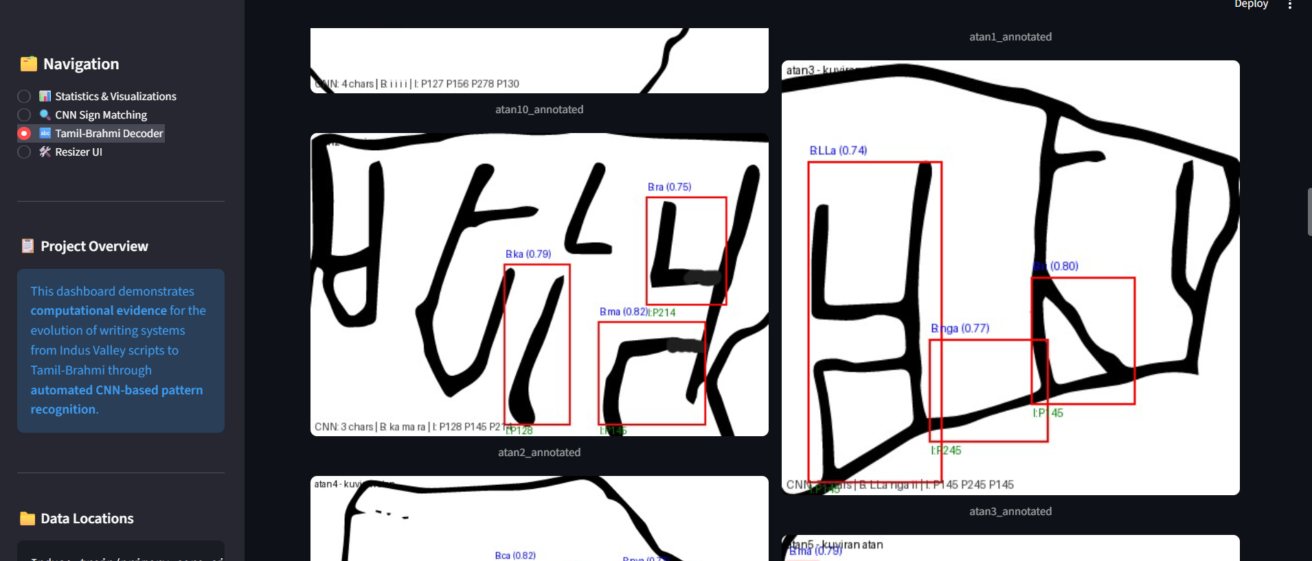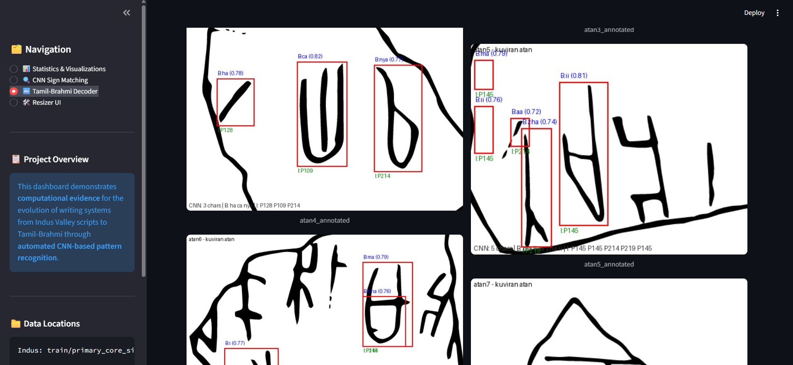

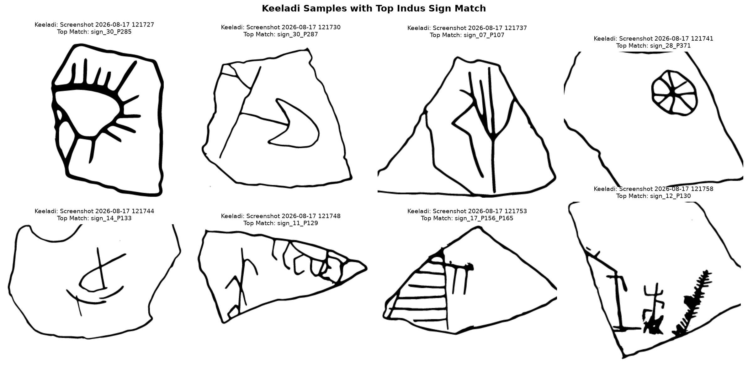
Fig 7.6 Keeladi gallery sample

7.3 Discussion
Two of four pairs correct with zero per-pair tuning and p=0.000 is the honest signal. Failures are informative: 225 confused with P245, 307 with P88 - allograph neighbours. Controls prove match-rate alone is not evidence. Stroke signs score zero by shape fact, excluded from claims. Siamese 0.859 is robustness, not generalisation. Visual proximity cannot establish descent.

8. Conclusion and Future Work

8.1 Conclusion
A reproducible audited CNN pipeline now scores every Keeladi sherd, verifies 2/4 curated pairs in top-1 (3/4 top-3, p=0.000), retrieves Fig.65 perturbations at 0.859, and proves its own limits: clean leakage, failed open-set on real data, zero-score strokes. The strongest result is the audit, not the accuracy.

8.2 Future work
- Populate 16->1001 Keeladi sherds (highest value).
- Collect independent allographs for real generalisation.
- Add Brahmi/graffiti hard negatives; wire GridDecomposer + fig65_embeddings into matcher.
- Run WeightTransfer unfreeze on real Keeladi.
- Re-run full audit after each change; null must stay possible.

8.3 Limitations
- Closed 43-way cannot say not-Indus (49-83% accept on real out-of-domain).
- 980 thin training imgs; Fig.65 39/40; strokes inseparable.
- Siamese upper bound only; transfer not executed; grid not wired.
- Similarity is not descent.

References
- The Indus Script - Recognition as an Alphabet (Figs 01-65; core alphabet Fig.65; grid Fig.01; modifiers/diacritics; allographs Fig.59). docs/ PDF.
- Keeladi Excavation Reports (1001 graffiti + 56 Brahmi; 4-sign table p.58). docs/keeladi_indus.pdf.
- Mahadevan M-1977; Wells W-2015; Parpola P-2010 concordances (FIG65_ROWS).
- TensorFlow/Keras, OpenCV, scikit-learn, Matplotlib/Seaborn, PyMuPDF, Streamlit, Pillow, PlantUML docs.

Annexure A - Technology Stack and Repository Layout
Layer | Tech
Lang | Python 3.11
DL | TensorFlow 2.21 / Keras 3 (CPU Win)
Vision | OpenCV, NumPy, Pillow
Metrics | scikit-learn
Plots | Matplotlib Agg, Seaborn
PDF | PyMuPDF
UI | Streamlit; Tkinter resizer
Diagrams | PlantUML (.puml + PNG)

run_pipeline.py | process_model.py | dashboard.py | src/train,evaluate,audit_validity,sign_matcher,siamese_embed,digitise_fig65,decoding | src/models, src/preprocessing | data/processed | models/evaluation_results | docs/uml,/figures | notebooks/

Annexure B - Configuration and How to Run
Task | Command
Retrain | python src/train.py (INDUS_AUG/EPOCHS/BATCH)
Full audit+evaluate | python run_pipeline.py
Read results | python process_model.py
Dashboard | streamlit run dashboard.py
Render UML | plantuml docs/uml/*.puml or VSCode Alt+D

Env: indus_keeladi_env/Scripts/python.exe. i7 CPU ~4min/20ep, ~16min/80ep. GPU: WSL2+CUDA or directml.

Annexure C - Glossary
Term | Meaning
P-2010 | Parpola sign number (e.g. P225)
M-1977 | Mahadevan number
Fig.65 | 40-row core alphabet plate
zz_ | rejection class (never a match)
Top-1/Top-3 | expected sign ranked 1st / in first 3
p-value | permutation null probability
Twin rate | val imgs with >=0.99 train twin

Research Paper References (Bibliography)
- [R1] Parpola, A. Deciphering the Indus Script. Cambridge University Press, 1994. Foundational epigraphic analysis; sign-list tradition behind the M/W/P concordances used in Fig. 65.
- [R2] Mahadevan, I. The Indus Script: Texts, Concordance and Tables. Memoirs of the Archaeological Survey of India, No. 77, 1977. M-1977 sign numbering adopted in FIG65_ROWS.
- [R3] Mahadevan, I. Early Tamil Epigraphy: From the Earliest Times to the Sixth Century A.D. Harvard Oriental Series, 2003. Tamil-Brahmi decipherment framing the Brahmi control readings.
- [R4] Wells, B. K. Epigraphic Approaches to Indus Writing. Ph.D. dissertation, Harvard University, 2015. W-2015 sign-list revision.
- [R5] Tamil Nadu State Department of Archaeology. Keeladi Excavation Reports (1,001 graffiti sherds, 56 Tamil-Brahmi sherds; 4-sign comparison table, p. 58). Primary archaeological source of this project.
- [R6] Palaniappan, S. and Adhikari, R. Deep Learning the Indus Script. arXiv:1702.00523 [cs.CV], 2017. First CNN pipeline for Indus grapheme segmentation and classification (jar-sign 92%).
- [R7] Diao, X. et al. Ancient Script Image Recognition and Processing: A Review. arXiv:2506.19208 [cs.CV], 2025. Survey of scarce, imbalanced and degraded script recognition.
- [R8] Sommerschield, T. et al. Machine Learning for Ancient Languages: A Survey. Computational Linguistics, vol. 49, no. 3, pp. 703-751, 2023. Digitization/recognize/restore/decipher taxonomy.
- [R9] Assael, Y. et al. Restoring and Attributing Ancient Texts Using Deep Neural Networks. Nature, vol. 603, pp. 280-283, 2022. Ithaca epigraphy paradigm.
- [R10] Koch, G., Zemel, R. and Salakhutdinov, R. Siamese Neural Networks for One-Shot Image Recognition. ICML Deep Learning Workshop, 2015. Basis of siamese_embed.py.
- [R11] Schroff, F., Kalenichenko, D. and Philbin, J. FaceNet: A Unified Embedding for Face Recognition and Clustering. Proc. IEEE CVPR, 2015. Triplet-loss L2 embedding template.
- [R12] Simonyan, K. and Zisserman, A. Very Deep Convolutional Networks for Large-Scale Image Recognition (VGG). ICLR, 2015. Basis of IndusClassifierCNN.
- [R13] He, K. et al. Deep Residual Learning for Image Recognition (ResNet). Proc. IEEE CVPR, 2016. Reference for WeightTransfer progressive unfreezing.
- [R14] Bendale, A. and Boult, T. E. Towards Open Set Deep Networks. Proc. IEEE CVPR, 2016. Closed-softmax cannot say none-of-the-above.
- [R15] Scheirer, W. J. et al. Toward Open Set Recognition. IEEE Trans. Pattern Analysis and Machine Intelligence, vol. 35, no. 7, 2013. Motivates zz_ rejection classes and the validity audit.
- [R16] Otsu, N. A Threshold Selection Method from Gray-Level Histograms. IEEE Trans. Systems, Man, and Cybernetics, vol. 9, no. 1, 1979. Otsu polarity in ImageNormalizer.
- [R17] Abadi, M. et al. TensorFlow: Large-Scale Machine Learning on Heterogeneous Systems. arXiv:1603.04467, 2016; Chollet, F. et al. Keras, 2015. Training stack.

