CLINIC APPOINTMENT
BOOKING SYSTEM
Software Project Documentation
Full-stack web application for clinic appointment management

Document Information | Details
Project | Clinic Appointment Booking System
Architecture | TypeScript monorepo with Node/Express backend, React SPA frontend, shared types
Database | MongoDB with Mongoose; replica set required for transactions
Frontend | React 18 + Vite
Backend | TypeScript 5 + Express 4
Authentication | JWT access token + HttpOnly refresh-token cookie
Primary invariant | The same doctor slot can never be double-booked
Prepared from | README.md, ARCHITECTURE.md, DESIGN.md, MODULES.md, API_REFERENCE.md, SECURITY.md

Version: Project documentation generated from the supplied reference files

Table of Contents
- Executive Summary
- Problem Statement and Objectives
- Functional Features
- Technology Stack
- System Architecture
- Data Model and Database Design
- Appointment Scheduling and Concurrency
- Authentication, Authorization and Security
- API Design and Endpoint Reference
- Frontend Design
- Timezone and Calendar Handling
- Testing and Verification
- Course Module Mapping
- Installation, Configuration and Operation
- Error Handling and Operational Behaviour
- Design Decisions and Rationale
- Conclusion
- Appendix A. Repository Structure
- Appendix B. API Status Codes
- Appendix C. Documentation Sources

1. Executive Summary
The Clinic Appointment Booking System is a full-stack web application designed to manage clinic appointments, doctors, patients, holidays, schedules and audit records. Patients can browse doctors, view availability and book appointments, while receptionists and administrators manage operational records. The system uses a TypeScript/Express backend, a React/Vite single-page frontend, MongoDB through Mongoose, and a shared types module.
The defining technical requirement is concurrency safety: when multiple users attempt to book the same doctor slot simultaneously, the database must guarantee that only one booked appointment survives. The project documents and tests this invariant using a partial unique MongoDB index, transactions, and an end-to-end real-HTTP concurrency proof.
- Four application roles are defined: patient, doctor, receptionist and admin.
- Protected API routes use JWT access tokens and HttpOnly refresh-token cookies.
- Role and ownership controls are enforced before sensitive operations.
- Sensitive patient reads are recorded in an audit trail.
- Working hours are clinic-timezone based, while appointment instants are represented in UTC.
- Rate limiting, input validation, request tracing and consistent error responses are included.
Source basis: README.md, ARCHITECTURE.md, DESIGN.md, SECURITY.md

2. Problem Statement and Objectives

2.1 Problem Statement
A clinic appointment system must coordinate shared doctor availability among multiple users. The critical correctness problem occurs when two or more patients select the same slot at nearly the same time. A simple application-level check followed by an insert is not sufficient because the check and write are separated by asynchronous I/O.

2.2 Objectives
- Provide authenticated access to clinic functionality according to user role.
- Allow patients to discover doctors, view availability and create appointments.
- Allow authorised staff to manage doctors, patients and holidays.
- Maintain appointment state and prevent illegal state transitions.
- Guarantee that one doctor cannot have two simultaneously booked appointments at the same start time.
- Protect patient and authentication data through layered security controls.
- Provide auditability for sensitive medical-data reads.
- Handle clinic-local working hours and UTC appointment instants consistently.
- Provide automated tests and explicit concurrency/IDOR evidence for key requirements.

2.3 Core Invariant
For every doctor and start time:
at most one Appointment may exist with status = "booked".
Database constraint:
{ doctor: 1, startsAt: 1 }
unique = true
partialFilterExpression = { status: "booked" }
Source basis: DESIGN.md, ARCHITECTURE.md

3. Functional Features
Feature | Description
Appointment booking | Patients browse doctors, view month/day availability and book a slot.
Concurrency-safe booking | Partial unique compound index plus transactions prevent double-booking.
Role-based access control | Patient, doctor, receptionist and admin permissions are separated.
Holiday management | Clinic-wide or doctor-specific closures can be managed by authorised users.
Audit logging | Sensitive patient record reads are written to an append-only audit trail.
Timezone-aware scheduling | Clinic-local working hours generate UTC appointment instants.
Refresh-token rotation | Refresh tokens rotate; password changes invalidate outstanding refresh chains.
Saka calendar display | Indian/Saka calendar information is displayed alongside Gregorian dates.
Rate limiting | Global API, login and booking-specific throttles are configured.
Request tracing | Requests carry an X-Request-Id through logs and responses.

Source basis: README.md, SECURITY.md

4. Technology Stack
Concern | Technology | Purpose
Backend language | TypeScript 5 | Strict mode, no any
HTTP framework | Express 4 | API host and middleware pipeline
Database | MongoDB | Replica set required for transactions
ODM | Mongoose 8 | Schemas, validation, hooks, indexes and transactions
Authentication | bcrypt 6 + jsonwebtoken 9 + HttpOnly cookies | Password hashing and JWT session model
Frontend | React 18 JSX | Single-page application
Build | Vite 5 | Frontend development/build tooling
Routing | react-router-dom v6 | Client-side route management
Styling | Hand-written responsive CSS | No UI framework
Rate limiting | express-rate-limit 7 | API/login/booking throttling
Backend tests | Jest 29 + ts-jest + supertest + mongodb-memory-server | Automated HTTP/database tests
Frontend tests | Node built-in --test runner | Date utility tests

Source basis: README.md, DESIGN.md

5. System Architecture

5.1 Repository Architecture
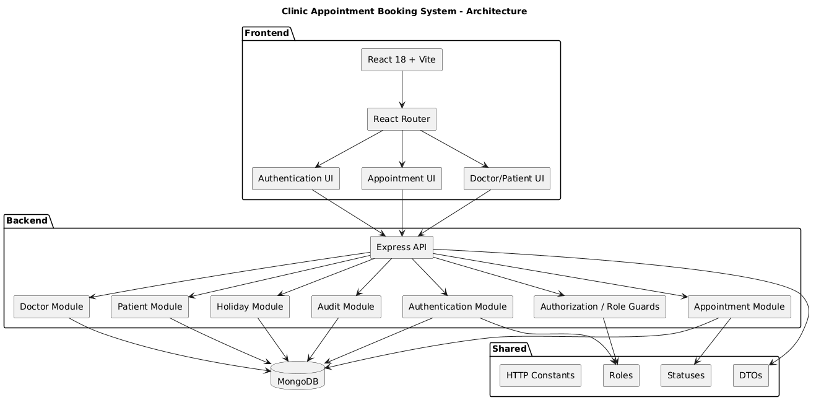The backend is organised into routes, controllers, services, models, middleware, utilities and types. The frontend is organised into pages, reusable components, authentication helpers, API wrappers and date/calendar utilities. The shared package provides a common contract used by both halves.

5.2 Four-Layer Backend Contract
Layer | Responsibility | Must not do
Routes | Declare HTTP method/path and middleware chain. | Business logic; Mongoose imports
Controllers | Parse request, call one service function, send response. | Role branches; direct DB access
Services | Business rules, role-scoped filtering, transactions and state-machine rules. | req/res access
Models | Mongoose schemas, field validation, indexes and password hooks. | Application/business logic

5.3 Request Lifecycle
Request
→ requestLogger
→ apiLimiter
→ cors
→ express.json
→ cookieParser
→ security headers
→ route handler
→ authenticate
→ authorize
→ ownership guard
→ validate
→ bookingLimiter (mutating appointment routes)
→ asyncHandler
→ controller
→ notFoundHandler
→ errorHandler
This ordering keeps authentication and authorization outside the service transaction boundary while allowing mutable-state checks such as availability and holiday status to be re-checked inside the transaction where required.

6. Data Model and Database Design

6.1 Entity Relationships
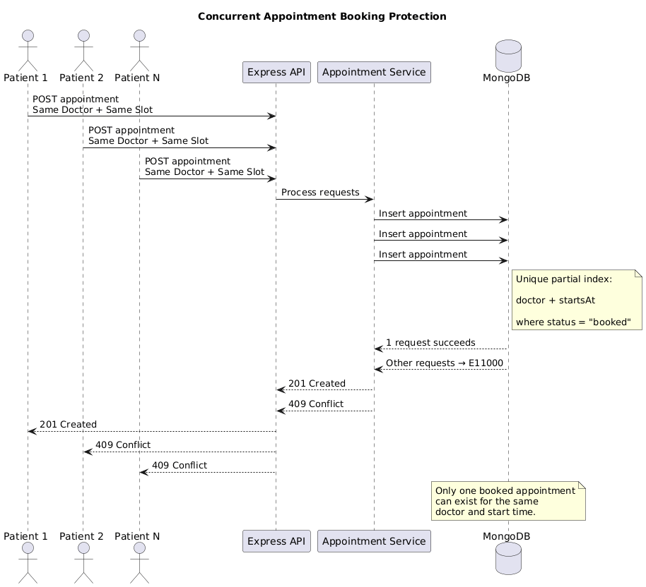

6.2 Important Schema Decisions
- Doctor workingHours are embedded because they travel with the doctor and are not queried independently.
- Appointments reference doctors and patients because appointments are the growth axis and are queried independently.
- The appointment index is partial so cancelled appointments no longer occupy a slot.
- User passwordHash is excluded from ordinary queries and removed during JSON serialization.
- Holiday records distinguish doctor-specific closures from clinic-wide closures.

7. Appointment Scheduling and Concurrency

7.1 Slot Generation
slotInstantsFor(doctor, date)
→ find clinic-local working-hours window
→ step forward by slotMinutes
→ keep only complete slots inside the window
getAvailability(...)
→ if holiday: []
→ read booked starts for the doctor/day
→ mark each computed slot available/not available
Slots are computed on demand and are not stored as separate database documents. Appointment starts and ends are UTC instants; working hours are interpreted using CLINIC_TZ.

7.2 Why Check-Then-Write Is Unsafe
The design documentation demonstrates that Node's single-threaded event loop does not eliminate the race. An awaited database read yields execution, allowing other requests to perform the same availability check before any of them writes the booking.
Request A: await findOne(...) → sees free → yields
Request B: await findOne(...) → sees free → yields
...
Multiple requests can pass the check before the first insert becomes visible.

7.3 Database-Level Backstop
appointmentSchema.index(
{ doctor: 1, startsAt: 1 },
{ unique: true, partialFilterExpression: { status: 'booked' } }
);
If concurrent transactions reach the final write at the same time, MongoDB rejects the duplicate with E11000. The service maps this conflict to HTTP 409. The partial condition means a cancelled appointment can be followed by a new booking for the same slot.

7.4 Transaction Boundary
Booking is a multi-step operation involving availability, holiday checks, appointment creation and audit work. The project uses a withTransaction<T>() helper that owns the MongoDB session lifecycle and ensures cleanup on every exit path.

7.5 Evidence
Test | Observed result | Meaning
Naive check-then-write without unique index | 50 attempts → 50 rows | Application-only check is unsafe.
Same pattern with partial unique index | 1 created; 49 E11000 → 409; 1 row | Database constraint enforces uniqueness.
Real HTTP concurrency proof | 50 authenticated patients; 1×201; 49×409; 1 booked row | End-to-end invariant holds.

Source basis: DESIGN.md, ARCHITECTURE.md, README.md

8. Authentication, Authorization and Security

8.1 Authentication
- Access tokens are short-lived (default 15 minutes) and sent using Authorization: Bearer <accessToken>.
- Refresh tokens are long-lived (default 7 days) and stored in an HttpOnly cookie.
- Access and refresh tokens use separate signing secrets.
- Refresh-token rotation issues a new refresh token on every refresh operation.
- refreshTokenVersion is embedded in tokens and checked against the database; password changes bump the version and invalidate outstanding refresh tokens.
- Passwords are hashed with bcrypt cost factor 12 in a User model pre-save hook.
- Login uses the same invalid-credential message for unknown emails and wrong passwords to reduce email enumeration.

8.2 Authorization
Authorization uses both role guards and ownership guards. The system distinguishes 401 Unauthorized (no valid identity) from 403 Forbidden (authenticated but not permitted).
Role | Documented scope
Patient | Own appointments; self booking; doctor/slot discovery
Doctor | Own schedule and appointment operations within documented permissions
Receptionist | Operational access to patients, appointments and clinic data
Admin | Full administrative management, including audit access

8.3 IDOR Prevention
- Foreign appointment access returns 403 through ownsAppointment rather than exposing an existence oracle through 404.
- The doctor schedule endpoint is protected so patients cannot enumerate another doctor's patient list.
- Availability responses reveal only startsAt, endsAt and available; patient identity is not exposed.
- List endpoints enforce patient/doctor scope in the service layer so query parameters cannot override identity constraints.

8.4 Validation and Rate Limiting
Control | Documented configuration
ObjectId validation | 24-character hexadecimal IDs; applied to path and query values.
Calendar date validation | YYYY-MM-DD with round-trip validity checking.
ISO date validation | ISO datetime parsing.
Enum validation | Strict whitelist of accepted values.
API limiter | 600 requests/minute/IP by default.
Login limiter | 5 attempts/15 minutes/IP by default.
Booking limiter | 200 requests/minute/user by default.

8.5 Logging, CORS and Secrets
- Authorization and Cookie headers are not logged.
- Password-related request-body keys are redacted.
- X-Request-Id is generated/propagated and echoed for tracing.
- CORS uses a single configured origin with credentials enabled; wildcard credentialed origins are not used.
- JWT secrets must be present, at least 32 characters, non-placeholder values and different from each other.
- The server fails closed when required secret validation fails.
Source basis: SECURITY.md, DESIGN.md

9. API Design and Endpoint Reference
The API is rooted at http://localhost:4000 by default and all application routes are prefixed with /api. Most protected endpoints use a JWT Bearer token. Refresh is handled through the HttpOnly cookie. All API errors use a consistent JSON structure with an error code, human-readable message, and development-only details.
{
"error": "ErrorCode",
"message": "Human-readable description",
"details": "Extra context (development only, omitted in production)"
}

9.1 Authentication Endpoints
Method | Endpoint | Auth | Purpose
POST | /api/auth/register | Public | Create patient User + Patient
POST | /api/auth/login | Public | Authenticate and issue tokens
POST | /api/auth/refresh | Refresh cookie | Rotate refresh token and issue access token
POST | /api/auth/logout | Cookie | Clear refresh-token cookie
GET | /api/auth/me | Bearer | Return authenticated user profile
PATCH | /api/auth/password | Bearer | Change password and invalidate other refresh sessions

9.2 Doctor Endpoints
Method | Endpoint | Auth | Purpose
GET | /api/doctors | Bearer | List doctors; optional speciality filter
GET | /api/doctors/:id | Bearer | Get doctor details
GET | /api/doctors/:id/slots | Bearer | Daily availability grid
GET | /api/doctors/:id/calendar | Bearer | Month availability summary
GET | /api/doctors/:id/schedule | Role/ownership | Doctor schedule with protected patient details
POST | /api/doctors | Admin | Create doctor
PATCH | /api/doctors/:id | Admin | Update doctor/working hours
DELETE | /api/doctors/:id | Admin | Delete/deactivate doctor

9.3 Patient Endpoints
Method | Endpoint | Auth | Purpose
GET | /api/patients | Admin/Receptionist | Paginated patient list
GET | /api/patients/:id | Admin/Receptionist | Patient record; audited
POST | /api/patients | Admin | Create patient, optionally linked login
PATCH | /api/patients/:id | Admin | Update patient
DELETE | /api/patients/:id | Admin | Delete patient/deactivate linked auth

9.4 Appointment, Holiday and Audit Endpoints
Method | Endpoint | Auth | Purpose
GET | /api/appointments | Scoped | List appointments according to role
GET | /api/appointments/:id | Scoped | Get appointment; ownership enforced
POST | /api/appointments | Patient/Staff | Book appointment
PATCH | /api/appointments/:id/cancel | Scoped | Cancel appointment
PATCH | /api/appointments/:id/reschedule | Scoped | Reschedule appointment
PATCH | /api/appointments/:id/status | Doctor/Admin | Set completed/no-show where permitted
GET | /api/holidays | Receptionist/Admin | List holidays
POST | /api/holidays | Admin | Create clinic/doctor holiday
DELETE | /api/holidays/:id | Admin | Remove holiday
GET | /api/audit | Admin | Query audit records
GET | /health | Public | Liveness/readiness with real MongoDB ping

9.5 Standard Status Codes
Code | Meaning
200 | OK
201 | Created
204 | No Content
400 | Bad Request
401 | Unauthorized
403 | Forbidden
404 | Not Found
409 | Conflict, including booking races/duplicate conflicts
422 | Unprocessable Entity / business rule violation
429 | Too Many Requests
500 | Internal Server Error

Source basis: API_REFERENCE.md

10. Frontend Design
The frontend is a React 18 single-page application built with Vite. It uses route-level pages, reusable components, authentication context and a central API client. The architecture keeps fetch calls inside the frontend api/ module rather than spreading HTTP logic through UI components.
Frontend area | Responsibility
App.jsx | Router and route definitions
api/client.js | Centralised fetch calls and token management
auth/AuthContext.jsx | Authentication state
auth/ProtectedRoute.jsx | Route protection
auth/useAuth.js | Authentication hook
pages/ | Page-level views
components/ | Reusable UI components such as SlotGrid, BookingCalendar, Toast, ErrorBanner
lib/dates.js | Date handling and calendar utilities
lib/indianCalendar.js | Saka/Indian calendar display support
App.css | Hand-written responsive CSS

10.1 UI/API Separation
- UI components render data and manage local interaction state.
- The API client is the central place for fetch calls and token handling.
- AuthContext and ProtectedRoute provide authenticated application flow.
- Shared constants from shared/types.ts prevent frontend values from drifting from backend contracts.

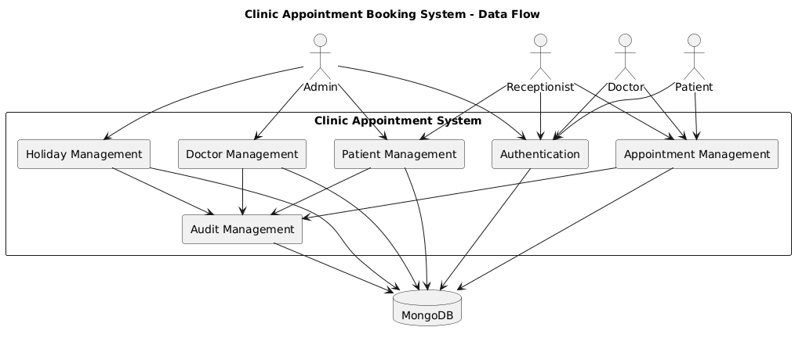

11. Timezone and Calendar Handling
The project distinguishes two different concepts: a calendar date such as 2026-10-06 and an instant such as 2026-10-06T08:00:00.000Z. Calendar dates are zone-less labels, while appointment instants are UTC values.
Concept | Representation | Rule
Instant | UTC ISO 8601 | Used for appointment startsAt/endsAt.
Calendar date | YYYY-MM-DD string | Used for holiday/date-selection concepts without a timezone.
Working hours | HH:MM in CLINIC_TZ | Converted into UTC slot instants by the server.
Viewer display | Viewer local timezone | Frontend renders appointment instants for the person viewing.

12. Testing and Verification

12.1 Automated Test Coverage
- Backend suites cover authentication, appointments, patients, doctors, slots, audit, holiday, validation, rate limiting, timezone, configuration and IDOR behaviour.
- The IDOR suite compares a deliberately vulnerable build with the real protected build.
- Frontend date utilities are tested across multiple timezones.
- Configuration tests verify that insecure placeholder/short/shared secrets cause startup failure.

12.2 Concurrency Proof
npm run test:concurrency
50 authenticated patients
↓
50 concurrent POST /api/appointments
↓
1 × HTTP 201 Created
49 × HTTP 409 Conflict
↓
1 booked appointment stored

12.3 Naive Comparison
npm run test:naive
Without unique index:
50 requests → 50 stored rows
With partial unique index:
50 requests → 1 stored row
49 duplicate conflicts

12.4 Operational Commands
Command | Purpose
npm test (backend) | Run backend automated test suite.
npm run test:idor | Run IDOR before/after proof.
npm run test:concurrency | Run real HTTP concurrency proof.
npm run test:naive | Demonstrate unsafe check-then-write versus indexed behaviour.
npm test (frontend) | Run frontend date utility tests.
npm run test:timezones | Run timezone regression tests.

Source basis: README.md, MODULES.md, DESIGN.md

13. Course Module Mapping
Module | Demonstrated skill
M1 | Project setup, monorepo layout and git hygiene
M2 | HTTP/Express application, headers, /health and request logging
M3 | MVC and CRUD for primary resources
M4 | Async controllers, Express 4 forwarding and custom error middleware
M5 | Mongoose schemas, validation, hooks and indexes
M6 | Authentication, JWT issue/verify/refresh rotation, roles and ownership
M8 | React components, controlled forms, centralised fetch and responsive CSS
M9 | Automated HTTP testing, race proof, IDOR proof and coverage
M10 | Layering contract, 401-vs-403 correctness and consistent errors

14. Installation, Configuration and Operation

14.1 Prerequisites
- Node.js 20+
- npm 9+
- MongoDB configured as a replica set, because transactions are required

14.2 MongoDB Replica Set Example
mongod --replSet rs0 --dbpath /data/db
mongosh --eval "rs.initiate()"

14.3 Installation
git clone <repository-url>
cd AWT
cd backend
npm install
cp .env.example .env
# Configure required values in backend/.env
cd ../frontend
npm install

14.4 Running
Terminal 1:
cd backend
npm run dev
# http://localhost:4000
Terminal 2:
cd frontend
npm run dev
# http://localhost:5173

14.5 Health Check
curl http://localhost:4000/health
A healthy response indicates that the application is running and MongoDB has been successfully pinged. A degraded response is returned when the server is up but the database is unreachable.

14.6 Demo Data
cd backend
npm run seed
Email | Role | Purpose
admin@clinic.io | admin | Administrative access
reception@clinic.io | receptionist | Reception/operational access
dr.nolan@clinic.io | doctor | General Practice doctor
dr.brady@clinic.io | doctor | Cardiology doctor
mary@example.com | patient | Patient demo account
john@example.com | patient | Patient demo account
siobhan@example.com | patient | Patient demo account
david@example.com | patient | Patient demo account

15. Error Handling and Operational Behaviour
The API uses a single error-handler path. Application errors are represented through an AppError hierarchy and converted into the standard JSON shape. Mongoose CastError and validation failures map to 400, duplicate-key errors map to 409, and unexpected failures map to 500.
Condition | Status | Example
Malformed input | 400 | Invalid ObjectId or invalid date
No/invalid authentication | 401 | Missing/expired/tampered access token
Authenticated but not allowed | 403 | Foreign appointment or prohibited schedule access
Missing resource | 404 | Unknown doctor/patient
Concurrency/duplicate conflict | 409 | Two requests attempt the same booked slot
Business-rule violation | 422 | Illegal appointment state transition
Rate limit | 429 | Login/API/booking threshold exceeded
Unexpected server failure | 500 | Unhandled internal error

16. Design Decisions and Rationale
Decision | Rationale
Partial unique index | Makes the no-double-booking invariant a database-level property shared by all application instances.
Transactions | Provides atomicity for multi-document operations and avoids leaked sessions through a central helper.
Service-layer role scoping | Prevents query parameters from overriding identity-based filters.
Route-declared guards | Keeps permission requirements visible while middleware performs enforcement.
Embedded working hours | Fits value semantics and avoids a separate resource/collection.
Referenced appointments | Appointments are the growth axis and need independent doctor/patient queries.
Split access/refresh tokens | Keeps access tokens short-lived while refresh credentials remain inaccessible to JavaScript.
Refresh-token versioning | Allows password change to invalidate all outstanding refresh chains without a token blocklist.
401 vs 403 | Preserves the distinction between authentication failure and permission failure.
403 for foreign resources | Avoids using 404 as an existence oracle in ownership-sensitive endpoints.
Canonical timezone handling | Separates clinic-local slot generation from viewer-local display.
Shared types | Keeps frontend and backend DTOs, roles, statuses and HTTP constants aligned.

17. Conclusion
The supplied project documentation describes a complete clinic appointment platform with a clear separation between presentation, HTTP handling, business services and persistence. Its most important correctness property—the prevention of double-booking—is enforced at the database layer and supported by transactions and executable concurrency evidence.
Security is treated as a cross-cutting concern rather than a single authentication feature: JWT separation, refresh rotation, password hashing, role/ownership checks, IDOR protection, input validation, rate limiting, request redaction, CORS restrictions, secret validation and audit logging are all documented.
The result is a project structure that is testable, explainable and aligned with the documented course module requirements. This report consolidates the supplied README, architecture, design, module mapping, API reference and security documentation into a single submission-ready document.

Appendix A. Repository Structure
AWT/
├── backend/
│ ├── src/
│ │ ├── app.ts
│ │ ├── server.ts
│ │ ├── config.ts
│ │ ├── db.ts
│ │ ├── controllers/
│ │ ├── services/
│ │ ├── models/
│ │ ├── routes/
│ │ ├── middleware/
│ │ ├── utils/
│ │ └── types/
│ ├── scripts/
│ ├── __tests__/
│ ├── seed.ts
│ └── .env.example
├── frontend/
│ └── src/
│ ├── App.jsx
│ ├── api/
│ ├── auth/
│ ├── pages/
│ ├── components/
│ └── lib/
└── shared/
└── types.ts
The repository also contains the six documentation artifacts used as the basis for this report: README.md, ARCHITECTURE.md, DESIGN.md, MODULES.md, API_REFERENCE.md and SECURITY.md.

Appendix B. API Status Codes
Code | Meaning | Typical project usage
200 | OK | Successful reads/updates
201 | Created | Registration, resource creation, successful booking
204 | No Content | Logout, password change and deletes
400 | Bad Request | Validation/malformed input
401 | Unauthorized | Missing/invalid authentication
403 | Forbidden | Authenticated but outside role/ownership scope
404 | Not Found | Requested resource does not exist
409 | Conflict | Duplicate booking/duplicate resource conflict
422 | Unprocessable Entity | Business-rule/state-machine violation
429 | Too Many Requests | Rate limit exceeded
500 | Internal Server Error | Unexpected failure

Appendix C. Documentation Sources
Source | Used for
README.md | Project overview, features, stack, setup, running, seeding, testing and environment information.
ARCHITECTURE.md | Repository layout, layering, request lifecycle, data model, slot model, concurrency and frontend architecture.
DESIGN.md | Detailed design rationale, concurrency proof, permissions, token storage, auditability, timezone decisions and design summary.
MODULES.md | Course module-to-file mapping and cross-cutting deliverables.
API_REFERENCE.md | Endpoint-by-endpoint API contract, authentication requirements, request/response details and status codes.
SECURITY.md | Authentication, authorization, IDOR prevention, validation, rate limiting, secret management, logging, CORS and audit controls.

This report was generated from the supplied project files. Where a detail was not supported by those files, it was not added as a project-specific claim.

