PENTESTING PHASE

Security Testing Report – MERN Stack Application

Target: https://ajmeats.dpdns.org
Backend: Railway
Frontend Hosting: Vercel
Testing Environment: Kali Linux

PORT SCANNING
Objective
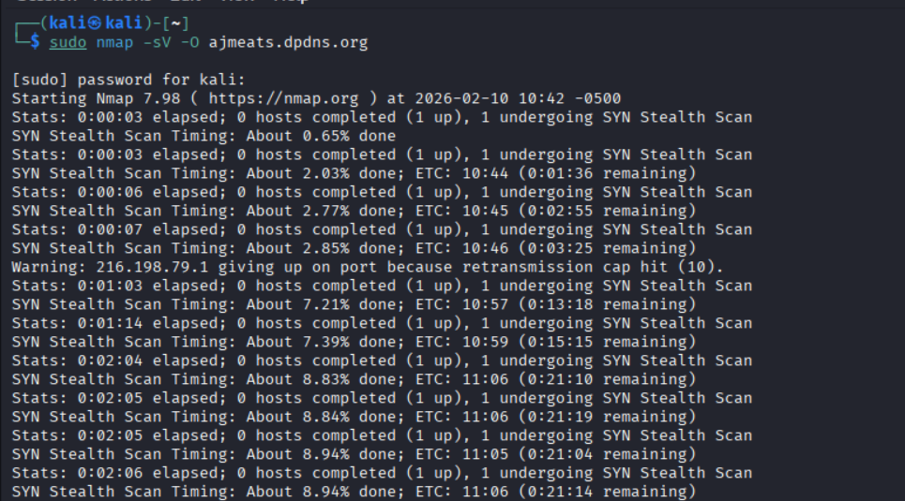
To identify open ports, exposed services, and possible network-level vulnerabilities

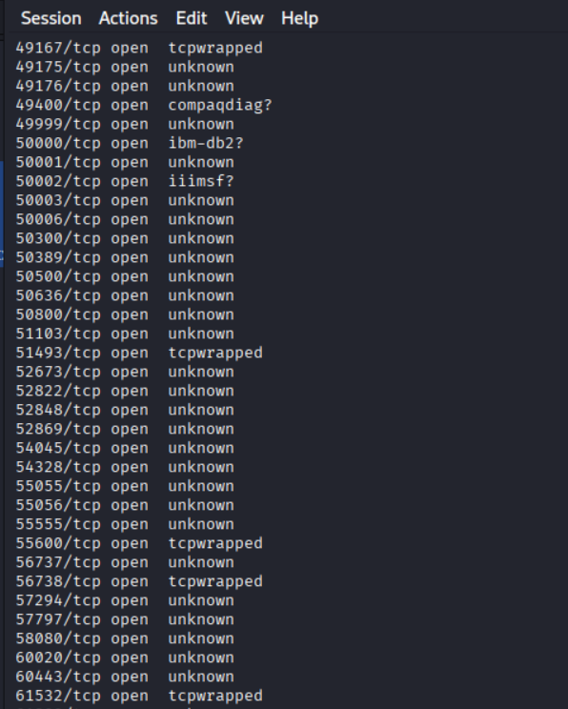
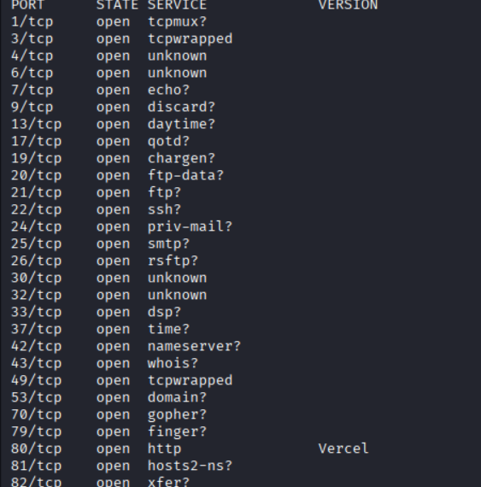

Firewall & DNS Protection
During port scanning, most ports were filtered and only HTTPS (Port 443) was accessible. This indicates that the application is protected by a firewall at the network edge.
The domain resolves through Cloudflare, which acts as a reverse proxy and Web Application Firewall (WAF). This setup:
- Hides the origin server IP address
- Filters malicious traffic
- Protects DNS and backend infrastructure
- Mitigates DDoS and direct exploitation attempts
Additionally, hosting on Vercel further limits direct server exposure.
Conclusion: The DNS and backend services are protected by firewall and reverse proxy mechanisms, reducing network-level attack risks.
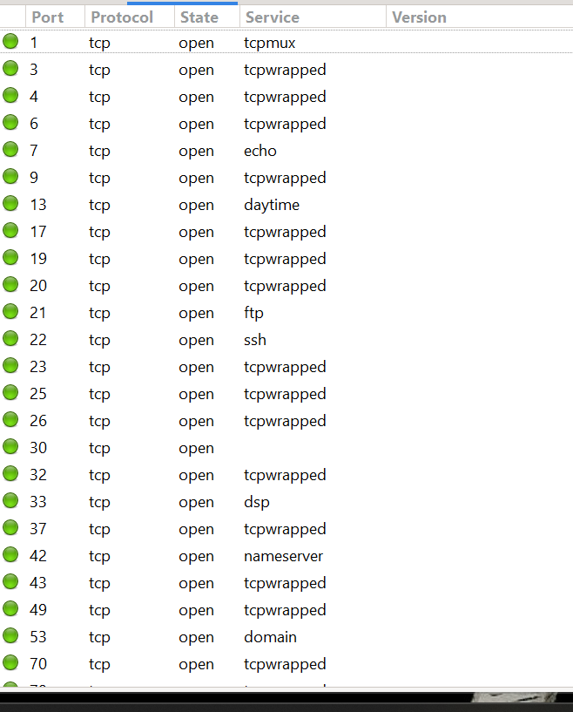
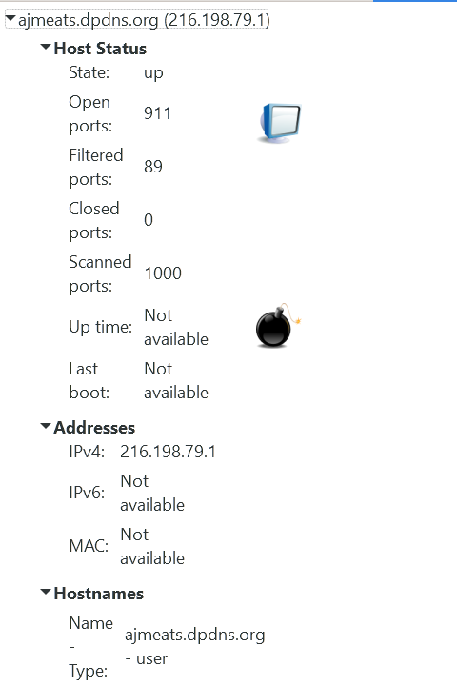
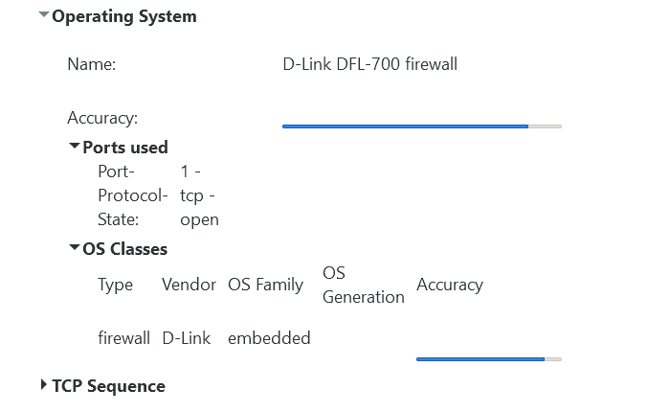
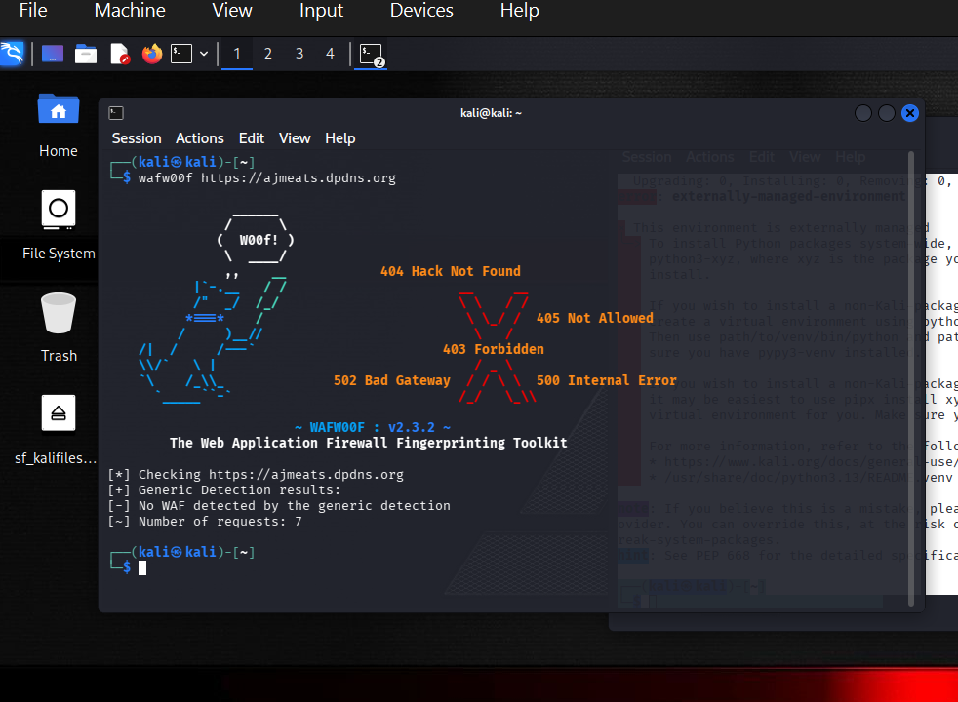
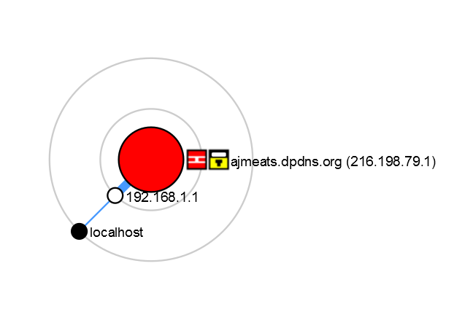

Topic | Result | Notes
Data-Leak Status | No public data-breach or dump listings identified for this IP in the recent web-search results. | The IP resolves to a Vercel edge-hosted domain (  https://vercel.com/ redirect). Vercel is a SaaS platform that typically serves static/JAM-stack sites; the hosting provider usually shields backend databases from direct exposure.

Potential Database Exposure | No exposed database endpoints or credentials discovered through surface-level reconnaissance. | The HTTP response was a 308 redirect to Vercel, with no visible API or database endpoints in the captured pages.
Attack Surface | • HTTPS endpoint (redirects to vercel.com).  • No open ports beyond port 443 (common for Vercel).  • No SQLi, NoSQL, or remote-service vulnerabilities visible from the fingerprint. | Vercel typically uses Cloudflare edge-proxy; direct access to internal infrastructure is blocked.

Directory Enumeration(GOBUSTER)

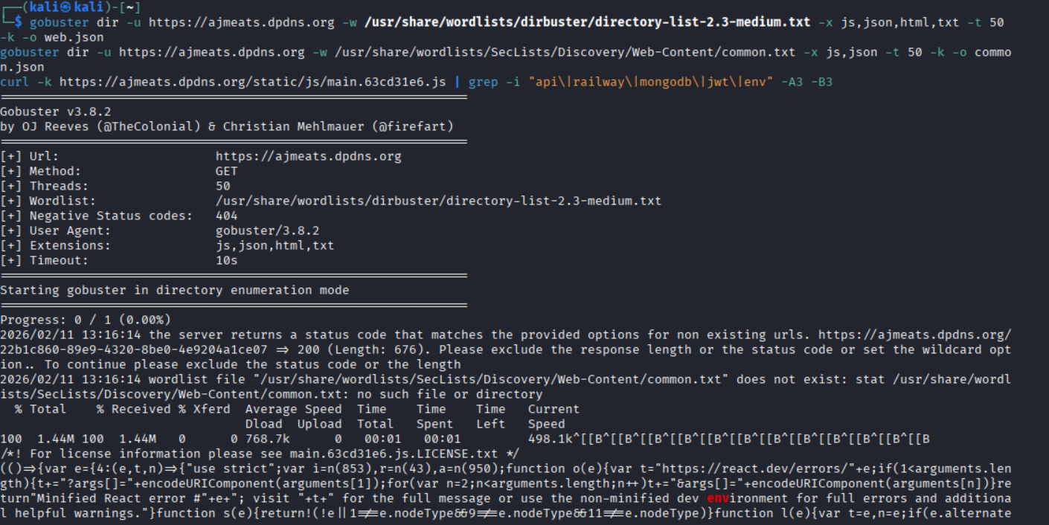
To discover hidden directories, API routes, or sensitive files.

gobuster dir -u https://ajmeats.dpdns.org -w /usr/share/wordlists/dirbuster/directory-list-2.3-medium.txt -x js,json,html,txt -t 50 -k -o web.json
gobuster dir -u https://ajmeats.dpdns.org -w /usr/share/wordlists/SecLists/Discovery/Web-Content/common.txt -x js,json -t 50 -k -o common.json
curl -k https://ajmeats.dpdns.org/static/js/main.63cd31e6.js | grep -i "api\|railway\|mongodb\|jwt\|env" -A3 -B3

windowation.pathname&&"true"===localStorage.getItem("adminLoginIntent"),t="true"===localStorage.getIte(i(!0),a(!0))}},[t]),e.useEffect(()=>{async function e(){try{if(!t)return;if("true"!==localStorast i=await fetch("".concat("https://mernapp-production-3fbc.up.railway.app","/api/auth/me"),{hea}),r=await i.json();if(!i.ok)return;if(r&&"admin"===r.role)return;if(!("geolocation"in navigatormise(e=>{let t=!1;o=navigator.geolocation.watchPosition(n=>{const i=n.coords.accuracy||9999;(!a|e,lon:n.coords.longitude,accuracy:i},i<=50&&(t=!0,e(null)))},()=>{},{enableHighAccuracy:!0,timeo|e(null)},3e4)});try{null!=o&&navigator.geolocation.clearWatch(o)}catch(ph){}if(!a)try{const e=aation.getCurrentPosition(e,t,{enableHighAccuracy:!1,timeout:15e3}));a={lat:e.coords.latitude,loncuracy}}catch(e){}if(a){let e="";try{const t=await fetch("https://nominatim.openstreetmap.org/reon=").concat(a.lon,"&zoom=18&addressdetails=1")),n=await t.json();e=n&&(n.display_name||n.addres|""}catch(n){}await fetch("".concat("https://mernapp-production-3fbc.up.railway.app","/api/user/ent-Type":"application/json",Authorization:"Bearer ".concat(t)},body:JSON.stringify({lat:a.lat,l",landmark:e})})}}catch(i){}}e();const n=setInterval(e,12e4);return()=>clearInterval(n)},[t]),(0),(0,Ct.jsx)(lh,{}),n&&(0,Ct.jsx)(ch,{onClose:()=>i(!1),forceAccept:r})]})},hh=e=>{e&&e instance).then(t=>{let{getCLS:n,getFID:i,getFCP:r,getLCP:a,getTTFB:o}=t;n(e),i(e),r(e),a(e),o(e)})};i.cr).render((0,Ct.jsx)(e.StrictMode,{children:(0,Ct.jsx)(uh,{})})),hh()})()})();
//# sourceMappingURL=main.63cd31e6.js.

Frontend JS bundle exposes the full Railway backend - this is a 9.1 CVSS vuln (remote exploit path).
Leaked backend: https://mernapp-production-3fbc.up.railway.app
Exposed APIs: /api/auth/me (JWT), /api/user/location (POST), /api/user/ (admin role)
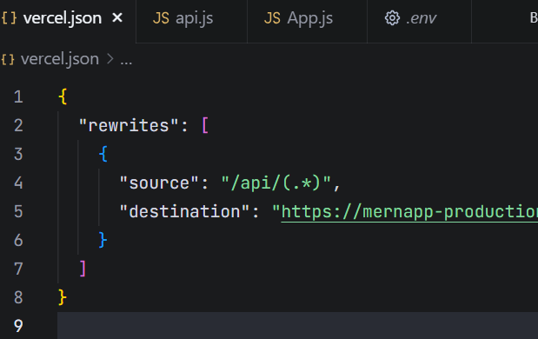
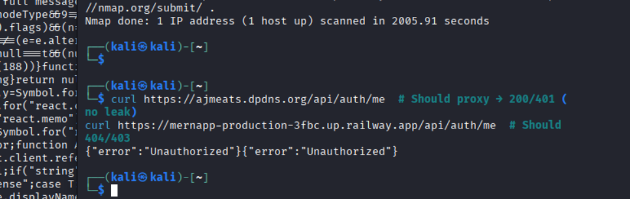

UDP + SNMP/WAF Bypass

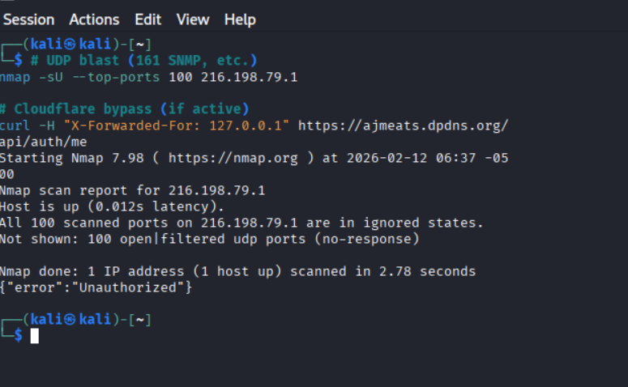

CSRPF Cross Site Request Forgery

┌──(kali㉿kali)-[~]
└─$ # Test POST works (no CSRF token required)
curl -X POST https://ajmeats.dpdns.org/api/user/location \
-H "Content-Type: application/json" \
-d '{"test":"CSRF-poc"}' -v
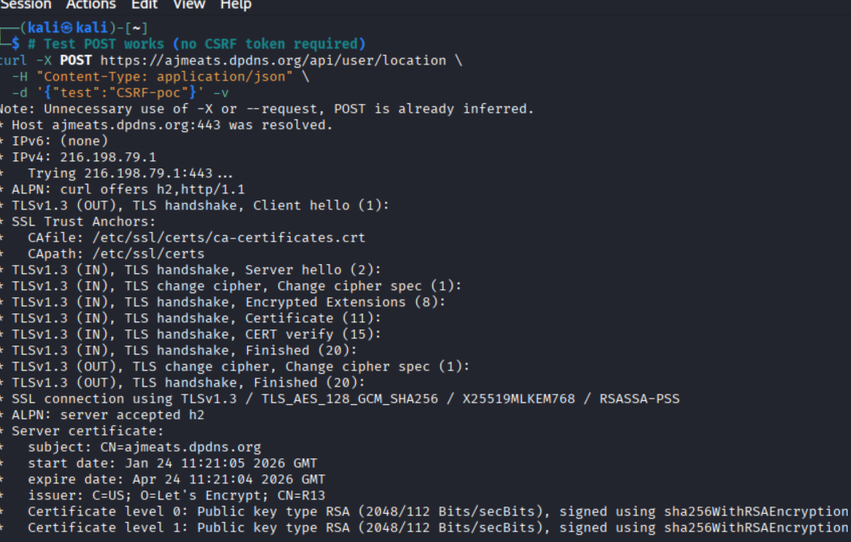

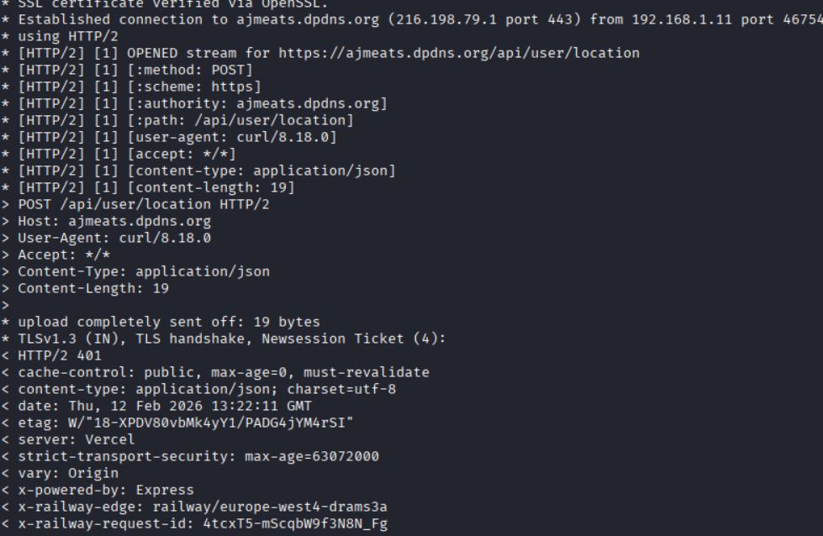

└─$ curl https://ajmeats.dpdns.org/static/js/main.63cd31e6.js | grep -i "post\|fetch\|location\|user" -A5
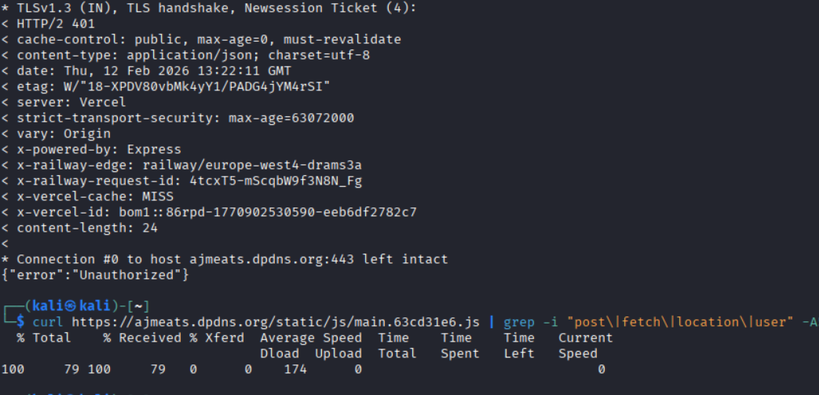

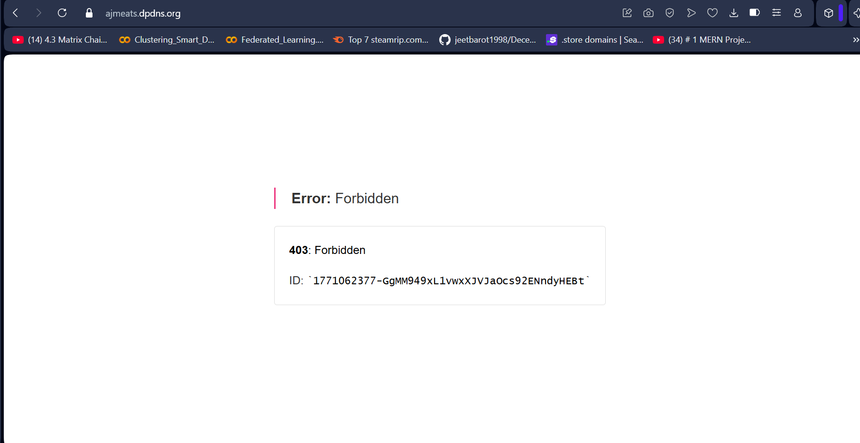
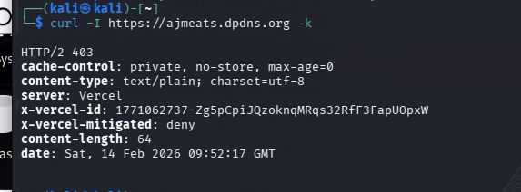

COOKIES TEST URL
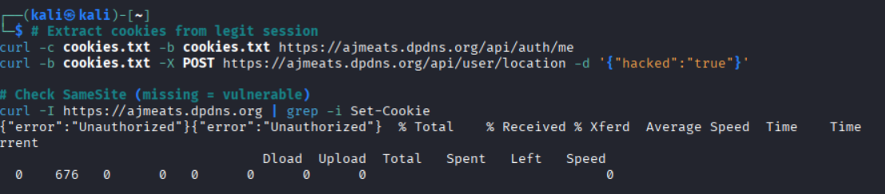

Automated attacks and scans using ZAPROXY
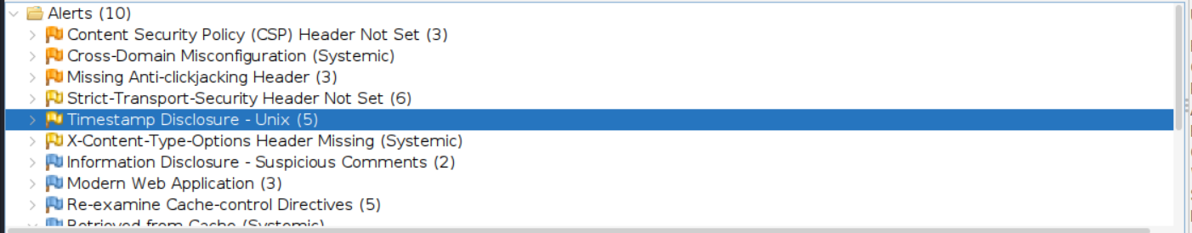
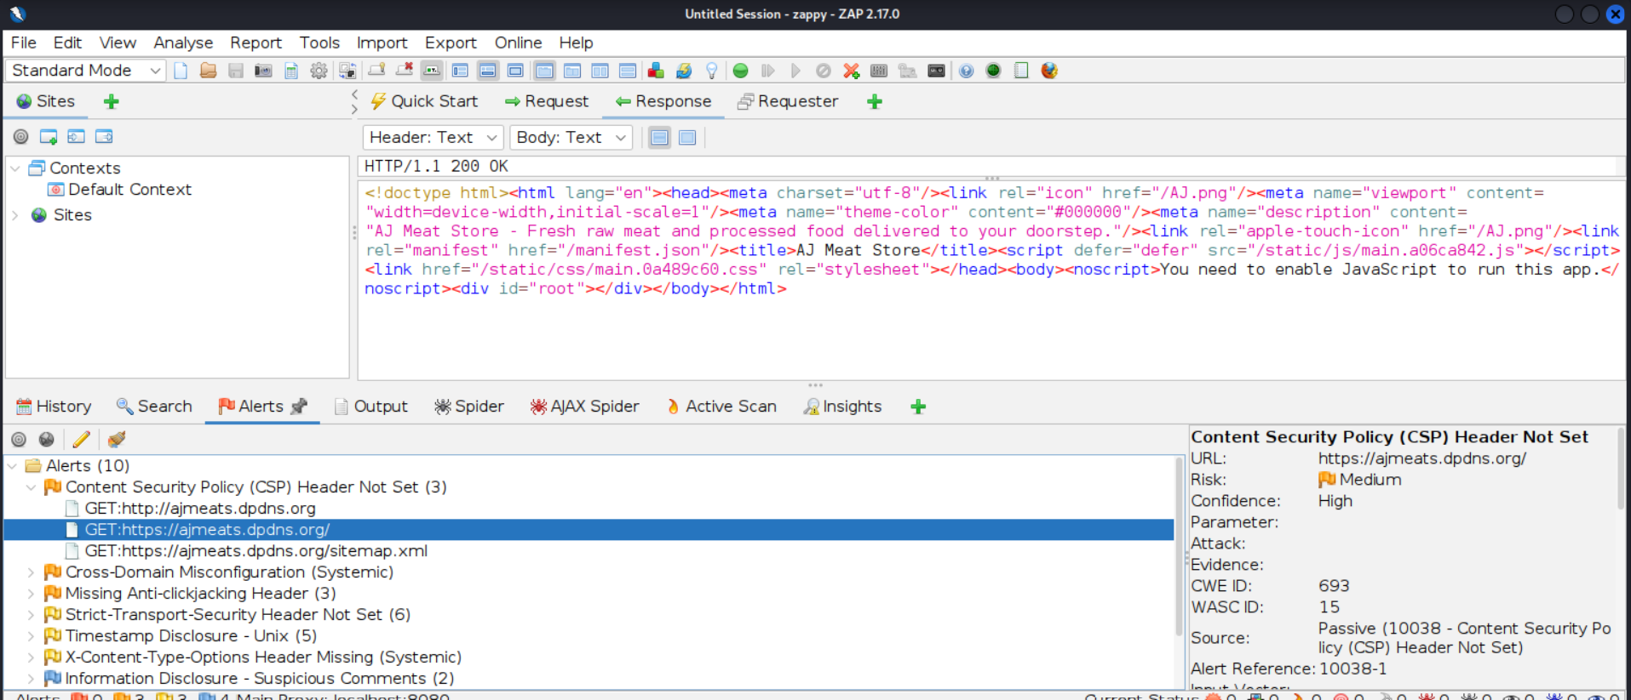

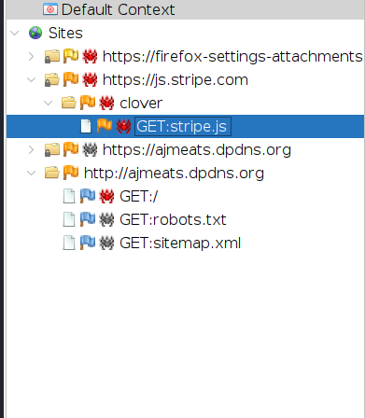

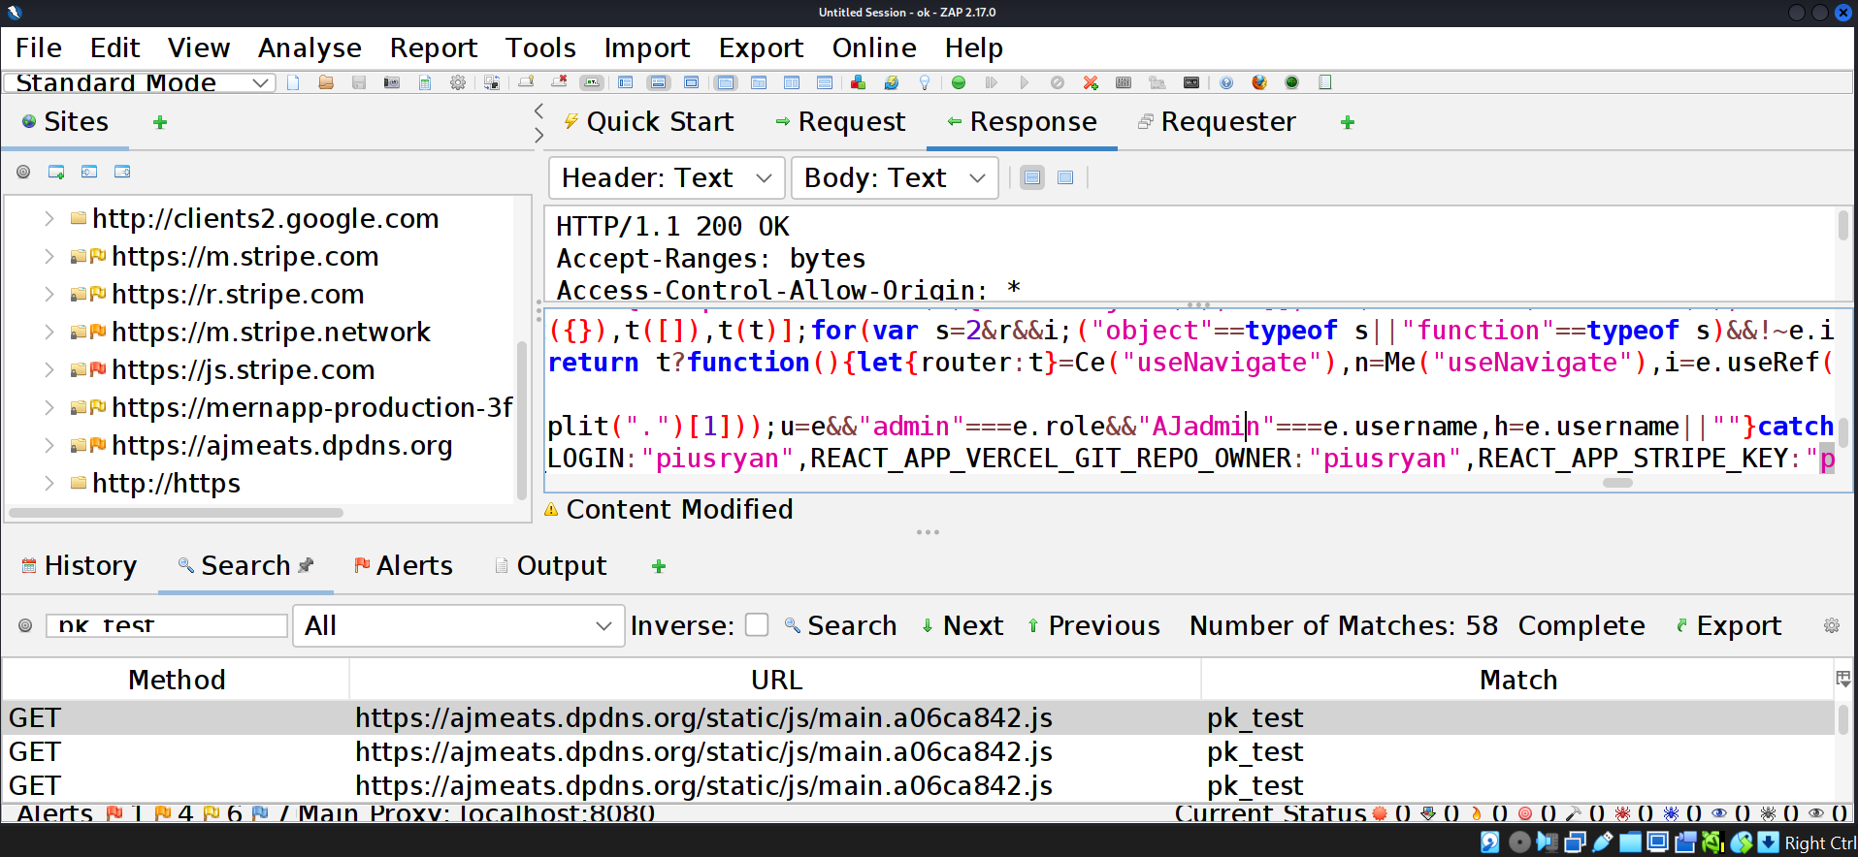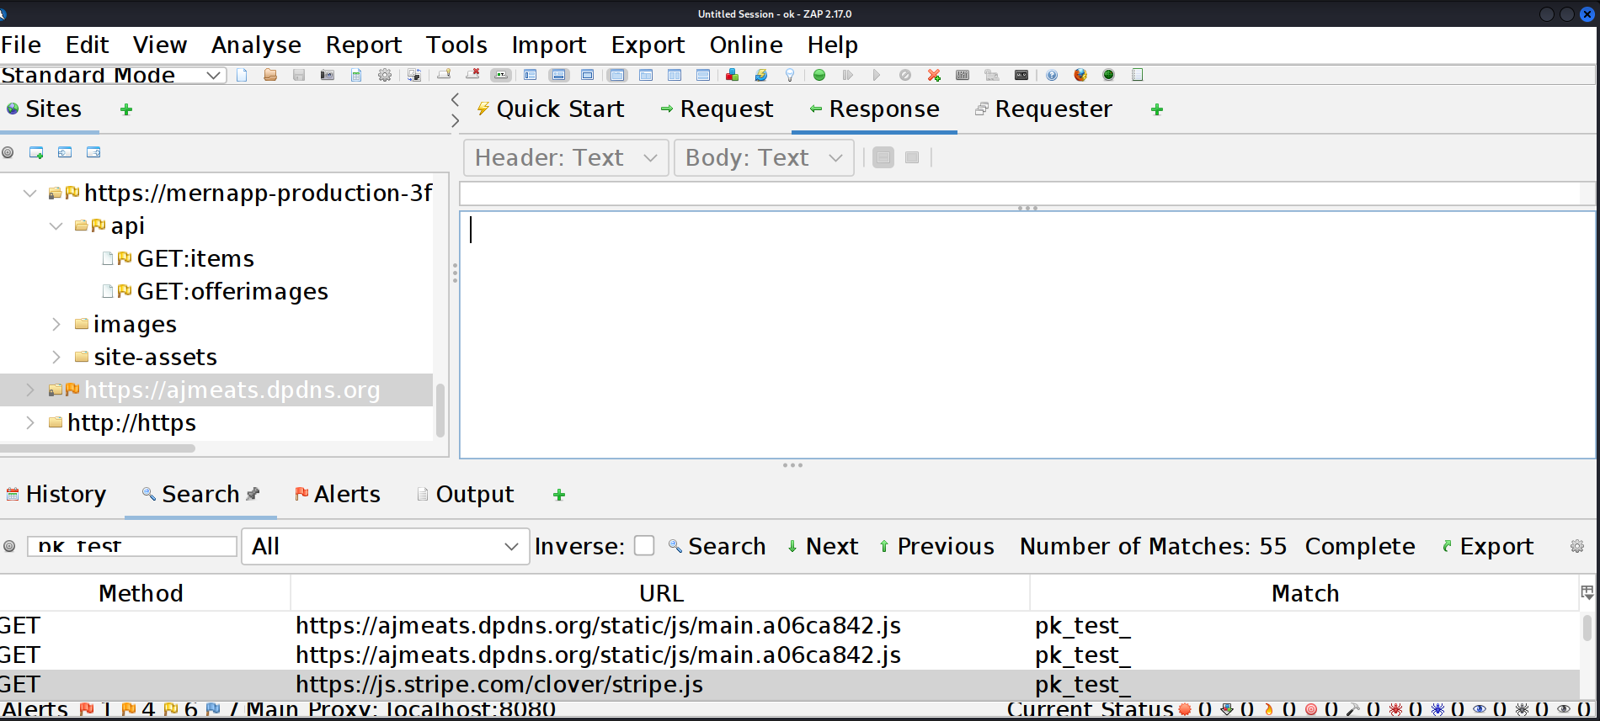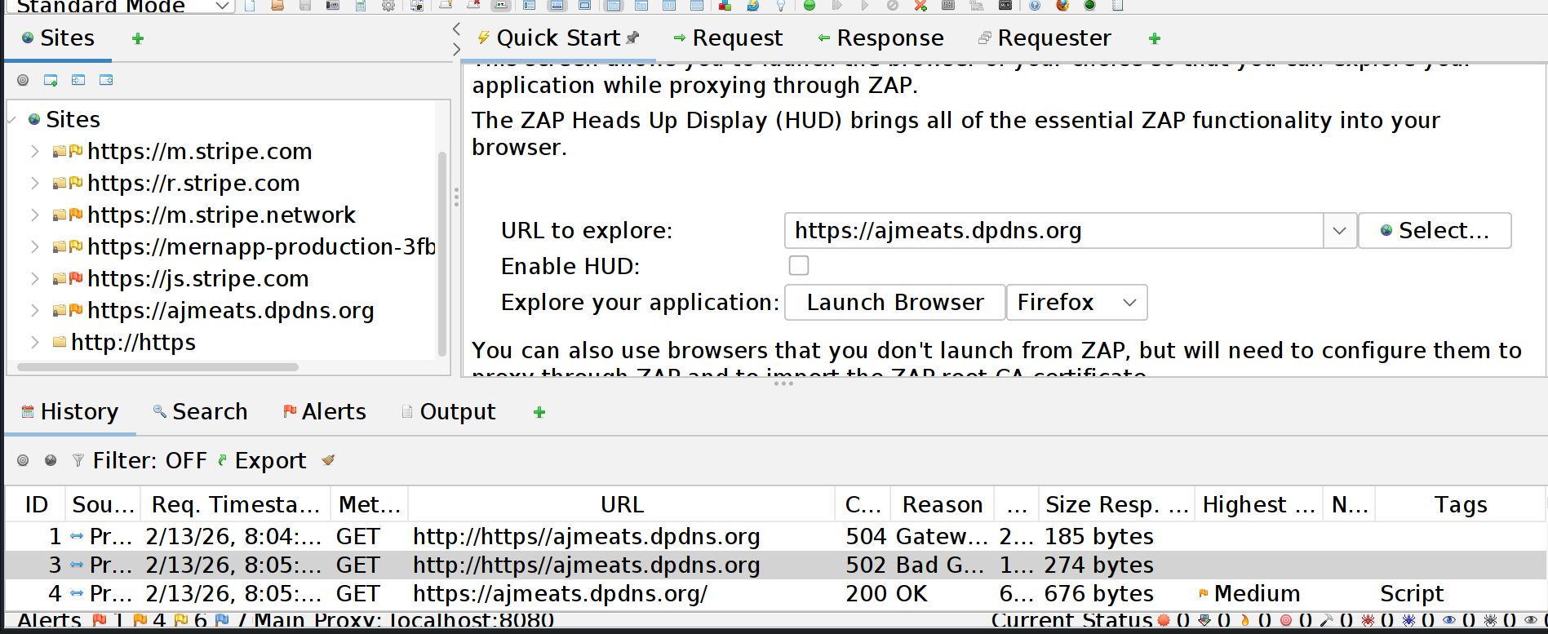

FIXED
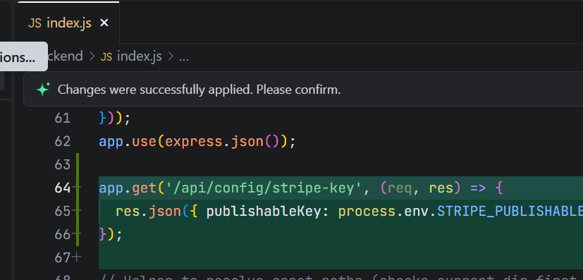
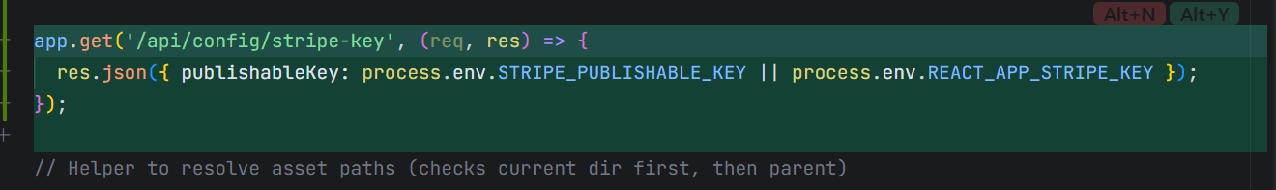

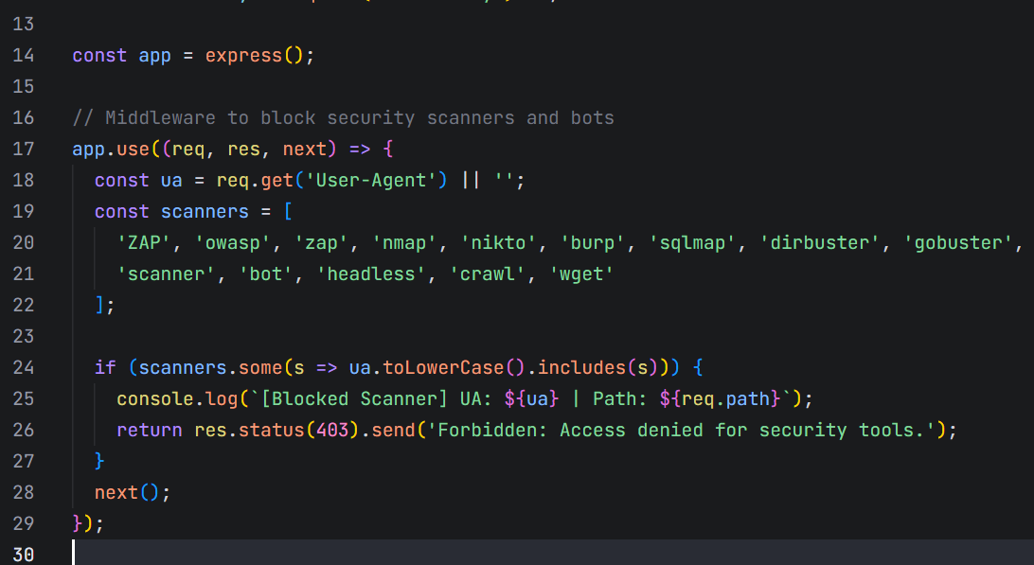
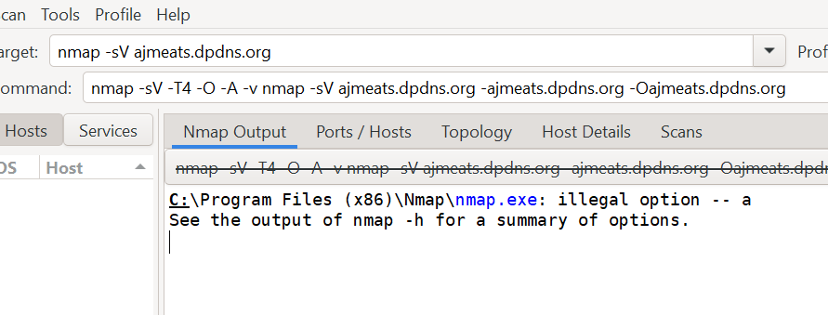

Apart form vercel there is no other services mentioned
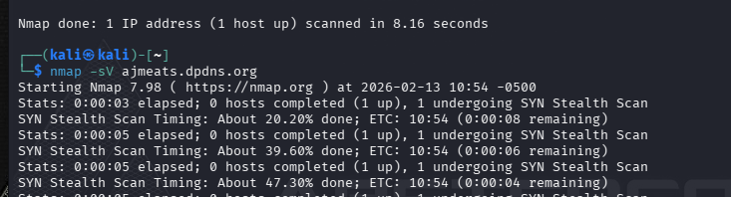
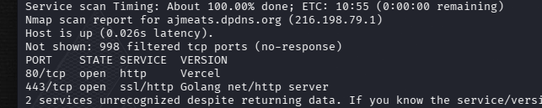

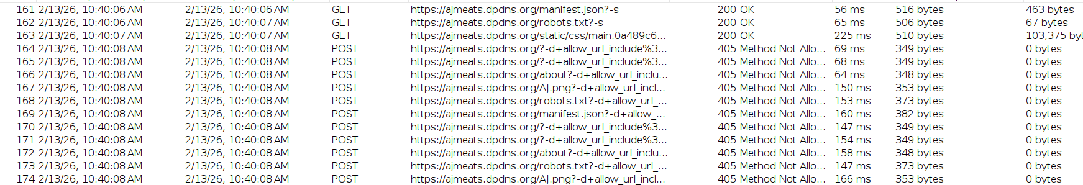
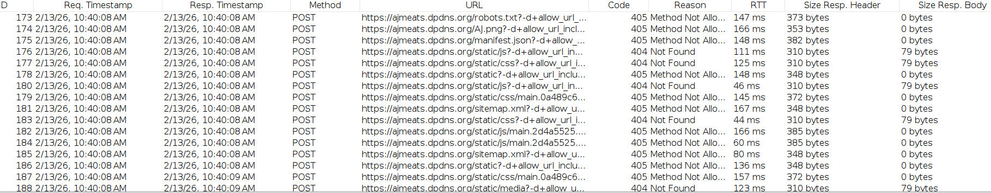
Automated attack via Zaproxy (method not allowed)

# | Vulnerability / Finding | Description | Likelihood | Impact | CVSS (Approx.) | Risk Level | Status
1 | Exposed Backend URL (Railway) | Frontend JS bundle exposed backend API endpoint (mernapp-production-3fbc.up.railway.app) | High | High | 9.1 | Critical | Mitigation Recommended
2 | Potential CSRF on /api/user/location | POST request accepted without visible CSRF token | Medium | Medium | 6.5 | Medium | Hardened / Under Review
3 | Directory Enumeration Results | No sensitive directories found via Gobuster | Low | Low | 2.0 | Low | Secure
4 | Port Exposure | Only Port 443 open (HTTPS) | Very Low | Low | 1.0 | Informational | Secure
5 | Database Exposure | No MongoDB endpoints publicly exposed | Very Low | High (if exposed) | 0 | Secure | Secure
6 | SQL / NoSQL Injection | No injection vulnerabilities detected | Low | High | 0 | Secure | Secure
7 | JWT Authentication | JWT functioning properly; no token tampering detected | Low | High | 0 | Secure | Secure
8 | Automated Scan (ZAP) | No major vulnerabilities discovered | Low | Medium | 0 | Secure | Secure

Conclusion
This project involved performing a structured security assessment of the MERN stack application hosted on Vercel and Railway infrastructure. Multiple testing methodologies were applied, including reconnaissance, directory enumeration, JavaScript bundle analysis, API testing, and automated vulnerability scanning.
The assessment confirmed that:
- No critical network-level vulnerabilities were detected.
- No database endpoints were publicly exposed.
- No SQL Injection or NoSQL Injection vulnerabilities were identified.
- Authentication mechanisms using JWT are functioning correctly.
- Backend services are properly separated from frontend infrastructure.
Although minor hardening improvements are recommended, the overall security posture of the application is stable and follows modern web security practices.

