RAPIDSMS ZAMBIA
MATERNAL AND CHILD HEALTH

Abstract

The usage of mobile phones is abundant in our daily lives in various aspects
from making phone calls or sending text messages to checking e-mails or news
updates to planning our activities or managing our budget.

This project aims at making use of this wide spread usage of mobiles to help in
the data collection process to continuously monitoring and communicating with the Community Health in order to reduce maternal and early child mortality. It designs and develops an SMS based system to provide a real time community based surveillance and alert system for maternal and child health in ZAMBIA.

Refer to the already existing RapidSMS system currently working in Rwanda. PIVOT ACCESS will customize it specifically to support maternal, neonatal and early child health at the community level by introducing tools to help Community Health Workers track pregnant women under their care, monitor antenatal care, identify and refer women at risk, and improve communication with health facility and district level facilities in the case of emergencies, in ZAMBIA.

Once the system design and implementation is completed it will be tested and
evaluated to ensure the satisfaction of at least the minimum requirements of the
proposed system.

Introduction

This document has the aim to describe the technical development plan for RapidSMS ZAMBIA. The plan is to upgrade the system being used in Kalomo District to include Maternal and Child health components. The backbone of the system and features will be comprised of the already existing RapidSMS system currently working in Rwanda.

PIVOT ACCESS will analyze the current Community Health Worker Program in ZAMBIA, the
different stakeholders' needs and the work flow between involved parties and based on the
findings, implement a system that will serve the following high level objectives
:

- Reduce maternal mortality.
- Increase birth deliveries at Health facilities.
- Increase attendance to Antenatal Care Visits.
- Reduce HIV transmission from mother to Child.

Data Entry Staff (Data Associates), at the health facilities will be responsible of the majority of data entered into the system, such as the registration of confirmed pregnancies. They will also supervise the Zonal Lay Counselors.
Each Lay Counselor will be provided with a basic mobile phone that they register within the system,

linking their unique lay zone and chain of reporting (clinic/district) to this number.

During emergencies, automated SMS alerts will also be sent by the server to key maternal health

supervisors at the clinic and district levels.
Also received transportation requests will be transmitted to the appropriate transportation manager or ambulance driver.

The system will allow this data to be integrated into the national Health Management Information System
(HMIS) for further analysis, and available in real time via a web-based user interface for monitoring of risk trends and
general surveillance.

System functionalities

Upon completion of the system development, the system will be able to deliver the following functionalities within a related proposed structure:

- Register all pregnancies

- Register births in community

- conduct follow up for pregnant women

- register community maternal and neo natal deaths

- Lay Counselor supervision

- Data facility supervision (i.e. reports, error logs)

- receive and log in emergency requests and follow up for outcomes

- register facility maternal and neo natal deaths

- Supervise facility Data Associates

- follows up on all emergency cases reported

- monitors web reports and web tool for direct facility management
.
- easy remote web access
.

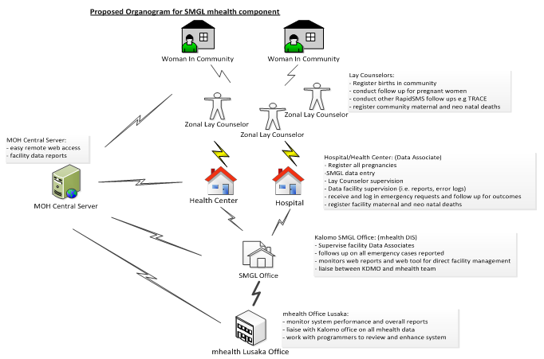

Development Approach

The development of RapidSMS ZAMBIA for Maternal and Child Health will follow the agile process as system development methodology. The service will be implemented using a phased, rapid prototyping approach from requirement to deployment. The phases and transitions in between will not need to be a single-pass sequential process, but it will tend to be iterative and incremental in nature and should be agile enough to accommodate revisions in situations where the scope cannot be completely defined up front.
The phases identified are: analysis and design, implementation, deployment, integration and Maintenance. Each phase and activities to be carried out are detailed in different paragraphs and brought together in the initial project schedule table of this document.

Analysis and Design

Refer to the RapidSMS Zambia System Requirements document (RapidSMS System Requirements, Final, 27 Jan 12.docx), during this phase Pivot Access will define system usage patterns and create user interface mock ups from different users of the system, with their different roles and goals. We will also outline non-functional requirements and describe the system's scenarios, document them to help later system enhancements and overall system support.

There is also a need to model and customize the design of the current working RapidSMS in Rwanda to meet the design specifications of RapidSMS ZAMBIA, on the mechanisms to compose or aggregate functionality, and document these specifications.

At this stage PIVOT ACCESS will recommend the required resources, server hardware and software to prepare and set up the deployment environment. From different operators, services and strength, available in ZAMBIA, Pivot Access can assist in choosing and acquiring an SMPP account and related short code with different mobile phone operators as well the system hosting.

Implementation

Due to some modifications and additional features required to meet the RapidSMS ZAMBIA requirements, this phase will concentrate on the development and implementation of these features. After coding and construction of programs that implement these additional features, with a complete customization of the system, we will perform an implementation test to fix and clean any bug that could be identified at this stage.

Deployment

When all required resources are available, we will set up, install and configure the production server environment. We will deploy, configure RapidSMS Zambia system's modules.
After the deployment environment setup, we will perform a deployment test with a small team of users and IT supporter of the system. This will help to collect feedback, discuss any issue that could be raised at this stage, and collect any caught bug. The period of this deployment test should be expected not to exceed one week.
Integration

During this phase PIVOT ACCESS will integrate the system with RemindMi to allow other existing RapidSMS based follow ups (TRACE). We will constantly collaborate with RapidSMS ZAMBIA team leaders and IT supporters to improve or verifying if the project’s requirements, aims and specification have
been met.
Additional requirements for the optimal performance of
the system will be outlined
and the collected feedback will be analyzed to help in modeling any new requirement and fixing system additional functionalities.

Maintenance
This phase will cover the corrective, preventive, and Assistance maintenance of the system.
PIVOT ACCESS will provide full system documentation to support the IT team. We will put up a backup plan for the system to prevent unnecessary production losses. We will also continuously follow up, providing recommendations and collaborate with the Zambian RapidsSMS team leaders.

Initial project schedule

PHASE | TASKS' DESCRIPTION | TIMELINE (in Weeks)
Analysis and Design | - define system usage patterns  - create user interface mock ups from different users of the system, with their different roles and goals.  - outline non-functional requirements and describe the system's scenarios.  - Data modeling and database design.  - Non-functional Requirements Specifications | 3 weeks
Implementation | - coding and construction of programs that implement system features and functionalities.  - Implementation test. | 6 weeks
Deployment | - install and configure the production server environment.  - Deploy and configure RapidSMS Zambia system's modules.  - Deployment Test.  - Training of users and collection of the system feedback. | 4 weeks
Integration | - Integration of RemindMi with the system  - Verification of the project’s requirements and aims.  - Constant collaboration with RapidSMS team leaders in Zambia to improve the system.  - modeling of new requirement and fixing of system additional functionalities if any. | 6 weeks
Maintenance | - provide full system documentation.  - Fixing of system bugs if any.  - Backup plan. | 5 weeks

