

RapidSMS 

The Rwanda RapidSMS application was designed specifically to support maternal, neonatal and early child health at the community.

USER GUIDE
http://www.rapidsms.moh.gov.rw

© 2011 MOH/UNICEF Rwanda
By PIVOT ACCESS LTD

Access RapidSMS
First of all we need to be connected in internet; a web browser is also needed. Once you are connected in internet you can navigate to www.rapidsms.moh.gov.rw.
Then you are at the home page.
I.HOME PAGE
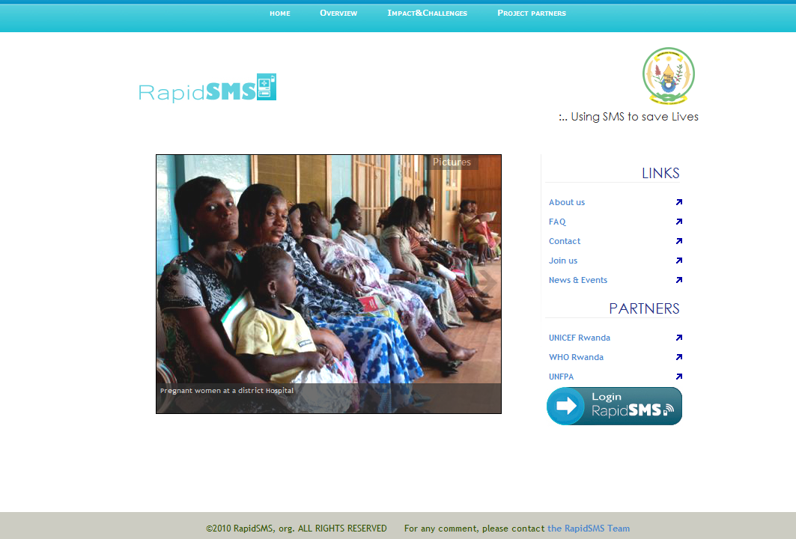
Figure1
To get authenticate to the RapidSMS, click the button like this below, of course from the home page:
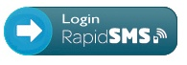

II.THE AUTHENTICATION PAGE
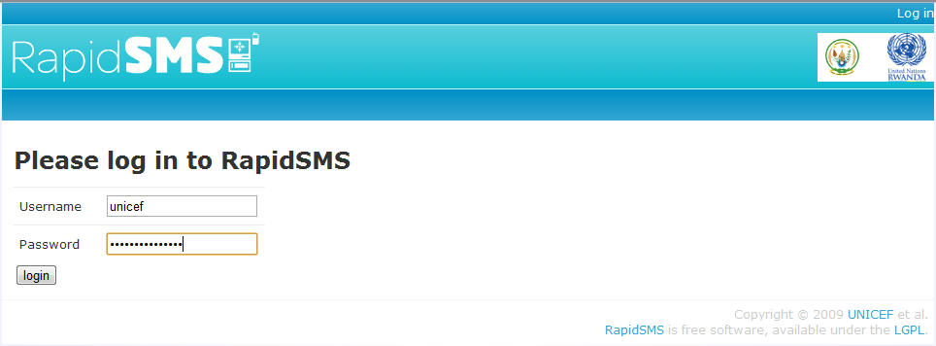
Figure2
Before you enter and use the system you must be authenticated and authorized, it is by Username and password that you can login in the system, the username and password are provided by the system administrator for security reasons.
After entering your username and password you click on button, and then you are now in the system on the main page, with main tabs of the system. Enjoy.

III.MAIN PAGE
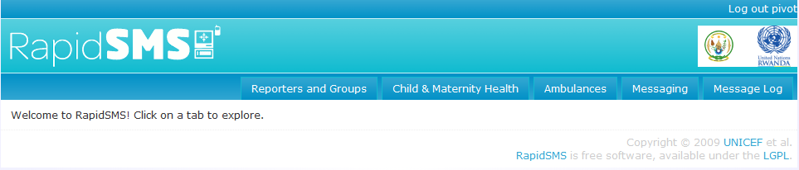
Figure3
This page has tabs, each of them has its details and well known to accomplish as we will explain and show the result of each one.

III.1 When you click on this tab the number of tabs increases, as you can see on the figure4:

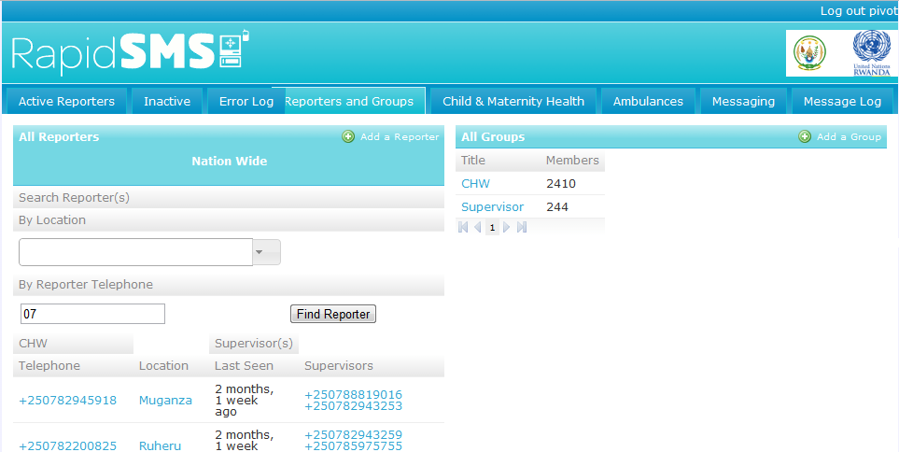
Figure4
The new tabs are these new tabs are sub tabs of Reporters and Groups tab.
This Reporters and Groups page helps in terms of getting news and details of Reporters or Supervisors.
It has an option of filtering either by location or by telephone number. Based on which criteria of your choice for filtering you can find yourself fall on a result that appears like this:
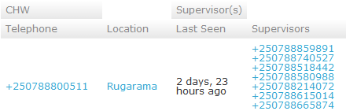
Figure5
- Within the result you get the Reporter details like his telephone number, his location, and last seen time in the system and his supervisors as you can see on the figure above.
- The user can add a reporter through the interface, according to the kind of user he is and the privileges he has as a user. For adding a new reporter you click on

III.1.1 This tab is a sub tab of Reporters and Groups tab, when you click on, you are automatically redirected to the Reporters Error Messages, and these Error messages can be filtered at 3 levels (Province, District and Health Center) and here you can also choose the start and the end date.
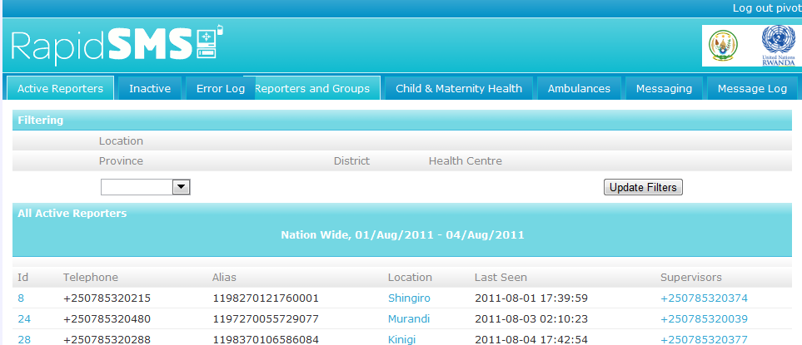
Figure6

III.1.2 This tab is also a sub tab of Reporters and Groups, once you click on, you get the page of all active CHWs and their details.
The list of active CHWs can be also filtered at 4 levels which are (National, Province, District, and Health Centre). The sub tab works like active reporters tab but in different case, because its shows Inactive reporters who have not reported for 15 days ago, as you can see on the figure7:

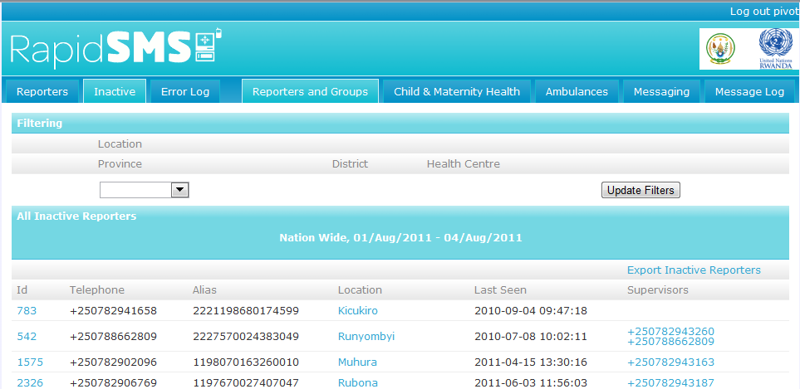
Figure7
Here we have Inactive CHWs and their details, the data of this report can also be exported to and read from an excel, for that option you have to click on

IV. This tab is a very sensitive tab and very used of all users of this system, by click on it, you get the page which contains all reports sent by CHWs for: Births, ANCs, Registrations, Pregnancies, Risks, Children Health, Refusals….and you can filter one of them at any level. By default data displayed are weekly data, but you can even select data for anytime as you can see it on figure8:
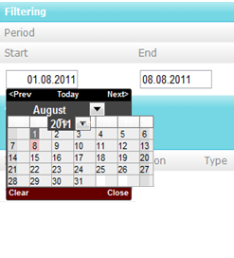
Figure8
This calendar has the Start date and the End date, so you can filter by the Start date which is the date of beginning of the period you want to filter and the End date which is the end date of the period you want to filter for, you can also select the year or any month you want 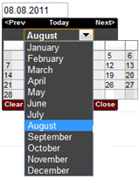 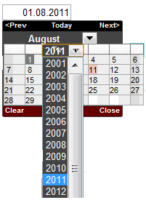
Figure9
After choosing the Start Period and the End Period, now you can filter data for the chosen period regarding privileges you have as a user:
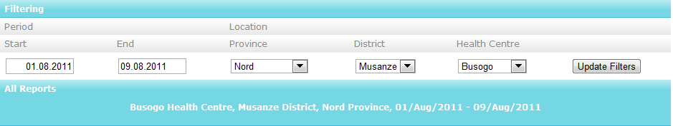
Figure10
If your privileges as user permit you to filter at 4 levels you will be able to filter as you want on those 4 levels, after filtering as you want, you click on button, and then you will have a message describing what you filtered.
The click on Child & Maternal Health tab redirect to this kind of page:
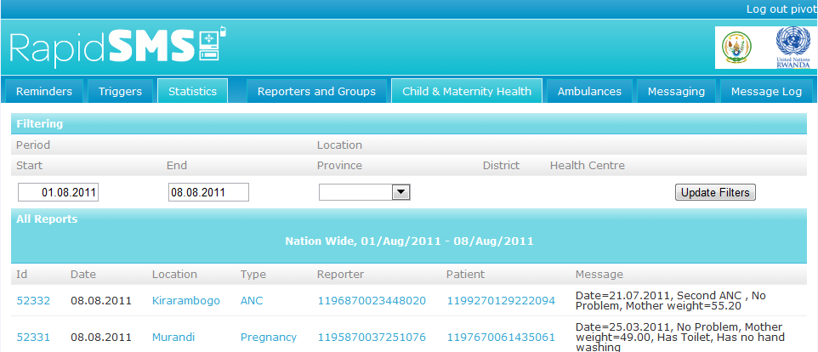
Figure11
On this page we have deferent details of information sent in all reports as you can see on the figure bellow; 52332 is the report id, when you click on that report id you get all information and details of that report as you can see on the figure12:
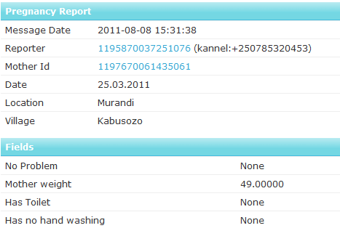
Figure12

- Here I want to remind that all report fields which has blue colors are links, once you click on Location you get all reports sent from that location in the chosen period;
- When you click on Type you will get the Reports of that type chosen, for the chosen period you filtered;
- When you click on reporter you get all reports sent by that reporter for the chosen period you filtered;
- When you click on the patient you get information related on that patient, as you can check on figure13:
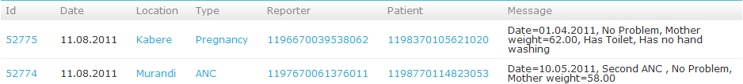
Figure13

The Child & Maternity Health tab has a sub tab of its statistics called Statistics, which shows different statistics of all reports received by the system.
When you click on Child & Maternity Health tab, you get the following page:
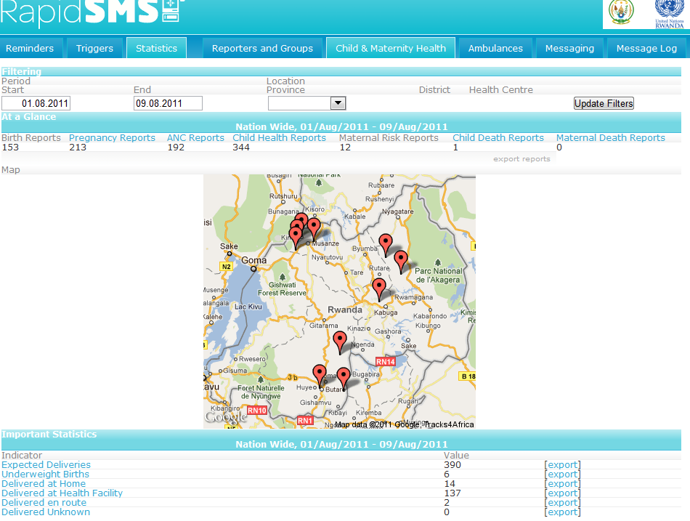
Figure14
This page has statistics of all report sent in the system by CHWs, and it can be also filtered at different levels according to the period you want, you can select the period using the calendar and select the level you want according to the privileges you have as user.
On this page you have statistics tabs:
Figure15
On these tabs you can see tabs of all report type sent and their numbers in figures, the ones in blue are linked to their reports type, you can click on them and have details of each of them, and these statistics can be also filtered at any level you want according to your user type.
For example the click on tab, redirects you on the following figure:
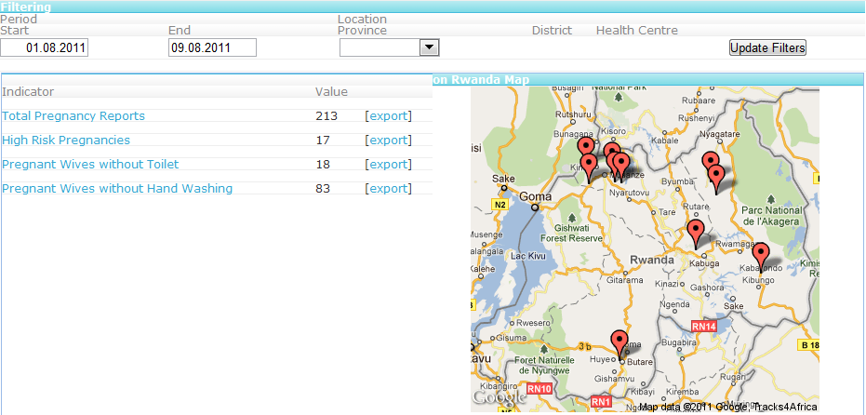
Figure16

- The data on this statistics page can be exported in Excel or other format very easily, by clicking on the link Export.
- The red pins on the map represent locations where CHWs are sending reports from;

- Every pin represents a Health Center where that CHW is registered.

- Once you click on one of the indicators, you get all reports related to that indicator.

Down the map there are other statistics, called Important Statistics, which are statistics of Birth Reports and their details as you see it on the next figure:
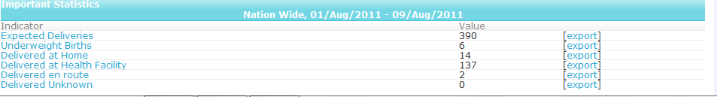
Figure17
Every indicator of these important Statistics is also a link which has its Report type details, it has also the value, which is the number of reports sent in the filtered period and levels; they can be exported also.
IV.1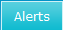
This tab is a sub tab of Child & Maternal Health tab, which is an alert log of all alerts sent by the system after receive a report that has a high risk message or any other massage that triggers an alert.
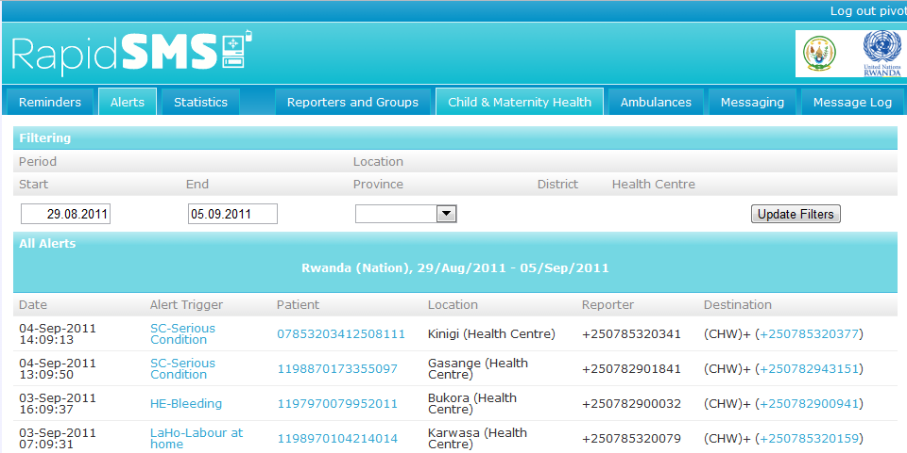
Figure18

- The Alert log has the date of the alert sent, the trigger (the action code or risk code), the patient number and his location, the reporter number and who has been alerted.
- All alert can be also filtered at different levels depending to your privileges as user.
V.
Once you click on the Ambulances tab you get this new tab:
Figure19
This tab has alphabetic letters, and each of them contain Health Centres which begins with that letter.
For example when you click on T you get the list of Health Centres begins by T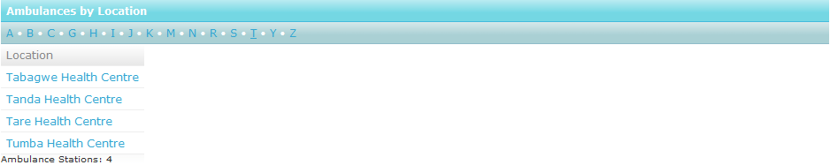
Figure20
As now you have the list of Health Centres, you can now click on one of them as you want, after clicking on it you will have the privilege of add or remove the Ambulance Drivers in that location
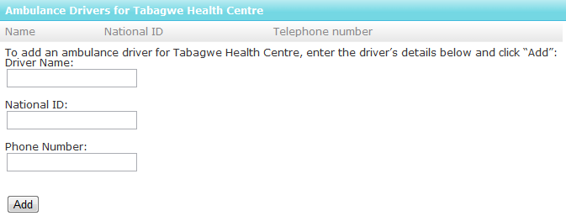
Figure21
- You have to fill the information required in the text fields then click on the button,

- When the Ambulance Driver shift from one Health center to another, or when he is no longer an ambulance driver for that specified Health Centre you can remove him by clicking on the button, you can check figure22.
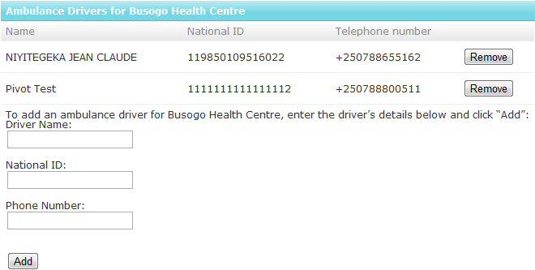
Figure22

VI
The messaging option helps the system user to send bulk SMSs to the CHWs or SUPs registered in the system.

When you click on Messaging tab you get such a page:
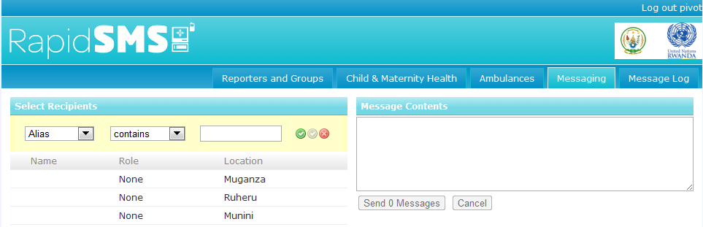
Figure23
This page has two parts, one is for the Recipients Selection and the other one is for the Message Contents
- Recipients Selection has two drop down list and a text box which are used in terms of specifying to who the message must be sent,
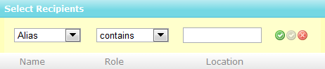
Figure24
- The first drop down list contains different identifiers of the registered CHWs we can use in filtering.
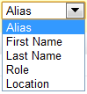 Figure25

- The second drop down list has 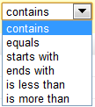Figure26
- Then click on (Green for submitting the action and the red for cancel )

- The message content must contain message you want to send to one or more CHWs or SUPs.
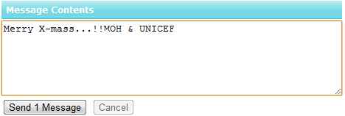
Figure27

If you are ready to send the message you click on and you see automatically the number of messages to send, if you want to cancel it you just click on.

VII 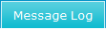
The message Log tab is linked on a page that has all kind of messages sent on 1110 while are in good format or not and the feedback given automatically by the system, the Message Log helps the system administrator to control the entry of all report.
The Message Log has details of all message received in the system, like the date and hour, the number of the sender, the message content and the direction.

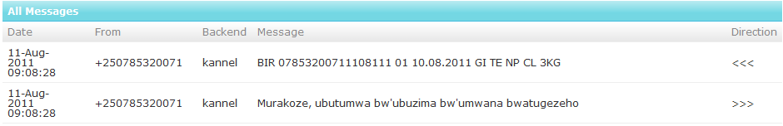
Figure28

The direction is in or out, this sign means that is the message received by the system, and this one is for the automatic feedback sent by the system.

Sometimes you can find that the message content is empty, that means that the message sent was empty, because the Message Log contains all kind of messages good format or bad.
E.g.:

Figure29

VIII. To import CHWs from an Excel sheet
To import CHWS from an excel sheet to the system database, you click on Reporters and Group tab, the system redirects you to the next figure, then you click on show help button

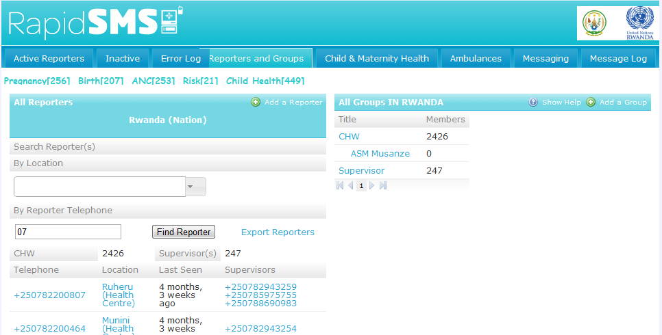
Figure30
After the click on Show help button you will get a new tab added on all Groups IN RWANDA tab, on your top right corner:
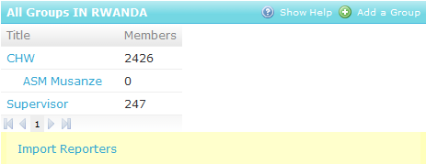
Figure 31:
The two last steps before importation is to click on import reporters, and the last is the click on Choose file button
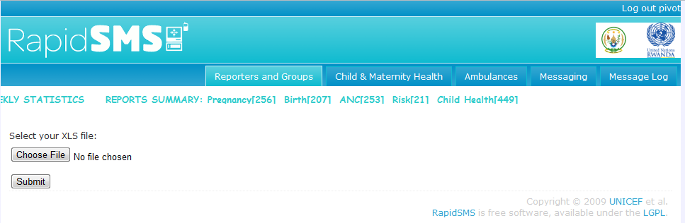
Figure32
The click on Choose file button will help you to go in your directories, to choose the file to import, after selecting the file you submit on the submit button.
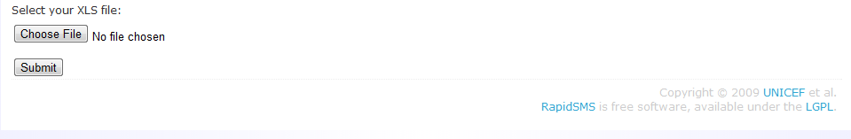
Figure33
Note: The Excel sheet should have the following format
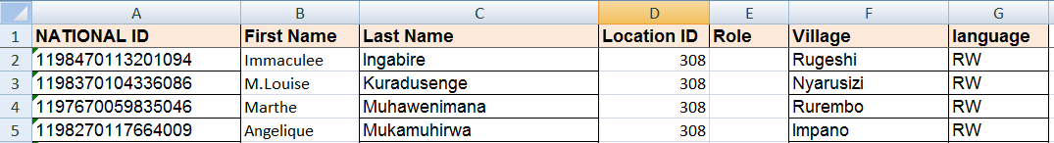
Figure34

IX. To add a Reporter
For adding a new reporter, we have to click on Reporters and Group tab, then click on add a Reporter button, it gives you the figure 35,
Figure35
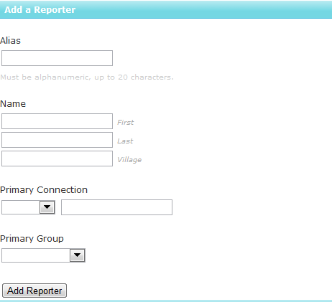
Figure36

After completing these required information you just click on Add Reporter button, here you are done!
For the End to log out you click on log out, on the top right corner.

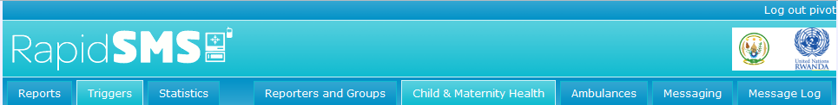
Figure37

