**Отчет по лабораторной работе №8 по курсу «Численные методы»**

Студент группы 8О-406: Полюбин А.И. Работа выполнена: 26.12.2022

Преподаватель: Пивоваров Д.Е. Отчет сдан: 4.01.2023

Итоговая оценка:

Подпись преподавателя:

Москва 2023

**1. Тема работы**

МЕТОД КОНЕЧНЫХ РАЗНОСТЕЙ РЕШЕНИЯ МНОГОМЕРНЫХ ЗАДАЧ МАТЕМАТИЧЕСКОЙ ФИЗИКИ. МЕТОДЫ РАСЩЕПЛЕНИЯ

**2. Цель работы**

Используя схемы переменных направлений и дробных шагов, решить двумерную начально-краевую задачу для дифференциального уравнения параболического типа. В различные моменты времени вычислить погрешность численного решения путем сравнения результатов с приведенным в задании аналитическим решением $U(x,t)$. Исследовать зависимость погрешности от сеточных параметров $t,h_{x},h_{y}$.

Вариант №4:

$\frac{∂u}{∂t}=a\frac{∂^{2}u}{∂x^{2}}+a\frac{∂^{2}u}{∂y^{2}}$, $a>0$,

$$\begin{aligned}u(0,y,t)=\text{cosh}(y)\text{exp}(−3\text{at}), \\ u(\frac{p}{4},y,t)=0,\end{aligned}$$

$$\begin{aligned}u(x,0,t)=\text{cos}(2x)\text{exp}(−3\text{at}), \\ u_{y}(x\text{,ln}2,t)=\frac{3}{4}\text{cos}(2x)\text{exp}(−3\text{at}),\end{aligned}$$

$u(x,y,0)=\text{cos}(2x)\text{cosh}(y)$.

Аналитическое решение: $U(x,y,t)=\text{cos}(2x)\text{cosh}(y)\text{exp}(−3\text{at})$.

**3. Ход выполнения работы**

В данной лабораторной реализованы метод переменных направлений и метод дробных шагов. Реализованы функции вычисления погрешности. Графики выводятся при помощи библиотеки matplotlib.

**4. Листинг**

import random

import matplotlib.pyplot as plt

import sys

import warnings

import numpy as np

from functools import reduce

from mpl_toolkits.mplot3d import Axes3D

#Граничные условия

def psi_0(x, t, a = 1):

return np.cos(2*x) * np.exp(-3*a*t)

def psi_1(x, t, a = 1):

return 3 * np.cos(2*x) * np.exp(-3*a*t) / 4

def phi_0(y, t, a = 1):

return np.cosh(y) * np.exp(-3*a*t)

def phi_1(y, t, a = 1):

return 0

def u0(x, y, a = 1):

return np.cos(2*x) * np.cosh(y)

#Истинное решение

def u(x, y, t, a = 1):

return np.cos(2*x) * np.cosh(y) * np.exp(-3*a*t)

class Schema:

def __init__(self, a = 1, rho = u0, psi0 = psi_0, psi1 = psi_1, phi0 = phi_0, phi1 = phi_1,

lx0 = 0, lx1 = np.pi/4, ly0 = 0, ly1 = np.log(2), T = 5, order2nd = True):

self.psi0 = psi0

self.psi1 = psi1

self.phi0 = phi0

self.phi1 = phi1

self.rho0 = rho

self.T = T

self.lx0 = lx0

self.lx1 = lx1

self.ly0 = ly0

self.ly1 = ly1

self.tau = None

self.hx = None

self.hy = None

self.order = order2nd

self.a = a

self.Nx = None

self.Ny = None

self.K = None

self.cx = None

self.bx = None

self.cy = None

self.by = None

self.hx2 = None

self.hy2 = None

def set_l0_l1(self, lx0, lx1, ly0, ly1):

self.lx0 = lx0

self.lx1 = lx1

self.ly0 = ly0

self.ly1 = ly1

def set_T(self, T):

self.T = T

def compute_h(self):

self.hx = (self.lx1 - self.lx0) / (self.Nx - 1)

self.hy = (self.ly1 - self.ly0) / (self.Ny - 1)

self.hx2 = self.hx * self.hx

self.hy2 = self.hy * self.hy

def compute_tau(self):

self.tau = self.T / (self.K - 1)

@staticmethod

def three_diagonal(A, b):

P = [-item[2] for item in A]

Q = [item for item in b]

P[0] /= A[0][1]

Q[0] /= A[0][1]

for i in range(1, len(b)):

z = (A[i][1] + A[i][0] * P[i-1])

P[i] /= z

Q[i] -= A[i][0] * Q[i-1]

Q[i] /= z

for i in range(len(Q) - 2, -1, -1):

Q[i] += P[i] * Q[i + 1]

return Q

@staticmethod

def nparange(start, end, step = 1):

now = start

e = 0.00000000001

while now - e <= end:

yield now

now += step

def compute_left_edge(self, X, Y, t, square):

for i in range(self.Ny):

square[i][0] = self.phi0(Y[i][0], t, self.a)

def compute_right_edge(self, X, Y, t, square):

for i in range(self.Ny):

square[i][-1] = self.phi1(Y[i][-1], t, self.a)

def compute_bottom_edge(self, X, Y, t, square):

for j in range(1, self.Nx - 1):

square[0][j] = self.psi0(X[0][j], t, self.a)

def compute_line_first_step(self, i, X, Y, last_square, now_square):

hy2 = self.hy2

hx2 = self.hx2

b = self.bx

c = self.cx

A = [(0, b, c)]

w = [

-self.cy*self.order*last_square[i-1][1] -

((self.order + 1)*hx2*hy2 - 2*self.cy*self.order)*last_square[i][1] -

self.cy*self.order*last_square[i+1][1] - c*now_square[i][0]

]

A.extend([(c, b, c) for _ in range(2, self.Nx - 2)])

w.extend([

-self.cy*self.order*last_square[i-1][j] -

((self.order + 1)*hx2*hy2 - 2*self.cy*self.order)*last_square[i][j] -

self.cy*self.order*last_square[i+1][j]

for j in range(2, self.Nx - 2)

])

A.append((c, b, 0))

w.append(

-self.cy*self.order*last_square[i-1][-2] -

((self.order + 1)*hx2*hy2 - 2*self.cy*self.order)*last_square[i][-2] -

self.cy*self.order*last_square[i+1][-2] - c*now_square[i][-1]

)

line = self.three_diagonal(A, w)

for j in range(1, self.Nx - 1):

now_square[i][j] = line[j - 1]

def compute_line_second_step(self, j, X, Y, t, last_square, now_square):

hx2 = self.hx2

hy2 = self.hy2

c = self.cy

b = self.by

A = [(0, b, c)]

w = [

-self.cx*self.order*last_square[1][j - 1] -

((self.order + 1)*hx2*hy2 - 2*self.cx*self.order)*last_square[1][j] -

self.cx*self.order*last_square[1][j + 1] - c*now_square[0][j]

]

A.extend([(c, b, c) for _ in range(2, self.Ny - 1)])

w.extend([

-self.cx*self.order*last_square[i][j - 1] -

((self.order + 1)*hx2*hy2 - 2*self.cx*self.order)*last_square[i][j] -

self.cx*self.order*last_square[i][j + 1]

for i in range(2, self.Ny - 1)

])

koeffs = self.implict_top_approx(j, X, Y, t, now_square, last_square)

A.append(koeffs[:-1])

w.append(koeffs[-1])

line = self.three_diagonal(A, w)

for i in range(1, self.Ny):

now_square[i][j] = line[i - 1]

def explict_top_approx(self, X, Y, t, square):

for j in range(1, self.Nx - 1):

square[-1][j] = 2*self.hy*self.psi1(X[-1][j], t, self.a)

square[-1][j] += 4*square[-2][j] - square[-3][j]

square[-1][j] /= 3

def implict_top_approx(self, j, X, Y, t, square, last_square):

hx2 = self.hx2

hy2 = self.hy2

c = 2 * self.a * self.tau * hx2

b = -(c + (1 + self.order)*hx2*hy2)

w = -self.cx*self.order*last_square[-1][j - 1]

w -= ((self.order + 1)*hx2*hy2 - 2*self.cx*self.order)*last_square[-1][j]

w -= self.cx*self.order*last_square[-1][j + 1]

w -= c*self.hy*self.psi1(X[-1][j], t, self.a)

return (c, b, 0, w)

def explict_top_approx_0(self, X, Y, t, square):

for j in range(1, self.Nx - 1):

square[-1][j] = self.hy*self.psi1(X[-1][j], t, self.a)

square[-1][j] += square[-2][j]

def implict_top_approx_0(self, j, X, Y, t, square, last_square):

return (-1, 1, 0, self.hy*self.psi1(X[-1][j], t, self.a))

def compute_square(self, X, Y, t, last_square):

square = [[0.0 for _ in range(self.Nx)] for _ in range(self.Ny)]

self.compute_left_edge(X, Y, t - 0.5*self.tau, square)

self.compute_right_edge(X, Y, t - 0.5*self.tau, square)

self.compute_bottom_edge(X, Y, t - 0.5*self.tau, square)

for i in range(1, self.Ny - 1):

self.compute_line_first_step(i, X, Y, last_square, square)

self.explict_top_approx(X, Y, t - 0.5*self.tau, square)

last_square = square

square = [[0.0 for _ in range(self.Nx)] for _ in range(self.Ny)]

self.compute_left_edge(X, Y, t, square)

self.compute_right_edge(X, Y, t, square)

self.compute_bottom_edge(X, Y, t, square)

for j in range(1, self.Nx - 1):

self.compute_line_second_step(j, X, Y, t, last_square, square)

return square

def init_t0(self, X, Y):

first = [[0.0 for _ in range(self.Nx)] for _ in range(self.Ny)]

for i in range(self.Ny):

for j in range(self.Nx):

first[i][j] = self.rho0(X[i][j], Y[i][j], self.a)

return first

def __call__(self, Nx=20, Ny=20, K=20):

self.Nx, self.Ny, self.K = Nx, Ny, K

self.compute_tau()

self.compute_h()

self.bx = -2*self.a*self.tau*self.hy2

self.bx -= (1 + self.order)*self.hx2*self.hy2

self.cx = self.a * self.tau * self.hy2

self.cy = self.a * self.tau * self.hx2

self.by = -2*self.a*self.tau*self.hx2

self.by -= (1 + self.order)*self.hx2*self.hy2

x = list(self.nparange(self.lx0, self.lx1, self.hx))

y = list(self.nparange(self.ly0, self.ly1, self.hy))

X = [x for _ in range(self.Ny)]

Y = [[y[i] for _ in x] for i in range(self.Ny)]

taus = [0.0]

ans = [self.init_t0(X, Y)]

for t in self.nparange(self.tau, self.T, self.tau):

ans.append(self.compute_square(X, Y, t, ans[-1]))

taus.append(t)

return X, Y, taus, ans

#Истинное значение функции в данный момент времени

def real_z_by_time(lx0, lx1, ly0, ly1, t, f):

x = np.arange(lx0, lx1 + 0.002, 0.002)

y = np.arange(ly0, ly1 + 0.002, 0.002)

X = np.ones((y.shape[0], x.shape[0]))

Y = np.ones((x.shape[0], y.shape[0]))

Z = np.ones((y.shape[0], x.shape[0]))

for i in range(Y.shape[0]):

Y[i] = y

Y = Y.T

for i in range(X.shape[0]):

X[i] = x

for i in range(Z.shape[0]):

for j in range(Z.shape[1]):

Z[i, j] = f(X[i, j], Y[i, j], t)

return X, Y, Z

def epsilon(X, Y, t, z, ut = u, a = 1):

ans = 0.0

for i in range(len(z)):

for j in range(len(z[i])):

ans += (ut(X[i][j], Y[i][j], t, a) - z[i][j])**2

return (ans / len(z) / len(z[0]))**0.5

def plot_by_time( nx=15, ny=15, k=50, t=1, a=1):

schema = Schema(T = t, a = a, order2nd = False)

xx, yy, tt, zz = schema(Nx = nx, Ny = ny, K = k)

z = zz[t]

extrems = search_minmax(zz)

fig = plt.figure(num=1, figsize=(20, 13), clear=True)

ax = fig.add_subplot(1, 1, 1, projection='3d')

ax.plot_surface(np.array(xx), np.array(yy), np.array(z))

ax.plot_wireframe(*real_z_by_time(0, np.pi/4, 0, np.log(2), t, u), color="red")

ax.set_xlabel('x')

ax.set_ylabel('y')

ax.set_zlabel('z')

ax.set_zlim(extrems[0], extrems[1])

fig.tight_layout()

plt.show()

def search_minmax(zz):

z = zz[0]

minimum, maximum = z[0][0], z[0][0]

for i in range(len(z)):

for j in range(len(z[i])):

minimum = z[i][j] if z[i][j] < minimum else minimum

maximum = z[i][j] if z[i][j] > maximum else maximum

return minimum, maximum

plot_by_time()

first = Schema(T = 1, order2nd = False) #метод дробных шагов

second = Schema(T = 1, order2nd = True) #метод переменных направлений

def graphic_h(solver, time = 0, tsteps = 400):

h = []

e = []

for N in range(4, 35, 1):

x, y, t, z = solver(Nx = N, Ny = N, K = tsteps)

h.append(solver.hx)

e.append(epsilon(x, y, t[time], z[time]))

return h, e

TSTEPS = 100

time = random.randint(0, TSTEPS - 1)

plt.figure(figsize = (16, 10))

plt.title("Зависимость погрешности от длины шага при t = " + str(time / TSTEPS))

plt.subplot(2, 1, 1)

h1, e1 = graphic_h(first, time, TSTEPS)

h2, e2 = graphic_h(second, time, TSTEPS)

plt.plot(h1, e1, label="Метод дробных шагов")

plt.plot(h2, e2, label="Метод переменных направлений")

plt.xlabel("$h_x$")

plt.ylabel("$\epsilon$")

plt.legend()

plt.grid()

plt.subplot(2, 1, 2)

plt.plot(list(map(np.log, h1)), list(map(np.log, e1)), label="Метод дробных шагов")

plt.plot(list(map(np.log, h2)), list(map(np.log, e2)), label="Метод переменных направлений")

plt.xlabel("$\log{h_x}$")

plt.ylabel("$\log{\epsilon}$")

plt.legend()

plt.grid()

def graphic_tau(solver):

tau = []

e = []

for K in range(15, 100, 2):

x, y, t, z = solver(Nx = 10, Ny = 10, K = K)

tau.append(solver.tau)

time = K // 2

e.append(epsilon(x, y, t[time], z[time]))

return tau, e

plt.figure(figsize = (16, 10))

plt.title("Зависимость погрешности от длины шага по времени")

plt.subplot(2, 1, 1)

tau1, e1 = graphic_tau(first)

tau2, e2 = graphic_tau(second)

plt.plot(tau1, e1, label="Метод дробных шагов")

plt.plot(tau2, e2, label="Метод переменных направлений")

plt.xlabel("$\tau$")

plt.ylabel("$\epsilon$")

plt.legend()

plt.grid()

plt.subplot(2, 1, 2)

plt.plot(list(map(np.log, tau1)), list(map(np.log, e1)), label="Метод дробных шагов")

plt.plot(list(map(np.log, tau2)), list(map(np.log, e2)), label="Метод переменных направлений")

plt.xlabel("$\log{\tau}$")

plt.ylabel("$\log{\epsilon}$")

plt.legend()

plt.grid()

**5. Результаты**

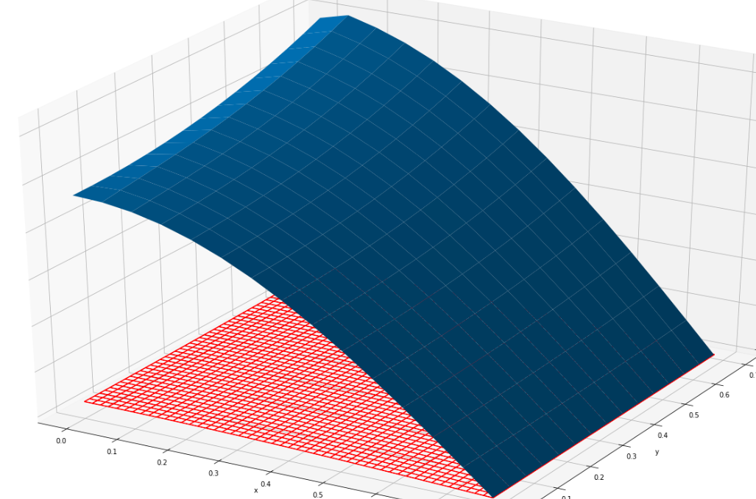

**6. Выводы**

При выполнении данной лабораторной работы я научился применять методы конечных разностей для решения многомерных задач математической физики.