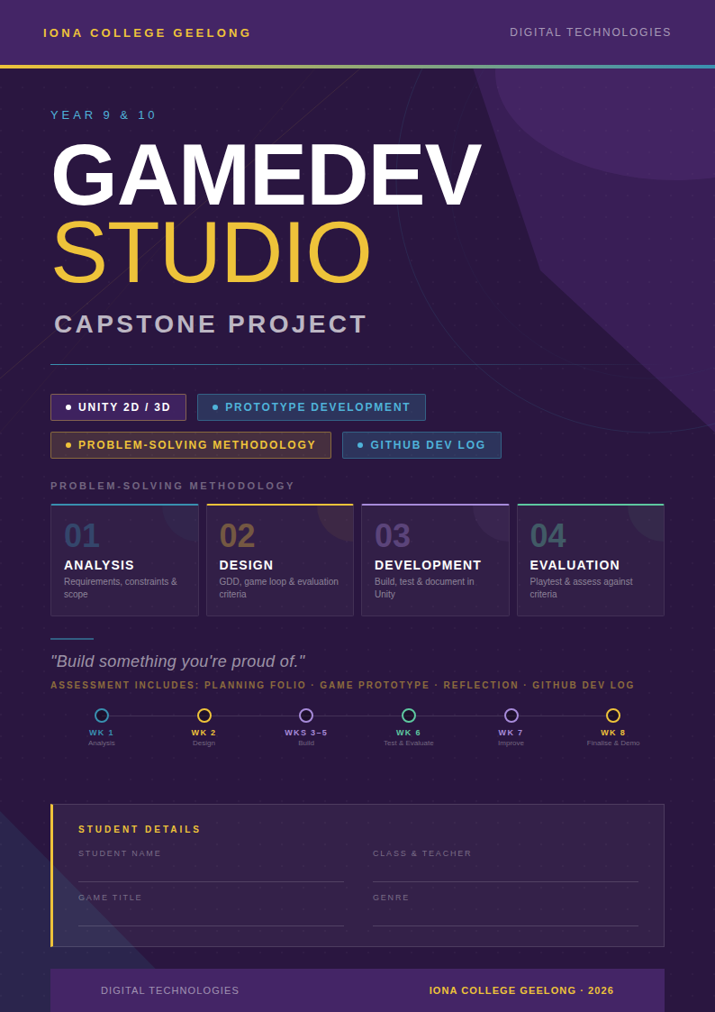

Section 1 — Project Overview

What is a Capstone Project?
A Capstone Project is a project in which you bring together the knowledge and skills you have developed throughout a course into one final, showcase project. It is your opportunity to demonstrate your learning in GameDev Studio.

Your Mission
For your Year 9 / 10 GameDev Studio Capstone Project, you will apply the Problem-Solving Methodology, the same process used in VCE Applied Computing and Software Development, to plan, design, build, test, and evaluate a game prototype of your own creation.

Minimum Requirement
You must produce a coherent, playable game experience — the game loads into a menu, the player presses Start, and there is at least 2–3 minutes of gameplay. This is a prototype, not a finished product.

Your Options
You have three pathways for completing this project:

🎮 | Use a project template — choose from available genre templates and build upon them.
🎬 | Follow a tutorial series — use a video tutorial to build a similar game, then customise it to match your design.
🚀 | Start from scratch — if you're feeling adventurous, create your own project from the ground up using your own found resources.

Whichever option you choose, you have 8 weeks to complete the project. Plan wisely!

What is a Prototype?
You are building a prototype … not a finished, released game. A prototype is a working version of your game concept that demonstrates the core mechanics, possible art style and intended experience. Think of it as a 'taster' of what the full game would be.

AI Usage Policy
Planning Stage | AI is NOT permitted during the Analysis and Design stages. Your planning folio must be your own work.
Development Stage | Full AI. Unrestricted use of AI is permitted during active game development, acknowledging the reality that sophisticated AI use is often undetectable.
Why? | These restrictions mirror what you will encounter in VCE. Learning to plan independently, then leverage AI during build phases, is a key professional skill.

Section 2 — The Problem-Solving Methodology

This project uses the Problem-Solving Methodology — the same framework used in VCE Applied Computing and Software Development. There are four stages: Analysis, Design, Development and Evaluation. You will move through each of these stages during your 8-week project.

Understanding these stages now will put you ahead when you reach VCE!

Stage 1 — Analysis: What is needed?

Analysis means figuring out what your game needs to do, who it is for, and what limits you are working within.

Activity | What you do
Functional Requirements | What must your game actually do? List the features and mechanics (e.g. player movement, scoring system, win/lose conditions, menus).
Non-Functional Requirements | What qualities should your game have? Think about usability, performance, visual style, accessibility, and how easy it is to pick up and play.
Solution Constraints | What are your limitations? Consider time (8 weeks), technology (Unity, your PC), skills (what you know how to build), and resources (assets, audio).
Solution Scope | What WILL your prototype include? What will it NOT include? Defining scope stops 'scope creep' and keeps your project manageable.

Stage 2 — Design: How will it work?

Design means planning what your game will look like and how it will function — before you start building.

Activity | What you do
Game Design Document (GDD) | Your central planning document. It captures your game concept, story, mechanics, characters, and visual style.
Onion Design | Map out the layers of your game experience — from the core mechanic at the centre, out to secondary systems and aesthetic elements.
Four Corners | Define the four key 'corners' of your game: Theme, Mechanics, Aesthetics, and Technology. This comes from the MDA framework.
Design Elements | Plan how your game will adhere to key game design elements and principles.
Core Game Loop | Design the repeated cycle of player actions and game responses that forms the heart of the gameplay experience.
Evaluation Criteria | Set measurable criteria, based on your requirements, that you will use later to judge how successful your prototype is.

Stage 3 — Development: Build it!

Development is where you transform your plans into a working game prototype using Unity.

Activity | What you do
Building | Implement your game design in Unity. Use scripts (C#), assets, scenes, and prefabs to construct the player experience.
Validation | Check that your game is behaving as expected as you build it. Catch issues early by testing regularly during development.
Testing | Structured testing to verify each feature works as intended. Compare against your requirements and evaluation criteria.
Documentation | Maintain your GitHub repository as you go. Commit regularly and record decisions, problems encountered, and how you solved them.

Stage 4 — Evaluation: How well did it work?

Evaluation means using your criteria to honestly assess how well your prototype meets the original requirements.

Activity | What you do
Evaluation Strategy | Plan how you will gather feedback through playtesting sessions with classmates and using your evaluation criteria as a checklist.
Solution Evaluation | Rate and reflect on how well your prototype meets each criterion. Identify what was successful and what could be improved.

Section 3 — Requirements & Evaluation Criteria

What are Requirements?
Requirements describe what your game must do and what qualities it must have. There are two types of requirements:

Functional Requirements  What your game does | Non-Functional Requirements  How well your game does it
These describe what the game must do:  - The player can move using WASD  - The game has a scoring system  - There is a main menu with Start and Quit  - The player can pause the game  - There is a win/lose condition | These describe the quality of the game:  - Usability — easy to learn and play  - Performance — runs at a smooth frame rate  - Reliability — doesn't crash during play  - Visual style — consistent art style  - Accessibility — readable fonts/UI

What are Constraints?
Constraints are the real-world limitations you must work within when building your game. You must consider:

Economic / Time | You have 8 weeks — no extensions. Plan your workload carefully.
Technical | You are using Unity on school computers.
Social | Consider your audience. The game should be appropriate for school and playable by your classmates.
Legal | You must use assets that are free to use (Creative Commons, royalty-free).
Usability | Your game must be playable by someone who has never seen it before. Test with real players!

Developing Evaluation Criteria
Evaluation criteria are measurable statements that you will use to judge how well your prototype meets its requirements. You write these during the Design stage, and use them again in the Evaluation stage.

Key Idea
Good evaluation criteria are SPECIFIC. Don't write 'The game is fun' — write 'The player can complete the first level in under 3 minutes without needing instructions.'

Example evaluation criteria for a game prototype:

# | Criterion | Requirement Type
1 | The game loads into a main menu without errors | Functional
2 | The player can move in at least two directions using keyboard input | Functional
3 | There is a visible score or progress indicator during gameplay | Functional
4 | The game runs at a consistent frame rate without stuttering | Non-functional
5 | A new player can understand the controls within 60 seconds | Non-functional
6 | The visual art style is consistent across all scenes | Non-functional

Section 4 — Assessment

Assessment of your Capstone Project will comprise four parts:

Part 1 — Game Planning Folio
Your Game Planning Folio is the evidence of your Analysis and Design stages. It must include:
- Game Design Document (GDD) — your full game concept overview
- Onion Design — layered diagram of game experience
- Four Corners — Theme, Mechanics, Aesthetics, Technology
- Design Elements — visual style guide (colours, fonts, art direction)
- Core Game Loop — diagram or description of your key gameplay loop
- Requirements — functional and non-functional requirements list
- Constraints — what limitations are you working within?
- Scope — what WILL and will NOT be included in the prototype?
- Evaluation Criteria — at least 6 measurable criteria you will use in Week 6

Note: AI is NOT permitted during this stage. Your folio must be your own thinking.

Part 2 — Game Prototype
Submit a copy of your Unity project / built game, whether it is completed or not. Your prototype will be assessed on:
- Does the game load and run?
- Does it include the core mechanic described in your planning?
- How well does it meet your evaluation criteria?
- How well does it demonstrate the Game Design Elements from your planning folio?
- Does it provide a coherent 2–3 minute gameplay experience?

Part 3 — Development Reflection
Write a reflection (approximately 100–150 words) that covers:
- What you feel has been most successful during development
- The biggest challenges you faced and how you overcame them
- How your game reflects the initial planning, and the reasoning behind any changes
- How well your prototype meets your evaluation criteria

Part 4 — GitHub Development Log
Submit a link to your GitHub repository. Your repo should document your project journey across the term, including:
- Screenshots added to your repo showing progress each week
- Problems you encountered and how you resolved them
- Playtest notes and feedback received
- Changes made based on testing and feedback

Section 5 — Term Timeline

Your 8-week project follows the Problem-Solving Methodology. Use the checklist below to track your progress each week.

Week 1  ANALYSIS | ☐ Read the project brief and understand the requirements  ☐ Brainstorm game ideas — at least 3 different concepts  ☐ Begin ideating your preferred concept  ☐ Draft your Functional and Non-Functional Requirements  ☐ Identify your Constraints and define your Scope  ☐ Commit to GitHub and update your repo

Week 2  DESIGN | ☐ Complete your Game Design Document (GDD)  ☐ Complete your Onion Design  ☐ Complete your Four Corners  ☐ Complete your Design Elements  ☐ Complete your Core Game Loop  ☐ Draft your Evaluation Criteria (at least 6 criteria)  ☐ Submit / finalise your Game Planning Folio  ☐ Commit to GitHub and update your repo

Week 3  DEVELOPMENT | ☐ Set up your Unity project and folder structure  ☐ Implement the core mechanic (player movement / main action)  ☐ Build the first scene layout  ☐ Begin sourcing and importing assets  ☐ Commit to GitHub and update your repo

Week 4  DEVELOPMENT | ☐ Expand core gameplay — add win/lose conditions  ☐ Implement the main menu and basic UI  ☐ Add at least one secondary mechanic  ☐ Begin testing core loop functionality  ☐ Commit to GitHub and update your repo

Week 5  DEVELOPMENT | ☐ Polish the primary gameplay loop  ☐ Add sound effects and/or background music  ☐ Implement visual feedback (score, health, etc.)  ☐ Begin internal testing against your Evaluation Criteria  ☐ Commit to GitHub and update your repo

Week 6  TEST & EVALUATE | ☐ Conduct playtesting sessions with classmates  ☐ Record playtest notes — what works, what does not  ☐ Evaluate your prototype against your Evaluation Criteria  ☐ Identify what still needs to be implemented  ☐ Based on feedback: Re-define scope if necessary  ☐ Commit to GitHub and update your repo

Week 7  DEVELOPMENT | ☐ Implement improvements identified from playtesting  ☐ Fix critical bugs  ☐ Add any remaining features within scope  ☐ Final polish — UI, sound, transitions  ☐ Create a HTML / CSS website for your prototype  ☐ Commit to GitHub and update your repo

Week 8  FINALISE | ☐ Complete the prototype — no new features  ☐ Build and test the final game build  ☐ Write your Development Reflection (100–150 words)  ☐ Ensure your GitHub Development Log is up to date  ☐ Submit: Game + Folio + Reflection + GitHub repo link  ☐ Demonstrate your game!

Section 6 — Planning Folio Worksheets

Complete all worksheets in this section during Weeks 1–2. AI is NOT permitted for these activities.

Worksheet 1 — Requirements & Scope

Game Title (working title):

Genre:

Target Audience (who is this game for?):

Functional Requirements
List at least 5 things your game MUST DO:
FR1

FR2

FR3

FR4

FR5

FR6

Non-Functional Requirements
List at least 4 quality attributes your game SHOULD HAVE:
NFR1

NFR2

NFR3

NFR4

NFR5

Constraints
What are your limitations? (Economic/Time, Technical, Social, Legal, Usability)

Scope
IN SCOPE — Will be included | OUT OF SCOPE — Will NOT be included

Worksheet 2 — Evaluation Criteria
Write at least 6 measurable evaluation criteria for your prototype. You will use these in Week 6 to assess your game.

Tip: Each criterion should link to one of your requirements. Include both functional and non-functional criteria.

# | Evaluation Criterion (specific & measurable) | Type | Links to
1
2
3
4
5
6
7
8

During this section, you will also complete the following planning documents:
- Game Design Document (GDD)
- Onion Design
- Four Corners
- Design Elements
- Core Game Loop

Worksheet 3 — Playtesting & Evaluation (Week 6)
Use this worksheet during your Week 6 testing phase. Have at least two people playtest your game and record their feedback below.
Playtester 1  Name: _________________________________  Things they liked:  Suggestions for improvement: |  | Playtester 2  Name: _________________________________  Things they liked:  Suggestions for improvement:

Evaluation Criteria Assessment
For each criterion you wrote in Worksheet 2, rate how well your prototype currently meets it:

# | Comments | Met? (Y/P/N)
1
2
3
4
5
6
7
8

Y = Fully met | P = Partially met | N = Not yet met

What changes will you make based on playtesting?

Worksheet 4 — Development Reflection (Week 8)
Write your final reflection here. Approximately 100–150 words, covering the four points below.

- What has been most successful during development?
- What were your biggest challenges and how did you overcome them?
- How does your prototype reflect your initial planning? What changed, and why?
- How well does your prototype meet your evaluation criteria?

Section 7 — Connections to VCE

This project intentionally uses the same terminology and methodology you will encounter in VCE Applied Computing (Units 1-2) and VCE Software Development (Units 3-4). By completing this Capstone Project you are building foundational knowledge for these subjects.

You did this in Capstone... | You will see this in VCE...
Identified Functional Requirements | VCE Applied Computing Unit 1 & 2 — Analysis stage: determining functional requirements
Identified Non-Functional Requirements | VCE Applied Computing Unit 1 & 2 — Analysis stage: determining non-functional requirements
Defined Scope & Constraints | VCE Applied Computing Unit 1 & 2 — Analysis stage: scope and constraints
Designed using planning tools (GDD, Onion, Loop) | VCE Applied Computing — Design stage: using design tools to represent functionality and appearance
Wrote Evaluation Criteria | VCE Applied Computing & Software Development — Design stage: developing evaluation criteria
Conducted Playtesting | VCE Applied Computing — Development stage: testing and validation
Evaluated against criteria | VCE Applied Computing & Software Development — Evaluation stage: solution evaluation
Maintained a GitHub Development Log (README) | VCE Software Development — Development stage: documentation

Looking ahead to VCE
In VCE Applied Computing (Units 1–4) and Software Development (Units 3–4), you will apply the same Problem-Solving Methodology to create sophisticated software solutions. The language of functional and non-functional requirements, evaluation criteria, constraints, and scope is core to both study designs and assessed in your SACs and examinations.

Glossary of Key Terms

Analysis | The first stage of the Problem-Solving Methodology. Involves determining what is required to solve a problem — identifying requirements, constraints, and scope.

Constraints | Conditions or limitations that must be considered when designing a solution, including economic (cost, time), technical, social, legal, and usability factors.

Core Game Loop | The repeated cycle of player actions and game responses that forms the primary gameplay experience.

Design | The second stage of the Problem-Solving Methodology. Involves planning how the solution will function and appear, and developing evaluation criteria.

Development | The third stage of the Problem-Solving Methodology. Involves building the solution, testing, validation, and documentation.

Evaluation | The fourth stage of the Problem-Solving Methodology. Involves assessing how well the solution meets its stated requirements using evaluation criteria.

Evaluation Criteria | Measurable statements used to judge whether a solution meets its requirements. Written during the Design stage and applied during Evaluation.

Functional Requirements | Describe what the software solution must do — the features, actions, and behaviours it must provide.

Game Design Document (GDD) | A planning document that captures the full concept of a game, including its story, mechanics, visual style, and technical overview.

Non-Functional Requirements | Describe the quality attributes of the solution — usability, reliability, performance, accessibility, and maintainability.

Prototype | A working version of a game or product that demonstrates core concepts without being a full, finished release.

Scope | The boundaries of a solution — defining what WILL and will NOT be included.

Final Submission Checklist

Use this checklist before submitting your Capstone Project at the end of Week 8.

Game Planning Folio
- Game Design Document completed
- Onion Design completed
- Four Corners completed
- Design Elements completed
- Core Game Loop completed
- Functional Requirements listed (min. 5)
- Non-Functional Requirements listed (min. 4)
- Constraints documented
- Scope defined (In and Out of Scope)
- Evaluation Criteria written (min. 6)

Game Prototype
- Game loads without errors
- Main menu is functional
- Core gameplay loop is playable
- At least 2–3 minutes of gameplay experience
- Build is saved and ready to submit

Development Reflection
- Written (approx. 100–150 words)
- Covers successes, challenges, planning alignment, and criteria evaluation

GitHub Development Log
- Repo updated with weekly progress entries and screenshots
- Includes screenshots from at least 4 different weeks of development
- GitHub repository link is public and shareable

Good luck!
Your GameDev Studio Capstone Project is your chance to show what you can do. Plan carefully, build consistently, and be proud of what you create. Your prototype is evidence of real skills that matter in VCE and beyond.

