Advanced SQL
Exercises for Online Retail Store
Exercise 1: Ranking and Window Functions
Goal: Use ROW_NUMBER(), RANK(), DENSE_RANK(), OVER(), and PARTITION BY.
Scenario:
Find the top 3 most expensive products in each category using different ranking functions.
Steps:
1. Use ROW_NUMBER() to assign a unique rank within each category.
2. Use RANK() and DENSE_RANK() to compare how ties are handled.
3. Use PARTITION BY Category and ORDER BY Price DESC.

CODE:
CREATE DATABASE ProductsDB;
GO
USE ProductsDB;
GO

CREATE TABLE products (
product_id INT IDENTITY(1,1) PRIMARY KEY,
product_name NVARCHAR(100) NOT NULL,
category NVARCHAR(50) NOT NULL,
price DECIMAL(10,2) NOT NULL,
brand NVARCHAR(50),
launch_date DATE
);
GO

INSERT INTO products (product_name, category, price, brand, launch_date) VALUES
-- Electronics
('Samsung Galaxy S24', 'Electronics', 79999.00, 'Samsung', '2024-01-15'),
('iPhone 15', 'Electronics', 79900.00, 'Apple', '2023-09-20'),
('OnePlus 12', 'Electronics', 64999.00, 'OnePlus', '2024-01-10'),
('Xiaomi 14', 'Electronics', 54999.00, 'Xiaomi', '2024-02-25'),
('Realme GT 6', 'Electronics', 42999.00, 'Realme', '2024-03-15'),
('Vivo V30 Pro', 'Electronics', 41999.00, 'Vivo', '2024-02-28'),

-- Clothing
('Fabindia Kurta Set', 'Clothing', 2499.00, 'Fabindia', '2024-01-01'),
('Allen Solly Shirt', 'Clothing', 1899.00, 'Allen Solly', '2024-01-15'),
('Levis Jeans', 'Clothing', 3499.00, 'Levis', '2024-02-01'),
('Raymond Suit', 'Clothing', 8999.00, 'Raymond', '2024-01-20'),
('Peter England Blazer', 'Clothing', 4999.00, 'Peter England', '2024-02-10'),
('Van Heusen Formal Shirt', 'Clothing', 1899.00, 'Van Heusen', '2024-01-25'),

-- Food & Beverages
('Amul Dark Chocolate', 'Food & Beverages', 299.00, 'Amul', '2024-01-01'),
('Tata Tea Premium', 'Food & Beverages', 450.00, 'Tata', '2024-01-05'),
('Britannia Good Day Cookies', 'Food & Beverages', 65.00, 'Britannia', '2024-01-10'),
('Haldirams Bhujia', 'Food & Beverages', 180.00, 'Haldirams', '2024-01-15'),
('MTR Ready Mix', 'Food & Beverages', 120.00, 'MTR', '2024-01-20'),
('Patanjali Honey', 'Food & Beverages', 450.00, 'Patanjali', '2024-01-25'),

-- Home & Kitchen
('Prestige Pressure Cooker', 'Home & Kitchen', 2299.00, 'Prestige', '2024-01-01'),
('Bajaj Mixer Grinder', 'Home & Kitchen', 4599.00, 'Bajaj', '2024-01-10'),
('Godrej Refrigerator', 'Home & Kitchen', 28999.00, 'Godrej', '2024-01-15'),
('LG Washing Machine', 'Home & Kitchen', 35999.00, 'LG', '2024-01-20'),
('Philips Air Fryer', 'Home & Kitchen', 8999.00, 'Philips', '2024-01-25'),
('Havells Ceiling Fan', 'Home & Kitchen', 2299.00, 'Havells', '2024-02-01');
GO

-- 1. ROW_NUMBER() - Top 3 products in each category (unique ranking)
WITH RankedProducts AS (
SELECT
product_name,
category,
price,
brand,
ROW_NUMBER() OVER (PARTITION BY category ORDER BY price DESC) as row_num
FROM products
)
SELECT
product_name,
category,
FORMAT(price, 'N2') as price_formatted,
brand,
row_num
FROM RankedProducts
WHERE row_num <= 3
ORDER BY category, row_num;
GO

-- 2. RANK() - Top 3 ranks in each category
WITH RankedProducts AS (
SELECT
product_name,
category,
price,
brand,
RANK() OVER (PARTITION BY category ORDER BY price DESC) as rank_num
FROM products
)
SELECT
product_name,
category,
FORMAT(price, 'N2') as price_formatted,
brand,
rank_num
FROM RankedProducts
WHERE rank_num <= 3
ORDER BY category, rank_num;
GO

-- 3. DENSE_RANK() - Top 3 dense ranks in each category
WITH DenseRankedProducts AS (
SELECT
product_name,
category,
price,
brand,
DENSE_RANK() OVER (PARTITION BY category ORDER BY price DESC) as dense_rank_num
FROM products
)
SELECT
product_name,
category,
FORMAT(price, 'N2') as price_formatted,
brand,
dense_rank_num
FROM DenseRankedProducts
WHERE dense_rank_num <= 3
ORDER BY category, dense_rank_num;
GO
SELECT
product_name,
category,
FORMAT(price, 'N2') as price_formatted,
brand,
ROW_NUMBER() OVER (PARTITION BY category ORDER BY price DESC) as row_num,
RANK() OVER (PARTITION BY category ORDER BY price DESC) as rank_num,
DENSE_RANK() OVER (PARTITION BY category ORDER BY price DESC) as dense_rank_num
FROM products
ORDER BY category, price DESC;
GO

OUTPUT:
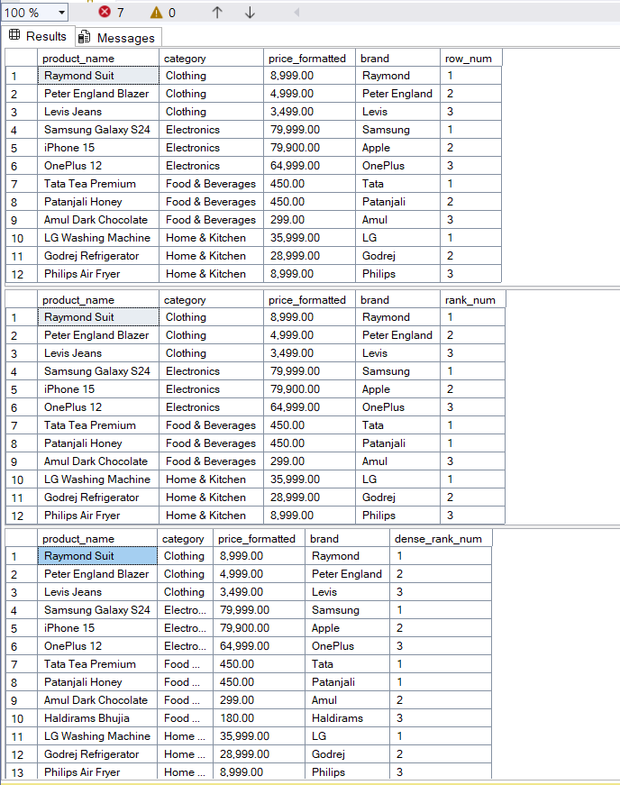
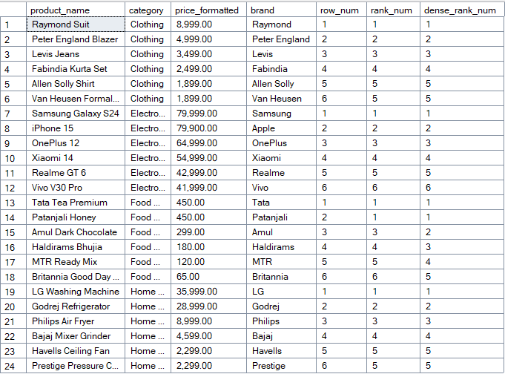

2. SQL Exercise – Index
Exercise 1: Creating a Non-Clustered Index
-- Goal: Create a non-clustered index on the ProductName column in the Products table and compare query execution time before and after index creation.

Exercise 2: Creating a Clustered Index -- Goal: Create a clustered index on the OrderDate column in the Orders table and compare query execution time before and after index creation.

Exercise 3: Creating a Composite Index -- Goal: Create a composite index on the CustomerID and OrderDate columns in the Orders table and compare query execution time before and after index creation.

OUTPUT:
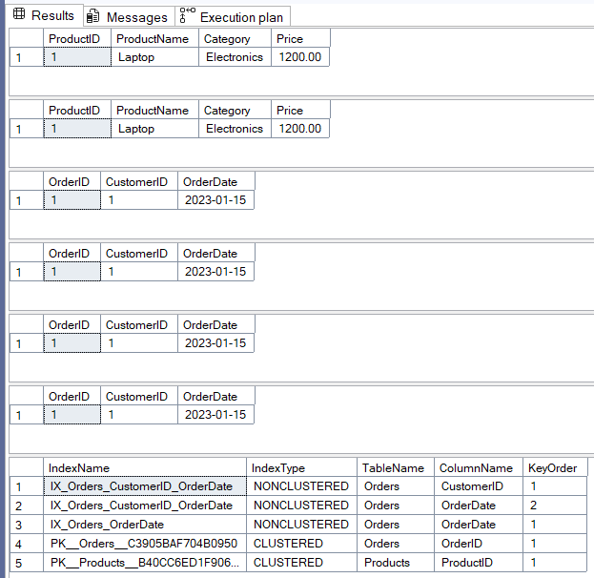

Before Index Creation: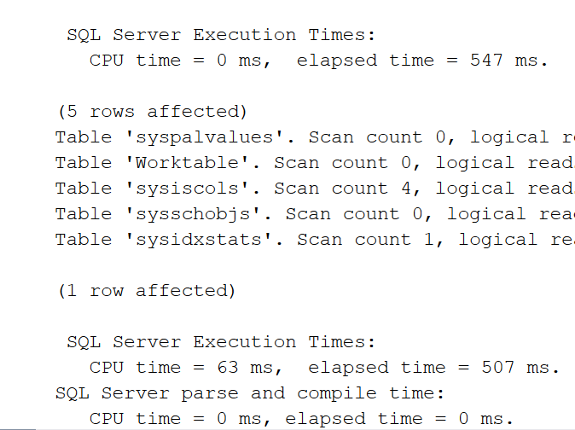
After Index Creation:
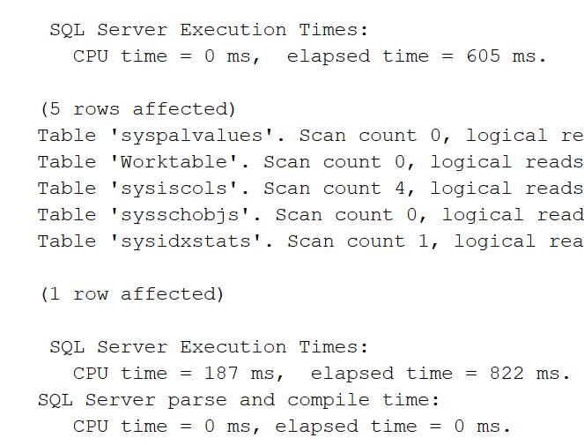
CODE:
-- Exercise 1: Creating a Non-Clustered Index

SET STATISTICS IO ON;
SET STATISTICS TIME ON;
SELECT * FROM Products WHERE ProductName = 'Laptop';
CREATE NONCLUSTERED INDEX IX_Products_ProductName
ON Products (ProductName);
SELECT * FROM Products WHERE ProductName = 'Laptop';
DROP INDEX IX_Products_ProductName ON Products;

-- Exercise 2: Creating a Clustered Index

SELECT * FROM Orders WHERE OrderDate = '2023-01-15';
CREATE NONCLUSTERED INDEX IX_Orders_OrderDate
ON Orders (OrderDate);
SELECT * FROM Orders WHERE OrderDate = '2023-01-15';

-- Exercise 3: Creating a Composite Index

SELECT * FROM Orders WHERE CustomerID = 1 AND OrderDate = '2023-01-15';
CREATE NONCLUSTERED INDEX IX_Orders_CustomerID_OrderDate
ON Orders (CustomerID, OrderDate);
SELECT * FROM Orders WHERE CustomerID = 1 AND OrderDate = '2023-01-15';
SELECT
i.name AS IndexName,
i.type_desc AS IndexType,
OBJECT_NAME(i.object_id) AS TableName,
COL_NAME(ic.object_id, ic.column_id) AS ColumnName,
ic.key_ordinal AS KeyOrder
FROM sys.indexes i
INNER JOIN sys.index_columns ic ON i.object_id = ic.object_id AND i.index_id = ic.index_id
WHERE OBJECT_NAME(i.object_id) IN ('Products', 'Orders')
ORDER BY TableName, IndexName, KeyOrder;

Employee Management System - SQL Exercises
Exercise 7: Return Data from a Scalar Function
Goal: Return the annual salary for a specific employee using `fn_CalculateAnnualSalary`.
Steps:
1. Execute the `fn_CalculateAnnualSalary` function for an employee with `EmployeeID = 1`.
2. Verify the result.
OUTPUT:
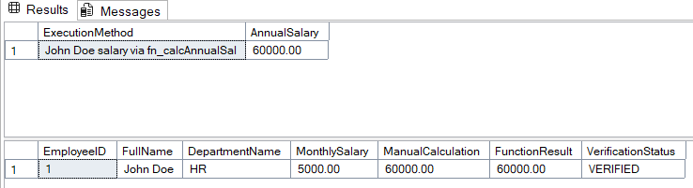
CODE:
USE master;
GO
IF NOT EXISTS (SELECT name FROM sys.databases WHERE name = 'EmployeeManagementSystem')
BEGIN
CREATE DATABASE EmployeeManagementSystem;
END
GO

USE EmployeeManagementSystem;
GO
IF NOT EXISTS (SELECT * FROM sysobjects WHERE name='Departments' AND xtype='U')
BEGIN
CREATE TABLE Departments (
DepartmentID INT PRIMARY KEY,
DepartmentName VARCHAR(100) NOT NULL
);
END
GO
IF NOT EXISTS (SELECT * FROM sysobjects WHERE name='Employees' AND xtype='U')
BEGIN
CREATE TABLE Employees (
EmployeeID INT PRIMARY KEY,
FirstName VARCHAR(50) NOT NULL,
LastName VARCHAR(50) NOT NULL,
DepartmentID INT,
Salary DECIMAL(10,2) NOT NULL,
JoinDate DATE NOT NULL,
FOREIGN KEY (DepartmentID) REFERENCES Departments(DepartmentID)
);
END
GO
IF NOT EXISTS (SELECT * FROM Departments)
BEGIN
INSERT INTO Departments (DepartmentID, DepartmentName) VALUES
(1, 'HR'),
(2, 'IT'),
(3, 'Finance');
END
GO
IF NOT EXISTS (SELECT * FROM Employees)
BEGIN
INSERT INTO Employees (EmployeeID, FirstName, LastName, DepartmentID, Salary, JoinDate) VALUES
(1, 'John', 'Doe', 1, 5000.00, '2020-01-15'),
(2, 'Jane', 'Smith', 2, 6000.00, '2019-03-22'),
(3, 'Bob', 'Johnson', 3, 5500.00, '2021-07-01');
END
GO
IF OBJECT_ID('dbo.fn_CalculateAnnualSalary', 'FN') IS NOT NULL
DROP FUNCTION dbo.fn_CalculateAnnualSalary;
GO

CREATE FUNCTION dbo.fn_CalculateAnnualSalary(@EmployeeID INT)
RETURNS DECIMAL(12,2)
AS
BEGIN
DECLARE @AnnualSalary DECIMAL(12,2);
SELECT @AnnualSalary = Salary * 12
FROM Employees
WHERE EmployeeID = @EmployeeID;
IF @AnnualSalary IS NULL
SET @AnnualSalary = 0;

RETURN @AnnualSalary;
END
GO
-- Method 1: Using SELECT statement
SELECT
'John Doe salary via fn_calcAnnualSal' AS ExecutionMethod,
dbo.fn_CalculateAnnualSalary(1) AS AnnualSalary;

-- Method 2: Using DECLARE and PRINT
DECLARE @Result DECIMAL(12,2);
SET @Result = dbo.fn_CalculateAnnualSalary(1);
SELECT
e.EmployeeID,
e.FirstName + ' ' + e.LastName AS FullName,
d.DepartmentName,
e.Salary AS MonthlySalary,
e.Salary * 12 AS ManualCalculation,
dbo.fn_CalculateAnnualSalary(e.EmployeeID) AS FunctionResult,
CASE
WHEN (e.Salary * 12) = dbo.fn_CalculateAnnualSalary(e.EmployeeID)
THEN 'VERIFIED'
ELSE 'ERROR'
END AS VerificationStatus
FROM Employees e
INNER JOIN Departments d ON e.DepartmentID = d.DepartmentID
WHERE e.EmployeeID = 1;
SQL Exercises – Stored Procedure
Exercise 1: Create a Stored Procedure
Goal: Create a stored procedure to retrieve employee details by department.
Steps:
1. Define the stored procedure with a parameter for DepartmentID.
2. Write the SQL query to select employee details based on the DepartmentID.
3. Create a stored procedure named `sp_InsertEmployee` with the following code:
CREATE PROCEDURE sp_InsertEmployee
@FirstName VARCHAR(50),
@LastName VARCHAR(50),
@DepartmentID INT,
@Salary DECIMAL(10,2),
@JoinDate DATE
AS
BEGIN
INSERT INTO Employees (FirstName, LastName, DepartmentID, Salary, JoinDate)
VALUES (@FirstName, @LastName, @DepartmentID, @Salary, @JoinDate);
END;

OUTPUT:
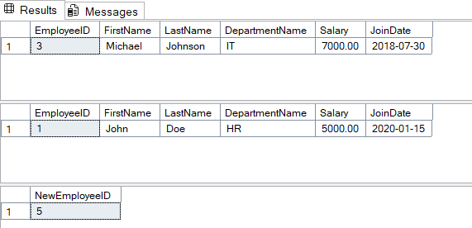
CODE:
DROP TABLE IF EXISTS Employees;
DROP TABLE IF EXISTS Departments;
DROP PROCEDURE IF EXISTS sp_GetEmployeesByDepartment;
DROP PROCEDURE IF EXISTS sp_InsertEmployee;
DROP PROCEDURE IF EXISTS sp_GetEmployeesByDepartment;
DROP PROCEDURE IF EXISTS sp_InsertEmployee;
DROP TABLE IF EXISTS Employees;
DROP TABLE IF EXISTS Departments;
--
CREATE TABLE Departments (
DepartmentID INT PRIMARY KEY,
DepartmentName VARCHAR(100)
);

CREATE TABLE Employees (
EmployeeID INT PRIMARY KEY IDENTITY(1,1),
FirstName VARCHAR(50),
LastName VARCHAR(50),
DepartmentID INT FOREIGN KEY REFERENCES Departments(DepartmentID),
Salary DECIMAL(10,2),
JoinDate DATE
);

INSERT INTO Departments (DepartmentID, DepartmentName) VALUES
(1, 'HR'),
(2, 'Finance'),
(3, 'IT'),
(4, 'Marketing');

INSERT INTO Employees (FirstName, LastName, DepartmentID, Salary, JoinDate) VALUES
('John', 'Doe', 1, 5000.00, '2020-01-15'),
('Jane', 'Smith', 2, 6000.00, '2019-03-22'),
('Michael', 'Johnson', 3, 7000.00, '2018-07-30'),
('Emily', 'Davis', 4, 5500.00, '2021-11-05');

GO

CREATE PROCEDURE sp_GetEmployeesByDepartment
@DepartmentID INT
AS
BEGIN
SET NOCOUNT ON;
SELECT
e.EmployeeID,
e.FirstName,
e.LastName,
d.DepartmentName,
e.Salary,
e.JoinDate
FROM Employees e
INNER JOIN Departments d ON e.DepartmentID = d.DepartmentID
WHERE e.DepartmentID = @DepartmentID
ORDER BY e.LastName, e.FirstName;
END;

GO

CREATE PROCEDURE sp_InsertEmployee
@FirstName VARCHAR(50),
@LastName VARCHAR(50),
@DepartmentID INT,
@Salary DECIMAL(10,2),
@JoinDate DATE
AS
BEGIN
SET NOCOUNT ON;
IF NOT EXISTS (SELECT 1 FROM Departments WHERE DepartmentID = @DepartmentID)
BEGIN
RAISERROR('Department ID %d does not exist.', 16, 1, @DepartmentID);
RETURN;
END
INSERT INTO Employees (FirstName, LastName, DepartmentID, Salary, JoinDate)
VALUES (@FirstName, @LastName, @DepartmentID, @Salary, @JoinDate);

-- Return the new employee ID
SELECT SCOPE_IDENTITY() AS NewEmployeeID;
END;
-- SQL query
EXEC sp_GetEmployeesByDepartment @DepartmentID = 3;
EXEC sp_GetEmployeesByDepartment @DepartmentID = 1;
EXEC sp_InsertEmployee
@FirstName = 'Priyanshu',
@LastName = 'Ranjan',
@DepartmentID = 3,
@Salary = 42060.00,
@JoinDate = '2025-06-28';

Exercise 4: Execute a Stored Procedure
Goal: Execute the stored procedure to retrieve employee details for a specific department.
Steps:
1. Write the SQL command to execute the stored procedure with a DepartmentID
parameter.
2. Execute the command and review the results.

OUTPUT:
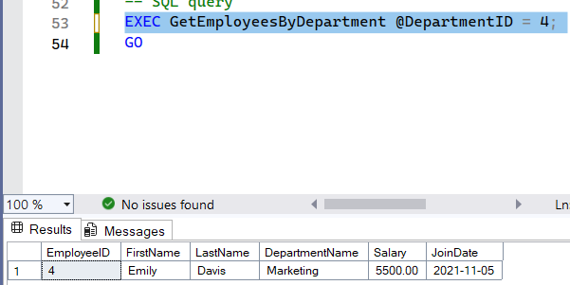

CODE:
CREATE TABLE Departments (
DepartmentID INT PRIMARY KEY,
DepartmentName VARCHAR(100)
);

-- Create Employees Table
CREATE TABLE Employees (
EmployeeID INT PRIMARY KEY,
FirstName VARCHAR(50),
LastName VARCHAR(50),
DepartmentID INT,
Salary DECIMAL(10,2),
JoinDate DATE,
FOREIGN KEY (DepartmentID) REFERENCES Departments(DepartmentID)
);

-- Insert Sample Data
INSERT INTO Departments (DepartmentID, DepartmentName) VALUES
(1, 'HR'),
(2, 'Finance'),
(3, 'IT'),
(4, 'Marketing');

INSERT INTO Employees (EmployeeID, FirstName, LastName, DepartmentID, Salary, JoinDate) VALUES
(1, 'John', 'Doe', 1, 5000.00, '2020-01-15'),
(2, 'Jane', 'Smith', 2, 6000.00, '2019-03-22'),
(3, 'Michael', 'Johnson', 3, 7000.00, '2018-07-30'),
(4, 'Emily', 'Davis', 4, 5500.00, '2021-11-05');

GO
CREATE PROCEDURE GetEmployeesByDepartment
@DepartmentID INT
AS
BEGIN
-- Set NOCOUNT ON to prevent extra result sets
SET NOCOUNT ON;
SELECT
e.EmployeeID,
e.FirstName,
e.LastName,
d.DepartmentName,
e.Salary,
e.JoinDate
FROM Employees e
INNER JOIN Departments d ON e.DepartmentID = d.DepartmentID
WHERE e.DepartmentID = @DepartmentID
ORDER BY e.LastName, e.FirstName;
END

GO

-- SQL query
EXEC GetEmployeesByDepartment @DepartmentID = 4;
GO

Exercise 5: Return Data from a Stored Procedure
Goal: Create a stored procedure that returns the total number of employees in a
department.
Steps:
1. Define the stored procedure with a parameter for DepartmentID.
2. Write the SQL query to count the number of employees in the specified department.
3. Save the stored procedure by executing the Stored procedure content.
OUTPUT:
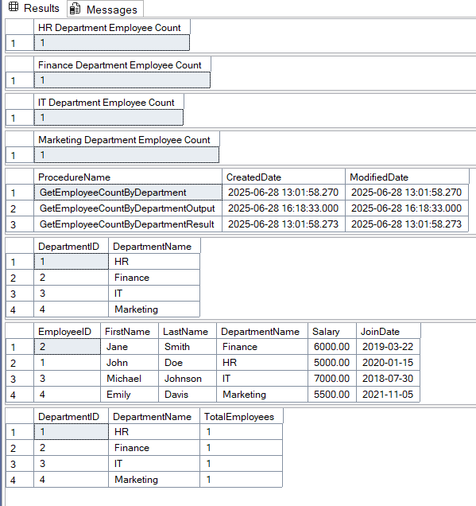

CODE:
CREATE TABLE Departments (
DepartmentID INT PRIMARY KEY,
DepartmentName VARCHAR(100)
);

-- Create Employees Table
CREATE TABLE Employees (
EmployeeID INT PRIMARY KEY,
FirstName VARCHAR(50),
LastName VARCHAR(50),
DepartmentID INT,
Salary DECIMAL(10,2),
JoinDate DATE,
FOREIGN KEY (DepartmentID) REFERENCES Departments(DepartmentID)
);

-- Insert Sample Data
INSERT INTO Departments (DepartmentID, DepartmentName) VALUES
(1, 'HR'),
(2, 'Finance'),
(3, 'IT'),
(4, 'Marketing');

INSERT INTO Employees (EmployeeID, FirstName, LastName, DepartmentID, Salary, JoinDate) VALUES
(1, 'John', 'Doe', 1, 5000.00, '2020-01-15'),
(2, 'Jane', 'Smith', 2, 6000.00, '2019-03-22'),
(3, 'Michael', 'Johnson', 3, 7000.00, '2018-07-30'),
(4, 'Emily', 'Davis', 4, 5500.00, '2021-11-05');

GO

CREATE PROCEDURE GetEmployeeCountByDepartment
@DepartmentID INT
AS
BEGIN
SET NOCOUNT ON;
SELECT
d.DepartmentID,
d.DepartmentName,
COUNT(e.EmployeeID) AS TotalEmployees
FROM Departments d
LEFT JOIN Employees e ON d.DepartmentID = e.DepartmentID
WHERE d.DepartmentID = @DepartmentID
GROUP BY d.DepartmentID, d.DepartmentName;
END

GO
EXEC GetEmployeeCountByDepartment @DepartmentID = 1;
EXEC GetEmployeeCountByDepartment @DepartmentID = 2;
EXEC GetEmployeeCountByDepartment @DepartmentID = 3;
EXEC GetEmployeeCountByDepartment @DepartmentID = 4;
EXEC GetEmployeeCountByDepartment @DepartmentID = 5;
GO
CREATE PROCEDURE GetEmployeeCountByDepartmentOutput
@DepartmentID INT,
@TotalEmployees INT OUTPUT
AS
BEGIN
SET NOCOUNT ON;
SELECT @TotalEmployees = COUNT(*)
FROM Employees
WHERE DepartmentID = @DepartmentID;
END

GO
DECLARE @EmployeeCount INT;
EXEC GetEmployeeCountByDepartmentOutput @DepartmentID = 1, @TotalEmployees = @EmployeeCount OUTPUT;
SELECT @EmployeeCount AS 'HR Department Employee Count';
EXEC GetEmployeeCountByDepartmentOutput @DepartmentID = 2, @TotalEmployees = @EmployeeCount OUTPUT;
SELECT @EmployeeCount AS 'Finance Department Employee Count';
EXEC GetEmployeeCountByDepartmentOutput @DepartmentID = 3, @TotalEmployees = @EmployeeCount OUTPUT;
SELECT @EmployeeCount AS 'IT Department Employee Count';
EXEC GetEmployeeCountByDepartmentOutput @DepartmentID = 4, @TotalEmployees = @EmployeeCount OUTPUT;
SELECT @EmployeeCount AS 'Marketing Department Employee Count';
GO
SELECT
name AS ProcedureName,
create_date AS CreatedDate,
modify_date AS ModifiedDate
FROM sys.procedures
WHERE name LIKE '%GetEmployeeCount%'
ORDER BY name;
SELECT * FROM Departments ORDER BY DepartmentID;
SELECT
e.EmployeeID,
e.FirstName,
e.LastName,
d.DepartmentName,
e.Salary,
e.JoinDate
FROM Employees e
INNER JOIN Departments d ON e.DepartmentID = d.DepartmentID
ORDER BY d.DepartmentName, e.LastName;
SELECT
d.DepartmentID,
d.DepartmentName,
COUNT(e.EmployeeID) AS TotalEmployees
FROM Departments d
LEFT JOIN Employees e ON d.DepartmentID = e.DepartmentID
GROUP BY d.DepartmentID, d.DepartmentName
ORDER BY d.DepartmentID;
GO

NUnit-Handson
TestFixture & Test
- Create a Unit test project(.Net Framework) in the solution provided.
- Add the CalcLibrary project as reference
- Create a class “CalculatorTests” to write all the test cases for the methods in the solution
- Use the ‘TestFixture’, ‘SetUp’ and ‘TearDown’ attributes, to declare, initialize and cleanup activities respectively
- Create a Test method to check the addition functionality
- Use the ‘TestCase’ attribute to send the inputs and the expected result
- Use Assert.That to check the actual and expected result match

OUTPUT:
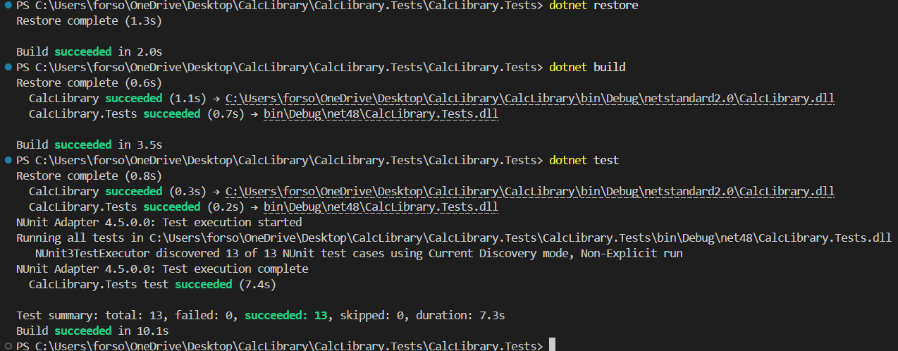

CODE:
MathLibrary.cs
using System;

namespace CalcLibrary
{
interface IMathLibrary
{
double Addition(double a, double b);
double Subtraction(double a, double b);
double Multiplication(double a, double b);
double Division(double a, double b);
}

public class SimpleCalculator : IMathLibrary
{
double result = 0;
public double Addition(double a, double b)
{
result = a + b;
return result;
}

public double Subtraction(double a, double b)
{
result = a - b;
return result;
}

public double Multiplication(double a, double b)
{
result = a * b;
return result;
}

public double Division(double a, double b)
{
if (b == 0)
throw new ArgumentException("Second Parameter Can't be Zero");
result = a / b;
return result;
}

public void AllClear()
{
result = 0;
}

public double GetResult
{
get { return result; }
}
}
}

Moq-Handson
Write Testable Code with Moq

Scenario

You are tasked to write a unit test code for the below scenario.
The application in which you are teamed up with, deals with a mail server communication in which your application tries to send mail to its users upon every transaction. Your role is to write unit testing the module that contains send mail functionality. You wanted to perform testing the module without sending any email.
After investigating the problem scenario, you found a solution and that is creating mock objects of these external dependencies in the unit testing project so that you can achieve speedier test execution and loose coupling of code.

OUTPUT:
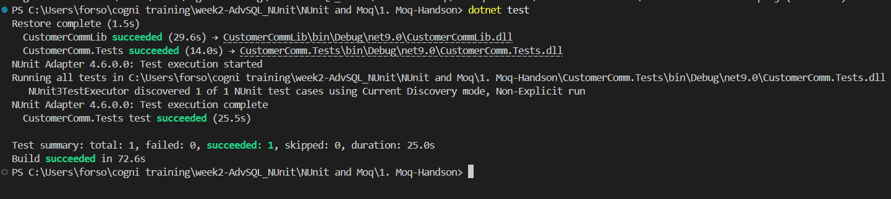

CODE:
CustomerCommTests.cs
using Moq;
using NUnit.Framework;
using CustomerCommLib;

namespace CustomerComm.Tests
{
[TestFixture]
public class CustomerCommTests
{
[Test]
public void SendMailToCustomer_ShouldReturnTrue()
{
var mockMailSender = new Mock<IMailSender>();

mockMailSender.Setup(ms => ms.SendMail(It.IsAny<string>(), It.IsAny<string>()))
.Returns(true);
var customerComm = new CustomerCommLib.CustomerComm(mockMailSender.Object);
bool result = customerComm.SendMailToCustomer();
Assert.That(result, Is.True);
mockMailSender.Verify(ms => ms.SendMail(It.IsAny<string>(), It.IsAny<string>()), Times.Once);
}
}
}

CustomerComm.cs
namespace CustomerCommLib
{
public class CustomerComm
{
private readonly IMailSender _mailSender;
public CustomerComm(IMailSender mailSender)
{
_mailSender = mailSender;
}

public bool SendMailToCustomer()
{
string email = "22052571@kiit.ac.in";
string message = "Hello!";
return _mailSender.SendMail(email, message);
}
}
}

IMailSender.cs
namespace CustomerCommLib
{
public interface IMailSender
{
bool SendMail(string toAddress, string message);
}
}
MailSender.cs
using System.Net;
using System.Net.Mail;

namespace CustomerCommLib
{
public class MailSender : IMailSender
{
public bool SendMail(string toAddress, string message)
{
MailMessage mail = new MailMessage();
SmtpClient SmtpServer = new SmtpClient("smtp.gmail.com");

mail.From = new MailAddress("sample@gmail.com");
mail.To.Add(toAddress);
mail.Subject = "Test Mail";
mail.Body = message;

SmtpServer.Port = 587;
SmtpServer.Credentials = new NetworkCredential("username", "password");
SmtpServer.EnableSsl = true;
return true;
}
}
}

Directory Structure:
