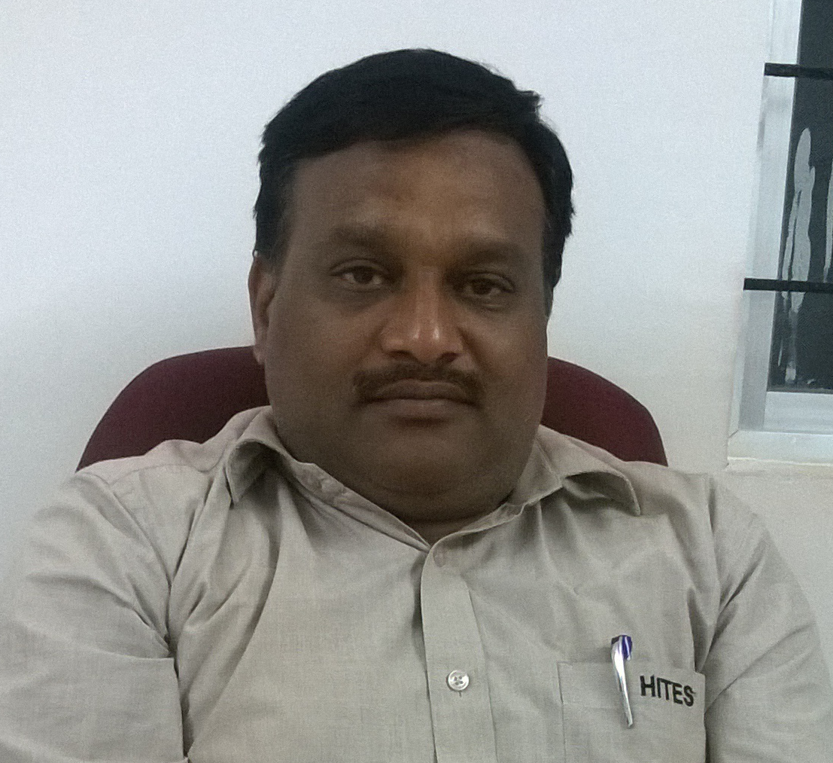
CURRICULUM VITAE

G . PRADEEP KUMAR REDDY
Contact Number: - 7337429404, 7842267937
Email: geereddypradeep@yahoo.co.in
Seeking assignments in Project Planning / Site & Construction Management with an organisation of high repute in the Construction sector.

PROFESSIONAL ABRIDGEMENT

- A Civil Engineer with over 23years 04 monthsof rich experience in managing Construction Projects encompassing planning, relationship management and resource planning.
- A strategic planner with expertise in planning, executing and spearheading construction projects.
- Holds the distinction of executing numerous Construction projects for Residential Towers, Villas, IT parks, Industrial Project (ITC Paper Plant) and Hospital including Interior Fit out, Water Supply & Underground sewerage/storm water Pipe lines etc. during the career path.
- Well-developed experience in project planning involving estimation, execution, QA/QC, monitoring and coordinating with respective agencies. Familiar with PERI and MIVAN Shuttering
- Excellent interpersonal, analytical and organisational skills with deftness in swiftly ramping up projects in co-ordination with clients, architects & consultants.

PROFICIENCY FORTE

Project Planning & Management:

- Managing overall operations, quality assurance and quality compliance for executing civil construction projects within cost & time norms; participating in project review meetings for evaluating project progress & de-bottlenecking.
- Preparing project schedules and monitoring projects with respect to Cost, Resource Deployment, Time over-runs and Quality Compliance to ensure timely execution of projects.
- Formulating operating budgets, work specific quality control plans, project progress reports, inspection reports, concrete pour cards, survey reports, daily deployment report & production reports.

Liasioning Operations:

- Managing the tendering process from floating of bids to awarding of contracts; coordinating with contractors with regard to techno-commercial negotiations.
- Liasing with clients, architects, consultants, contractors, subcontractors & external agencies for determining technical specifications, approvals and obtaining statutory clearances.
Site & Construction Management:
- Anchoring on-site construction activities to ensure completion of project within the time & cost parameters and effective resource utilisation to maximise the output.
- Implementing Quantity Surveying services; inspecting field sites to observe and evaluate condition and operability of facilities and structures, and to collect field survey data and measurements.
- Designing and implementing stringent systems and quality plans / manuals to ensure high quality standards during all the stages of project.

Quality Assurance & Controls:
- Ensuring implementation of all Quality Management System; inspection & test activities as per project specifications.
- Compiling test pack pertaining to discipline in coordination with the QA/QC Engineer / QC Inspector.
- Preparation of ITPs and method of statements for client approvals.
- Checking the shop drawings before submitting to the consultant / client for approvals.
- Review the material approvals before submitting to the consultant /client for approvals.
Resource Planning & Control:
- Material Planning & developing vendors for obtaining timely procurement of materials & equipments at cost effective prices to ensure smooth execution of projects.
- Ensuring suitable deployment of manpower & timely availability of manpower (designers & engineers); coordinating for guaranteeing conformance with specifications and CQR.
Team Management
- Designing and implementing strategies for building team effectiveness by promoting a spirit of cooperation between team members.
- Conducting meetings for setting up objectives and streamlining processes to ensure smooth functioning of operations.

Educational Background

Bachelor of Engineering (Civil) completed with First class (65%) from
Nagpur University. Maharashtra, INDIA.
H.S.C. Completed with First class (68.7%) from Board of Intermediate Education,
Andhra Pradesh. INDIA.
S.S.C. Completed with First class (69.5%) from Board of Secondary Education,
Andhra Pradesh. INDIA.

ORGANISATION EXPERIENCE

7. Period of working : Feb 2017 to Till Date
Seventh Company : RNR DEVELOPERS , Hyderabad

RNR TRANQUIL TOWER (Residential building)
Of basement , stilt 1, stilt 2 + 9 floors with 1,25,500 sft
built up area with 63 flats of high end premium flats,
with amenities like swimming pool, gym ,indoor games,
children play area. In gated community.

EDEN VISTAS (VILLAS) at UPPER PALLY
ATTAPUR (COMPLETED)
4.5 Acres of 47 villas , club house
Each of 150 sq yrds to 323 sq yrds , each of G+2 floors
In gated community

Project Name : FORT VIEW TOWERS (Multi storied Residential
Buildings) (COMPLETED)
( each comprising G + 9 floors and 2 basements with 237300 sft of blkA , 78250sft of blk B built up area located at Hyderabad, with 198 apartments of high end finishing and all amenities like club house, gym, swimming pool & batmenton court etc in Gated community)

Project Cost : 60 Crores
Department : Construction
Designation : Senior project Manager
6. Period of working : Sept 2013 to Jan 2017
Sixth Company : Aditya Construction Company , Hyderabad.
Project Name : EMPRESS TOWERS (Multi storied Residential
Buildings)BLOCK E (VICTORIYA) COMPLETED
( each comprising Stilt+22 floors and 2 basements with 323400 sft built up area located at Hyderabad, with 176 apartments of high end finishing and all amenities like club house, gym, basketball & long tennis court etc in Gated community)

Project Cost : 110 Crores
Department : Construction
Designation : Joint project Manager

5. Period of working : Jan 2009 to Aug 2013
Fifth Company : Janapriya Engineers Syndicate,Hyderabad.
Project Name : NILE VALLEY (Multi storied Residential Buildings)
( 4 Residential Towers – each comprising G+9 floors and 2 basements with 11 lakhs sft built up area located at Hyderabad, with 978 apartments of high end finishing and all amenities like club house, gym, basketball & long tennis court etc in Gated community) 2BLKS COMPLETED
PMC : FABS
Project Cost : 125 crores.
Department : Projects
Designation : Deptuty Project Manager

4. Period of working : Feb 2005 to Sept 2008
Fourth Company : LARSEN & TOUBRO , Hyderabad
Project Name : IT PARKS (HSBC,MOTOROLA,PHEONIX,
DELOITE, ICICI )
Project Cost : 200crores
PMC : JLL,CBRE
Department : Projects
Designation : Asst Const Manager

3. Period of working : March 2004 to Jan 2005
Third Company : Sudha Construction, Hyderabad
Project Name : YASHODHA HOSPITAL
each comprising of b1+b2+G+7floors
Project Cost : 50 crores.
Department : Construction
Designation : Project Engineer

2. Period of working : June 2003 to Feb 2004
Second Company : Larsen & Toubro
Project Name : ITC Paper plant (Bhadrachalam)
Client : ITC
Project Cost : 70 crores.
Department : Constructions
Designation : Site Engineer

- Period of working : June 2001 to May 2003
First Company : MJR Construction company, Hyderabad
Project Name : MJR CLASSIC
Malakpet – each comprising of stilt + 5 floors . COMPLETED
Project Cost : 10 crores.
Department : Constructions
Designation : Site Engineer

Technical Skills

Operating System : Windows 2007, Windows XP Professional.
Packages : AutoCAD, MS - Projects.
STAAD PRO,

Personal Profile

Date of Birth : 14th July 1976
Address : Fno 507 B BLOCK , HALL MARK TRANQUIL
Road no 12, QULI QUTUB SHAH COLONY
Puppalaguda , Manikonda , Gandipet , RangaReddy
Hyderabad ,Telangana, 500089
Nationality : Indian
Marital status : Married
Languages : Telugu, English, Hindi, Marathi, kannada

Declaration

I consider myself familiar with Civil Engineering concepts. I am confident of my ability to work in team. I hereby declare that the information furnished above is true to the best of my knowledge.

G . PRADEEP KUMAR REDDY

