PIXEL & CODE
Design and Development of a Freelance Web & App Development Platform
A Project Report
Prepared by Bharath

1. Abstract & Keywords
Pixel & Code is a freelance web and application development service created to offer affordable, custom-built websites and apps to small businesses, tutors, and individuals who currently lack an online presence. This project documents the complete design-to-deployment lifecycle of the Pixel & Code platform, from brand identity and UI design through to a live, publicly accessible website with a working client-inquiry system. Unlike template-based site builders, the website was hand-coded using HTML, CSS, and JavaScript to allow full creative control over branding — a visual identity built around a “pixel meeting code” concept, expressed through a split amber-and-cyan color scheme representing design and engineering merging into one discipline. The project also required solving practical, real-world deployment problems: version control through GitHub, static hosting through Netlify and Tiiny.host, and lead-capture through a third-party form service (Formspree), since no traditional backend server was used. The result is a fully functional, zero-cost business website that can accept genuine client inquiries. This report outlines the objectives, methodology, and findings of building Pixel & Code from concept to a live, working product, and reflects on the practical challenges of deploying a static site without prior web-hosting experience.
Keywords: Web Development, Freelancing Platform, Static Site Hosting, Contact Form Integration, Portfolio Website

2. Introduction
Freelance web and app development is one of the most accessible entry points into the technology industry, requiring minimal upfront capital compared to traditional software businesses. However, freelancers — particularly students and first-time entrepreneurs — often lack a professional online presence of their own, which limits their credibility when approaching potential clients. Pixel & Code was created to solve this problem directly: a self-branded website that not only showcases the service being offered (web and app development) but also serves as a working demonstration of the developer's own capability.
The project required more than visual design. A functioning freelance business website needs a clear services breakdown, transparent pricing, a portfolio section, and — critically — a way for potential clients to actually make contact. Each of these needs shaped a specific part of the development process, described in detail in the sections that follow.

3. Literature Review — Review of Existing Platforms
As this is an applied web-development project rather than an academic research study, the “literature” reviewed here consists of existing website-building and freelancing platforms rather than published research papers. Reviewing these systems helped identify what already exists in the market and where an independent, custom-coded approach like Pixel & Code offers an advantage.
- WordPress — A widely used content management system offering plugin-based customization, but often requiring paid hosting and themes for a fully professional result.
- Wix — A drag-and-drop website builder aimed at non-developers; fast to use but limited in custom design control and often locks advanced features behind subscriptions.
- Squarespace — Template-driven site builder known for polished designs, but subscription-based with limited flexibility for fully custom branding.
- Webflow — A more design-flexible no-code builder popular with professional designers, though its learning curve and pricing exceed what a beginner freelancer typically needs.
- GitHub Pages — A free static-site hosting service tied directly to a GitHub repository, well suited to developers comfortable with version control.
- Netlify — A free-tier hosting platform offering continuous deployment from GitHub and built-in form handling for static sites.
- Fiverr — A freelance marketplace connecting service providers with clients through fixed-price “gigs,” used as the primary client-acquisition channel for Pixel & Code.
- Upwork — A freelance marketplace oriented toward larger, ongoing contracts rather than fixed-price gigs, requiring more active proposal-based bidding.
- Formspree — A third-party form-backend service that allows static websites (with no server of their own) to receive and process form submissions by email.
- Tiiny.host — A lightweight static file hosting service allowing a single HTML file to be published instantly to a public link, used as the final hosting solution for Pixel & Code.

4. Research Gap
Existing site-builder platforms (Wix, Squarespace, Webflow) are optimized for non-developers but restrict full creative and structural control, and frequently require ongoing subscription costs that are impractical for a zero-budget student freelancer. Conversely, fully custom-coded development is flexible and free to host but assumes prior knowledge of deployment tools, version control, and backend form handling — knowledge a first-time freelancer typically does not yet have. The gap identified in this project is the lack of a documented, low-cost, end-to-end pathway that takes a freelancer from “no website” to “live, custom-branded site with a working contact system,” using entirely free tools, without requiring a paid subscription or a pre-existing template.

5. Research Methodology
The project followed an applied, iterative development methodology rather than a formal experimental one, consisting of the following stages:
- Requirement gathering: defining the services (website development, app development, bundled packages, maintenance), pricing tiers, and brand name (“Pixel & Code”).
- Visual design: selecting a split amber-and-cyan color identity to visually represent the duality of “pixel” (design) and “code” (engineering), paired with monospace typography for a technical feel.
- Development: hand-coding the site using HTML for structure, CSS for styling and layout, and JavaScript for interactivity (navigation, form submission handling).
- Version control: creating a GitHub account and repository to store and track the website's source code.
- Deployment: connecting the repository to Netlify for automatic redeployment, and separately publishing through Tiiny.host as the platform's official public link.
- Form integration: connecting the contact form to Formspree, since static hosting has no built-in backend to process submissions.
- Testing: manually submitting test entries through the live contact form to confirm end-to-end delivery to the developer's email.

6. Objective
- To design and develop a fully custom, professionally branded website for the Pixel & Code freelance service without incurring any development or hosting cost.
- To implement a functional client-inquiry system on a static (serverless) website by integrating a third-party form-handling service, enabling real lead capture.

7. Algorithm & Flowchart

Algorithm
- Start.
- Define project requirements: services offered, pricing structure, and brand identity.
- Design the user interface: choose color palette, typography, and page layout.
- Develop the website using HTML, CSS, and JavaScript.
- Push the completed source code to a GitHub repository.
- Connect the repository to a static hosting provider (Netlify / Tiiny.host).
- Configure the contact form to submit to a Formspree endpoint.
- Test the live website: verify navigation, responsiveness, and form submission.
- Publish the final live site and share the public link.
- End.

Flowchart
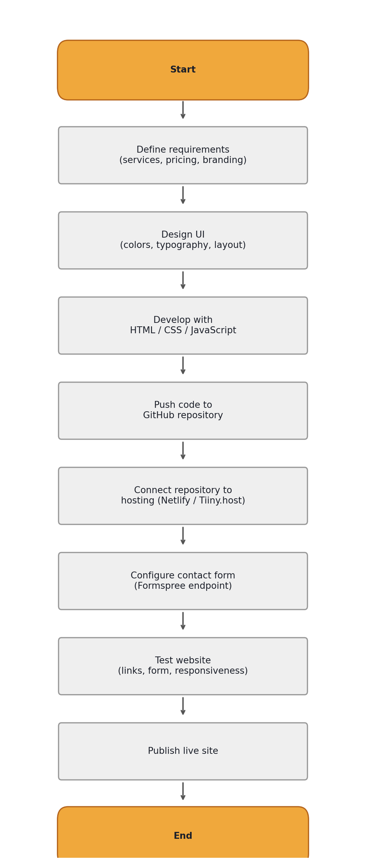

8. Code
A representative excerpt of the contact form implementation, showing the HTML structure and the JavaScript submission handler connecting to the Formspree endpoint:
<form id="contactForm" action="https://formspree.io/f/xvzevbgg"
method="POST" onsubmit="return handleSubmit(event)">
<input id="name" name="name" type="text" required>
<input id="email" name="email" type="email" required>
<textarea id="message" name="message" required></textarea>
<button type="submit">Send request</button>
</form>

<script>
function handleSubmit(e) {
e.preventDefault();
const form = e.target;
const data = new FormData(form);
fetch(form.action, {
method: "POST", body: data,
headers: { "Accept": "application/json" }
}).then(res => {
form.reset();
});
return false;
}
</script>

9. Findings
The development process confirmed that a fully custom, professional website can be built and hosted at zero cost using free-tier tools (GitHub, Netlify, Tiiny.host, Formspree), validating the project's first objective. Several practical obstacles were encountered during deployment that are typically absent from academic descriptions of web development but proved to be the most time-consuming part of the project in practice:
- The GitHub mobile app does not support direct file uploads to a repository; this had to be done through the desktop browser version of github.com instead.
- Static hosting providers such as Netlify and Tiiny.host require the main file to be named exactly “index.html” to be recognized as the homepage.
- A contact form on a static site does not function without an external backend service — Formspree was required to receive and forward form submissions, and required creating an account and verifying the form endpoint before it worked correctly.
- The initial deployment produced a “Page not found” error, traced to a file-naming and root-directory issue in the repository, resolved by re-uploading the file correctly named at the repository root.
Once these issues were resolved, end-to-end testing confirmed that a genuine form submission on the live site was successfully received, validating the project's second objective.

10. Conclusion
This project successfully delivered a fully functional, custom-branded freelance business website for Pixel & Code, built entirely with free tools and without any paid hosting or subscription costs. Beyond the visual design, the project demonstrated a complete real-world web deployment pipeline — from version control, to static hosting, to third-party form integration — that many beginner tutorials omit. The final live website, hosted at a public Tiiny.host link, is capable of receiving genuine client inquiries through a working contact form, making Pixel & Code operationally ready to take on real freelance client work.

11. Reference
- MDN Web Docs — HTML, CSS, and JavaScript documentation. Mozilla. https://developer.mozilla.org
- GitHub Docs — Repositories and Pages documentation. GitHub Inc. https://docs.github.com
- Netlify Docs — Deployment and Forms documentation. Netlify Inc. https://docs.netlify.com
- Formspree Documentation — Form endpoint setup. Formspree Inc. https://formspree.io
- Tiiny.host — Static site hosting service. https://tiiny.host
- Fiverr — Freelance services marketplace. https://www.fiverr.com

