🧠 HOW TO READ THIS DIAGRAM (IMPORTANT)
🔹 Ordering Flow
Customer → Order → Order Items → Inventory (via reservation)
🔹 Payment Flow
Customer → Payments → Payment Items → Order Items → Products
🔹 Shipping Flow
Order Item → Order Shipping (FORWARD / RETURN)
🔹 Return Flow
Order Item → Return → Inspection → Refund → Inventory update
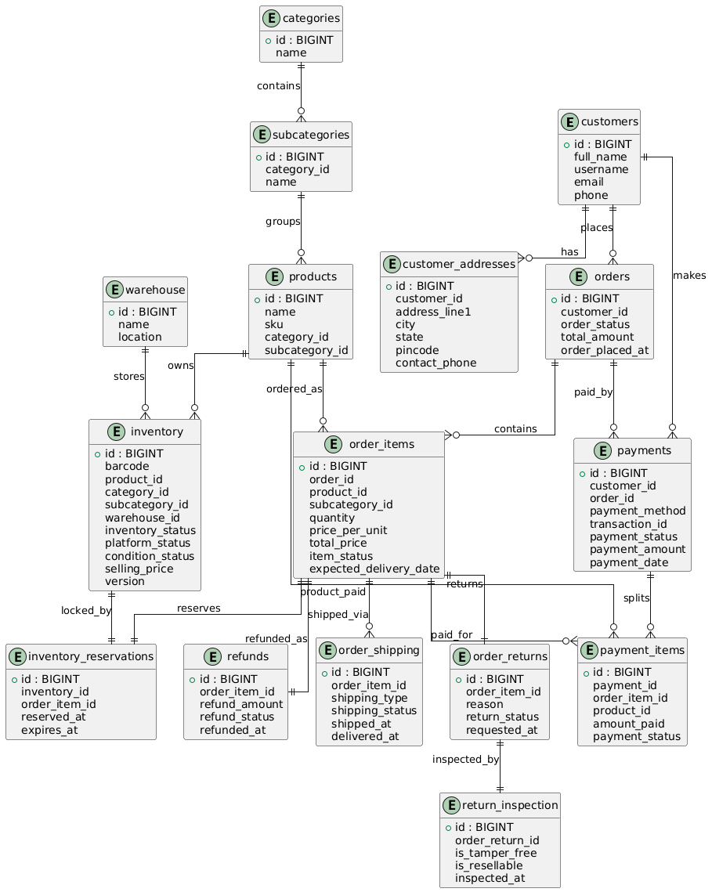
📌 What this diagram clearly shows
✔ One Customer → many Orders
✔ One Order → many Order Items
✔ One Product → many Inventory units
✔ Inventory locked per Order Item
✔ Partial / split payments supported
✔ Shipping, Returns, Refunds tracked per item

3️⃣ Important improvements (recommended)
🔴 1. Inventory ↔ Reservation cardinality
Current:
inventory ||--|| inventory_reservations
📌 Reality:
- Inventory item may or may not be reserved
- At a time → max one active reservation
✅ Better:
inventory ||--o| inventory_reservations

🔴 2. OrderItem ↔ Return / Refund
Right now you used ||--|| (mandatory)
But:
- Not every order item is returned
- Not every order item is refunded
✅ Better:
order_items ||--o| order_returns
order_items ||--o| refunds

🔴 3. Product → Inventory cardinality
You wrote:
products ||--o{ inventory
This is correct, because:
- One product → many inventory records (warehouse, condition, barcode)
✅ Keep this 👍

🔴 4. Category IDs duplicated in inventory
You already have:
product_id
category_id
subcategory_id
📌 Best practice:
- Category should be derived from product
- Avoid duplication unless needed for performance
✅ Optional improvement:
Remove category_id, subcategory_id from inventory
🧠 CORE PRINCIPLE (IMPORTANT)
Start with the service that OWNS THE DATA and ENFORCES CONSISTENCY
In your system, inventory consistency & locking is the hardest and most critical problem.
Everything else depends on it.

✅ CORRECT BUILD ORDER (REAL-WORLD)

1. inventory-service 🧠 CORE
2. product-service
3. customer-service
4. order-service
5. payment-service
6. shipping-service
7. notification-service
8. authentication-service
9. api-gateway-service
10. config-service

🥇 1️⃣ inventory-service (START HERE)
Why first?
- Owns inventory table
- Handles optimistic locking
- Controls RESERVED → SOLD → AVAILABLE
- Prevents overselling
- Required by:
  - order-service
  - payment-service
  - shipping-service
  - notification-service
What to implement first
✔ Inventory entity
✔ Inventory reservation
✔ Stock availability API
✔ Lock / unlock logic
✔ Optimistic locking retry
📌 Without this, nothing else is safe.

🥈 2️⃣ product-service
Why second?
- Owns:
  - categories
  - subcategories
  - products
- Inventory references product, not vice versa
- Needed for:
  - catalog
  - order validation
  - UI listing
Implement
✔ Product CRUD
✔ Category & subcategory
✔ Enable/disable based on inventory signal

🥉 3️⃣ customer-service
Why now?
- Orders, payments, shipping all need customers
- Low coupling, easy to build
Implement
✔ Customer profile
✔ Address management
✔ Contact info

🏅 4️⃣ order-service
Why now?
- Depends on:
  - customer-service
  - product-service
  - inventory-service
Responsibilities
✔ Order creation
✔ Order items
✔ Call inventory-service to reserve stock
✔ Maintain order lifecycle
🚨 Order service never updates inventory DB directly

🏅 5️⃣ payment-service
Why after orders?
- Payment only makes sense after order exists
- Needs:
  - order-service
  - inventory-service
Responsibilities
✔ Payment tracking
✔ Transaction ID
✔ Success/failure callbacks
✔ Notify inventory-service on success/failure

🏅 6️⃣ shipping-service
Why later?
- Shipping only after payment success
- Depends on:
  - order-service
  - customer-service
Responsibilities
✔ Forward shipping
✔ Return shipping
✔ Delivery status updates

🏅 7️⃣ notification-service
Why later?
- Stateless
- Event-driven
- Depends on all services
Responsibilities
✔ Email/SMS/WhatsApp
✔ Retry logic
✔ Async handling

🏅 8️⃣ authentication-service
Why later?
- Cross-cutting
- Can be stubbed initially
- Needed before production
Responsibilities
✔ JWT / OAuth
✔ Role-based access
✔ Service-to-service auth

🏅 9️⃣ api-gateway-service
Why near the end?
- Needs all APIs to exist
- Routing + auth + rate-limiting

🏁 1️⃣0️⃣ config-service
Why last?
- Helps scaling
- Not required initially
- Can be added when services mature

🧩 FINAL BUILD SEQUENCE (CLEAR)
1. inventory-service 🧠 CORE
2. product-service
3. customer-service
4. order-service
5. payment-service
6. shipping-service
7. notification-service
8. authentication-service
9. api-gateway-service
10. config-service

🔐 LOCKING & OWNERSHIP RULE (VERY IMPORTANT)
Data | Owner Service
inventory | inventory-service
products | product-service
customers | customer-service
orders | order-service
payments | payment-service
shipping | shipping-service
notifications | notification-service
🚫 No service updates another service’s DB

🧠 COMMUNICATION STRATEGY
Need | Approach
Inventory locking | Sync REST
Payment confirmation | Sync REST
Notifications | Async events
Shipping updates | Async events

📦 INVENTORY-SERVICE (AUTHORITATIVE OWNER)
Owns these tables
- inventory
- inventory_reservations
- inventory_status_history
- inventory_defects (optional)
🔐 IMPORTANT DESIGN RULES (READ FIRST)
❌ Admin should NOT hard-delete inventory rows
Because:
- Orders, returns, audits depend on history
- Barcode must never be reused
✅ Soft delete = disable inventory
So:
- DELETE → logical delete
- PUT → full replace
- PATCH → partial update

1️⃣ DELETE INVENTORY (SOFT DELETE)
Behavior
- Sets platformStatus = DISABLED
- Sets inventoryStatus = REMOVED
- Keeps DB row
✅ RECOMMENDED APPROACH
✔ Use PATCH (Partial Update)
Not PUT, not DELETE.
Why?
- Only price fields change
- No risk of overwriting other fields
- Clear intent: price correction

PATCH /api/admin/inventory/TV-LG-0201/disable?adminId=101

PATCH /api/admin/inventory/{barcode}/enable

PATCH /api/admin/inventory/{barcode}

{
"platformStatus": "DISABLED",
"inventoryStatus": "DAMAGED",
"conditionStatus": "WAREHOUSE_DAMAGED",
"isWarehouseDamaged": true,
"updatedBy": 101
}

2️⃣ Entity Relationship (Product-service DB)
Category 1 ──── * Subcategory 1 ──── * Product
✔ Product belongs to exactly one subcategory
✔ Subcategory belongs to exactly one category
3️⃣ REST APIs – PRODUCT CRUD
🔹 Create Product
POST /api/products
Request
{
"categoryId": 1,
"subcategoryId": 101,
"sku": "TV-LG-32-HD",
"name": "LG 32 Inch HD Ready TV",
"description": "Smart TV with webOS",
"brand": "LG",
"model": "32LM560B"
}
Behavior
- Validates category + subcategory
- Creates catalog entry
- No inventory interaction here

🔹 Get Product by ID
GET /api/products/{productId}
Response
{
"id": 1001,
"sku": "TV-LG-32-HD",
"name": "LG 32 Inch HD Ready TV",
"brand": "LG",
"model": "32LM560B",
"categoryId": 1,
"subcategoryId": 101,
"productStatus": "ACTIVE"
}

🔹 List Products (Catalog View)
GET /api/products?categoryId=1&subcategoryId=101
Inventory availability will be fetched via inventory-service

🔹 Update Product (Admin)
PUT /api/products/{productId}
{
"name": "LG 32 Inch HD Smart TV",
"description": "Updated description",
"brand": "LG",
"model": "32LM560B-2024"
}
✔ No stock / price update here
✔ Metadata only

🔹 Disable Product (Soft Delete)
PATCH /api/products/{productId}/disable
{
"reason": "Discontinued by manufacturer"
}
Effect
product_status = DISABLED

🔹 Enable Product
PATCH /api/products/{productId}/enable

4️⃣ Category & Subcategory APIs
Category
POST /api/categories
GET /api/categories
PATCH /api/categories/{id}/disable
Subcategory
POST /api/subcategories
GET /api/subcategories?categoryId=1
PATCH /api/subcategories/{id}/disable

5️⃣ Inventory → Product ENABLE / DISABLE FLOW
🧠 Rule
Product availability on UI depends on inventory-service signal
Scenario
- All inventory items for a subcategory are:
  - SOLD / DAMAGED / REMOVED
- Product-service should disable products under that subcategory

🔗 REST Call (SYNC – for now)
Inventory-service → Product-service
PATCH /api/products/availability
Request
{
"subcategoryId": 101,
"available": false
}
Product-service behavior
product_status = DISABLED

Enable when stock comes back
{
"subcategoryId": 101,
"available": true
}

6️⃣ Product-service → Inventory-service (Validation Call)
When order-service places order:
GET /api/products/{productId}/validate
Response:
{
"valid": true,
"productStatus": "ACTIVE"
}

7️⃣ Why This Design is CORRECT
✔ Product-service is catalog owner
✔ Inventory-service is physical stock owner
✔ Order-service orchestrates both
✔ No circular dependency
✔ Clean microservice boundaries

8️⃣ Future (NO CHANGE REQUIRED LATER)
Later you can replace:
Inventory → Product REST call
with:
InventoryStockChangedEvent
Without DB or API redesign 🔥

✅ FINAL SUMMARY
Service | Owns
product-service | category, subcategory, product
inventory-service | physical stock
order-service | reservation & locking
payment-service | transaction
shipping-service | delivery

If you want next:
➡ order-service entity + locking
➡ cart vs reservation
➡ event-based inventory sync
➡ API-gateway routing
Just say which one 🚀

⚖️ When to use WHAT (Golden Rule)
Use Case | Best Choice
Temporary in-method data | HashMap
Thread-safe local cache (single instance) | ConcurrentHashMap
Shared cache across services | Redis
Availability / stock cache | Redis
Distributed locking | Redis
Session / token cache | Redis
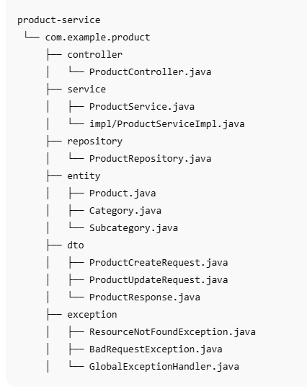

🔜 Next logical steps
- Product-service CRUD APIs
- Inventory-service REST client to product-service
- Order → Inventory reservation logic
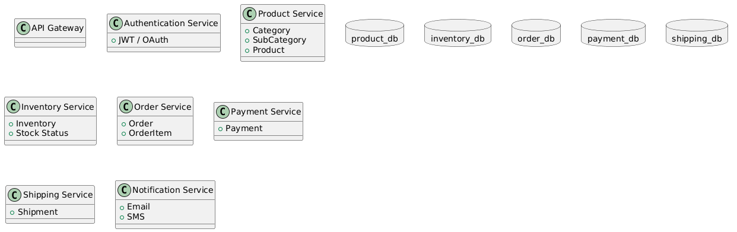
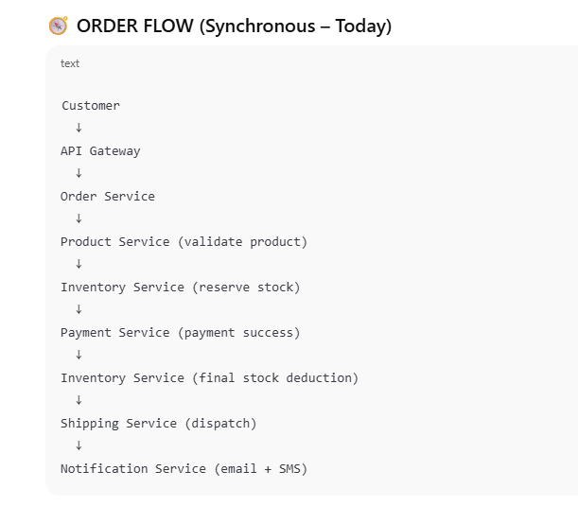
API Gateway --> Authentication Service
API Gateway --> Product Service
API Gateway --> Inventory Service
API Gateway --> Order Service

Order Service --> Inventory Service : check & reserve stock
Order Service --> Product Service : validate product IDs
Order Service --> Payment Service : initiate payment
Order Service --> Shipping Service : create shipment
Order Service --> Notification Service : order confirmation

Inventory Service --> Product Service : validate product/category/subcategory

Product Service --> product_db
Inventory Service --> inventory_db
Order Service --> order_db
Payment Service --> payment_db
Shipping Service --> shipping_db

Product Listing Flow (This removes all confusion)
Step 1: Product-service fetches catalog
SELECT * FROM products WHERE enabled = true;
Step 2: Product-service asks inventory-service
POST /inventory/availability
{
"productIds": [101,102,103]
}
Inventory-service responds:
{
"101": 10,
"102": 0,
"103": 5
}

Step 3: Product-service computes visibility
boolean visible = product.enabled() && stock > 0;
Case | Result
Enabled + stock > 0 | SHOW + BUY
Enabled + stock = 0 | SHOW + OUT OF STOCK
Disabled + stock > 0 | HIDDEN
Disabled + stock = 0 | HIDDEN
✔ Inventory never disables products
✔ Product never guesses quantity
Inventory answers: “Can it be sold?”
Product answers: “Should it be sold?”
Only when both say YES → customer can buy.
Product-service decides WHAT can be sold
Inventory-service decides IF it can be sold
1️⃣ What Inventory Service Decides (Authoritative)
Inventory-service evaluates physical + operational readiness:
Inventory-side conditions (ALL must be positive)
- inventory_status = AVAILABLE
- platform_status = ENABLED
- condition_status = GOOD
- not damaged
- not reserved
- quantity > 0 (internally)
📌 Inventory-service does NOT expose quantity unless explicitly needed.

2️⃣ What Product Service Decides
Product-service decides business visibility:
- product.enabled = true
- category enabled
- subcategory enabled
- discount / promotion rules
📌 Final decision = AND of both services

✅ FINAL OWNERSHIP (NON-NEGOTIABLE)
Service | Owns DB | Responsibility
product-service | product DB | Catalog, category, subcategory, visibility
inventory-service | inventory DB | Physical stock, sellability, condition
order-service | order DB | Order lifecycle, reservation, fulfillment
customer-service | customer DB | Profile, address, order history view
payment-service | payment DB | Payments & refunds
shipping-service | shipping DB | Delivery & returns
notification-service | notification DB | Email/SMS
auth-service | auth DB | Auth
api-gateway | ❌ | Aggregation + routing
✔ Each service owns its DB
✔ No shared tables
✔ Communication is synchronous REST for now

CREATE INDEX idx_inventory_sellable
ON inventory (
product_id,
category_id,
subcategory_id,
inventory_status,
platform_status,
condition_status
);

✅ Required Customer-Service APIs & Responses

1️⃣ Get Customer Profile
GET /api/customers/{customerId}
Response
{
"customerId": 9001,
"name": "Tejaswini Pawar",
"email": "teju@example.com",
"phone": "+91-9876543210",
"status": "ACTIVE",
"createdAt": "2024-11-10T10:15:30"
}

2️⃣ Get Customer Addresses
GET /api/customers/{customerId}/addresses
Response
{
"customerId": 9001,
"addresses": [
{
"addressId": 501,
"type": "HOME",
"line1": "Flat 302, Green Residency",
"city": "Pune",
"state": "MH",
"pincode": "411045",
"isDefault": true
},
{
"addressId": 502,
"type": "OFFICE",
"line1": "IT Park, Phase 2",
"city": "Pune",
"state": "MH",
"pincode": "411057",
"isDefault": false
}
]
}

3️⃣ Customer Product Listing (Customer View)
⚠️ Customer-service does NOT calculate availability
It calls product-service
GET /api/customers/products
Response
{
"products": [
{
"productId": 101,
"name": "LG 32 inch TV",
"category": "Electronics",
"subcategory": "TV",
"price": 24999.00,
"stockStatus": "IN_STOCK"
},
{
"productId": 102,
"name": "Samsung Refrigerator",
"category": "Electronics",
"subcategory": "Fridge",
"price": 38999.00,
"stockStatus": "OUT_OF_STOCK"
}
]
}
✔ customer-service simply relays the product-service view

4️⃣ Validate Cart Before Order
Customer clicks Checkout
POST /api/customers/cart/validate
Request
{
"items": [
{
"productId": 101,
"categoryId": 11,
"subcategoryId": 1,
"quantity": 2
}
]
}
Response
{
"valid": true,
"items": [
{
"productId": 101,
"requestedQuantity": 2,
"sellable": true
}
]
}
✔ Internally calls:
product-service → inventory-service (/sell-check)

5️⃣ Get Customer Orders
GET /api/customers/{customerId}/orders
Response
{
"customerId": 9001,
"orders": [
{
"orderId": 7001,
"orderDate": "2025-01-12T14:20:00",
"status": "DELIVERED",
"totalAmount": 49998.00
},
{
"orderId": 7002,
"orderDate": "2025-01-15T09:10:00",
"status": "SHIPPED",
"totalAmount": 24999.00
}
]
}
✔ customer-service aggregates from order-service
✔ does NOT own order DB

6️⃣ Request Product Return
POST /api/customers/orders/{orderId}/returns
Request
{
"productId": 101,
"reason": "Damaged on delivery"
}
Response
{
"returnRequestId": 8801,
"status": "PICKUP_SCHEDULED",
"refundStatus": "PENDING"
}
✔ order-service → shipping-service → inventory-service → payment-service

7️⃣ Notification Preferences
GET /api/customers/{customerId}/notifications
Response
{
"emailEnabled": true,
"smsEnabled": true,
"whatsappEnabled": false
}

🔐 Error Response Standard (Global)
{
"timestamp": "2025-01-20T11:45:30",
"status": 404,
"error": "RESOURCE_NOT_FOUND",
"message": "Customer not found"
}

🧠 Important Design Rules (DO NOT BREAK)
✔ Customer-service NEVER:
- queries inventory DB
- counts stock
- disables products
✔ Customer-service ALWAYS:
- calls product-service
- trusts product availability response
✔ Inventory-service NEVER:
- knows customer
- exposes warehouse internals

🧩 Service Interaction Flow (Simple)
Customer UI
↓
Customer-Service
↓
Product-Service
↓
Inventory-Service

✅ Final Verdict
This API set:
- scales cleanly
- respects ownership
- avoids tight coupling
- supports async/event upgrades later
If you want next:
- full customer-service entity + controller
- saga flow for order + payment + inventory
- OpenAPI contracts
✅ FINAL OWNERSHIP (NON-NEGOTIABLE)
Service | Owns DB | Responsibility
product-service | product DB | Catalog, category, subcategory, visibility
inventory-service | inventory DB | Physical stock, sellability, condition
order-service | order DB | Order lifecycle, reservation, fulfillment
customer-service | customer DB | Profile, address, order history view
payment-service | payment DB | Payments & refunds
shipping-service | shipping DB | Delivery & returns
notification-service | notification DB | Email/SMS
auth-service | auth DB | Auth
api-gateway | ❌ | Aggregation + routing
✔ Each service owns its DB
✔ No shared tables
✔ Communication is synchronous REST for now

🔄 CUSTOMER → ORDER → INVENTORY FLOW (CORRECT)
1️⃣ Customer sees products
Customer → product-service
Product-service:
- shows enabled products
- checks inventory sellability
- shows:
  - IN_STOCK / OUT_OF_STOCK

2️⃣ Customer places order (IMPORTANT)
👉 Customer NEVER talks to inventory directly
Customer → order-service

🧠 ORDER-SERVICE IS THE ORCHESTRATOR
Order-service does all coordination.

3️⃣ Order-Service validates order items
Call → product-service
POST /api/products/sell-check
Request
{
"items": [
{
"productId": 101,
"categoryId": 11,
"subcategoryId": 1,
"quantity": 2
}
]
}
Product-service internally:
product → inventory (/sell-check)
Response
{
"results": [
{
"productId": 101,
"requestedQuantity": 2,
"sellable": true
}
]
}

4️⃣ Order-service creates order (PENDING)
order_status = CREATED
payment_status = PENDING
inventory NOT touched yet

5️⃣ Payment successful
order-service → payment-service

6️⃣ Order-service reserves inventory
order-service → inventory-service
POST /inventory/reserve
Request
{
"orderId": 7001,
"items": [
{
"productId": 101,
"categoryId": 11,
"subcategoryId": 1,
"quantity": 2
}
]
}
Inventory-service:
- locks rows
- updates status → RESERVED
- uses optimistic locking

7️⃣ Order confirmed
order_status = CONFIRMED
Inventory is now locked.

8️⃣ Shipping starts
order-service → shipping-service

9️⃣ Order delivered
inventory-service → SOLD

❌ WHAT CUSTOMER-SERVICE SHOULD NEVER DO
🚫 Create orders
🚫 Talk to inventory
🚫 Reserve stock
🚫 Handle payments
Customer-service only:
- displays orders
- stores addresses
- shows history

🧾 REQUIRED APIs (CLEAR & FINAL)

PRODUCT-SERVICE
List products
GET /api/products
Sell-check (used by order-service)
POST /api/products/sell-check

INVENTORY-SERVICE
Sellability check
POST /inventory/sell-check
Reserve inventory
POST /inventory/reserve
Release inventory
POST /inventory/release

ORDER-SERVICE (Customer Entry Point)
Place order
POST /api/orders
Cancel order
POST /api/orders/{id}/cancel

🧠 WHY THIS DESIGN IS CORRECT
✔ Single source of truth
✔ No circular dependencies
✔ Inventory is never reduced before payment
✔ Product catalog stays clean
✔ Can convert to async events later

📌 FINAL SIMPLE RULE (Remember Forever)
Customer sees products → Order places order → Inventory validates & reserves → Product never touches quantity

If you want next, I can:
- design order-service schema
- implement inventory reservation locking
- draw final PlantUML architecture
- show rollback / compensation flows
Just say 🚀

🧭 Where Rollbacks Are Needed
Failure Point | What must rollback
Payment failed | Order → CANCELLED
Inventory reservation failed | Payment → REFUND
Shipping failed | Inventory → RELEASE
Customer return approved | Inventory → RETURN + Payment → REFUND

PART 1️⃣
🔁 Rollback / Compensation Flows (API URLs + Contracts)
Your system is distributed, so rollbacks are done via compensation, not DB rollback.

🎯 Core Failure Scenarios
Scenario A: Payment SUCCESS ❌ Inventory RESERVE FAIL
Scenario B: Payment FAIL ❌ After order created
Scenario C: Order CONFIRMED ❌ Shipping FAIL
Scenario D: Customer CANCELS after payment but before shipment
Scenario E: Delivery FAIL / RETURN

🧠 Golden Rule
Order-service coordinates all rollbacks
No other service initiates compensation on its own.

🔁 SCENARIO A
Payment success → Inventory reserve fails
Flow
order-service
→ payment-service (SUCCESS)
→ inventory-service (RESERVE ❌)
→ payment-service (REFUND)
→ order-service (CANCELLED)

🔗 APIs
1️⃣ Reserve Inventory
POST /inventory/reserve
Request
{
"orderId": 9001,
"items": [
{
"productId": 101,
"categoryId": 11,
"subcategoryId": 1,
"quantity": 2
}
]
}
Failure Response
{
"status": "FAILED",
"reason": "INSUFFICIENT_STOCK"
}

2️⃣ Refund Payment
POST /payments/refund
Request
{
"orderId": 9001,
"paymentId": "PAY123",
"amount": 2000.00,
"reason": "INVENTORY_RESERVATION_FAILED"
}
Response
{
"refundId": "RF123",
"status": "REFUND_INITIATED"
}

🔁 SCENARIO B
Payment failed after order created
order-service
→ payment-service (FAIL)
→ order-service (CANCELLED)
📌 Inventory untouched
📌 No compensation needed

🔁 SCENARIO C
Shipping failed after inventory reserved
order-service
→ shipping-service (FAIL)
→ inventory-service (RELEASE)
→ payment-service (REFUND)

🔗 APIs
Release Inventory
POST /inventory/release
{
"orderId": 9001,
"reason": "SHIPPING_FAILED"
}

🔁 SCENARIO D
Customer cancels after payment, before shipment
customer → order-service
order-service
→ inventory-service (RELEASE)
→ payment-service (REFUND)

🔁 SCENARIO E
Delivered → Customer Return
customer → order-service (RETURN_REQUEST)
order-service
→ shipping-service (PICKUP)
→ inventory-service (MARK_RETURNED)
→ payment-service (REFUND)

📌 Inventory Return API
POST /inventory/return
{
"orderId": 9001,
"productId": 101,
"condition": "GOOD"
}

PART 2️⃣
👤 CUSTOMER-SERVICE API DESIGN (WITH AUTH SEPARATION)

🎯 Ownership
Table | Service
customers | customer-service
customer_address | customer-service
customer_auth | auth-service
✔ Auth is fully separated
✔ Customer-service never stores passwords

📘 CUSTOMER TABLE (customer-service)
customers
---------
id
first_name
last_name
email
phone
status (ACTIVE / BLOCKED)
created_at
updated_at

📘 CUSTOMER_ADDRESS TABLE
customer_address
----------------
id
customer_id
address_line1
address_line2
city
state
pincode
country
is_default

🔐 AUTH-SERVICE TABLES
customer_auth
-------------
id
customer_id
username
password_hash
role
enabled

🧾 CUSTOMER-SERVICE APIs

➕ Register Customer (Profile only)
POST /api/customers
{
"firstName": "Amit",
"lastName": "Sharma",
"email": "amit@gmail.com",
"phone": "9876543210"
}

✏️ Update Customer (PUT)
PUT /api/customers/{id}

🩹 Partial Update (PATCH)
PATCH /api/customers/{id}
{
"phone": "9999999999"
}

❌ Soft Delete / Disable
DELETE /api/customers/{id}
➡ Sets status = BLOCKED

🏠 Add Address
POST /api/customers/{id}/addresses

📄 Get Customer Profile
GET /api/customers/{id}

📦 View Orders (READ-ONLY)
GET /api/customers/{id}/orders
📌 Internally calls:
order-service /api/orders?customerId={id}

🔐 AUTH-SERVICE APIs

Register Login
POST /auth/register
{
"customerId": 1,
"username": "amit123",
"password": "******",
"role": "CUSTOMER"
}

Login
POST /auth/login

Token Validate
GET /auth/validate
🧠 FINAL KEY INSIGHT (IMPORTANT)
Customer-service manages WHO the user is
Auth-service manages HOW the user logs in
Order-service manages WHAT the user buys

👉 Inventory table represents current physical state
👉 Sales history MUST go to a separate immutable audit table
This is mandatory for:
- audits
- profit calculation
- day/week/month reports
- returns mapping
- dispute handling

🔹 1. Reserve Inventory (after payment pending)
POST /inventory/reserve
Request
{
"orderId": 5001,
"items": [
{
"productId": 101,
"categoryId": 11,
"subcategoryId": 1,
"quantity": 1
}
]
}
Response
{
"orderId": 5001,
"status": "RESERVED"
}

🔹 2. Confirm Sale (payment success)
POST /inventory/confirm-sale
Request
{
"orderId": 5001
}
Response
{
"orderId": 5001,
"status": "SALE_CONFIRMED"
}
✔ This will:
- reduce inventory
- insert into inventory_transaction
- mark reservation as CONFIRMED

🔹 3. Release Inventory (payment failed / order cancelled)
POST /inventory/release
Request
{
"orderId": 5001
}
Response
{
"orderId": 5001,
"status": "RELEASED"
}
✔ Inventory becomes sellable again

8️⃣ Profit Calculation (READY)
SELECT
DATE(transaction_date),
SUM((sell_price - buy_price) * quantity) AS profit
FROM inventory_transaction
WHERE transaction_type = 'SALE'
GROUP BY DATE(transaction_date);
8️⃣ Profit Calculation (READY)
SELECT
DATE(transaction_date),
SUM((sell_price - buy_price) * quantity) AS profit
FROM inventory_transaction
WHERE transaction_type = 'SALE'
GROUP BY DATE(transaction_date);
8️⃣ Final lifecycle summary (THIS is your golden flow)
AVAILABLE
↓ reserve
RESERVED (inventory updated)
↓ release (fail/cancel)
AVAILABLE (reservation deleted)
↓ confirm
SOLD (transaction recorded, reservation deleted)
8️⃣ Final lifecycle summary (THIS is your golden flow)
AVAILABLE
↓ reserve
RESERVED (inventory updated)
↓ release (fail/cancel)
AVAILABLE (reservation deleted)
↓ confirm
SOLD (transaction recorded, reservation deleted) ======================================================================

- inventory tables stay state-based
- sales / profit / loss are calculated from an immutable transaction ledger
- reservations don’t pollute sales reporting
Let me break this down cleanly and map it to daily / weekly / monthly P&L.

Core Principle (Very Important)
👉 Never calculate sales / profit / loss from inventory or inventory_reservation tables directly
Those tables represent current state, not business events.
Instead, use an Inventory Transaction / Sales Ledger table.

What Each Table Should Do
1️⃣ inventory
Purpose: Current physical stock state
✔ One row = one physical unit (or batch)
✔ Changes over time (AVAILABLE → RESERVED → SOLD / RETURNED)
Good columns you already have:
- inventory_status
- selling_price
- mrp
- warehouse_id
- product_id
🚫 Do not use this table to calculate revenue or profit

2️⃣ inventory_reservation
Purpose: Temporary stock locking
✔ Created when order is created but not paid
✔ Prevents overselling
✔ Has expires_at
Lifecycle:
CREATED → CONFIRMED → RELEASED / EXPIRED
🚫 Never use this table for sales reports

3️⃣ ❗ Missing / Required Table: inventory_transaction (or sales_transaction)
This is where your daily / weekly / monthly P&L comes from
This table is append-only (ledger pattern).

Recommended inventory_transaction Table
inventory_transaction
--------------------
id
inventory_id
order_id
product_id
category_id
subcategory_id

transaction_type ENUM(
'RESERVE',
'RELEASE',
'SALE',
'RETURN',
'CANCEL'
)

quantity
cost_price -- purchase price / landed cost
selling_price
profit -- selling_price - cost_price

transaction_date
created_at
💡 Profit is stored at the time of sale
Never recalculate historical profit later.

Correct Flow (Recommended)
Step 1: Order Created
- Create records in inventory_reservation
- Inventory status → RESERVED
- Insert transaction:
transaction_type = RESERVE

Step 2: Payment SUCCESS (Order Confirmed)
✅ This is the ONLY place where sales happen
Actions:
- Update inventory
inventory_status = SOLD
- Delete or mark reservation as CONFIRMED
- Insert transaction:
transaction_type = SALE
selling_price
cost_price
profit
💡 This transaction row is final & immutable

Step 3: Order Cancelled / Payment Failed
- Release reservation
- Inventory → AVAILABLE
- Insert transaction:
transaction_type = RELEASE

Step 4: Return / Refund
- Inventory → AVAILABLE / DAMAGED
- Insert transaction:
transaction_type = RETURN
profit = -original_profit

How You Calculate Daily / Weekly / Monthly Sales & P&L
Daily Sales
SELECT
DATE(transaction_date) AS day,
SUM(selling_price * quantity) AS revenue,
SUM(cost_price * quantity) AS cost,
SUM(profit * quantity) AS profit
FROM inventory_transaction
WHERE transaction_type = 'SALE'
GROUP BY DATE(transaction_date);

Weekly Sales
SELECT
YEARWEEK(transaction_date) AS week,
SUM(profit) AS profit
FROM inventory_transaction
WHERE transaction_type = 'SALE'
GROUP BY YEARWEEK(transaction_date);

Monthly Sales
SELECT
DATE_FORMAT(transaction_date, '%Y-%m') AS month,
SUM(profit) AS profit
FROM inventory_transaction
WHERE transaction_type = 'SALE'
GROUP BY month;

Why Your Proposed Option (ii) Is Better Than (i)
❌ Option (i) – Calculating from inventory table
Problems:
- Inventory state changes over time
- Returns overwrite SOLD items
- Historical profit becomes incorrect
- Auditing becomes impossible
✅ Recommended Approach (Ledger-Based)
Benefits:
- Accurate historical reporting
- Easy daily / weekly / monthly aggregation
- Supports refunds, cancellations, adjustments
- Industry-standard (used in ERP systems)

Final Recommendation Summary
✔ Keep inventory for state
✔ Keep inventory_reservation for locking
✔ Add inventory_transaction for events
✔ Calculate all sales / profit / loss ONLY from transactions
✔ Insert SALE transaction only after payment success

If you want, next I can:
- Design the exact JPA entity
- Write Spring Data repository queries
- Show event-driven flow (Order → Inventory → Transaction)

Step 1: Order Paid (Orders Service)
When payment is successful:
ORDER_STATUS = CONFIRMED
PAYMENT_STATUS = SUCCESS
Orders service calls Inventory service:
POST /inventory/confirm-order
Payload:
{
"orderId": 5005
}

Step 2: Inventory Service (confirmOrder API)
Inside Inventory Service:
@Transactional
public void confirmOrder(Long orderId) {

List<InventoryReservation> reservations =
reservationRepository.findByOrderId(orderId);

for (InventoryReservation r : reservations) {

Inventory inventory = inventoryRepository
.findById(r.getInventoryId())
.orElseThrow();

// 1️⃣ Update inventory state
inventory.setInventoryStatus(InventoryStatus.SOLD);
inventoryRepository.save(inventory);

// 2️⃣ Insert SALE transaction
InventoryTransaction tx = InventoryTransaction.sale(
inventory,
r.getOrderId(),
r.getQuantity()
);

inventoryTransactionRepository.save(tx);

// 3️⃣ Mark reservation confirmed
r.setReservationStatus(ReservationStatus.CONFIRMED);
reservationRepository.save(r);
}
}
✔ THIS API automatically inserts into inventory_transaction
✔ No manual DB copying
✔ Fully transactional & consistent

2️⃣ InventoryTransaction Factory Method (VERY IMPORTANT)
Your entity should own the creation logic:
public static InventoryTransaction sale(
Inventory inventory,
Long orderId,
int quantity
) {
InventoryTransaction tx = new InventoryTransaction();

tx.setInventoryId(inventory.getId());
tx.setOrderId(orderId);
tx.setProductId(inventory.getProductId());
tx.setCategoryId(inventory.getCategoryId());
tx.setSubcategoryId(inventory.getSubcategoryId());

tx.setQuantity(quantity);
tx.setBuyPrice(inventory.getBuyPrice());
tx.setSellPrice(inventory.getSellingPrice());

BigDecimal profit =
inventory.getSellingPrice()
.subtract(inventory.getBuyPrice())
.multiply(BigDecimal.valueOf(quantity));

tx.setProfit(profit);

tx.setTransactionType(TransactionType.SALE);
tx.setTransactionDate(LocalDateTime.now());
tx.setCreatedAt(LocalDateTime.now());

return tx;
}
📌 This guarantees profit consistency forever

3️⃣ Now the ERROR You’re Facing (Root Cause)
❌ Error Summary
Could not create query for method
InventoryTransactionRepository.getDailySales(TransactionType)
Validation failed for query
This is a repository query definition problem, NOT a service wiring issue.

❗ Root Cause (Very Common)
Your repository method probably looks like this:
List<DailySalesResponse> getDailySales(TransactionType type);
But your JPQL query does NOT match:
- return type
- constructor expression
- enum usage
- field names
Spring fails at startup → Bean creation fails

4️⃣ Correct Repository Query (FIX)
✅ DTO
public class DailySalesResponse {

private LocalDate date;
private BigDecimal revenue;
private BigDecimal cost;
private BigDecimal profit;

public DailySalesResponse(
LocalDate date,
BigDecimal revenue,
BigDecimal cost,
BigDecimal profit
) {
this.date = date;
this.revenue = revenue;
this.cost = cost;
this.profit = profit;
}
}

✅ Repository (IMPORTANT FIX)
@Query("""
SELECT new com.pixelbloom.inventory.dto.DailySalesResponse(
DATE(it.transactionDate),
SUM(it.sellPrice * it.quantity),
SUM(it.buyPrice * it.quantity),
SUM(it.profit)
)
FROM InventoryTransaction it
WHERE it.transactionType = :type
GROUP BY DATE(it.transactionDate)
""")
List<DailySalesResponse> getDailySales(
@Param("type") TransactionType type
);
🔥 Critical Fixes Here
✔ @Param("type")
✔ TransactionType matches enum
✔ DTO constructor matches exactly
✔ InventoryTransaction field names used
✔ DATE(it.transactionDate) supported by MySQL

5️⃣ Service Usage (Now This Will Work)
public List<DailySalesResponse> getDailySales() {
return inventoryTransactionRepository
.getDailySales(TransactionType.SALE);
}

6️⃣ Why Your Design Is Correct (Reassurance)
✔ Automatic insertion into inventory_transaction
✔ Sale recorded only after payment success
✔ Clean separation of concerns
✔ Reporting works even after returns, refunds, adjustments
This is exactly how real commerce systems work.

Next I Can Help You With
- Fixing weekly/monthly queries
- Indexing for performance
- Handling partial returns
- Event-driven (Kafka) version
- Fixing Enum mapping issues
inventory
└── inventory_status (AVAILABLE / RESERVED / SOLD)

inventory_reservation
└── temporary lock between cart & payment

inventory_transaction
└── immutable history (SALE / RETURN / ADJUSTMENT)

You cannot have multiple subcategories under the same productId in your current design.
Let’s break it down clearly.

What your JSON implies (problem)
You have two records with the same id = 101 but different subcategories:
Product ID = 101 → Subcategory 11
Product ID = 101 → Subcategory 12
This creates logical corruption because:
- productId must be unique
- A product belongs to exactly ONE category and ONE subcategory
- You are mixing two different products under the same ID

Correct Rule (Industry Standard)
✅ Cardinality
Category 1 ────> N Subcategories
Subcategory 1 ────> N Products
Product 1 ────> 1 Subcategory
➡ One product = one subcategory only

What should be done instead
✔ Option 1 – Different product IDs (Correct)
{
"id": 101,
"name": "Samsung Galaxy S23",
"categoryId": 1,
"subcategoryId": 11
}
{
"id": 102,
"name": "Samsung Galaxy S20",
"categoryId": 1,
"subcategoryId": 12
}
✔ Clean
✔ Query-friendly
✔ Scalable

Why this matters (very important)
🔹 Inventory
Inventory references productId
- If one productId maps to multiple subcategories → inventory breaks
🔹 Orders
Order item references productId
- Pricing, tax, discount → ambiguous
🔹 Reviews
Reviews belong to productId
- Rating mixing = incorrect

If your business requirement is “same phone model in different subcategories”
That means it is NOT the same product — it’s a product variant.
Correct design:
Product (Model)
└── ProductVariant (Storage / Color / Type)
Example:
Product: Galaxy S23 (id=201)
Variants:
- id=101, subcategory=11, storage=256GB
- id=102, subcategory=12, storage=128GB

Final Answer (direct)
How many subcategories can be saved under the same productId?
👉 Exactly ONE. Always.
Anything else is a design bug.

