Rezerv
Payment Gateway API (2C2P)
Technical documentation: overview, API reference, payment flows and unit tests
Item | Value
Product | Rezerv.API (ASP.NET Core, .NET 10)
Payment provider | 2C2P PGW v4.3 (sandbox)
Document version | 1.2 (adds payment retry; 1.1 added saved-card removal)
Date | 13 October 2026

Contents

Right-click the table and choose Update Field if page numbers are missing.

1. Overview
Rezerv is an ASP.NET Core Web API that lets a customer pay for a product by credit card through the 2C2P payment gateway. It supports one-time and recurring products, new cards entered on the 2C2P hosted page, and cards saved from earlier payments. It also handles refunds and voids from a back-office page.
The most important property of the system is exactly-once checkout: a double-click, a page refresh or a retry on a slow network never creates two charges for the same purchase.

1.1 Key features
- Hosted page (Redirect API) for new payment methods. Recurring products show card only, with the save-card option.
- Saved card (Direct API): Payment Token, then Do Payment, then Payment Inquiry. No hosted page unless 3DS is needed.
- Backend notification handler that verifies the HS256 JWT signature, checks amount and currency, and is idempotent.
- Idempotency and locking: Idempotency-Key header, Redis distributed lock, MySQL unique index as the final guard.
- Refunds and voids through the 2C2P Payment Action API, with an atomic reservation so refunds never exceed the payment.
- Retry a failed payment as a new, linked payment: idempotent, and at most one retry per failed payment, so it can never charge twice.
- Remove saved card from both the 2C2P vault (Store Card Maintenance) and MySQL.
- Caching of customers, products and saved cards in Redis, with MySQL as the source of truth.
- Observability with Serilog: structured console, rolling JSON files and Seq.

1.2 Technology stack
Concern | Technology
Runtime / framework | ASP.NET Core Web API, .NET 10, C#
Architecture | Clean Architecture (API, Application, Domain, Infrastructure) with the Repository pattern
Database | MySQL 8.4 via Entity Framework Core (MySql.EntityFrameworkCore)
Cache and locks | Redis 7.4 via StackExchange.Redis
Payment gateway | 2C2P PGW v4.3: Payment Token, Do Payment, Payment Inquiry, Payment Action (refund/void, store card maintenance)
API documentation | Swagger / Swashbuckle (XML comments)
Logging | Serilog (console, file, Seq)
Tests | xUnit, Moq
Containers | Docker Compose: mysql, redis, seq, api

1.3 Architecture
The solution follows Clean Architecture. Dependencies point inward: the Application layer defines interfaces (IPaymentGateway, ICacheService, repositories) and the Infrastructure layer implements them, so the use cases can be unit tested without MySQL, Redis or 2C2P.
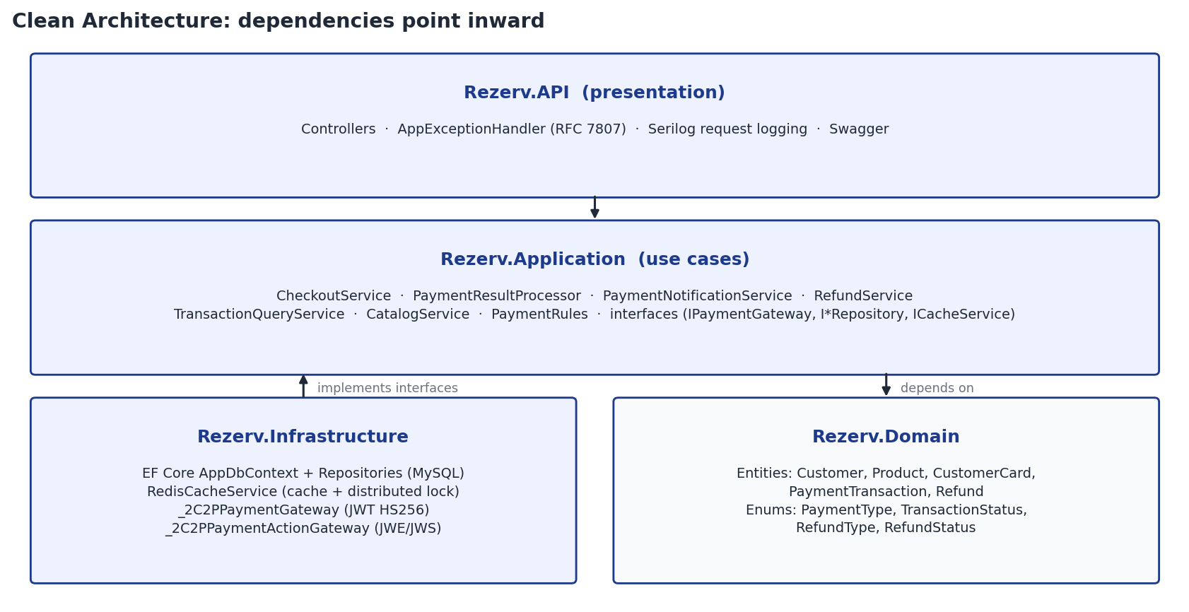
Figure 1. Solution layers and dependencies
Project | Responsibility
Rezerv.API | Controllers, exception-to-ProblemDetails mapping, Swagger, Serilog request logging, startup and seeding.
Rezerv.Application | Use-case services (checkout, notification, inquiry reconciliation, refunds, card removal, queries), payment rules, DTOs, interfaces.
Rezerv.Domain | Entities and enums: Customer, Product, CustomerCard, PaymentTransaction, Refund.
Rezerv.Infrastructure | EF Core DbContext and repositories, Redis cache and lock, 2C2P gateways (JWT HS256, JWE/JWS), seed data.
Rezerv.Test | xUnit tests for all layers with in-memory test doubles.

1.4 Payment rules
Every Payment Token request carries invoiceNo, amount, currencyCode: "SGD", frontendReturnUrl and backendReturnUrl. The rest depends on the scenario (PaymentRules.cs):
Scenario | Payment Token parameters | What the customer sees
OneTime, new payment method | No paymentChannel restriction | 2C2P hosted page with every method enabled for the merchant
Recurring, new payment method | paymentChannel ["CC"], tokenize: true | Hosted page, card only, with the save-card option
Saved card (any product) | paymentChannel ["CC"], customerToken [token], customerTokenOnly: true, request3DS: "N"; then Do Payment and Payment Inquiry | No hosted page. respCode 1001 sends the browser to the 3DS URL; otherwise straight to the result page

1.5 Seed data
On first start DbInitializer creates the schema and seeds test data:
Type | Records
Customers | Alice Tan, Bob Lim, Chloe Ng
Products | Single Session Pass (OneTime, 25.00 SGD)  Event Ticket (OneTime, 120.00 SGD)  Monthly Membership (Recurring, 49.90 SGD)  Annual Membership (Recurring, 499.00 SGD)
Saved cards | None. Cards are created only by 2C2P: pay once for a Recurring product with a new card and tick save-card; the customerToken from the backend notification is saved to customer_card.

Placeholder card tokens are no longer seeded, because 2C2P rejects them for Do Payment and for card removal. Every saved card therefore holds a real 2C2P token that can be charged and removed.

1.6 Running the system
Everything runs together with Docker Compose:
docker compose up -d --build
Service | Address | Purpose
api | http://localhost:5080/swagger | Rezerv API and Swagger UI
seq | http://localhost:5341 | Log viewer for Serilog events
mysql | localhost:3308 | Database (user rezerv / rezerv)
redis | localhost:6380 | Cache and distributed locks

For development, run only the infrastructure in Docker (docker compose up -d mysql redis seq) and the API from source with dotnet run --project src/Rezerv.API (http://localhost:5222).
2C2P must reach backendReturnUrl from the internet, so point it at a tunnel (for example ngrok or Dev Tunnels) with the TWOC2P_BACKEND_RETURN_URL variable.

1.7 Configuration
Setting | Meaning
ConnectionStrings:DefaultConnection | MySQL connection string
ConnectionStrings:RedisConnection | Redis endpoint
_2C2P:MerchantId, SecretKey | Merchant credentials; SecretKey signs and verifies the HS256 JWTs
_2C2P:FrontendReturnUrl | Where 2C2P sends the browser after payment ({invoiceNo} is replaced)
_2C2P:BackendReturnUrl | Public URL of POST /api/payments/2c2p/notification
_2C2P:PaymentAction:* | Payment Action endpoint and keys for refunds and card removal; Simulate: true uses a simulator in Development
_2C2P:PaymentAction:MaintenanceVersion | Store Card Maintenance request version (default 2.3)
Checkout:LockTtl | Redis lock lifetime per Idempotency-Key (default 2 minutes)
Checkout:WaitTimeout / WaitPollInterval | How long a concurrent request waits for the first one (10 s, polling every 200 ms) before 409
Checkout:ResponseTtl | How long the checkout response is cached in Redis for replays (1 day)
Checkout:InquiryThrottle | Minimum time between Payment Inquiry calls per invoice while polling (5 s)
Checkout:CatalogCacheTtl | Redis cache lifetime for customers, products and cards (10 minutes)

1.8 Observability
Serilog replaces the default logger. All existing ILogger<T> calls use message templates (for example {InvoiceNo}, {RespCode}), so every log line becomes a structured, searchable event.
- Console: readable one-line output.
- File: compact JSON in logs/rezerv-YYYYMMDD.json, rolled daily, 14 days kept.
- Seq: http://localhost:5341. Every request event carries IdempotencyKey, InvoiceNo, ClientIp and the trace id.
Useful Seq queries: InvoiceNo = 'INV...' (one payment end to end), IdempotencyKey = '...' (proves a double-click created one transaction), @Level = 'Fatal' or @Level = 'Critical' (results that need manual review).

2. API reference
Base URL: http://localhost:5080 (Docker) or http://localhost:5222 (dotnet run). All bodies are JSON and enums are serialized as strings (Pending, Succeeded, Failed, OneTime, Recurring). Swagger UI at /swagger documents the same endpoints interactively.

2.1 Summary
Method | Route | Purpose
GET | /api/customers | List seeded customers
GET | /api/customers/{id}/cards | Saved cards for a customer (masked)
DELETE | /api/customers/{id}/cards/{cardId} | Remove a saved card at 2C2P and in MySQL
GET | /api/products | List active products
POST | /api/checkout | Start a payment (hosted page or saved card)
POST | /api/payments/2c2p/notification | 2C2P backend notification (backendReturnUrl)
GET | /api/transactions/{invoiceNo} | Transaction status and details for the result page
POST | /api/transactions/{invoiceNo}/retry | Retry a failed payment as a new linked payment
GET | /api/transactions/{customerId} | A customer's transactions, newest first (refund page)
POST | /api/transactions/{invoiceNo}/refunds | Refund or void a succeeded payment
GET | /api/transactions/{invoiceNo}/refunds | Refunds of a transaction

2.2 Errors
Errors use RFC 7807 Problem Details. AppExceptionHandler maps application exceptions to status codes; the detail field carries the message for application errors only, so unexpected exceptions never leak internals.
Exception | Status | Title
ValidationException | 400 | Invalid request
InvalidSignatureException | 400 | Invalid signature
NotFoundException | 404 | Not found
ConflictException | 409 (+ Retry-After: 1) | Conflict
IdempotencyKeyMismatchException | 422 | Idempotency-Key reused
PaymentGatewayException | 502 | Payment gateway error
NotConfiguredException | 503 | Not configured
Any other exception | 500 | Unexpected error

{
"type": "https://tools.ietf.org/html/rfc9110#section-15.5.10",
"title": "Conflict",
"status": 409,
"detail": "A checkout with this Idempotency-Key is still in progress. Retry shortly."
}

2.3 List customers
Method | Route
GET | /api/customers

Returns the seeded customers. Served from Redis when cached, otherwise from MySQL (and the cache is filled).
Status | When
200 | List of CustomerDto

[
{ "id": 1, "firstName": "Alice", "lastName": "Tan", "email": "alice.tan@example.com" }
]

2.4 List a customer's saved cards
Method | Route
GET | /api/customers/{id}/cards

Returns masked saved cards for the checkout dropdown. The 2C2P customerToken is never returned.
Parameter | In | Description
id | route | Customer id (integer)

Status | When
200 | List of CustomerCardDto
404 | Customer not found

[
{ "id": 1, "maskedCardNo": "411111XXXXXX1111", "paymentChannel": "CC",
"createdAt": "2026-10-12T08:00:00Z", "lastUsedAt": null }
]

2.5 Remove a saved card
Method | Route
DELETE | /api/customers/{id}/cards/{cardId}

Removes a saved card everywhere it is stored. The token is deleted from the 2C2P vault first (Store Card Maintenance API, action D, sent over the signed and encrypted Payment Action channel); only after 2C2P confirms with respCode 00 is the row deleted from MySQL and the customer's cached card list dropped from Redis. Past transactions keep their own masked card number, so receipts and the refund page are unaffected. A card that is still in use by a Pending payment (for example waiting for 3DS) cannot be removed.
Parameter | In | Description
id | route | Customer id (integer)
cardId | route | Saved card id from GET /api/customers/{id}/cards

Status | When
204 | Card removed at 2C2P and in MySQL
404 | Unknown customer, card of another customer, or card already removed
409 | The card is already being removed (Redis lock held), or a payment with it is still Pending
502 | 2C2P could not be reached or did not confirm the removal; the card was kept and the request can be retried
503 | Payment Action keys not configured

DELETE /api/customers/1/cards/2

HTTP/1.1 204 No Content

2.6 List products
Method | Route
GET | /api/products

Returns active products with price, currency and payment type (OneTime or Recurring).
Status | When
200 | List of ProductDto

[
{ "id": 3, "name": "Monthly Membership", "description": "Recurring monthly plan",
"price": 49.90, "currency": "SGD", "paymentType": "Recurring" }
]

2.7 Checkout
Method | Route
POST | /api/checkout

Creates a Pending transaction and starts the payment. Without customerCardId the response redirects to the 2C2P hosted page. With customerCardId the saved card is charged directly; redirectUrl is the 3DS page when 2C2P asks for it (respCode 1001), otherwise null and the status is already final.
Parameter | In | Description
Idempotency-Key | header | Required. A UUID generated when the checkout page loads. The same key returns the original response.
customerId | body | Customer id
productId | body | Product id (must be active and priced in SGD)
customerCardId | body | Optional saved card id; must belong to the customer

Status | When
200 | CheckoutResponse { invoiceNo, status, redirectUrl }. Also returned when the payment itself failed (status Failed).
400 | Missing or non-UUID Idempotency-Key; product not in SGD
404 | Unknown customer, product, or card not owned by the customer
409 | Another request with the same key is still in progress after the wait timeout
422 | The key was already used with a different body

Request
POST /api/checkout
Idempotency-Key: 3f6c1a52-8a0e-4b8e-9d1f-1d2b7c9e4a10
Content-Type: application/json

{ "customerId": 1, "productId": 3, "customerCardId": null }
Response
{
"invoiceNo": "INV20261012080000123A1B2C3D4E5",
"status": "Pending",
"redirectUrl": "https://sandbox-pgw-ui.2c2p.com/payment/4.3/#/token/..."
}

2.8 2C2P backend notification
Method | Route
POST | /api/payments/2c2p/notification

Webhook configured as backendReturnUrl. 2C2P posts a signed JWT with the payment result. The handler verifies the HS256 signature with the merchant secret key, checks merchant, amount and currency, sets the final status with a conditional update (WHERE status = 'Pending') and saves any customerToken as a new card. It returns 200 for every verified notification, including duplicates, unknown invoices and mismatches, because a retry from 2C2P would not change the outcome.
Parameter | In | Description
payload | body | JWT signed by 2C2P (HS256)

Status | When
200 | Notification verified (applied, already final, unknown invoice or mismatch)
400 | Missing payload or invalid signature

POST /api/payments/2c2p/notification
Content-Type: application/json

{ "payload": "eyJhbGciOiJIUzI1NiIsInR5cCI6IkpXVCJ9..." }

2.9 Get transaction
Method | Route
GET | /api/transactions/{invoiceNo}

Used by the result page. The result is always read from the database, never from the redirect query string. While the transaction is Pending, the API asks 2C2P with Payment Inquiry (at most once every InquiryThrottle per invoice): a saved-card payment without a redirect applies Succeeded or Failed, while a hosted-page or 3DS payment applies only Succeeded, because the customer may still be paying.
Parameter | In | Description
invoiceNo | route | Invoice number returned by checkout

Status | When
200 | TransactionDto
404 | Unknown invoice

{
"invoiceNo": "INV20261012080000123A1B2C3D4E5",
"status": "Succeeded",
"customerId": 1, "productId": 3, "productName": "Monthly Membership",
"amount": 49.90, "currency": "SGD",
"paymentChannel": "CC", "maskedCardNo": "411111XXXXXX1111",
"providerRef": "6587351", "respCode": "0000", "respDesc": "Success",
"createdAt": "2026-10-12T08:00:00Z", "paidAt": "2026-10-12T08:01:10Z",
"refundedAmount": 0.00, "refundableAmount": 49.90,
"retryOfInvoiceNo": null, "retryInvoiceNo": null, "canRetry": false
}
Status | Result page shows
Succeeded | "Payment succeeded", product name, amount, invoice number, payment method and masked card
Failed | respDesc; a Try again button when canRetry is true (POST /retry, section 2.10), or a link to retryInvoiceNo when it was already retried; and a Go back button to checkout with the same customer and product preselected
Pending | "Processing payment" and polls this endpoint every few seconds

2.10 Retry a failed payment
Method | Route
POST | /api/transactions/{invoiceNo}/retry

Retries a Failed payment. 2C2P never accepts an invoiceNo twice, so the retry is a new checkout for the same customer and product with a new invoiceNo, linked to the failed transaction through transaction.retry_of_transaction_id. The failed transaction is never changed. The answer and the rest of the flow (hosted page, saved card, 3DS, notification, result page) are exactly those of POST /api/checkout. The amount is the product's current price.
Parameter | In | Description
Idempotency-Key | header | Required UUID, new per retry attempt (e.g. generated when the result page loads). Same key returns the same retry and 2C2P is not called again.
invoiceNo | route | The failed transaction
customerCardId | body (optional) | Saved card to pay with (Do Payment). Omit, or send no body, to use the 2C2P hosted page.

Status | When
200 | CheckoutResponse of the new payment: invoiceNo, status, redirectUrl (also when replayed)
400 | Missing or invalid Idempotency-Key, or the transaction is not Failed
404 | Unknown transaction, product no longer sold, or the card does not belong to the customer
409 | Already retried (the message names the retry's invoiceNo), or this retry is still in progress
422 | The Idempotency-Key was already used for a different request

POST /api/transactions/INV20261012080000123A1B2C3D4E5/retry
Idempotency-Key: 4f1c2b9e-8d7a-4e3b-9c6d-1a2b3c4d5e6f
Content-Type: application/json

{ "customerCardId": null }
{
"invoiceNo": "INV20261012170739978845452738",
"status": "Pending",
"redirectUrl": "https://sandbox-pgw-ui.2c2p.com/payment/4.3/#/token/..."
}
One retry per failed payment. The unique index uq_txn_retry_of allows a single retry for each failed transaction, so two retries with different keys (two tabs, two devices) can never both charge the customer: the second gets 409. If the retry fails too, retry that one; the attempts form a chain (retryOfInvoiceNo / retryInvoiceNo in the transaction details).

2.11 List a customer's transactions
Method | Route
GET | /api/transactions/{customerId}

Transactions of a customer, newest first, for the refund page. Read from MySQL only. refundableAmount > 0 marks the transactions that can be refunded. The route only matches integers, so it never clashes with invoice lookups (invoice numbers start with INV).
Parameter | In | Description
customerId | route | Customer id (integer)

Status | When
200 | List of TransactionDto
404 | Customer not found

2.12 Refund or void a payment
Method | Route
POST | /api/transactions/{invoiceNo}/refunds

Back-office operation. Only Succeeded transactions can be refunded. The API checks the payment at 2C2P first: an authorized (unsettled) payment is voided for the full amount; a settled payment is refunded fully or partially. Omit amount to refund everything not refunded yet. The amount is reserved atomically, so concurrent refunds never exceed the payment. Protect this endpoint with authentication before exposing it.
Parameter | In | Description
Idempotency-Key | header | Required UUID; the same key returns the original refund
invoiceNo | route | Invoice of the succeeded payment
amount | body | Optional; positive, at most 2 decimals, not above the refundable amount
reason | body | Optional free text (max 255)

Status | When
200 | RefundDto (Pending, Succeeded or Failed)
400 | Not succeeded, already fully refunded, amount invalid or too high, partial void, already voided
404 | Unknown invoice
409 | Same key still in progress
422 | Same key with a different amount
502 | 2C2P could not be reached before anything was written (safe to retry)
503 | Payment Action keys not configured

Request
POST /api/transactions/INV20261012080000123A1B2C3D4E5/refunds
Idempotency-Key: 9b2f0c7e-1d4a-4f7b-8c3e-5a6d7e8f9012
Content-Type: application/json

{ "amount": 10.00, "reason": "Customer request" }
Response
{
"id": 1, "invoiceNo": "INV20261012080000123A1B2C3D4E5",
"type": "Refund", "status": "Pending", "amount": 10.00, "currency": "SGD",
"reason": "Customer request", "providerStatus": null, "providerRef": null,
"respCode": null, "respDesc": null,
"createdAt": "2026-10-12T09:00:00Z", "completedAt": null
}

2.13 List refunds
Method | Route
GET | /api/transactions/{invoiceNo}/refunds

Refunds of the transaction, oldest first. Pending refunds are checked with 2C2P (throttled per invoice); poll until they are final.
Parameter | In | Description
invoiceNo | route | Invoice number

Status | When
200 | List of RefundDto
404 | Unknown invoice

3. Payment flows

3.1 Hosted page flow
Payments with a new payment method, for both OneTime and Recurring products, go through the 2C2P hosted page and are confirmed by the backend notification.
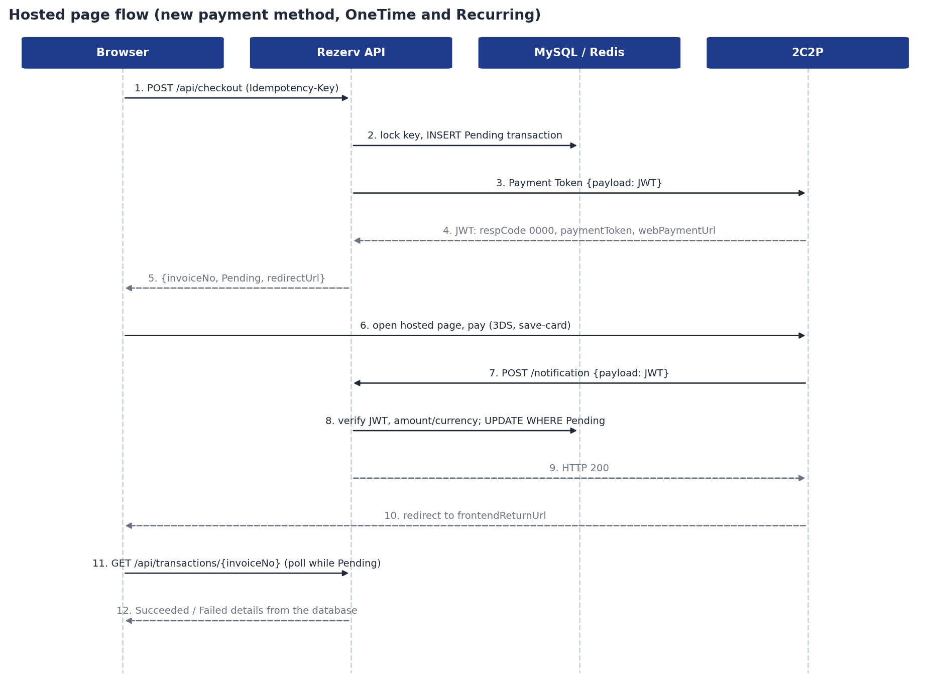
Figure 2. Hosted page flow
- The client calls POST /api/checkout with an Idempotency-Key. The API takes the Redis lock and inserts a Pending transaction with a new invoiceNo.
- The API signs a JWT (merchantID, invoiceNo, description, amount, currencyCode, return URLs and the scenario parameters) and posts { "payload": "<JWT>" } to the Payment Token API.
- The response JWT is verified and decoded. On respCode 0000 the paymentToken is stored and webPaymentUrl is returned as redirectUrl; otherwise the transaction is marked Failed with respCode and respDesc.
- The browser opens the hosted page and the customer pays; 3DS is handled there. For Recurring products the customer can tick save-card.
- 2C2P posts the backend notification. The API verifies it, sets the final status and saves any customerToken.
- 2C2P sends the browser to frontendReturnUrl. The result page reads GET /api/transactions/{invoiceNo} and polls while the status is Pending.

3.2 Saved-card flow
Saved-card payments skip the hosted page and are confirmed with Payment Inquiry.
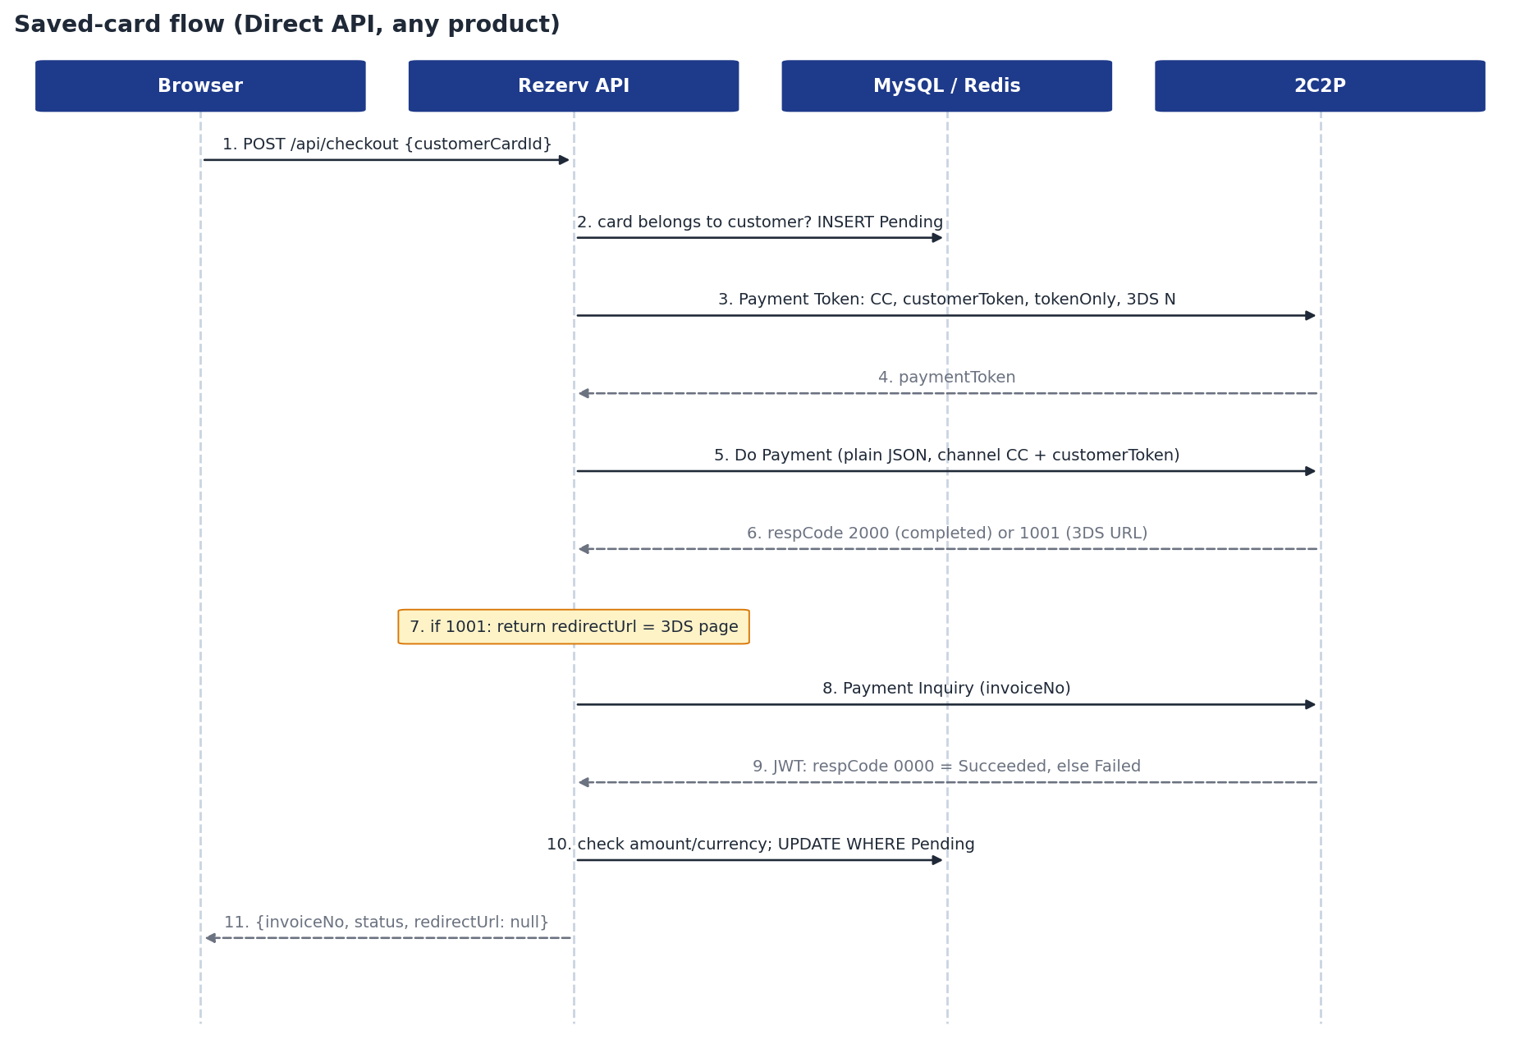
Figure 3. Saved-card flow
- Check that customerCardId belongs to the customer, then insert the Pending transaction.
- Request a Payment Token with paymentChannel ["CC"], customerToken [token], customerTokenOnly: true and request3DS: "N".
- Call Do Payment (plain JSON, not a JWT) with the paymentToken, channel code CC and the customerToken.
- On respCode 1001, return the 3DS URL as redirectUrl; the result is confirmed when the customer returns.
- On respCode 2000 (transaction completed), call Payment Inquiry. 2000 alone does not mean success: the transaction becomes Succeeded only on inquiry respCode 0000, otherwise Failed.
- The inquiry result is treated like a notification: JWT verified, amount and currency checked, update only WHERE status = 'Pending'.
- If Do Payment gets no answer (timeout), the transaction stays Pending and is reconciled later by the result page instead of being marked Failed, so a charge that did happen is never lost.

3.3 Backend notification handling
- Verify the JWT signature with the merchant secret key (HMAC SHA-256); reject alg: none, tampered or foreign-merchant tokens.
- Find the transaction by invoiceNo and check that amount and currencyCode match what was stored; a mismatch is logged and ignored.
- On respCode 0000, set Succeeded and save channelCode, accountNo (masked card), tranRef and paid_at.
- If a customerToken is present, save it to customer_card unless it already exists (unique index on customer_id + token).
- On any other respCode, set Failed and save respCode and respDesc.
- Idempotent: a duplicate notification changes nothing. A final status is never overwritten; a conflicting result is logged as Critical for manual review.
- Return HTTP 200 quickly.

3.4 Idempotency and locking
A double-click, a refresh or a retry must never create two charges. The checkout uses three layers of protection:
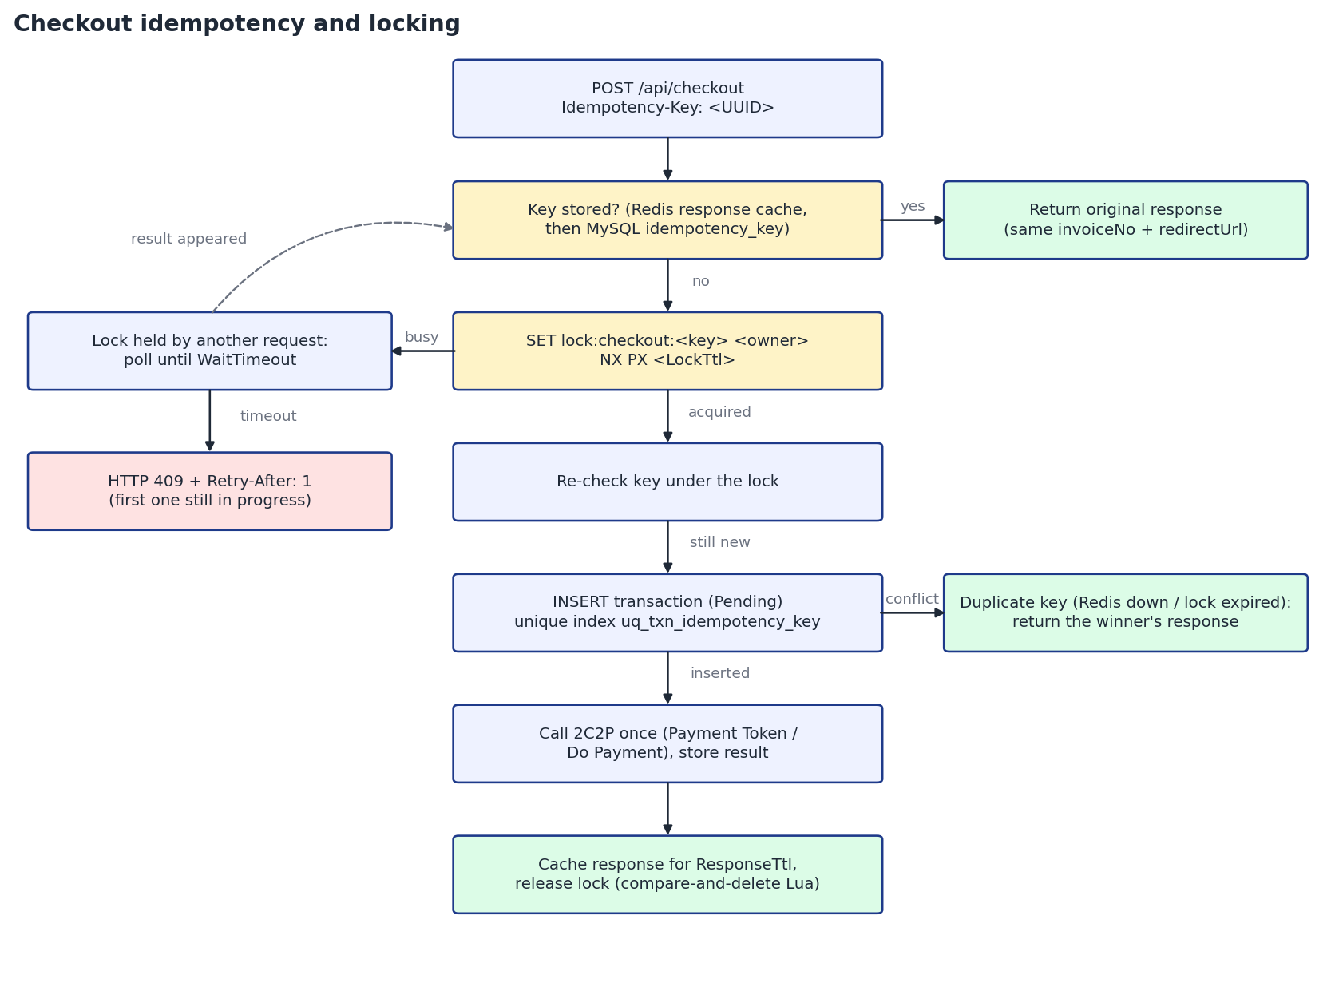
Figure 4. Checkout idempotency decision flow
Layer | Mechanism | Protects against
Response replay | The response is cached in Redis per key (ResponseTtl) and can be rebuilt from MySQL | Retries and refreshes after the first request finished
Distributed lock | SET lock:checkout:<key> <owner> NX PX <LockTtl>, released by its owner with a compare-and-delete Lua script | Concurrent requests on one or many API instances
Unique index | uq_txn_idempotency_key on transaction.idempotency_key | Redis down or lock expired: the second INSERT fails and the winner's result is returned

- Same key, same body: the original invoiceNo and redirectUrl are returned and 2C2P is not called again.
- Same key, different body: HTTP 422.
- Concurrent requests with the same key: exactly one creates the transaction and calls 2C2P; the others wait up to WaitTimeout for its result, then get HTTP 409 with Retry-After.
- A transaction left Pending by a crashed instance (older than LockTtl) is replayed as-is and reconciled by Payment Inquiry, never charged again.
- The notification handler is safe under concurrency through the conditional update WHERE status = 'Pending'.

3.5 Refund flow
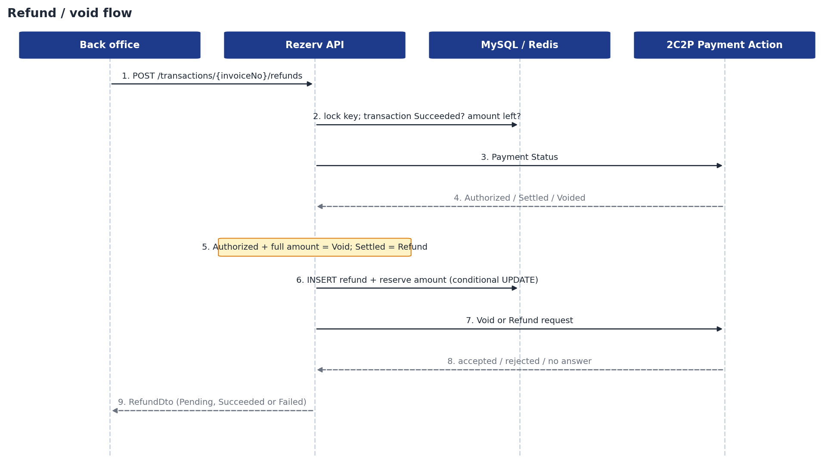
Figure 5. Refund and void flow
- Validate the key and amount, take the Redis lock for the refund key.
- Load the transaction: it must be Succeeded and have an amount left to refund.
- Ask 2C2P for the payment status. Authorized with the full amount becomes a Void; Settled becomes a Refund (full or partial); a partial amount on an unsettled payment or an already voided payment is rejected.
- In one database transaction, insert the refund and reserve the amount with a conditional update, so concurrent refunds with different keys can never exceed the payment.
- Send the void or refund. A rejection marks the refund Failed and releases the reserved amount; no answer keeps it Pending and the list endpoint reconciles it later.

3.6 Remove saved card flow
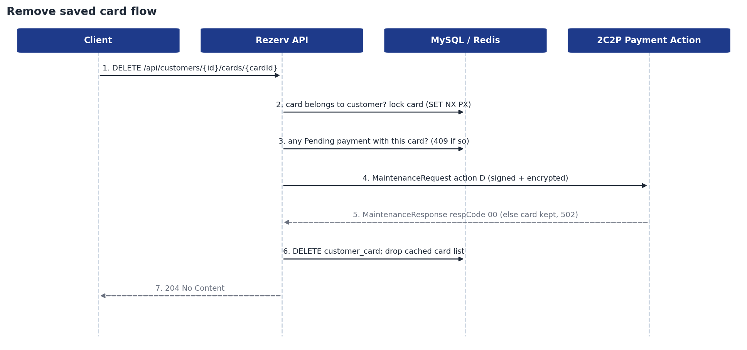
Figure 6. Remove saved card flow
- Check that the customer exists and that cardId belongs to them (404 otherwise, before anything is locked or sent).
- Take the Redis lock rezerv:card:{cardId}:remove:lock (SET NX PX). If another request holds it, answer 409 instead of sending a second deletion.
- Re-read the card under the lock, then refuse with 409 if a Pending payment uses it, because deleting the token would break a payment still waiting for 3DS or Payment Inquiry.
- Send a MaintenanceRequest (version 2.3, merchantID, storeCardUniqueID = customerToken, cardholderName, cardholderEmail, action D) to the Payment Action endpoint. The answer must be signed by 2C2P and refer to the same token.
- On respCode 00, delete the row (DELETE ... WHERE id = @id AND customer_id = @customerId). MySQL sets transaction.customer_card_id to NULL (fk_txn_customer_card ON DELETE SET NULL); the transaction keeps its masked card number.
- Drop the cached card list so the next GET /cards reads MySQL, release the lock and return 204.
- Any other respCode, a timeout or an unsigned answer keeps the card in MySQL and returns 502. 2C2P is always asked first, so the system never hides a card whose token can still be charged.

3.7 Retry a failed payment flow
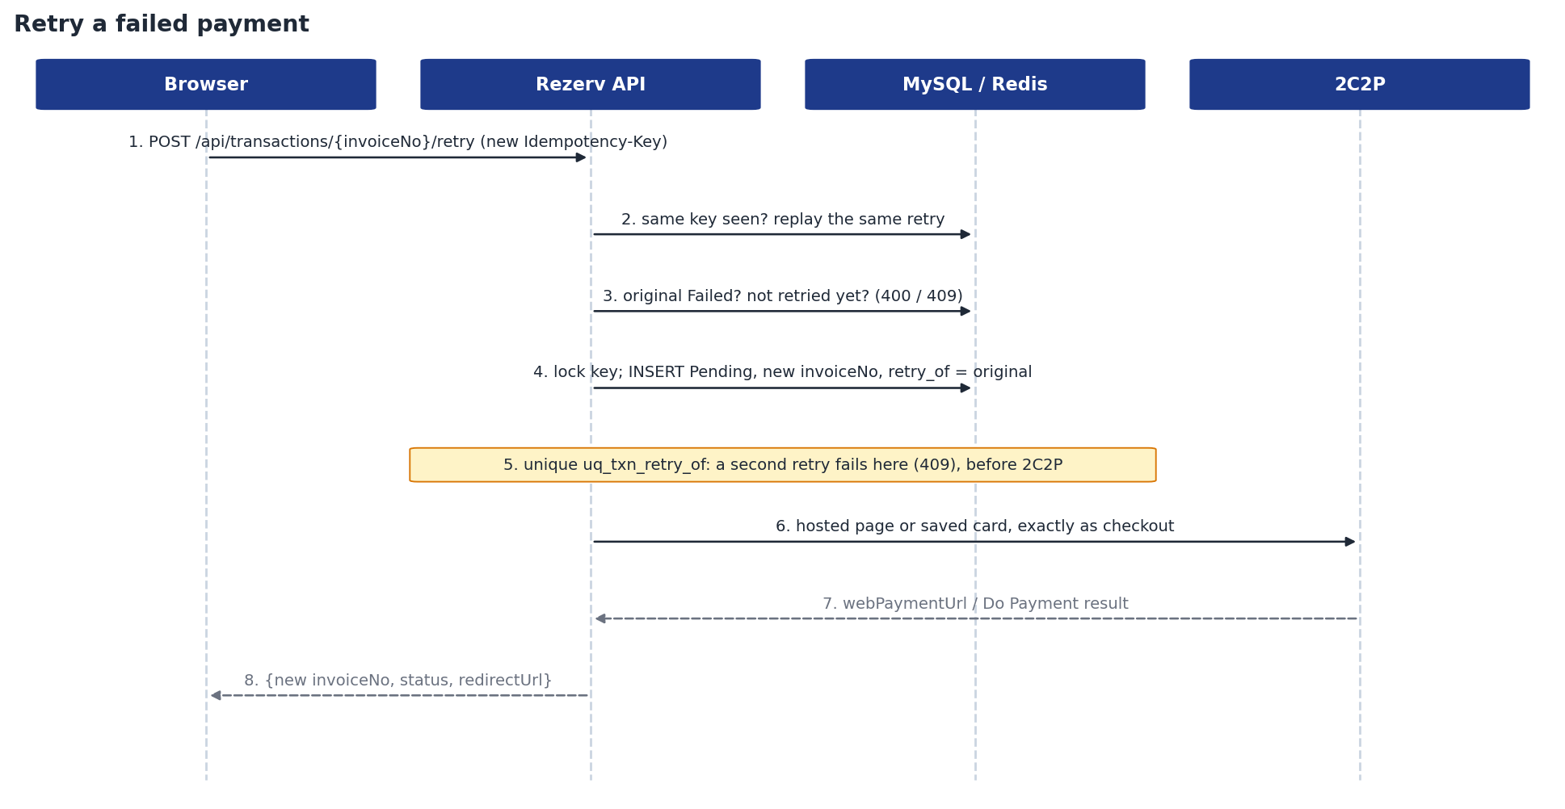
Figure 7. Retry a failed payment
- Validate the Idempotency-Key and load the failed transaction (404 if unknown).
- If this key was already used, replay its result (Redis, then MySQL); a key used for another request gets 422.
- Check that the transaction is Failed (400 otherwise) and has not been retried yet (409, naming the existing retry).
- Run the normal checkout for the same customer and product: Redis lock on the key, INSERT a Pending transaction with a new invoiceNo and retry_of_transaction_id = the failed transaction.
- If another retry of the same failed transaction was inserted first (different key, same moment), the unique index uq_txn_retry_of rejects this INSERT and the request gets 409. This happens before 2C2P is called, so only one retry is ever charged.
- Continue exactly as checkout: hosted page (Payment Token, redirectUrl) or saved card (Payment Token, Do Payment, Payment Inquiry), and the backend notification sets the final status.

3.8 Transaction status model
Status | Set by | Final?
Pending | Checkout (row created before calling 2C2P) | No
Succeeded | Notification or inquiry with respCode 0000 | Yes, never overwritten
Failed | Payment Token error, notification or inquiry with another respCode | Yes, never overwritten (a retry creates a new transaction)

4. Data model
MySQL tables created by EF Core. The unique indexes are part of the correctness design, not only performance.
Table | Key columns | Important indexes
customer | id, first_name, last_name, email | Primary key
product | id, name, price, currency, payment_type, is_active | Primary key
customer_card | id, customer_id, customer_token, masked_card_no, payment_channel, last_used_at | Unique (customer_id, customer_token): no duplicate cards from repeated notifications. Removing a card sets transaction.customer_card_id to NULL (ON DELETE SET NULL)
transaction | id, invoice_no, idempotency_key, customer_id, product_id, customer_card_id, amount, currency, status, payment_channel, masked_card_no, provider_ref, resp_code, resp_desc, payment_token, redirect_url, paid_at, refunded_amount, retry_of_transaction_id | Unique invoice_no; unique idempotency_key (final guard); unique retry_of_transaction_id (one retry per failed payment, FK to transaction.id); (customer_id, created_at); (status, created_at)
refund | id, transaction_id, idempotency_key, type, status, amount, currency, reason, provider_status, provider_ref, resp_code, resp_desc, completed_at | Unique idempotency_key

5. Unit tests
The test project test/Rezerv.Test uses xUnit and Moq. It contains 182 test methods across 14 classes; with theory data rows the runner executes 216 test cases, all passing at the time of writing (13 October 2026).

5.1 Running the tests
dotnet test Rezerv.slnx

# one class
dotnet test --filter "FullyQualifiedName~CheckoutServiceTests"

# with coverage (coverlet collector)
dotnet test --collect:"XPlat Code Coverage"

5.2 Test approach
The tests run the real Application services against fast in-memory test doubles, so they need no MySQL, Redis or network:
Test double | Role
TestHarness | Wires real services with seeded data (customers Alice and Bob, OneTime, Recurring, inactive and USD products, saved cards) and short timeouts.
InMemoryDatabase | Repositories and unit of work in memory, including the unique indexes and conditional updates (WHERE status = 'Pending') that the concurrency guarantees rely on.
FakeCacheService | Redis replacement with a real lock (NX semantics) and the option to simulate Redis being down.
Mock<IPaymentGateway> (strict) | 2C2P is mocked with MockBehavior.Strict, so any unexpected call fails the test. This proves, for example, that a replayed key never calls 2C2P again.
Fake HTTP handler | Infrastructure gateway tests capture the exact JSON/JWT sent to 2C2P and return signed or tampered responses.

5.3 Coverage by requirement
Requirement | Proven by
Same key returns the original response, no second 2C2P call | Same_key_returns_the_original_response_without_calling_2c2p_again; Same_key_is_replayed_from_mysql_when_the_redis_response_is_gone
Concurrent requests: exactly one transaction, one 2C2P call | Concurrent_requests_with_the_same_key_create_one_transaction_and_call_2c2p_once
Waiting request gets 409 while the first is in progress | Waiting_request_gets_409_when_the_first_is_still_in_progress_after_the_wait_timeout
Unique index as final guard when Redis is down | Unique_index_is_the_final_guard_when_redis_is_down
Payment rules per scenario | PaymentRulesTests; OneTime_/Recurring_/Saved_card_ payment token tests
2000 alone is not success; inquiry decides | Saved_card_2000_is_confirmed_by_payment_inquiry_0000_as_succeeded; Saved_card_2000_alone_is_not_success_when_inquiry_says_otherwise
Notification: signature, amount/currency, idempotency | Notification_signed_with_another_key_is_rejected; Amount_or_currency_mismatch_is_rejected_and_nothing_changes; Duplicate_notification_is_idempotent; Concurrent_duplicate_notifications_update_once_and_save_one_card
Final status never overwritten | Final_status_is_never_overwritten
Result page reads from the database and polls safely | Transaction_details_come_from_the_database; Pending_hosted_page_payment_is_not_failed_by_an_inquiry; Polling_is_throttled_to_one_inquiry_per_interval
Remove card: 2C2P first, never while a payment is Pending, one deletion under concurrency | Card_is_removed_at_2c2p_with_its_token_then_from_the_database; Card_is_kept_when_2c2p_refuses_the_removal; Card_with_a_pending_payment_is_not_removed; Concurrent_removals_call_2c2p_once; Remove_card_sends_a_signed_maintenance_request_with_action_D
Retry: only failed payments, one retry per failed payment, never two charges | Only_failed_transactions_can_be_retried; A_second_retry_with_another_key_is_a_conflict_that_names_the_first_retry; Concurrent_retries_with_different_keys_create_one_transaction_and_call_2c2p_once; Same_idempotency_key_returns_the_same_retry_and_calls_2c2p_once
Refunds only for succeeded payments, never over the amount | Only_succeeded_payments_can_be_refunded; Concurrent_refunds_with_different_keys_never_exceed_the_payment

5.4 Test catalogue
Every test method by class. Names are written as sentences describing the expected behaviour.
Test class | Area | Methods
AppExceptionHandlerTests | Exception to Problem Details mapping | 4
ControllerTests | Controllers wired to the real services | 24
CatalogServiceTests | Customers, products and cards with Redis caching | 6
CustomerCardServiceTests | Removing saved cards at 2C2P and in MySQL | 14
CheckoutServiceTests | Checkout flows, idempotency and locking | 27
PaymentResultProcessorTests | Notification and inquiry results, card saving, reconciliation | 20
PaymentRetryTests | Retrying failed payments once, as new linked checkouts | 16
PaymentRulesTests | Payment Token parameters per scenario | 4
RefundServiceTests | Refunds, voids, reservation and idempotency | 19
TransactionQueryServiceTests | Result page and refund page queries | 12
Hs256JwtTests | JWT signing and verification | 6
SimulatedPaymentActionGatewayTests | Refund simulator for development | 8
TwoC2PPaymentActionGatewayTests | Store Card Maintenance over the signed Payment Action channel | 5
TwoC2PPaymentGatewayTests | 2C2P HTTP gateway: requests, responses and notifications | 17

AppExceptionHandlerTests (4)
Exception to Problem Details mapping
- Maps exceptions to status codes
- Application exception message is returned as detail
- Unexpected exception details are not leaked
- Conflict tells the client when to retry

ControllerTests (24)
Controllers wired to the real services
- Customers lists seeded customers
- Customer cards are masked
- Customer cards of an unknown customer throw not found
- Remove card returns 204 and the card is gone
- Remove card of another customer throws not found
- Products lists active products
- Checkout passes body and idempotency key and returns redirect
- Checkout twice with the same key returns the same invoice
- Checkout without idempotency key is a validation error
- Checkout sends the client ipv4 to do payment
- Notification without payload is 400
- Verified notification updates the transaction and returns 200
- Notification for an unknown invoice or with a mismatch still returns 200
- Duplicate notification returns 200 and changes nothing
- Notification with a bad signature throws invalid signature
- Transaction details come from the database
- Unknown transaction throws not found
- Customer transactions endpoint lists refundable transactions
- Customer route only matches numeric ids so invoice lookups still work
- Retry of a failed payment returns a new invoice with the hosted page
- Retry of a succeeded payment is a validation error
- Retry route is a post on the invoice
- Refund creates a refund for a succeeded payment
- Refund of a failed payment is a validation error

CatalogServiceTests (6)
Customers, products and cards with Redis caching
- Customers are loaded from the database and cached
- Cached customers are served from redis
- Database is used when redis is down
- Only active products are listed
- Cards are masked and scoped to the customer
- Cards of an unknown customer are not found

CustomerCardServiceTests (14)
Removing saved cards at 2C2P and in MySQL
- Card is removed at 2C2P with its token then from the database
- Removing a card invalidates the cached card list
- Past payments keep their masked card after the card is removed
- Removed card can no longer be used for checkout
- Unknown customer is not found
- Card of another customer is not found and is kept
- Already removed card is not found and 2C2P is not called again
- Card with a pending payment is not removed
- Card being removed by another request is a conflict
- Concurrent removals call 2C2P once
- Card is kept when 2C2P refuses the removal
- Card is kept when 2C2P cannot be reached
- Removal requires payment action configuration
- Lock is released after a failed removal so it can be retried

CheckoutServiceTests (27)
Checkout flows, idempotency and locking
- Rejects missing or non uuid idempotency key
- NormalizeKey accepts any uuid format and returns canonical form
- NewInvoiceNo is alphanumeric unique and at most 50 chars
- Unknown customer is not found
- Unknown or inactive product is not found
- Product not priced in SGD is rejected
- Saved card must belong to the customer
- Validation failure releases the lock so the key can be retried
- OneTime new payment method creates pending transaction and returns hosted page without channel restriction
- Recurring new payment method requests card only with tokenize
- Payment token error marks transaction failed with respCode and respDesc
- Payment token transport error marks transaction failed with gateway error
- Saved card requests token with customerToken only and no 3ds then calls do payment
- Saved card 2000 is confirmed by payment inquiry 0000 as succeeded
- Saved card 2000 alone is not success when inquiry says otherwise
- Saved card do payment without response stays pending and is not failed
- Saved card payment token failure never calls do payment
- Same key returns the original response without calling 2C2P again
- Same key is replayed from mysql when the redis response is gone
- Same key in a different uuid format is the same key
- Same key with a different body is rejected
- Failed checkout is replayed too and not retried with the same key
- Different keys create separate transactions
- Concurrent requests with the same key create one transaction and call 2C2P once
- Waiting request gets 409 when the first is still in progress after the wait timeout
- Unique index is the final guard when redis is down
- Orphaned pending transaction past the lock ttl is replayed instead of charging again

PaymentResultProcessorTests (20)
Notification and inquiry results, card saving, reconciliation
- Success sets status and saves channel account tranRef and paidAt
- Other respCode sets failed with respCode and respDesc
- Unknown invoice is reported not found
- Amount or currency mismatch is rejected and nothing changes
- Currency match is case insensitive
- Pending result does not change the transaction
- CustomerToken is saved as a new card for the customer
- Saving a card invalidates the cached card list
- Existing customerToken is not saved twice
- No card is saved without a customerToken or on failure
- Duplicate notification is idempotent
- Final status is never overwritten
- Concurrent duplicate notifications update once and save one card
- Reconcile final applies a failed inquiry
- Reconcile success only ignores a failed inquiry while the customer may still be paying
- Reconcile success only applies a succeeded inquiry
- Reconcile keeps the stored status when the inquiry fails
- Reconcile does not trust an inquiry with a different amount
- Notification service parses the payload with the gateway and applies it
- Notification with a bad signature is rejected and nothing changes

PaymentRetryTests (16)
Retrying failed payments once, as new linked checkouts
- Failed payment is retried as a new transaction linked to the failed one
- Retry without a card uses the hosted page even if the failed payment used a saved card
- Retry with a saved card pays with do payment
- Transaction details link the failed payment and its retry
- A retry that failed too can itself be retried
- Same idempotency key returns the same retry and calls 2C2P once
- Same key still replays after the cached response expired
- A second retry with another key is a conflict that names the first retry
- Concurrent retries with different keys create one transaction and call 2C2P once
- Key used for a checkout cannot be reused for a retry
- Only failed transactions can be retried
- Unknown transaction is not found
- Retry needs a uuid idempotency key
- Saved card must belong to the customer of the failed payment
- Product that is no longer sold cannot be retried
- A rejected retry does not use up the single retry

PaymentRulesTests (4)
Payment Token parameters per scenario
- OneTime new payment method has no channel restriction
- Recurring new payment method is card only with tokenize
- Saved card is card only with customer token only and no 3ds
- Currency is SGD

RefundServiceTests (19)
Refunds, voids, reservation and idempotency
- Only succeeded payments can be refunded
- Unknown invoice is not found
- Refund requires payment action configuration
- Refund requires a uuid idempotency key
- Amount must be positive with two decimals
- Amount above what is left is rejected
- Fully refunded payment is rejected
- Unsettled payment is voided for the full amount
- Partial refund of an unsettled payment is rejected
- Settled payment is refunded partially
- Refund without amount refunds what is left
- Payment that cannot be refunded at 2C2P is rejected
- Rejected refund is failed and releases the reserved amount
- Refund without an answer stays pending and keeps the reservation
- Same key returns the original refund without calling 2C2P again
- Same key with a different amount is rejected
- Concurrent refunds with different keys never exceed the payment
- List reconciles a pending refund with 2C2P
- List of an unknown invoice is not found

TransactionQueryServiceTests (12)
Result page and refund page queries
- Unknown invoice is not found
- Final transaction is returned from the database without calling 2C2P
- Failed transaction exposes respDesc and product for the go back button
- Pending saved card without redirect is reconciled with a final inquiry
- Pending hosted page payment is not failed by an inquiry
- Pending hosted page payment picks up a succeeded inquiry
- Customer transactions are listed newest first and only for that customer
- Customer transactions show what is left to refund
- Customer without transactions gets an empty list
- Customer transactions of an unknown customer are not found
- Listing customer transactions never calls 2C2P
- Polling is throttled to one inquiry per interval

Hs256JwtTests (6)
JWT signing and verification
- Encode then decode round trips the claims
- Null values are omitted
- Wrong secret is rejected
- Tampered payload is rejected
- Alg none is rejected
- Malformed tokens are rejected

SimulatedPaymentActionGatewayTests (8)
Refund simulator for development
- Payments are reported settled so partial refunds are allowed
- Refund succeeds and shows up in the refund status
- Same idempotency id returns the same refund
- Card token removal is confirmed
- Refund service works end to end with the simulator
- Simulate in development registers the simulator
- Simulate outside development refuses to start
- Without simulate the real 2C2P gateway is used

TwoC2PPaymentActionGatewayTests (5)
Store Card Maintenance over the signed Payment Action channel
- Remove card sends a signed maintenance request with action D
- Any respCode other than 00 is not removed
- Answer for another card token is rejected
- Unsigned answer is a gateway error
- Long cardholder name is truncated to the 2C2P limit

TwoC2PPaymentGatewayTests (17)
2C2P HTTP gateway: requests, responses and notifications
- Payment token sends a signed jwt with the required fields
- OneTime payment token has no payment channel
- Recurring payment token is card only with tokenize
- Saved card payment token sends customer token array token only and no 3ds
- Payment token error answer is returned unsuccessful
- Payment token response with a bad signature is a gateway error
- Http or parse failures are gateway errors
- Do payment sends plain json with cc channel and customer token
- Do payment 1001 redirects to 3ds
- Inquiry maps 0000 to succeeded and anything else to failed
- Inquiry requires a signed response
- Notification is verified and decoded
- Notification with a non success code is failed
- Notification signed with another key is rejected
- Notification for another merchant is rejected
- Notification without invoice is rejected
- Converted notification reports the requested fx amount and currency

