Milestone #3
Results

Directions: Please fill out this form (2 pages) and submit to the Milestone 3 submission form. Note, you may use a different template but please ensure the same information is present.

Team Name | VoxAnima
Link to Project Page and Team Number | https://joinlaunchpad.com/#/projects/7245/project-voxanima  Team number - 7245
Team Student Member(s) | Darsh A, Domenica M,Cat Tuong T,Vihaan G,Zhamilya S,Samriddhi S
Team Mentor | N/A

Data/Feedback  Summarize the data you obtained from experiments and/or feedback you gathered. | All results are computational. The EEG comes from public Sleep-EDF recordings and the acoustics from a simplified 2D simulation. No ultrasound was given to anyone, and nothing here is experimentally or clinically validated.  1. EEG sleep-stage classifier  We used one EEG channel, 10 Welch band-power features and a random forest. We then froze the model and tested it once on 3 new people.  Table 1. Sleep-stage classification  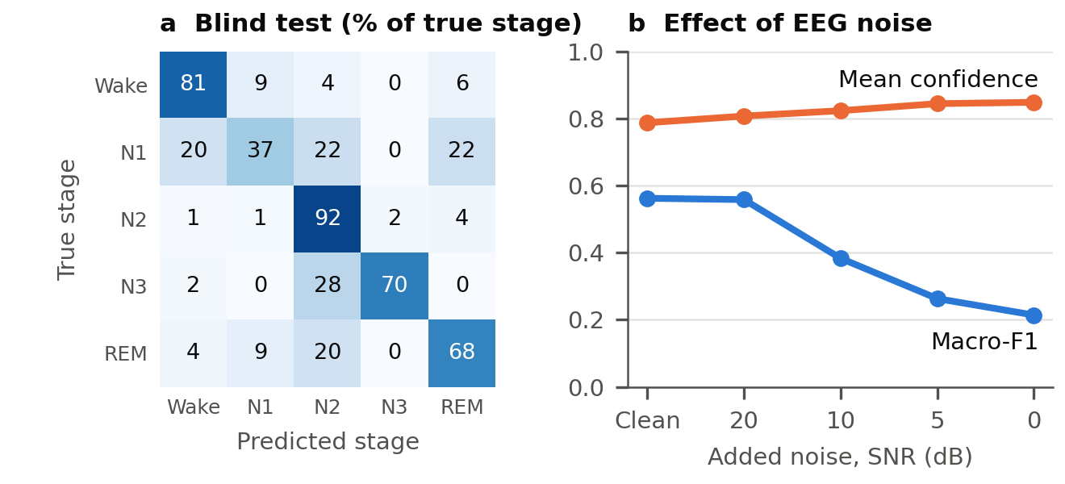  Figure 1. (a) Blind-test predictions; N1 is the weakest stage. (b) As noise increases, performance falls while confidence rises (random forest, 5 development participants, mean of 3 noise seeds).  • Wake vs sleep only (blind test, within 30 min of sleep): AUC 0.97, accuracy 91.8% (89.1–94.2% per person), using a cut-off chosen on development data. Epochs with confidence of 0.80 or higher were correct 84–99.6% of the time; below 0.80, about 40–55%.  • Spotting its own errors: confidence gave an error-detection AUC of 0.79–0.86. In the blind test, 90% conformal prediction sets covered 93.9% of epochs, but only 78% of N1.  2. LIFU acoustic simulation  We modelled a 500 kHz focused source and a curved skin / 3-layer skull / brain head in 2D, using published tissue values (Aubry et al., 2022). All pressures are relative to the same source in water.  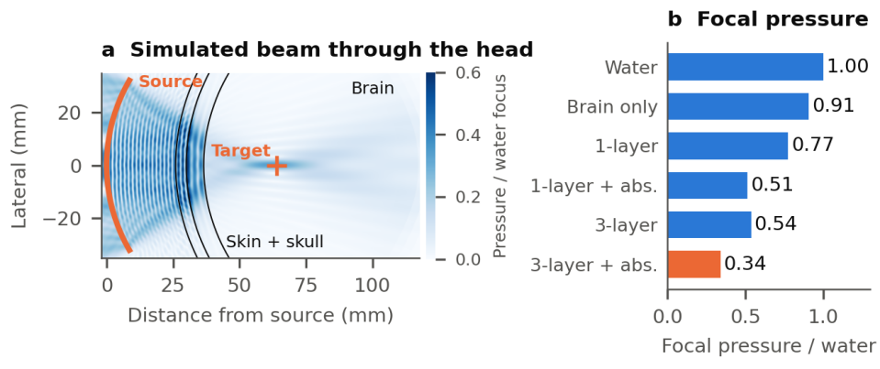  Figure 2. (a) Simulated peak pressure, 2D at 0.25 mm; colour saturates at 0.6 near the source. (b) Focal pressure for each model; abs. = absorption.  Table 2. Focused-beam results at 0.25 mm  • Checks: layer transmission was within 0.5% of the exact solution. The 2D water focus matched the analytic field (axial 27.09 vs 27.12 mm at 0.25 mm). The 0.5 and 0.25 mm grids agreed within 0.6%.  • Uncertainty (19 of 32 planned samples finished): focal pressure ranged 0.25–0.58 (5–95%). Runs were stopped early, and the unfinished samples had more absorption, so this reads high; a fit to all 32 inputs estimates 0.22–0.52. Main drivers: bone absorption (rank correlation −0.84) and skull thickness (−0.57).  3. EEG + LIFU integration (software only)  We asked how often a hypothetical trigger would fire at the wrong time if it depended on the classifier. N2 and N3 are example targets only; this work does not support targeting any stage.  Table 3. Hypothetical stage-triggered timing
  Test | Accuracy | Macro-F1 | N1 F1
  Cross-validation, 5 people (each held out in turn) | 76.5% | 0.551 | 0.22
  Blind test, 3 new people | 79.8% | 0.610 | 0.16
  Blind test, within 30 min of sleep | 75.3% | 0.678 | 0.34
  Baseline on blind test: always predict Wake | 75.7% | 0.172 | 0.00
  Baseline on blind test: logistic regression | 75.5% | 0.599 | 0.14
  Model | Focal pressure | Focus shift | Axial × lateral size
  Water | 1.00 | 1.1 mm | 27.1 × 3.5 mm
  Brain only, no skull | 0.91 | 2.3 mm | 26.6 × 3.6 mm
  1-layer skull + absorption | 0.51 | 4.5 mm | 30.8 × 3.8 mm
  3-layer skull, no absorption | 0.54 | 1.3 mm | 28.6 × 3.7 mm
  3-layer skull + absorption | 0.34 | 2.3 mm | 29.0 × 3.8 mm
  Target and rule | Precision | Recall | Triggers in Wake
  N2, no filter (blind) | 0.65 | 0.92 | 19.1%
  N2, confidence ≥ 0.7 and 3 consecutive epochs (blind) | 0.94 | 0.55 | 0.2%
  N3, no filter (blind) | 0.87 | 0.70 | 6.9%
  N3, no filter (5 development participants) | 0.27 | 0.57 | 60.5%
Lessons Learned  Summarize the most important findings from your testing. Note: Where could you have tested more? What were some of your limitations? | • Accuracy alone is misleading. Always predicting Wake scores 75.7% in the blind test, so macro-F1 and per-stage results matter more. The random forest was not clearly better than logistic regression on macro-F1.  • Confidence can fail silently. Under noise, confidence rose while performance fell, and error-detection AUC dropped from 0.86 to 0.66. Signal-quality screening is needed before staging.  • People differ. Blind accuracy ranged from 73% to 91%, and the poor N3 timing seen in development did not repeat in the 3 new people. Results must be reported per person.  • Skull modelling matters. Skull layers and absorption reduced simulated focal pressure to about one-third of water; a single-layer skull overestimated it by about 50%.  • Checking against known answers is essential. Exact solutions caught an array-order bug in our code, and an error guard caught instabilities caused by absorption at fine grids.  Where we could have tested more / limitations  • Only 8 people from one dataset, with one EEG channel, and only Gaussian noise instead of real artefacts. These recordings were not selected for anxiety.  • The acoustic model is 2D, with an idealised head, assumed uncertainty ranges and no far-side skull reflections or thermal model. Its pressures are uncalibrated.  • Laptop memory (8 GB) limited the work. Grid convergence is not established, because the 0.125 mm runs did not finish, and the 3D comparison with the published benchmark was not completed. The uncertainty study is partial.  • The EEG and acoustic parts are linked only through timing, not shared physics, and nothing here tests any effect on sleep or anxiety.  Possible impacts  • Positive: low-risk software testing could help future studies learn when a model should not be trusted before anyone is exposed to ultrasound. The public data make the work reproducible.  • Negative: simulated numbers could be misread as safe doses or proven benefits. Models tested on so few people may also work worse for others, so all results must be labeled as simulated and preliminary.
Next Steps  Describe how you plan to refine your solution based on what you learned and conduct further testing. Will you modify your testing methods? | • Finish numerical checks: complete the 0.125 mm runs and the 3D benchmark comparison on a stronger machine, and correct the array order in our older acoustic.py script.  • Improve the acoustic model: add skull shape and far-side skull effects, use literature-based ranges, and complete the uncertainty study.  • Expand EEG testing: add about 20 more participants, trim long Wake periods, add signal-quality screening and test realistic artefacts. Keep new participants unseen for a final blind test.  • Change our testing methods: fix test rules before running them, report per-person results, report precision with recall and trigger counts, and save results as each run finishes.  • Repeat integration: rerun the timing study using the Wake-vs-sleep gate and updated acoustic uncertainty.  • Stay in software for now: any work beyond simulation would need expert guidance, safety and ethics review, and is outside this stage.

Milestone 3 Tips:
- This is an important time to think about your results and how they will impact communities, people, and the environment. Think through how those results could positively and negatively affect those areas and include them in your findings. Remember, telling the whole story is important and a well-rounded solution includes both positive and negative aspects.
- This is also a good time to begin to reflect on your team dynamics. How did you individually contribute to the tasks at hand and how did you work together as a group to get results? Thinking about this now, and jotting down some notes while it is fresh in your mind, will help later reflections in Milestone 4.

