Gamification and Inference Workflow (GIW)
S. Tanimoto, Nov. 1, 2025.
Background:
This document describes part of the New Insights from Gamification Project (NIFGP) at the University of Washington in collaboration with scholars across multiple institutions and disciplines. The project director is Steven L. Tanimoto, a faculty member in the Paul G. Allen School of Computer Science and Engineering at the University of Washington, Seattle. The project timeframe is expected to be October 2025 to June 2028.
The project is investigating a new process for helping scholars gain new insights related to their scholarly documents through a process of creating games based on those documents. The game creation process involves the scholar, a human collaborator who understands the gamification methods and tools, and generative artificial intelligence services.
The games produced in this process have a special format so that they run with a family of game engines and analysis tools in a game ecosystem called SOLUZION. The two most important SOLUZION game engines are the Text SOLUZION engine and the Web SOLUZION engine. The former runs on a single computer without the use of networking, browsers, or graphics. The latter runs using a web server and involving web browsers, potentially multiple users on separate computers, and browser media affordances such as graphics and audio.
SOLUZION supports the formulation and running of both problems and games using a special problem formulation structure which consists primarily of one Python code file per problem, called the formulation file. However, there may be accompanying Python files that it imports so that the formulation can be expressed in terms of multiple Python modules.
Gamification Workflow
Before gamification begins, the scholar or collaborator provides one or more source documents on which one or more new games will be based. Once the source documents have been identified and made available to the gamification software, a gamification project is initiated by the collaborator, and its progress will be captured and represented in a text file named for that project. See Figure 1 for a diagram showing most of the workflow.
The collaborator will next select a first stage prompt from a repository of files called the Repository of Guidelines. The collaborator will then tailor a prompt to an LLM such as Claude Code or Google Gemini that includes the selected guidelines document and the scholar’s documents as context. The result from the LLM will be a design document suggesting one or more ideas for games based on the materials provided. This step may be repeated as needed, with a retailoring of the prompt until a design proposal from the LLM meets with the users’ approval. The collaborator may also be choosing different guideline documents as this iteration proceeds.
In the next phase shown in the diagram, the LLM (or another one, if the collaborator wishes to have a different LLM do the coding), a working game is requested. The LLM will produce not only the code for the game, but enough documentation that the users can do a preliminary evaluation without even playing the game. On the basis of this preliminary evaluation, the collaborator may request additional versions of the game or even go back to the previous phase to request a new game idea and design. However, when a game has been produced that looks promising, the next phase in the workflow can proceed.
Inference Workflow
In the analysis phase, a combination of play-testing and technical analysis takes place. The technical analysis may include components such as game integrity testing through autoplaying; game-space characterization in terms of branching factors and state reachability, and advance HCI issue detection such as finding overflowing text boxes or images, or inappropriately long audio sequences, etc. The human play-testing will typically be coordinated with game-engine features that instrument the game sessions, capturing game history in log files, and in some cases, automatically prompting players to think aloud during game-play in order to produce richer records of their sessions than pure game-play would offer.

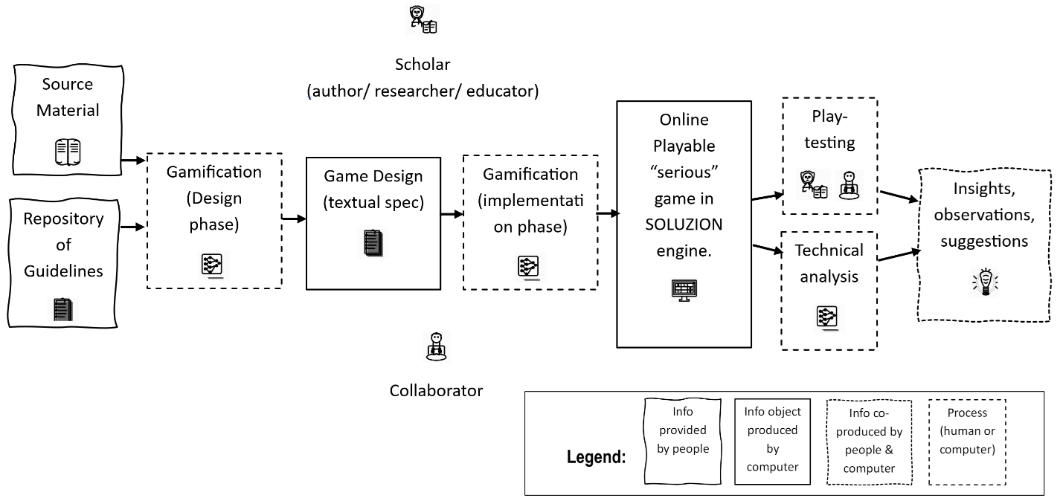
Not shown in the diagram are two final phases of inference and documentation. After play-testing and technical analysis of the game itself, the main inference process takes the products of play-testing and technical analysis and derives conclusions about the game, including a comparison of the pros and cons of the players’ experience, statistics related to difficulties, surprises, teachable moments for learning, etc. It may also include an evaluation of the relationship between the game, the players’ experience and the key points of the source documents, indicating, for example, that the key points were lost or that they were admirably amplified.
The final phase of the workflow is documentation of the project and its main inferences. Thus, part of the output is a narrative description of the preceding phases of the gamification and testing, and the rest of the output is the key findings from the previous phase (inference). The result should be a project retrospective, with a version number or subname associated with it. This is because we expect that these workflows will typically be re-run multiple times with different choices, different game-play experiences, etc., and end up with different inferences and results, even for the same source documents. The documentation will ideally contain some degree of due-diligence reporting of roughly how much time was spent on each phase of activity, especially if multiple hours or days have been involved.

