ARCHIDRAFT STUDIO
Admin Panel Operator Manual & Button Guide
Comprehensive Mobile & Desktop Reference Guide for ArchiDraft Studio
📌 SYSTEM ACCESS & CREDENTIALS
Production Admin URL: https://admin-web-eight-wine.vercel.app
Cloudflare Worker API: https://archi-draft-worker-staging.imserratex.workers.dev
Studio Admin Email: contact@draughtsmanstudio.com
Primary Password: AAAJ@PMS (PMS = PixelMint Studio)
Fallback Password: AAAJ@PIXELMINT
Canonical Role: STUDIO_ADMIN (Full Governance Permissions)

The ArchiDraft Studio Admin Portal is the central management engine for architectural blueprint drafting, specialist dispatch, quality control inspection, and student apprentice education. This guide provides full wordings, workflows, and button-by-button references for every screen in the application.
1. Authentication & Security Gateway [Route: /login]
The login portal ensures that only authorized studio administrators can access project files, client records, and financial statements. Authentication is handled by Firebase Auth, and user permissions are validated in the Cloudflare D1 database.
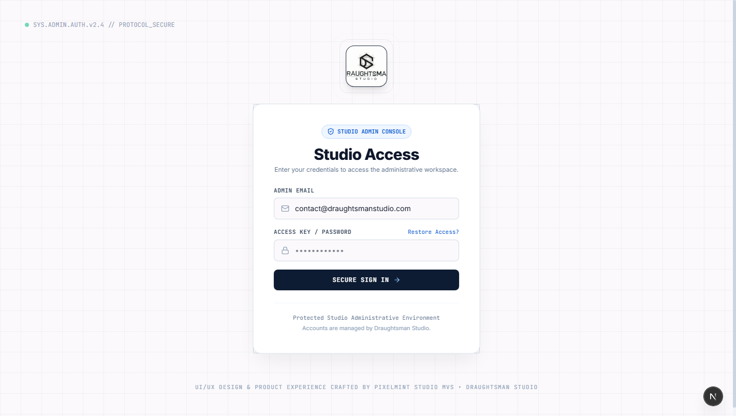
Figure: Studio Admin Authentication Gateway Shell
Interface Element / Button | Operational Purpose & Action | System / Database Result
Email Input (#admin-email-input) | Enter registered administrator email address (contact@draughtsmanstudio.com). | Validates RFC regex format
Password Input (#admin-password-input) | Enter admin password (AAAJ@PMS). Eye icon toggles cleartext visibility. | Masked secure credential entry
Sign In Button (#admin-login-submit) | Transmits credentials to Firebase Auth, retrieves Google JWT, checks role in Cloudflare D1. | Redirects to /dashboard
Forgot Password Link | Navigates to /forgot-password to trigger password reset email via Firebase Auth. | Dispatches recovery workflow
3D Monogram Canvas | Interactive 3D architectural geometric monogram rendered with Three.js. | Interactive tilt on mouse move

2. Executive Command Cockpit [Route: /dashboard]
The executive dashboard provides an at-a-glance operational overview of active drafting projects, studio capacity, and real-time cloud infrastructure health.
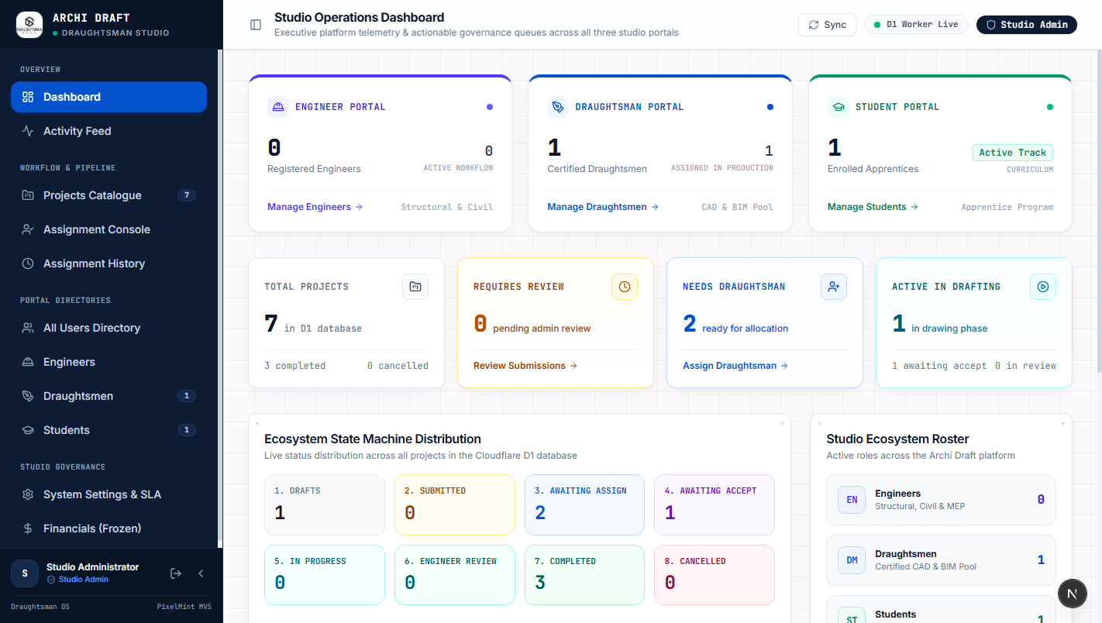
Figure: Executive Dashboard Hydrated with Live Cloud Metrics
Interface Element / Button | Operational Purpose & Action | System / Database Result
Total Projects Card | Aggregates total number of all projects commissioned across all clients. | Live D1 project count
In Progress Card | Shows count of projects currently undergoing active drafting by draughtsmen/students. | Filters projects by IN_PROGRESS
Under Review Card | Highlights deliverables awaiting administrator redline inspection or signoff. | Filters projects by UNDER_REVIEW
Active Draughtsmen Card | Displays total number of professional drafters currently carrying active assignments. | Live D1 drafter count
Cloud Health Indicators | Performs round-trip ping checks to Cloudflare D1, Cloudflare R2, and Firebase Auth. | Green status indicates healthy
View All Projects Button | Direct jump from recent projects list to the complete project catalogue. | Redirects to /projects

3. Projects Catalogue & Lifecycle Queue [Route: /projects]
The projects catalogue is the operational hub for organizing all project deliverables across their complete lifecycle states.
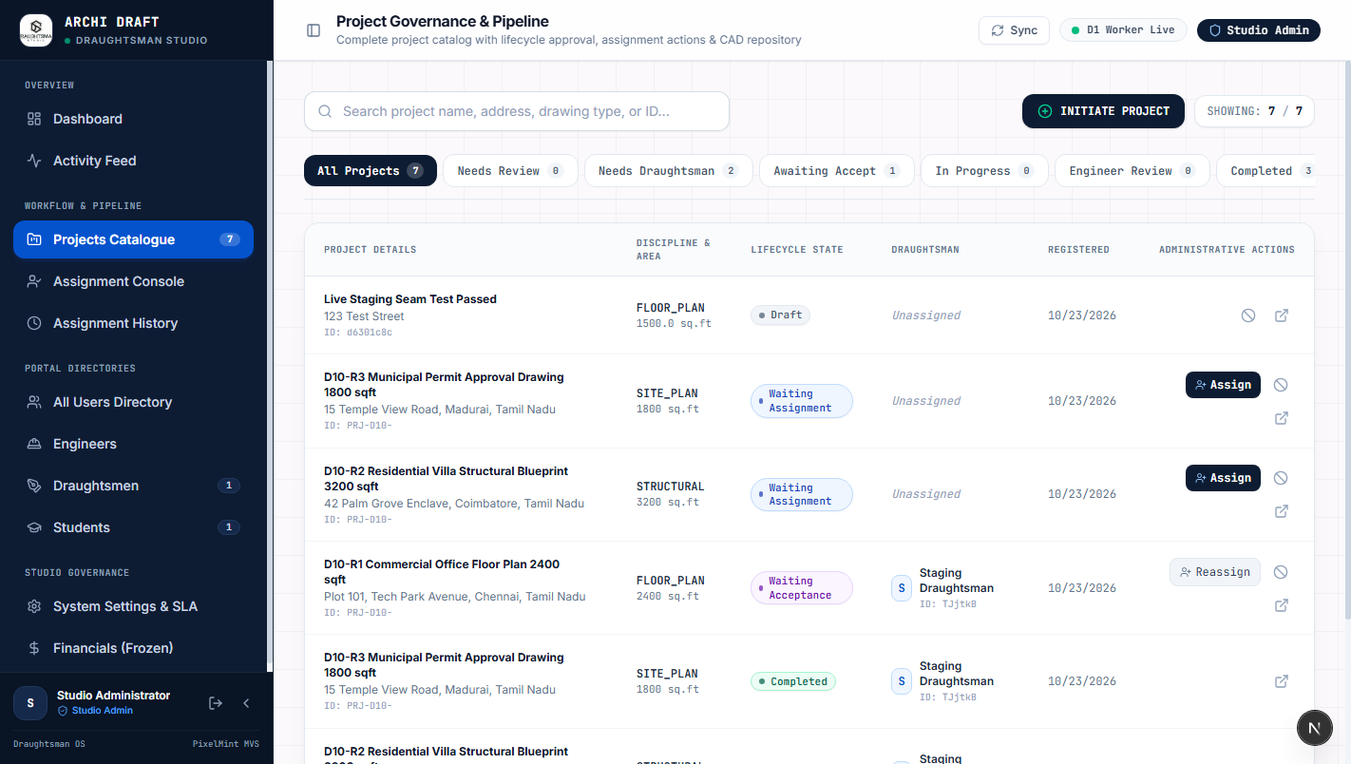
Figure: Projects Catalogue with Status Lifecycle Filter Tabs
Interface Element / Button | Operational Purpose & Action | System / Database Result
Status Tabs (All, Brief, Assign...) | Filters project cards by lifecycle state: Brief Submitted, Ready to Assign, Assigned, In Progress, Under Review, Completed. | Instant table re-filter
Search Bar (#project-search-input) | Searches instantaneously across project titles, site addresses, and client engineer names. | Live client-side substring match
+ New Project Button | Opens the 3-step project commissioning wizard modal. | Launches creation modal
Assign Draughtsman Button | Direct quick-action button on unassigned project cards to dispatch a drafter. | Opens assignment modal
Project Card / Dossier Link | Clicking any project card opens the full Project Dossier detailing scope, redlines, and files. | Navigates to /projects/[id]

4. Project Creation Wizard (3-Step Modal) [Route: /projects -> + New Project]
Administrators can manually commission architectural projects on behalf of clients or create training projects for academy students.
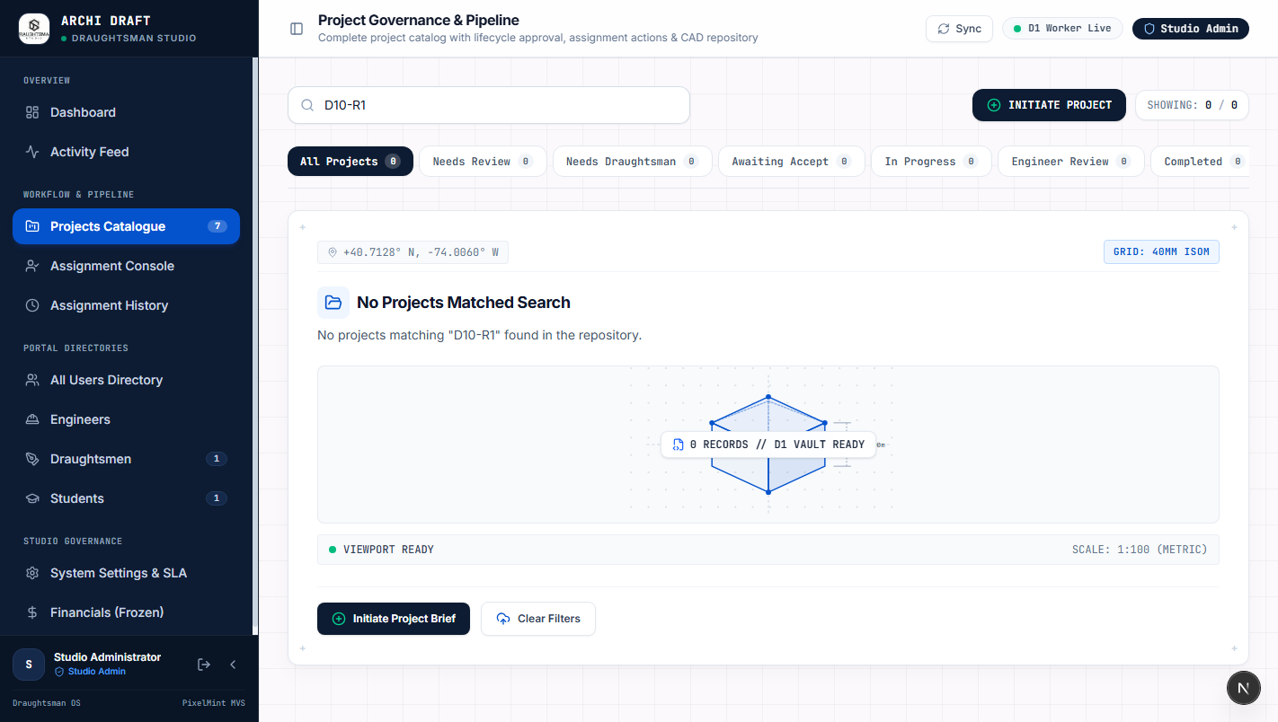
Figure: 3-Step Project Creation Wizard Modal
Interface Element / Button | Operational Purpose & Action | System / Database Result
Assignee Target Dropdown | Selects target draughtsman or academy student (e.g. Student 1 / Sarah Jenkins) to bind to the assignment. | Sets assignee_id foreign key
Project Name & Address Fields | Defines project title and geocoded physical site location. | Stored in projects table
Discipline Selector | Selects architectural discipline: Architectural Layout, Structural Framing, MEP & HVAC, Interior, or Municipal Permit. | Sets technical requirements tag
Scale & Area Inputs | Specifies drawing scale (1:50, 1:100, 1:200) and square footage (e.g. 1500 sq. ft.). | Determines drafter workload
CAD & Brief File Uploader | Drag-and-drop uploader for hand sketches, PDF briefs, or reference AutoCAD files. | Streams directly to Cloudflare R2
Create Project Submit Button | Submits form via POST /api/projects, generates unique project ID, and alerts assignee. | Creates record in D1 database

5. Draughtsman Dispatch & Capacity Modal [Route: /projects -> Assign]
Ensures projects are allocated to specialist drafters who possess both the appropriate discipline credentials and available bandwidth.
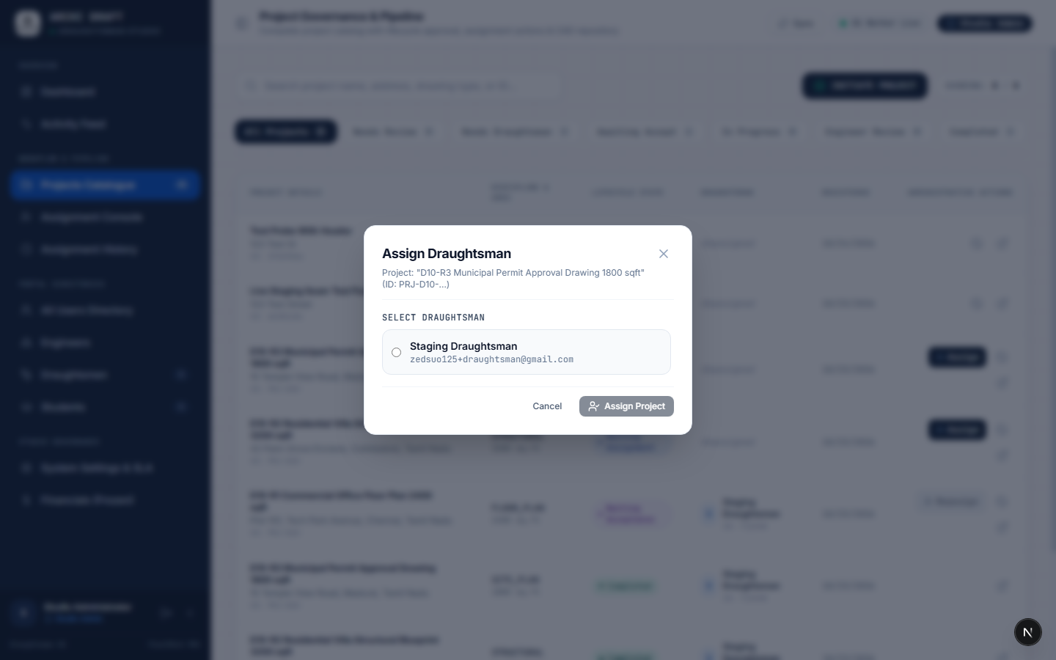
Figure: Draughtsman Dispatch Modal with Live Workload Indicators
Interface Element / Button | Operational Purpose & Action | System / Database Result
Specialist Selection List | Lists all verified professional draughtsmen along with their current active project load (e.g., 0/3 projects). | Visualizes drafter availability
Discipline Compatibility Tag | Highlights whether the specialist has verified proficiency in the project's required discipline. | Prevents qualification mismatches
Assignment Directives Field | Admin input for specific instructions, drafting standards, and turnaround priorities. | Stored in assignment notes
Deadline Date Picker | Sets target deliverable milestone date and time. | Initializes SLA countdown timer
Confirm & Dispatch Button | Executes POST /api/projects/:id/assign, transitions project to ASSIGNED, and pings the specialist. | Locks assignment in D1

6. Project Dossier: Scope & Client Brief [Route: /projects/[id] -> Overview]
The single source of truth for all project parameters, client communications, and administrative metadata.
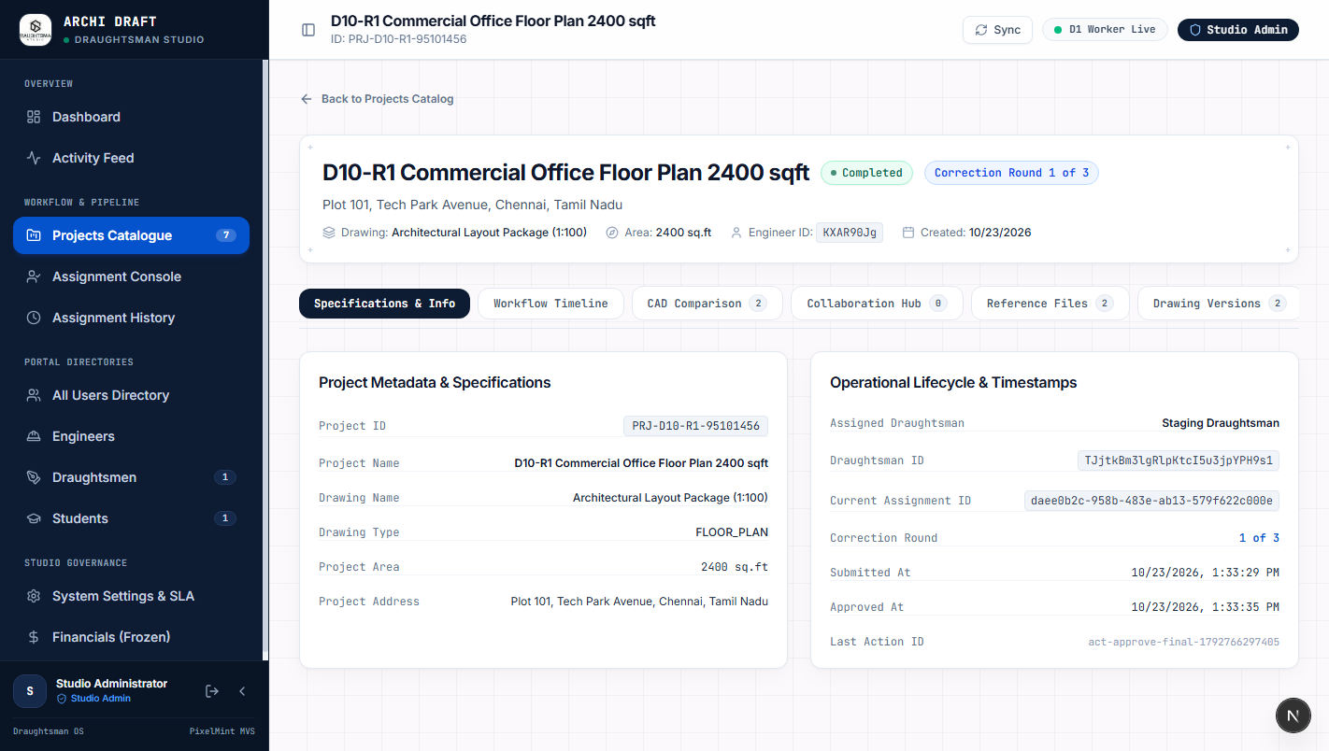
Figure: Project Dossier Master Overview Screen
Interface Element / Button | Operational Purpose & Action | System / Database Result
Lifecycle Status Pill | Displays current real-time state (e.g. IN_PROGRESS, UNDER_REVIEW, COMPLETED). | Visual reference of progress
Dossier Navigation Tabs | Switches between Overview, Redlines & Quality Control, and Deliverables. | Swaps active sub-view
Client Engineer Card | Displays registered client contact name, firm, email, and phone for direct communications. | Quick contact access
Scope of Work Narrative | Complete unedited client drafting requirements detailing sheet list and conventions. | Full brief documentation
Edit Project Action | Opens modification modal to adjust project deadline, scale, or address. | Updates project in D1

7. Project Dossier: Redlines & Quality Control [Route: /projects/[id] -> Redlines]
Digitizes the traditional architectural red-pen markup review cycle, allowing administrators to inspect submissions and request revisions.
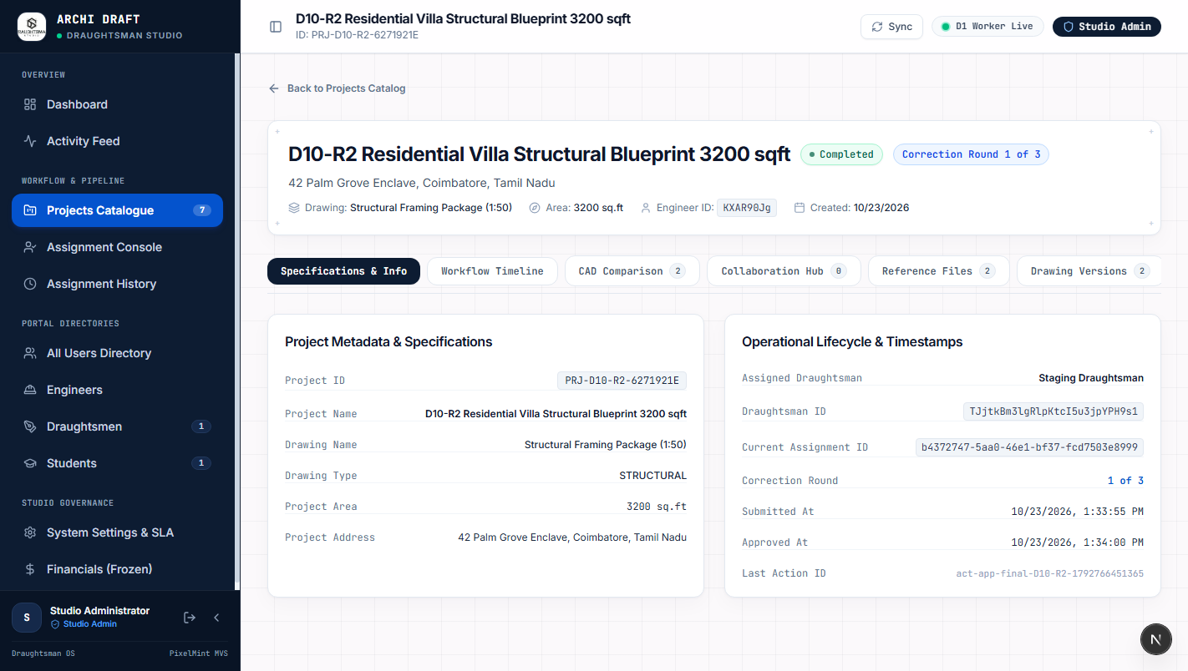
Figure: Architectural Redline Inspection & Revision History
Interface Element / Button | Operational Purpose & Action | System / Database Result
Revision Tabs (R1, R2, R3) | Cycles through iterative revisions to inspect how previous markup notes were addressed. | Historical milestone tracking
Redline Drawing Viewer | Visual inspection canvas displaying CAD drawing sheets with overlaid redline markups. | High-res drawing inspection
+ Upload Redline Markup | Uploads annotated PDF or CAD sketch detailing required technical adjustments. | Uploads markup to Cloudflare R2
Approve Deliverable Button | Signs off on drawing technical accuracy, advancing state to COMPLETED and authorizing payment. | Unlocks final asset release
Request Changes Button | Rejects submission with mandatory defect notes, resetting status to IN_PROGRESS for drafter rework. | Sends revision ping to drafter

8. Project Dossier: CAD File Repository [Route: /projects/[id] -> Deliverables]
Secure vault for reviewing, hashing, and releasing final AutoCAD (.dwg), PDF, and BIM project files.
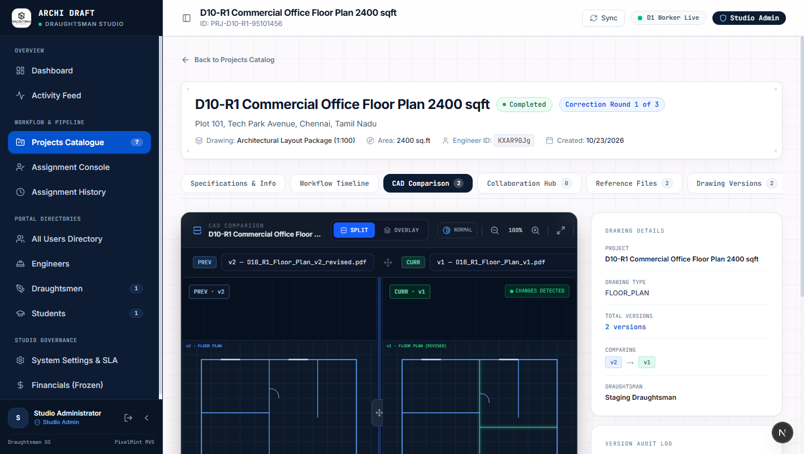
Figure: CAD Deliverables Vault and Student Assessment Rubric
Interface Element / Button | Operational Purpose & Action | System / Database Result
Deliverables File List | Lists all drawing sheets, formats (.dwg, .pdf, .zip), and exact file sizes. | Inventory of deliverables
Download CAD Package Button | Generates secure pre-signed Cloudflare R2 download URL to download all drawing files. | Direct encrypted download
SHA-256 Checksum | Cryptographic hash confirming file was not modified or corrupted in transit. | Guarantees file integrity
Release to Client Toggle | Permission switch unlocking deliverable download links on the Client Engineer Portal. | Enforces payment before release
Student Assessment Rubric | Grading scorecard (Accuracy, Layering, Line Weights) for academy student submissions. | Saves grade in student transcript

9. User & Talent Directory Administration [Route: /users]
Enables full administrative governance over studio personnel, registered client engineers, and academy students.
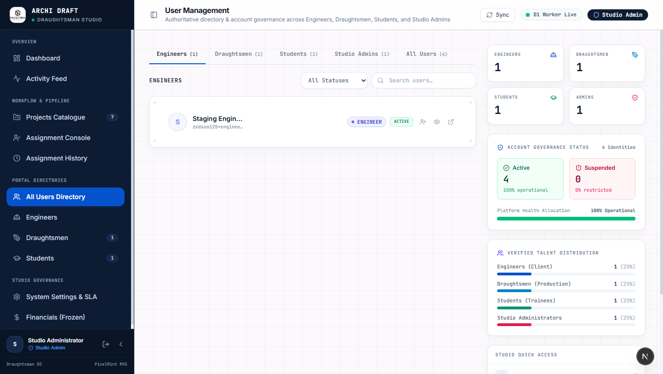
Figure: User Directory with Role Filtering and Verification Badges
Interface Element / Button | Operational Purpose & Action | System / Database Result
Role Filter Tabs | Filters user table by role: All, Studio Admins, Draughtsmen, Client Engineers, and Students. | Segmented directory views
Verification Status Pills | Displays visual badge: Verified, Pending Verification, or Suspended. | Compliance status tracking
Search & Query Field | Filters users by full name, email address, phone, or corporate affiliation. | Real-time user search
+ Add / Invite User Button | Launches invitation modal to enroll new draughtsmen or register student accounts. | Sends onboarding invitation
Context Action Menu (···) | Allows changing user role, resetting authentication password, or deactivating account. | Administrative role modification

10. Global Assignment & Workload Matrix [Route: /assignments]
Provides an overarching studio capacity overview to balance workloads, prevent delivery bottlenecks, and ensure deadlines are met.
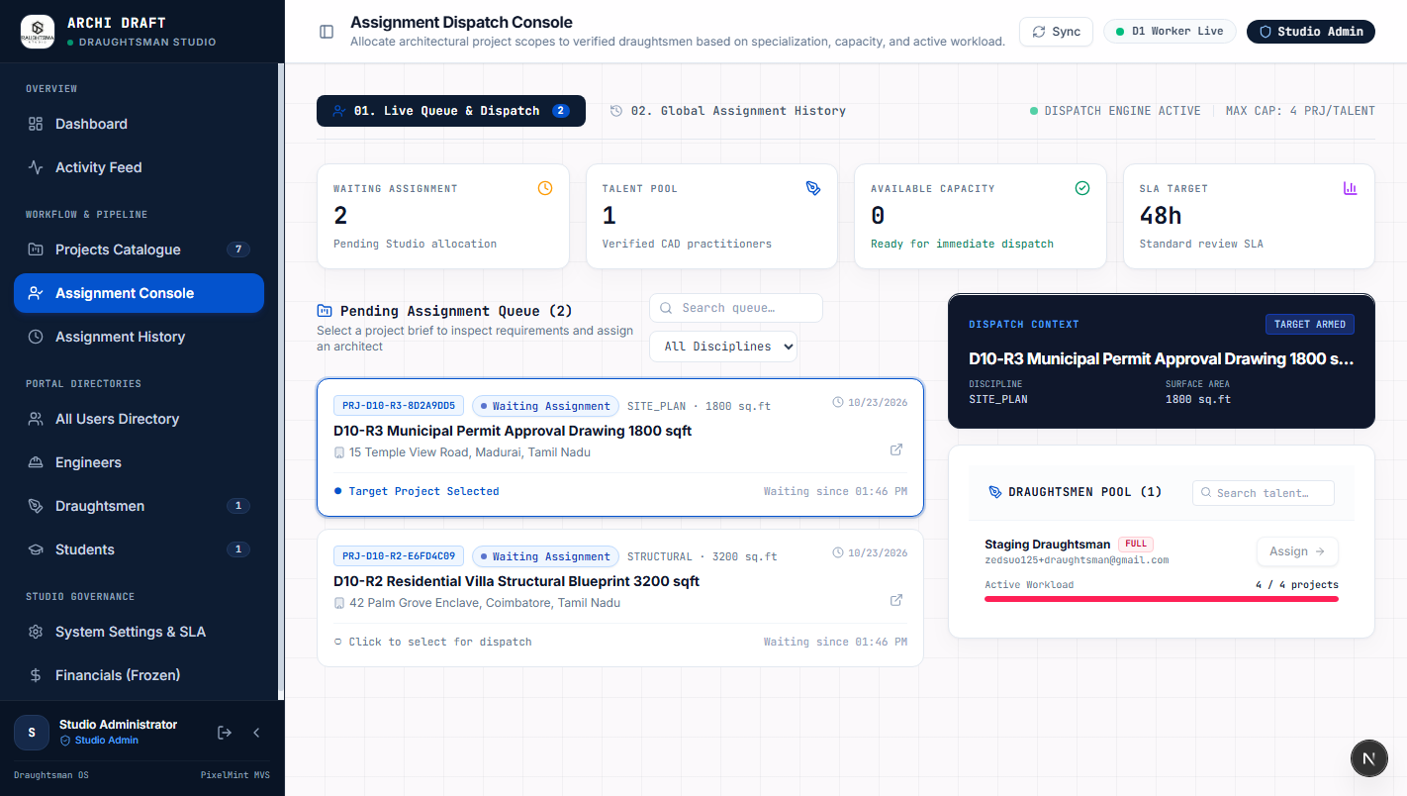
Figure: Studio-Wide Assignment Matrix and Workload Tracker
Interface Element / Button | Operational Purpose & Action | System / Database Result
Specialist Workload Table | Displays each draughtsman alongside their current active sheet counts and commitments. | Visualizes studio capacity
SLA Countdown Indicators | Color-coded tags highlighting deliverable urgency (Green >48h, Amber <24h, Red Overdue). | Proactive bottleneck alerts
Reassign Emergency Override | Transfers project from one draughtsman to another in the event of illness or delay. | Immediate reassignment in D1
Export Matrix Button | Downloads the entire studio workload ledger as a CSV or Excel spreadsheet. | Exports operational report

11. Studio Governance & Infrastructure Settings [Route: /settings]
Configures organizational profile, CAD drawing defaults, and cloud infrastructure bindings.
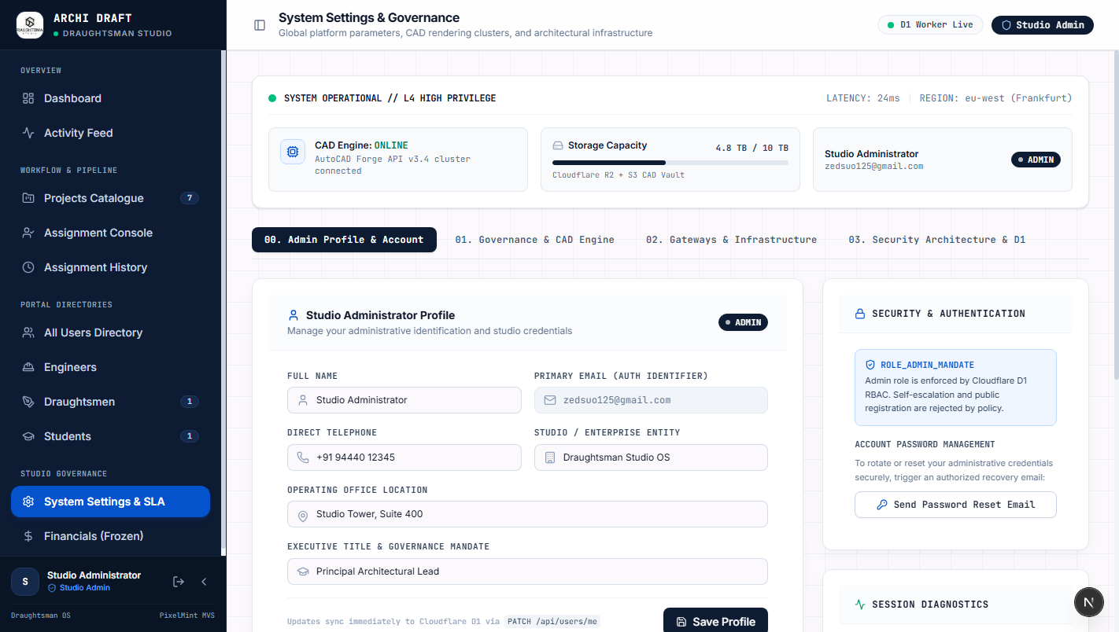
Figure: Studio Governance and Cloudflare/Firebase Settings
Interface Element / Button | Operational Purpose & Action | System / Database Result
Studio Profile Fields | Configures official studio name, primary contact email, and standard drafting unit system. | Sets system-wide defaults
Worker API Route Input | Specifies active Cloudflare Worker endpoint (imserratex.workers.dev). | Directs all frontend API calls
R2 Bucket Binding Status | Verifies active connection to archi-draft-storage-staging R2 bucket. | Confirms file storage health
Firebase Project Config | Displays connected Firebase project ID (archi-draft-staging) and web app ID. | Confirms SSO integration
Test Connections Button | Executes diagnostic ping across Cloudflare D1, R2, and Firebase Auth simultaneously. | Comprehensive health report

12. Security & Activity Audit Logging [Route: /audit]
Immutable compliance audit trail tracking every project state modification, deliverable release, and administrative access event.
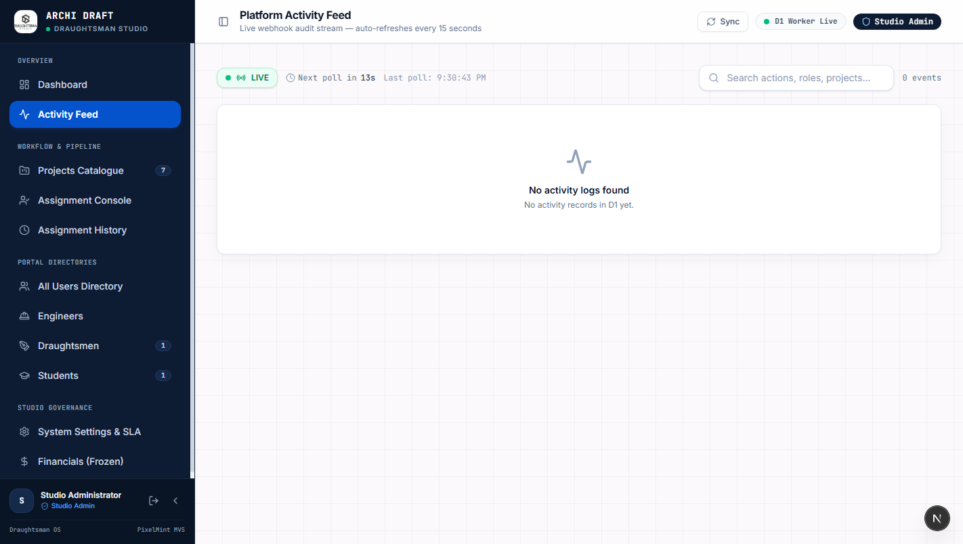
Figure: Security and Compliance Event Audit Trail
Interface Element / Button | Operational Purpose & Action | System / Database Result
Event Category Filter | Filters log events by Auth Events, Project Lifecycle, File Downloads, or Admin Actions. | Isolates audit categories
Actor Attribution Column | Displays exact email and user ID of the individual who triggered the action. | Complete accountability
IP Address & Timestamp | Records client IP address, user-agent, and exact UTC timestamp for each event. | Meets architectural compliance
Export Audit Log Button | Downloads cryptographically verifiable CSV compliance log for client reporting. | Produces compliance artifact

13. Commercial Financials & Invoicing [Route: /financials]
Coordinates architectural drafting deliverables with client accounts receivable and draughtsman payroll disbursements.
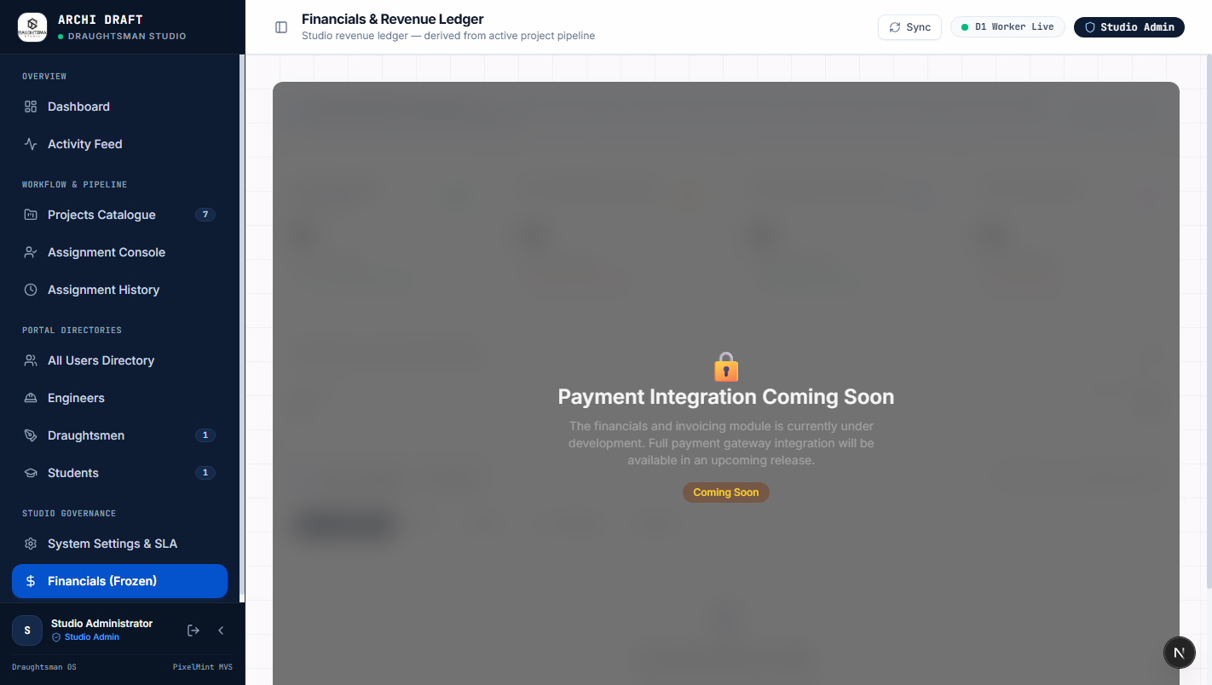
Figure: Commercial Invoicing Ledger and Drafter Disbursements
Interface Element / Button | Operational Purpose & Action | System / Database Result
Revenue Metric Cards | Displays total invoiced value, collected revenue, and outstanding receivables. | Visualizes studio cashflow
Project Invoicing Table | Tracks billing status per project: Pending Deposit, Invoiced, Paid, or Locked. | Coordinates CAD file release
Drafter Payout Ledger | Calculates contractor payouts based on approved sheet counts and square footage tier. | Automates payroll calculations
Generate Invoice Button | Generates PDF invoice detailing project milestones, drawing sheets, and bank wire info. | Produces commercial invoice

14. Daily Administrator Operating Rhythm [Operating Cheatsheet]
Recommended daily sequence for studio administrators to maximize drafting throughput and maintain zero deliverable backlog:
📌 DAILY ROUTINE CHEATSHEET
09:00 — Morning Cockpit Check: Log into /dashboard, verify green cloud health, inspect new client submissions.
10:00 — Capacity & Dispatch: Open /assignments, check drafter sheet loads, dispatch briefs in /projects.
14:00 — Redline Review & QA: Open /projects/[id], inspect submitted R1/R2 drawings, upload markups or approve.
17:00 — Asset Release & Financials: Confirm payment in /financials, toggle 'Release to Client' on approved CAD files.

