Excel
Labels, Values & Formulas

Labels and values
Entering data into a spreadsheet is just like typing in a word processing program, but you have to first click the cell in which you want the data to be placed before typing the data.
All words describing the values (numbers) are called labels. The numbers, which can later be used in formulas, are called values.
Notice also that the labels (composed of letters) are all left justified and the values (composed of numbers) are all right justified in their cells.

Simple Formula:
Click the cell in which you want the answer (result of the formula) to appear. Press Enter once you have typed the formula.
All formulas start with an = sign.
Refer to the cell address instead of the value in the cell e.g. =A2+C2 instead of 45+57. That way, if a value changes in a cell, the answer to the formula changes with it.
+ means add | e.g. A2+C2 | Add the value (number) in A2 to the value (number) in C2.
- means subtract | e.g. A2-C2 | Subtract the value (number) in C2 from the value (number) in A2.
* means multiply | e.g. A2*4 | Multiply the value (number) in A2 by 4.
/ means divide | e.g. A2/3 | Divide the value (number) in A2 by 3.

Functions
These formulas are used for working with long lists of numbers. A typical function looks like this:
=SUM(A3:A30)
- SUM is a function, meaning that it sums (adds up) the list of numbers.
- The list of numbers is indicated in brackets.
- The address of the first cell in the list is A3.
- A colon : separates this cell address from the last cell in the list, which is A30.

=SUM(B3:B9)  Adds list of values from cell B3 to cell B9 | =AVERAGE(B3:B9)  Averages the values from cell B3 to cell B9
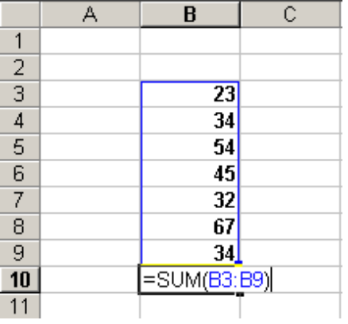 | 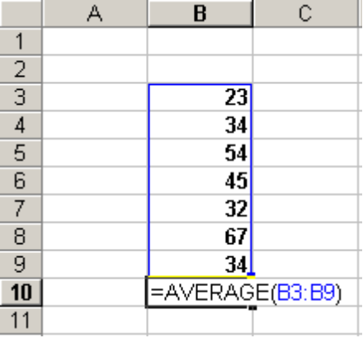

Other functions:
There are many functions that you could explore with time. SUM and AVERAGE are two of the most common, below are a few more:
SUM | adds the numbers in the list
AVERAGE | averages the numbers in the list
PRODUCT | multiplies the numbers in the list
MAX | identifies the highest number in the list
MIN | identifies the lowest number in the list
COUNT | counts the number of numerical items in the list
COUNTA | counts the number of alphabetical items in the list
COUNTIF | counts the number of items that satisfy certain criteria  e.g. =COUNTIF(A4:A20,">50") counts the number of values that are higher than 50 in the list from A4 to A20 - notice the use of the comma and quotation marks to separate the list (A4:A20) from the criteria (>50).

