**Article 4. Neighborhood 1 Zoning Districts: N1-A, N1-B, N1-C, N1-D, N1-E, N1-F**

**4.1 PURPOSE**

**4.2 USES**

**4.3 DIMENSIONAL AND DESIGN STANDARDS**

**4.4 OPEN SPACE REQUIREMENTS**

**4.5 ALTERNATIVE RESIDENTIAL DEVELOPMENT OPTIONS**

**4.6 ON-SITE PEDESTRIAN CONNECTIVITY REQUIREMENTS**

**4.7 SUPPLEMENTAL DEVELOPMENT STANDARDS**

# 4.1 PURPOSE

The Neighborhood 1 Zoning Districts respect the character and development patterns of Charlotte’s established residential neighborhoods and promote new residential neighborhood development in a manner that implements the City’s vision for the future. The N1-A through N1-E Zoning Districts allow for the development of single-family, duplex, and triplex dwellings on all lots. Additionally, quadraplex dwellings are allowed on arterial streets in these zoning districts when an affordable housing unit is provided within the dwelling. The N1-F Zoning District allows all dwelling types allowed in N1-A through N1-E Zoning Districts, as well as small-scale multi-family dwellings, and is intended for application typically on arterial streets within Neighborhood 1 Place Type.

Specific standards within each of the zoning districts address building form and promote context-sensitive, compatible neighborhood development. The Neighborhood 1 Zoning Districts also allow for select nonresidential uses, such as places of worship and educational facilities, and for the reuse of existing neighborhood commercial establishments under prescribed conditions.

A. N1-A Neighborhood 1 Zoning District

The N1-A Zoning District allows for the development of residential dwellings on lots of 10,000 square feet or greater. The N1-A Zoning District is typically applied to established neighborhoods.

B. N1-B Neighborhood 1 Zoning District

The N1-B Zoning District allows for the development of residential dwellings on lots of 8,000 square feet or greater. The N1-B Zoning District is typically applied to established neighborhoods.

C. N1-C Neighborhood 1 Zoning District

The N1-C Zoning District allows for the development of residential dwellings on lots of 6,000 square feet or greater. The N1-C Zoning District is typically applied to established neighborhoods.

D. N1-D Neighborhood 1 Zoning District

The N1-D Zoning District allows for the development of residential dwellings on lots of 3,500 square feet or greater.

E. N1-E Neighborhood 1 Zoning District

The N1-E Zoning District allows for the development of residential dwellings on lots of 3,000 square feet or greater.

F. N1-F Neighborhood 1 Zoning District

The N1-F Zoning District allows for the development of residential dwellings on lots of 3,000 square feet or greater and is intended to be applied predominantly along arterials.

# 4.2 USES

Article 15 lists permitted, temporary, and accessory uses for the Neighborhood 1 Zoning Districts. Use definitions are found in Article 15. Prescribed conditions applicable to certain principal uses, temporary uses, and accessory uses are also found in Article 15.

# 4.3 DIMENSIONAL AND DESIGN STANDARDS

**A.** **General**

**1.** The tables below include the dimensional and design standards for the Neighborhood 1 Zoning Districts. Abbreviation included shall be interpreted as follows: MF = Multi-family. (Additional abbreviations are described in Section 2.2.)

**2.** Where this Ordinance refers to frontages in general, a transit station, off-street public path, or public park shall not be considered a frontage within the Neighborhood 1 Zoning Districts.

**3.** In the tables below, where a cell contains a standard or a “✓” the standard shall be applicable. Where a cell is blank and shaded, the standard shall not apply.

B. Lot

Lot standards govern the basic dimensions of lots, including but not limited to minimum area, width, and coverage as applicable. These standards are intended to provide a rational basis for the division, organization, and development of land within the City of Charlotte.

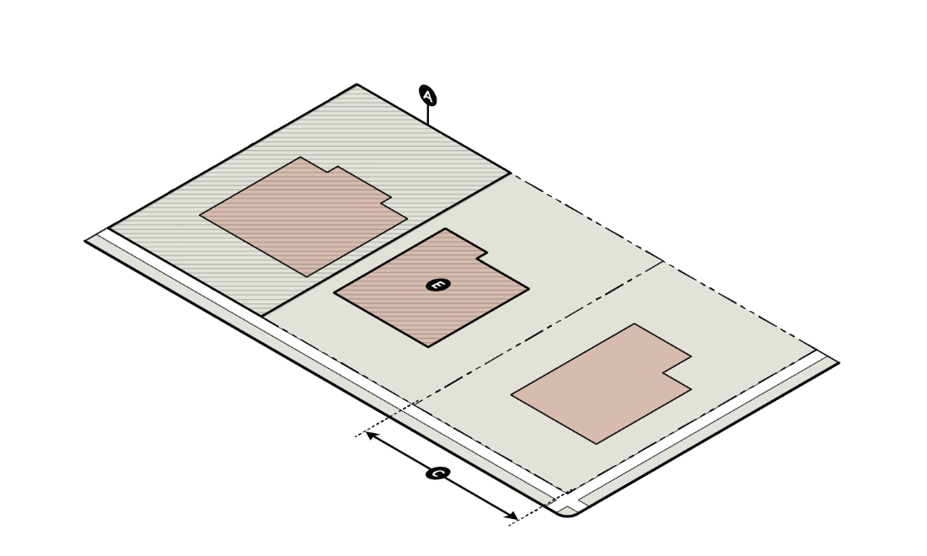

| **Table 4-1: Neighborhood 1 Zoning Districts Lot Standards1** | | | | | | | |
| --- | --- | --- | --- | --- | --- | --- | --- |
|  | | **N1-A** | **N1-B** | **N1-C** | **N1-D** | **N1-E** | **N1-F** |
| **A** | **Minimum Lot Area – Residential** (square feet) | 10,000 | 8,000 | 6,000 | 3,500 | 3,000 | 3,000 |
| **B** | **Minimum Lot Area – Nonresidential and Mixed-Use** (square feet) | 12,000 | 12,000 | 12,000 | 12,000 | 12,000 | 12,000 |
| **C** | **Minimum Lot Width – Residential** (feet) | 70 | 60 | 50 | 40 | 30 | 30  MF: 50 |
| **D** | **Minimum Lot Width – Nonresidential and Mixed-Use** (feet) | 70 | 70 | 70 | 70 | 70 | 70 |
| **E** | **Maximum Building Coverage** (%) | Lots 10,000 square feet and greater: 40  Lots Less than 10,000 square feet: 50 | | | | | |

**1** Lot Standards do not apply to individual sublots but do apply to the parcel on which the sublot(s) is located.

C. Building Siting

Building siting standards govern the placement of buildings on lots and are intended to ensure that development maintains compatibility with its surrounding context and the intent of the applicable zoning district.

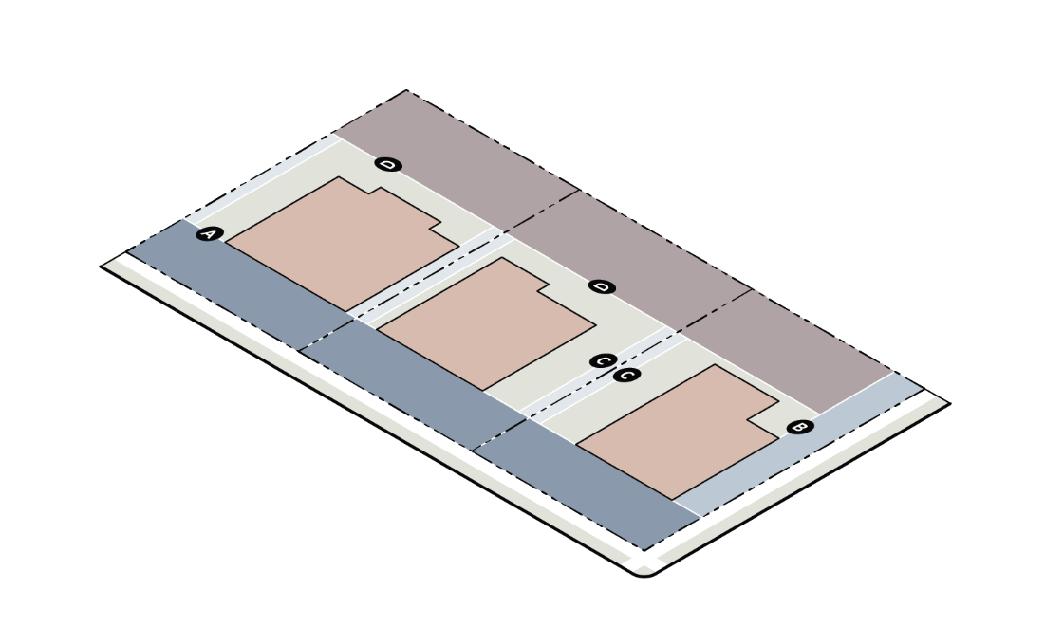

| **Table 4-2: Neighborhood 1 Zoning Districts Building Siting Standards** | | | | | | | |
| --- | --- | --- | --- | --- | --- | --- | --- |
|  | | **N1-A** | **N1-B** | **N1-C** | **N1-D** | **N1-E** | **N1-F** |
| **A** | **Min. Front Setback from Street** (Measured from Right-of-Way)(feet) **1, 2, 3, 4, 6, 7** | 27 | 27 | 17 | 17 | 10 | 17 |
| **B** | **Min. Corner Side Setback from Street** (Measured from Right-of-Way)(feet) **4, 5, 6, 7** | 13.5 | 13.5 | 10 | 10 | 10 | 10 |
| **C** | **Minimum Side Setback** (feet) | 5 | 5 | 5 | 5 | 5 | 5 |
| **D** | **Minimum Rear Setback** (feet) | 40 | 35 | 30 | 25 | 20 | 20 |
| **1** | Front setbacks shown on a plat recorded at the Register of Deeds shall supersede required zoning district front setbacks. | | | | | | |
| **2** | The following alternative setback standards may be used for an established blockface that is at least 25% developed or has at least four existing dwellings:  1. A new single-family, duplex, or triplex dwelling on an established blockface shall be located at or behind the average of the front setback of the two closest residential buildings on the same blockface.  2. In no case shall the minimum setback be less than ten feet or intrude into a required clear sight triangle at an intersection (Section 16.1). | | | | | | |
| **3** | In the case of a lot abutting both a local or collector street and a parallel arterial street (through lot), buildings shall orient toward the local or collector street. | | | | | | |
| **4** | In no case shall any building entry be located closer than six feet to an existing or proposed off-street public path or shared use path. | | | | | | |
| **5** | When the corner side setback is located along an arterial street, the corner side setback shall be subject to the minimum front setback dimension for the zoning district. | | | | | | |
| **6** | Street includes public and network-required private streets. For network-required private streets, front setback is measured from the back of curb, and shall be as indicated for the zoning district, plus an additional 14 feet. | | | | | | |
| **7** | Setbacks on existing local and collector streets shall be measured from the existing right-of-way. Setbacks on existing arterial and limited access streets shall be measured from two feet behind the future sidewalk as defined by the Charlotte Streets Map. | | | | | | |

D. Building Height

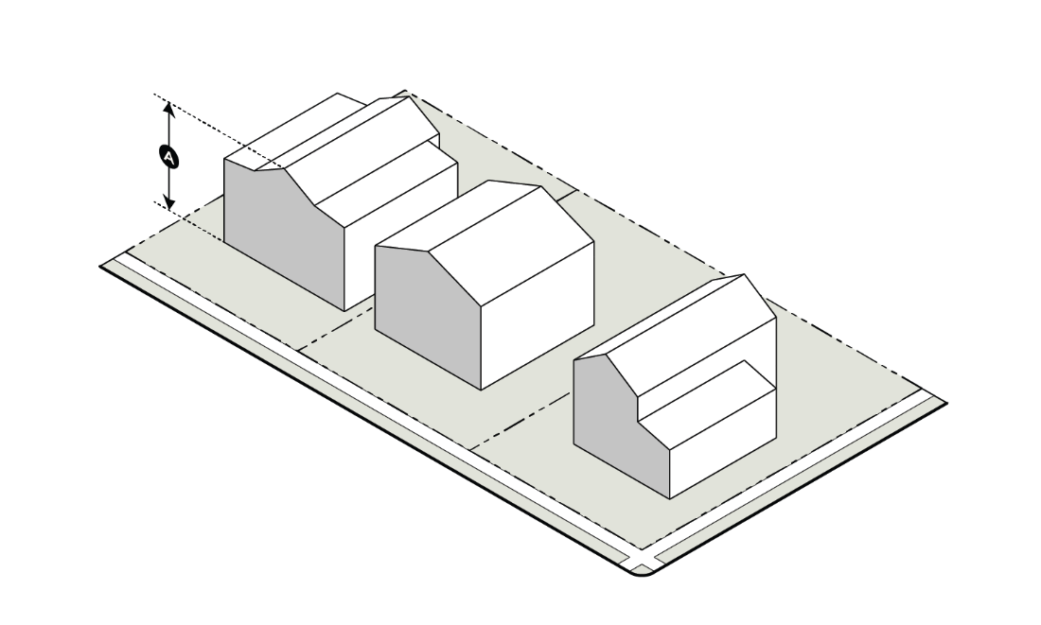Building height standards govern the maximum heights of buildings, as applicable, and are intended to provide flexibility while maintaining appropriate transitions to adjacent areas.

|  |  |  |  |  |  |  |  |
| --- | --- | --- | --- | --- | --- | --- | --- |
| **Table 4-3: Neighborhood 1 Zoning Districts Building Height Standards** | | | | | | | |
|  | | **N1-A** | **N1-B** | **N1-C** | **N1-D** | **N1-E** | **N1-F** |
| **A** | **Maximum Building Height – Residential** (feet) **1** | 48 | 48 | 40 | 40 | 40 | 48 |
| **B** | **Maximum Building Height – Nonresidential and Mixed-Use** (feet) **1,2,3** | 48 | 48 | 48 | 48 | 48 | 48 |
| **1** | The height and location of structures may be restricted by the limitations set forth in the Code of Federal Regulations (CFR) Title 14 Part 77: Safe, Efficient Use, and Preservation of the Navigable Airspace.  A notice of proposed construction FAA Form 7460-1 must be filed with the FAA for construction or alteration that impacts any of the imaginary surfaces as defined in 14 CFR Part 77 or is more than 200 feet in height above the ground at its site at least 45 days prior to construction. The Aviation Department Planning Division may serve as a point of contact for information regarding building notification requirements and obstruction evaluation. | | | | | | |
| **2** | The maximum building height of any structure within 200 feet from the lot line of residential uses or vacant land in a Neighborhood 1 Place Type is limited as follows: Portions of a structure within the first 100 feet are limited to a maximum height of 50 feet. Building heights for all portions of a structure shall be measured from the average grade established for the whole building. | | | | | | |
| **3** | Building height may be increased by one foot for each additional one foot of building setback from required side and rear setbacks to a maximum height of 65 feet. | | | | | | |

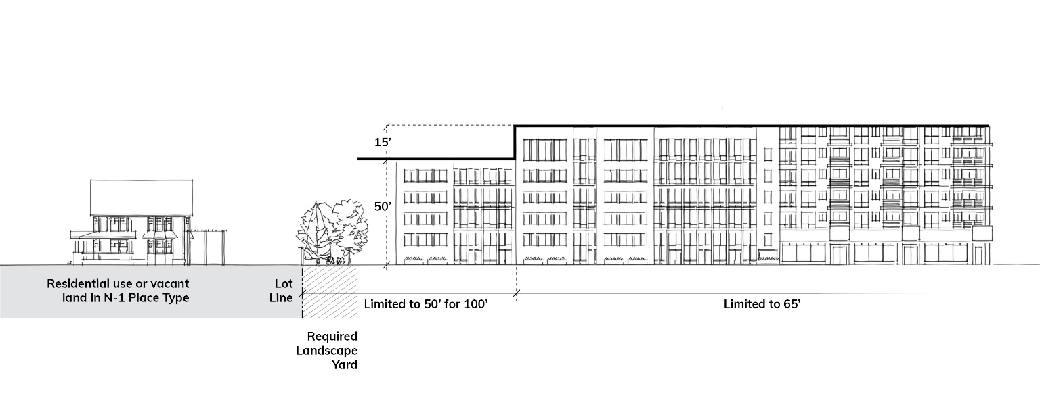

**1. Maximum Sidewall Height for Duplexes and Triplexes**

All duplex and triplex buildings within the Neighborhood 1 Zoning Districts shall meet the maximum sidewall height regulations below.

1. The sidewall height forall duplex and triplex buildings is limited to 20 feet. The sidewall height may be increased above 20 feet if the average height of the facing sidewalls of the single-family, duplex, or triplex buildings on both sides of the lot exceeds 20 feet. In such case, the sidewall height of the subject duplex or triplex building may be increased up to this average height.

**i.** Sidewalls shall be measured from the finished floor elevation at the ground floor to the eave or, if no eave is present on the building, to the bottom of the finished roof plane.

**ii.** For a lot that does not have single-family, duplex, or triplex buildings on both sides of the lot, the two closest single-family, duplex, or triplex buildings on the same blockface are used for averaging.

**iii.** When a sidewall height of greater than 20 feet is proposed, a sidewall height survey of the relevant single-family, duplex, or triplex buildings is required at the time of plan submittal.

**b.** If no single-family, duplex, or triplex buildings exist on the same blockface as a new duplex or triplex building under development, the maximum building height for the zoning district controls.

**c.** When an existing local street is extended for a new subdivision, as defined by Section 30.3.A, a 50’ wide landscape yard may be used to establish a new blockface if it meets the following:

**i.** The landscape yard shall be planted to Class B standards, per Table 20-2, for each 25’ of width of landscape yard.

**ii.** The landscape yard shall abut, and be the depth of, the last existing residential lot(s) prior to the new local street extension.

**iii.** The new blockface shall only be for the purposes of establishing the maximum sidewall height requirements of this Section.

**2. Building Height Plane for Duplexes and Triplexes**

In addition to the maximum building height requirement for the zoning district, all duplex and triplex buildings within the Neighborhood 1 Zoning Districts shall meet the building height plane regulations below.

**a.** One additional foot of height, above the maximum permitted sidewall height at the required minimum side setback, is allowed for each additional one foot in distance the portion of the building is located from the required minimum side setback. This establishes a building height plane of 45 degrees. The building height plane does not allow an increase in the maximum sidewall height. Buildings may not exceed the maximum building height of the zoning district.

**b.** Dormers and gable ends may extend into and through the 45 degree building height plane but shall comply with the maximum building height. The cumulative width of dormers extending into and through the building height plane shall be limited to 25% of the depth of the sidewall.

**BUILDING HEIGHT PLANE (DUPLEX AND TRIPLEX)**

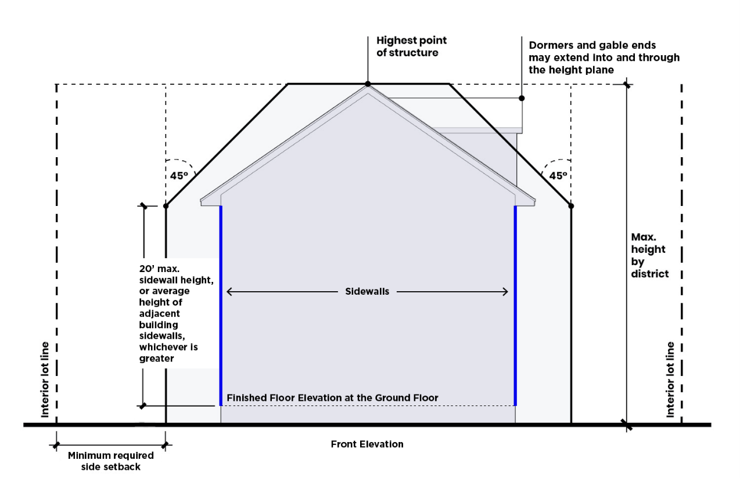

E. Building Articulation

Building articulation standards govern the dimensions of building facade elements and entry features and are intended to facilitate the enhancement of a pedestrian-oriented environment. The following standards apply only to building façades facing a frontage, except for Limited Access. The standards below apply to all uses unless a use has a specific standard. When only specific uses are cited, then the standard applies only to those uses.

|  |  |  |  |  |  |  |  |
| --- | --- | --- | --- | --- | --- | --- | --- |
| **Table 4-4: Neighborhood 1 Zoning Districts Building Articulation Standards** | | | | | | | |
|  | | **N1-A** | **N1-B** | **N1-C** | **N1-D** | **N1-E** | **N1-F** |
| **A** | **Maximum Building Length – Residential** (feet) |  |  |  |  |  | MF: 150 |
| **B** | **Maximum Building Length – Nonresidential and Mixed-Use** (feet)**2** | 300 | 300 | 300 | 300 | 300 | 300 |
| **C** | **Maximum Blank Wall Area – Residential** (Ground floor and upper floors; Horizontal or Vertical; Per building)(feet) |  |  |  |  |  | MF**1**: 20 |
| **D** | **Maximum Blank Wall Area – Nonresidential and Mixed-Use** (Ground floor and upper floors; Horizontal or Vertical; Per building)(feet) | 20 | 20 | 20 | 20 | 20 | 20 |
| **E** | **Maximum Spacing for Required Prominent Entrances - Residential** (feet) |  |  |  |  |  | MF**1**: 250 |
| **F** | **Maximum Spacing for Required Prominent Entrances – Nonresidential and Mixed-Use** (feet) | 250 | 250 | 250 | 250 | 250 | 250 |

**1** Does not apply to Multi-family Attached When Units are on Sublots.

**2** The Maximum Building Length shall be 500 feet for an Educational Facility – Primary or Secondary, for an Educational Facility – University or College, or for a Place of Worship when these uses are located on an arterial street.

F. Transparency

Transparency standards govern the required amount of ground floor and upper floor transparency and are intended to facilitate the enhancement of a pedestrian-oriented environment. The following standards apply only to building façades facing a frontage, except for Limited Access. These standards do not apply to multi-family attached development on sublots. The standards below apply to all uses unless a use has a specific standard. When only specific uses are cited, then the standard applies only to those uses.

|  |  |  |  |  |  |  |  |
| --- | --- | --- | --- | --- | --- | --- | --- |
| **Table 4-5: Neighborhood 1 Zoning Districts Transparency Standards** | | | | | | | |
|  | | **N1-A** | **N1-B** | **N1-C** | **N1-D** | **N1-E** | **N1-F** |
| **A** | **Ground Floor Transparency – Residential** (% of wall area between 3’ and 10’ from grade; Per building) |  |  |  |  |  | MF: 25 |
| **B** | **Ground Floor Transparency – Nonresidential and Mixed-Use** (% of wall area between 3’ and 10’ from grade; Per building) | 30 | 30 | 30 | 30 | 30 | 30 |
| **C** | **Upper Floor Transparency – Residential** (% of Wall Area per Story; Per building) |  |  |  |  |  | MF: 15 |
| **D** | **Upper Floor Transparency – Nonresidential and Mixed-Use** (% of Wall Area per Story; Per building) | 15 | 15 | 15 | 15 | 15 | 15 |

G. Site Layout Standards

**1. Residential Site Layout Standards**

The table below establishes site layout standards for multi-family attached, both when located on and when not located on sublots, multi-family stacked, and triplex and quadraplex development. Multi-dwelling developments are also subject to the prescribed conditions in Article 15.

|  |  |  |  |  |
| --- | --- | --- | --- | --- |
| **Table 4-6: Neighborhood 1 Zoning Districts Residential Site Layout Standards** | | | | |
|  | **Multi-family Attached When Units Not On Sublots** | **Multi-family Stacked** | **Multi-family Attached**  **When Units On Sublots** | **Triplex / Quadraplex** |
| The primary pedestrian entry to each principal structure abutting a frontage shall face the frontage. On corner lots, the primary pedestrian entry of the principal structure closest to the intersection may be oriented to either frontage.  If a principal structure abuts both a frontage and common open space perpendicular to the frontage, the primary pedestrian entry may face the common open space**1** if it meets the following:   1. The common open space has a minimum width of 50' for the length of the common open space provided. 2. The common open space has a maximum length of 500'.   Principal structures not abutting a frontage do not have to orient primary pedestrian entries to a frontage or common open space. | ✓ | ✓ |  |  |
| The sidewalls of each principal structure abutting a frontage shall be oriented perpendicular to the frontage. On corner lots, sidewalls of the principal structure closest to the intersection may be oriented perpendicularly to either frontage.  If a principal structure abuts both a frontage and common open space, the sidewalls may orient perpendicularly to the common open space**1** if it meets the following:   1. The common open space has a minimum width of 50' for the length of the common open space provided. 2. The common open space has a maximum length of 500'.   Principal structures not abutting a frontage do not have to orient sidewalls perpendicularly to a frontage or common open space. |  |  | ✓ | ✓ |

1 Common open space shall also comply with the standards of Table 16-2: Design of Open Space.

H. Building Design Standards

**1. Residential Building Design Standards**

The table below establishes building design standards for multi-family stacked and multi-family attached development when not on sublots within the Neighborhood 1 Zoning Districts.

**RESIDENTIAL BUILDING DESIGN STANDARDS**

**(MULTI-FAMILY STACKED AND MULTI-FAMILY ATTACHED WHEN NOT ON SUBLOTS)**

| **Table 4-7: Neighborhood 1 Zoning Districts Residential Building Design Standards** | | | |
| --- | --- | --- | --- |
|  | | **Multi-family Attached When Not On Sublots** | **Multi-family Stacked** |
| The primary pedestrian entry shall be a prominent entrance along a frontage as defined by this Ordinance, except for a Limited Access frontage. In the case of a building with individual units with multiple exterior entrances, at least one of the entrances for each individual unit shall be a prominent entrance and that entrance shall be located on the highest frontage classification as per the hierarchy in Section 3.5.D. | | ✓ | ✓ |
| All ground floor entrances to individual units on a frontage with a sidewalk shall be between 1’ and 5’ above the grade of the adjacent sidewalk when located within 10’ of the back of sidewalk. Residential units located below the grade of the adjacent sidewalk are permitted to have below-grade entrances, which shall be between 1’ and 3’ below the grade of the adjacent sidewalk. 1 | | ✓ | ✓ |
| Structures shall incorporate elements of variation on any façade facing a frontage, public open space, or common open space. Variation shall be achieved as follows:  1. For multi-family attached buildings when not on sublots, one of the following shall be incorporated into the design of the structure:  a. Variation in the façade depth of adjoining dwelling units of at least 3’. Such variation shall extend the entire height of the façade.  b. Architectural features, such as balconies, bay windows, or other elements along the façade of each dwelling unit, subject to the standards of Article 18.  2. For multi-family stacked buildings 150’ or more in length, recesses or projections of the façade of at least 1’ in depth, and no less than 10’ in width are required at intervals of no more than 60’ linearly. This shall not be required on any portion of a multi-family stacked building 50’ or more in height above average grade. | | ✓ | ✓ |
| Windows, doors, porches, or other architectural features are required on all frontage-facing facades to avoid the appearance of blank walls. | | ✓ | ✓ |
| **1** | Zoning Administrator may allow adjustments to standards if adjacent average sidewalk slope is greater than 10% or to comply with federal and state law. | | | |

**2. Nonresidential and Mixed-Use Building Design Standards**

The following design standards apply to nonresidential and mixed-use buildings in the Neighborhood 1 Zoning Districts.

**NONRESIDENTIAL AND MIXED-USE BUILDING DESIGN STANDARDS**

**a.** A frontage shall have a minimum of one prominent entrance, as defined in this Ordinance. This does not apply to Limited Access roads. The number of prominent entrances required shall be determined by the building length along the frontage and the maximum spacing in F of Table 4-4.

**i.** In the case of a building with two frontages located on a corner, one prominent entrance located on the corner may count as a required prominent entrance for both frontages, subject to the following:

**(A)** A prominent corner entry shall include design features that reinforce intersections as key locations for pedestrian activity. Two of the following shall be included:

**(1)** A chamfered or rounded corner design.

**(2)** Awnings, canopies, or other covered entry features.

**(3)** Special paving, landscape, or lighting features.

**(4)** Unique architectural detailing that emphasizes the corner entry.

**b.** A minimum of one prominent entrance on the ground floor is required per building on a site.

**c.** A minimum of one ground floor entrance along each frontage facing façade, except for a Limited Access frontage, shall include a pedestrian connection between doors and adjacent pedestrian facilities, where such facilities are present or are required by this Ordinance. The Zoning Administrator may waive this requirement if they determine that the nature of the use does not require such pedestrian connections, for example warehouse and distribution centers, airports, truck and rail freight terminals, and other similar uses.

**d.** Pedestrian-oriented ground-floor designs are encouraged, including arcades, galleries, colonnades, outdoor dining areas, and outdoor plazas.

I. Building Material Restrictions

The building material restrictions apply to the following development in the Neighborhood 1 Zoning Districts: nonresidential development, mixed-use buildings, multi-family stacked, and multi-family attached when not on sublots.

**1.** The following building materials are limited to 25% of each façade along a frontage. They may also be used as a component of construction when not a surface finish material without limitation.

**a.** Corrugated metal siding; however, the reuse of pre-fabricated shipping containers is permitted and is not subject to this limitation, subject to compliance with the building code and other applicable codes

**b.** Exterior insulation finishing systems (EIFS) is prohibited on the ground floor of a multi-family dwelling (the 25% permission in item 1 above does not apply)

**c.** Plain concrete masonry units (CMU)

**d.** Plastic

**e.** T-111 composite plywood siding

**f.** Vinyl

# 4.4 OPEN SPACE REQUIREMENTS

New construction of a principal building of 1,000 square feet or greater and/or expansion of buildings by 5,000 square feet or 20% of the building area, whichever is less, is required to provide open space as specified in this section.

A. Residential On-Site Open Space

On-site open space is required in the N1-F Zoning District for all multi-family and multi-dwelling developments in accordance with the following:

**1.** For multi-family stacked and multi-dwelling developments, a minimum of 10% of the site area shall be designed as on-site open space. Such open space may be private open space, common open space, public open space, or any combination thereof. For multi-family attached dwellings which are components of multi-dwelling developments, the provisions of item 2 below, as applicable by appropriate zoning district, may be used in lieu of this requirement.

**2.** Multi-family attached development shall provide a minimum of 250 square feet of open space per dwelling unit. Such open space may be private open space, common open space, public open space, or any combination thereof.

**3.** Residential on-site open space shall meet the design requirements of Section 16.5.

**4.** Residential on-site open space may be provided as land dedicated to Mecklenburg County Park and Recreation, a fee-in-lieu provided to Mecklenburg County Park and Recreation, or a combination thereof in accordance with the requirements of Section 16.5.

**5.** For projects with multiple phases, the open space required for each phase, per this Section, shall be installed prior to completion of that phase.

B. Nonresidential and Mixed-Use On-Site Open Space

**1.** Nonresidential and mixed-use development in the Neighborhood 1 Zoning Districts is required to provide on-site open space, except for developments on sites of one-half acre or less in size.

**2.** Development shall provide a minimum of 10% of the site area in on-site open space. Such open space may be common open space, public open space, or any combination thereof.

**3.** Nonresidential and mixed-use on-site open space shall meet the design requirements of Section 16.5.

**4.** Nonresidential and mixed-use on-site open space may be provided as land dedicated to Mecklenburg County Park and Recreation, a fee-in-lieu provided to Mecklenburg County Park and Recreation, or a combination thereof in accordance with the requirements of Section 16.5.

**5.** For projects with multiple phases, the open space required for each phase, per this Section, shall be installed prior to completion of that phase.

# 4.5 ALTERNATIVE RESIDENTIAL DEVELOPMENT OPTIONS

A. Conservation Residential Development

A conservation residential development permits a reduction in minimum lot size in exchange for the provision and conservation of green area and common open space beyond the requirements of this Ordinance. The purpose of the conservation residential development standards is to protect open space and/or natural resources and features through alternative development standards. The intent of the conservation residential development standards of this Section is to emphasize the importance of the conservation of natural areas and important habitats, enhance surface water quality, maintain and enhance tree canopy and provide useable common open space for residents.

**1. Applicability**

Conservation residential development is permitted in the N1-A, N1-B, and N1-C Zoning Districts. A conservation residential development site shall be a minimum of five acres. The conservation residential development provisions shall not be paired with the Voluntary Mixed Income incentives of Section 4.5.B. or the Compact Residential Development option of Section 4.5.C.

**2. Development Standards**

Where there are comparable development standards in the N1-A, N1-B, and N1-C Zoning Districts, the development standards below replace those development standards. All other applicable UDO standards apply unless stated otherwise.

**a. Site Layout**

**i.** All lots within a conservation residential development shall front a public street, common open space, or green area. All applicable emergency access requirements must be met regardless of lot frontage.

**ii.** A 25 foot Class B landscape yard shall be provided along the perimeter of a conservation residential development site, except for where the site abuts an existing public street or network required private street. The perimeter landscape yard shall not be in a lot or sublot and shall not count toward any required common open space. As an alternative, a 30 foot perimeter landscape yard that meets the planting standards of a Class B landscape yard per Table 20-2 may be counted toward green area credits if the standards of Section 20.15.E (Tree Save Standards) are also met.

**iii.** The maximum number of lots permitted within a conservation residential development is determined by the gross acreage of the site, exclusive of the rights-of-way for existing public streets, divided by the minimum lot area of the zoning district.

**iv.** Lots within the conservation residential development shall meet the standard lot requirements of the underlying zoning district with the exception of the following:

**(A)** Minimum lot area and minimum lot width may be reduced by 50%.

**(B)** Maximum building coverage does not apply to lots of 5,000 square feet or less.

**v.** Minimum setbacks apply as follows:

**(A)** A minimum side setback of five feet applies to all lots within a conservation residential development.

**(B)** A minimum corner side setback of ten feet applies to all corner lots within a conservation residential development.

**(C)** Front and rear setbacks may be reduced by 50% for all lots within the conservation residential development, unless otherwise specified below.

**(D)** Where a lot within a conservation residential development fronts on a common open space or green area, the front setback shall be five feet behind the property line abutting the common open space or green area.

**(E)** Where a garage is accessed from an alley and parking is not located between the garage and alley, the garage shall be located between five and seven feet from the edge of pavement of an alley. Where parking spaces are located between a garage and an alley, the garage shall be located at least 20 feet from the edge of pavement of the alley.

**(F)** The driveway requirements of Section 19.6.A.1 are applicable in a conservation residential development unless otherwise noted in this Section.

**(G)** Where a lot within the conservation residential development abuts a public or network-required private street at the perimeter of the conservation residential development, minimum front setback and minimum lot width shall be in accordance with the underlying zoning district requirements.

**(H)** Where common open space abuts a public or network-required private street at the perimeter of a conservation residential development, the minimum front setback and minimum lot width for any lot fronting on this common open space shall be in accordance with the underlying zoning district requirements.

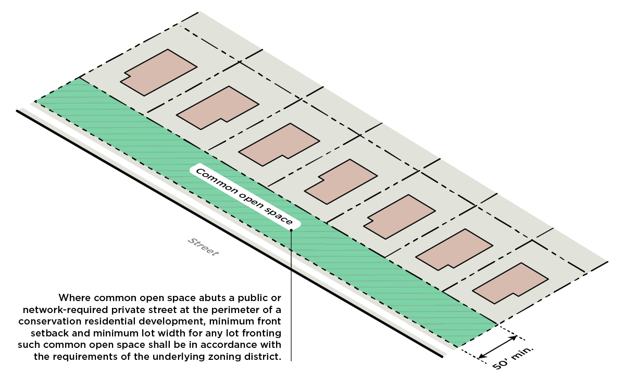

**vi.** Alleys where all lots on at least one side of the alley front a public street are not limited in length. Alleys shall not exceed 200 feet in length for the following:

**(A)** Lots on both sides of the alley front on common open space or green area.

**(B)** Lots on one side of the alley front on common open space or green area and no residential lots exist on the opposite side of the alley.

**vii.** In addition to any required parking, the conservation residential development shall provide one visitor parking space for every four units in the development site.

**(A)** Any required visitor parking spaces may be satisfied through on-street parking or one or more common parking lots.

**(B)** No common parking lot shall contain more than ten parking spaces.

**b. Conservation Protection Area**

**i.** A minimum of 40% of a conservation residential development shall comprise conservation protection area. For the conservation protection area, 30% of the overall site shall be green area and 10% of the overall site shall be common open space. The 30% green area shall be inclusive of the base 15% requirement for green area per Section 20.15.D. The standards of Table 16-2 for common open space do not apply for conservation residential development. Additional standards for green area and common open space are as follows:

**(A)** Green area credits shall be used to achieve required green area. Green area credits are based on the corresponding multipliers for each credit and found in Table 20-5.

**(B)** Trees on private lots or sublots shall not count toward required green area.

**(C)** Dimensions of required green areas are subject to the requirements of Section 20.15.

**(D)** Green areas fronted by residential lots shall have a minimum width of 50 feet.

**(E)** Required common open space areas need not be contiguous, but each common open space area shall have a minimum dimension of at least 50 feet in all dimensions.

**(F)** All required common open space areas shall have a minimum frontage of 50 feet on a public street.

**(G)** At least one common open space area shall be accessible from all residential lots in the conservation residential development within a 1,000 foot radius of the common open space area. This radius is measured in a straight line from the lot line, without regard for street, sidewalk or trail connections, to the nearest point of the open space. Multiple common open space areas may be needed to meet this requirement.

**(H)** Easements for above-ground utilities located within the site area shall not count toward required common open space.

**(I)** The required common open space shall be improved for either active or passive use.

**(1)** The required common open space area shall be improved with grass, live groundcover, shrubs, plants, trees, or usable outdoor hardscape features, such as courtyards, walkways, seating areas, patios, or fountains/water features.

**(2)** Usable outdoor amenities, such as grills, pools, tennis courts, or playgrounds, are permitted as part of the required common open space area.

**(J)** No more than 25% of the required common open space area shall be covered by water. These bodies of water shall not be part of a stormwater control measure.

**(K)** Residential lots fronting common open space per Section 2.a.i. above shall provide perimeter trees at a rate of one large maturing tree for every 40 feet of lot width. Perimeter trees may be located anywhere within the common open space area abutting said lots and need not be arranged along the edge of the open space, subject to the tree planting requirements of Section 20.17.B.

**(L)** Structures located within any required common open space shall be accessory to any recreational use of the space.

**(M)** Structures located in designated green areas shall be subject to the requirements of Article 20.

**(N)** Retaining walls in required common open space areas shall be limited to five feet in height. Retaining walls are not permitted within 10 feet of a green area.

**(O)** Landscape yards shall not be located on private lots or sublots.

**ii.** Green area and common open space may be conveyed as follows:

**(A)** To Mecklenburg County in support of the Mecklenburg County Park and Recreation Department, if accepted by the County.

**(B)** To a conservation organization approved by the City, if accepted by the designated organization.

**(C)** To one or more homeowner’s associations.

**iii.** Green area and common open space shall not be sold.

**iv.** Green area and common open space shall have no development rights except when these areas are improved for active or passive recreational purposes.

B. Voluntary Mixed-Income Residential Development

A voluntary mixed-income residential development allows for an increase in development intensity in exchange for the provision of a mixture of affordable and market-rate housing units, expanding housing options and opportunities within the City. The voluntary mixed-income residential development provisions shall not be paired with the conservation residential development incentives of Section 4.5.A.

**1. Applicability**

Voluntary mixed-income residential development is permitted in the N1-A, N1-B, N1-C, and N1-D Zoning Districts.

**2. Development Bonus**

In exchange for setting aside affordable housing units, voluntary mixed-income residential developments may receive a bonus allowing for the development of property in accordance with the standards of a zoning district of greater intensity as follows:

**a.** Property zoned the N1-A Zoning District may be developed in accordance with the standards

of the N1-C Zoning District.

**b.** Property zoned the N1-B Zoning District may be developed in accordance with the standards

of the N1-D Zoning District.

**c.** Property zoned the N1-C Zoning District may be developed in accordance with the standards

of the N1-E Zoning District.

**d.** Property zoned the N1-D Zoning District may be developed in accordance with the standards

of the N1-E Zoning District.

*An example of a calculation of bonus lots is as follows: If the N1-A Zoning District allows 100 lots and the N1-C Zoning District allows 167 lots, then there are 67 bonus lots. (167 lots minus 100 lots).*

**3. Affordability Set-Aside**

**a.** All units constructed on 50% of the bonus lots accommodated through the development bonus shall be developed as affordable units set aside for households earning 80% Area Median Income (AMI) or less. The period of affordability shall be 15 years for rental properties and the City or a nonprofit shall have first right of refusal for for-sale properties.

**b.** AMI averaging is permitted; however, no unit designated as affordable shall be set aside for households earning more than 100% AMI.

**c.** For lots on arterial streets, any affordable units required for a quadraplex dwelling are in addition to the required number of affordable units in item a above.

**4. Development Standards**

**a.** A minimum contiguous development site of one acre is required for a voluntary mixed-income residential development. No fewer than two affordable units may be developed as part of a voluntary mixed-income development receiving a development bonus.

**b.** Development standards applicable to a voluntary mixed-income development shall be those of the zoning district achieved through the development bonus.

**c.** Affordable housing units provided as a component of the voluntary mixed-income residential development shall be distributed throughout the development, not concentrated in any one structure or area of the site, unless the total affordable housing units in the development is five or fewer.

**5. Compliance and Monitoring**

Voluntary mixed-income residential developments are subject to monitoring to ensure continued compliance with the standards of this section, and in accordance with Section 2.1 of the UDO Zoning Administration Manual.

**C. Compact Residential Development**

A compact residential development permits a reduction in lot size and setbacks in exchange for the provision of common open space beyond the requirements of this Ordinance. The purpose of these compact residential development standards is to align residential development standards with current development and design patterns to support increased access to housing.

**1. Applicability**

**a.** Compact residential development is permitted in the N1-A, N1-B, N1-C, and N1-D Zoning Districts. A compact residential development site shall include at least one parcel with a minimum size of two acres as of June 1, 2023. If the site does not include at least one parcel of two acres or more, assembly of multiple parcels into a parcel of two acres or more is allowed when either of the following conditions are met:

**i.** At least one of the parcels in the assemblage has frontage on an arterial street of four lanes or more, per the Charlotte Streets Map.

**ii.** The assemblage includes no more than three separate parcels to achieve the minimum two-acre requirement. If the minimum two-acre requirement is met, additional parcels may be added to the assemblage.

**b.** The compact residential development option shall not be used on a parcel, or a portion thereof, included in the 65 DNL contour on the most recently published Airport Noise Exposure Map for Charlotte-Douglas International Airport, nor the Critical and Protected Watershed Areas (Article 23).

**c.** The compact residential development provisions shall not be paired with the Conservation Residential Development option of Section 4.5.A or the Voluntary Mixed Income incentives of Section 4.5.B.

**2. Development Standards**

Where there are comparable development standards in the N1-A, N1-B, N1-C, and N1-D zoning districts, the development standards below replace those development standards. All other applicable UDO standards apply unless otherwise stated.

**a. Site Layout**

**i.** All lots within a compact residential development shall front a public street or common open space. However, no more than 30% of residential lots on the development site shall front on common open space. All applicable emergency access requirements must be met regardless of lot frontage.

**ii.** A 25 foot Class B landscape yard shall be provided along the perimeter of a compact residential development site where the site abuts the Neighborhood 1 Place Type, except for where the site abuts an existing public street or network required private street. The perimeter landscape yard shall not be in a lot or sublot and shall not count toward any required common open space. As an alternative, a 30 foot perimeter landscape yard that meets the planting standards of a Class B landscape yard per Table 20-2 may be counted toward green area credits if the standards of Section 20.15.E (Tree Save Standards) are also met.

**iii.** No landscape yard is required between lots fronting an external street and abutting property in a Neighborhood 1 Place Type. This allowance does not exempt a compact residential development from the landscape yard requirements of Sections 20.10 and 20.11.

**iv.** Lots within a compact residential development shall meet the following standards:

|  |  |  |  |  |  |
| --- | --- | --- | --- | --- | --- |
| **Table 4-8: Compact Residential Development Standards** | | | | | |
|  | | **N1-A** | **N1-B** | **N1-C** | **N1-D** |
| **A** | **Minimum Front Setback** (feet)1 | 10 | 10 | 5 | 5 |
| **B** | **Minimum Corner Side Setback** (feet) | 10 | 10 | 5 | 5 |
| **C** | **Minimum Side Setback** (feet) | 5 | 5 | 5 | 5 |
| **D** | **Minimum Rear Setback** (feet)**1** | 15 | 10 | 10 | 10 |
| **E** | **Minimum Lot Area – Residential** (square feet) | 5,000 | 4,000 | 3,000 | 3,000 |
| **F** | **Minimum Lot Width – Residential** (feet) | 50 | 40 | 30 | 30 |
| **G** | **Maximum Building Coverage (%)** |  |  |  |  |

**1** The rear setback may be reduced to 5 feet if the parking and garages for all units in a building are accessed from an alley to the rear of the building. This reduction shall be available when the front setback is increased by five feet.

**(A)** Where a lot within a compact residential development fronts on a common open space, the front setback shall be five feet behind the property line abutting the common open space.

**(B)** Where a lot within the compact residential development abuts a public or network-required private street at the perimeter of the compact residential development, the minimum front setback shall be in accordance with the underlying zoning district requirements.

**(C)** Where a garage is accessed from an alley and parking is not located between the garage and alley, the garage shall be located between five and seven feet from the edge of pavement of an alley. Where parking spaces are located between a garage and an alley, the garage shall be located at least 20 feet from the edge of pavement of the alley.

**(D)** The driveway requirements of Section 19.6.1 are applicable in a compact residential development unless otherwise noted in this Section.

**v.** The maximum height for buildings in a compact residential development is 48 feet. The maximum sidewall height standards for duplexes and triplexes in Section 4.3.D.1 shall apply.

**vi.** Alleys where lots on both sides of the alley front on common open space shall not exceed 200 feet in length. Alleys where all lots on at least one side of the alley front a public street are not limited in length. Alleys that connect at either end to a public street within the development are also not limited in length.

**vii.** Alleys shall not be located within the property boundaries of lots or sublots.

**b. Common Open Space and Green Area**

**i.** A minimum of 10% of the compact residential development site area shall be comprised of common open space. The standards of Table 16-2 for common open space do not apply for compact residential development. The site shall also meet the base 15% green area requirement and standards per Section 20.15.D. Additional standards for common open space and green area:

**(A)** Required common open space areas may be noncontiguous, but each area of common open space shall have a minimum dimension of at least 50 feet in all dimensions. Common open space areas located between lots shall have a minimum dimension of at least 50 feet in all dimensions.

**(B)** All required common open space areas shall have a minimum frontage of 50 feet on a public street.

**(1)** In lieu of a 50 foot minimum frontage on a public street, a 20 foot wide connection that includes a minimum six foot wide hardscape path may be provided to connect common open space to the public street.

**(2)** The 20 foot wide connection shall not count toward the required common open space.

**(C)** At least one common open space area shall be accessible from all residential lots in the compact residential development within a 1,000 foot radius of the common open space area. This radius is measured in a straight line from the lot line, without regard for street, sidewalk or trail connections, to the nearest point of the open space. Multiple common open space areas may be needed to meet this requirement.

**(D)** Required common open space shall not include more than 25% of its area for above-ground utilities easements.

**(E)** The required common open space shall be improved for either active or passive use.

**(1)** The required common open space area shall be improved with grass, live groundcover, shrubs, plants, trees, or usable outdoor hardscape features, such as courtyards, walkways, seating areas, patios, or fountains/water features.

**(2)** Usable outdoor amenities, such as grills, pools, tennis courts, or playgrounds, are permitted as part of the required common open space area.

**(F)** No more than 25% of the required common open space area shall be covered by water. Such water shall not be part of a stormwater control measure.

**(G)** Residential lots fronting common open space per Section 2.a.i above shall provide perimeter trees at a rate of one large maturing tree for every 40 feet of lot width. Perimeter trees may be located anywhere within the common open space area abutting said lots and need not be arranged along the edge of the open space, subject to the tree planting requirements of Section 20.17.B.

**(H)** Structures located within any required common open space shall be accessory to any recreational use of the space.

**(I)** Retaining walls in required common open space areas shall be limited to five feet in height. Retaining walls are not permitted within 10 feet of a green area.

**(J)** Trees on private lots or sublots, except for preserved heritage trees as defined by Section 2.3 and governed by Section 20.14, shall not count toward the green area (tree save) requirements of Section 20.15.

**(K)** Landscape yards shall not be located on private lots or sublots.

**ii.** Common open space and green area may be conveyed as follows:

**(A)** To Mecklenburg County in support of the Mecklenburg County Park and Recreation Department, if accepted by the County.

**(B)** To a conservation organization approved by the City, if accepted by the designated organization.

**(C)** To one or more homeowner’s associations.

**(D)** Green area and common open space shall not be sold.

**iii.** Green area and common open space shall have no development rights except when these areas are improved for active or passive recreational purposes.

# 4.6 ON-SITE PEDESTRIAN CONNECTIVITY REQUIREMENTS

Standards for required on-site pedestrian connectivity are found in Section 16.6.

# 4.7 SUPPLEMENTAL DEVELOPMENT STANDARDS

A. General Development Standards

General development standards are found in Article 16.

B. Accessory Structures

Standards for accessory structures are found in Article 17.

C. Architectural Features

Standards for architectural features are found in Article 18.

D. Off-Street Parking

Standards for off-street parking and bicycle parking are found in Article 19.

E. Landscaping and Screening

Landscaping and screening standards are found in Article 20.

F. Loading and Service

Standards for loading spaces and service areas are found in Article 21.

G. Signs

Standards for signs are found in Article 22.

**H. Drainage**

Standards for drainage are found in Article 24.