

Hypermarket · I N T E R N A L S Y S T E M S

S Y S T E M D O C U M E N TAT I O N
Inventory & Sales Database System
Technical Documentation & User Manual


Prepared by
Osamah Esam Amayiri · Database Developer

Version 1.0
June 2026

Contents

Part 1 — About this document
  - Purpose and audience 4
  - The problem this system solves 4

Part 2 — Technical Documentation

2.1 | System overview | 5
2.2 | Technology used | 5
2.3 | Database structure (the five tables) | 6
2.4 | How the tables connect | 7
2.5 | Data rules and integrity (constraints) | 7
2.6 | How the application is organised | 8
2.7 | Data flow diagram (DFD) | 9
2.8 | Process flowcharts | 10
2.9 | Installation & setup guide | 12
2.10 | Maintenance & backup procedures | 12
Part  3.1 | 3 — User Manual  Welcome | 13
3.2 | Logging in | 13
3.3 | What you can see (your role) | 14
3.4 | Adding a new product | 14
3.5 | Recording a sale | 15
3.6 | Viewing suppliers, customers & staff | 16
3.7 | Running reports (managers) | 16
3.8 | Messages you may see | 17
3.9 | Moving around & logging out | 17
3.10 | Quick answers (FAQ) | 18

Part 1 — About this document

Purpose and audience

This document describes the HyperMax inventory and sales database system. It is written in two parts so that two different readers each get what they need:

This part… | Is written for… | And helps them…
Technical Documentation | The IT team and any future developer | Understand how the system is built, set it up, and keep it running

User Manual Store staff — managers, sales staff, stock clerks
Use the application for daily work, step by step

The problem this system solves

Before this system, HyperMax managed products, stock, suppliers and sales using separate spreadsheets. That approach caused three recurring problems:
Reports are produced instantly from live data with one click
Slow, manual reports
How the new system fixes it
Old problem
Stock count errors and stockouts Stock updates automatically the moment a sale is recorded
Bad data (wrong prices, typos, duplicates) Built-in rules block invalid data before it can be saved

The result is one connected system where every record is accurate, protected, and instantly available.



02

Technical Documentation
For the IT team and future developers. Covers the system design, database structure, data flow, setup, and maintenance.

System overview

The solution has two parts that work together:
A Microsoft SQL Server database named HyperMaxStoreDB . It stores all the
store's data in five connected tables and protects it with built-in rules.
The database
What it does
Part
The application A desktop application (C# Windows Forms). Staff use simple screens and buttons; the application sends the correct database commands for them and shows the results.

Key design idea
Staff never type database commands. The application always sits in the middle. This keeps the system both easy to use and safe — users can only do what their screen allows.

Technology used

Microsoft SQL Server
Database engine
Detail
Item
Database name
HyperMaxStoreDB
Application
C# Windows Forms (.NET Framework), built in Visual Studio
Connection setting
Stored in one place (the Db class) so it is easy to change
Server connection localhost , using Windows Authentication
Database tool SQL Server Management Studio (SSMS)

Database structure (the five tables)

All data lives in five tables. Each table has a — a unique number that identifies each record.
Some tables also hold — links that point to a record in another table.
primary key
foreign keys

Staff

Column | Type | Notes
StaffID | INT (Primary Key) | Auto-numbered, unique

StaffName | VARCHAR(100) | Required
StaffRole | VARCHAR(50) | Manager, Sales Staff, or Stock Clerk
ContactNumber | VARCHAR(20) | Required
HireDate | DATE | Employment start date
Login_Infos | VARCHAR(155) | Login credentials, must be unique
Customers

Column | Type | Notes
CustomerID | INT (Primary Key) | Auto-numbered, unique

CustomerName | VARCHAR(100) | Required
Phone | VARCHAR(20) | Must be unique
Email | VARCHAR(100) | Unique; can be empty
Address | VARCHAR(255) | Can be empty
JoinDate | DATE | Set automatically when added
LoyaltyPoints | INT | Starts at 0

Suppliers

Column | Type | Notes
SupplierID | INT (Primary Key) | Auto-numbered, unique

SupplierName | VARCHAR(100) | Required
ContactPhone | VARCHAR(20) | Must be unique

Products
ProductName | VARCHAR(255) | Required
Category | VARCHAR(50) | Snacks, Beverages, Dairy, or Bakery
Price | DECIMAL(10,2) | Must be greater than 0

Column | Type | Notes
ProductID | INT (Primary Key) | Auto-numbered, unique

StockQuantity | INT | Cannot be negative
ExpiryDate | DATE | Can be empty (non-perishable items)
SupplierID | INT (Foreign Key) | Links to Suppliers

Sales

Column | Type | Notes
SaleID | INT (Primary Key) | Auto-numbered, unique

SaleDate | DATETIME | Set automatically
StaffID | INT (Foreign Key) | Who processed the sale — links to Staff
CustomerID | INT (Foreign Key) | The customer; empty for walk-ins
ProductID | INT (Foreign Key) | What was sold — links to Products
Quantity | INT | Must be greater than 0
UnitPrice | DECIMAL(10,2) | Price at time of sale
TotalAmount | Calculated | Quantity × UnitPrice — worked out automatically
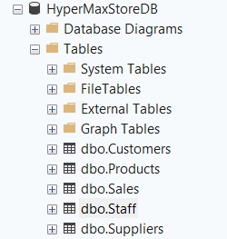

How the tables connect

The tables are linked so that records always stay consistent with each other:
One supplier can supply many products
Suppliers → Products
Meaning
Relationship
Products → Sales One product can appear in many sales
Staff → Sales One staff member can process many sales
Customers → Sales One customer can have many sales (or none, for a walk-in)

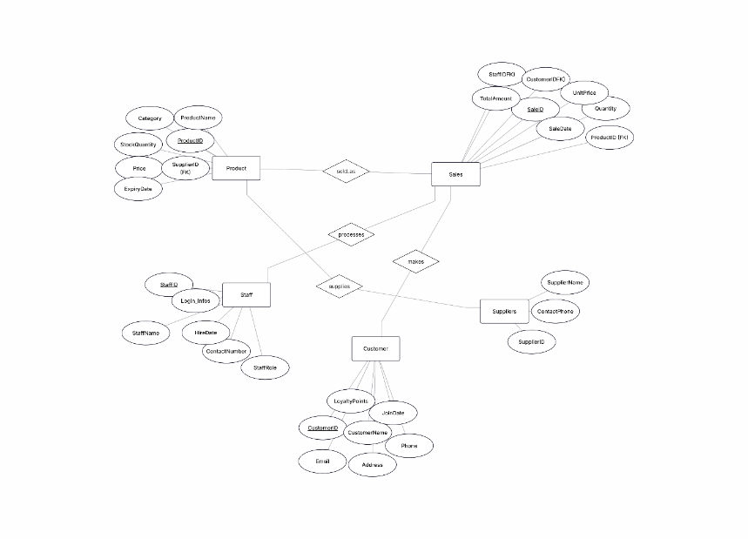

Data rules and integrity (constraints)

The database protects itself with built-in rules. These rules cannot be bypassed — even a command sent directly to the database is checked.

Rule | Where | What it prevents
Price must be > 0 | Products | Free or negative prices

Stock cannot be negative | Products | Impossible stock counts
Category must be one of four | Products | Typos like "Snek"
Role must be one of three | Staff | Invalid job roles
Unique login, phone, email, supplier phone | All tables | Duplicate people or logins
Foreign keys | Sales, Products | A record pointing to data that doesn't exist
TotalAmount is calculated | Sales | A wrongly typed total
Two layers of protection
The application also checks data before sending it (for example, "Price must be greater than 0"). This gives staff a friendly message early, while the database rules above act as the final, unbreakable wall.

How the application is organised

The application is made of separate screens (forms). Each screen has one clear job and runs specific database commands behind the scenes.

Screen | Job | Main database action
Login | Check username and password | Read from Staff

Main Menu | Show only the screens allowed for the user's role | None (controls access)
Products | View and add products | Read & add
Sales | View and record sales | Read, add & update stock
Suppliers | View suppliers | Read
Customers | View customers | Read
Staff | View staff | Read
Reports | Run the four management reports | Read & summarise
Role-based access
When a user logs in, the Main Menu reads their role and shows only the buttons that role is allowed to use. A sales staff member, for example, never sees the Reports button, so financial information stays with managers only.

Data flow diagram (DFD)

This diagram shows how information moves through the system — from the person using it, through the application, into the database, and back again.
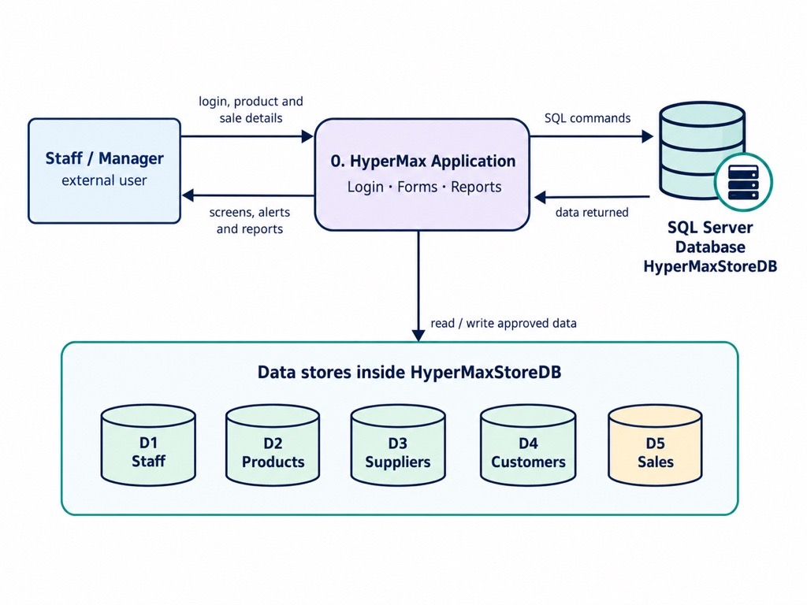

How to read it
The staff member or manager types something into the application — a login, a new product, or a
sale.
1
What happens
Step
2 The application turns that action into a database command and sends it to the database.
3 The database reads from or writes to the correct table(s) among the five data stores.
4 The database sends the data back, and the application shows it on screen.

The user never reaches the database directly. The application is always the middle layer, which keeps the data both organised and secure.

Process flowcharts

These flowcharts show the steps of the two most important actions in the system. Diamond-style boxes are decision points (yes / no).
Start / End User input Decision System action Blocked Success

Flowchart A — Logging in

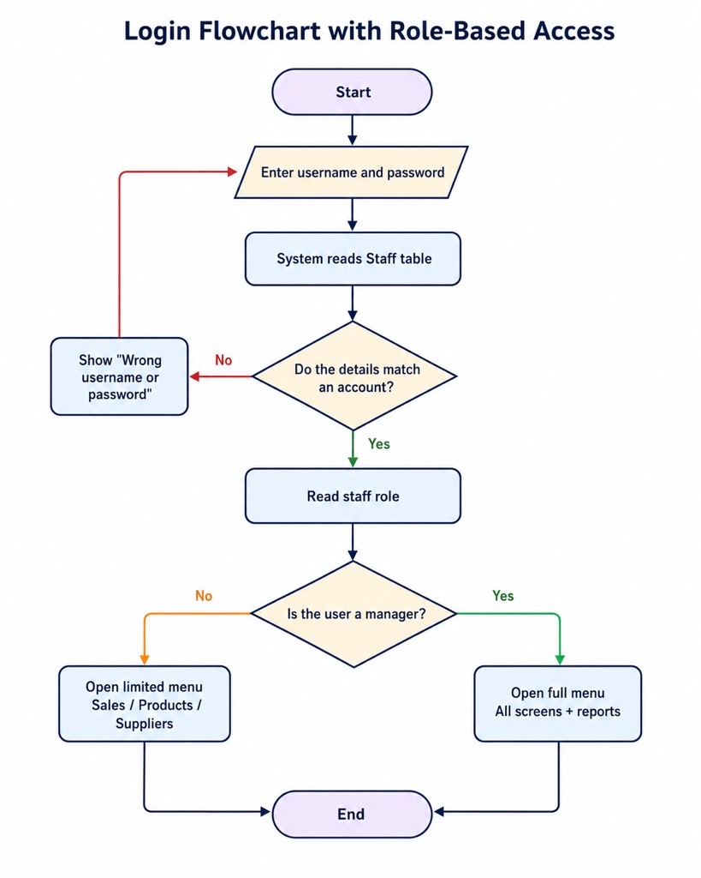

Flowchart B — Recording a sale
This is the most important process. The sale and the stock reduction happen together as one unit, so stock can never drop without a matching sale.
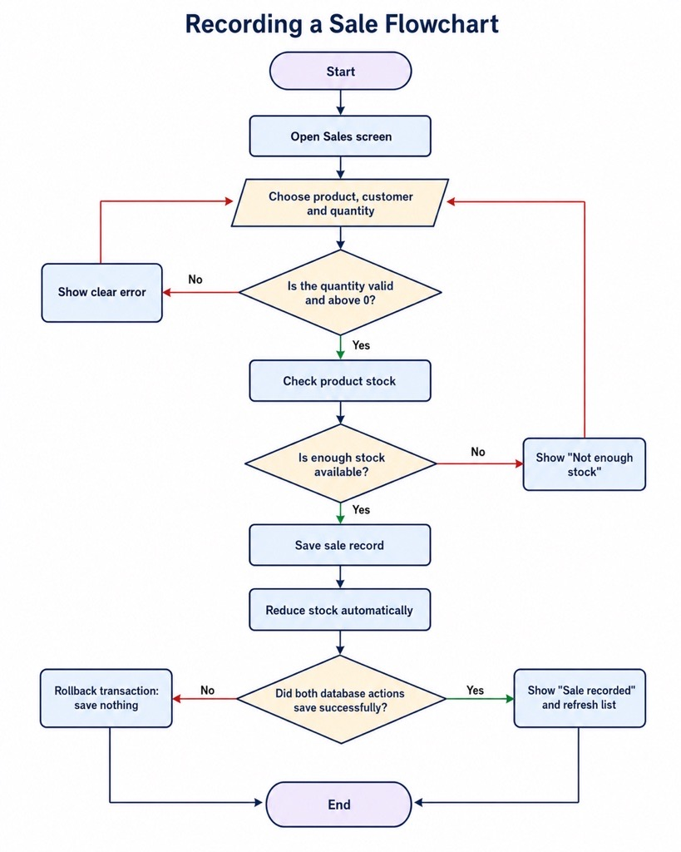

Installation & setup guide

To set the system up on a new computer, follow these steps in order:
Install Microsoft SQL Server and SQL Server Management Studio (SSMS).
1
Action
Step

2 In SSMS, run the provided SQL script. This creates the tables, the rules, and the starting data.
HyperMaxStoreDB
database, the five

3 Open the application project in Visual Studio.


4 Check the connection setting in the
Db
).
localhost
class matches the server name (for example

5 Run the application and log in with a valid account.

If the application cannot connect
The server name in the Db setting must match the name shown in SSMS. Common names are
localhost or localhost\SQLEXPRESS . Also check the SQL Server service is running.

Maintenance & backup procedures

To keep the system healthy and recoverable over time, two routine procedures should be in place.

Backups
A regular backup means the store loses nothing if a disk fails or data is damaged. The backup command is:

BACKUP DATABASE HyperMaxStoreDB
TO DISK = 'C:\Backups\HyperMaxStoreDB.bak' WITH FORMAT, NAME = 'HyperMax full backup';
So a backup is never forgotten
Run nightly (when the store is
closed)
Why
Practice

Keep several days of backups So you can restore from before a problem started
Copy backups to a second
location
So fire or theft cannot destroy both copies
Test a restore from time to time So you know the backup actually works before you need it

Indexes (keeping reports fast)
As the Sales table grows to thousands of records, reports that filter by date or category can slow down. Indexes let the database jump straight to the rows it needs. These are created once:

CREATE INDEX IX_Sales_SaleDate ON Sales(SaleDate); CREATE INDEX IX_Products_Category ON Products(Category);
On a small dataset the speed difference is not noticeable — these are created in advance so reporting stays fast as the data grows.



03

User Manual
For everyone who uses the system day to day — managers, sales staff, and stock clerks. Simple steps, with pictures.

Welcome

This application helps you run the store. Depending on your job, you can add products, record sales, look up information, and (for managers) see reports. It replaces the old spreadsheets with one simple, reliable system.
You do not need any technical knowledge. Every screen uses clear buttons, and the system will warn you with a friendly message if something is not right.

Logging in
Open the HyperMax application.
1
What to do
Step

2 Type your username.
3 Type your password.
4 Click the Login button.

If your details are correct, you go to the Main Menu. If not, you will see a message — just check your details and try again.
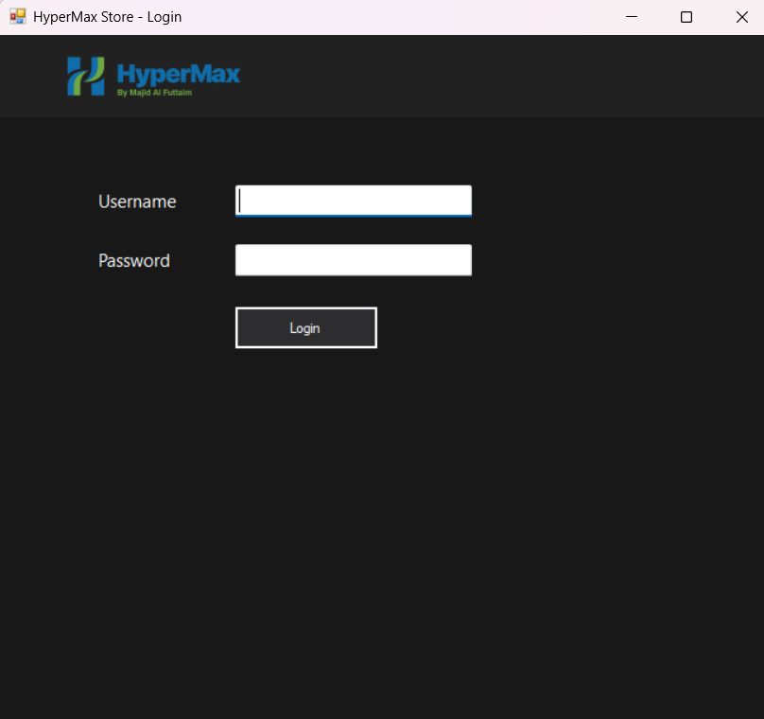

What you can see (your role)

The system shows you only the screens your job needs. This keeps things simple and keeps sensitive information protected.
Everything, including Reports
Manager
Screens you can use
Your role
Sales Staff Sales and Products
Stock Clerk Products and Suppliers
Don't see a button?
If a button is not on your menu, your role does not use that screen. This is normal and not an error.

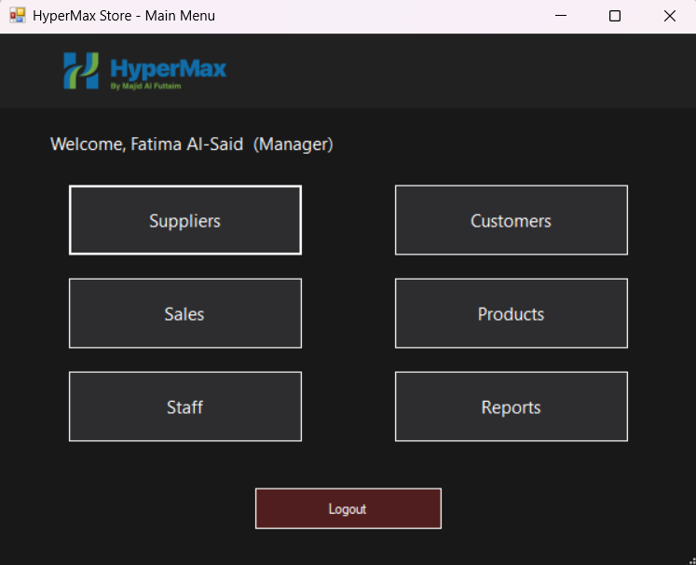

Adding a new product

For stock clerks and managers.
From the menu, click Products.
1
What to do
Step
2 Type the product name.
4
Type the price (it must be more than 0).
6
Choose the supplier.
7 Tick "Has expiry date" only if the product expires, then pick the date.
5 Type the stock amount.
3 Choose a category from the list.
8 Click Add Product.

If anything is missing or wrong, the system will tell you in a small message. Fix it and click Add Product again.
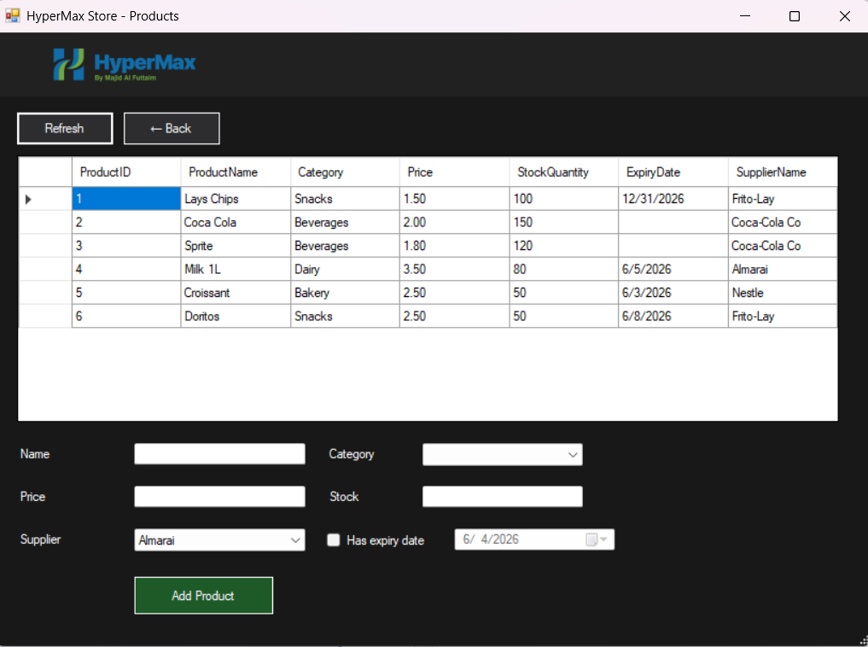

Recording a sale

For sales staff and managers.
From the menu, click Sales.
1
What to do
Step
2 Choose the product.
4
Type how many they are buying (the quantity).
5 Click Record Sale.
3 Choose the customer, or pick "Walk-in" if they are not a member.
The system does the rest for you
It saves the sale under your name, and it lowers the stock for that product automatically. You do not need to update stock yourself.

If you try to sell more than is in stock, the system will stop you with a "Not enough stock" message.

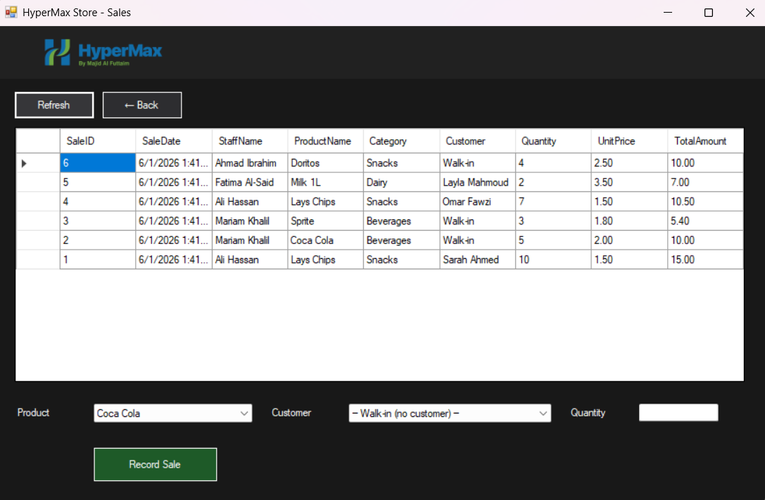

Viewing suppliers, customers & staff

These screens are for looking up information. Open them from the menu (if your role allows). Each one shows a clear table, and a Refresh button reloads the latest data.
Supplier names and contact phone numbers
Suppliers
Shows
Screen
Customers (managers) Customer details and loyalty points
Staff (managers) Staff names, roles, contact numbers and hire dates
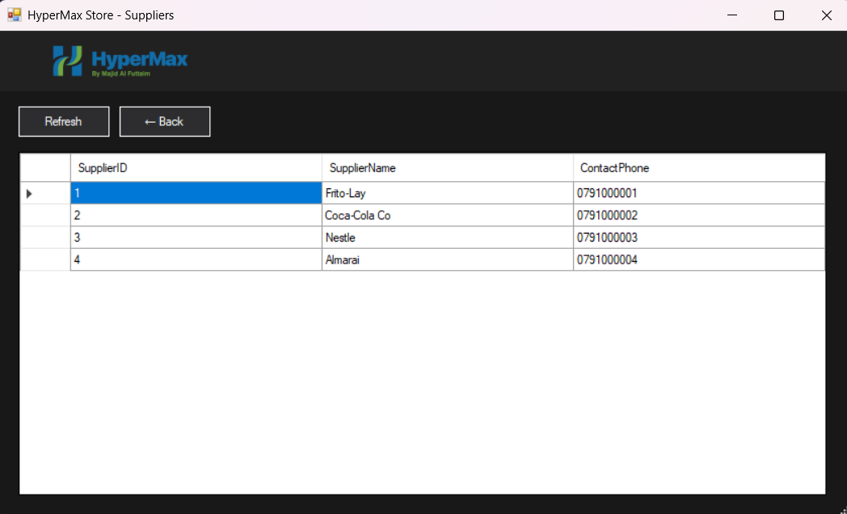

Running reports (managers)

Reports turn the store's data into useful answers. Open Reports from the menu, then click the report you want.
Products that will expire within a week — so you can discount them
before they are wasted
New Expiry (7 days)
Tells you
Report
Sales By Category Which section of the store earns the most money
Sales By Staff How much each staff member has sold
Low Stock Products running low — so you can reorder before they sell out

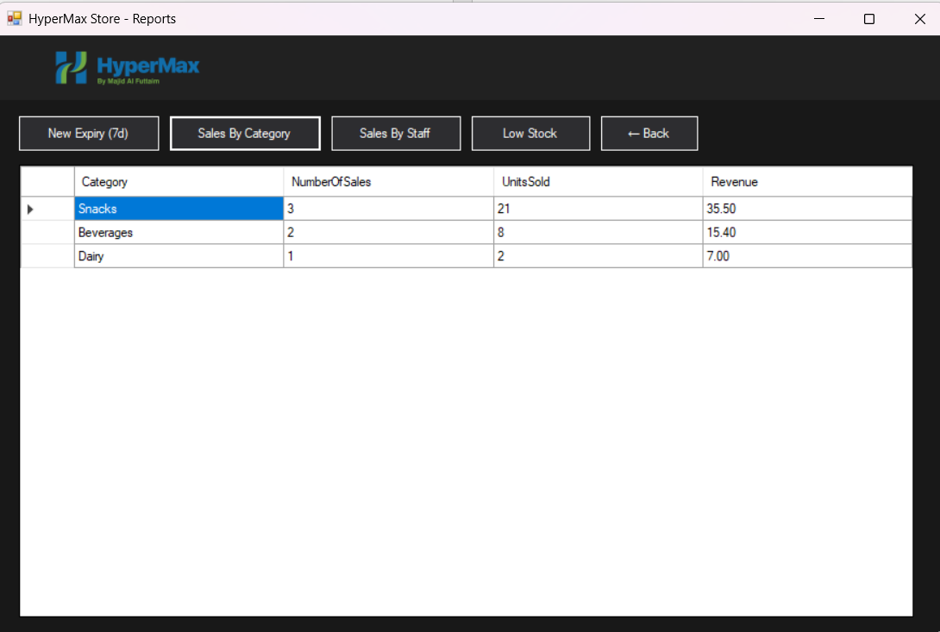

Messages you may see

The system uses simple messages to keep your data correct. Here is what the common ones mean.
Your login details are not correct. Check them and retype.
"Wrong username or password"
What it means & what to do
Message
"Price must be greater than 0" You typed 0 or a negative price. Enter a real price.
"Name cannot be empty" You left the product name blank. Type the name.
"Stock must be a whole number" You typed letters or a decimal in the stock box. Enter a whole
number.
"Not enough stock" You tried to sell more than is available. Sell a smaller amount.

Moving around & logging out
Click the ← Back button
Go back one screen
…do this
To do this…

Reload the latest data Click the Refresh button
Log out Return to the menu and click Logout

Quick answers (FAQ)
No. Choose "Walk-in" for customers who are not members.
I forgot to choose a customer — is that a
problem?
Answer
Question

Do I need to lower the stock after a sale? No. The system does it for you automatically.
Why can't I see the Reports button? Reports are for managers only. This is by design.

I made a mistake adding a product. What do I do?
Ask a manager — they can correct or remove records.

The app won't open or connect. Contact the IT team. See the Installation & setup section.

HyperMax Store — Inventory & Sales Database System · Version 1.0 · June 2026 Prepared by Osamah Esam Amayiri

