**2014 Bike Course**

**12 miles**

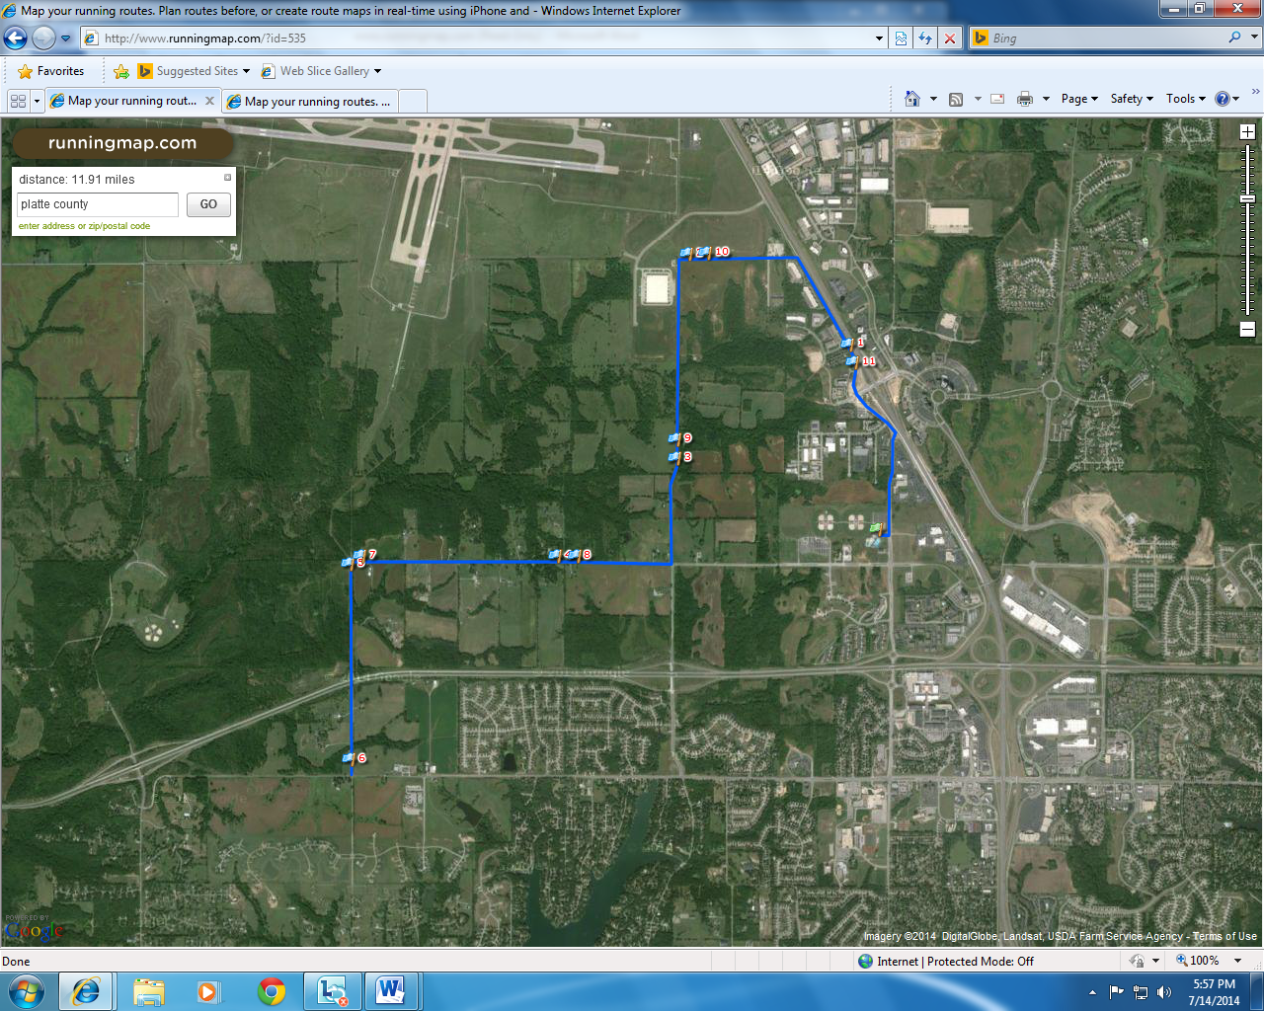

Turn by turn description

* START -> Springs Aquatic Center
* LEFT TURN (northbound) on Congress Ave (right lane w/traffic)
* LEFT TURN (northwest) on NW Prairie View Rd. (right land w/ traffic)
* LEFT TURN (westbound) on NW 104th St. (right land w/traffic)
* LEFT TURN (southbound) on N Amity Ave. (right lane w/traffic)
* RIGHT LANE (westbound) on NW Tiffany Springs Rd. (right lane w/traffic
* LEFT TURN (southbound) on Childress Ave (right lane w/traffic)
* TURN AROUND POINT- Intersection of Childress Ave and NW Barry Rd.
* RIGHT TURN (eastbound) on NW Tiffany Springs Rd. (right lane w/traffic)
* LEFT TURN (northbound) on N Amity Ave. (right lane w/traffic)
* RIGHT TURN (eastbound) on NW 104th St. (right lane w/traffic)
* RIGHT TURN (southbound) on NW Prairie View Rd. (right lane w/ traffic)
* RIGHT TURN (southbound) on Congress Ave (right lane)
* FINISH -> Springs Aquatic Center

Road Closures

**The majority of the bike portion will be an open course meaning there will be normal traffic flow.

* Congress Ave.

Bike Course Volunteers

* 1 volunteer at START
* 1 volunteer at intersection of NW Prairie View Rd. and Congress Ave.
* 1 volunteer at intersection of NW Prairie View Rd. and NW 104th St.
* 1 volunteer at 104th St. and N Amity Ave.
* 1 volunteer at N Amity Ave. and NW Tiffany Springs Rd. intersection
* 1 volunteer at NW Tiffany Springs Rd and N Childress Ave. intersection
* 1 volunteer at turn around point

Policing

* 1 police at intersection of NW Prairie View Rd. and Congress Ave.
  + Direction traffic on NW Prairie View Rd.
* 1 police at intersection of NW Prairie View Rd. and NW Tiffany Springs Parkway
  + Directing traffic on/off of interstate I-29
* 1 police at intersection of NW Prairie View Rd. and NW 104th St.
  + Directing traffic on NW Prairie View Rd.
* 1 police at N Amity Ave. and NW Tiffany Springs Rd. intersection
  + Directing traffic on south and north side of N Amity Ave.
  + Directing traffic on NW Tiffany Springs Rd.
* 1 police at NW Tiffany Springs Rd and N Childress Ave. intersection
  + Directing traffic on N Childress Ave.
* 1 police at turn around point
  + Directing traffic on Barry Rd.

Coning, Signage, and Barricade

* Coning and signage will be used at all turns
* Comfort cones will be placed throughout course
* Signage will be placed on course to make traffic aware of race