**2014 Run Course**

**3.1 Miles**

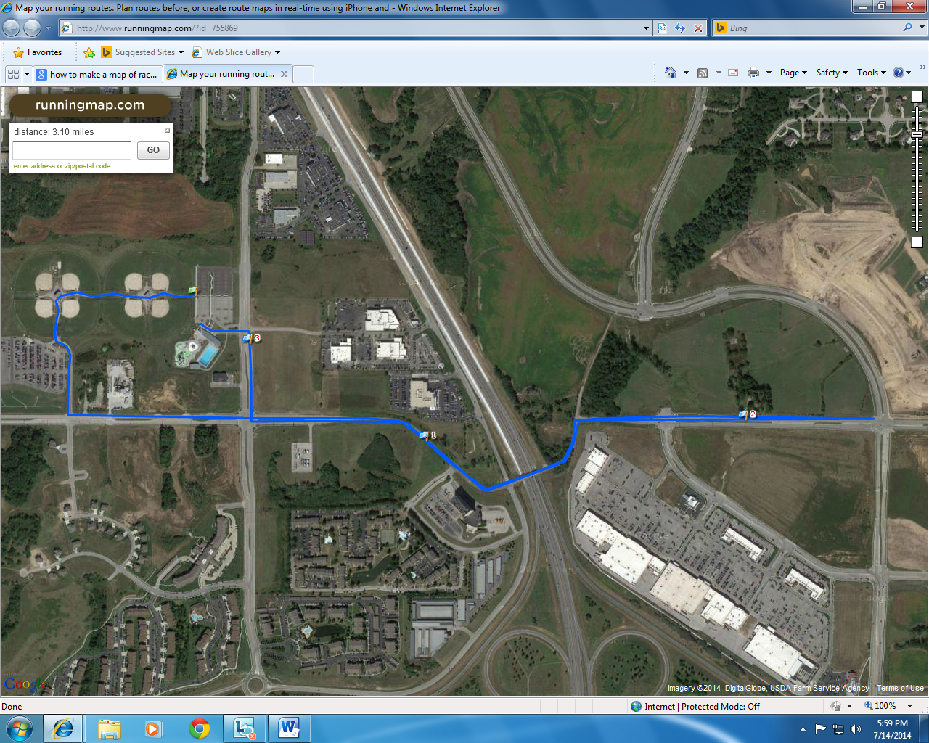

Turn By Turn Description

* Start-> Springs Aquatic Center
* Exit Springs Aquatic Center parking lot going westbound towards baseball complex
* LEFT TURN (southbound) towards Seymour Ave.
* Keep right onto Seymour Ave.
* LEFT TURN (eastbound) on NW Tiffany Springs Rd.
* Keep right onto NW Tiffany Springs Rd.
* TURN AROUND POINT – N Ambassador Dr. and NW Tiffany Springs Rd. intersection
* Head westbound on NW Tiffany Springs Rd.
* RIGHT TURN (northbound) on N Congress Ave.
* LEFT TURN into Springs Aquatic Center -> FINISH

Road Closures

* NW Old Tiffany Springs Road – From Seymour Ave to N Ambassador Dr.
* Congress Ave –From the Springs Aquatic Center to NW Old Tiffany Springs Rd.

Run Course Volunteers

* 1 volunteer at turn of baseball complex
* 2 volunteers at Seymour Ave. and NW Old Tiffany Springs Rd. intersection
* 1 volunteer at N Congress Ave and NW Tiffany Springs Rd intersection
* 1 volunteer at NW Prairie View Road and NW Tiffany Springs Rd. intersection
* 1 volunteer at NW Tiffany Springs Rd. and NW Skyview Ave intersection
* 1 volunteer at N Skyview Ave and NW Tiffany Springs Rd intersection
* 1 volunteer at N Ambassador Dr. and NW Tiffany Springs Rd intersection
* 1 volunteer at entrance of the Springs Aquatic Center on Congress Ave.

Policing

* 1 police – Seymour Ave and NW Old Tiffany Springs Rd intersection
* 1 police – NW Congress and NW Tiffany Springs Rd intersection
* 1 police – NW Prairie View Rd and NW Tiffany Springs Rd intersection
* 1 police – N Ambassador Dr. and NW Tiffany Springs Rd intersection

Coning, Signage, and Barricade

* Coning, signage, and Barricade will be placed at intersection of Seymour Ave and NW Old Tiffany Springs Rd. to alert motorists of the start of road closures along the course.
* Coning and signage will be placed along Congress Ave.
* Coning, signage, and barricade will be used along intersection of Congress Ave and NW Tiffany Springs Rd to create a turning lane that will shuttle runners to the closed running lane of NW Tiffany Springs Rd.
* Coning on closed lane of NW Tiffany Springs Rd to create two running lanes for our and back.
* Coning and signage at intersection of NW Tiffany Springs Rd. and NW Prairie View Rd.
* Coning and signage at intersection of NW Tiffany Springs Rd. and Skyview Ave.
* Coning and signage at turnaround point of NW Tiffany Springs Rd. and N Ambassador Dr.