New Document/Label System

Documents:

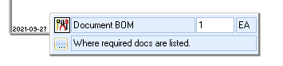

Use this ‘Tool’

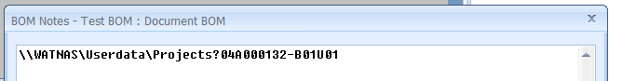

Copy the folder path of the file you need to print, but ensure the length of the file is in one line, otherwise the system cannot print.

Remove subdirectories until it fits in one line as shown,

Also ensure that the majority of the file name is included, so it can be searched for and not find multiple results when searching for a file with that string of characters in the path specified.

Include a question mark between the end of the path, and the file name regardless if you can fit all of the path in the line.

Labels:

Same system as before, with a different way of typing in the BOM Notes;

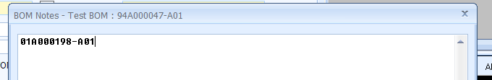

If you need to just print to a label type

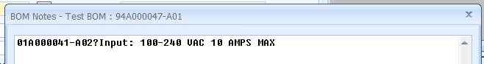

If the label specified as a parameter to enter, separate with a question mark for each.

Up to 3 parameters

Ensure that the parameters do not exceed one line aswell.

If you need multiple labels/documents, use the next line down.

Don’t leave a blank line at the end

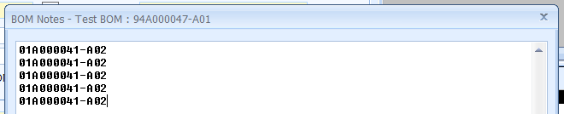

What not to do:

Documents:

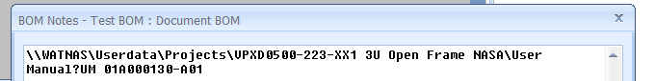

* Multiple lines

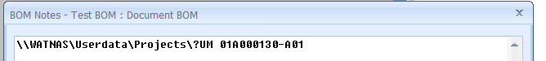

* Extra \ before the ?

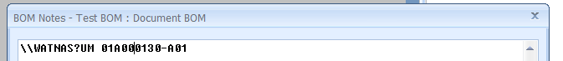

* Does work, but will take a long time to search through the whole WATNAS

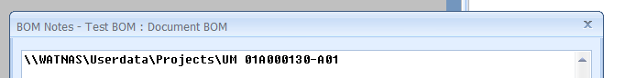

* No question mark

Lables:

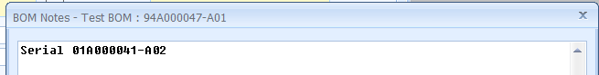

* Word infront