1. Write a  program to find maximum between two numbers.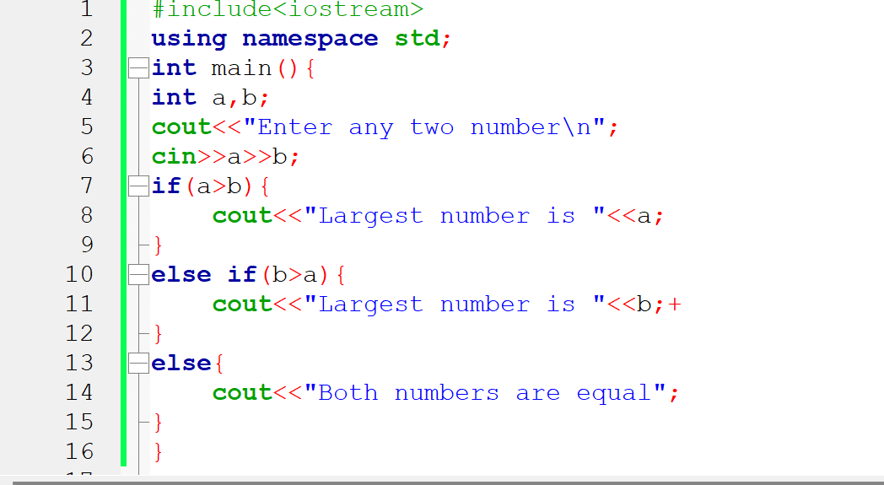

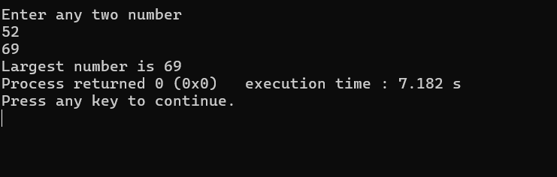

2. Write a  program to find maximum between three numbers.

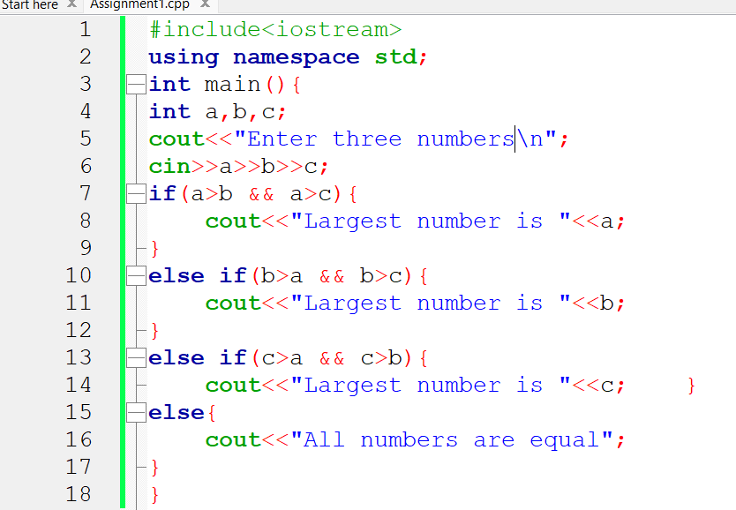

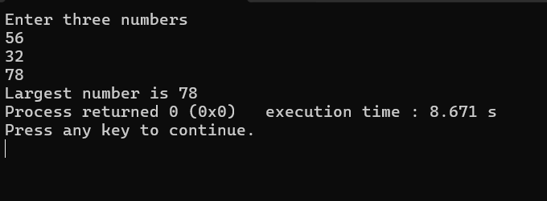

3. Write a  program to check whether a number is negative, positive or zero.

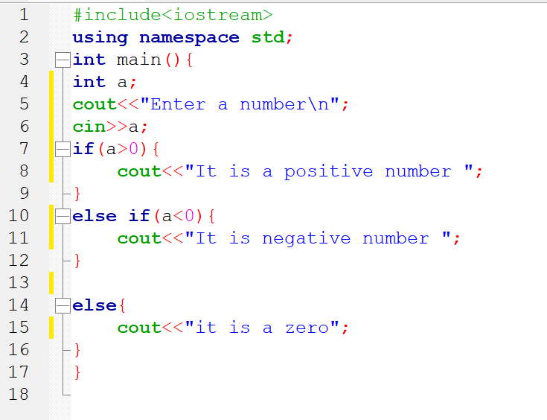

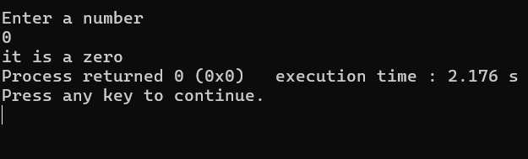

4. Write a program to check whether a number is divisible by 5 and 11 or not.

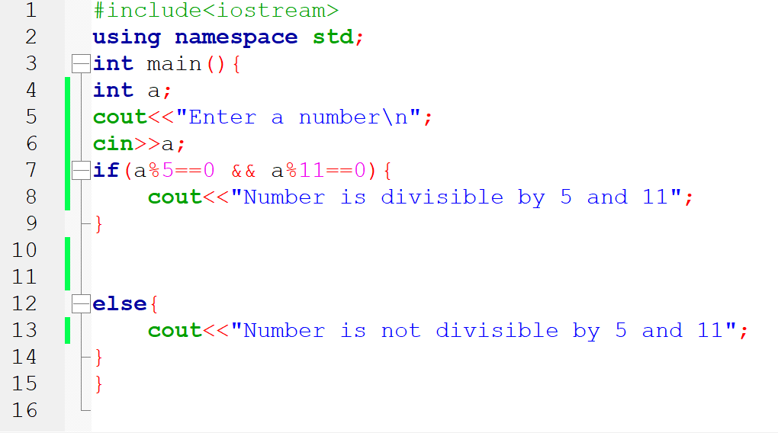

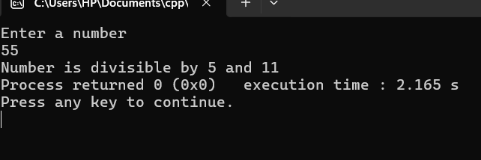5. Write a  program to check whether a number is even or odd

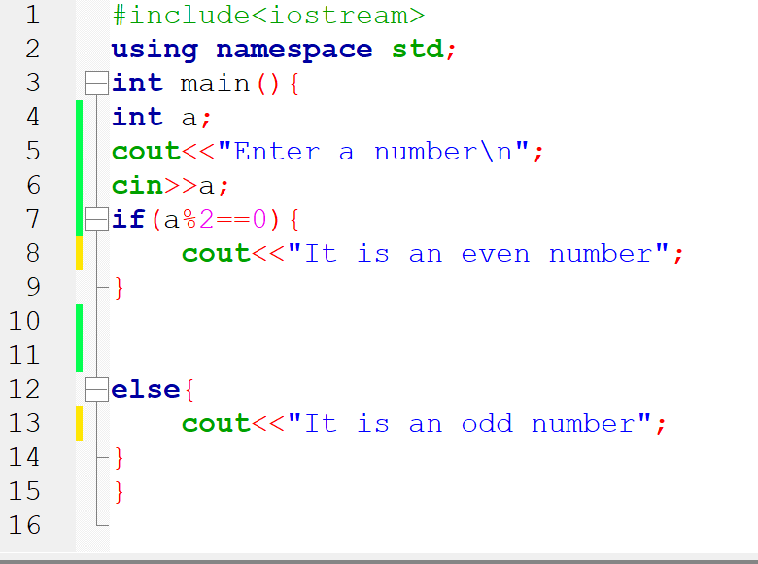

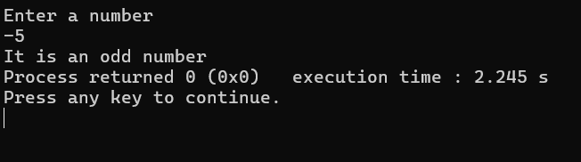

6. Write a  program to check whether a year is leap year or not.

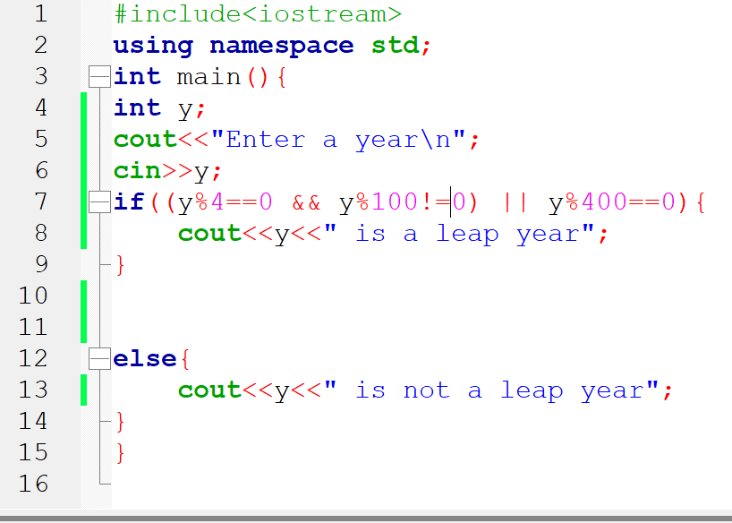

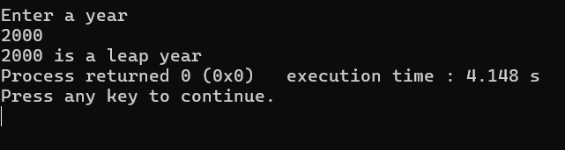

7. Write a program to check whether a character is alphabet or not.

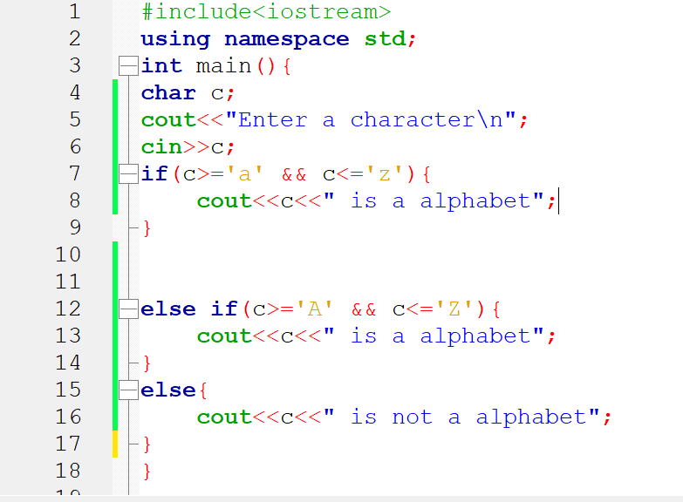

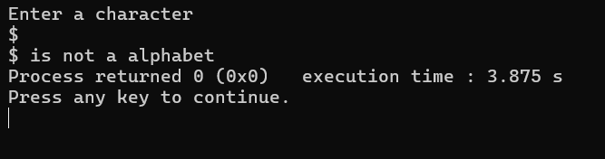

8. Write a  program to input any alphabet and check whether it is vowel or consonant.

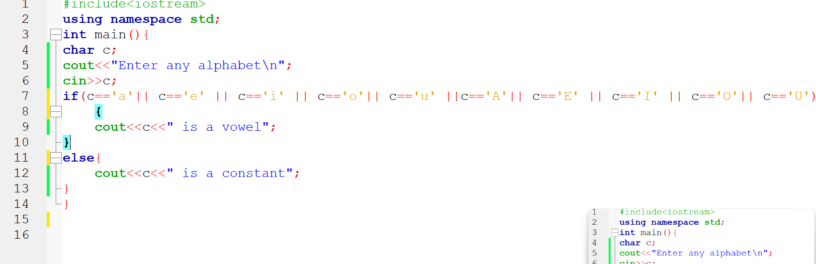

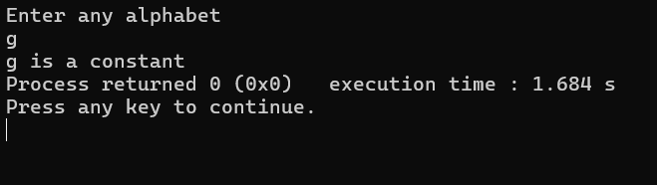

9. Write a  program to input any character and check whether it is alphabet, digit or special character.

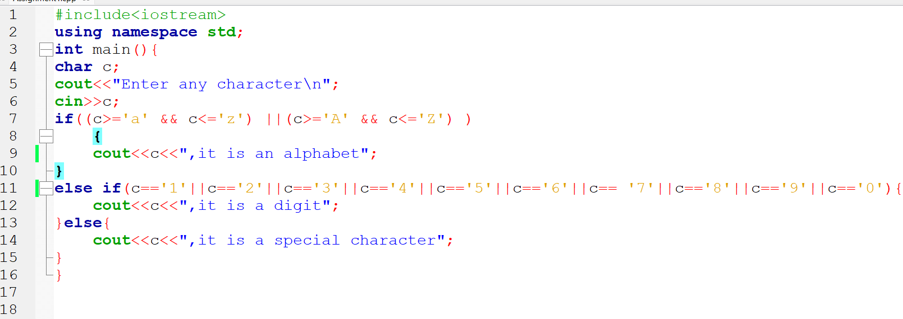

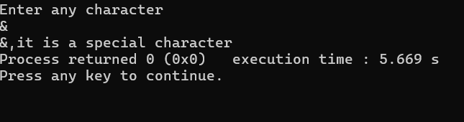

10. Write a program to check whether a character is uppercase or lowercase alphabet.

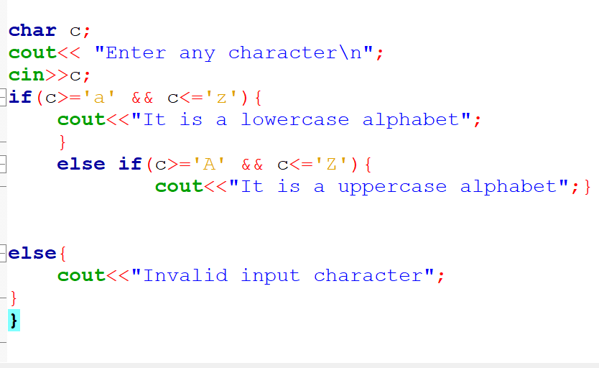

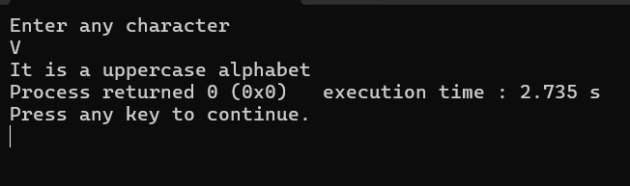

11. Write a  program to input week number and print week day.

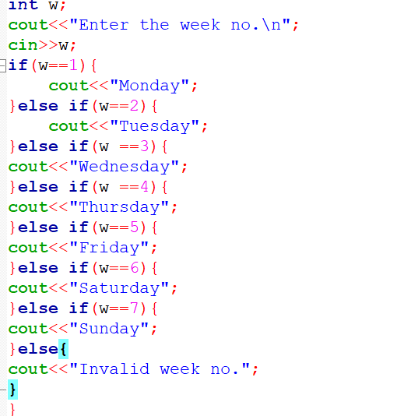

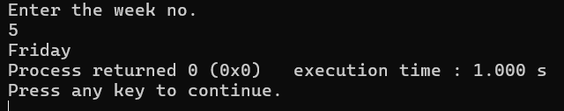

12. Write a  program to input month number and print number of days in that month.

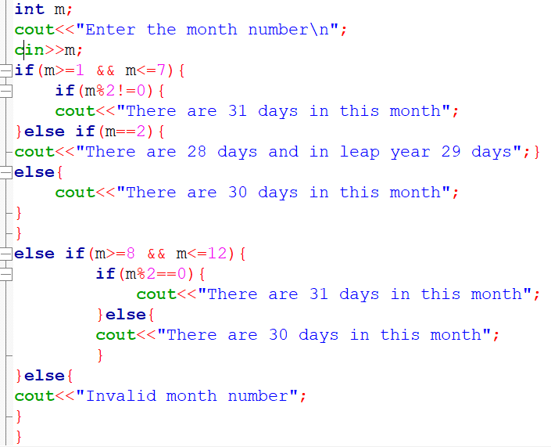

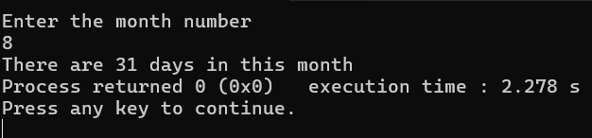

13. Write a  program to count total number of notes in given amount.

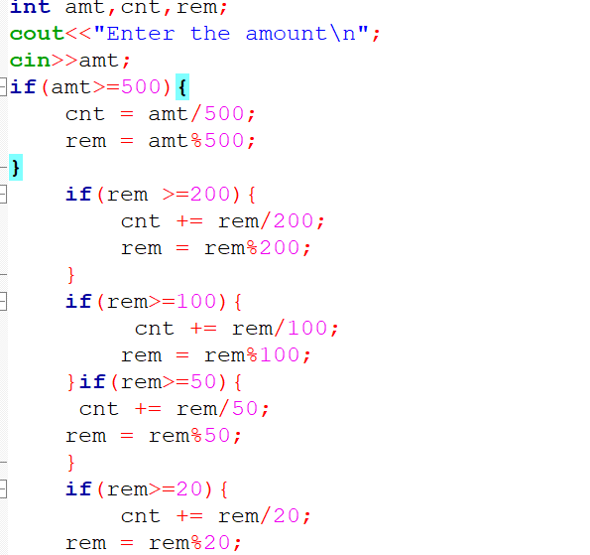

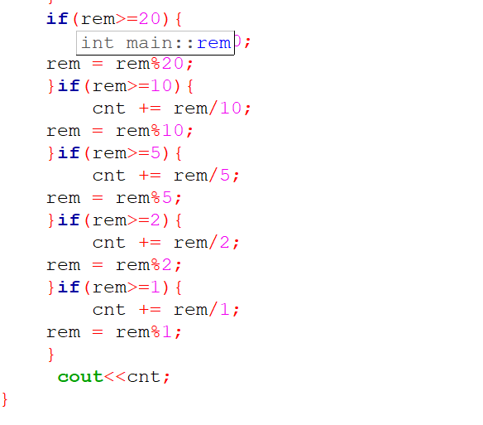

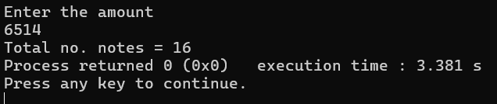

14. Write a  program to input angles of a triangle and check whether triangle is valid or not.

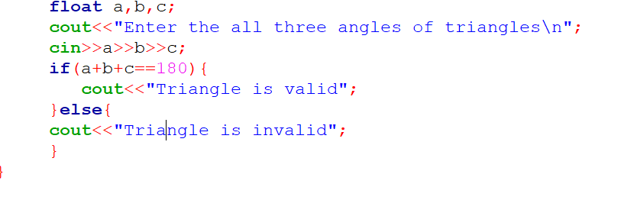

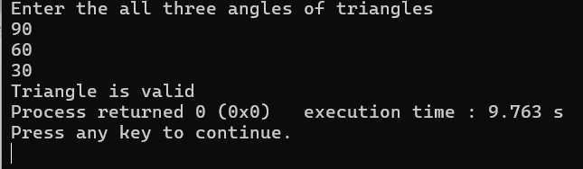

15. Write a  program to input all sides of a triangle and check whether triangle is valid or not.

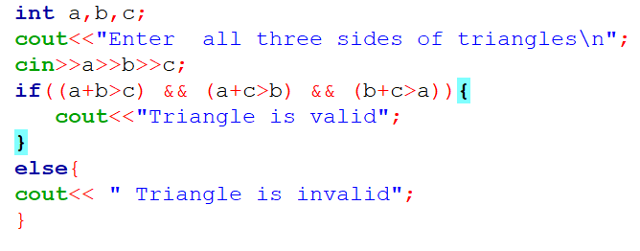

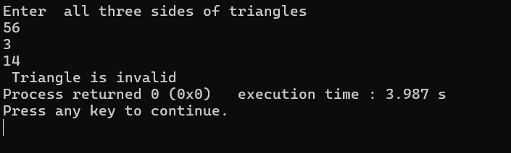

16. Write a  program to check whether the triangle is equilateral, isosceles or scalene triangle

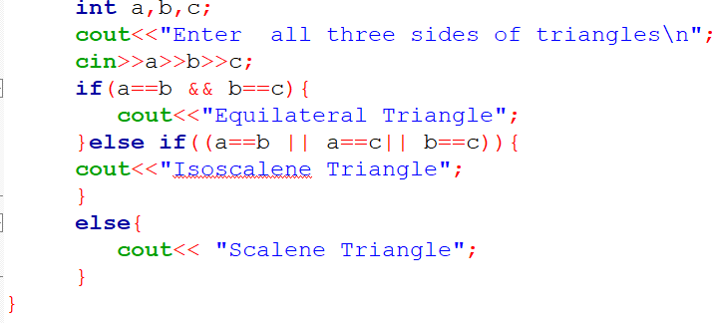

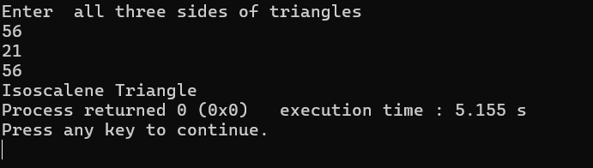

17. Write a  program to calculate profit or loss.

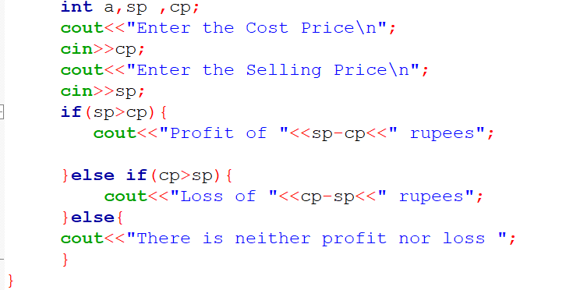

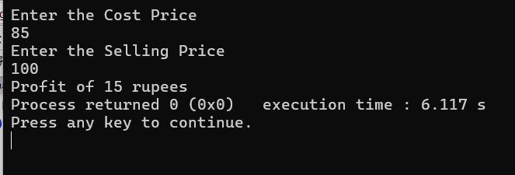

18. Write a  program to input marks of five subjects Physics, Chemistry, Biology, Mathematics and Computer. Calculate percentage and grade according to following:  
Percentage >= 90% : Grade A  
Percentage >= 80% : Grade B  
Percentage >= 70% : Grade C  
Percentage >= 60% : Grade D  
Percentage >= 40% : Grade E  
Percentage < 40% : Grade F

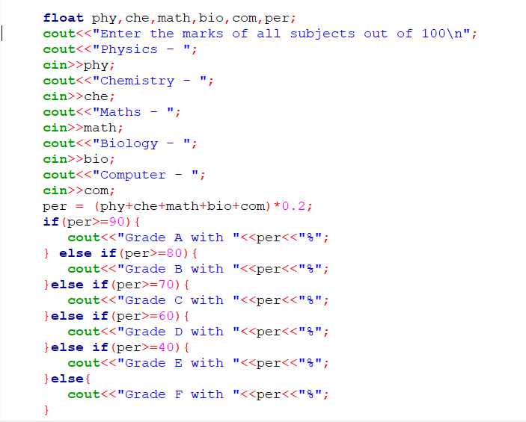

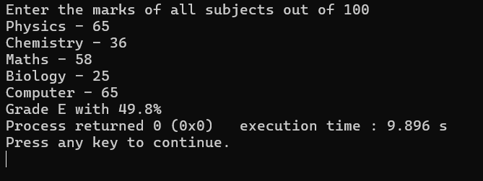

19. Write a  program to input basic salary of an employee and calculate its Gross salary according to following:  
Basic Salary <= 10000 : HRA = 20%, DA = 80%  
Basic Salary <= 20000 : HRA = 25%, DA = 90%  
Basic Salary > 20000 : HRA = 30%, DA = 95%

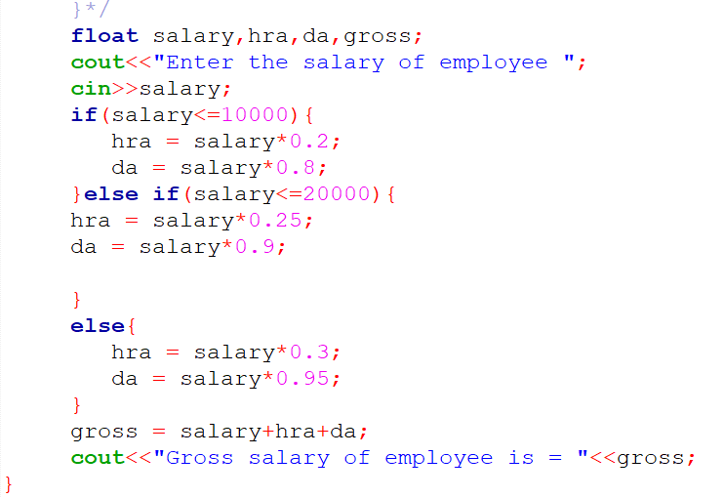

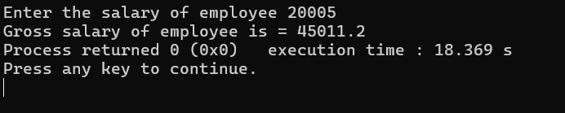

20. Write a  program to input electricity unit charges and calculate total electricity bill according to the given condition:  
For first 50 units Rs. 0.50/unit  
For next 100 units Rs. 0.75/unit  
For next 100 units Rs. 1.20/unit  
For unit above 250 Rs. 1.50/unit  
An additional surcharge of 20% is added to the bill

