C++ Test -2 Function and Array Test(2nd test)

Q.1) Write a function named reverseString that takes a as an argument and returns the reversed string. The function should not use any built-in functions for reversing the string. write a program that reads a string from the user, calls the reverseString function, and prints the reversed string.

Q.2) Write the difference between Call by value method and Call by reference method . Write a function named findMax (no return function ) that takes three integer references as arguments. The function should set the first argument to the maximum of the three integers, second and the third argument should be left unchanged.

Q.3 A ) What is recursion and classify its type , WAP to display 10 natural number using head recursion and tail recursion

OR

Q.3 B) WAP to convert the given 2-d matrix to shown matrix.

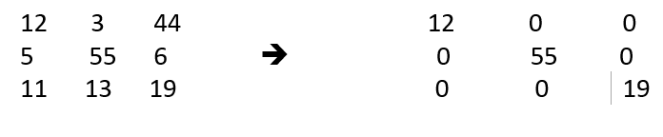

Q.4 A ) WAP to manipulate the following string s as.(capitalized each word)

S=”pass by value and pass by reference”

output=”Pass By Value And Pass By Reference”.

Or

Q.4 B ) WAP to find how many students get passed in an examination ,we have an array of marks.

Marks[]={88,45,66,77,8,9,22,69}

Passing marks :60

Output: 4

Q.5) Write a function named sumOfDigits that takes an integer as an argument and returns the sum of its digits. For example, if the input is 1234, the function should return 10. Write a program that reads an integer from the user, calls the sumOfDigits function, and prints the result.

Or

Write a function named matchA() takes string s as a arguments , and if ‘a’ or ‘A’ is present in a string then returns true ,otherwise false .