Automatic Flood Detection System

by

Examination Roll: 193213

A Project Report submitted to the Institute of Information Technology in partial fulfillment of the requirements for the degree of Professional Masters in
Information Technology

Supervisor
Dr. Rashed Mazumder
Assistant Professor, IIT, JU



Institute of Information Technology

Jahangirnagar University
Savar, Dhaka-1342

December, 2022

DECLARATION

I am announcing that this project report is based on the results found by one and only myself. Resources for this report found by other researchers are mentioned herewith by reference. This project has not been submitted before for any course or degree partially or fully.

Roll:193213

CERTIFICATE

The project titled “Automatic Flood Detection System” submitted by Sourav Das, ID: 193213, Session: Fall-2019, has been accepted as satisfactory in partial fulfillment of the requirement for the degree of Professional Masters in Information Technology on December, 2022.

Dr. Rashed Mazumder, Assistant Professor, IIT, JU

Supervisor

BOARD OF EXAMINERS

ACKNOWLEDGEMENTS

I'm grateful for the chance to convey my sincere gratitude and thanks to everyone who contributed to the creation of this report. This project is performed under the supervision of Dr. Rashed Mazumder, Assistant Professor, Institute of In-formation Technology (IIT), Jahangirnagar University (JU), Savar, Dhaka. During the whole working process, he supplied a lot of important advice and materials related to the current state of investigation. I would not have been able to complete the project work satisfactorily and on schedule without his assistance, courteous support, and generous time spans. I want to start by expressing my deep appreciation to him for his advice, insightful recommendations, encouragement, and friendly collaboration.
I also want to express my gratitude to the other IIT faculty members who have supported me in any way, whether directly or indirectly, in finishing this work. I want to thank all the various places I've gotten assistance. I owe thanks to everyone who contributed in some way to getting this job done, whether directly or indirectly.
Finally, I want to thank everyone at IIT, Jahangirnagar University, and my friends for supporting me and cooperating with me during the project.

ABSTRACT

Bangladesh is a low-lying country, and it contains several rivers, canals, and coast streams, as well as vast flood plains through which about 1.7 million square kilometers of surface water flows yearly. Even though Bangladesh's population is well acclimated to typical monsoon floods, many places continue to experience damage from flooding, riverbank erosion, embankment breaches, etc., virtually every monsoon. They frequently have adverse effects, including serious harm to infrastructure, severe losses of property, livestock, crops, and other types of property, human misery, and the plight of the destitute. This project ensures that the people and livestock residing in the flood-prone area can be evacuated before the flood reaches a certain danger level. This project keeps a database which contains contact information of the local residents and alerts them through text messages when a potential flood initiates. It also triggers an alarm system which physically warns the residents about flooding.

LIST OF FIGURES

Figure
1 | Block diagram of whole process……………………………………….. | 13
2 | Water level sensor………………………………………………………. | 14
3 | Circuit diagram of water level sensor…………………………………. | 14
4 | Circuit diagram of motor driver IC……………………………………... | 14
5 | GSM device……………………………………………………………… | 15
6 | Arduino Uno……………………………………………………………… | 15
7 | Arduino Uno pin configuration…………………………………………. | 16
8 | ATmega328P in Arduino board………………………………………... | 16
9.1 | Material preparation…………………………………………………….. | 21
9.2 | Booting up GSM SIM900A……………….……………………………... | 21
9.3 | Connecting to Arduino…………………………………………………… | 22
9.4 | GSM SIM900A is powered up………………………………………….. | 22
9.5 | Overall view of GSM SIM900A connected to Arduino Uno………….. | 22
10 | Arduino library……………………………………………………………. | 23
11 | Sample source code…………………………………………………….. | 23
12 | Sending and receiving SMS through GSM SIM900A………………... | 23
13 | Circuit setup for simulation……………………………………………… | 26
14 | Running the simulation………………………………………………….. | 26

TABLE OF CONTENTS

DECLARATION……………………………………………....................................... |  |  | 2
CERTIFICATE……….…….………………………………........................................ |  |  | 3
BOARD OF EXAMINERS……………………………………………………….….. |  |  | 4
ACKNOWLEDGEMENTS………...……………………………................................ |  |  | 5
ABSTRACT .................................................................................................................. |  |  | 6
LIST OF FIGURES....................................................................................................... |  |  | 7
CHAPTER
I. Introduction ……………………………………………………………………….. |  |  | 10
1.1 | Problem Statement………………………………………………… |  | 10
1.2 | Motivation………………………………………………………… |  | 10
1.3 | Objective & Scope………………………………..……………….. |  | 11
1.4 | Assumptions & Limitations………………………..……………… |  | 11
1.5 | Research Outline………………………………...………………… |  | 11
II. Experimental Description………………………………………………………... |  |  | 12
2.1 | Hardware Configuration….………………….…………………….. |  | 12
2.2 | Block Diagram………………..……………………………………. |  | 13
2.3 | Hardware Configuration.……………….….………………………. |  | 14
 | 2.3.1 | Water Level Sensor………………………………………. | 17
 | 2.3.2 | Motor Driver Circuit……………………………………… | 17
 | 2.3.2.1 | Working of L293D……………………………….. | 17
 | 2.3.3 | GSM……………………………………………………… | 17
 | 2.3.3.1 | Operations of GSM……………………………… | 17
 | 2.3.3.2 | GSM SIM 900A…...…………………………….. | 17
 | 2.3.4 | Arduino…………………………………………………... | 18
 | 2.3.4.1 | Overview…………………………………………. | 18
 | 2.3.4.2 | Arduino Pin Configuration………..……………… | 19
 | 2.3.4.5 | Using Arduino Board…………………………….. | 19
 | 2.3.4.3 | Communication………...………………………… | 20
 | 2.3.4.4 | Software……………..…………………………… | 20

III. Interfacing Arduino with GSM SIM900A……………………………………………. |  | 21
3.1 | Material Preparation……..…………………………………….. | 24
3.2 | Booting Up SIM900A…………………………………………. | 24
3.3 | Pin Connection………………….………………………….….. | 24
3.4 | Library…………………………………………………………. | 25
3.5 | Sample Source Code.. …………………...…………………….. | 25
3.6 | Send and Receive SMS………………………………………… | 25
IV. Simulation…………………………………………………………………………….. |  | 26
4.1 | Overview……………………………………………………… | 27
4.2 | Description…………………………………………………….. | 27
V. Results and Conclusion………………………………………………………………... |  | 28
5.1 | Results……………………………………………................................ | 28
5.2 | Conclusion……………………………………………………………. | 28
5.3 | Future Works…………………………………………………………. | 28
References............................................................................................................................ |  | 29

CHAPTER I

Introduction

1.1 Problem Statement

One of the most severe natural calamities that frequently strike Bangladesh is flooding. Flooding is the overflow of water from bodies of water like rivers and lakes that results in or threatens to result in damage. Some of the main problems regarding floods are: [10]

- Water-borne diseases can spread if the warning is delayed.

- Delayed warning can cause a threat to the lives and livestock.

- Valuable belongings may be damaged.

So, there must be a way of ensuring early flood detection so that the described problems can be minimized.

1.2 Motivation

Floods are the most frequent natural disasters, and they are becoming a more prevalent occurrence in Asia, according to expert Abhas Jha [9]. The following categories of people could find this study to be helpful.
Commuters: Notifications about impassable flooding roads will be provided through the SMS advice service. As a result, commuters won't get stranded on the route. The commuters will benefit from cost, time, and effort reductions.
Local Government: Once this innovation is adopted, the official in charge of the flood will find it easier to monitor and disseminate information to citizens. Officials may also provide further information or advise on preventive measures to take during the rainy season.

1.3 Objective & Scope

This project has several goals that must be reached, and the goals will serve as a roadmap for completing the project effectively.
i. To use the microcontroller to develop a circuit and write a program.
ii. To create a system that can alert people to local flooding and monitor it in order to lessen the impact and expense of flood damage.
iii. Create a flood detection prototype system utilizing the included hardware and software.
iv. To comprehend communication system fundamentals and applications for the Arduino Uno.

1.4 Assumptions & Limitations

This research is done to find solutions for the issues caused by floods. The following characteristics must be present in the device: It features a water sensor to determine the existence of water caused by a flood. The technology has serial communication capabilities for text message alerts that provide information about the warning for the floods. The three modules that make up the system are Users, Logs, and Contact Numbers. Admins can only change it. It is recommended that the device that contains the sensor should be positioned in a secured place where the water hits first after a flood has taken place. If the sensor is not positioned perpendicular to the floodwater, ultrasonic waves may reflect unevenly, leading to inaccurate measurement results. It is advised that the sensor be mounted on a pole that is between three and five meters tall. A 80k mAh solar power system will power the flood sensors and microcontrollers, ensuring continuous operation of water flood height detection and network data transfer [3].

1.5 Project Outline

The rest part of the report is structured like this:
In chapter II an experimental description is given. Here different types of hardware are explained in detail which we used in our project. In chapter lll, we will talk about interfacing the Arduino with GSM module. Moreover, the working procedure of GSM is also described here. Then we have chapter lV where the simulation part of the project is briefly highlighted. And in the last part (chapter V), the final results, discussion and conclusion take place.

CHAPTER II

Experimental Description

2.1 Hardware Configuration

For this investigation, an Arduino microcontroller R3 with operating voltages of 5V and 3.3V and a frequency of 16MHz is employed. It has three GNDs, five analog pins, 13 digital pins, and PWM respectively. Although they function as standard digital pins, these pins can also be utilized for a process known as pulse-width modulation (PWM). We use AREF for analog reference. We can generally leave this pin alone. The top limit for the analog input ports can occasionally be adjusted to an external reference voltage of 0-5 volts. The temperature sensors are attached to the analog pin (A0). The TX and RX pins of Arduino are linked to the RX and TX pins of GSM module [1].

2.2 Block Diagram

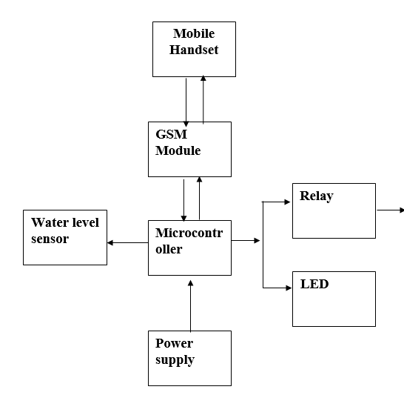
Buzzer

Figure 1: Block Diagram of whole process.

Here is the overall block diagram of the process. The microcontroller (Arduino Uno) is in the center of it. At the upper side, it is connected to a mobile phone through GSM Module. At the left side, it is connected to Water Sensor. The microcontroller is powered by a power supply externally. And finally at the right side, it is connected to a buzzer and a led for output purpose. The buzzer is connected through a relay switch as it needs more voltage than the output voltage. So, the relay is used as an amplifier here.

2.3 Hardware Details

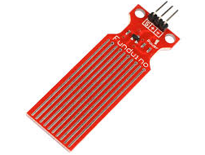
Figure 2: Water level sensor [11].

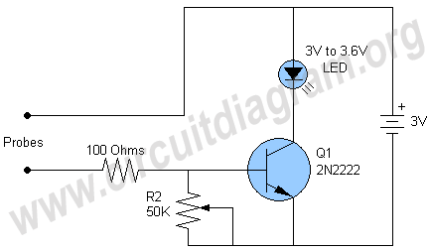

Figure 3: Circuit diagram of water level sensor [11].
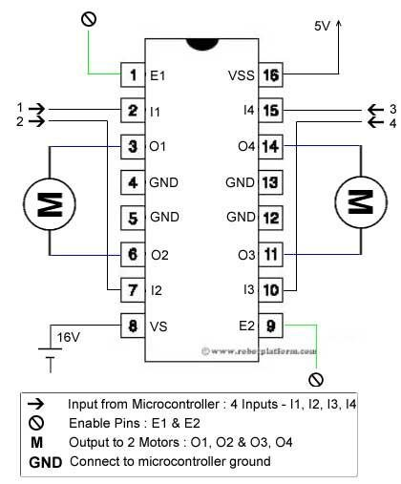
Figure 4: Circuit diagram of motor driver IC [13].
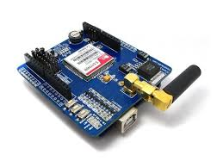
Figure 5: GSM device [12].
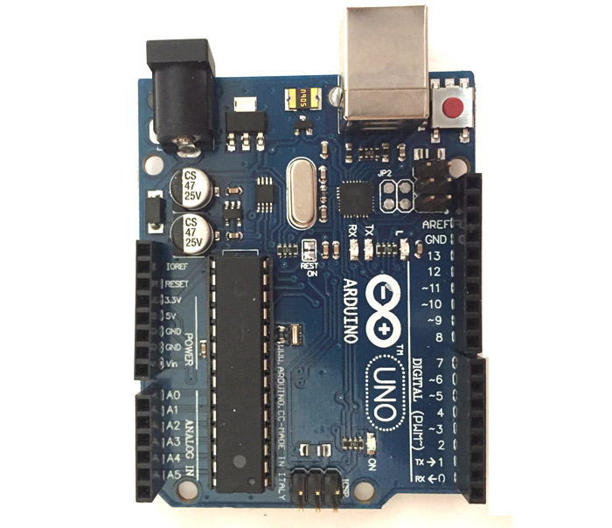

Figure 6: Arduino Uno [1].

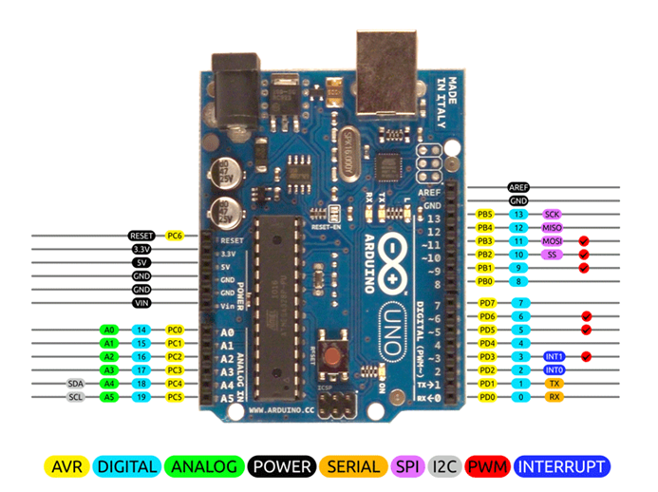

Figure 7: Arduino Uno pin configuration [1].
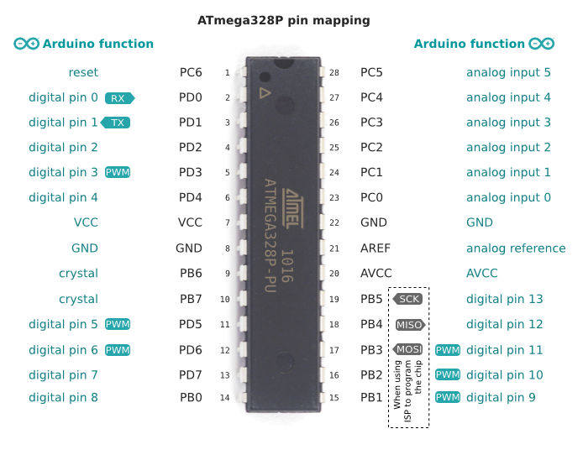
Figure 8: ATmega328P in Arduino board [14].

2.3.1 Water Level Sensor

For measuring or detecting the required amount of water or liquid in a space, a water level sensor or water level detector (fig: 2) is a highly important tool. The water level indicator is relatively straightforward but does a superb job of monitoring the ideal level of any liquid. When any of the two probes in the circuit detects liquid, the LED will turn on. If we have all the necessary parts on hand, the circuit may be constructed in a matter of minutes using only four components.
The circuit's operation (fig: 3) is straightforward; it relies on a 2N2222 NPN transistor that serves as a switch. If the water touches the two probes, the transistor switches on, turning on the LED in the circuit. Any size pair of 1.5V batteries will work in the circuit [2].

2.3.2 Motor Driver Circuit
L293D, a typical motor driver or integrated circuit (IC)(fig: 4), enables DC motors to drive in both direction. The 16-pin IC L293D can simultaneously drive two DC motors in either direction. It denotes that a single L293D IC, Dual H-bridge Motor Driver integrated circuit, can power two DC motors (IC). The L293D can drive both small and large motors and, in the end, check voltage parameters.

2.3.2.1 Working of L293D

According to the pin specifications, the L293d has four input pins: pin 2, 7, on the left, and pin 15, 10, on the right. The right input for the motor on the right and the left input for the motor linked across the left will control rotation. The inputs LOGIC 0 or LOGIC 1 applied to the input pins cause the motors to revolve in one of two directions. Simply add logic 0 or 1 to the input pins to rotate the motor.

2.3.3 GSM
The second generation of mobile technology is known as the Global System for Mobile (GSM) communication. Although third and fourth generation technology is becoming more and more common, GSM is currently the most successful and widely used communication technology. In this project, the GSM module (fig: 5) and MC microcontroller are interfaced. With the aid of MC, the message will be transmitted using AT instructions to a specific GSM mobile.

2.3.3.1 Operations of GSM
- Run the basic AT command.
- Note the GSM modem's IMEI (International Mobile Station Equipment Identifier) number.
- Establish a call connection to a GSM mobile phone (dial a number).
- Text the specified cellphone number.
- Using AT instructions, these actions are carried out. Four tactile switches have been used to provide the supply of these four operations. Each switch relates to one of the aforementioned purposes. With the AT+CMGF message format command, we may switch between text mode and PDU (Protocol Data Unit) mode. At+CMGS transmits a message to the network through GSM. On successful message delivery, the message reference value is returned to the GSM.
- The ESC key may be used to cancel sending, and ctrl-z is required to denote the end of the message body.

2.3.3.2 GSM SIM 900A

Description
SIM900A Modem by SIMCOM is based on a Dual Band GSM/GPRS modem. It operates between 900 and 1800 MHz. The SIM900A can automatically search these two bands. AT Commands can also be used to set the frequency bands. Through the AT command, the baud rate is programmable between 1200-115200. To enable you to connect with the internet through GPRS, the GSM/GPRS Modem has an inbuilt TCP/IP stack. The wireless module SIM900A is incredibly small and dependable. This entire GSM/GPRS module is of the SMT variety, has an AMR926EJ-S core integrated single-chip CPU, and benefits from compact dimensions and low-cost solutions.

2.3.4 Arduino

2.3.4.1 Overview

Arduino is a microcontroller and Uno is one of the various versions of it(fig: 6). It is based on the 8-bit ATmega328P microprocessor. It has some additional parts to work with the ATmega328P microprocessor which consists of a voltage regulator, crystal oscillator and serial connectivity. The Arduino Uno comes with a USB connection, a Power barrel jack, an ICSP header, 6 analog input pins, 14 digital input/output pins and six of which can be used as PWM (Pulse Width Modulation) outputs and other features.
2.3.4.2 Arduino Pin Configuration

Fig: 7 describes the pin configuration for Arduino Uno. Here are 5 input pins (A0 to A5) and 13 output pins (PD0 to PD7 and PB0 to PB5). The PD0 and PD1 pins are used for transmitting and receiving signals. The PD2 and PD3 pins are used as ‘interrupts’ which gets triggered after a specific task is done. There are also SS, MOSI, MISO, SCK, SCL and SDA pins in the input and output pins. Moreover, there are 3 GND (ground) pins, 3 voltage pins (1 voltage-in and 2 voltage-out), 1 RESET pin and 1 AREF pin. All these pins have different functionalities, and they are briefly described in the next section.

2.3.4.3 Using Arduino Board
When programming an Arduino, the pinMode(), digitalRead(), and digitalWrite() methods are usually used and they operate the digital input/output pins. There are fourteen of them. Each pin generally operates at five volts, but 3.3 volts is also a standard unit for this task. It has a built-in resistor(pull-up) of 20–50 kilo ohms. This resistor is usually placed as disconnected. It can conduct a current of 40mA (max). Some of these I/O pins have particular purposes and they are described below:
- RX and TX pins are used to receive and send serial data respectively. The USB to TTL serial chip in the microprocessor is used to connect them.
- There are some interrupt pins. Of them, the external interrupt pins 2 and 3 may be used to trigger an interrupt by changing in input to low values, rising or falling edges, or value changes.
- Pulse Width Modulation pins are 3, 5, 6, 9 and 11 and they can generate an 8-bit PWM signal by analogWrite() method.
- There are four SPI pins. Pin 10 is SS, 11 is MOSI, 12 is MISO and 13 is SCK. They are used to conduct SPI communication properly.
- Pin 13 is called the built-in LED pin which we used in our project experiment. The high state reflects that the LED is on and the low state signals that the LED is off.
- There are also six analog input pins. They can provide 10 bits of data which are as large as 1024 different values. These pins can calculate any value between 0 volt to 5 volts. We can also use the AREF pin and analog Reference() function to extend this limit.
- Analog pin 4 is SDA and pin 5 is SCA. They are responsible for TWI communication.
- The AREF pin is used to generate an analog voltage for the analog inputs. The analogReference() function is used therefore.
- The RESET pin is used to restart the microcontroller from scratch.

2.3.4.4 Communication
With the aid of an Arduino board, Arduino can communicate with a computer. The ATMega328P microcontroller lies at the heart of this Arduino board. It supports serial connection through pins 0 and 1. The Arduino software has a specific function called serial monitor. It facilitates data delivery and reception in text format from the Arduino board. When data is sent via the USB-to-serial chip and USB connection to the computer, the Arduino board's RX and TX LEDs blink. For serial communication, any digital pin on the Uno can be utilized. Furthermore, the ATmega328P supports I2C/TWI and SPI connectivity. The Arduino software includes a library that simplifies the use of the I2C bus.
The pin mapping between the two is displayed in the image below when an ATmega328 chip can be used in place of an Arduino Uno, or vice versa.

2.3.4.5 Software
It's necessary to use the Arduino IDE (Integrated Development Environment) to program the Arduino Uno board. This software is open source and available in the internet for free. Though we can manually write the script in text editor and compile separately, we must use the IDE to insert the compiled code into the physical Arduino Uno microcontroller. So, this software is a must for any Arduino project. Moreover, this software has many library support which helps in many cases.

CHAPTER III

Interfacing Arduino with GSM SIM900A Module

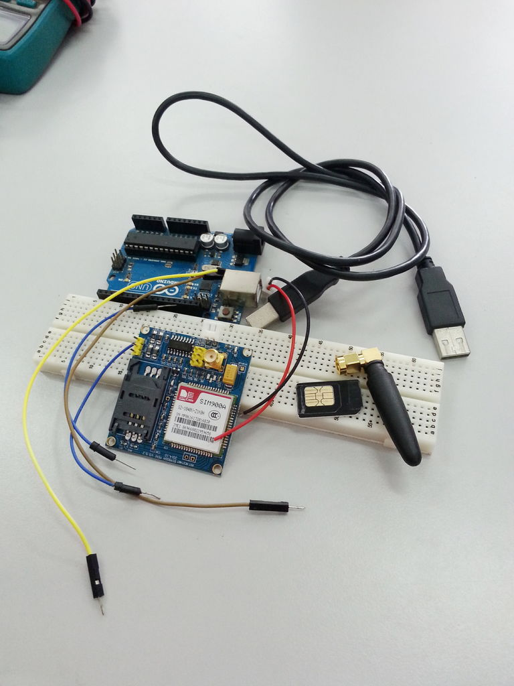

Figure 9.1: Material preparation [12].

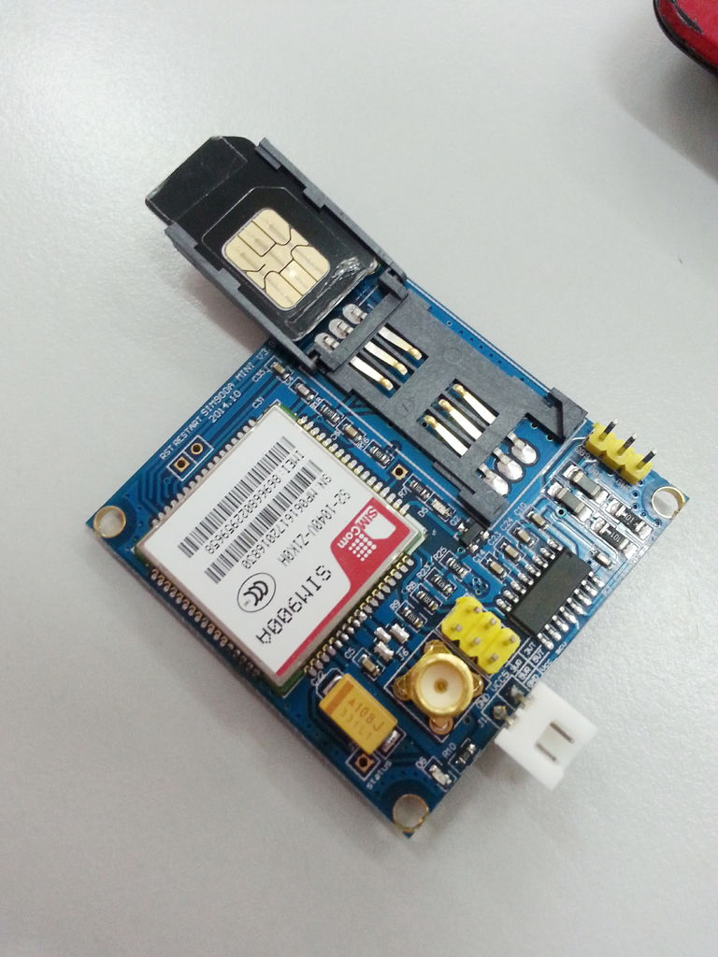

Figure 9.2: Booting up GSM SIM900A [12].
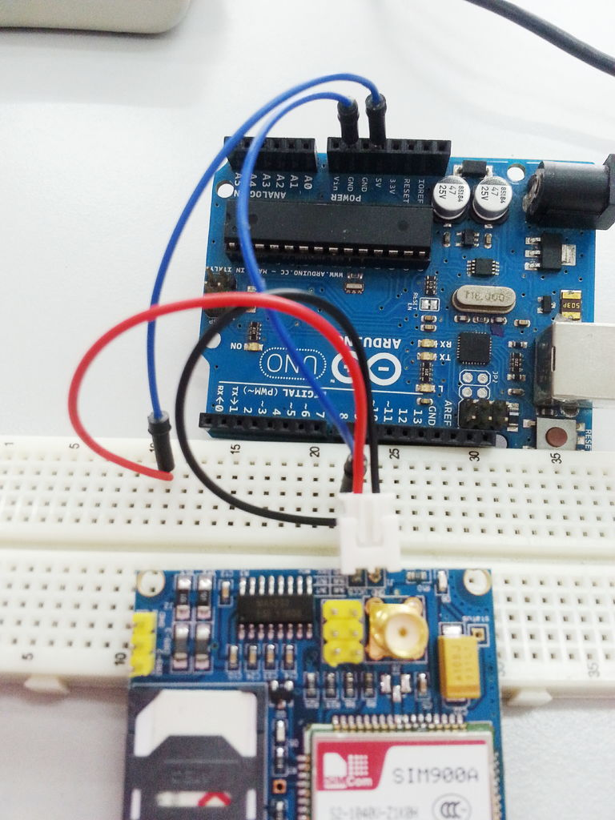
Figure 9.3: Connecting to Arduino [12].

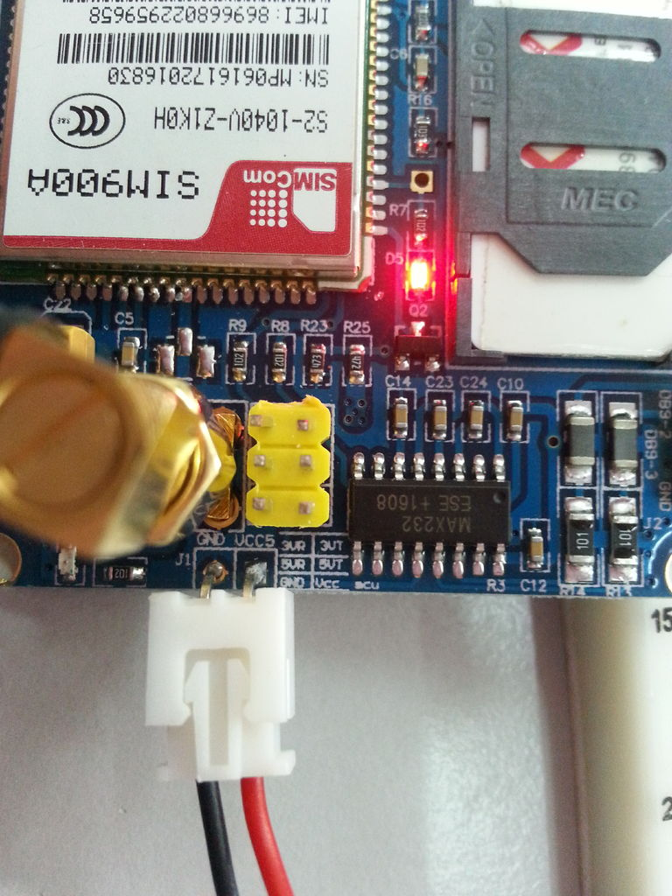
Figure 9.4: GSM SIM900A is powered up [12].

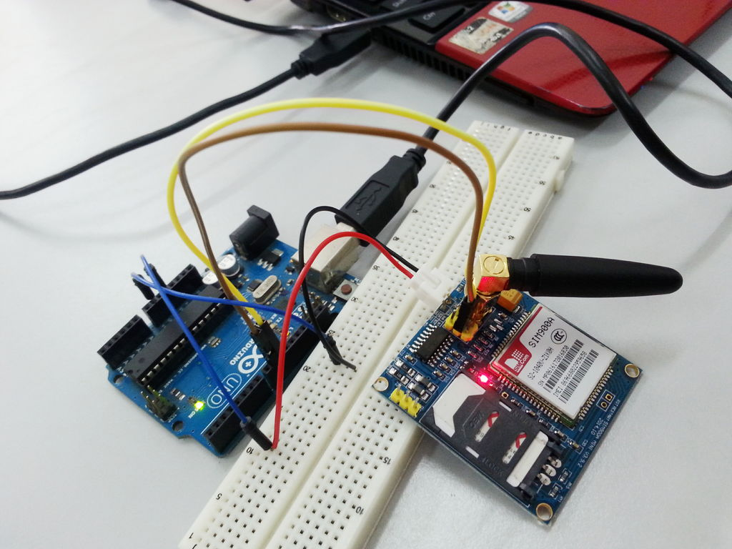
Figure 9.5: Overall view of GSM SIM900A connected to Arduino Uno [12].
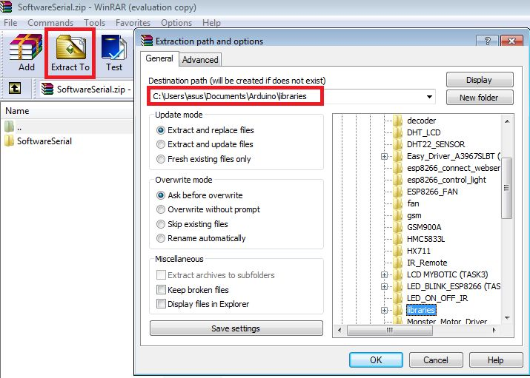
Figure 10: Arduino library [12].
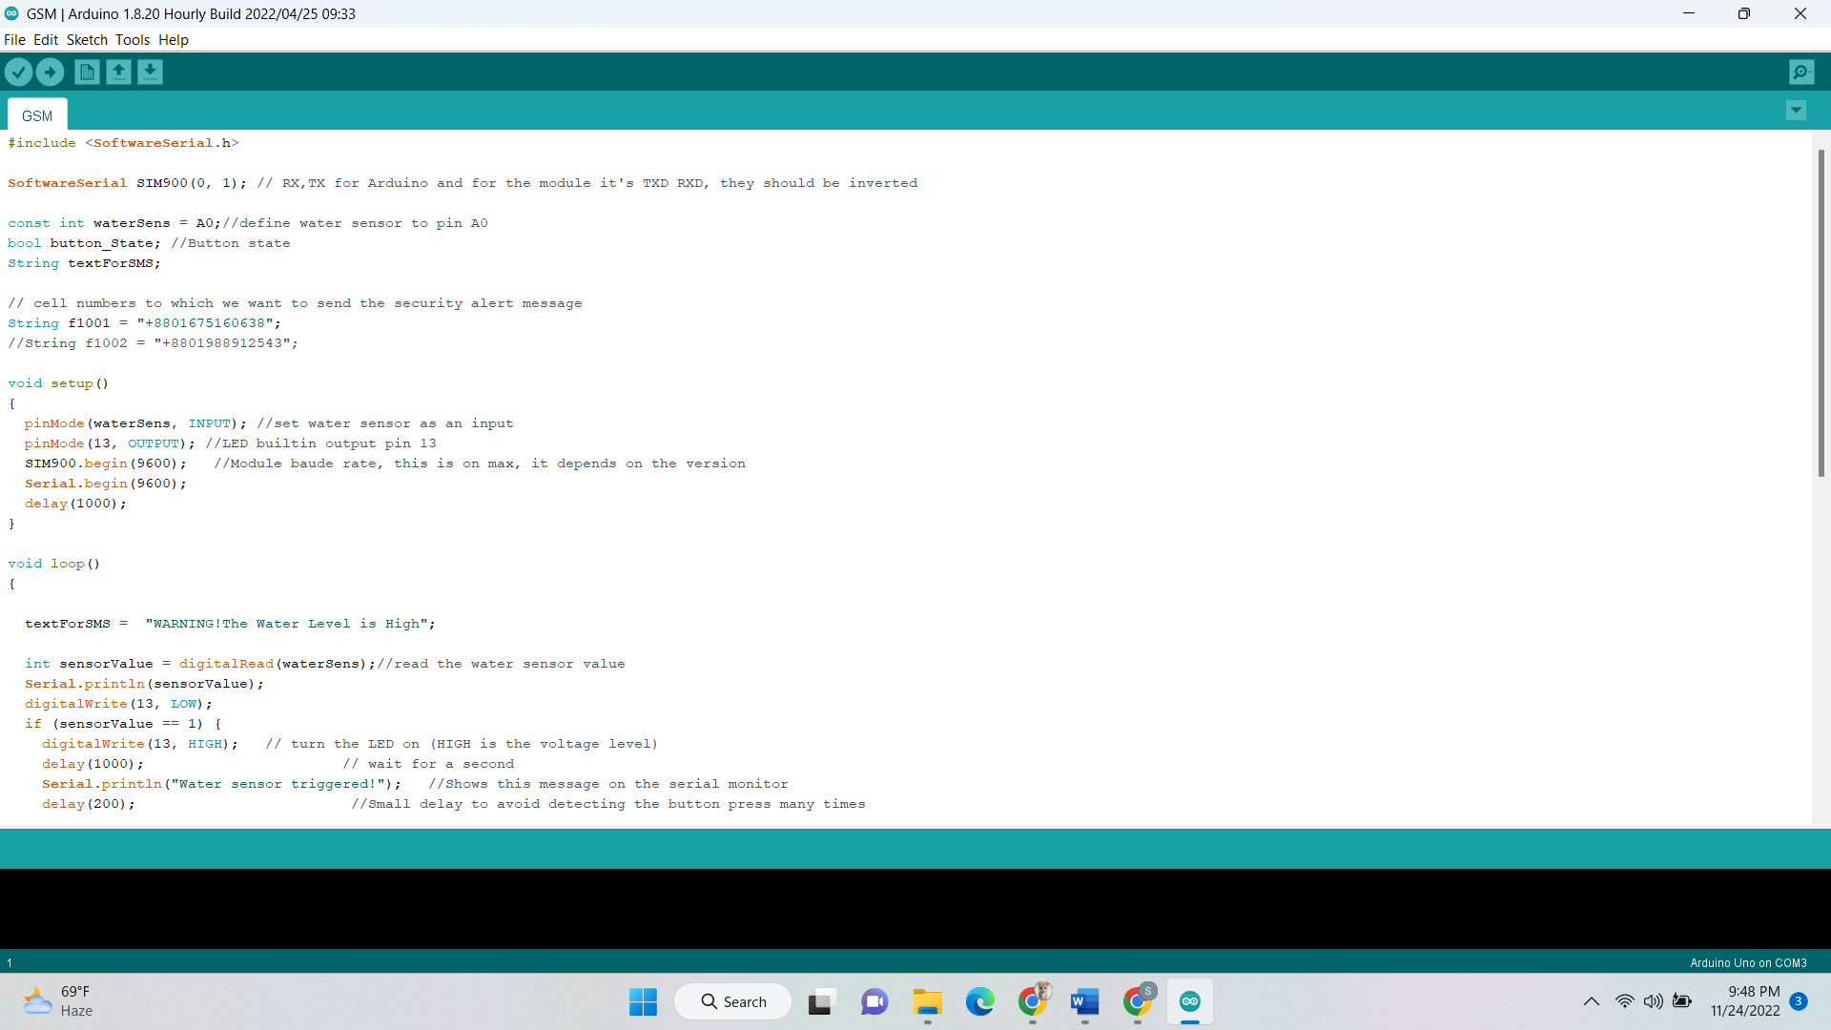

Figure 11: Sample source code.

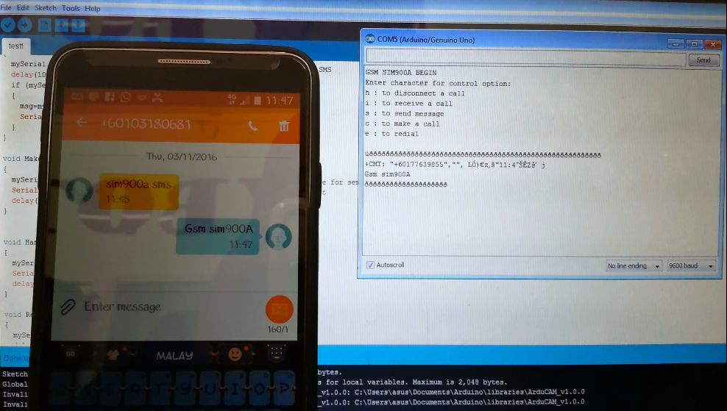

Figure 12: Sending and receiving SMS through GSM SIM900A [12].
3.1 Material Preparation

We are going to need:
  - Arduino Uno with connector
  - GSM SIM900A
  - 5V power adapter
  - SIM card
  - Some wires and breadboard
Bottom of Form

3.2 Booting Up SIM900A
First, the SIM card is inserted and secured into the GSM module. GSM is activated by connecting it to the Arduino's 5V and GND. The GSM module is linked to the antenna. Now we wait for a while to watch how fast the LED blinks. This is due to the fact that the GSM module often takes some time to establish a connection with the mobile network. When the connection is properly established, the LED will blink continuously every 3 seconds. We might try calling the sim card's mobile number from within the GSM module. If we get a ring back, we know the GSM module has successfully established a network connection.

3.3 Pin Connection

On the SIM900A, a TTL pin with the following pin numbers can be seen: 3VR, 3VT, 5Vr, 5VT, VCC, and GND. For serial communication between Arduino and the SIM900A module, we must connect GSM's 5VT to Arduino D9 and GSM's 5VR to Arduino D10. The TX pin of one must be connected to the RX pin of the other in order to complete the transmission and receiving process. In our case, the line that plays the most important role is the TX pin of SIM900A connected to the RX pin of Arduino Uno as the signal will go from SIM900A to Arduino Uno as an input signal.

3.4 Library
An Arduino library called SoftwareSerial enables serial data transfer via the board's additional digital pins. The library manages serial communication as well as hardware functionality replication. We must download and extract this library into your Arduino's libraries in order to connect. This library will also be necessary for the simulation as this can’t be found as a built-in option. So, we must configure it manually before working with this.

3.5 Sample Source Code

The main source code can be found in the provided GitHub repository [15]. A sample is attached herewith in fig:11. In gist, the code looks like a C-program. Here, we declared some global variables. The setup() function initializes all the variables that we used in our code. And the loop() function is called continuously. So, the main task is written in the loop() function. The main task here is to check if the water sensor is triggered. This check is done continuously in this loop() function. If the check becomes true, some necessary changes are made. Such as, transferring the signal to Arduino Uno. And when the Arduino Uno gets this information, it first rings the buzzer along with the alarm. Moreover, it also sends text message to the numbers that were saved previously in our database. Another function named sendsms() is used to complete this task.
Here we used some delay so that we can get some time to adjust with the situation which means the GSM Module will get enough time to operate i.e., send messages to the targeted persons.

3.6 Send and receive SMS

With the help of GSM module, we can easily send messages to our desired person very easily. Demo can be found in fig:12. The sendsms() function is responsible for sending and receiving the messages. The receiver has nothing to do in order to receive the message. However, the sender GSM Module must stay in range of the network area of the sim that we used here. We must be careful about the network coverage area. It is very possible that flood-prone area doesn’t have high coverage network of every sim company of our country. So, we must make a trial session before deploying this system for working. The sim card with the highest accuracy rate should be taken for consideration.

CHAPTER IV

Simulation

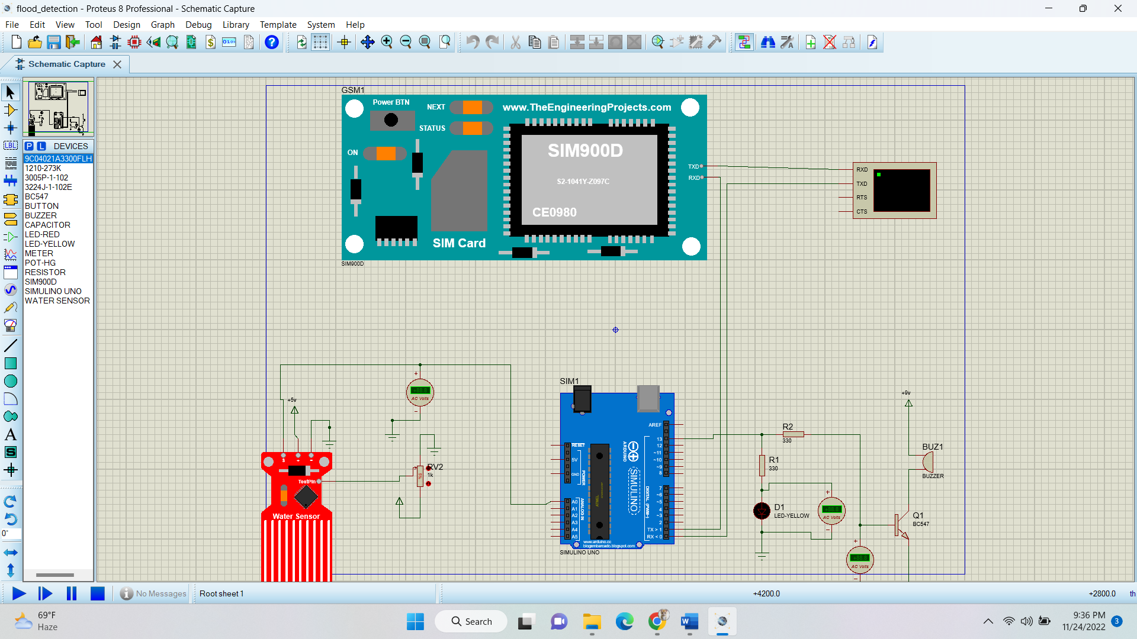

Figure 13: Circuit setup for simulation.

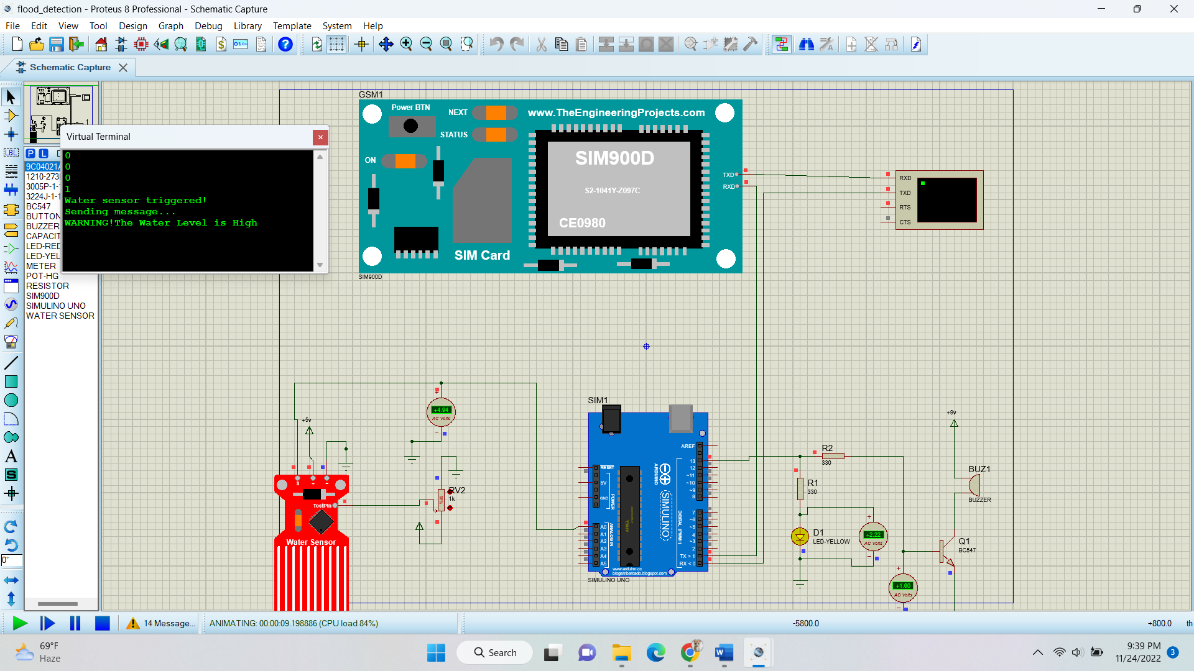

Figure 14: Running the simulation.

4.1 Overview

Along with physical project, we also did the same thing virtually. We used Proteus 8.4 SPO version as simulation software. The overall circuit setup looks like fig: 13. Proteus is one of the most used simulation software now a days. Though it doesn’t provide built-in solution for all the components we used, it has a high community support. Thus, the libraries provided by the external sources were used here.

4.2 Description

The main components used here (Arduino, GSM and Water sensor) weren’t present in the proteus. So, we had to use external libraries. Most of them were collected from [2]. We used a virtual terminal to show the messages that people will see on their mobile phones.
We know the water sensor gets triggered when drops of water fall on it. But it isn’t possible to show in simulation. For that reason, we used a variable resistor in order to get the water sensor triggered by manually providing voltage to it.
We used some voltmeters in order to observe the changes in voltage. We also had to use some extra resistors so that the components don’t get over-voltage or under-voltage.
After a successful detection in the water sensor, the outcome looks something fig: 14.

At that time, the LED gets lightened, and the buzzer starts beeping.
The details of the simulation, necessary codes along with a video demonstration can be found in the provided GitHub repository [15].

CHAPTER V

Results and Conclusion

5.1 Results

In gist, the main procedure for both real-life and simulation works like this:
After a successful detection of water, the signal passes to the Arduino through a line. This signal does two tasks at a time. Firstly, it makes the LED lighten and beeps the buzzer. Secondly, it triggers the GSM so that the GSM device can send messages to the nearby residents. The mobile numbers of the residents should be kept in a database. This warning alert can be sent to as many people as we want. In this way, our project can be a great help to the people of flood-prone areas as they will be notified earlier about a potential flood occurrence.

5.2 Conclusion

In this report, we tried to implement a hardware-based flood detection system that can be named “Automatic Flood Detection System”. After the study is over, the objectives have been developed as the basis for working. The " Automatic Flood Detection System ", which was intended to assist travelers progressively avoid becoming stopped in traffic, achieved our overall goal. The commuters will benefit from saving money, time, and effort. One of the quickest ways to check for and monitor flooding is the Automatic Flood Detection System.

5.3 Future Works

We would like to suggest that the Local Government Unit Flood Control see the study "Flood Detector System using Arduino" as a critical source of flood information based on the outcomes of the findings and conclusions acquired. We would also seek to provide households with access to a website that contains information on the flood level. Additionally, it is expected that the established system serve our entire country. Finally, we would like to advise continuing the study or progressively enhancing it for the benefit of upcoming researchers.

References

[1] | N/A, "Components 101," [Online]. Available: https://components101.com/tags/arduino.
[2] | D. Watson, "The Engineering Projects," 07 2020. [Online]. Available: https://www.theengineeringprojects.com/2020/07/water-sensor-library-for-proteus.html.
[3] | Baballe, M. Ahmad and Z.-A. Abbati, "A Review of Flood Detection Systems," 2022.
[4] | Z. Y. Z. a. H. W. Wu, "Real-time prediction of the water accumulation process of urban stormy accumulation points based on deep learning," IEEE Access 8, pp. 151938-151951, 2020.
[5] | U. K. H. A. a. S. Y. S. Panchal, "Flooding level classification by gait analysis of smartphone sensor data," Ieee Access 7, pp. 181678-181687, 2019.
[6] | N. &. M. E. N. &. Z. N. &. N. K. Mahzan, "Design of an Arduino-based home fire alarm system with GSM module," Journal of Physics: Conference Series, pp. 1019. 012079. 10.1088/1742-6596/1019/1/012079, 2018.
[7] | V. S. C. A. G. D. L. C. V. EDWIN DE GUZMAN, "FLOOD DETECTOR SYSTEM USING ARDUINO," [Online]. Available: https://docplayer.net/52575716-Flood-detector-system-using-arduino.html.
[8] | vandenbrande, "Arduino - FLOOD ALARM - Using a Simple Water Level Sensor," [Online]. Available: https://www.instructables.com/Arduino-FLOOD-ALARM-Using-a-Simple-Water-Level-Sen/.
[9] | S. &. S. M. R. &. U. M. Rahaman, "Flood and Flood Management in Bangladesh," 2017.
[10] | M. H. Kabir and M. N. Hossen, "Impacts of flood and its possible solution in Bangladesh," 2019.
[11] | "Simple Water Level Sensor Or Liquid Level Detector," [Online]. Available: http://www.circuitdiagram.org/simple-water-level-sensor-liquid-detector.html.
[12] | N/A. [Online]. Available: https://www.fabian.com.mt/viewer/36294/pdf.pdf.
[13] | "Android Controlled Solar based Grass Cutter Robot - Scientific Figure on ResearchGate," [Online]. Available: https://www.researchgate.net/figure/Motor-driver-IC-L239D-vii-Solar-Panel-This-system-uses-12V-10-Watt-solar-panel-It-has_fig5_343056142. [Accessed 24 Dec 2022].
[14] | "ATmega328P Pin mapping," [Online]. Available: https://www.pinterest.com/pin/414401603184128742/.
[15] | S. Das, "Flood Detection using Arduino," [Online]. Available: https://github.com/piy4l/Flood-Detection-using-Arduino.

