**Host a Website on S3**

**Steps to create**

1.Create a S3 bucket and disable block public access, rest are default.

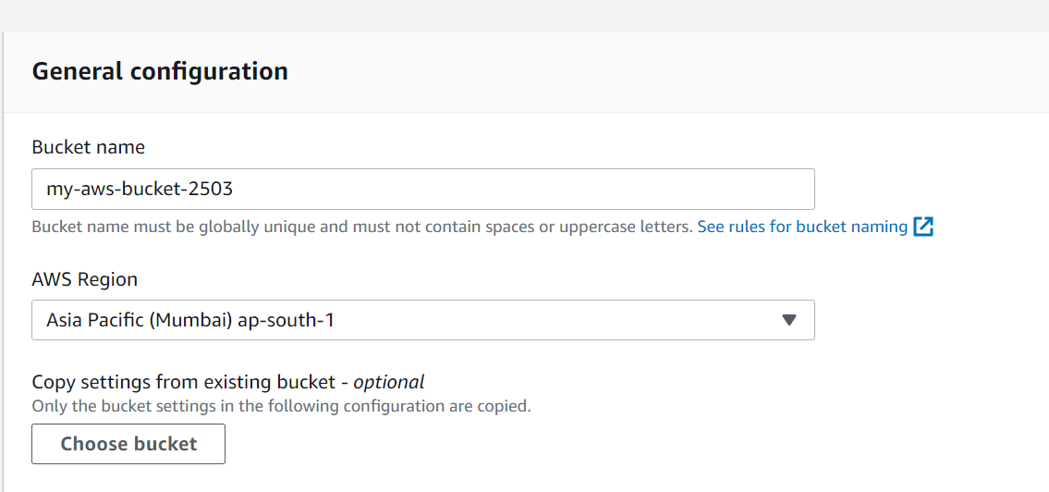

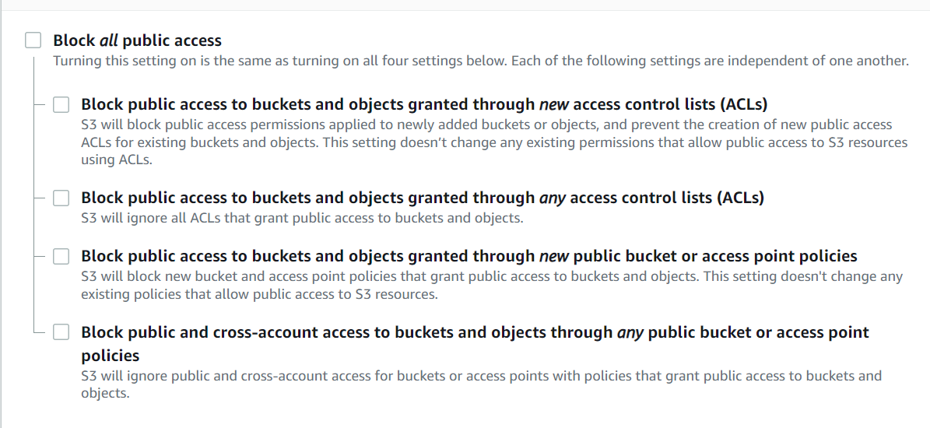

2. Enable Static website hosting

Goto🡪Properties🡪Static website Hosting

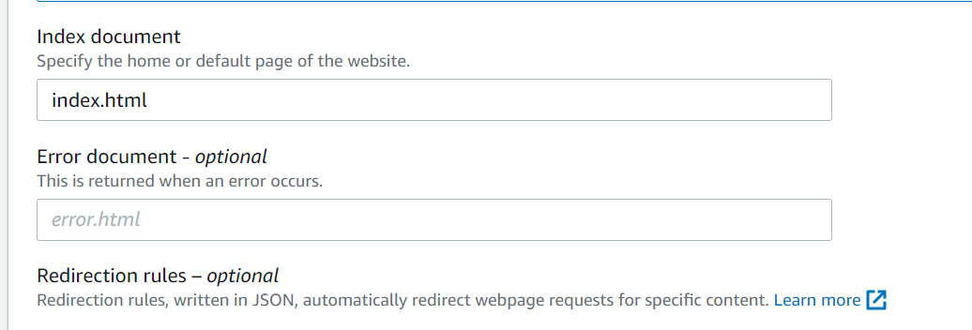

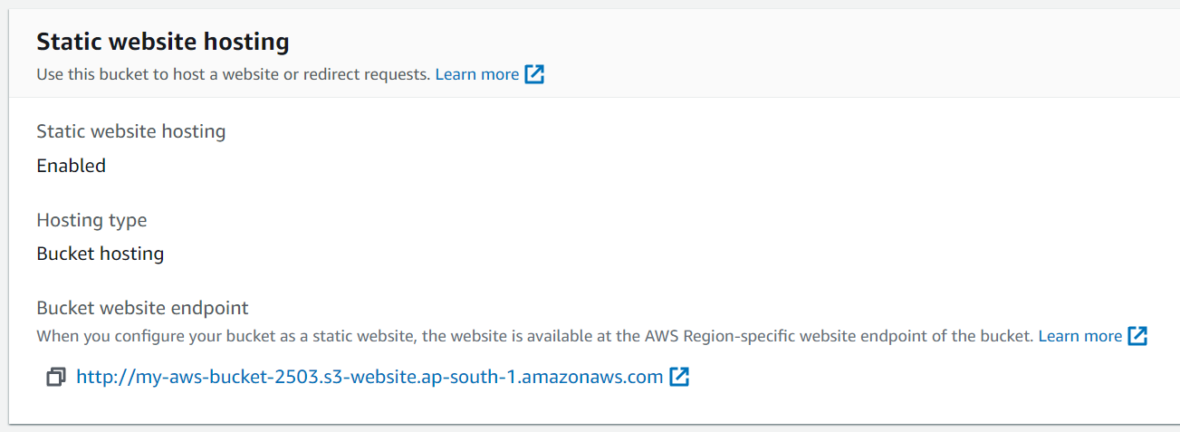

3. Enable Bucket policies

Goto🡪Permissions🡪Bucket Policy

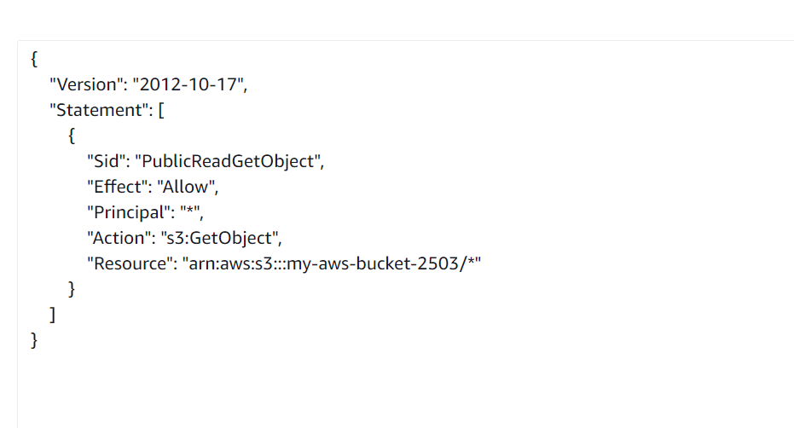

Copy the below policy

{

"Version": "2012-10-17",

"Statement": [

{

"Sid": "PublicReadGetObject",

"Effect": "Allow",

"Principal": "*",

"Action": "s3:GetObject",

"Resource": "arn:aws:s3:::bucketname /*"

}

]

}

4. Finally access your website

