EXPERIMENT 2

**Aim:**

Design christmas dual led chaser lights

**Apparatus:**

Arduino ,LED’s ,resistance 470 ohm ,wires, Breadboard

**Circuit Diagram:**

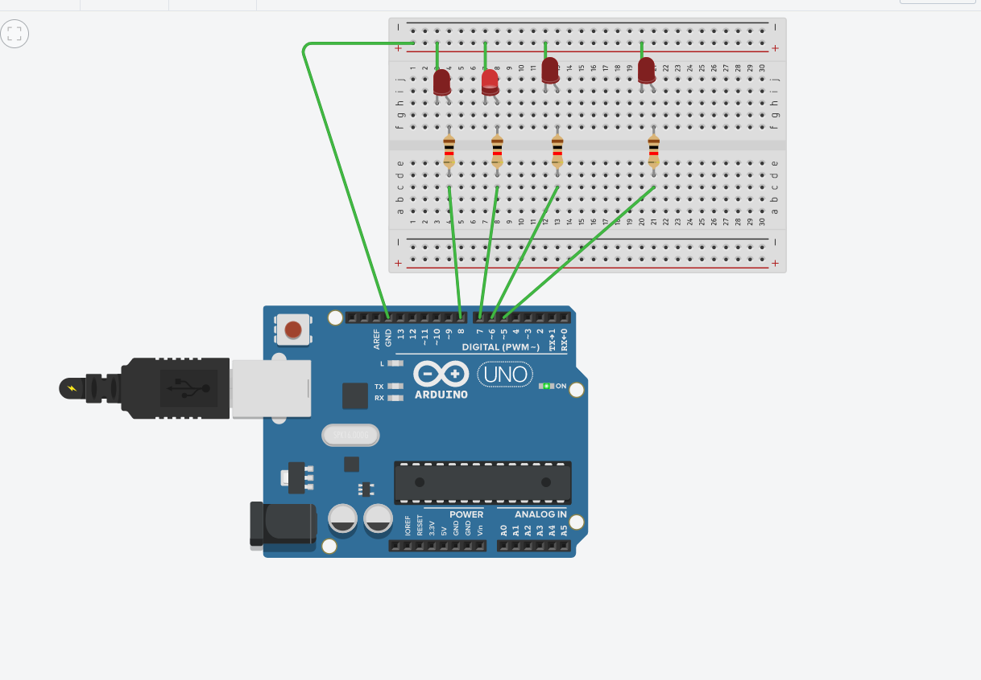

**THEORY:**

**CONCEPT USED:**

* In series circuit voltage gets divided and in parallel circuit current gets divided.
* Kirchoff’s current law:

Total current flowing through a junction is equal to current flowing out.

**LEARNING AND OBSERVATIONS:**

* **LEARNING:**
* How we can use loop to get the desired pattern of LED.
* How to make parallel connections of LEDs on breadboard.
* **OBSERVATION:**
* When we upload the code we noticed that first two LEDs glow and then first LED goes off while second and third glow .This pattern continues till loop don’t end.

**PROBLEM AND TROUBLE SHOOTING:**

* The cable connecting arduino was loose from one end so it should be connected properly.
* Connection between the ground and n side of diode were not proper.
* At first desired pattern was not created because there is some error in the code.

**PRECAUTIONS:**

* The connections at different points should be proper.
* As four LEDs are used so make the circuit neat and proper to avoid confusion.
* Check LEDs before hand and check there working to avoid error in the circuit.

**LEARNING OUTCOMES:**

* By doing this experiment I have gained the skill of making different kind of patterns of light using LEDs and arduino board.