**DOCKER ASSIGNMENT NO.1**

**Deployment of 3 different git repositories in 3 different apache httpd containers respectively by using jenkins pipeline**

**1.SCRIPT**

pipeline{

agent any

stages{

stage('git-clone 2024Q1 branch'){

steps{

git branch:'master', url:'https://github.com/piyali1994/2024Q1.git'

}

}

stage('port 80 binding with httpd docker container'){

steps{

sh 'docker rm -f server1'

sh 'docker run -dp 80:80 --name server1 httpd'

sh 'chmod -R 777 index.html'

sh 'docker cp index.html server1:/usr/local/apache2/htdocs/'

}

}

stage('git-clone 2024Q2 branch'){

steps{

git branch:'master', url:'https://github.com/piyali1994/2024Q2.git'

}

}

stage('port 90 binding with httpd docker container'){

steps{

sh 'docker rm -f server2'

sh 'docker run -dp 90:80 --name server2 httpd'

sh 'chmod -R 777 index.html'

sh 'docker cp index.html server2:/usr/local/apache2/htdocs/'

}

}

stage('git clone 2024Q3 branch'){

steps{

git branch:'master', url:'https://github.com/piyali1994/2024Q3.git'

}

}

stage('port 100 binding with httpd docker container'){

steps{

sh 'docker rm -f server3'

sh 'docker run -dp 100:80 --name server3 httpd'

sh 'chmod -R 777 index.html'

sh 'docker cp index.html server3:/usr/local/apache2/htdocs/'

}

}

}

}

**2.CONSOLE OUTPUT**

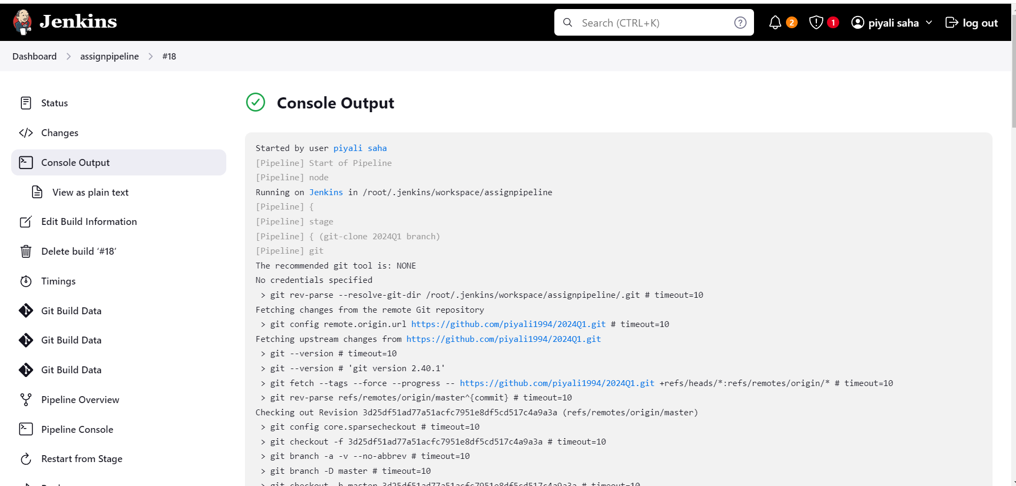

**3.PIPELINE OVERVIEW**

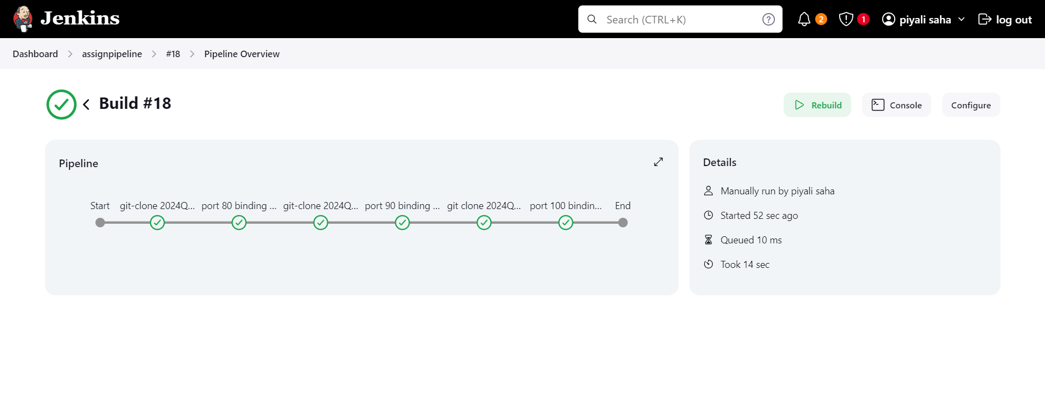

**REPOSITORY 1 DEPLOYED AT PORT 80**

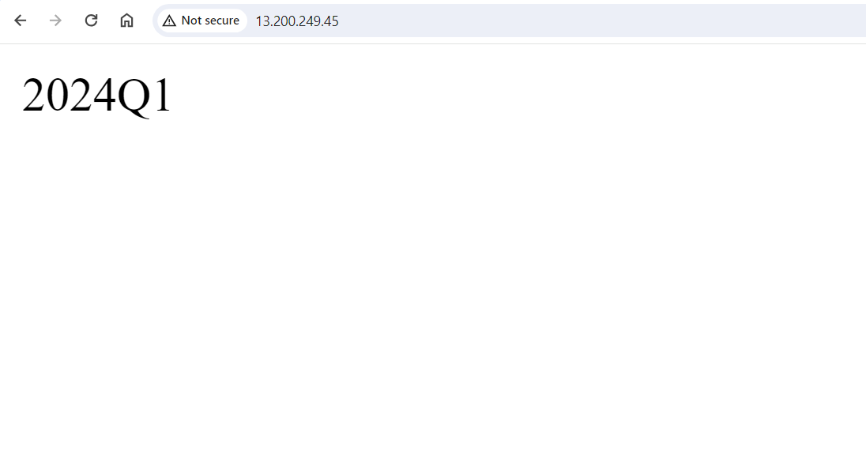

**REPOSITORY 2 DEPLOYED AT PORT 90**

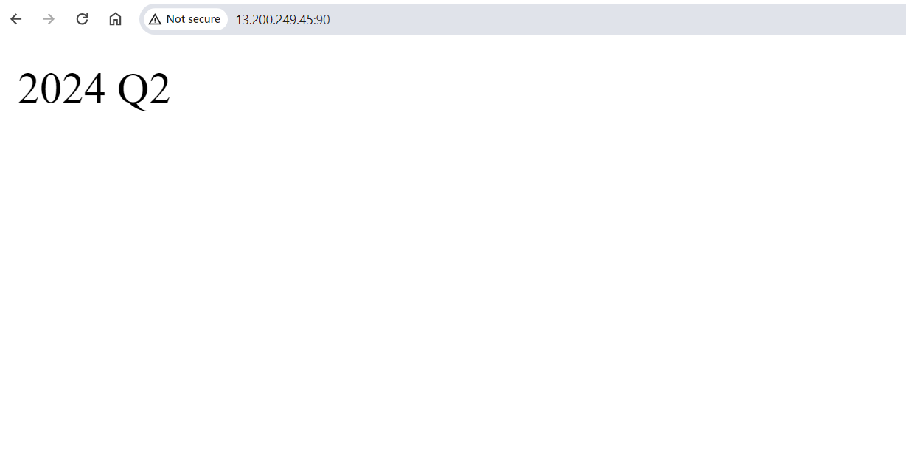

**REPOSITORY 3 DEPLOYED AT PORT 100**

