**Assignment No. 6**

**Install Apache-httpd and deploy index.html file in Jenkins master by using pipeline**

**PIPELINE SCRIPT**

pipeline{

agent{

label "built-in"

}

stages{

stage('stage-1'){

steps{

sh 'yum install httpd -y'

sh 'service httpd start'

sh 'echo "JENKINS-PIPELINE IN JENKINS-MASTER" >> /var/www/html/index.html'

sh 'chmod -R 777 /var/www/html/index.html'

}

}

}

}

**CONSOLE OUTPUT**

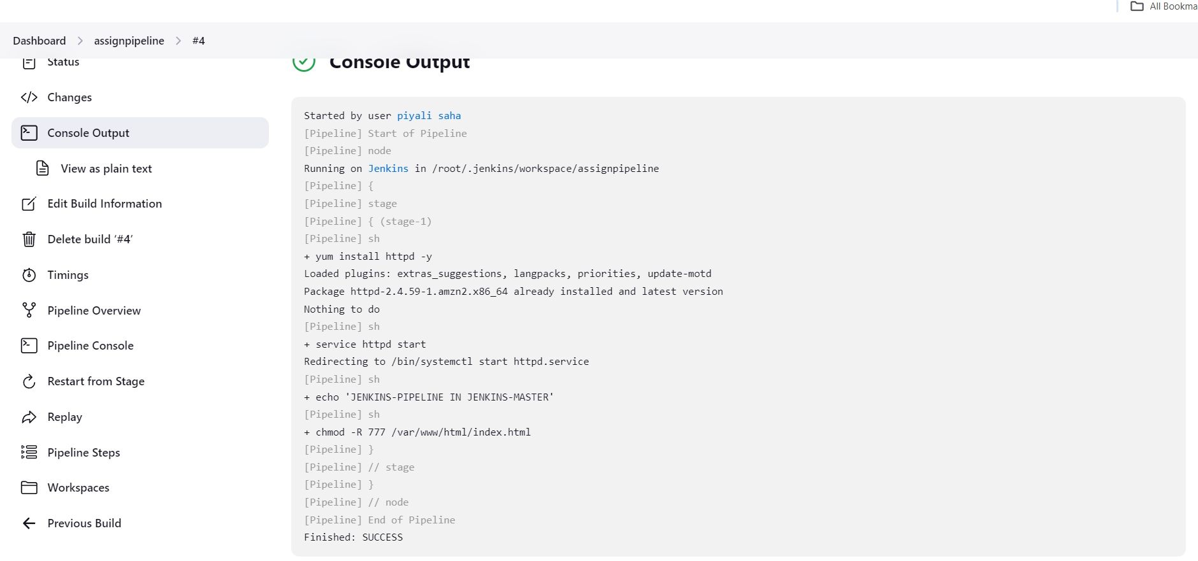

**PIPELINE OVERVIEW**

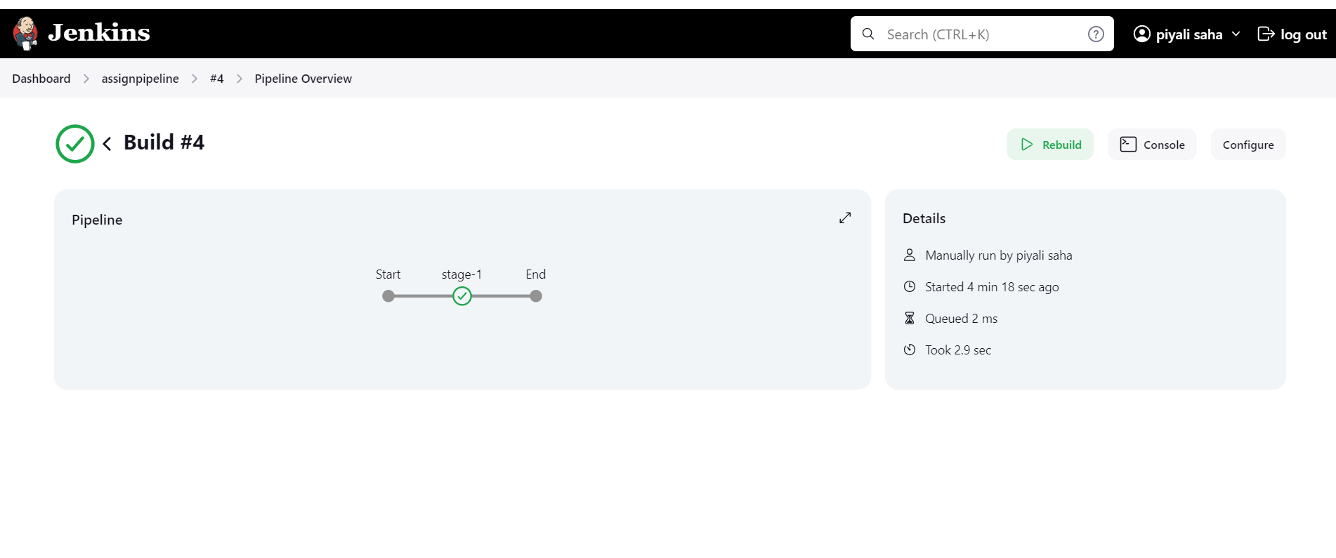

**Screenshot of Content index.html file**

