**Assignment No. 7**

**Pull git repository and deploy index.html file in apache htttpd by using Jenkins pipeline**

**PIPELINE SCRIPT**

pipeline{

agent{

label "slave-1"

}

stages {

stage('stage-1') {

steps {

git branch: 'master', url: 'https://github.com/piyali1994/Repo1.git'

}

}

stage('stage-pull') {

steps {

sh 'git pull origin master'

}

}

stage('stage-deploy') {

steps {

sh 'yum install httpd -y'

sh 'service httpd start'

sh 'cp * /var/www/html/'

sh 'chmod -R 777 /var/www/html/

}

}

}

}

**CONSOLE OUTPUT**

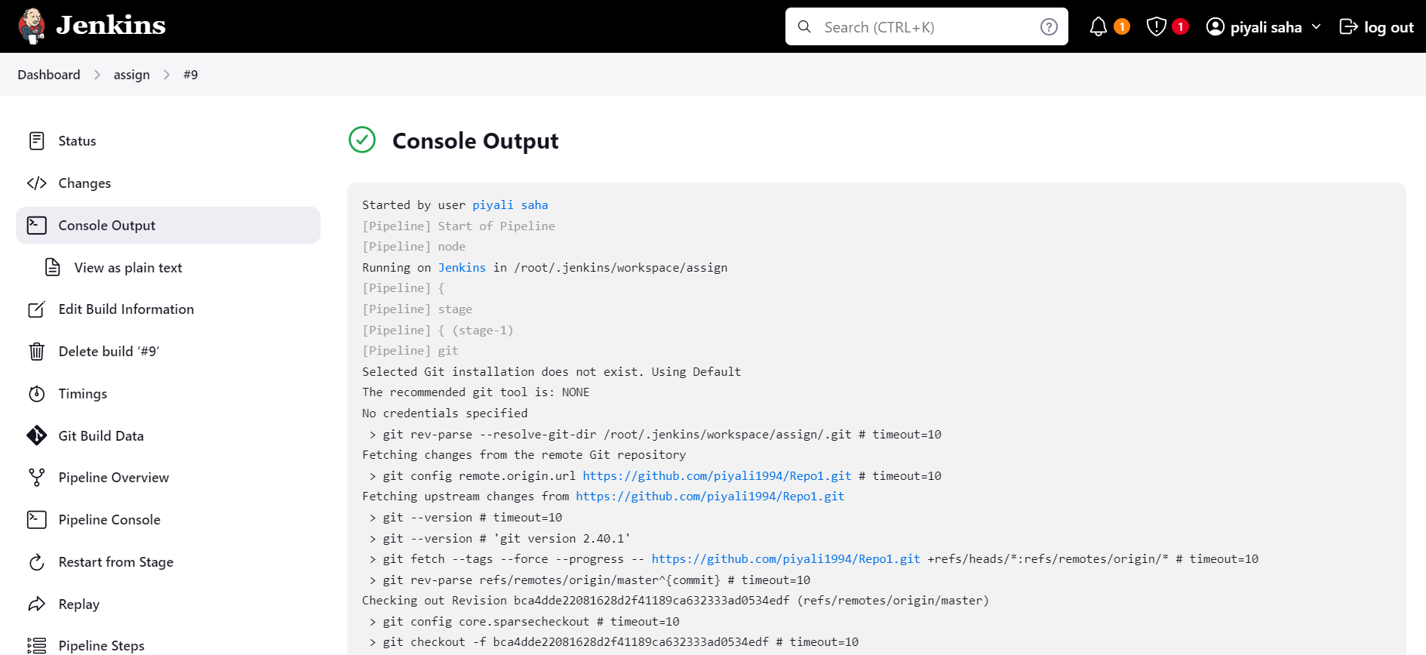

**PIPELINE OVERVIEW**

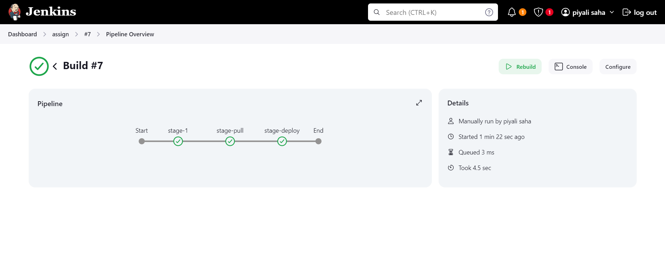

**Screenshot of Content index.html file**

