ASSIGNMENT NO.2

First repository index.html file

[root@ip-172-31-39-143 ec2-user]# cd REPO-1

[root@ip-172-31-39-143 REPO-1]# git config --global user.name piyali

[root@ip-172-31-39-143 REPO-1]# git config --global user.email piyalisaha@gmail.com

[root@ip-172-31-39-143 REPO-1]# vi index.html

[root@ip-172-31-39-143 REPO-1]# git add *

[root@ip-172-31-39-143 REPO-1]# git commit -m "repo1 commit"

[root@ip-172-31-39-143 REPO-1]# git log

commit 2884b758f374a4d4c3e9494c6404db15426357bc (HEAD -> master)

Author: piyali <piyalisaha@gmail.com>

Date: Mon May 20 12:38:20 2024 +0000

repo1 commit

[root@ip-172-31-39-143 REPO-1]# git remote add origin https://github.com/piyali1994/Repo1.git

[root@ip-172-31-39-143 REPO-1]# git push origin master

Likewise I followed this same steps for Repository2 index.html file and Repository3 index.html file.

Then I created job1 in Jenkins

1. Adding URL of repository 1.
2. Enabling built trigger as GitHub hook trigger for GITScm polling
3. Build steps as follows

yum install httpd -y

service httpd start

service httpd status

cp * /var/www/html/

chmod -R 777 /var/www/html/

1. Then I made changes in git hub webhook

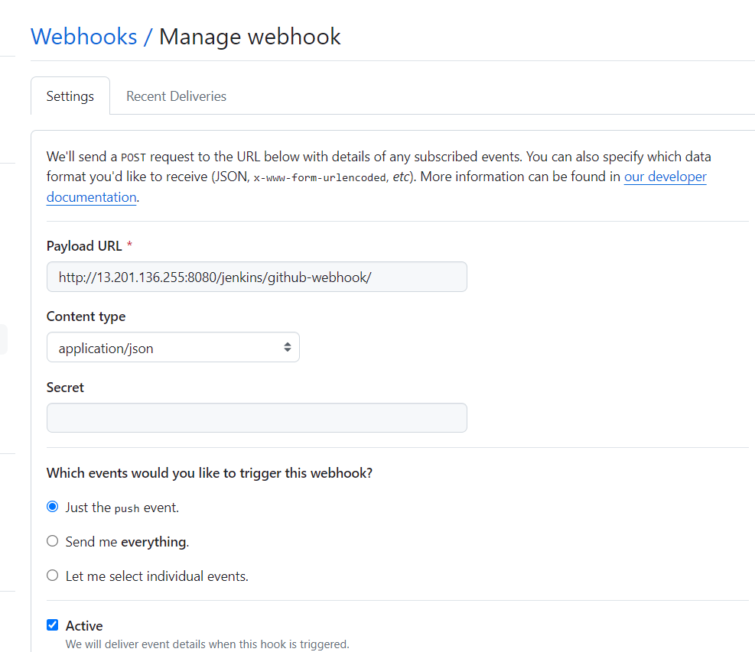

Simultaneously I followed this steps for my other 2 jobs in Jenkins.

**This is the screenshot of my all 3 jobs**

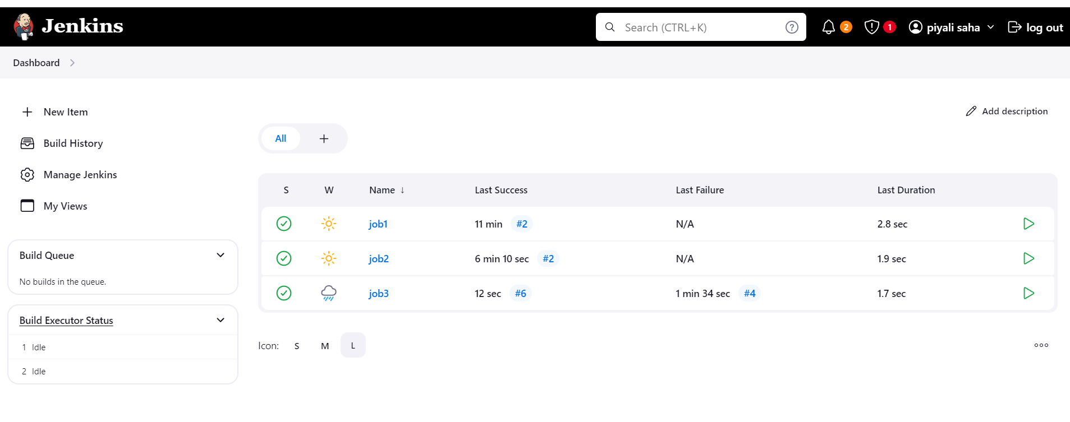

1. **If I commit changes in my repository 1 then my job 1 builds automatically**

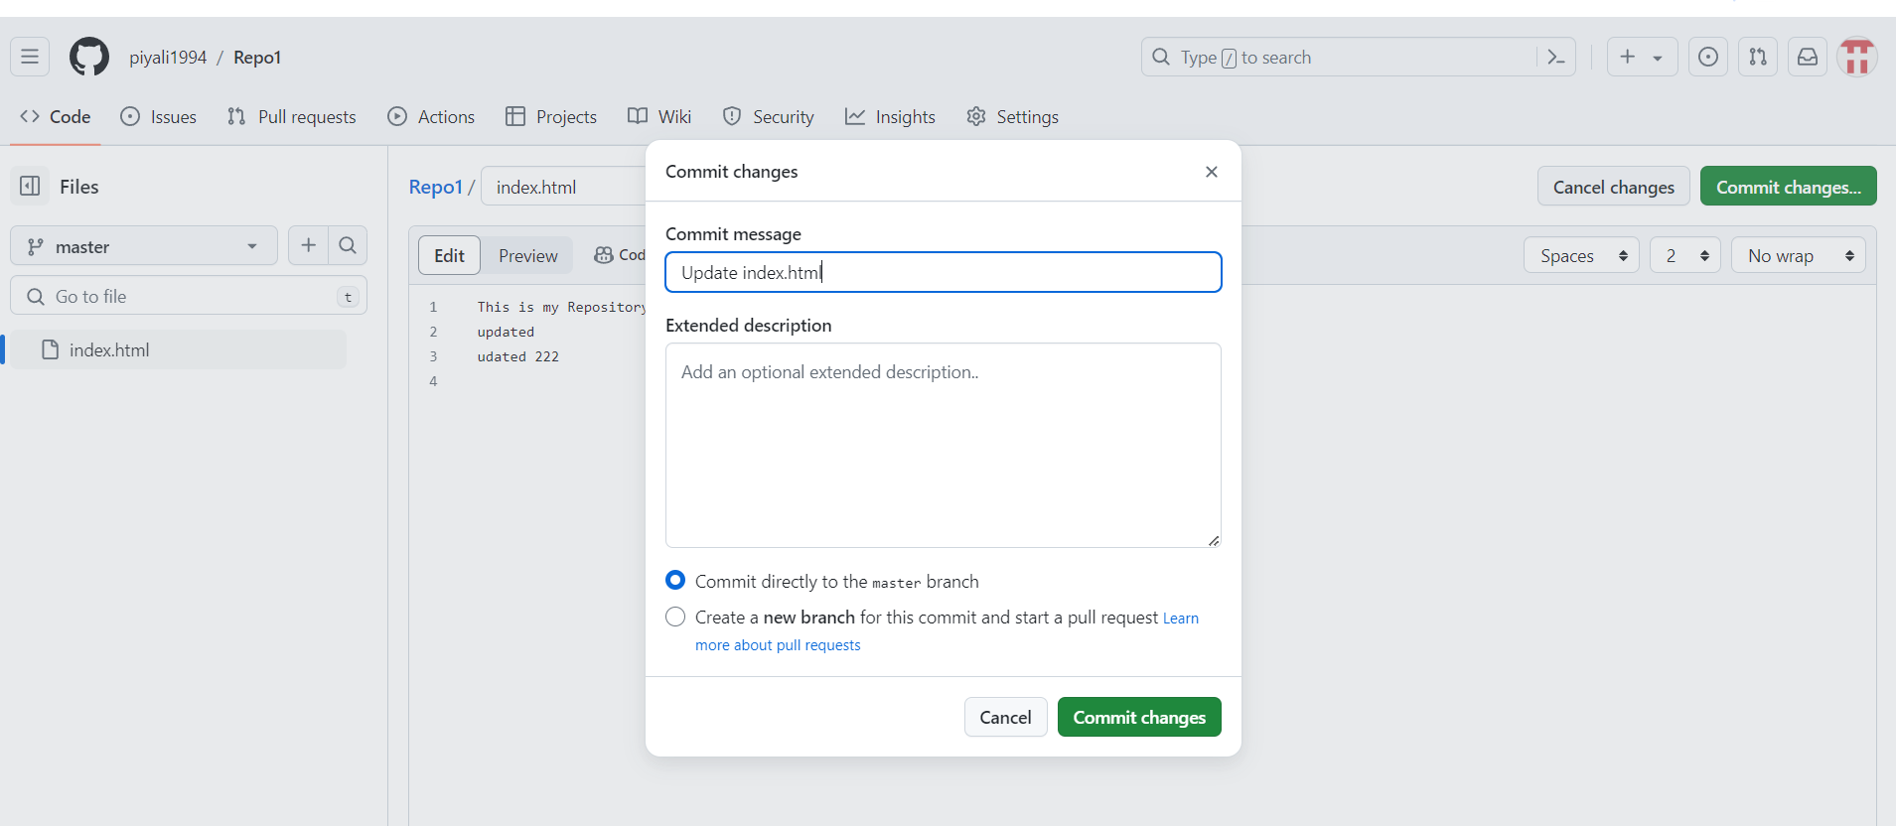

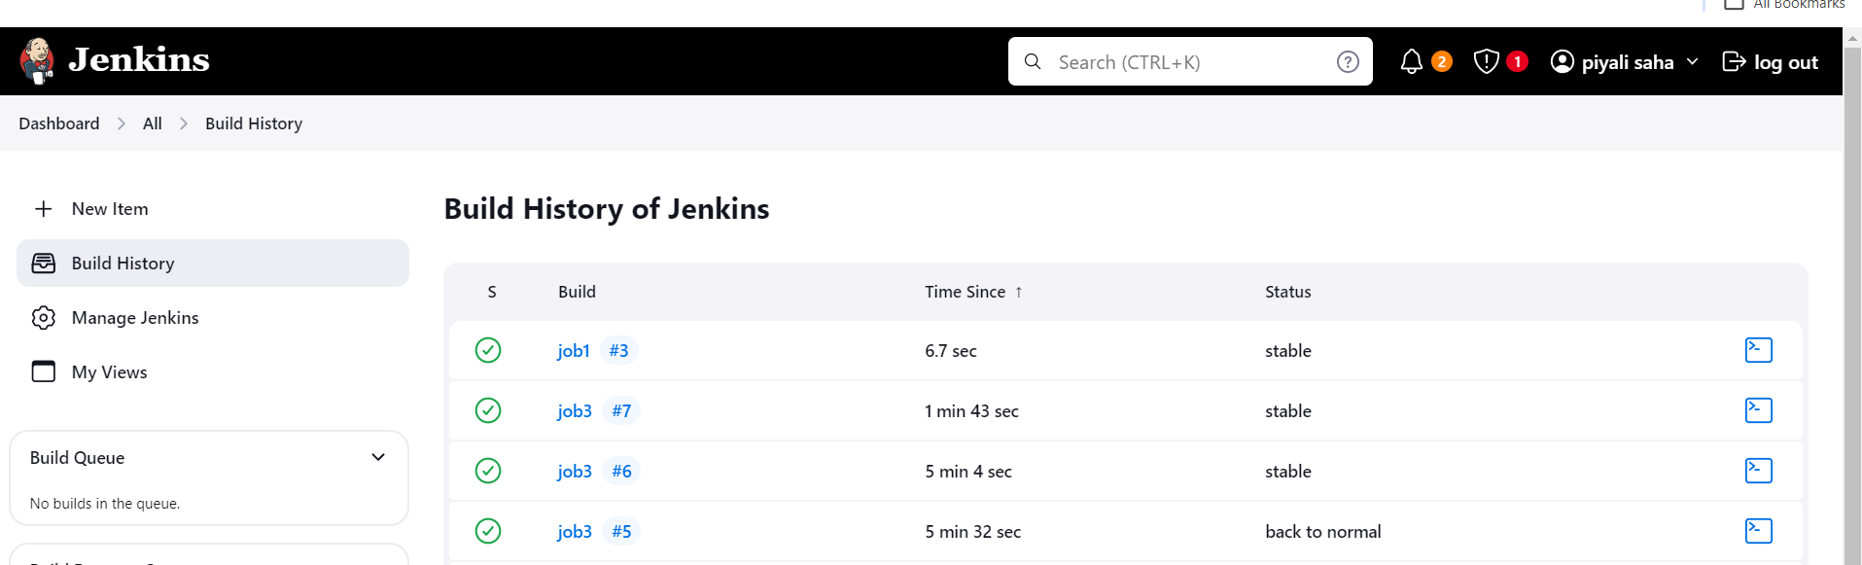

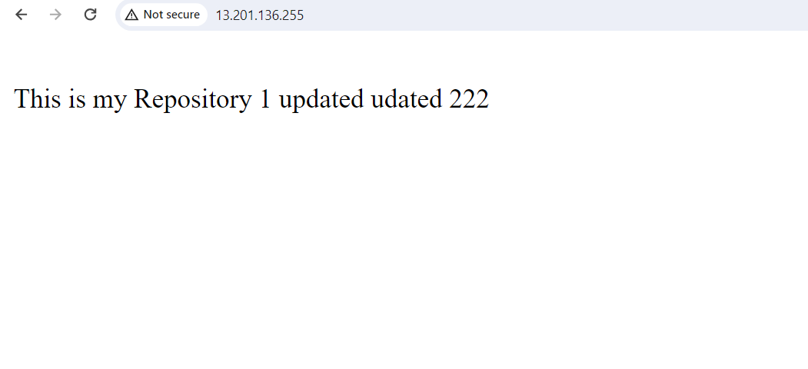

1. **If I commit changes in my repository 2 then my job 2 builds automatically**

