1595971406 - full report

# Data parameters

* Shape : (1350, 1024, 7812)
* Num of ants 62
* Num of corr 7812
* Num of chans 1024
* Num of scans 19

# CONTENTS

===============================================================================  
Name: file:///data/mohan//1595971406/1595971406_sdp_l0.rdb | 1595971406-sdp-l0 (version 4.0)  
===============================================================================  
Observer: Operator Experiment ID: 20200728-0067  
Description: 'Upgrade Tests: Stability Track'  
Observed from 2020-07-28 23:23:28.948 SAST to 2020-07-29 02:23:30.996 SAST  
Dump rate / period: 0.12498 Hz / 8.002 s  
Subarrays: 1  
 ID Antennas Inputs Corrprods  
 0 m000,m001,m002,m003,m004,m005,m006,m007,m008,m009,m010,m011,m012,m013,m014,m015,m016,m017,m018,m019,m020,m021,m022,m023,m024,m026,m027,m028,m029,m030,m031,m032,m033,m034,m035,m036,m037,m038,m040,m041,m042,m043,m044,m045,m046,m047,m048,m049,m050,m051,m052,m053,m054,m055,m056,m057,m058,m059,m060,m061,m062,m063 124 7812  
Spectral Windows: 1  
 ID Band Product CentreFreq(MHz) Bandwidth(MHz) Channels ChannelWidth(kHz)  
 0 L bc856M1k 1284.000 856.000 1024 835.938  
-------------------------------------------------------------------------------  
Data selected according to the following criteria:  
 spw=0  
 subarray=0  
-------------------------------------------------------------------------------  
Shape: (1350 dumps, 1024 channels, 7812 correlation products) => Size: 86.394 GB  
Antennas: m000,m001,m002,m003,m004,m005,m006,m007,m008,m009,m010,m011,m012,m013,m014,m015,m016,m017,m018,m019,m020,m021,m022,m023,m024,m026,m027,m028,m029,m030,m031,m032,m033,m034,m035,m036,m037,m038,m040,m041,m042,m043,m044,m045,m046,m047,m048,m049,m050,m051,m052,m053,m054,m055,m056,m057,m058,m059,m060,m061,m062,m063 Inputs: 124 Autocorr: yes Crosscorr: yes  
Channels: 1024 (index 0 - 1023, 856.000 MHz - 1711.164 MHz), each 835.938 kHz wide  
Targets: 1 selected out of 1 in catalogue  
 ID Name Type RA(J2000) DEC(J2000) Tags Dumps ModelFlux(Jy)  
 0 J1939-6342 radec 19:39:25.03 -63:42:45.6 bpcal delaycal 1350   
Scans: 19 selected out of 19 total Compscans: 18 selected out of 18 total  
 Date Timerange(UTC) ScanState CompScanLabel Dumps Target  
 28-Jul-2020/21:23:32 - 21:24:04 0:slew 0:track 5 0:J1939-6342  
 21:24:12 - 21:33:57 1:track 0:track 74 0:J1939-6342  
 21:34:05 - 21:43:57 2:track 1:track 75 0:J1939-6342  
 21:44:05 - 21:53:57 3:track 2:track 75 0:J1939-6342  
 21:54:05 - 22:03:57 4:track 3:track 75 0:J1939-6342  
 22:04:05 - 22:13:57 5:track 4:track 75 0:J1939-6342  
 22:14:05 - 22:23:57 6:track 5:track 75 0:J1939-6342  
 22:24:05 - 22:34:05 7:track 6:track 76 0:J1939-6342  
 22:34:13 - 22:44:05 8:track 7:track 75 0:J1939-6342  
 22:44:13 - 22:54:05 9:track 8:track 75 0:J1939-6342  
 22:54:13 - 23:04:06 10:track 9:track 75 0:J1939-6342  
 23:04:14 - 23:14:06 11:track 10:track 75 0:J1939-6342  
 23:14:14 - 23:24:06 12:track 11:track 75 0:J1939-6342  
 23:24:14 - 23:34:06 13:track 12:track 75 0:J1939-6342  
 23:34:14 - 23:44:14 14:track 13:track 76 0:J1939-6342  
 23:44:22 - 23:54:14 15:track 14:track 75 0:J1939-6342  
 23:54:22 - 29-Jul-2020/00:04:14 16:track 15:track 75 0:J1939-6342  
 29-Jul-2020/00:04:22 - 00:14:14 17:track 16:track 75 0:J1939-6342  
 00:14:22 - 00:23:26 18:track 17:track 69 0:J1939-6342

Bands used

* Band chs 0: 131-261
* Band chs 1: 546-781
* Full band chs : 546-781
* Percentage of auto flags in pol 0 is 10.5 %
* Percentage of auto flags in pol 1 is 9.5 %
* Percentage of cross flags in pol 0 is 8.5 %
* Percentage of cross flags in pol 1 is 8.2 %

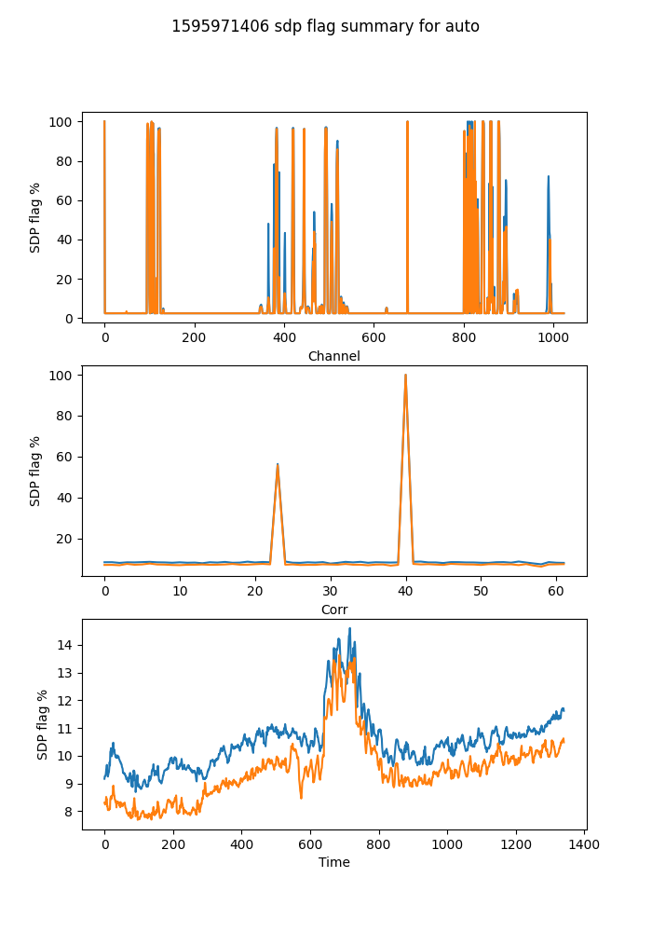

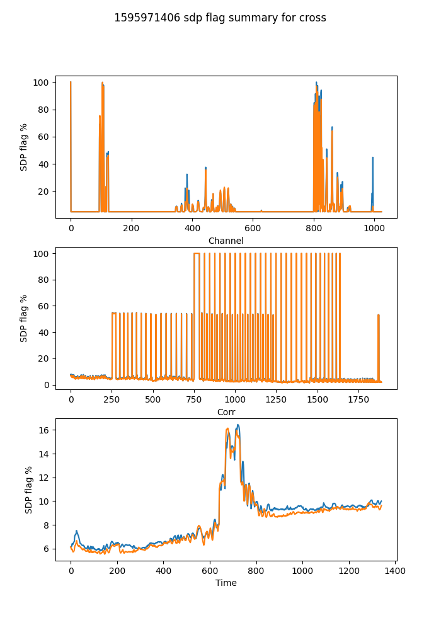

## Spectral mean and variance

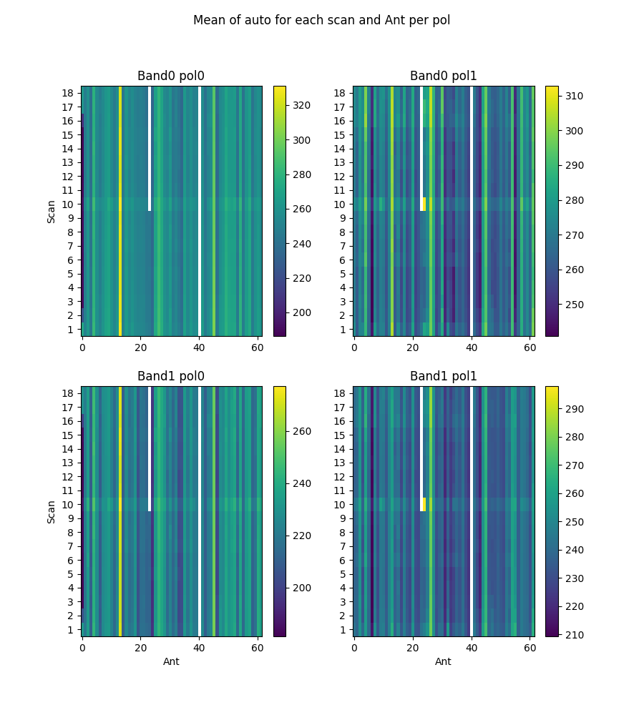

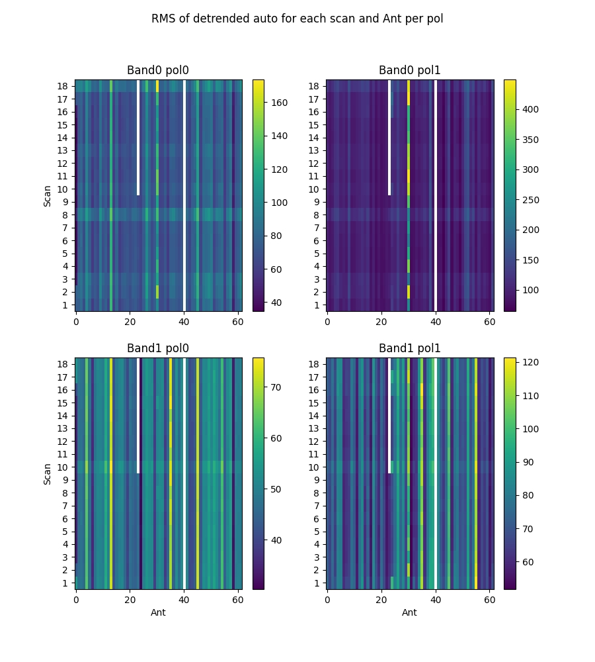

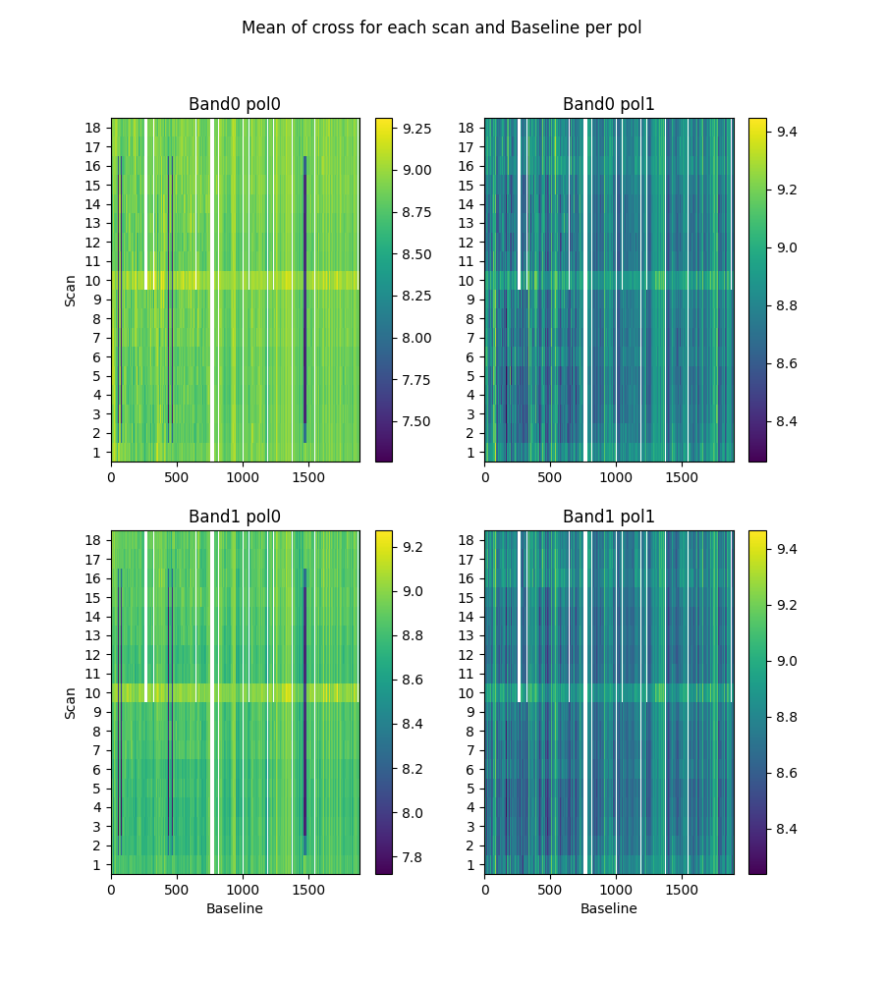

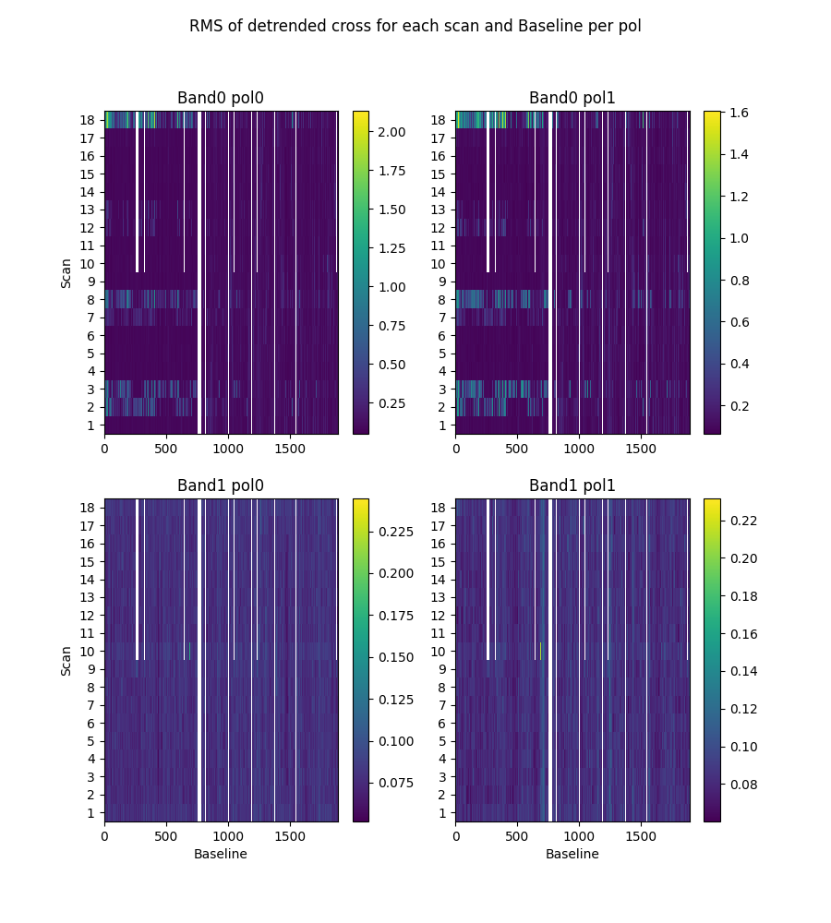

# 2-channel ringing

Using threshold of ringing index of 0.67  
(1->perfect ringing, 0-> none, neg->higher periods)

* Num of bad auto is 0
* Num of bad cross is 0

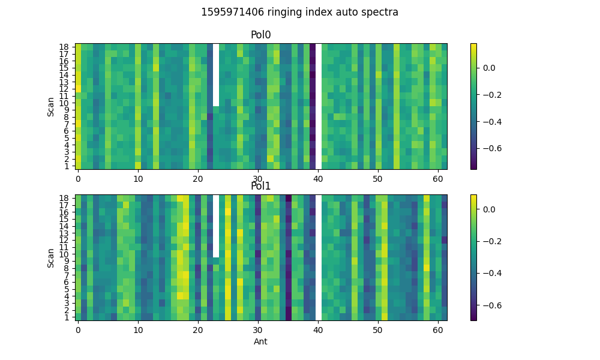

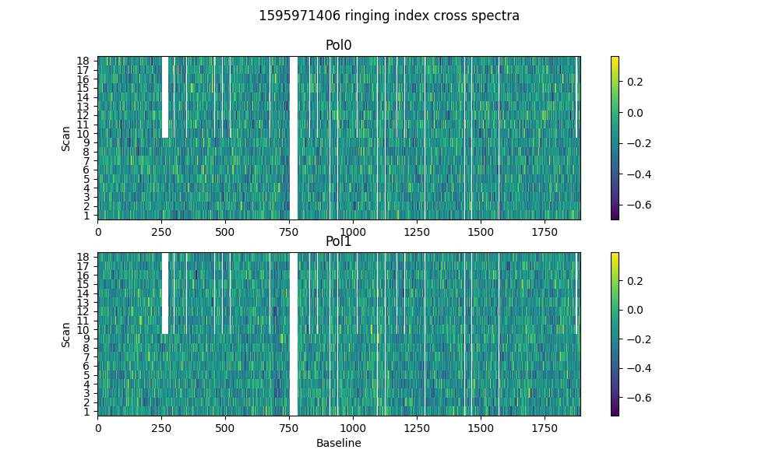

# 2-dump ringing in DC

Threshold = 0.67  
Plotting for scans >20dumps)

* Num of bad auto is 0
* Num of bad cross is 36

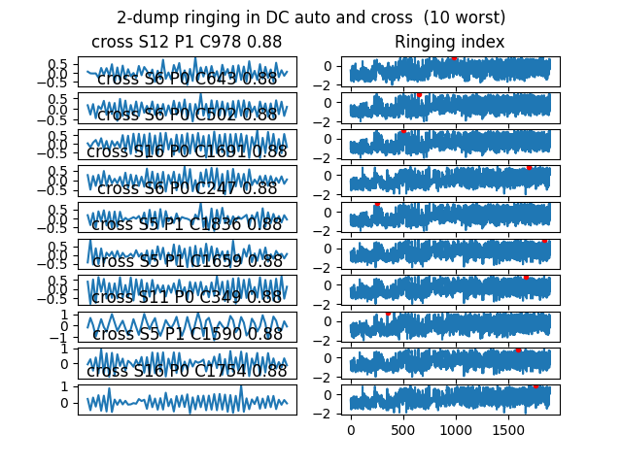

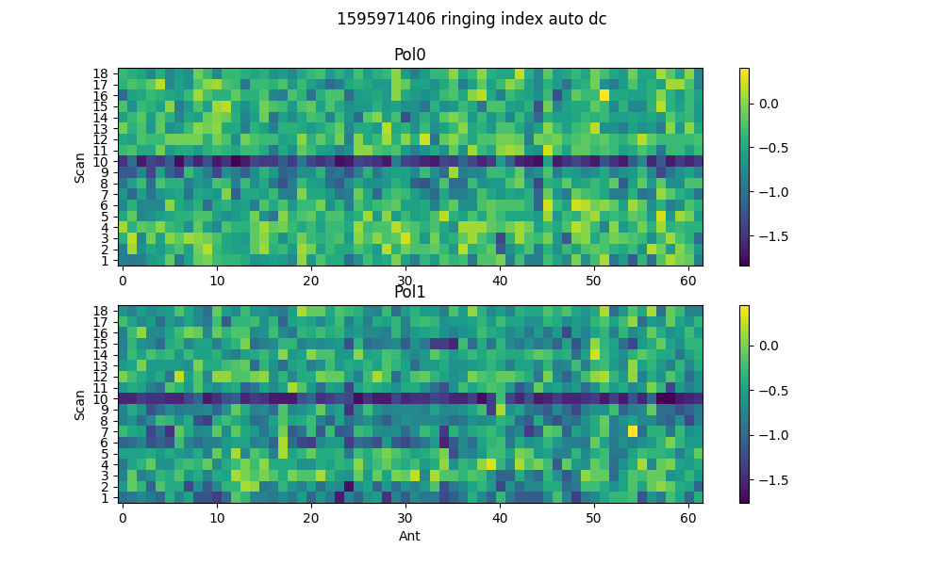

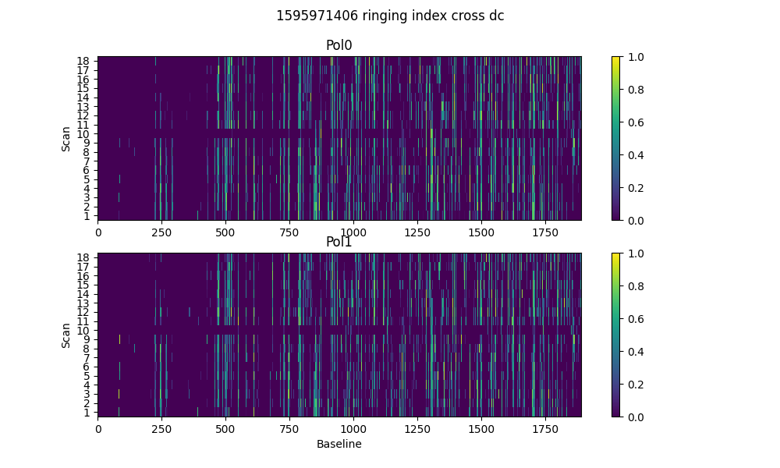

# Spectral periodicities

Using threshold of 10.0 sigma  
after detrending by polyfit(51)

* Found 275 bad spectra in auto in band0
* Found 196 bad spectra in auto in band1
* Found 3829 bad spectra in cross in band0
* Found 56 bad spectra in cross in band1

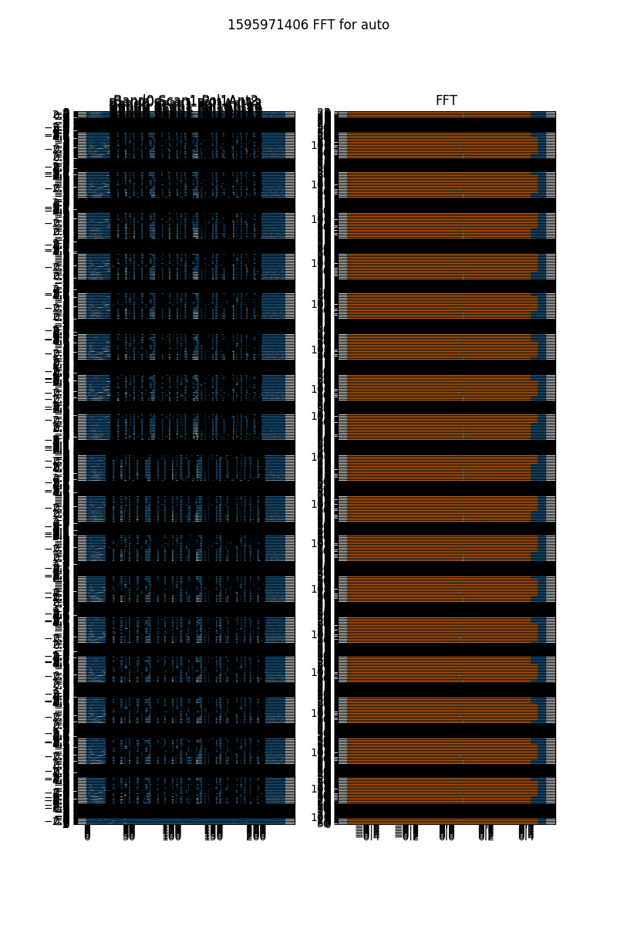

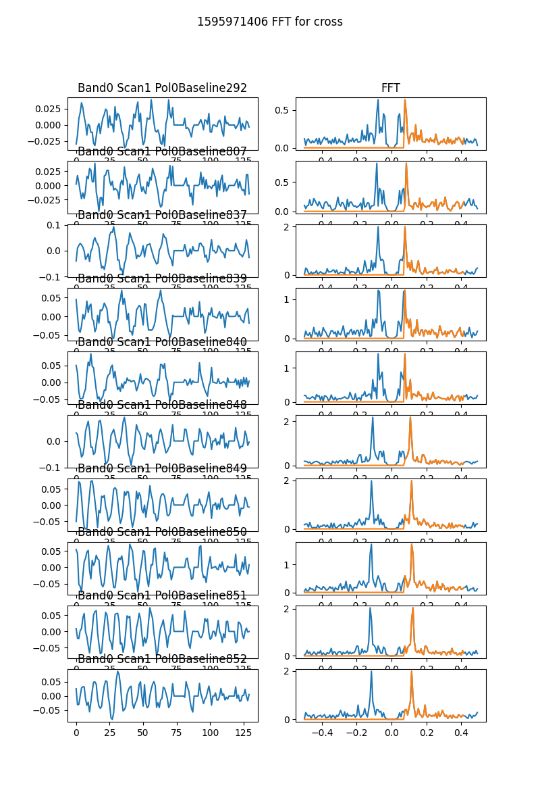

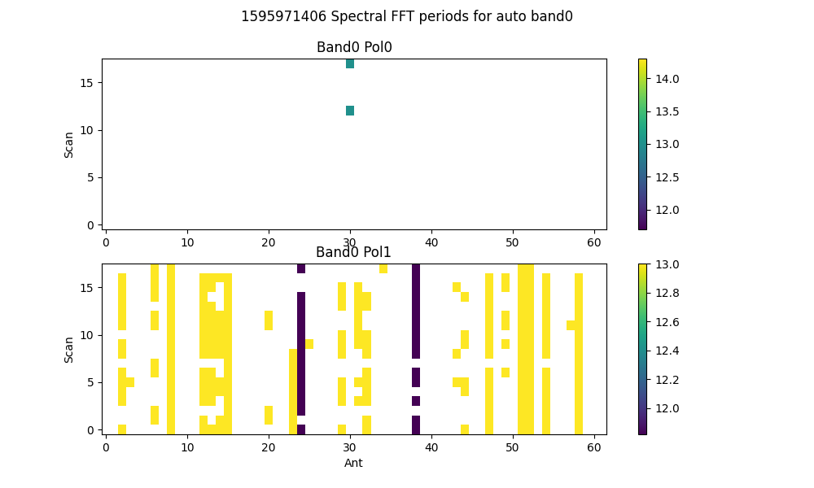

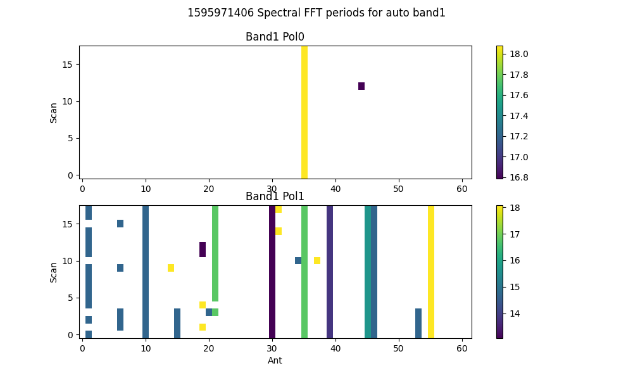

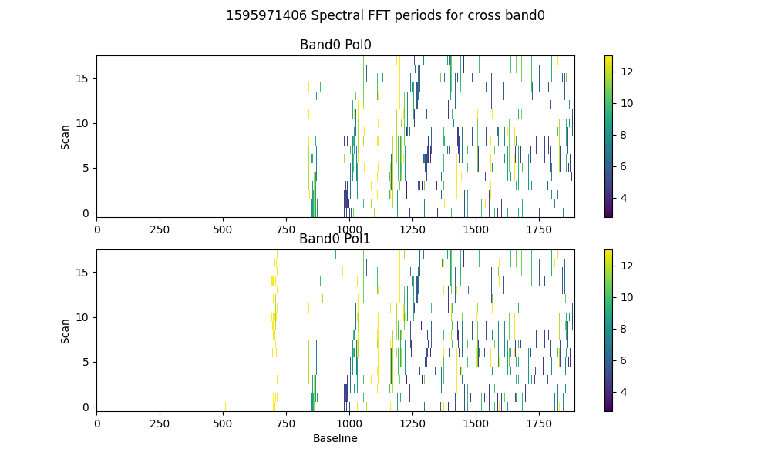

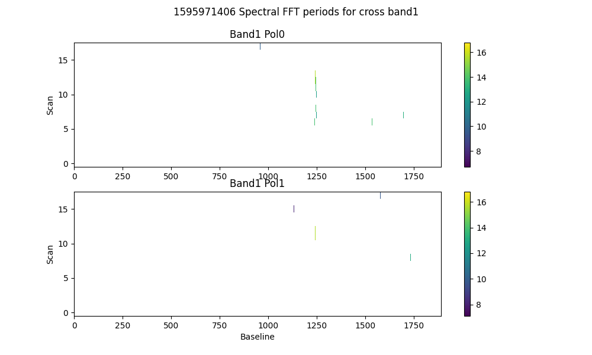

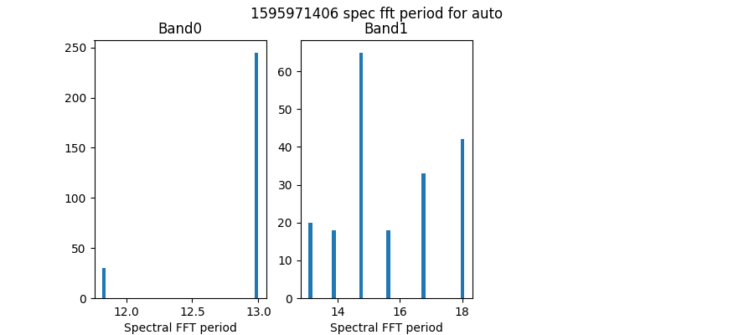

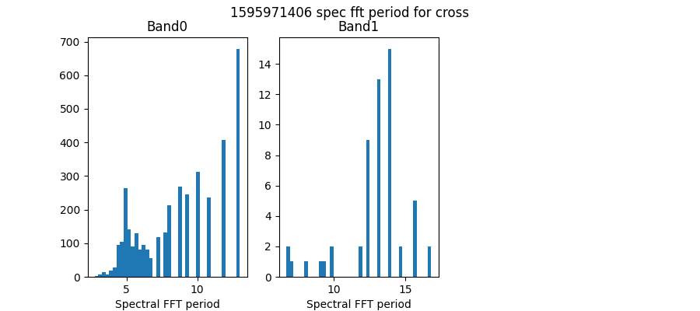

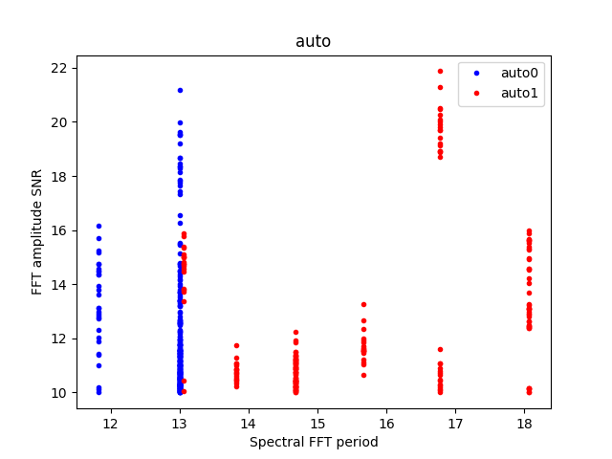

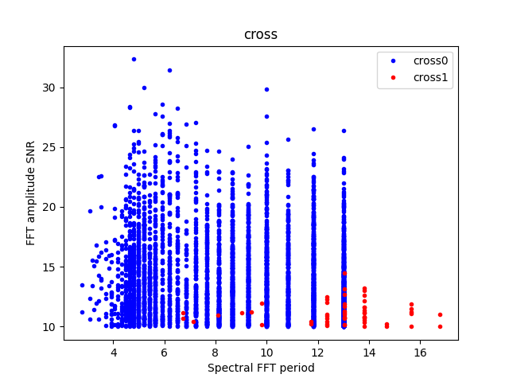

# Detrending

Applying polynomial filter with window 31 channels

# 2-chan ringing in average detrended spectrum

* Ringing index for auto pol 0 is -0.28
* Ringing index for auto pol 1 is -0.97
* Ringing index for cross pol 0 is -0.25
* Ringing index for cross pol 1 is -0.37

# X-Y pol correlation in spectra

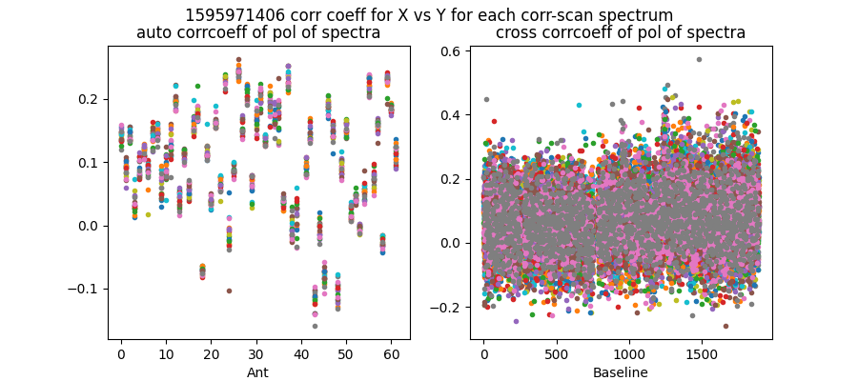

Mean and median corrcoeff for auto is 0.10 0.11

Mean and median corrcoeff for cross is 0.07 0.07

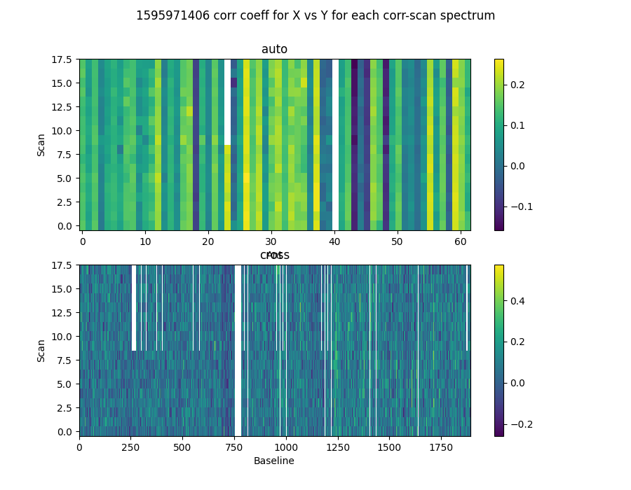

* Corr coeff for auto av spectrum X vx Y is -0.08
* Corr coeff for auto folded av spec X vx Y is 0.11
* Corr coeff for cross av spectrum X vx Y is -0.05
* Corr coeff for cross folded av spec X vx Y is -0.17

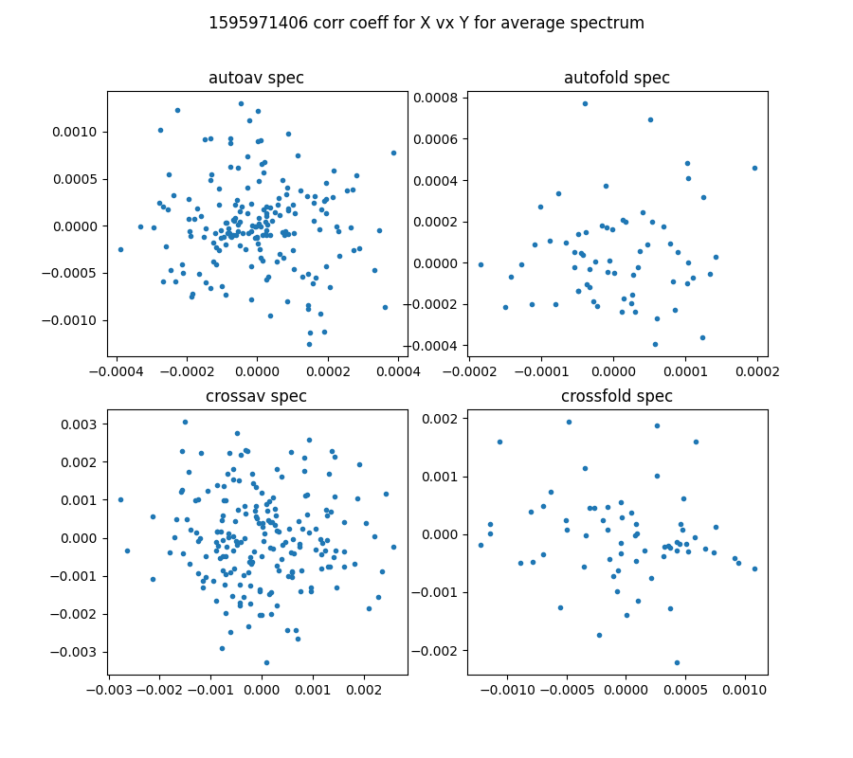

# 64-channel folded spectra

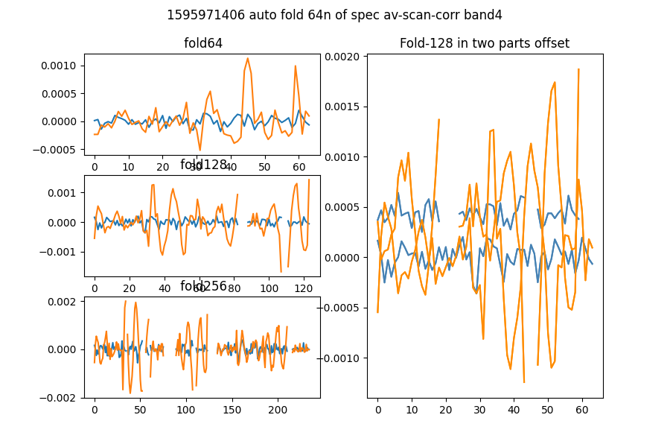

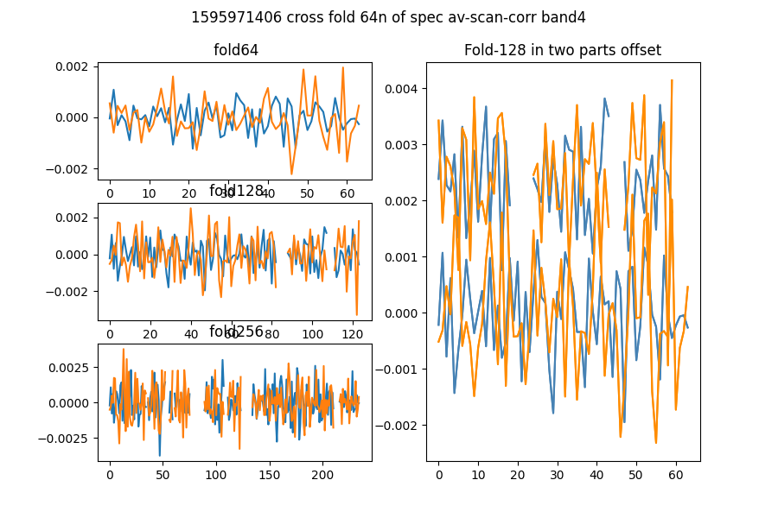

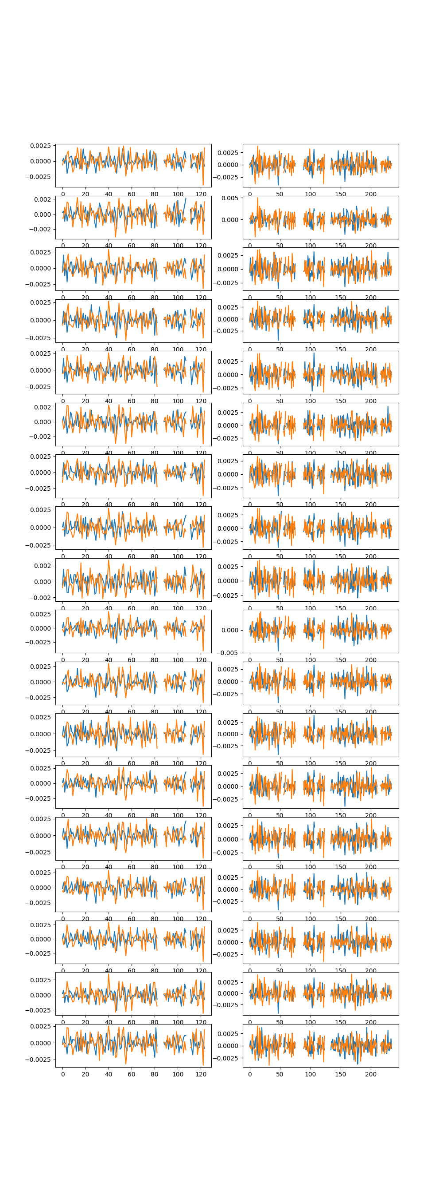

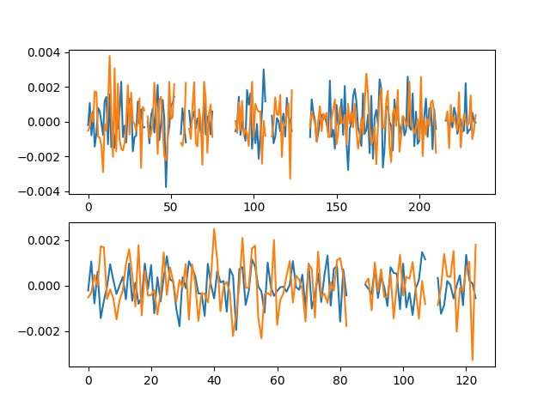

# Comb function analysis

Using nsearch=1; minfold=5; thresh=5.0

* Max (fold,start) [55, 47] with snr 5.46

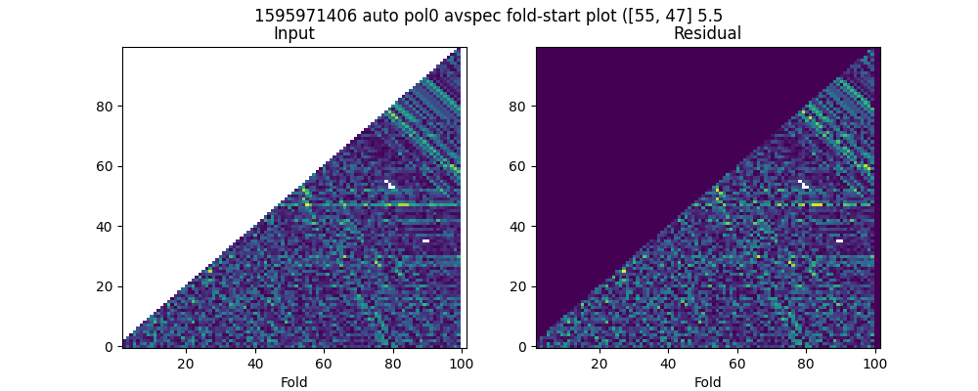

* Max (fold,start) [78, 45] with snr 5.58

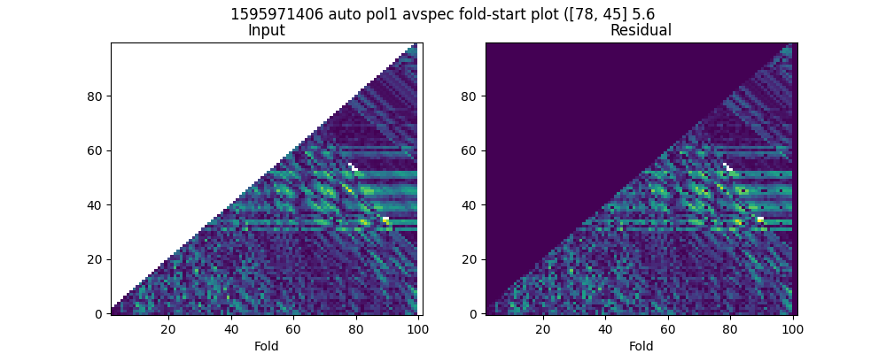

* Max (fold,start) [55, 47] with snr 4.88

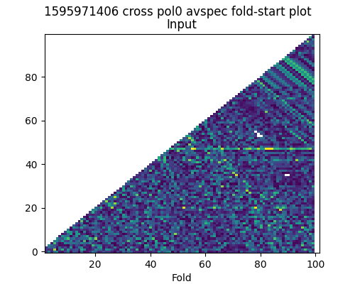

* Max (fold,start) [39, 13] with snr 4.85

