1596017058 - full report

# Data parameters

* Shape : (901, 4096, 4704)
* Num of ants 48
* Num of corr 4704
* Num of chans 4096
* Num of scans 14

# CONTENTS

===============================================================================  
Name: file:///data/mohan//1596017058/1596017058_sdp_l0.rdb | 1596017058-sdp-l0 (version 4.0)  
===============================================================================  
Observer: Operator Experiment ID: 20200729-0017  
Description: 'Upgrade Tests: Stability Track'  
Observed from 2020-07-29 12:04:26.729 SAST to 2020-07-29 14:04:31.681 SAST  
Dump rate / period: 0.12505 Hz / 7.997 s  
Subarrays: 1  
 ID Antennas Inputs Corrprods  
 0 m000,m002,m003,m009,m011,m012,m013,m014,m015,m016,m017,m018,m019,m020,m021,m022,m023,m024,m026,m027,m029,m030,m031,m032,m033,m034,m035,m036,m037,m038,m040,m041,m042,m043,m044,m045,m046,m047,m048,m049,m050,m051,m052,m055,m056,m059,m061,m063 96 4704  
Spectral Windows: 1  
 ID Band Product CentreFreq(MHz) Bandwidth(MHz) Channels ChannelWidth(kHz)  
 0 L c856M4k_n107M 1284.000 856.000 4096 208.984  
-------------------------------------------------------------------------------  
Data selected according to the following criteria:  
 spw=0  
 subarray=0  
-------------------------------------------------------------------------------  
Shape: (901 dumps, 4096 channels, 4704 correlation products) => Size: 138.881 GB  
Antennas: m000,m002,m003,m009,m011,m012,m013,m014,m015,m016,m017,m018,m019,m020,m021,m022,m023,m024,m026,m027,m029,m030,m031,m032,m033,m034,m035,m036,m037,m038,m040,m041,m042,m043,m044,m045,m046,m047,m048,m049,m050,m051,m052,m055,m056,m059,m061,m063 Inputs: 96 Autocorr: yes Crosscorr: yes  
Channels: 4096 (index 0 - 4095, 856.000 MHz - 1711.791 MHz), each 208.984 kHz wide  
Targets: 1 selected out of 1 in catalogue  
 ID Name Type RA(J2000) DEC(J2000) Tags Dumps ModelFlux(Jy)  
 0 J0408-6545 radec 4:08:20.38 -65:45:09.1 bpcal delaycal 901   
Scans: 14 selected out of 14 total Compscans: 12 selected out of 12 total  
 Date Timerange(UTC) ScanState CompScanLabel Dumps Target  
 29-Jul-2020/10:04:30 - 10:04:38 0:slew 0:track 2 0:J0408-6545  
 10:04:46 - 10:14:30 1:track 0:track 74 0:J0408-6545  
 10:14:38 - 10:24:30 2:track 1:track 75 0:J0408-6545  
 10:24:38 - 10:34:37 3:track 2:track 76 0:J0408-6545  
 10:34:45 - 10:44:37 4:track 3:track 75 0:J0408-6545  
 10:44:45 - 10:54:37 5:track 4:track 75 0:J0408-6545  
 10:54:45 - 11:04:37 6:track 5:track 75 0:J0408-6545  
 11:04:45 - 11:14:36 7:track 6:track 75 0:J0408-6545  
 11:14:44 - 11:24:36 8:track 7:track 75 0:J0408-6545  
 11:24:44 - 11:34:44 9:track 8:track 76 0:J0408-6545  
 11:34:52 - 11:44:44 10:track 9:track 75 0:J0408-6545  
 11:44:52 - 11:54:43 11:track 10:track 75 0:J0408-6545  
 11:54:51 - 12:04:19 12:track 11:track 72 0:J0408-6545  
 12:04:27 - 12:04:27 13:stop 11:track 1 0:J0408-6545

Bands used

* Band chs 0: 525-1045
* Band chs 1: 2187-3125
* Full band chs : 2187-3125
* Percentage of auto flags in pol 0 is 2.6 %
* Percentage of auto flags in pol 1 is 2.5 %
* Percentage of cross flags in pol 0 is 1.4 %
* Percentage of cross flags in pol 1 is 1.4 %

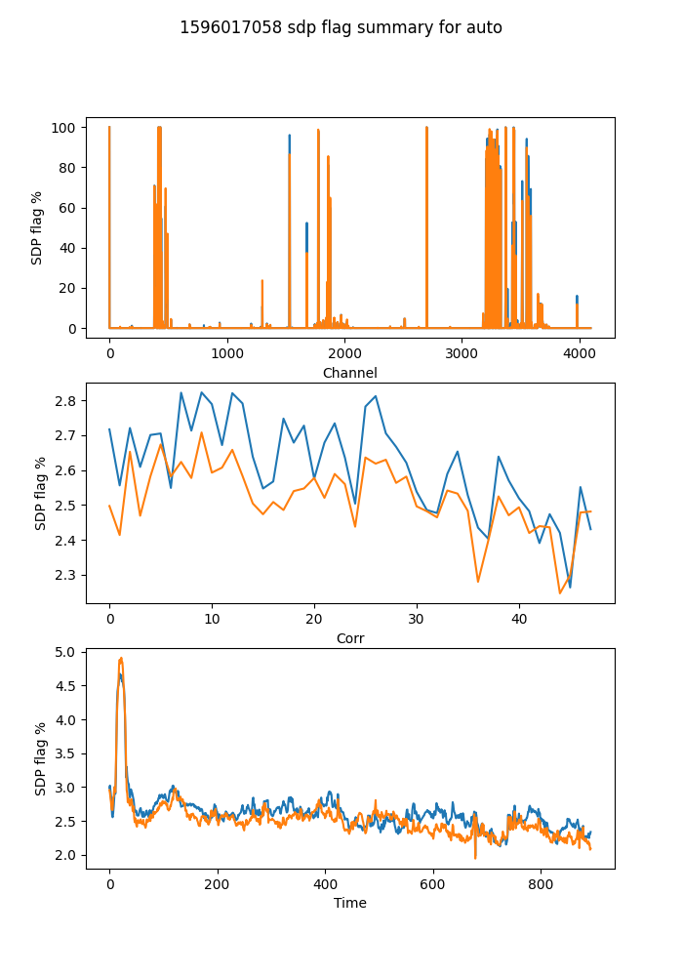

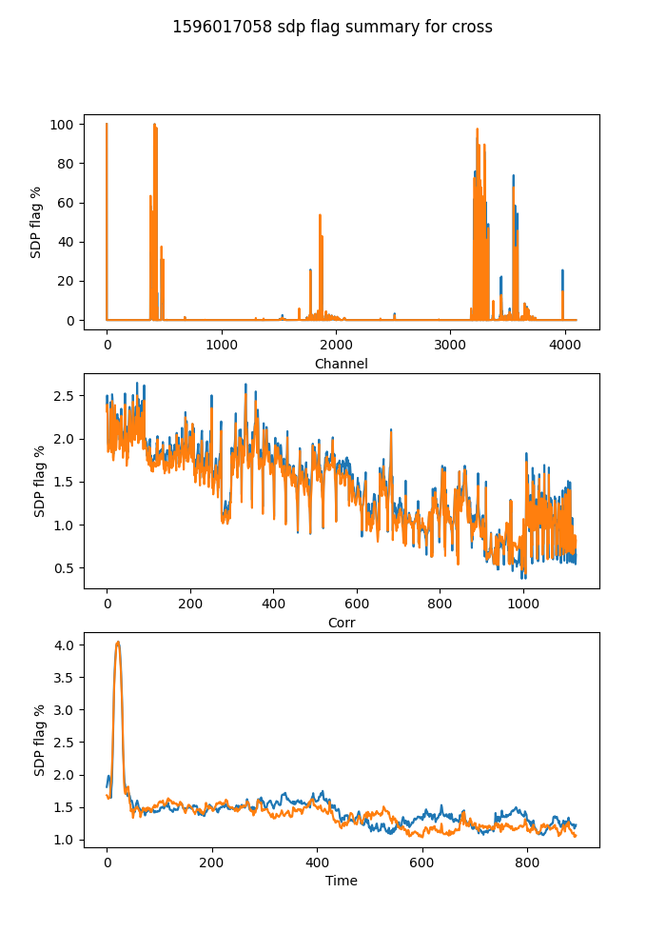

## Spectral mean and variance

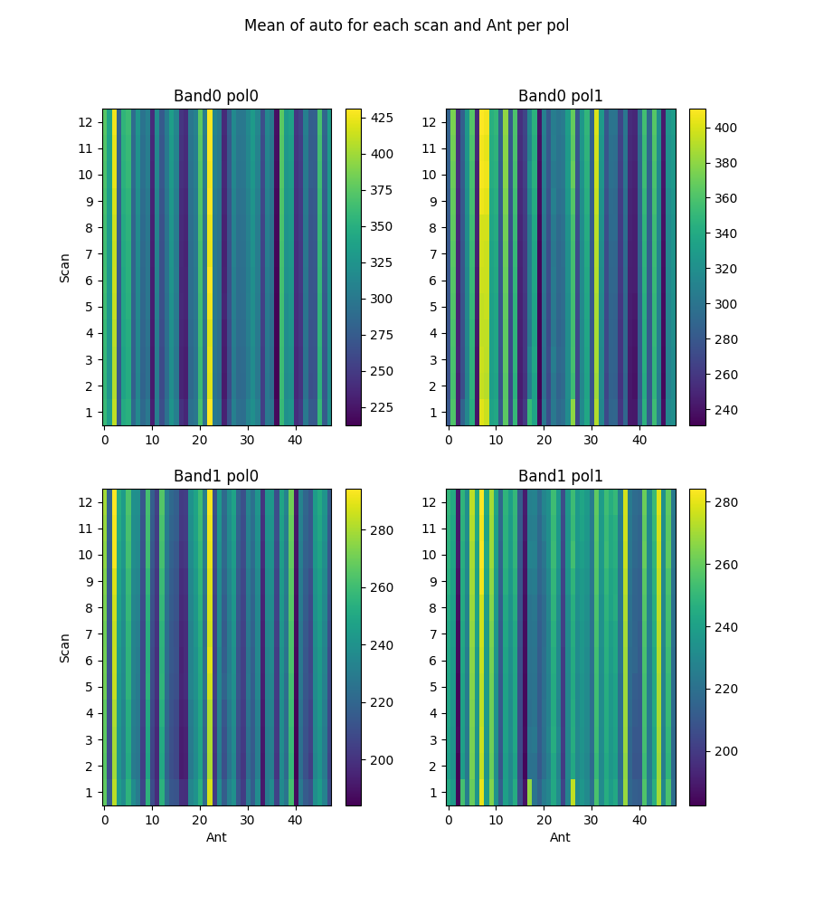

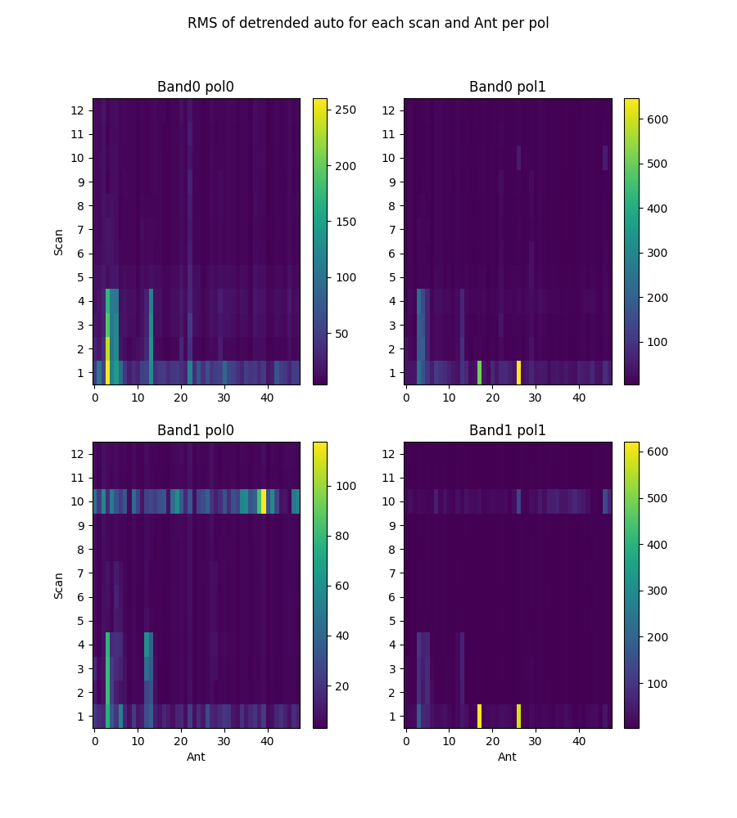

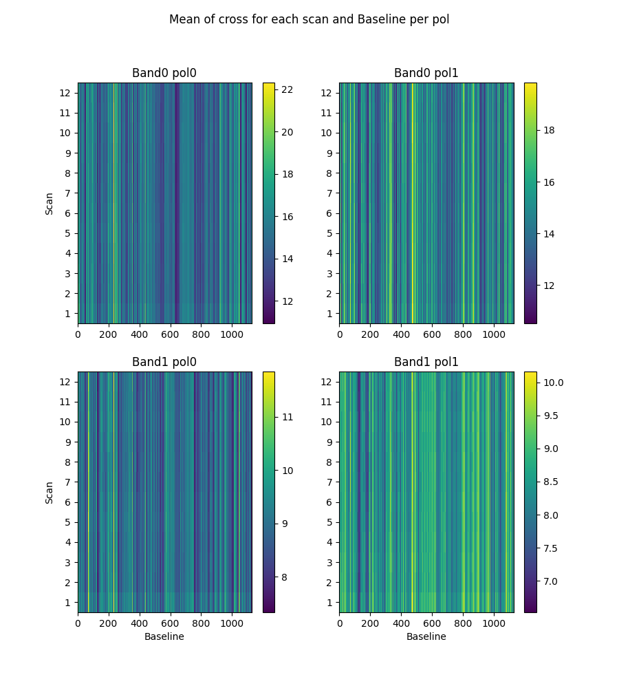

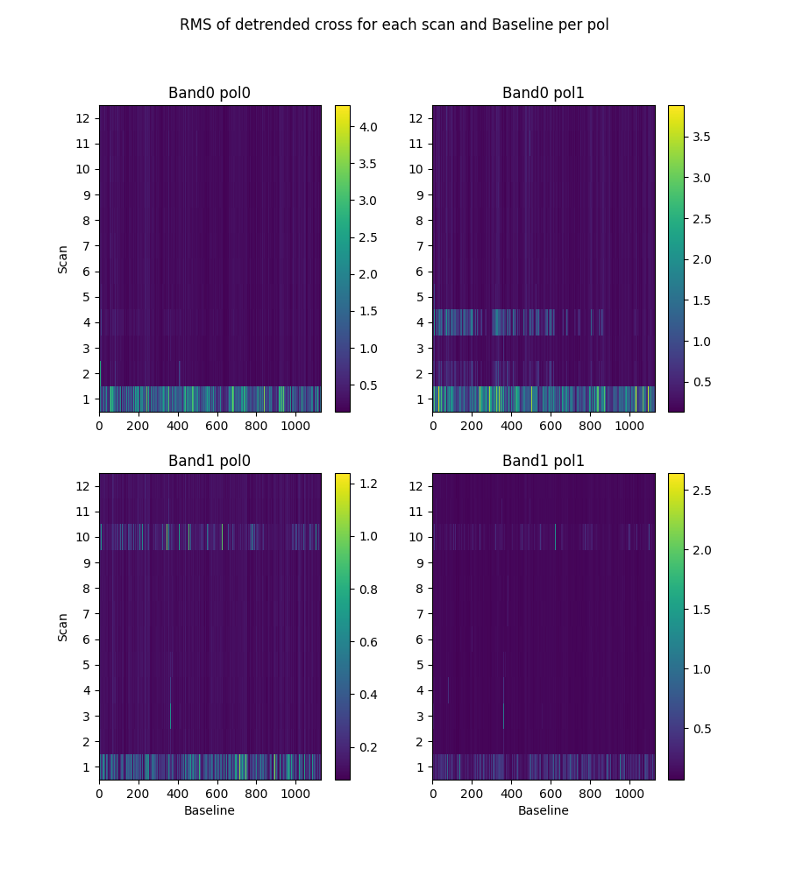

# 2-channel ringing

Using threshold of ringing index of 0.67  
(1->perfect ringing, 0-> none, neg->higher periods)

* Num of bad auto is 0
* Num of bad cross is 0

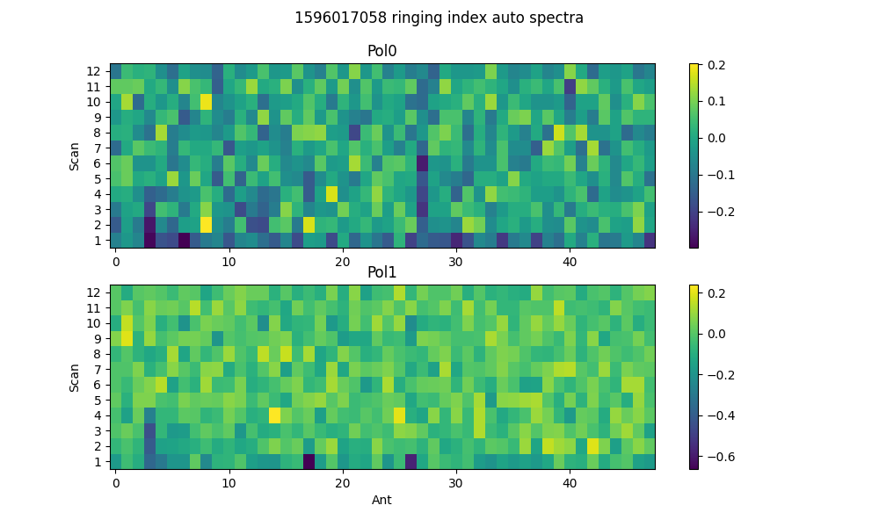

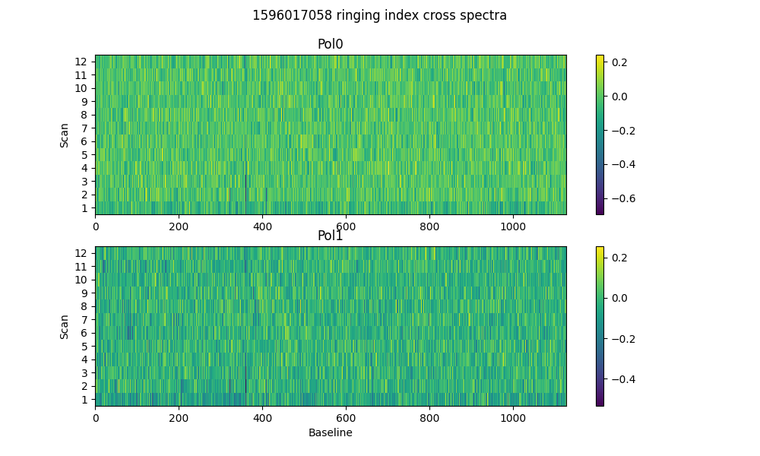

# 2-dump ringing in DC

Threshold = 0.67  
Plotting for scans >20dumps)

* Num of bad auto is 0
* Num of bad cross is 20

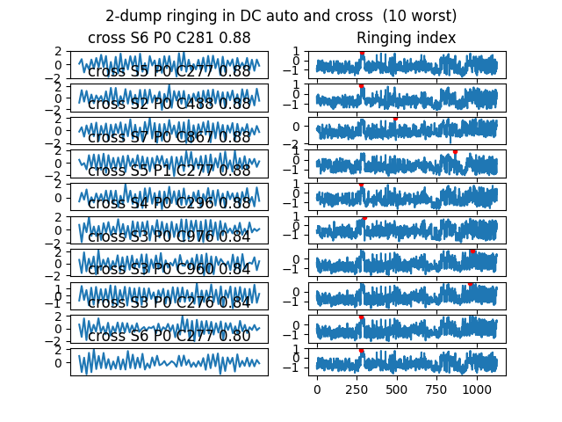

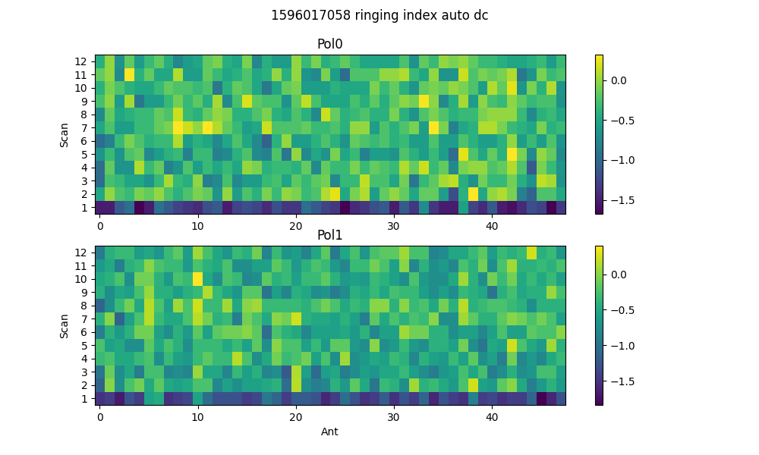

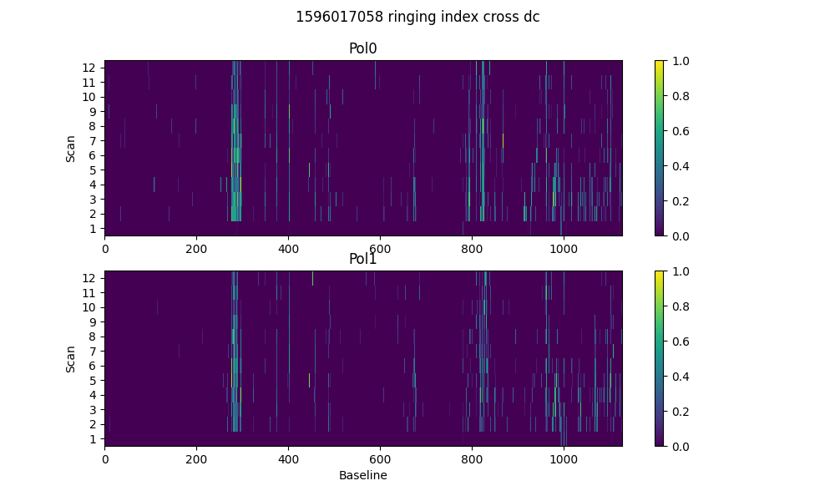

# Spectral periodicities

Using threshold of 10.0 sigma  
after detrending by polyfit(51)

* Found 14 bad spectra in auto in band0
* Found 14 bad spectra in auto in band1
* Found 629 bad spectra in cross in band0
* Found 221 bad spectra in cross in band1

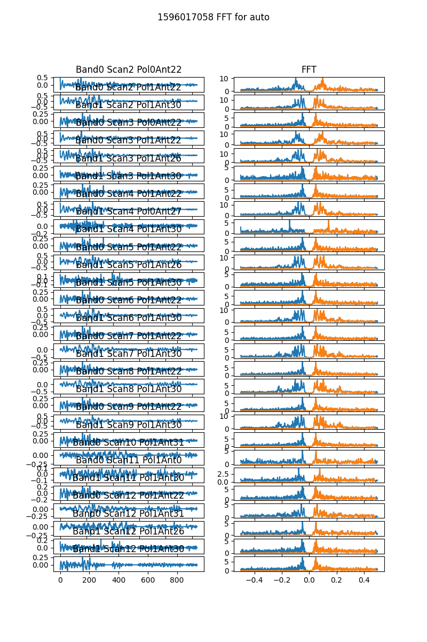

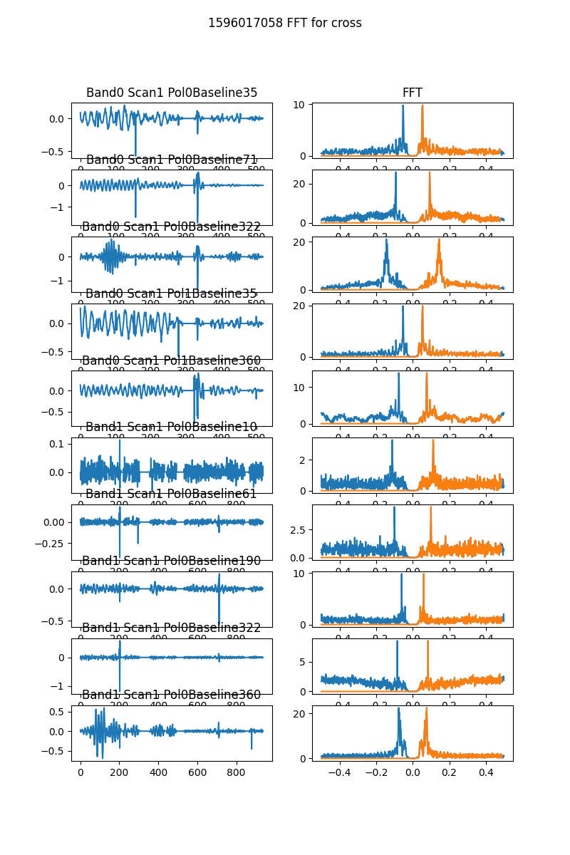

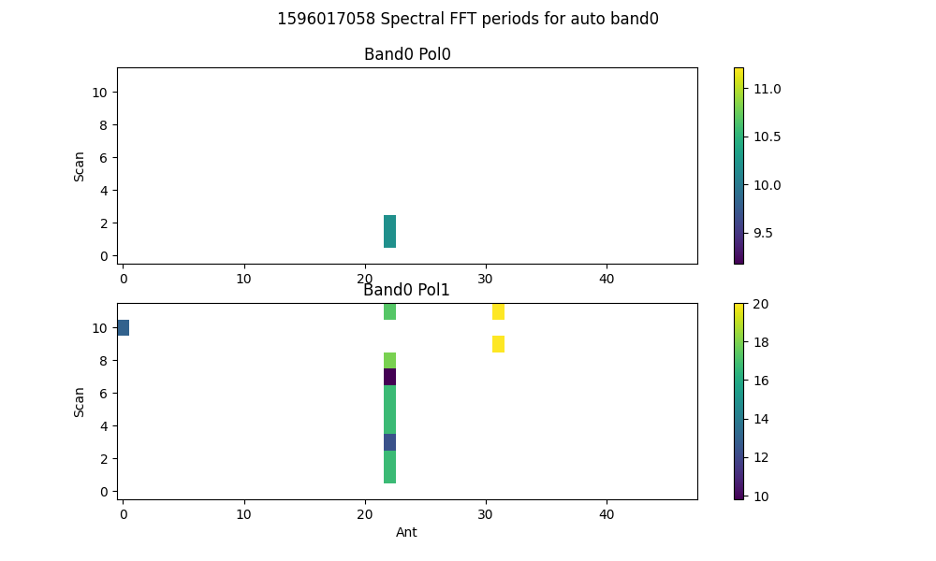

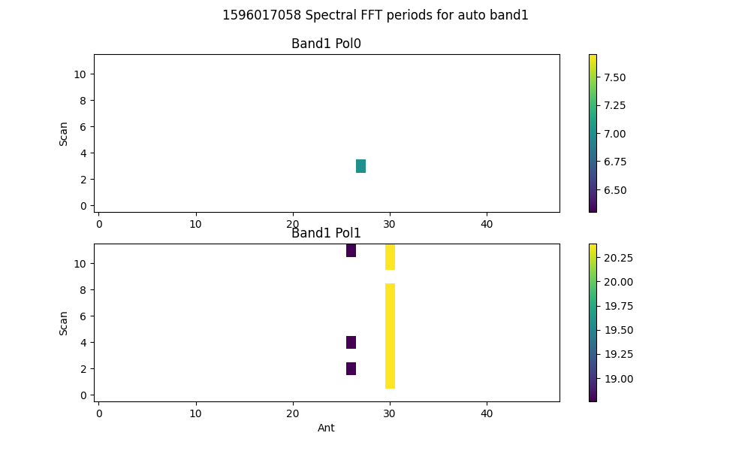

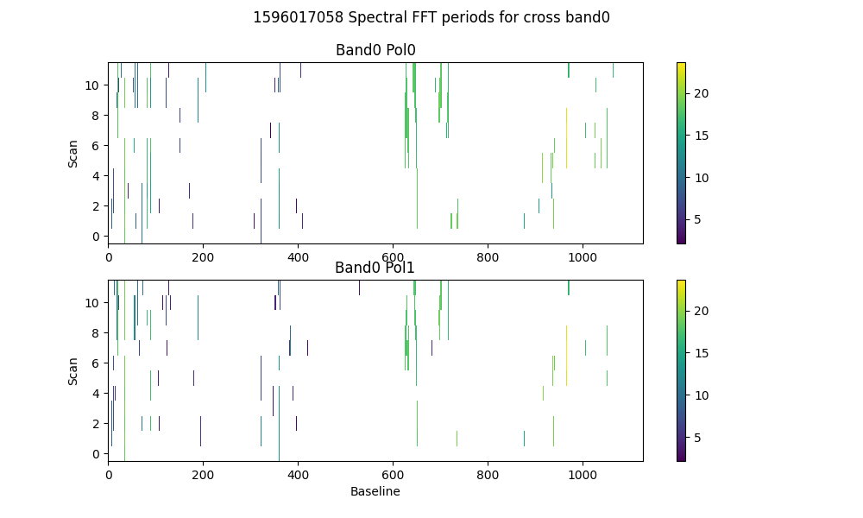

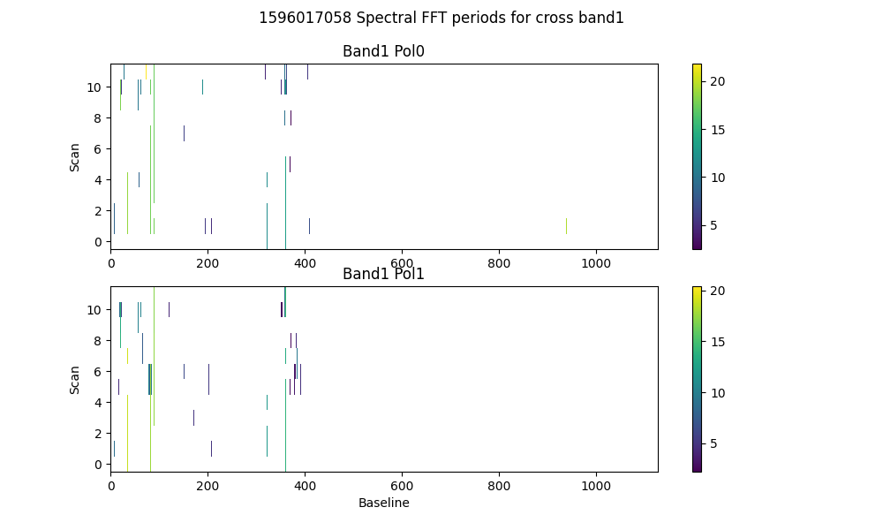

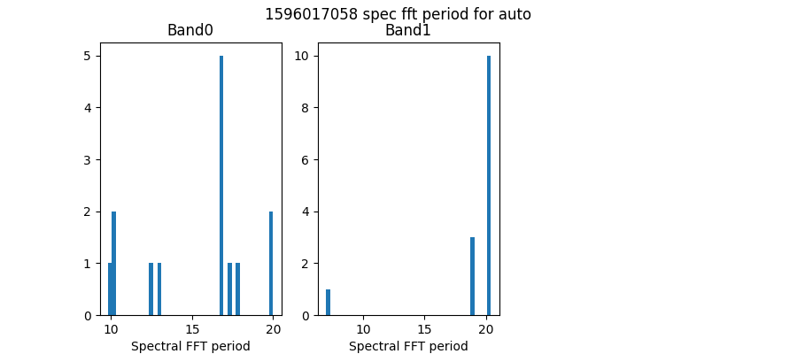

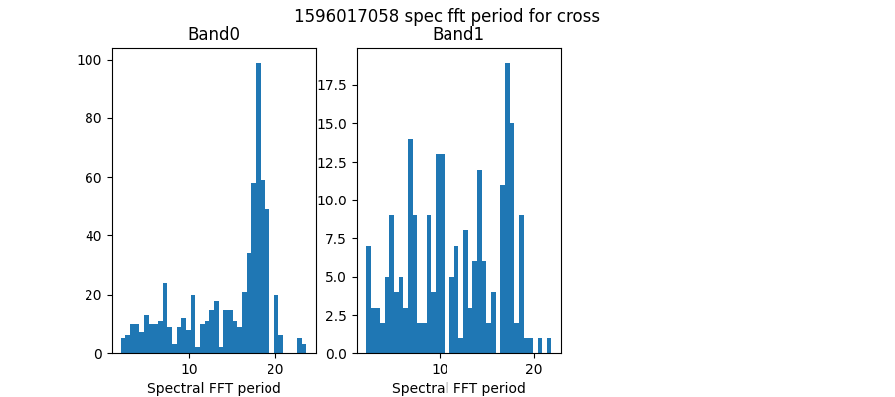

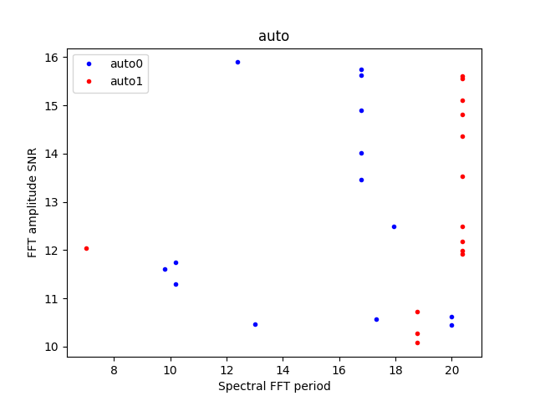

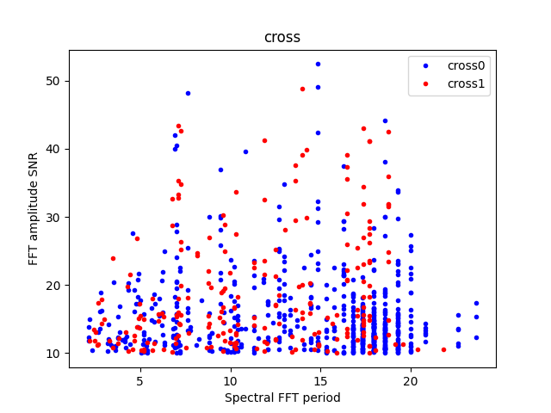

# Detrending

Applying polynomial filter with window 31 channels

# 2-chan ringing in average detrended spectrum

* Ringing index for auto pol 0 is -0.22
* Ringing index for auto pol 1 is -0.18
* Ringing index for cross pol 0 is -0.07
* Ringing index for cross pol 1 is -0.06

# X-Y pol correlation in spectra

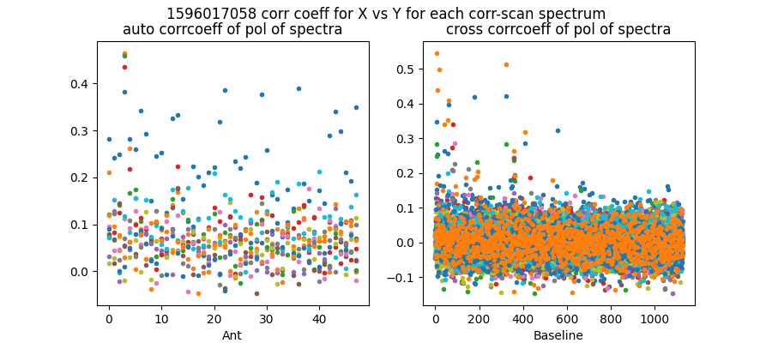

Mean and median corrcoeff for auto is 0.08 0.07

Mean and median corrcoeff for cross is 0.01 0.00

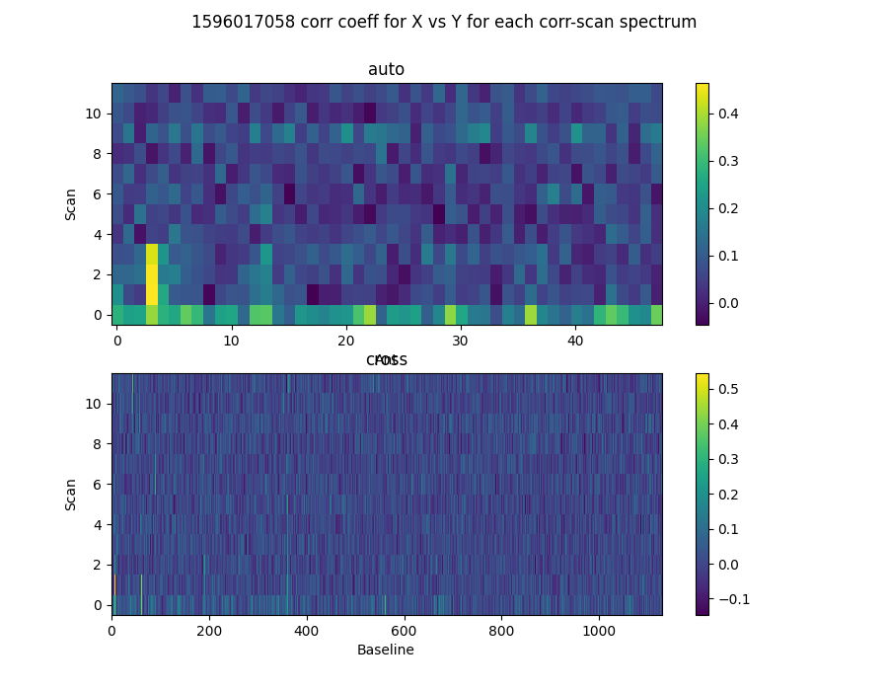

* Corr coeff for auto av spectrum X vx Y is 0.62
* Corr coeff for auto folded av spec X vx Y is 0.91
* Corr coeff for cross av spectrum X vx Y is 0.21
* Corr coeff for cross folded av spec X vx Y is 0.42

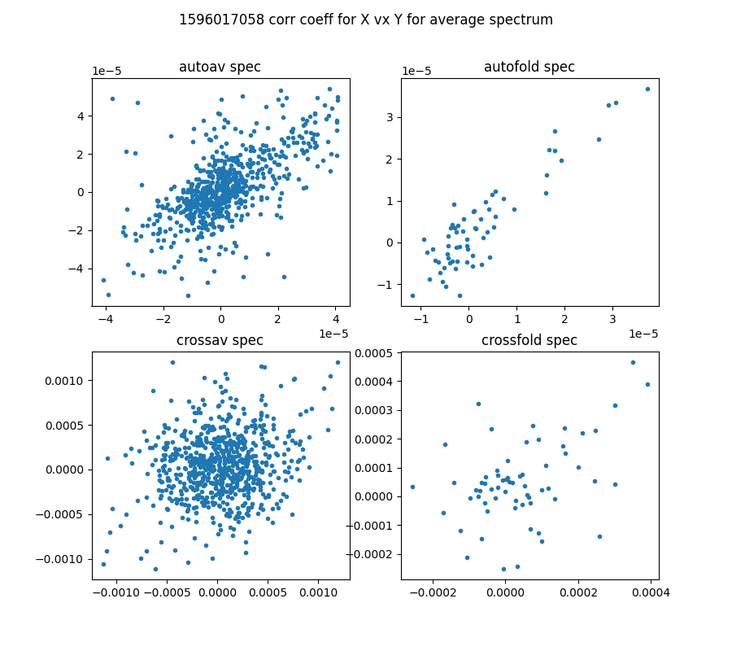

# 64-channel folded spectra

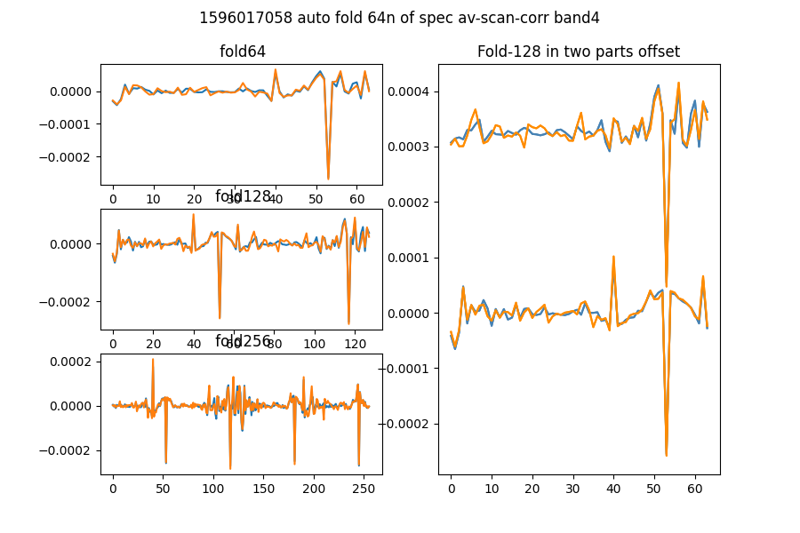

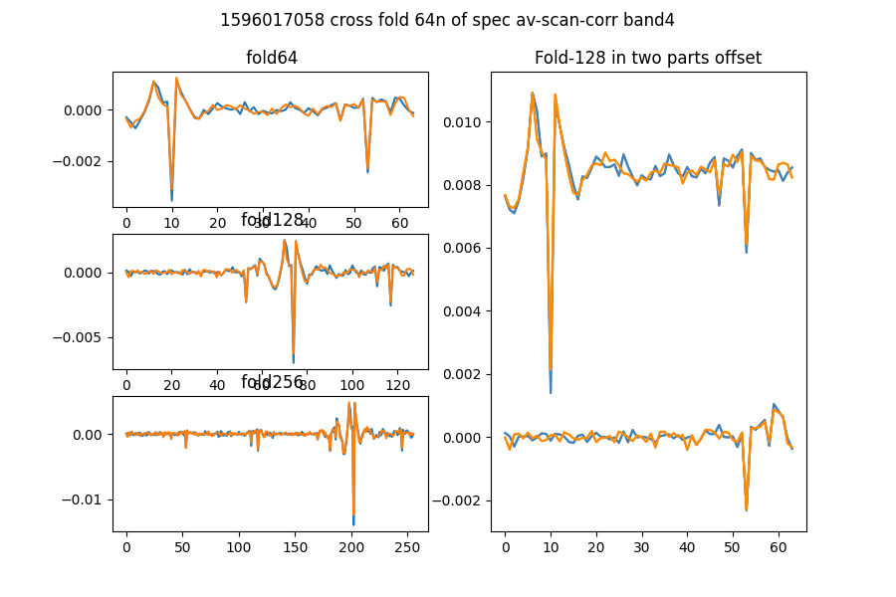

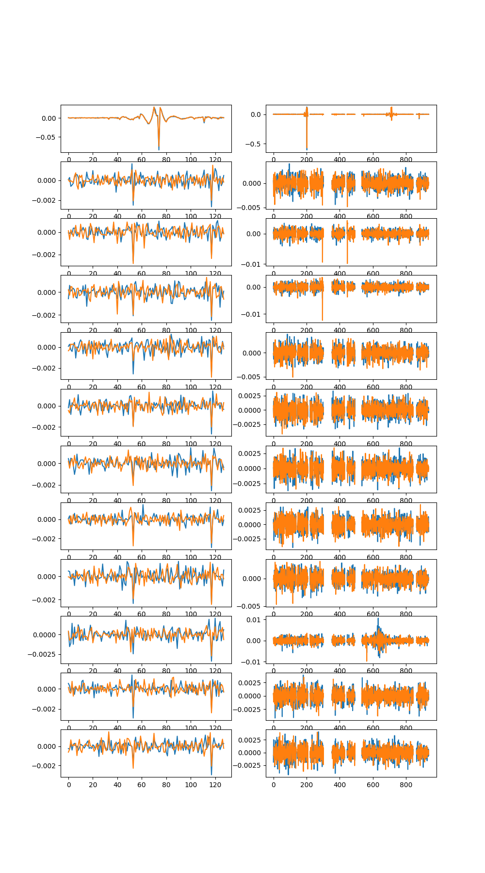

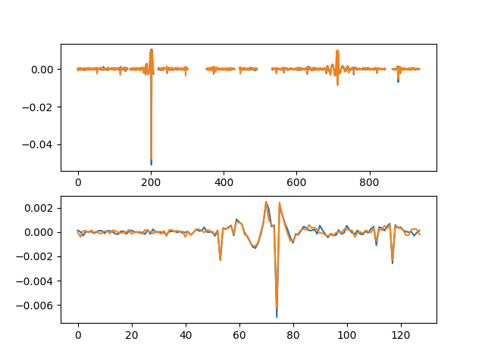

# Comb function analysis

Using nsearch=1; minfold=5; thresh=5.0

* Max (fold,start) [64, 53] with snr 21.70

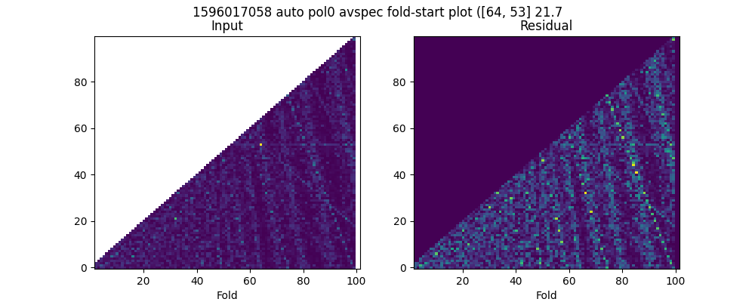

* Max (fold,start) [64, 53] with snr 23.31

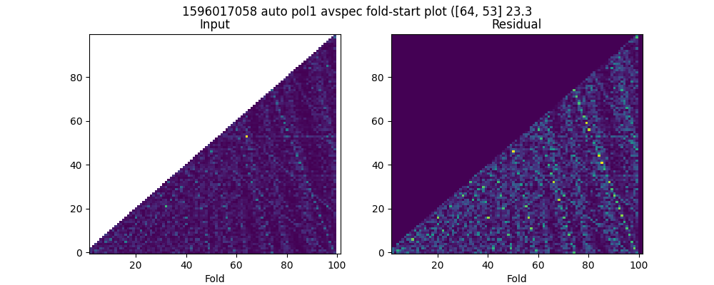

* Max (fold,start) [73, 56] with snr 27.86

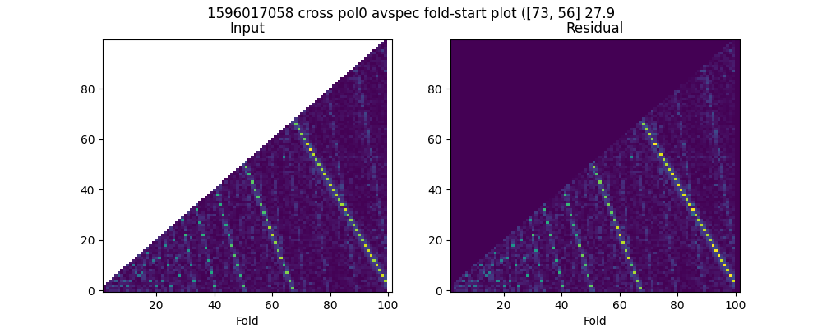

* Max (fold,start) [73, 56] with snr 28.98

