1596017061 - full report

# Data parameters

* Shape : (900, 32768, 4704)
* Num of ants 48
* Num of corr 4704
* Num of chans 32768
* Num of scans 13

# CONTENTS

===============================================================================  
Name: file:///data/mohan//1596017061/1596017061_sdp_l0.rdb | 1596017061-sdp-l0 (version 4.0)  
===============================================================================  
Observer: Operator Experiment ID: 20200729-0017  
Description: 'Upgrade Tests: Stability Track'  
Observed from 2020-07-29 12:04:21.596 SAST to 2020-07-29 14:04:18.551 SAST  
Dump rate / period: 0.12505 Hz / 7.997 s  
Subarrays: 1  
 ID Antennas Inputs Corrprods  
 0 m000,m002,m003,m009,m011,m012,m013,m014,m015,m016,m017,m018,m019,m020,m021,m022,m023,m024,m026,m027,m029,m030,m031,m032,m033,m034,m035,m036,m037,m038,m040,m041,m042,m043,m044,m045,m046,m047,m048,m049,m050,m051,m052,m055,m056,m059,m061,m063 96 4704  
Spectral Windows: 1  
 ID Band Product CentreFreq(MHz) Bandwidth(MHz) Channels ChannelWidth(kHz)  
 0 L c856M4k_n107M 1444.500 107.000 32768 3.265  
-------------------------------------------------------------------------------  
Data selected according to the following criteria:  
 spw=0  
 subarray=0  
-------------------------------------------------------------------------------  
Shape: (900 dumps, 32768 channels, 4704 correlation products) => Size: 1109.813 GB  
Antennas: m000,m002,m003,m009,m011,m012,m013,m014,m015,m016,m017,m018,m019,m020,m021,m022,m023,m024,m026,m027,m029,m030,m031,m032,m033,m034,m035,m036,m037,m038,m040,m041,m042,m043,m044,m045,m046,m047,m048,m049,m050,m051,m052,m055,m056,m059,m061,m063 Inputs: 96 Autocorr: yes Crosscorr: yes  
Channels: 32768 (index 0 - 32767, 1391.000 MHz - 1497.997 MHz), each 3.265 kHz wide  
Targets: 1 selected out of 1 in catalogue  
 ID Name Type RA(J2000) DEC(J2000) Tags Dumps ModelFlux(Jy)  
 0 J0408-6545 radec 4:08:20.38 -65:45:09.1 bpcal delaycal 900   
Scans: 13 selected out of 13 total Compscans: 12 selected out of 12 total  
 Date Timerange(UTC) ScanState CompScanLabel Dumps Target  
 29-Jul-2020/10:04:25 - 10:04:41 0:slew 0:track 3 0:J0408-6545  
 10:04:49 - 10:14:33 1:track 0:track 74 0:J0408-6545  
 10:14:41 - 10:24:33 2:track 1:track 75 0:J0408-6545  
 10:24:41 - 10:34:32 3:track 2:track 75 0:J0408-6545  
 10:34:40 - 10:44:32 4:track 3:track 75 0:J0408-6545  
 10:44:40 - 10:54:40 5:track 4:track 76 0:J0408-6545  
 10:54:48 - 11:04:40 6:track 5:track 75 0:J0408-6545  
 11:04:48 - 11:14:39 7:track 6:track 75 0:J0408-6545  
 11:14:47 - 11:24:39 8:track 7:track 75 0:J0408-6545  
 11:24:47 - 11:34:39 9:track 8:track 75 0:J0408-6545  
 11:34:47 - 11:44:39 10:track 9:track 75 0:J0408-6545  
 11:44:47 - 11:54:38 11:track 10:track 75 0:J0408-6545  
 11:54:46 - 12:04:14 12:track 11:track 72 0:J0408-6545

Bands used

* Band chs 0: 4200-8360
* Band chs 1: 17500-25000
* Full band chs : 17500-25000
* Percentage of auto flags in pol 0 is 0.1 %
* Percentage of auto flags in pol 1 is 0.1 %
* Percentage of cross flags in pol 0 is 0.1 %
* Percentage of cross flags in pol 1 is 0.1 %

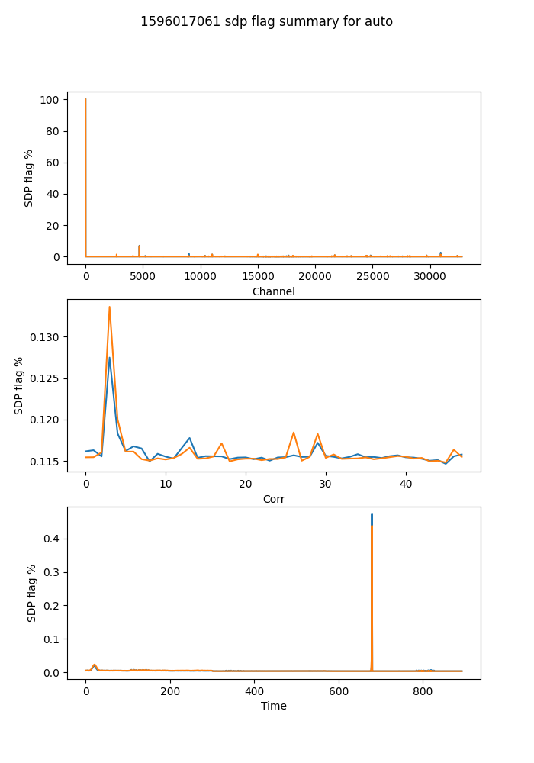

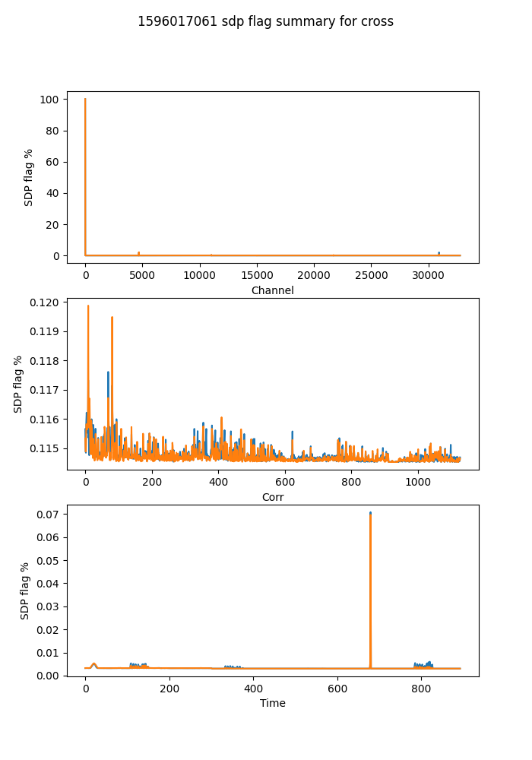

## Spectral mean and variance

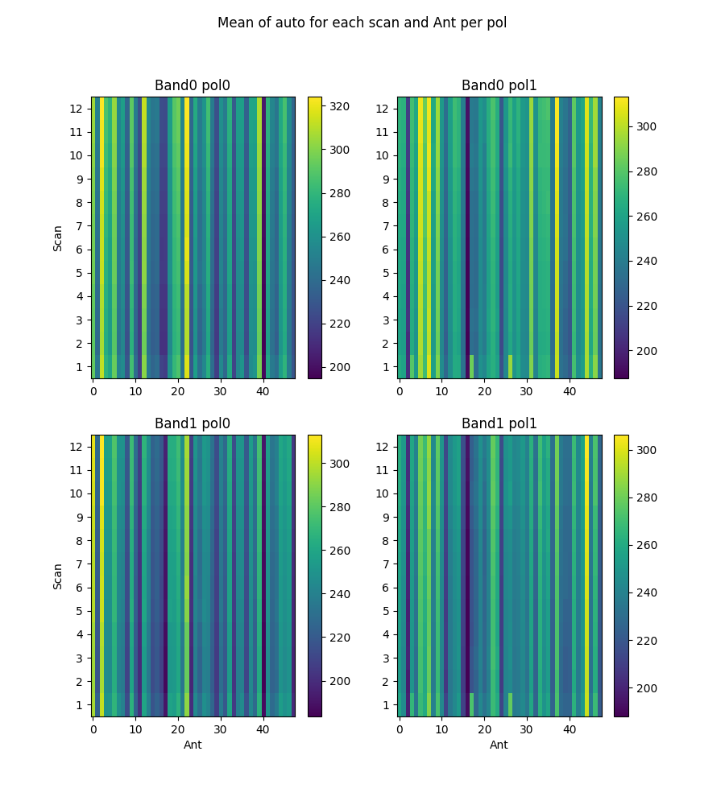

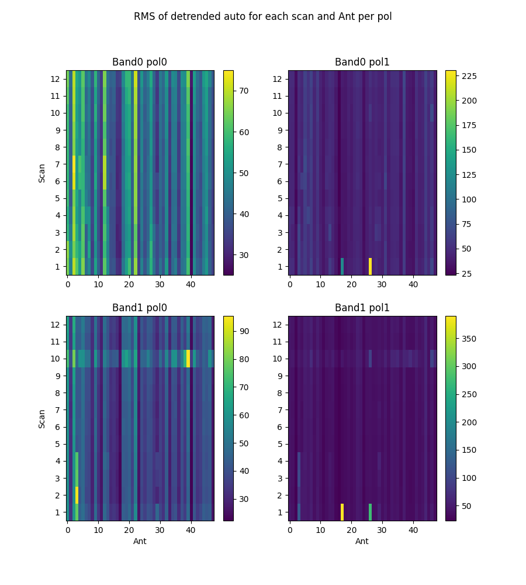

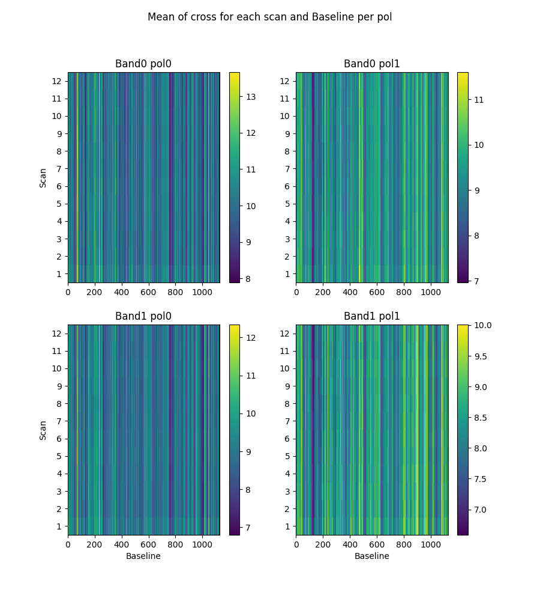

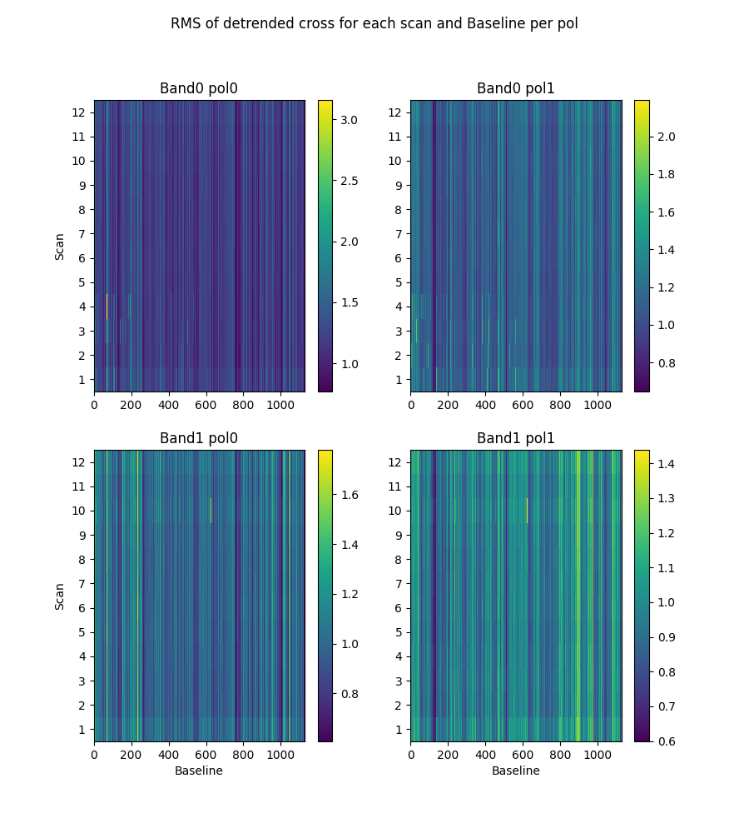

# 2-channel ringing

Using threshold of ringing index of 0.67  
(1->perfect ringing, 0-> none, neg->higher periods)

* Num of bad auto is 0
* Num of bad cross is 0

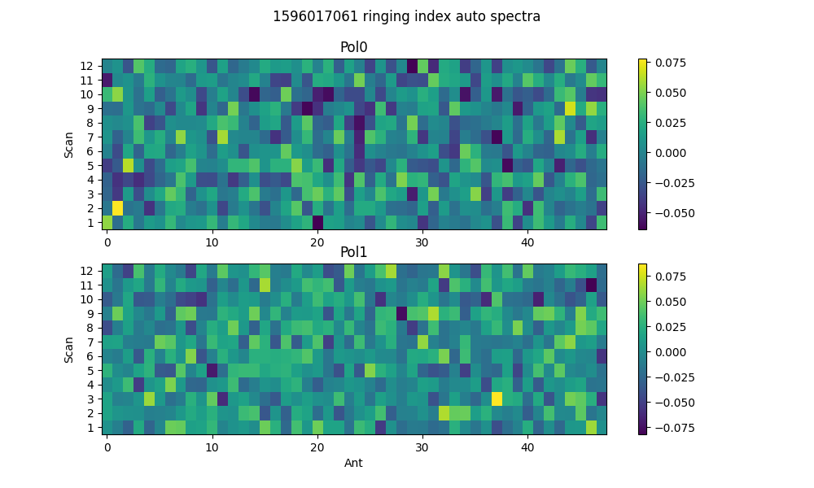

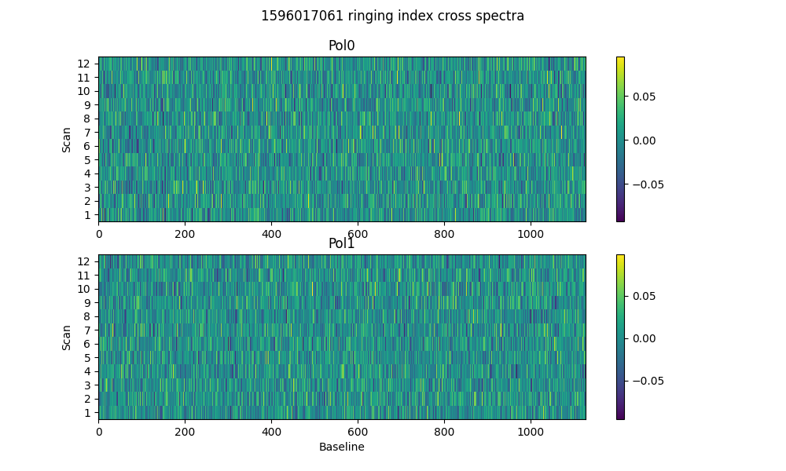

# 2-dump ringing in DC

Threshold = 0.67  
Plotting for scans >20dumps)

* Num of bad auto is 0
* Num of bad cross is 18

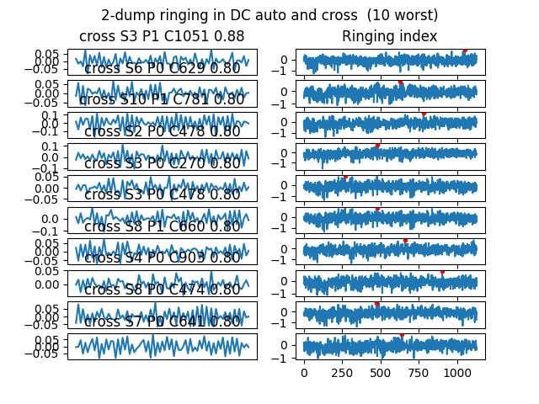

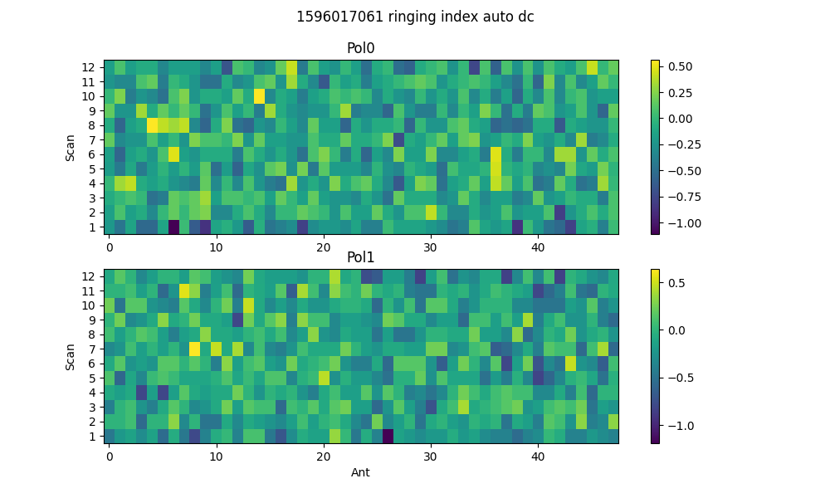

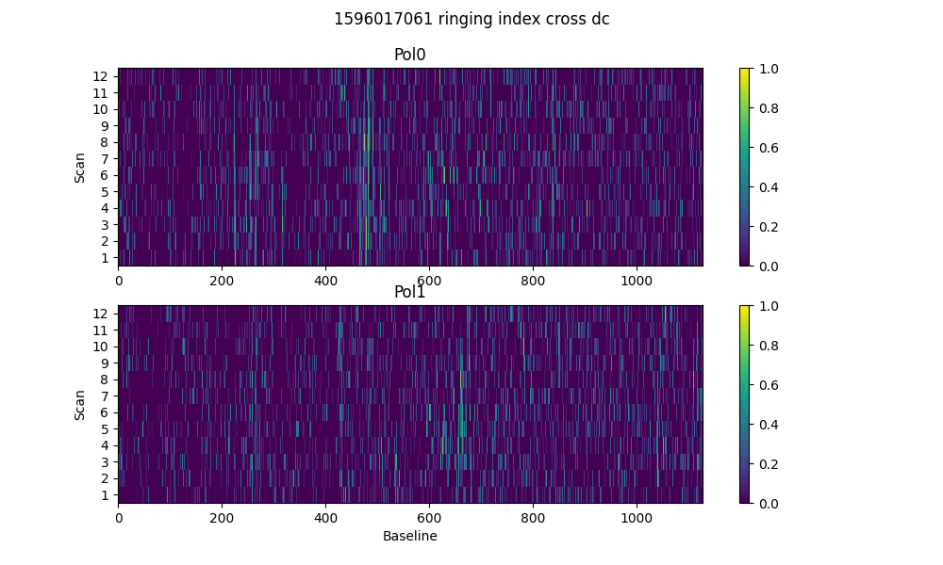

# Spectral periodicities

Using threshold of 10.0 sigma  
after detrending by polyfit(51)

* Found 0 bad spectra in auto in band0
* Found 0 bad spectra in auto in band1
* Found 0 bad spectra in cross in band0
* Found 0 bad spectra in cross in band1

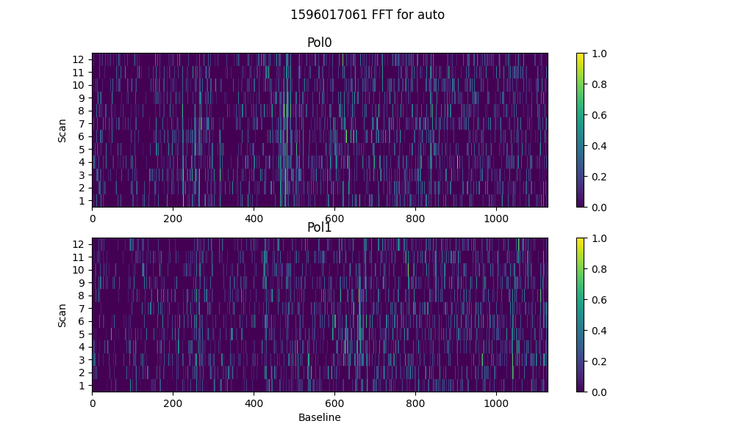

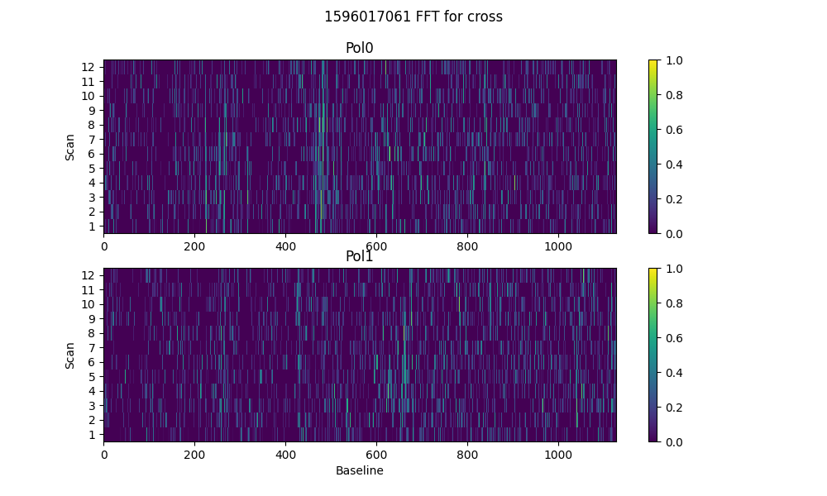

# Detrending

Applying polynomial filter with window 31 channels

# 2-chan ringing in average detrended spectrum

* Ringing index for auto pol 0 is -0.02
* Ringing index for auto pol 1 is -0.01
* Ringing index for cross pol 0 is 0.01
* Ringing index for cross pol 1 is -0.01

# X-Y pol correlation in spectra

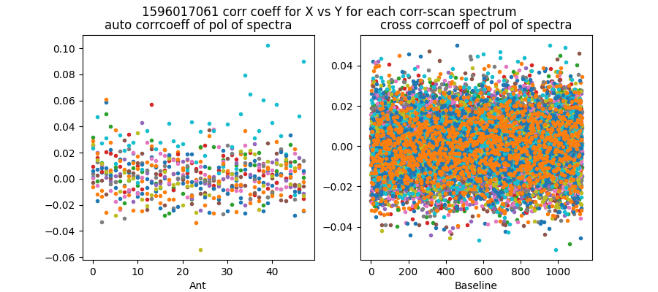

Mean and median corrcoeff for auto is 0.00 0.00

Mean and median corrcoeff for cross is 0.00 0.00

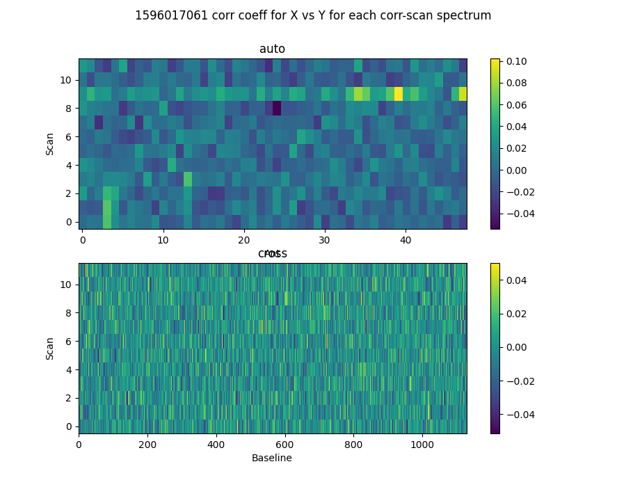

* Corr coeff for auto av spectrum X vx Y is 0.07
* Corr coeff for auto folded av spec X vx Y is -0.01
* Corr coeff for cross av spectrum X vx Y is -0.01
* Corr coeff for cross folded av spec X vx Y is -0.22

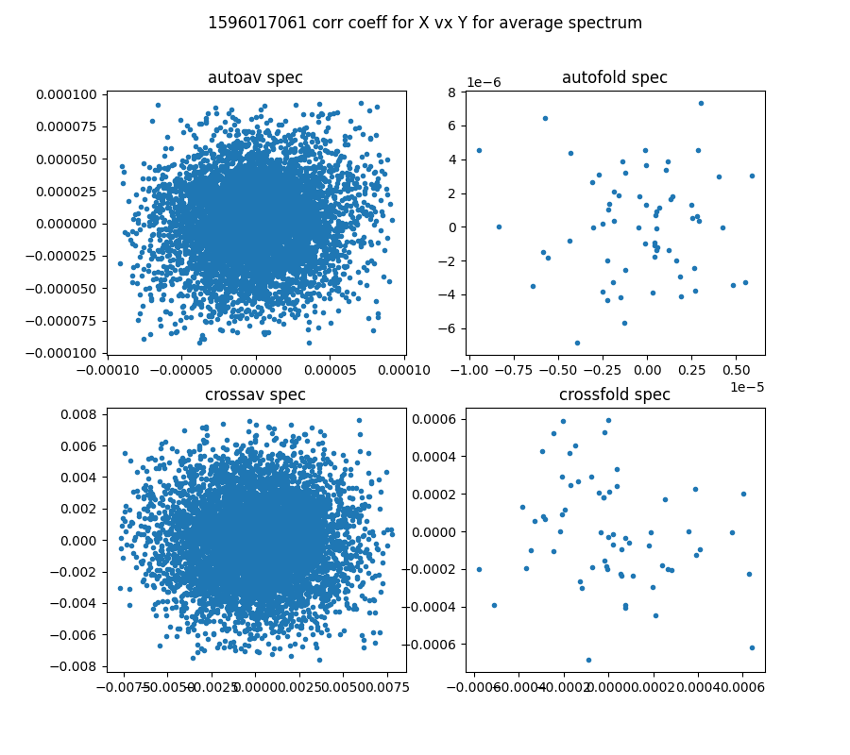

# 64-channel folded spectra

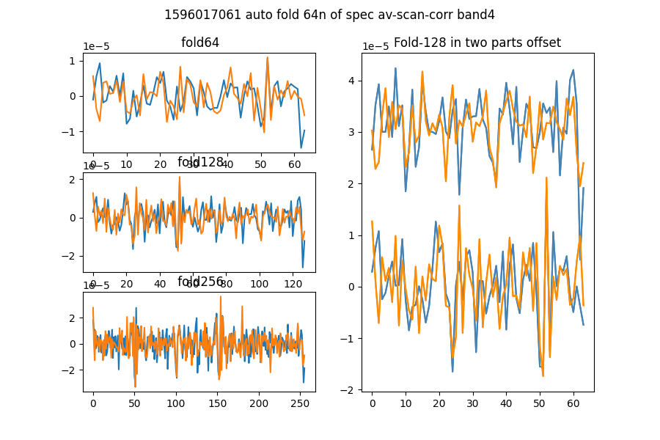

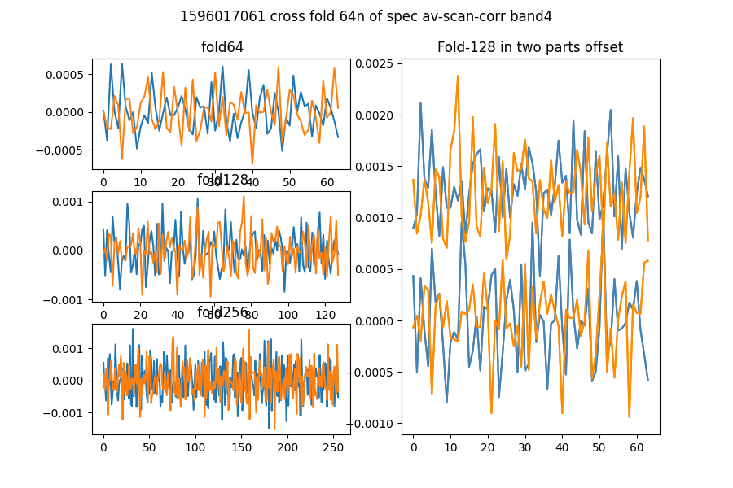

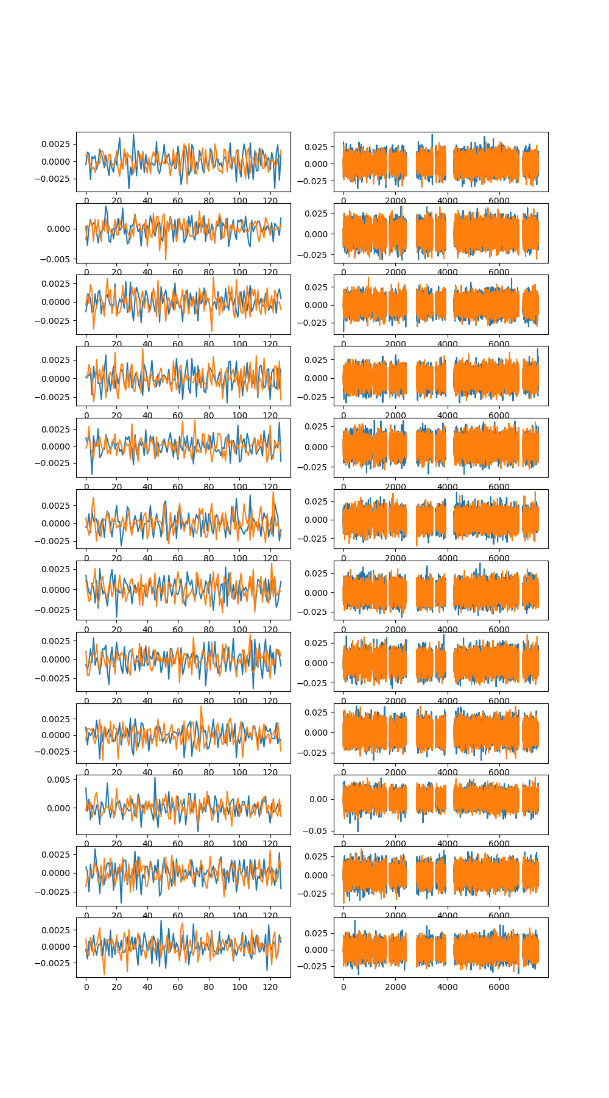

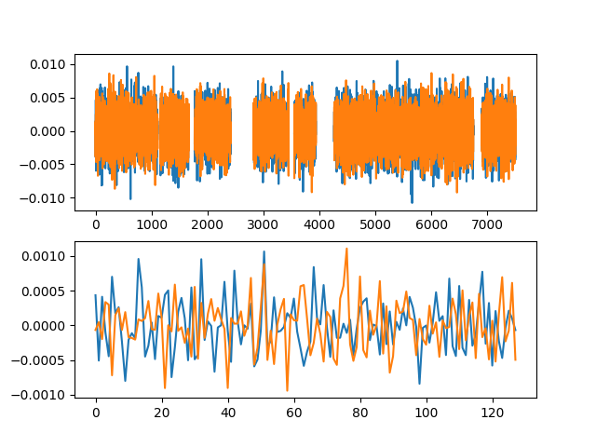

# Comb function analysis

Using nsearch=1; minfold=5; thresh=5.0

* Max (fold,start) [51, 51] with snr 12.07

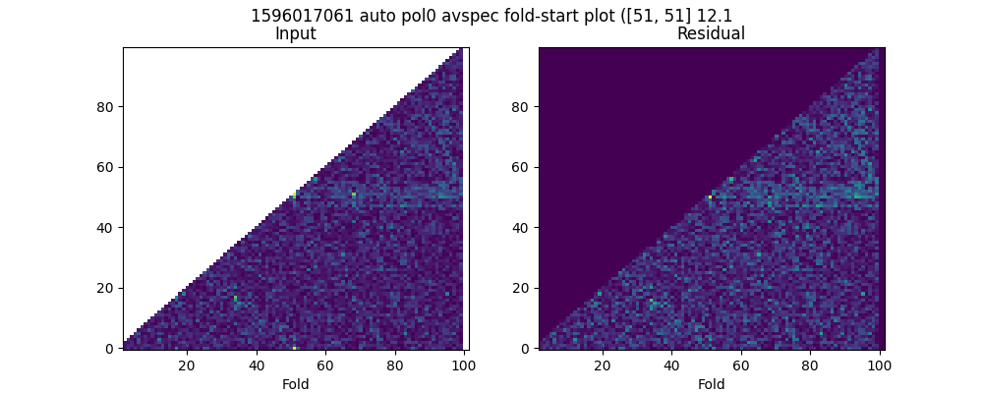

* Max (fold,start) [51, 50] with snr 8.57

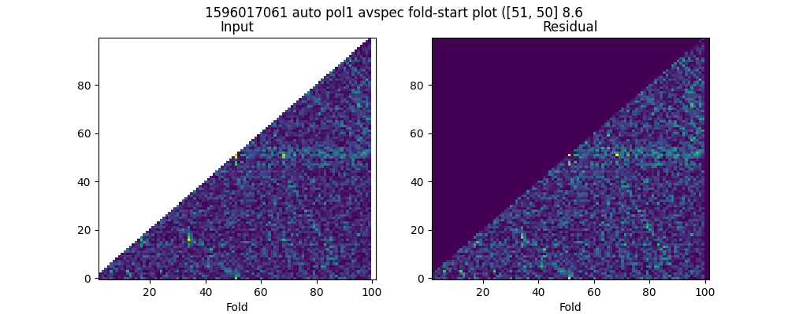

* Max (fold,start) [62, 58] with snr 5.52

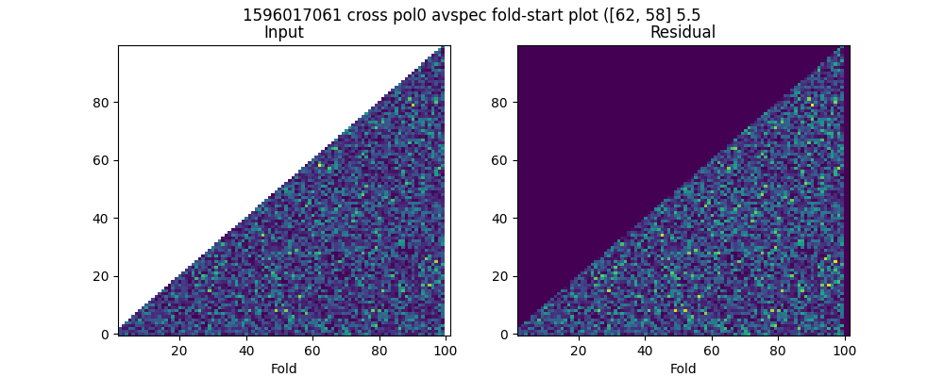

* Max (fold,start) [87, 52] with snr 5.42

