1596094172 - full report

# Data parameters

* Shape : (1350, 1024, 5724)
* Num of ants 53
* Num of corr 5724
* Num of chans 1024
* Num of scans 20

# CONTENTS

===============================================================================  
Name: file:///data/mohan//1596094172/1596094172_sdp_l0.rdb | 1596094172-sdp-l0 (version 4.0)  
===============================================================================  
Observer: Operator Experiment ID: 20200730-0021  
Description: 'Upgrade Tests: Stability Track'  
Observed from 2020-07-30 09:29:37.009 SAST to 2020-07-30 12:29:41.197 SAST  
Dump rate / period: 0.12495 Hz / 8.003 s  
Subarrays: 1  
 ID Antennas Inputs Corrprods  
 0 m001,m002,m003,m008,m009,m010,m011,m012,m013,m014,m015,m016,m017,m018,m019,m020,m021,m023,m024,m026,m027,m028,m029,m030,m031,m033,m034,m035,m037,m038,m040,m041,m042,m043,m044,m045,m046,m047,m048,m049,m050,m051,m052,m053,m054,m055,m057,m058,m059,m060,m061,m062,m063 106 5724  
Spectral Windows: 1  
 ID Band Product CentreFreq(MHz) Bandwidth(MHz) Channels ChannelWidth(kHz)  
 0 UHF c544M1k 816.000 544.000 1024 531.250  
-------------------------------------------------------------------------------  
Data selected according to the following criteria:  
 spw=0  
 subarray=0  
-------------------------------------------------------------------------------  
Shape: (1350 dumps, 1024 channels, 5724 correlation products) => Size: 63.303 GB  
Antennas: m001,m002,m003,m008,m009,m010,m011,m012,m013,m014,m015,m016,m017,m018,m019,m020,m021,m023,m024,m026,m027,m028,m029,m030,m031,m033,m034,m035,m037,m038,m040,m041,m042,m043,m044,m045,m046,m047,m048,m049,m050,m051,m052,m053,m054,m055,m057,m058,m059,m060,m061,m062,m063 Inputs: 106 Autocorr: yes Crosscorr: yes  
Channels: 1024 (index 0 - 1023, 544.000 MHz - 1087.469 MHz), each 531.250 kHz wide  
Targets: 1 selected out of 1 in catalogue  
 ID Name Type RA(J2000) DEC(J2000) Tags Dumps ModelFlux(Jy)  
 0 J0408-6545 radec 4:08:20.38 -65:45:09.1 bpcal delaycal 1350   
Scans: 20 selected out of 20 total Compscans: 18 selected out of 18 total  
 Date Timerange(UTC) ScanState CompScanLabel Dumps Target  
 30-Jul-2020/07:29:41 - 07:29:49 0:slew 0:track 2 0:J0408-6545  
 07:29:57 - 07:39:41 1:track 0:track 74 0:J0408-6545  
 07:39:49 - 07:49:41 2:track 1:track 75 0:J0408-6545  
 07:49:49 - 07:59:41 3:track 2:track 75 0:J0408-6545  
 07:59:49 - 08:09:41 4:track 3:track 75 0:J0408-6545  
 08:09:49 - 08:19:42 5:track 4:track 75 0:J0408-6545  
 08:19:50 - 08:29:42 6:track 5:track 75 0:J0408-6545  
 08:29:50 - 08:39:42 7:track 6:track 75 0:J0408-6545  
 08:39:50 - 08:49:42 8:track 7:track 75 0:J0408-6545  
 08:49:50 - 08:59:43 9:track 8:track 75 0:J0408-6545  
 08:59:51 - 09:09:51 10:track 9:track 76 0:J0408-6545  
 09:09:59 - 09:19:51 11:track 10:track 75 0:J0408-6545  
 09:19:59 - 09:29:51 12:track 11:track 75 0:J0408-6545  
 09:29:59 - 09:39:52 13:track 12:track 75 0:J0408-6545  
 09:40:00 - 09:49:52 14:track 13:track 75 0:J0408-6545  
 09:50:00 - 09:59:52 15:track 14:track 75 0:J0408-6545  
 10:00:00 - 10:09:52 16:track 15:track 75 0:J0408-6545  
 10:10:00 - 10:19:52 17:track 16:track 75 0:J0408-6545  
 10:20:00 - 10:29:29 18:track 17:track 72 0:J0408-6545  
 10:29:37 - 10:29:37 19:stop 17:track 1 0:J0408-6545

Bands used

* Band chs 0: 125-337
* Band chs 1: 425-625
* Full band chs : 125-625
* Percentage of auto flags in pol 0 is 2.0 %
* Percentage of auto flags in pol 1 is 1.9 %
* Percentage of cross flags in pol 0 is 1.3 %
* Percentage of cross flags in pol 1 is 1.4 %

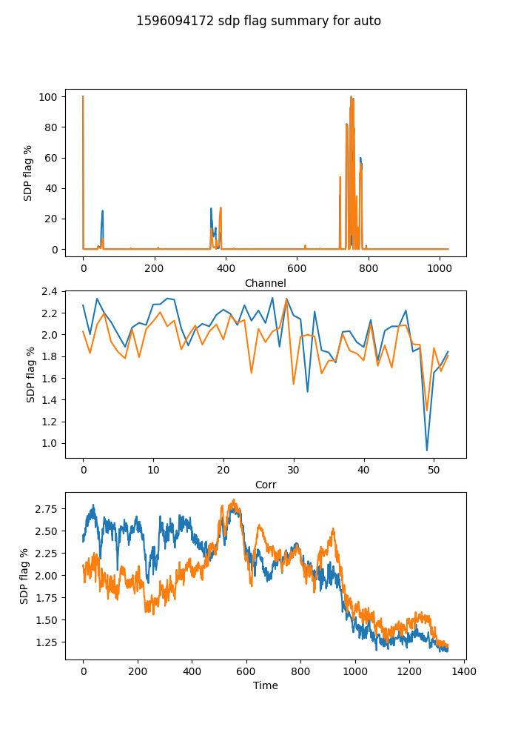

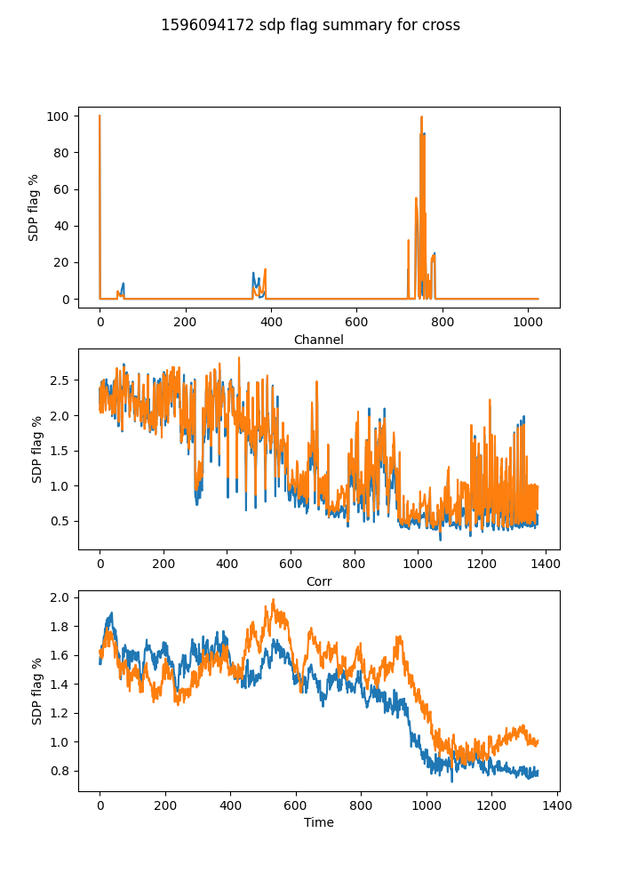

## Spectral mean and variance

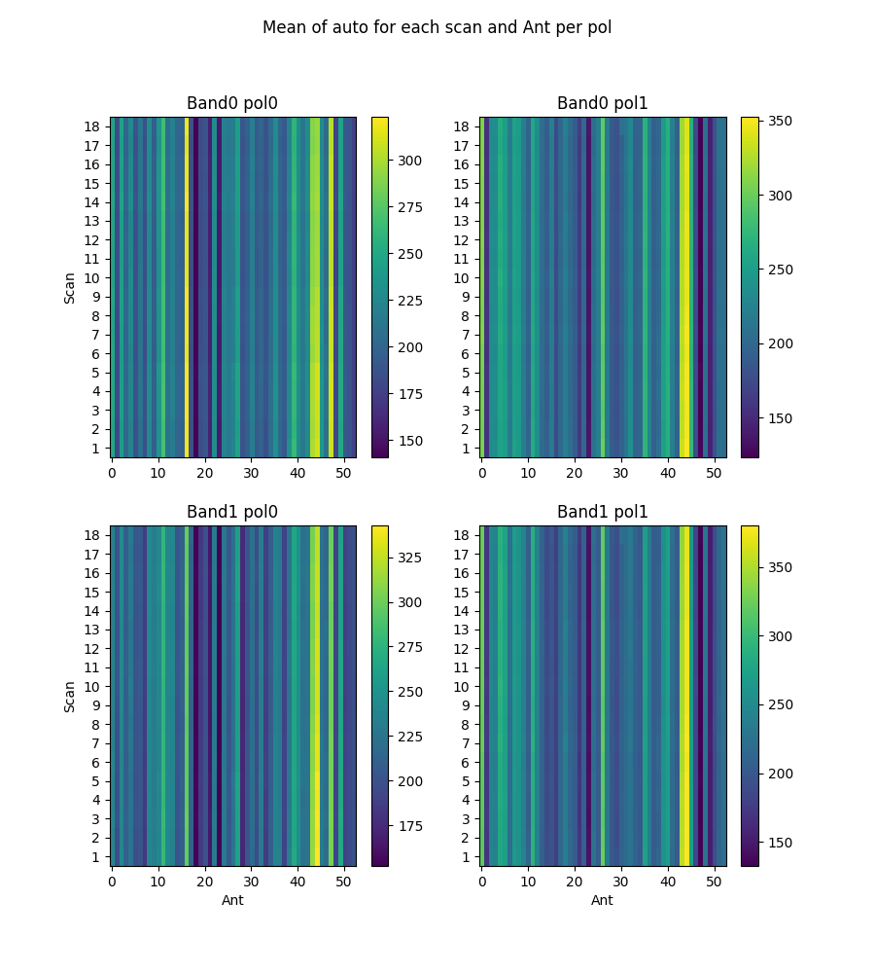

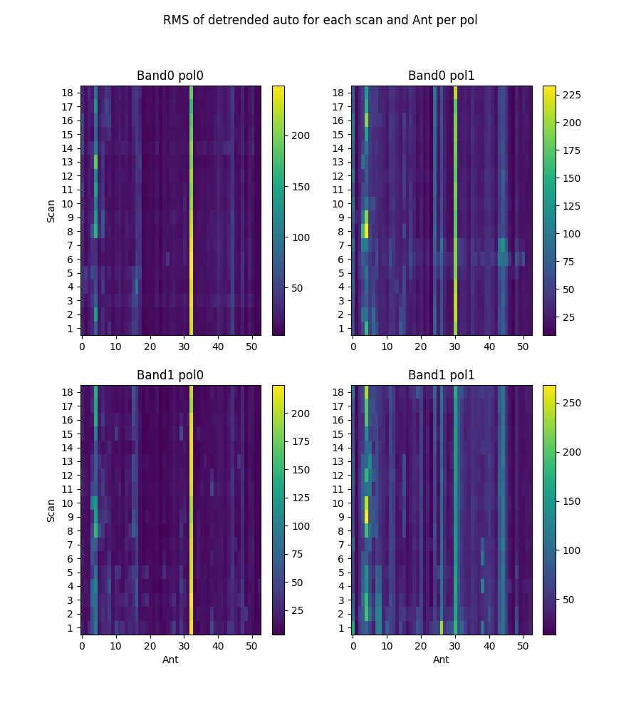

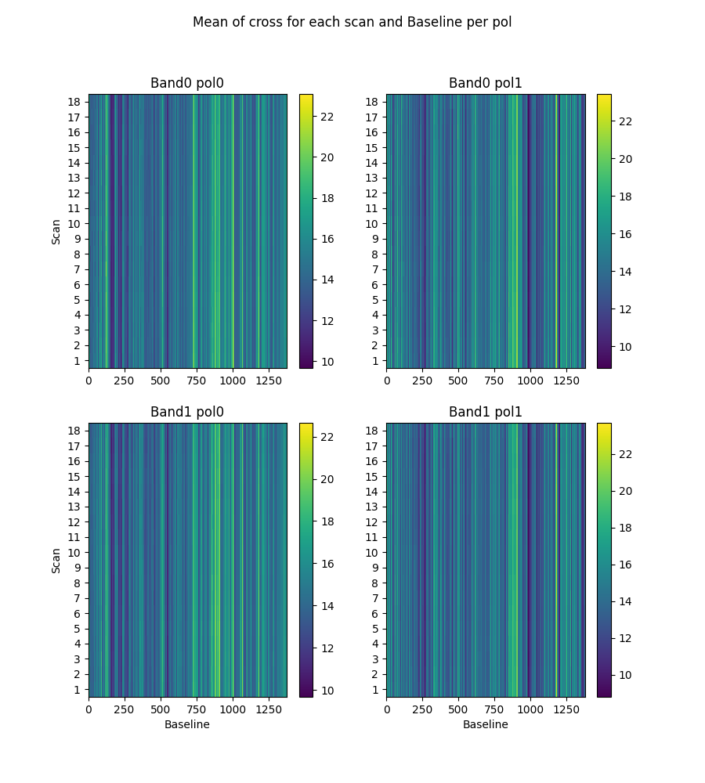

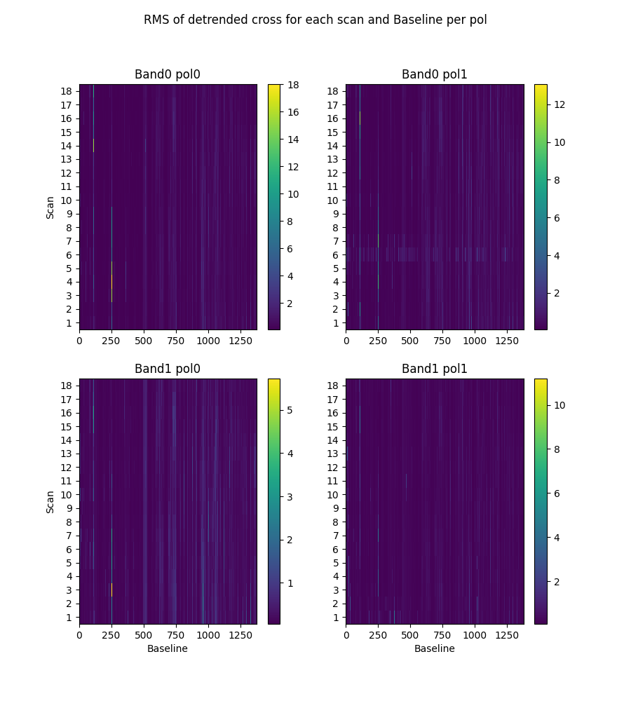

# 2-channel ringing

Using threshold of ringing index of 0.67  
(1->perfect ringing, 0-> none, neg->higher periods)

* Num of bad auto is 0
* Num of bad cross is 28

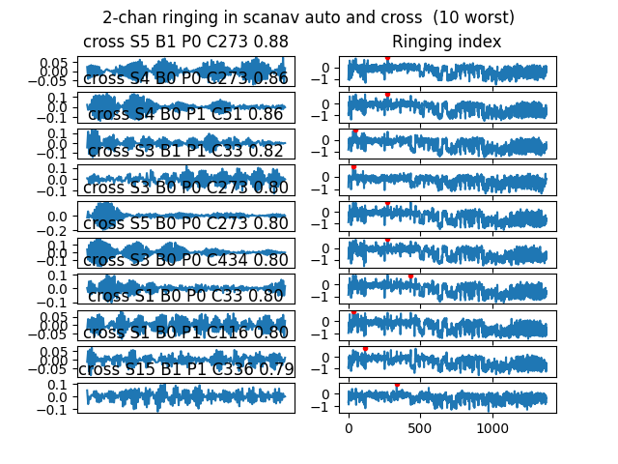

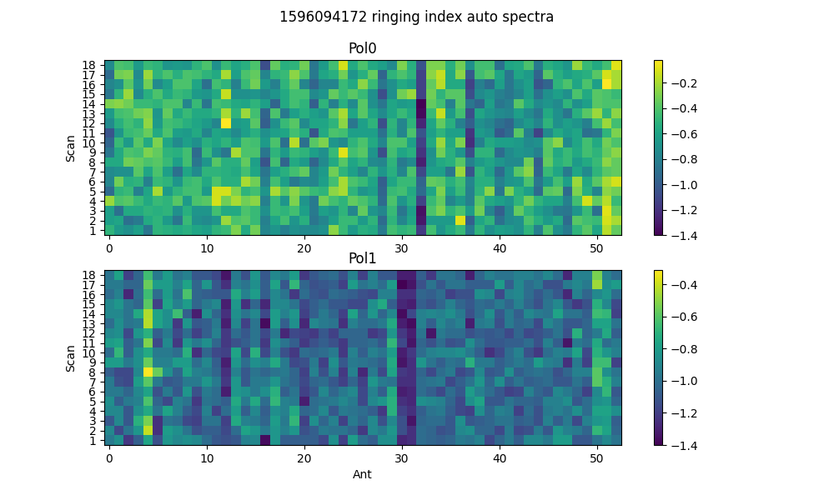

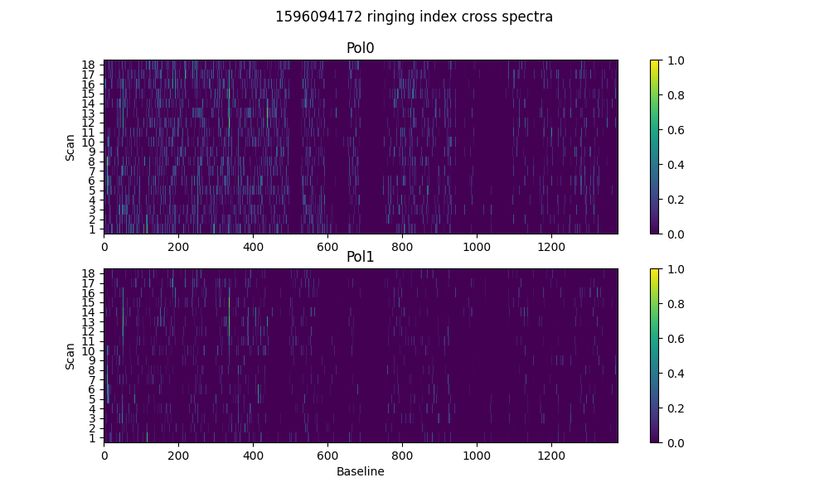

# 2-dump ringing in DC

Threshold = 0.67  
Plotting for scans >20dumps)

* Num of bad auto is 0
* Num of bad cross is 36

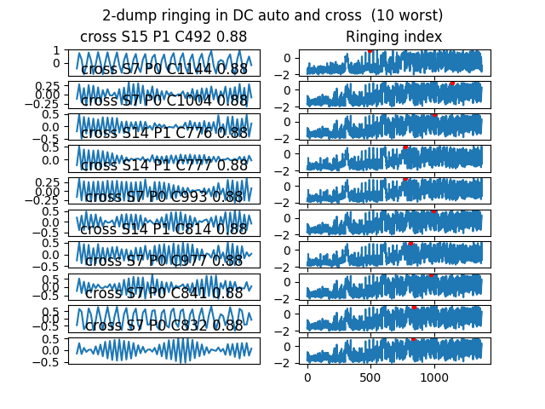

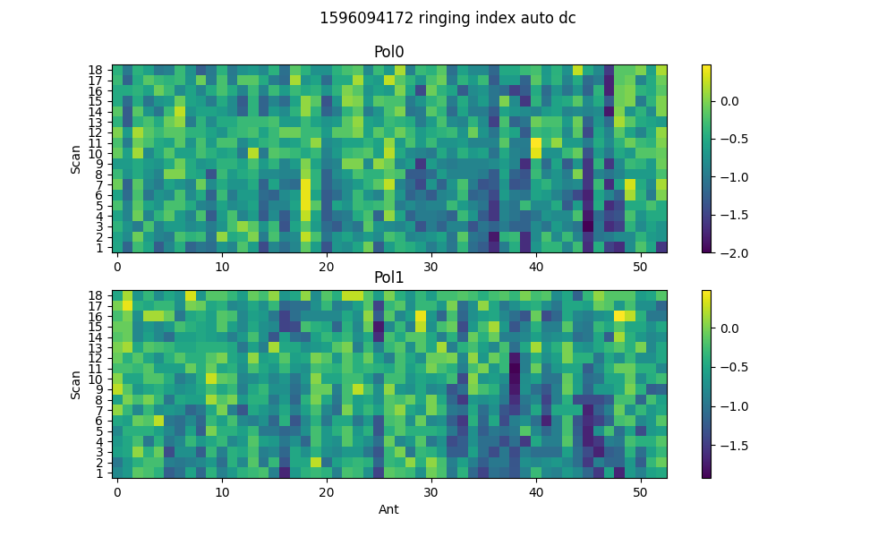

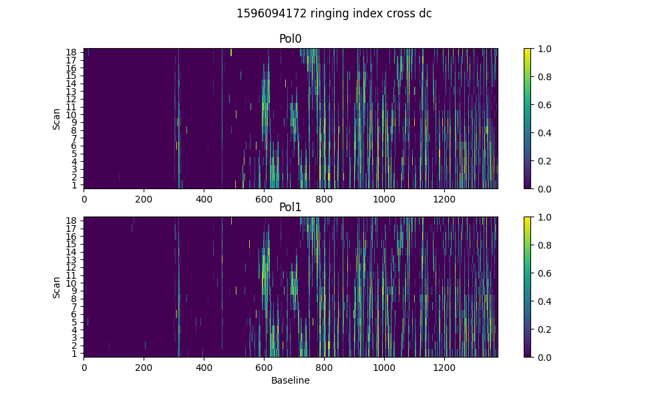

# Spectral periodicities

Using threshold of 10.0 sigma  
after detrending by polyfit(51)

* Found 1834 bad spectra in auto in band0
* Found 1776 bad spectra in auto in band1
* Found 42478 bad spectra in cross in band0
* Found 38331 bad spectra in cross in band1

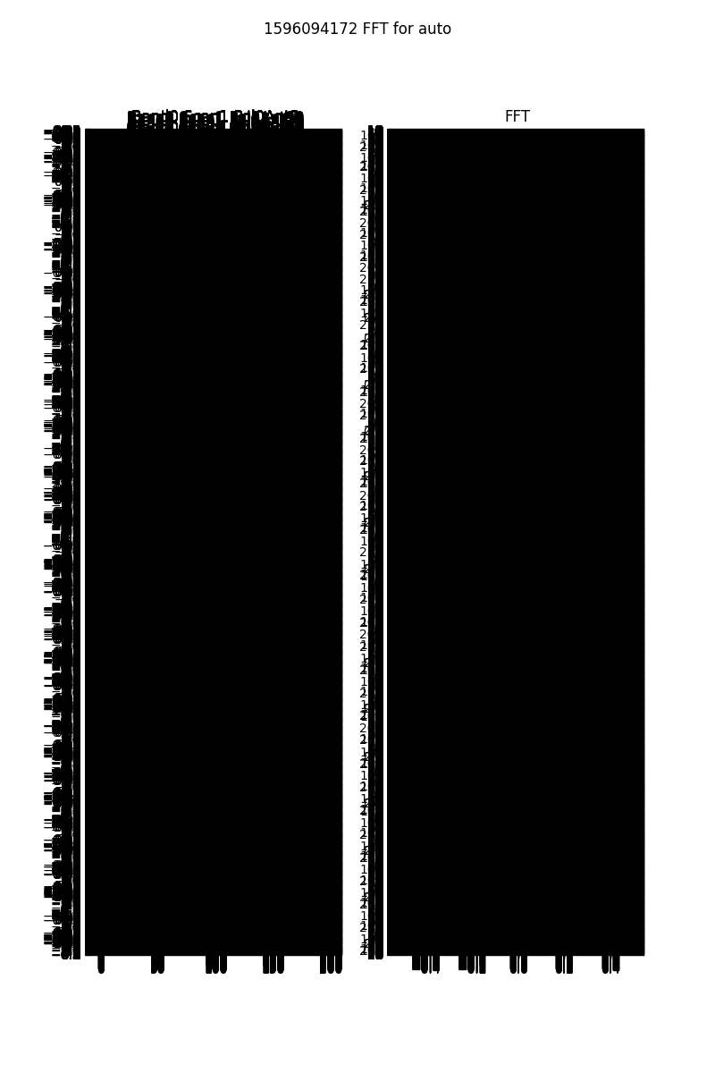

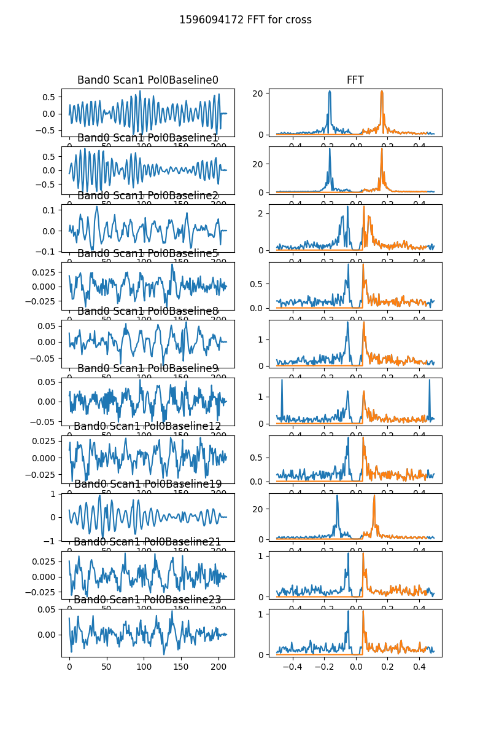

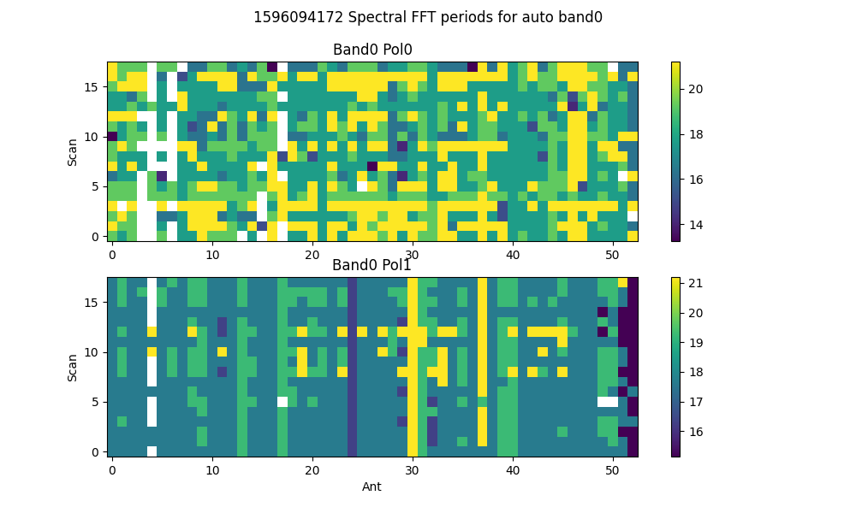

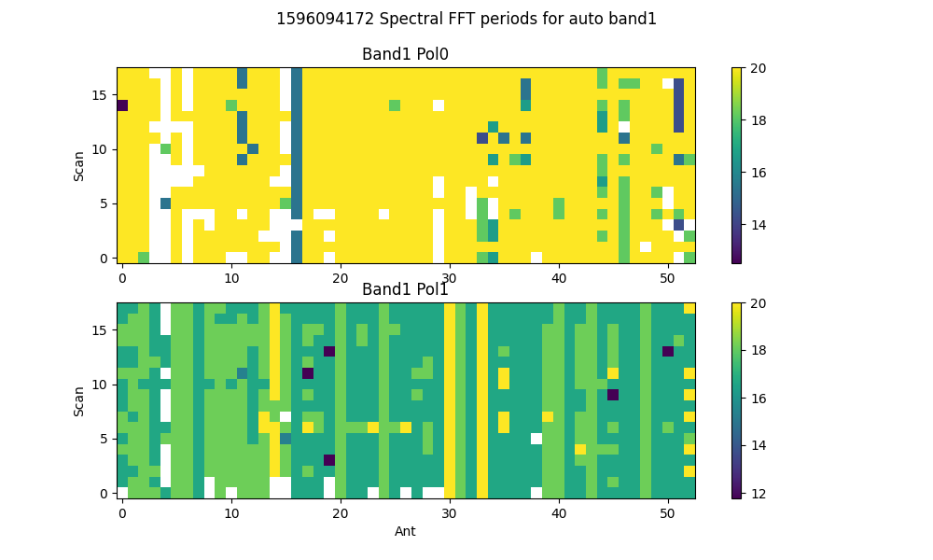

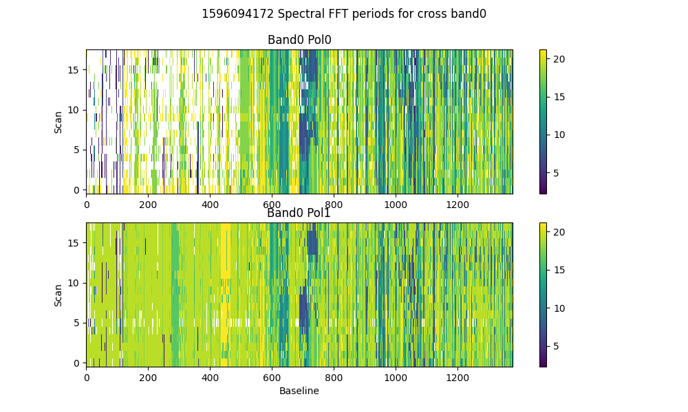

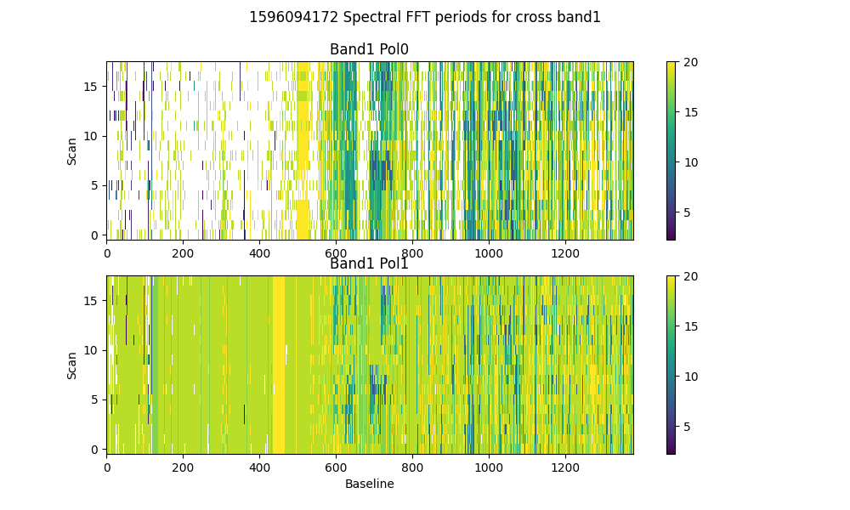

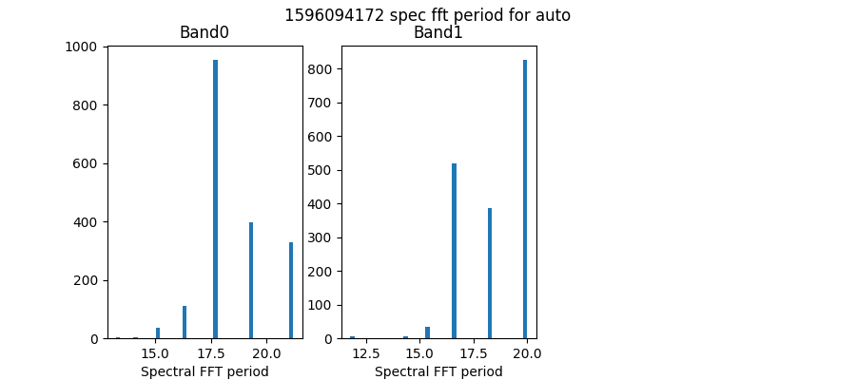

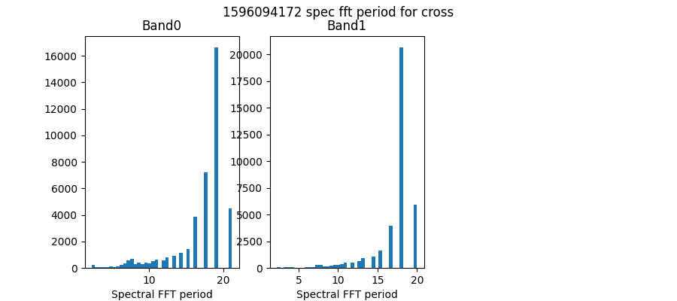

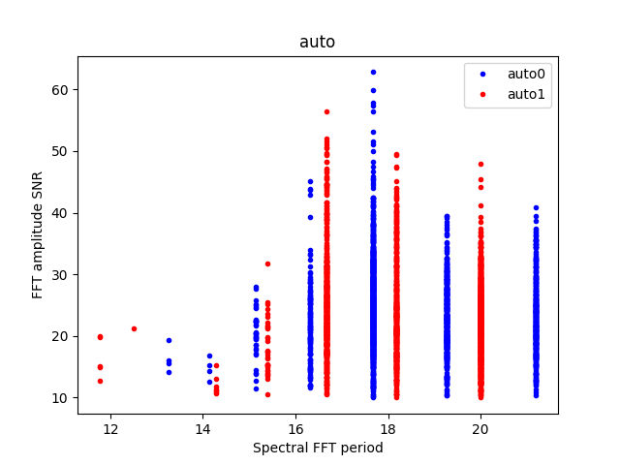

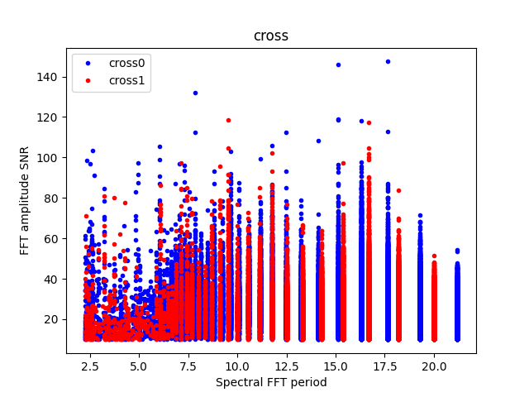

# Detrending

Applying polynomial filter with window 31 channels

# 2-chan ringing in average detrended spectrum

* Ringing index for auto pol 0 is -0.81
* Ringing index for auto pol 1 is -1.04
* Ringing index for cross pol 0 is -0.91
* Ringing index for cross pol 1 is -1.13

# X-Y pol correlation in spectra

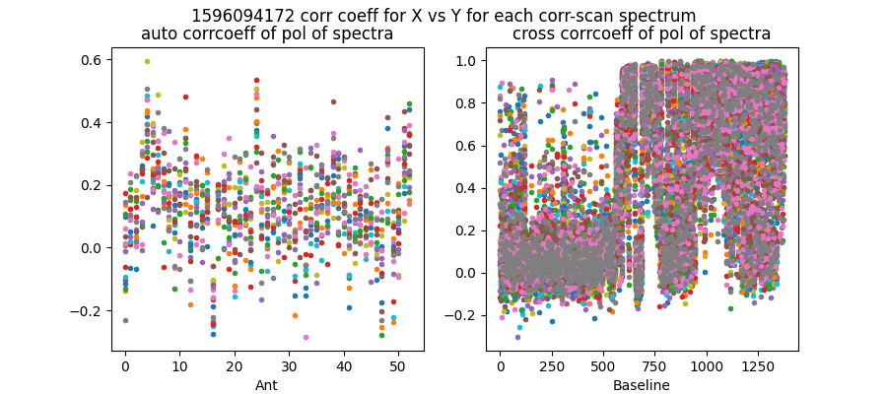

Mean and median corrcoeff for auto is 0.13 0.13

Mean and median corrcoeff for cross is 0.38 0.22

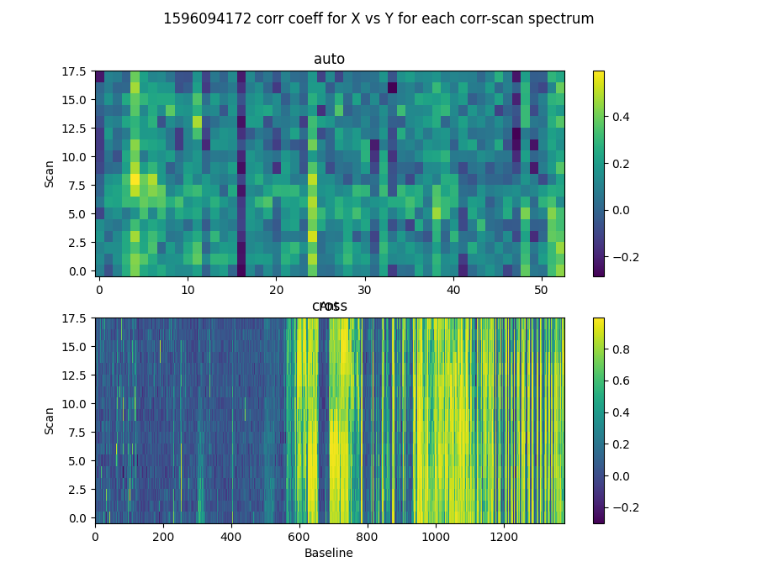

* Corr coeff for auto av spectrum X vx Y is 0.34
* Corr coeff for auto folded av spec X vx Y is 0.06
* Corr coeff for cross av spectrum X vx Y is 0.37
* Corr coeff for cross folded av spec X vx Y is 0.56

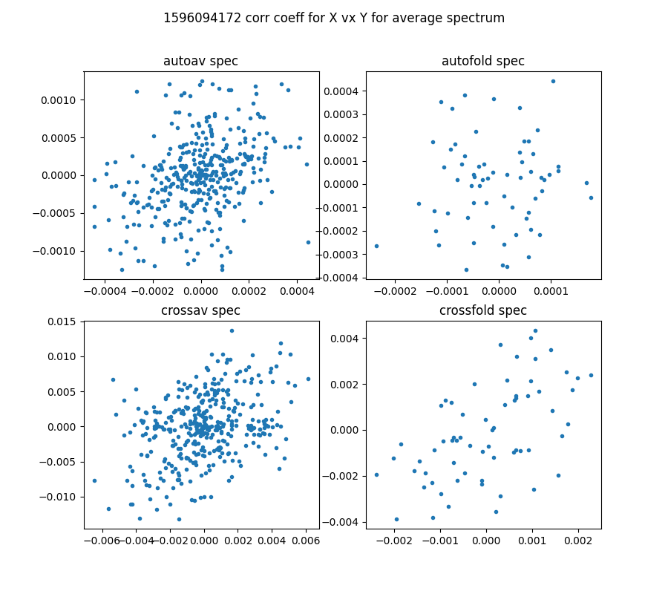

# 64-channel folded spectra

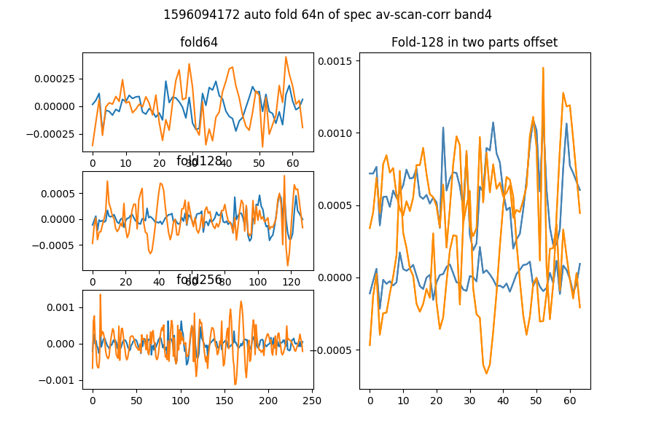

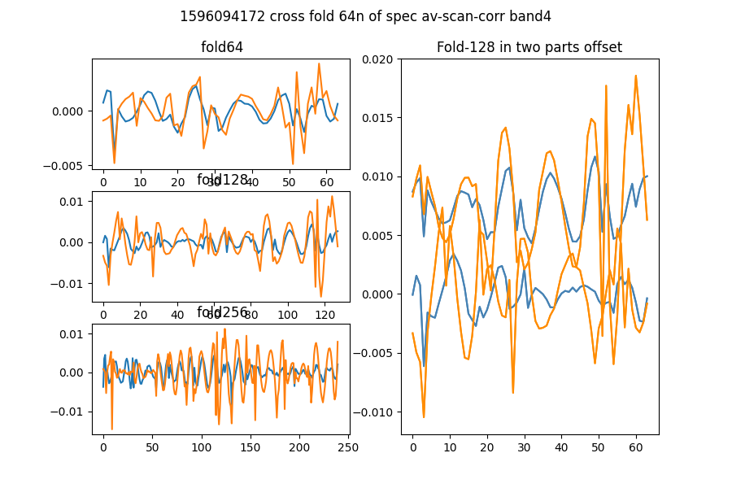

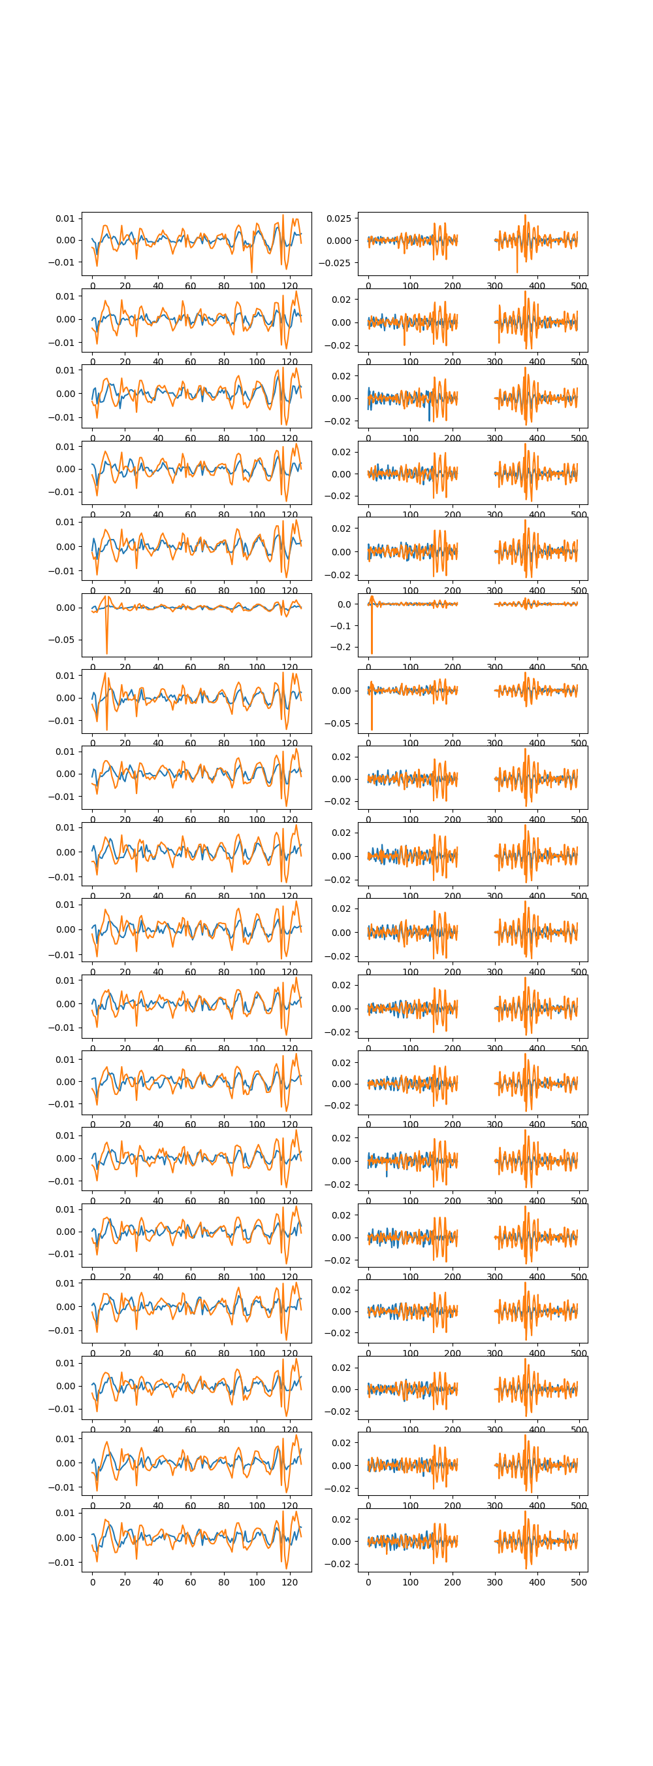

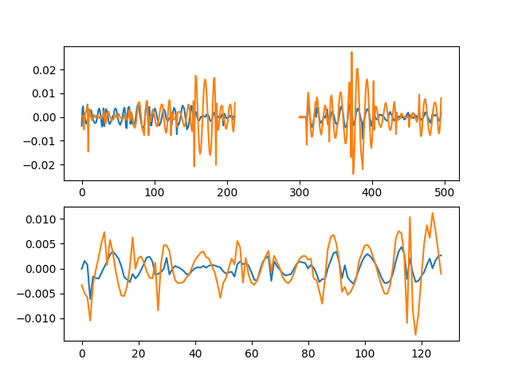

# Comb function analysis

Using nsearch=1; minfold=5; thresh=5.0

* Max (fold,start) [89, 86] with snr 6.02

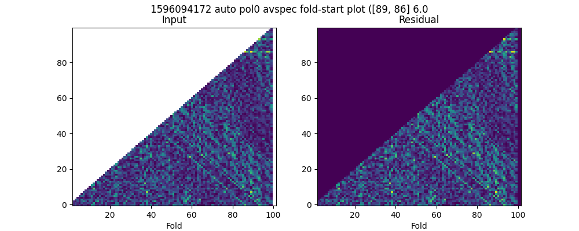

* Max (fold,start) [88, 81] with snr 4.80

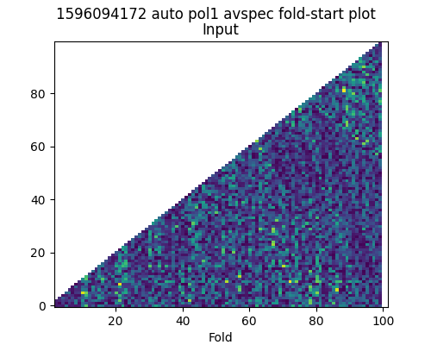

* Max (fold,start) [64, 3] with snr 6.47

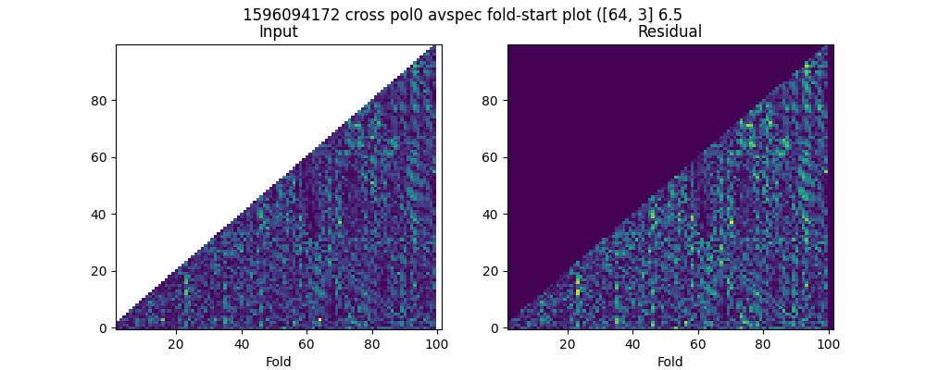

* Max (fold,start) [73, 9] with snr 5.03

