1596158164 - full report

# Data parameters

* Shape : (341, 4096, 7564)
* Num of ants 61
* Num of corr 7564
* Num of chans 4096
* Num of scans 13

# CONTENTS

===============================================================================  
Name: file:///data/mohan//1596158164/1596158164_sdp_l0.rdb | 1596158164-sdp-l0 (version 4.0)  
===============================================================================  
Observer: Sarah Buchner Experiment ID: 20200727-0023  
Description: 'Standard field for correlator tests [c856M4k]'  
Observed from 2020-07-31 03:16:22.030 SAST to 2020-07-31 04:01:48.876 SAST  
Dump rate / period: 0.12505 Hz / 7.997 s  
Subarrays: 1  
 ID Antennas Inputs Corrprods  
 0 m000,m001,m002,m003,m004,m006,m007,m008,m009,m010,m011,m012,m013,m014,m015,m016,m017,m018,m019,m020,m021,m022,m023,m024,m026,m027,m028,m029,m030,m031,m032,m033,m034,m035,m036,m037,m038,m040,m041,m042,m043,m044,m045,m046,m047,m048,m049,m050,m051,m052,m053,m054,m055,m056,m057,m058,m059,m060,m061,m062,m063 122 7564  
Spectral Windows: 1  
 ID Band Product CentreFreq(MHz) Bandwidth(MHz) Channels ChannelWidth(kHz)  
 0 L c856M4k 1284.000 856.000 4096 208.984  
-------------------------------------------------------------------------------  
Data selected according to the following criteria:  
 spw=0  
 subarray=0  
-------------------------------------------------------------------------------  
Shape: (341 dumps, 4096 channels, 7564 correlation products) => Size: 84.519 GB  
Antennas: m000,m001,m002,m003,m004,m006,m007,m008,m009,m010,m011,m012,m013,m014,m015,m016,m017,m018,m019,m020,m021,m022,m023,m024,m026,m027,m028,m029,m030,m031,m032,m033,m034,m035,m036,m037,m038,m040,m041,m042,m043,m044,m045,m046,m047,m048,m049,m050,m051,m052,m053,m054,m055,m056,m057,m058,m059,m060,m061,m062,m063 Inputs: 122 Autocorr: yes Crosscorr: yes  
Channels: 4096 (index 0 - 4095, 856.000 MHz - 1711.791 MHz), each 208.984 kHz wide  
Targets: 3 selected out of 3 in catalogue  
 ID Name Type RA(J2000) DEC(J2000) Tags Dumps ModelFlux(Jy)  
 0 J1939-6342 radec 19:39:25.03 -63:42:45.6 delaycal bpcal 79   
 1 J2147-7536 radec 21:47:12.73 -75:36:13.2 gaincal 20   
 2 J2147-8132 radec 21:47:23.62 -81:32:08.6 target 242   
Scans: 13 selected out of 13 total Compscans: 6 selected out of 6 total  
 Date Timerange(UTC) ScanState CompScanLabel Dumps Target  
 31-Jul-2020/01:16:26 - 01:16:26 0:slew 0:track 1 0:J1939-6342  
 01:16:34 - 01:21:21 1:track 0:track 37 0:J1939-6342  
 01:21:29 - 01:21:45 2:slew 1:track 3 1:J2147-7536  
 01:21:53 - 01:22:41 3:track 1:track 7 1:J2147-7536  
 01:22:49 - 01:22:57 4:slew 2:track 2 2:J2147-8132  
 01:23:05 - 01:38:49 5:track 2:track 119 2:J2147-8132  
 01:38:57 - 01:39:13 6:slew 3:track 3 1:J2147-7536  
 01:39:21 - 01:40:09 7:track 3:track 7 1:J2147-7536  
 01:40:17 - 01:40:25 8:slew 4:track 2 2:J2147-8132  
 01:40:33 - 01:56:17 9:track 4:track 119 2:J2147-8132  
 01:56:25 - 01:56:49 10:slew 5:track 4 0:J1939-6342  
 01:56:56 - 02:01:36 11:track 5:track 36 0:J1939-6342  
 02:01:44 - 02:01:44 12:stop 5:track 1 0:J1939-6342

Bands used

* Band chs 0: 525-1045
* Band chs 1: 2187-3125
* Full band chs : 2187-3125
* Percentage of auto flags in pol 0 is 2.6 %
* Percentage of auto flags in pol 1 is 2.7 %
* Percentage of cross flags in pol 0 is 1.8 %
* Percentage of cross flags in pol 1 is 1.9 %

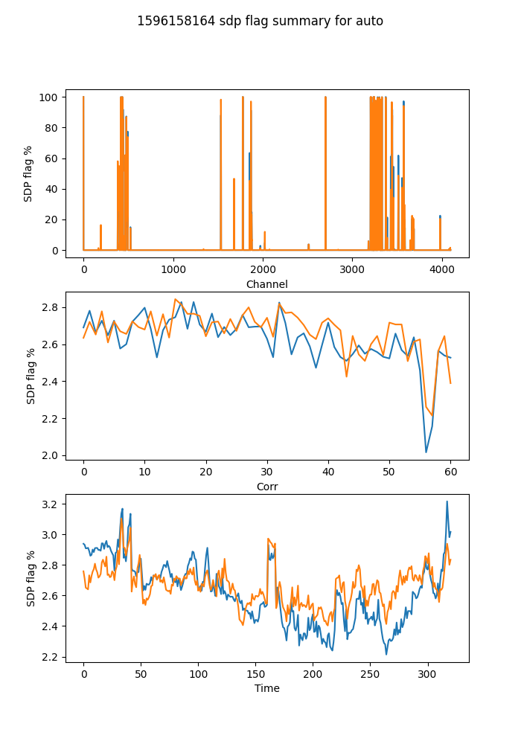

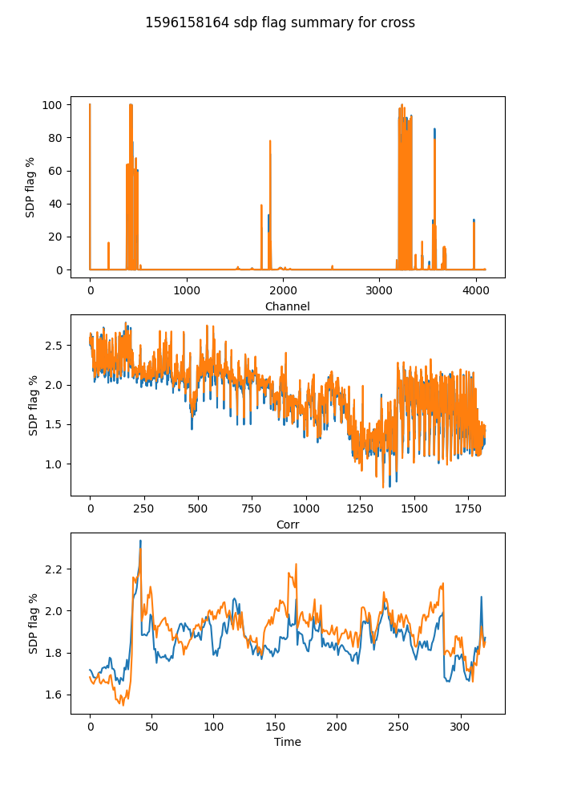

## Spectral mean and variance

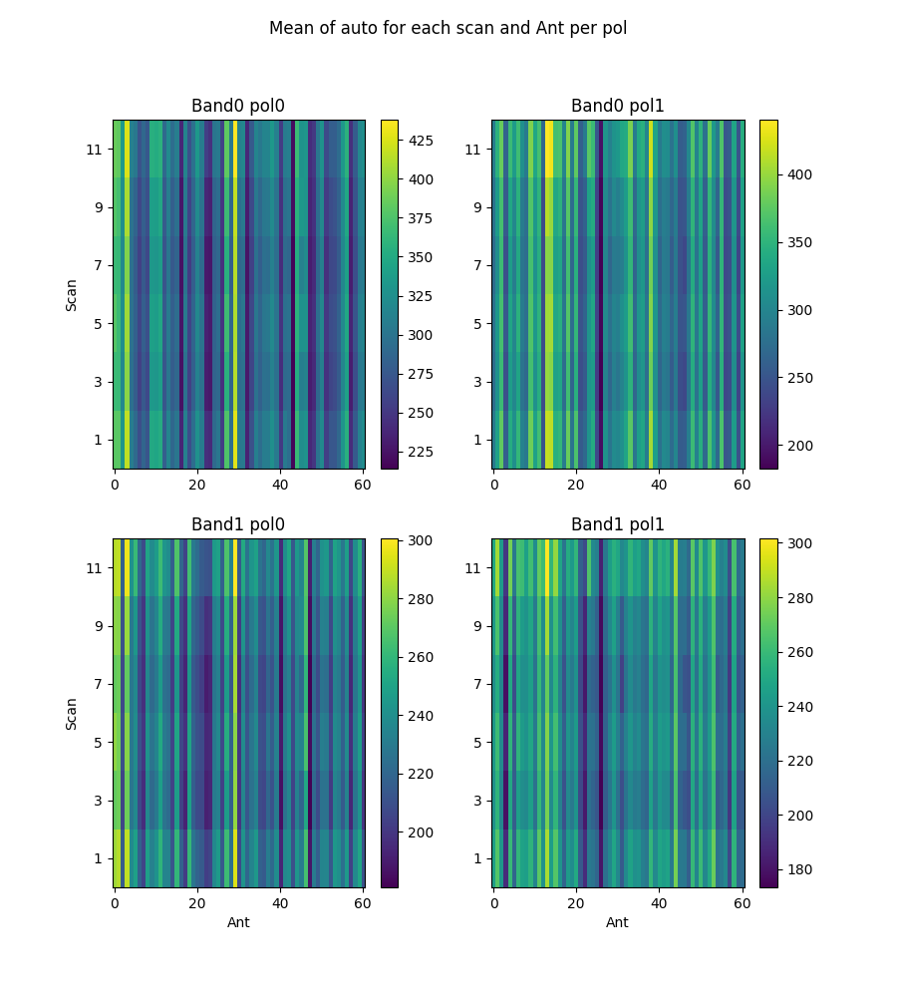

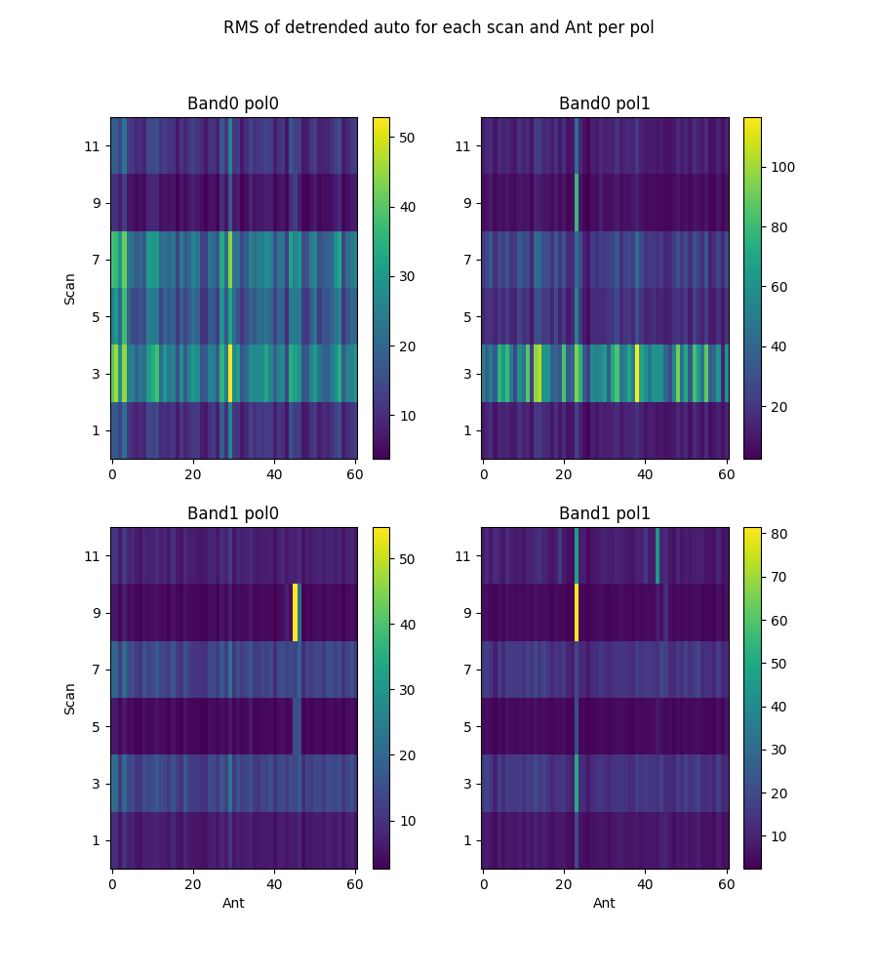

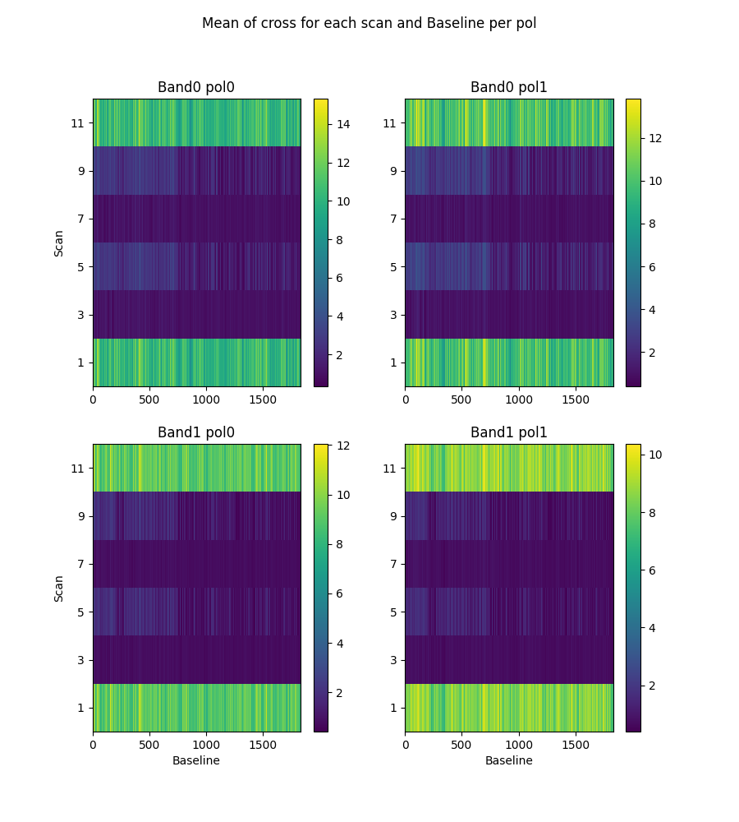

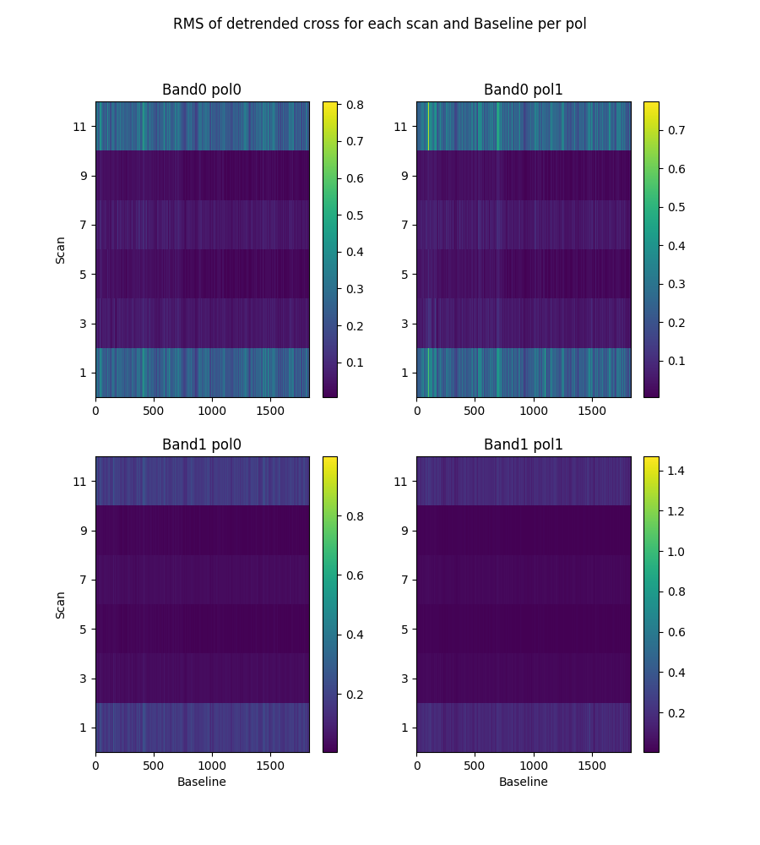

# 2-channel ringing

Using threshold of ringing index of 0.67  
(1->perfect ringing, 0-> none, neg->higher periods)

* Num of bad auto is 0
* Num of bad cross is 0

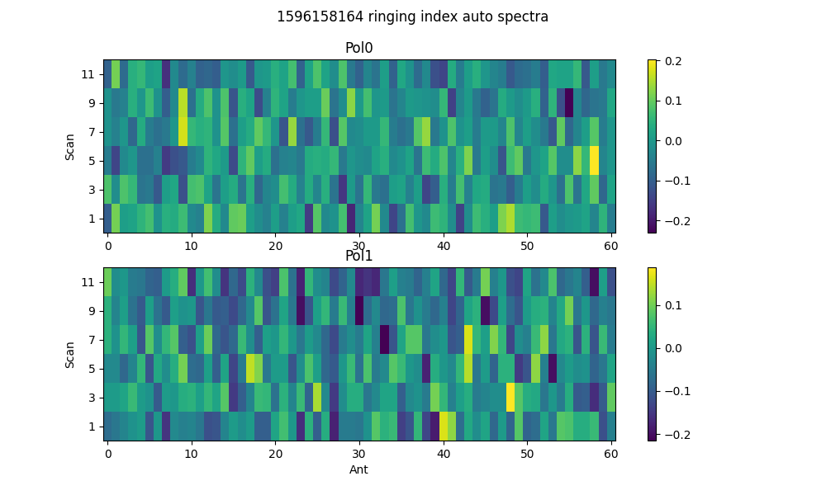

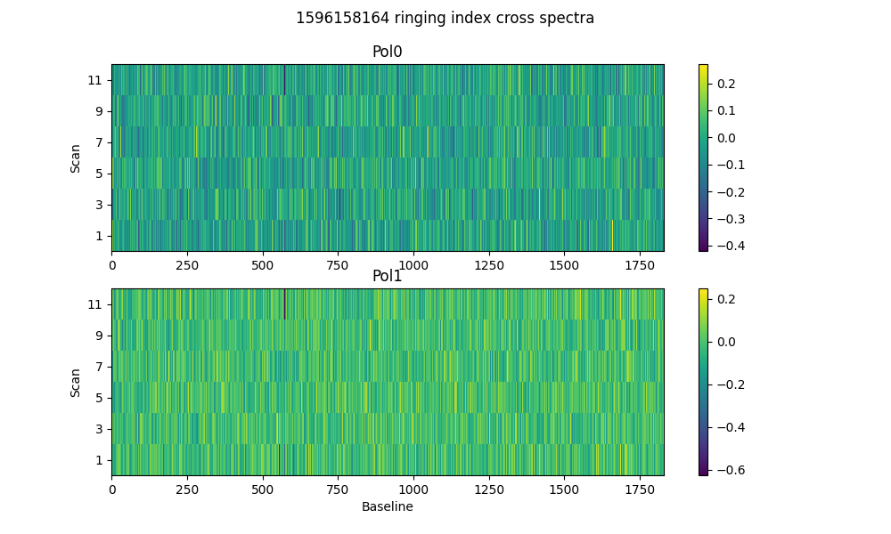

# 2-dump ringing in DC

Threshold = 0.67  
Plotting for scans >20dumps)

* Num of bad auto is 0
* Num of bad cross is 0

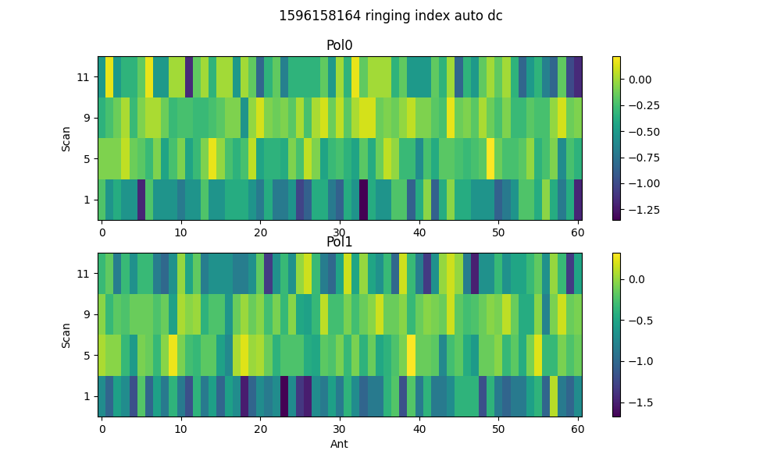

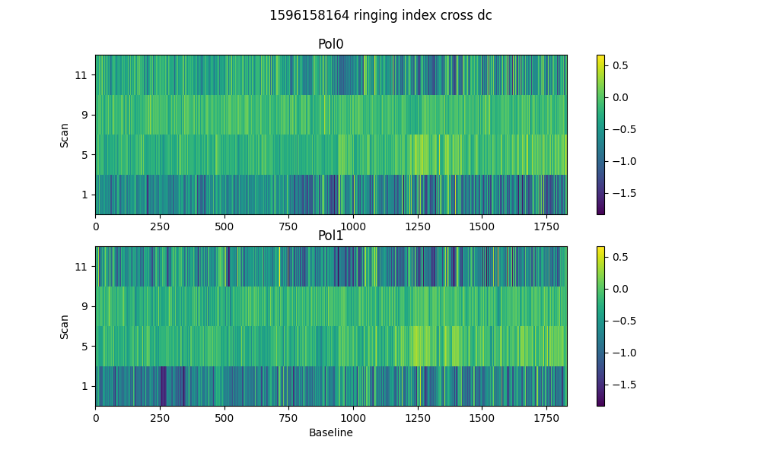

# Spectral periodicities

Using threshold of 10.0 sigma  
after detrending by polyfit(51)

* Found 2 bad spectra in auto in band0
* Found 9 bad spectra in auto in band1
* Found 324 bad spectra in cross in band0
* Found 126 bad spectra in cross in band1

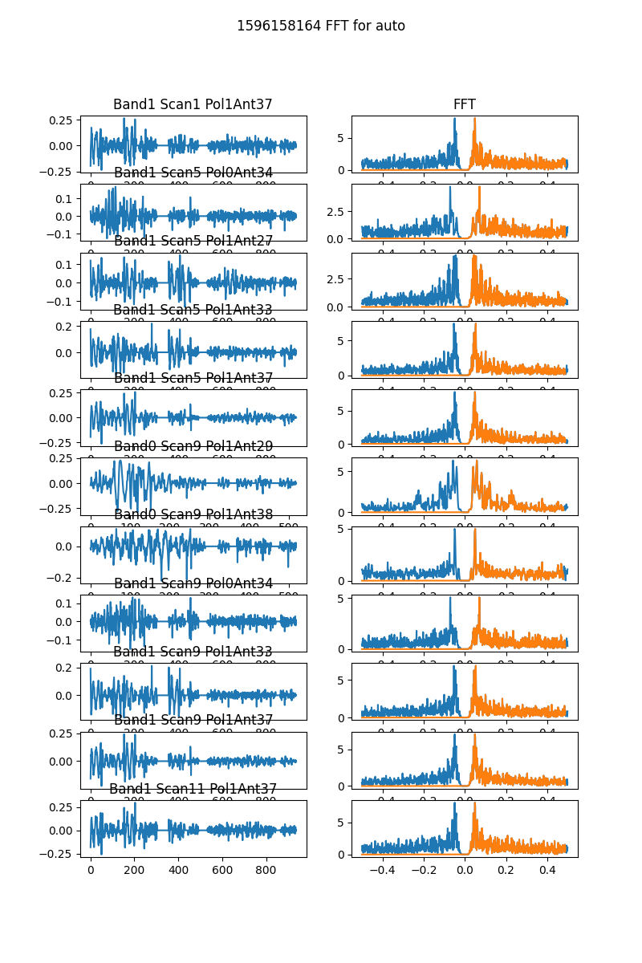

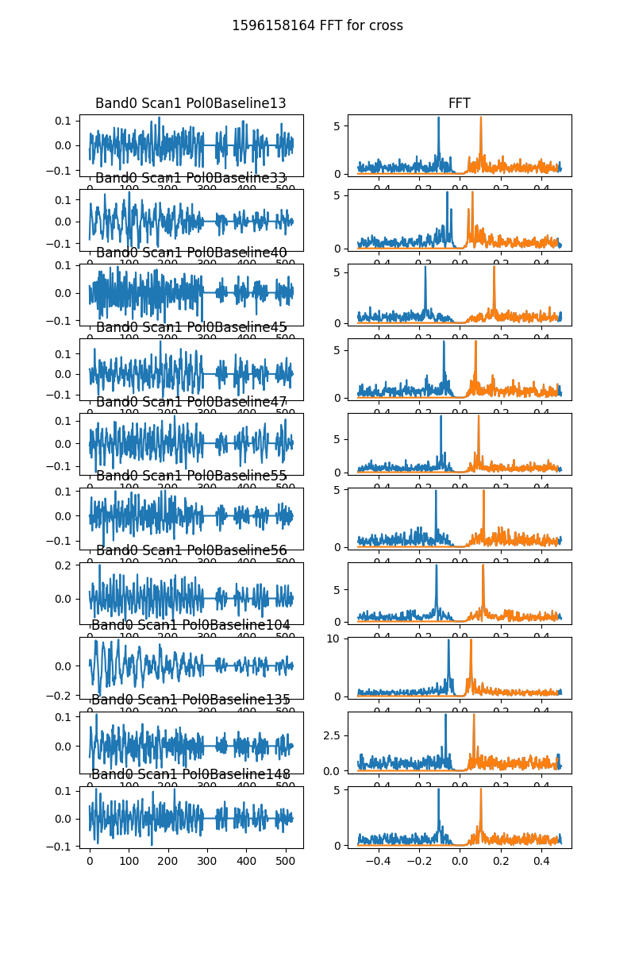

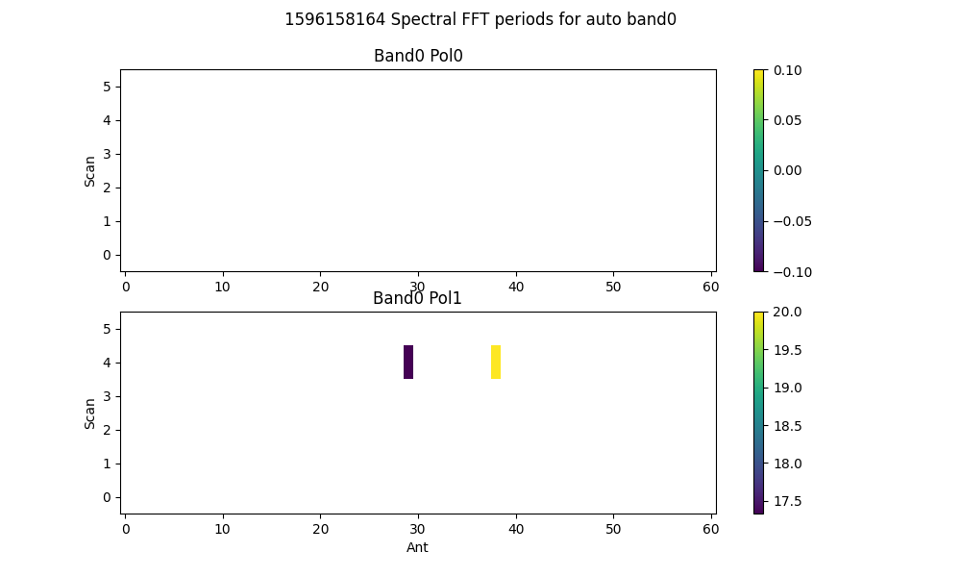

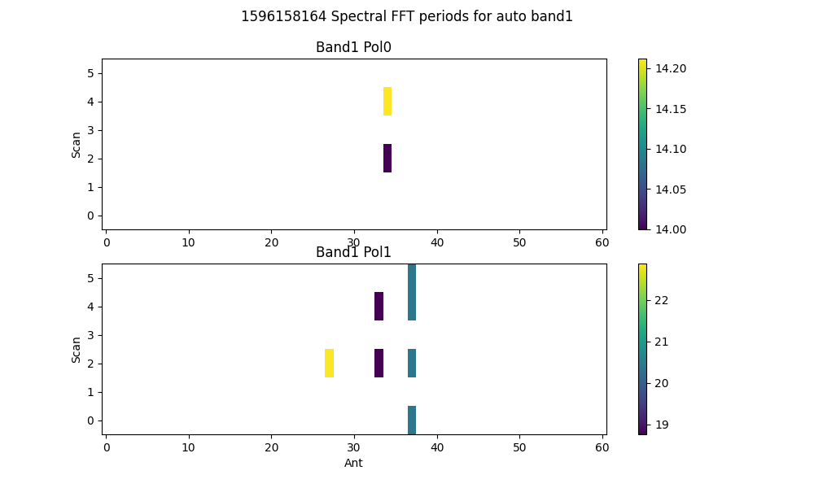

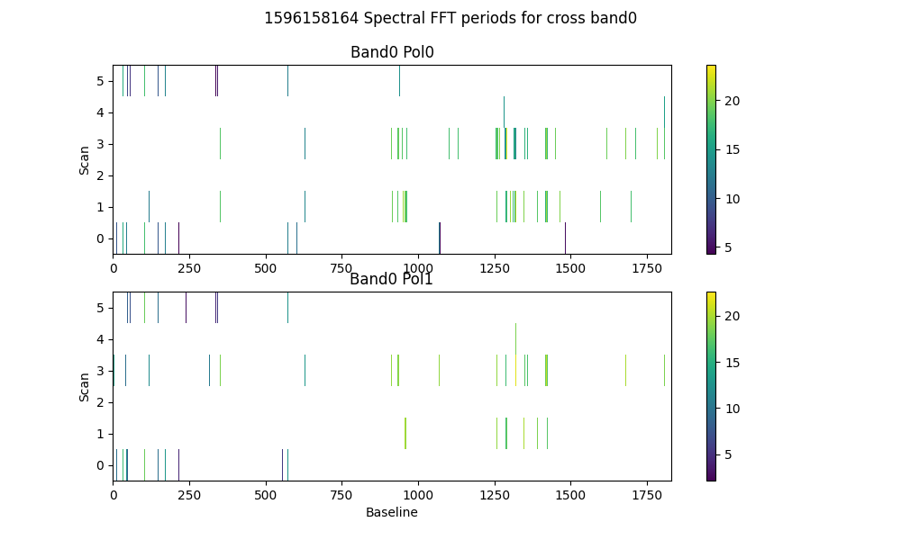

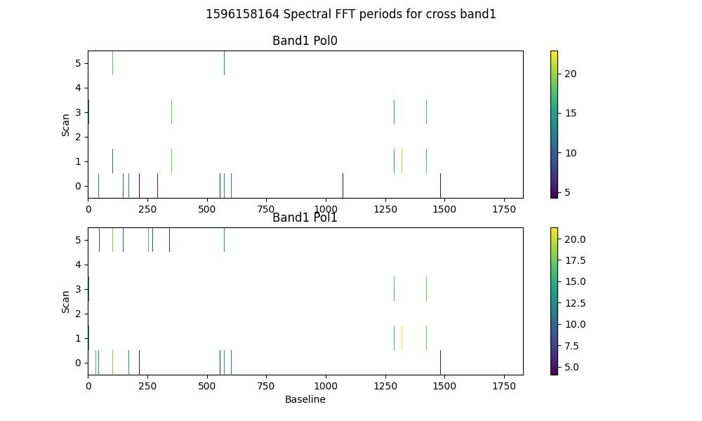

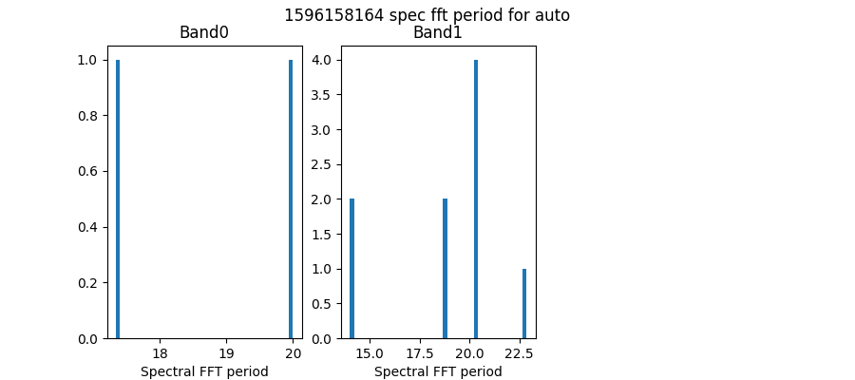

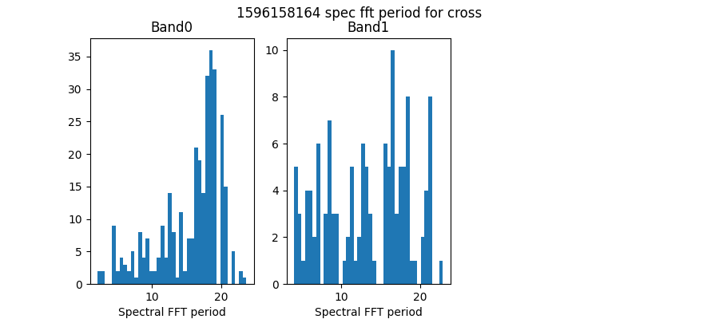

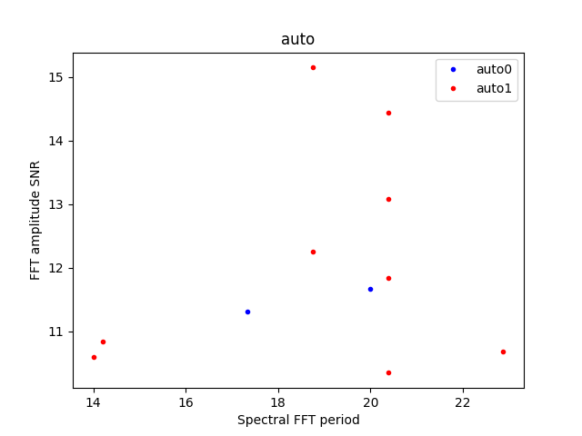

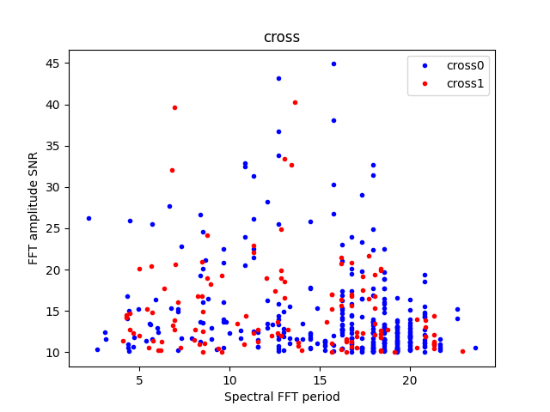

# Detrending

Applying polynomial filter with window 31 channels

# 2-chan ringing in average detrended spectrum

* Ringing index for auto pol 0 is -0.20
* Ringing index for auto pol 1 is -0.11
* Ringing index for cross pol 0 is -0.08
* Ringing index for cross pol 1 is 0.11

# X-Y pol correlation in spectra

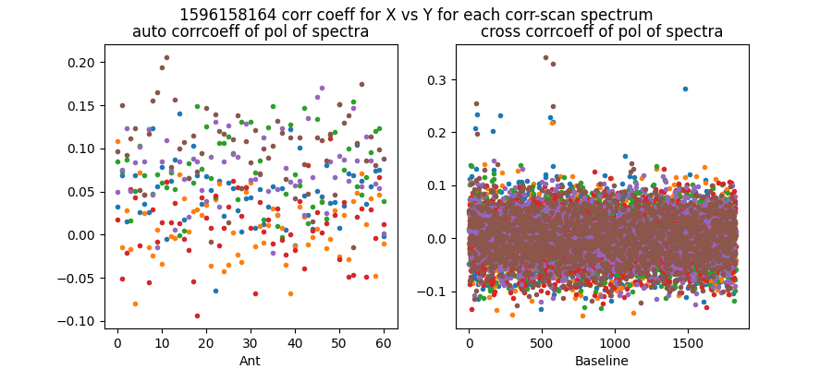

Mean and median corrcoeff for auto is 0.05 0.05

Mean and median corrcoeff for cross is 0.00 0.00

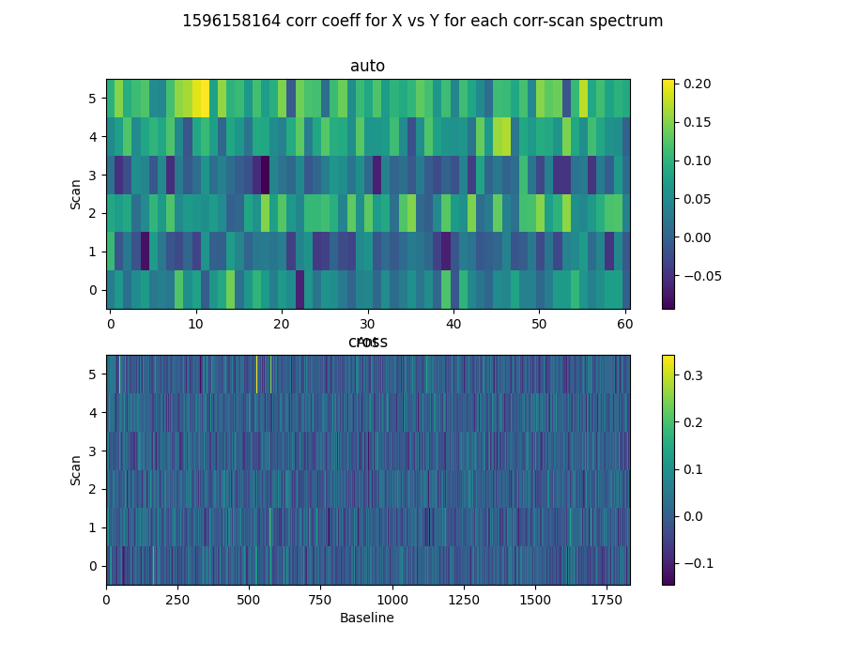

* Corr coeff for auto av spectrum X vx Y is 0.61
* Corr coeff for auto folded av spec X vx Y is 0.92
* Corr coeff for cross av spectrum X vx Y is 0.12
* Corr coeff for cross folded av spec X vx Y is 0.49

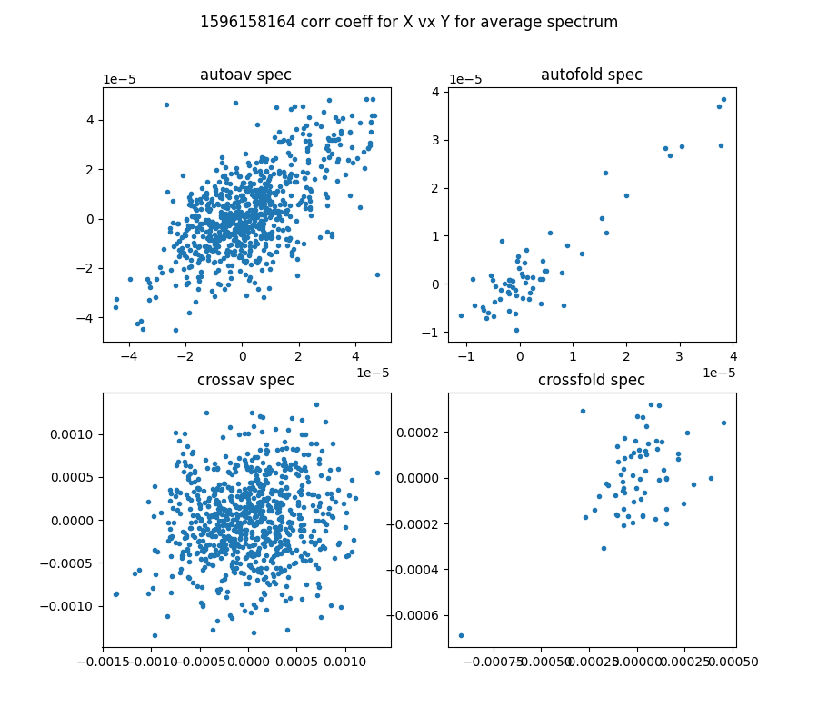

# 64-channel folded spectra

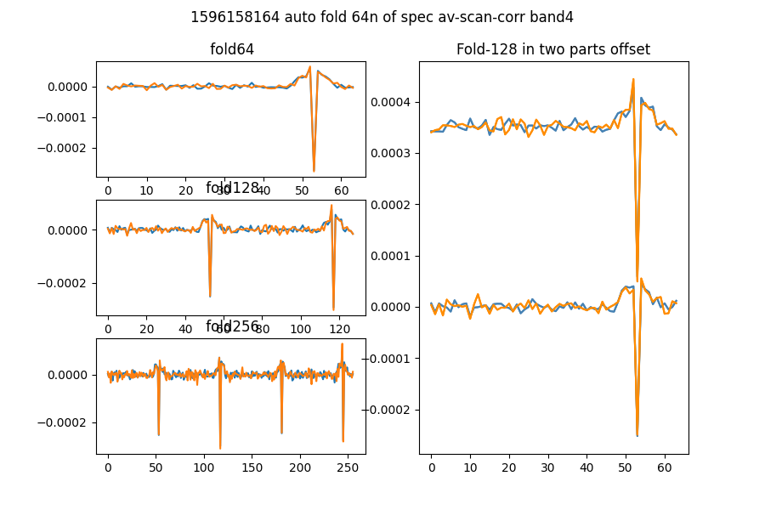

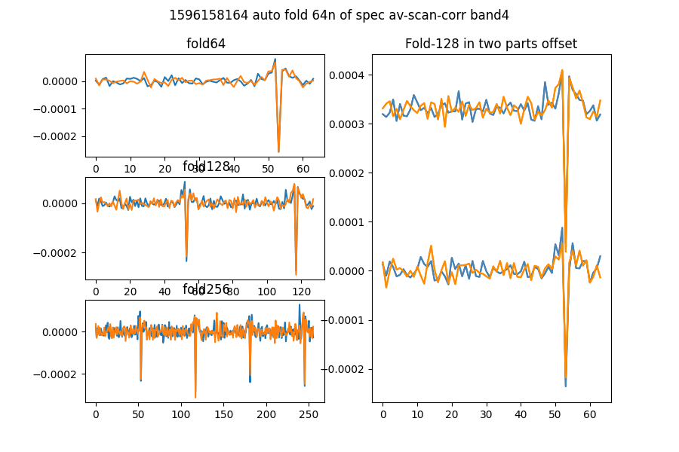

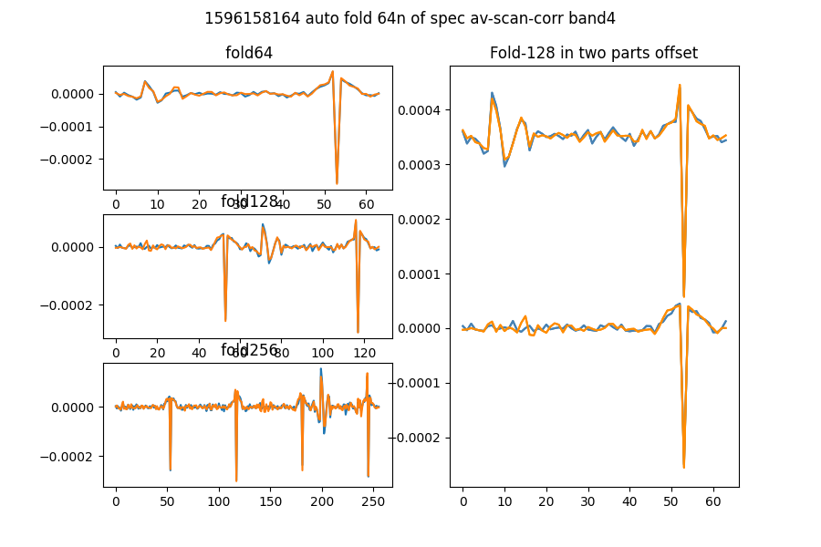

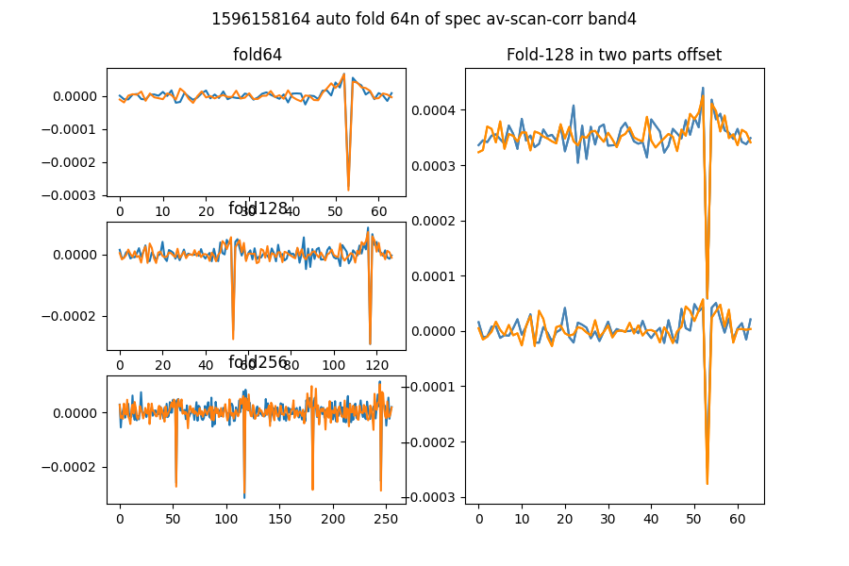

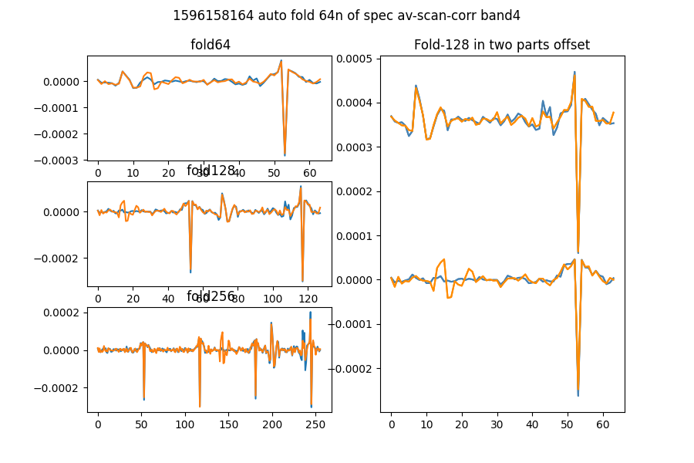

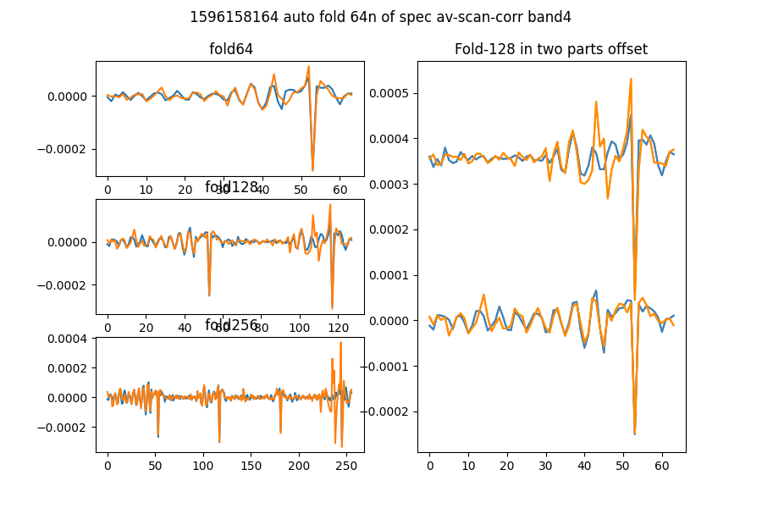

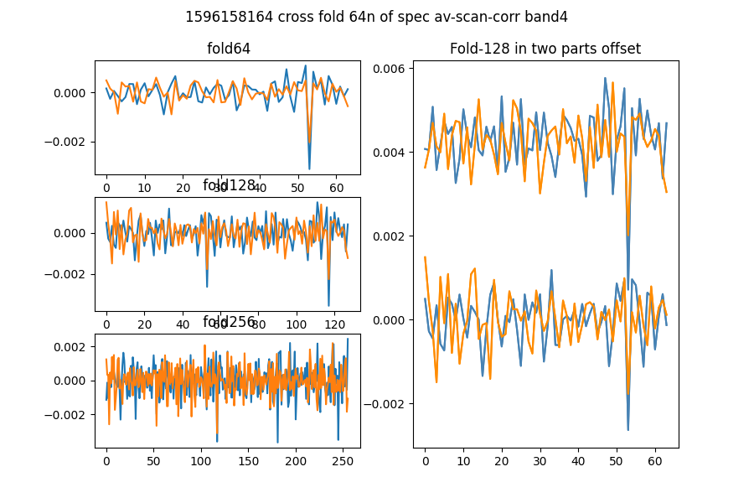

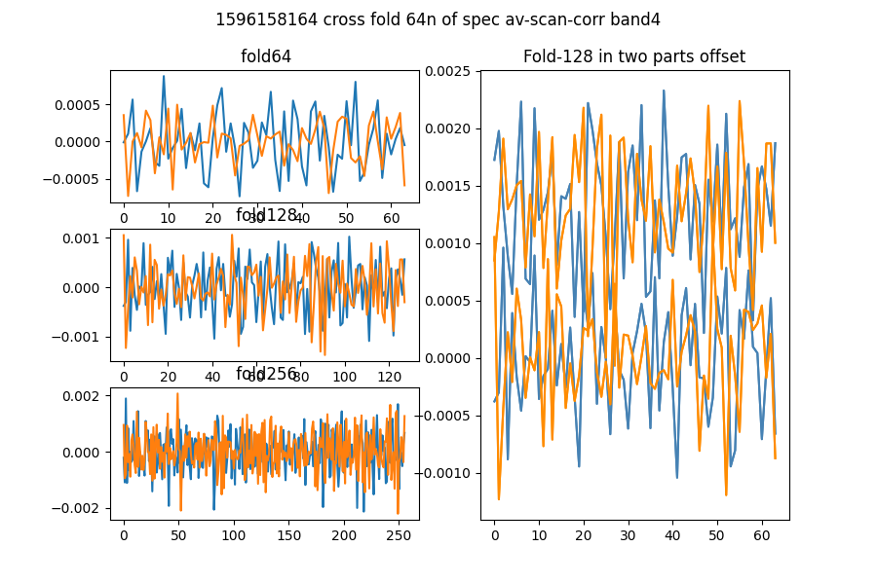

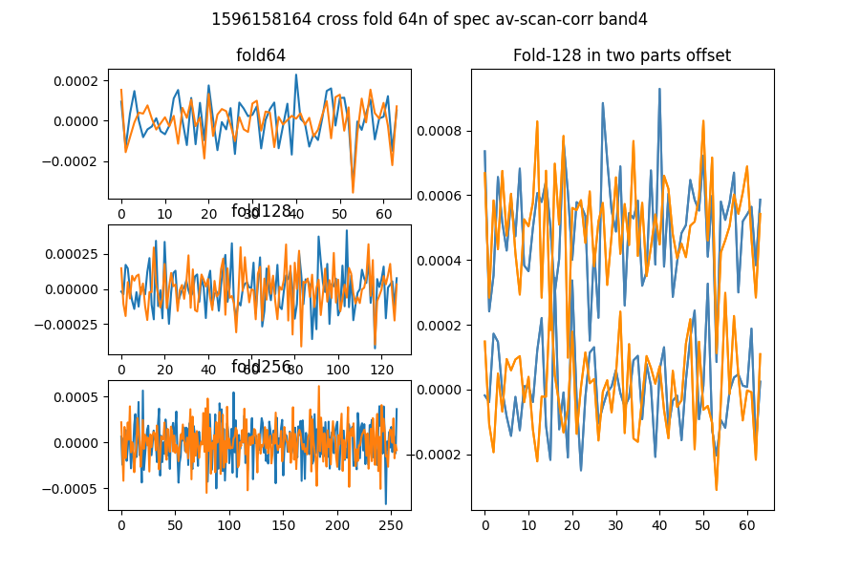

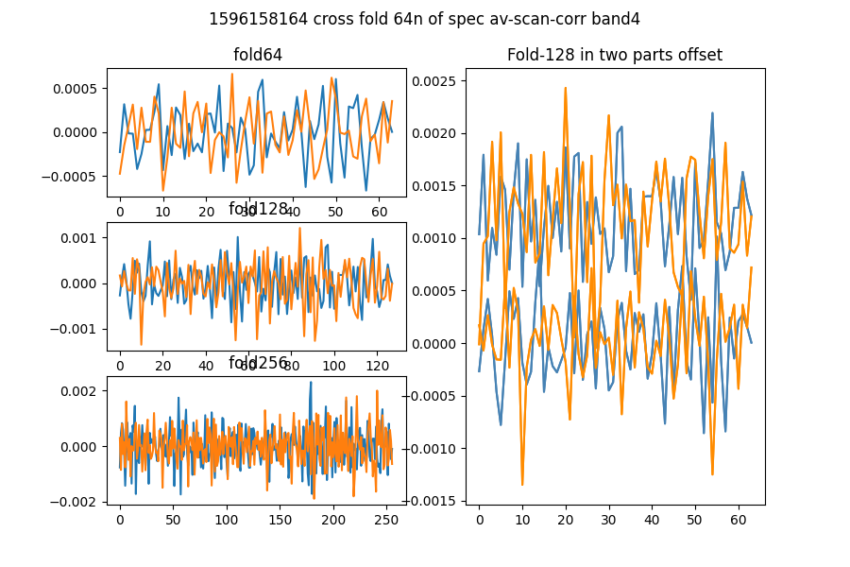

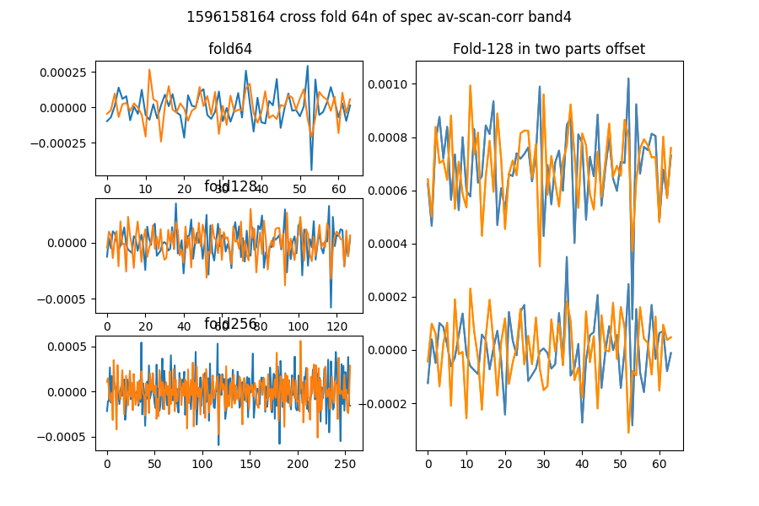

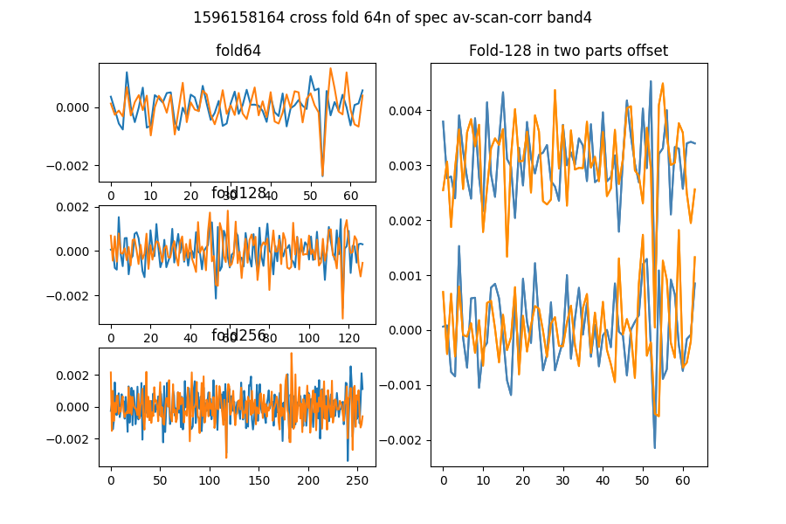

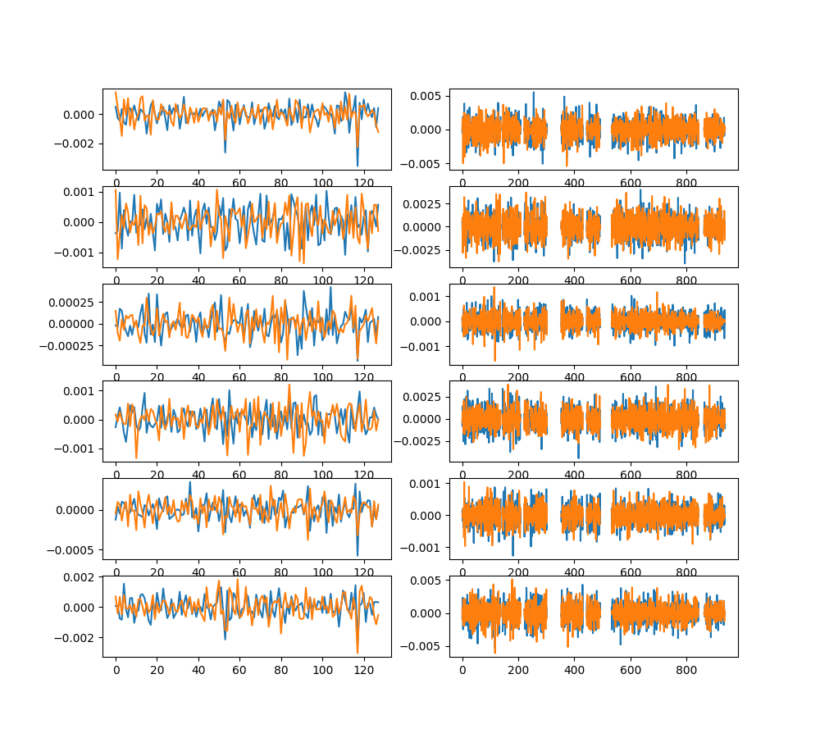

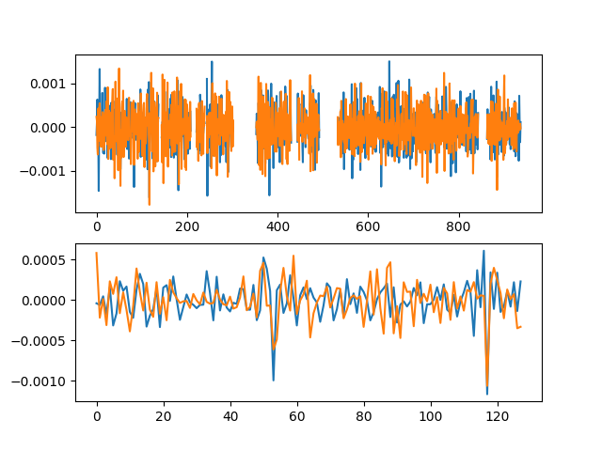

# Comb function analysis

Using nsearch=1; minfold=5; thresh=5.0

* Max (fold,start) [64, 53] with snr 44.59

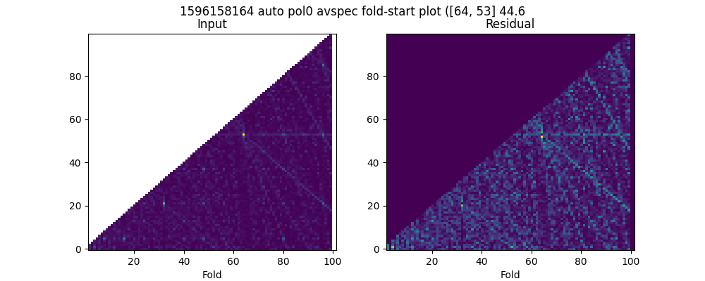

* Max (fold,start) [64, 53] with snr 41.46

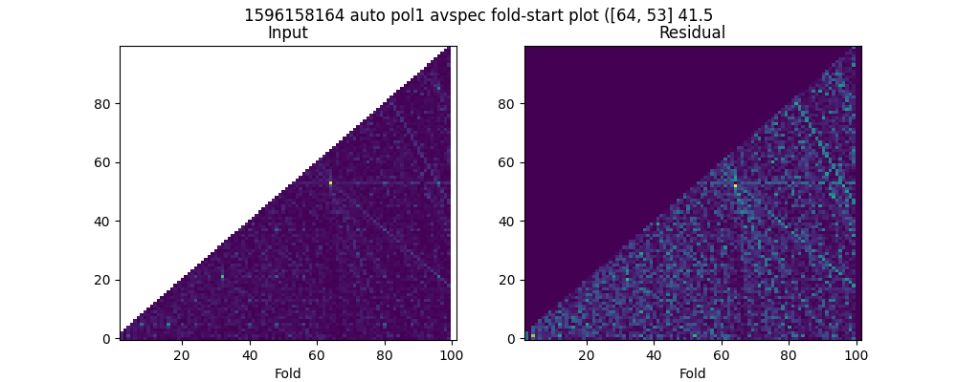

* Max (fold,start) [64, 53] with snr 11.39

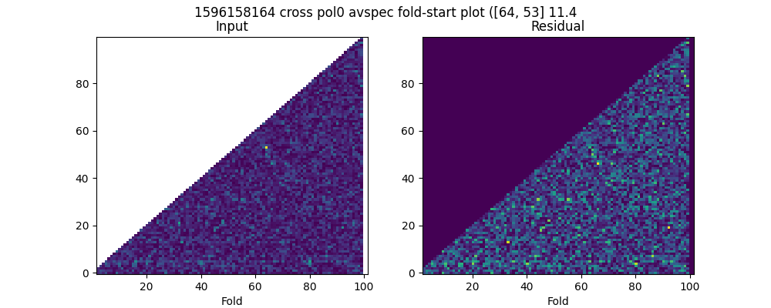

* Max (fold,start) [64, 53] with snr 8.96

