1596163435 - full report

# Data parameters

* Shape : (340, 4096, 6844)
* Num of ants 58
* Num of corr 6844
* Num of chans 4096
* Num of scans 12

# CONTENTS

===============================================================================  
Name: file:///data/mohan//1596163435/1596163435_sdp_l0.rdb | 1596163435-sdp-l0 (version 4.0)  
===============================================================================  
Observer: Sarah Buchner Experiment ID: 20200727-0022  
Description: 'Standard field for correlator tests [c544M4k]'  
Observed from 2020-07-31 04:44:11.747 SAST to 2020-07-31 05:29:27.559 SAST  
Dump rate / period: 0.12519 Hz / 7.988 s  
Subarrays: 1  
 ID Antennas Inputs Corrprods  
 0 m000,m001,m002,m003,m006,m007,m008,m009,m010,m011,m012,m013,m014,m015,m016,m017,m018,m019,m020,m021,m022,m023,m024,m026,m027,m028,m029,m030,m031,m033,m034,m035,m037,m038,m040,m041,m042,m043,m044,m045,m046,m047,m048,m049,m050,m051,m052,m053,m054,m055,m056,m057,m058,m059,m060,m061,m062,m063 116 6844  
Spectral Windows: 1  
 ID Band Product CentreFreq(MHz) Bandwidth(MHz) Channels ChannelWidth(kHz)  
 0 UHF c544M4k 816.000 544.000 4096 132.812  
-------------------------------------------------------------------------------  
Data selected according to the following criteria:  
 spw=0  
 subarray=0  
-------------------------------------------------------------------------------  
Shape: (340 dumps, 4096 channels, 6844 correlation products) => Size: 76.250 GB  
Antennas: m000,m001,m002,m003,m006,m007,m008,m009,m010,m011,m012,m013,m014,m015,m016,m017,m018,m019,m020,m021,m022,m023,m024,m026,m027,m028,m029,m030,m031,m033,m034,m035,m037,m038,m040,m041,m042,m043,m044,m045,m046,m047,m048,m049,m050,m051,m052,m053,m054,m055,m056,m057,m058,m059,m060,m061,m062,m063 Inputs: 116 Autocorr: yes Crosscorr: yes  
Channels: 4096 (index 0 - 4095, 544.000 MHz - 1087.867 MHz), each 132.812 kHz wide  
Targets: 3 selected out of 3 in catalogue  
 ID Name Type RA(J2000) DEC(J2000) Tags Dumps ModelFlux(Jy)  
 0 J1939-6342 radec 19:39:25.03 -63:42:45.6 delaycal bpcal 78   
 1 J2147-7536 radec 21:47:12.73 -75:36:13.2 gaincal 19   
 2 J2147-8132 radec 21:47:23.62 -81:32:08.6 target 243   
Scans: 12 selected out of 12 total Compscans: 6 selected out of 6 total  
 Date Timerange(UTC) ScanState CompScanLabel Dumps Target  
 31-Jul-2020/02:44:15 - 02:49:03 0:track 0:track 37 0:J1939-6342  
 02:49:11 - 02:49:27 1:slew 1:track 3 1:J2147-7536  
 02:49:35 - 02:50:23 2:track 1:track 7 1:J2147-7536  
 02:50:31 - 02:50:39 3:slew 2:track 2 2:J2147-8132  
 02:50:47 - 03:06:37 4:track 2:track 120 2:J2147-8132  
 03:06:45 - 03:06:53 5:slew 3:track 2 1:J2147-7536  
 03:07:01 - 03:07:49 6:track 3:track 7 1:J2147-7536  
 03:07:57 - 03:08:05 7:slew 4:track 2 2:J2147-8132  
 03:08:13 - 03:23:56 8:track 4:track 119 2:J2147-8132  
 03:24:04 - 03:24:28 9:slew 5:track 4 0:J1939-6342  
 03:24:36 - 03:29:15 10:track 5:track 36 0:J1939-6342  
 03:29:23 - 03:29:23 11:stop 5:track 1 0:J1939-6342

Bands used

* Band chs 0: 500-1350
* Band chs 1: 1700-2500
* Full band chs : 500-2500
* Percentage of auto flags in pol 0 is 2.9 %
* Percentage of auto flags in pol 1 is 3.0 %
* Percentage of cross flags in pol 0 is 4.5 %
* Percentage of cross flags in pol 1 is 4.6 %

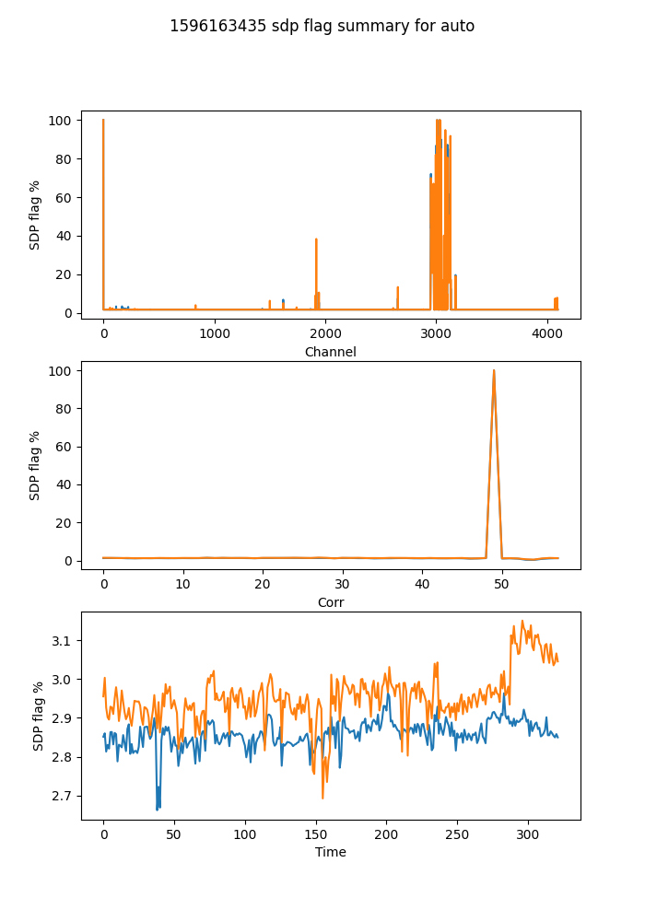

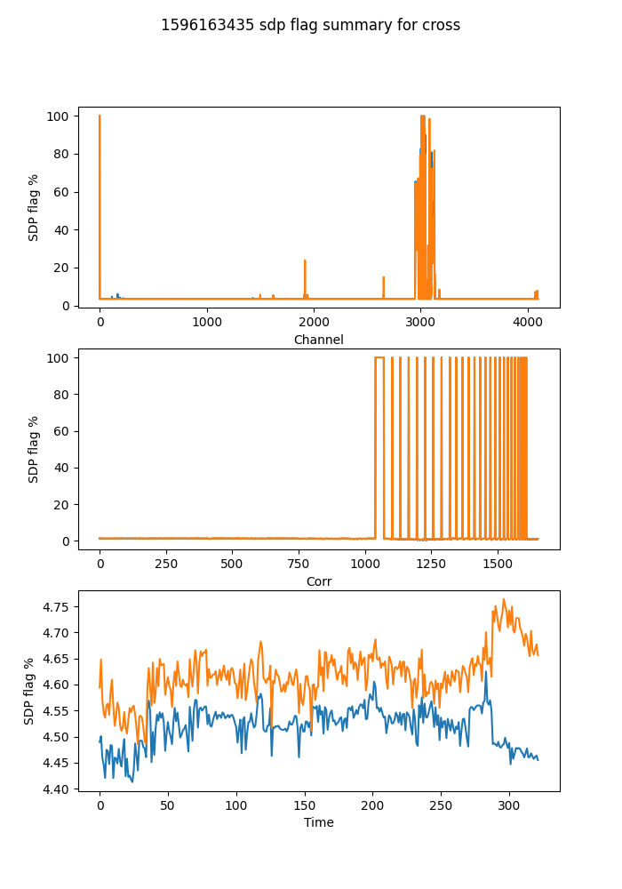

## Spectral mean and variance

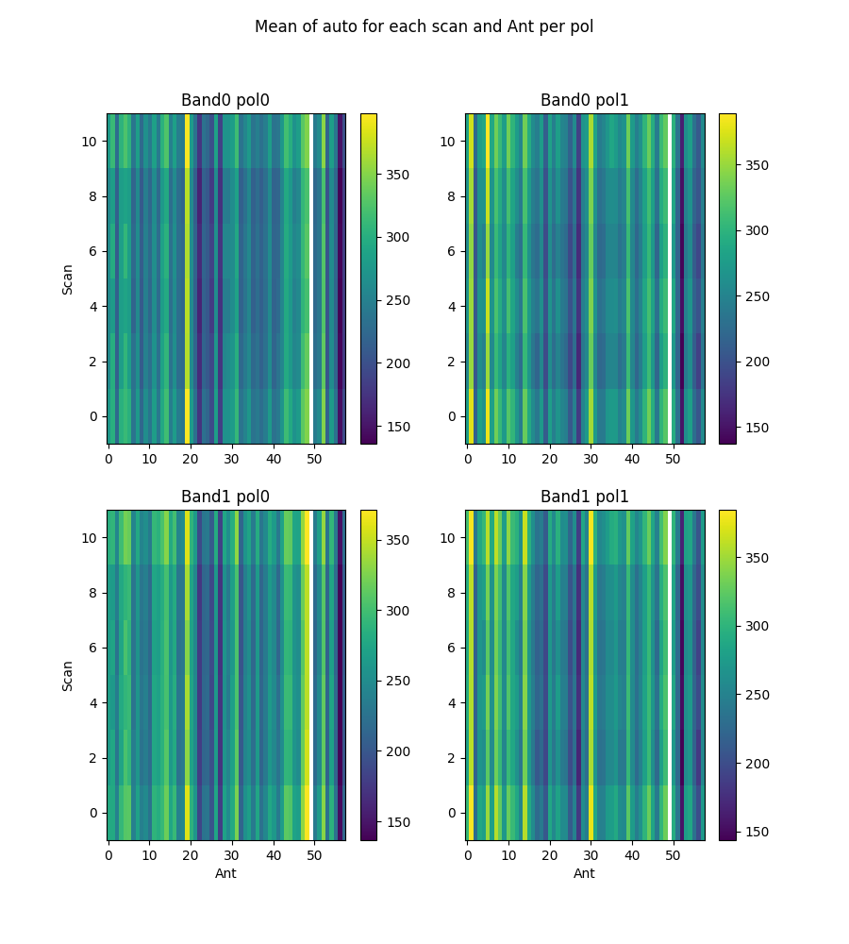

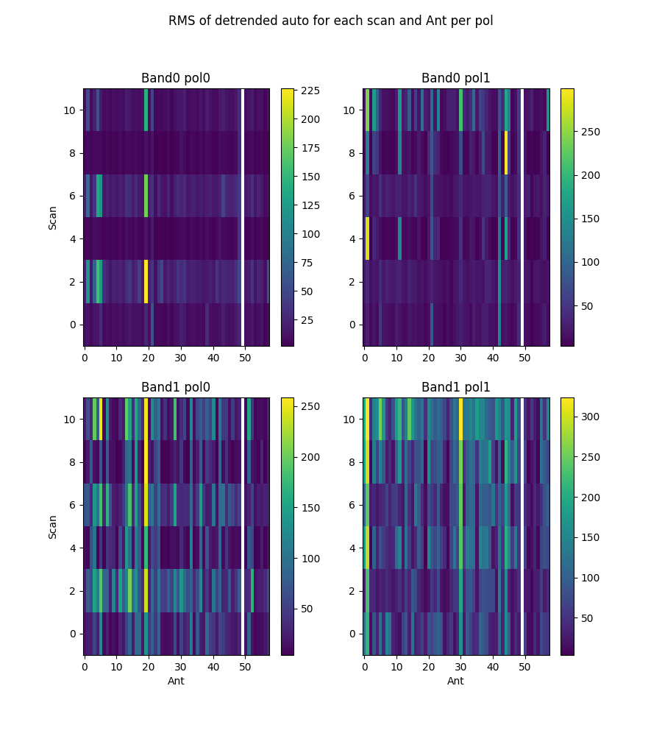

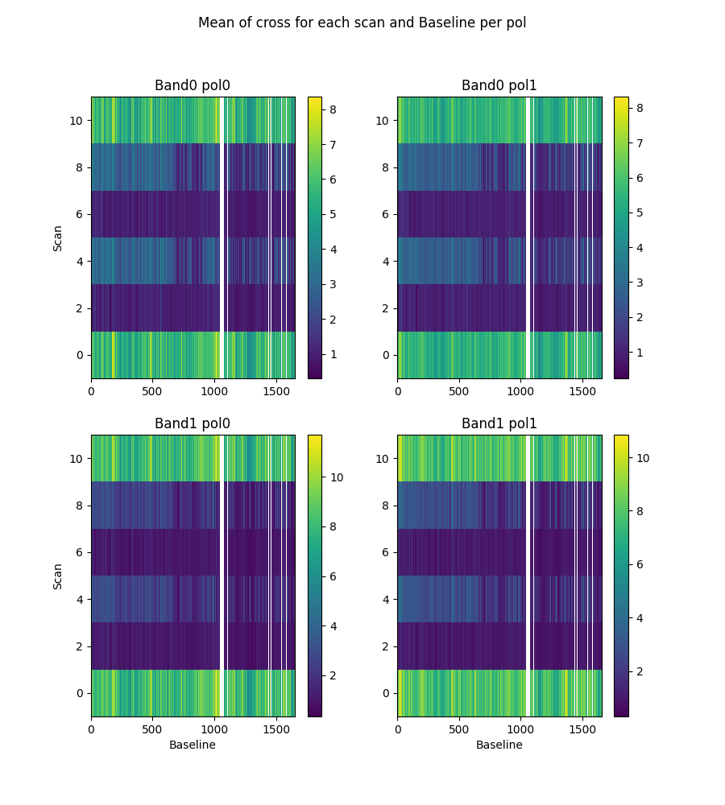

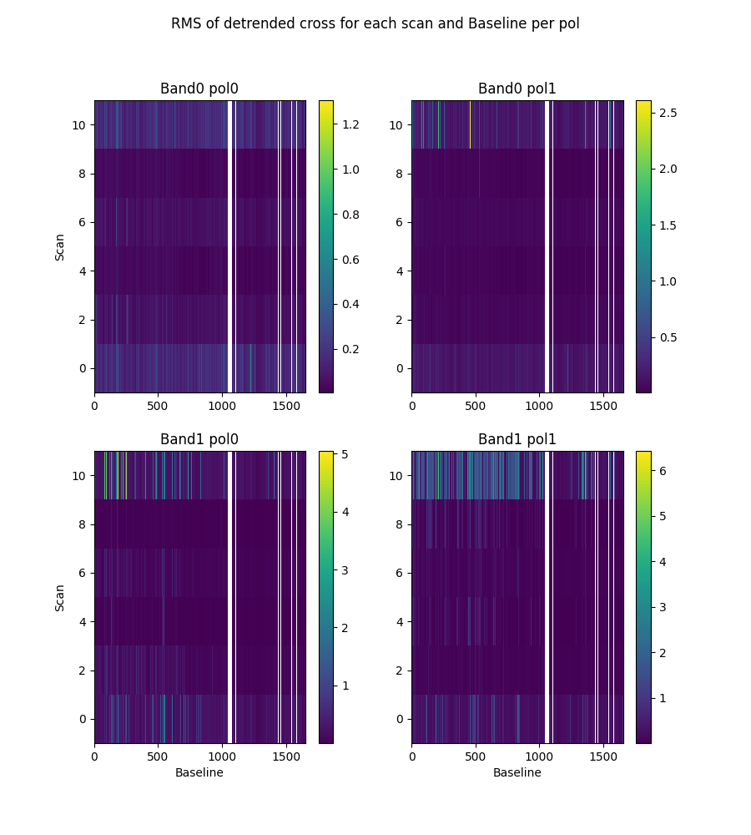

# 2-channel ringing

Using threshold of ringing index of 0.67  
(1->perfect ringing, 0-> none, neg->higher periods)

* Num of bad auto is 0
* Num of bad cross is 0

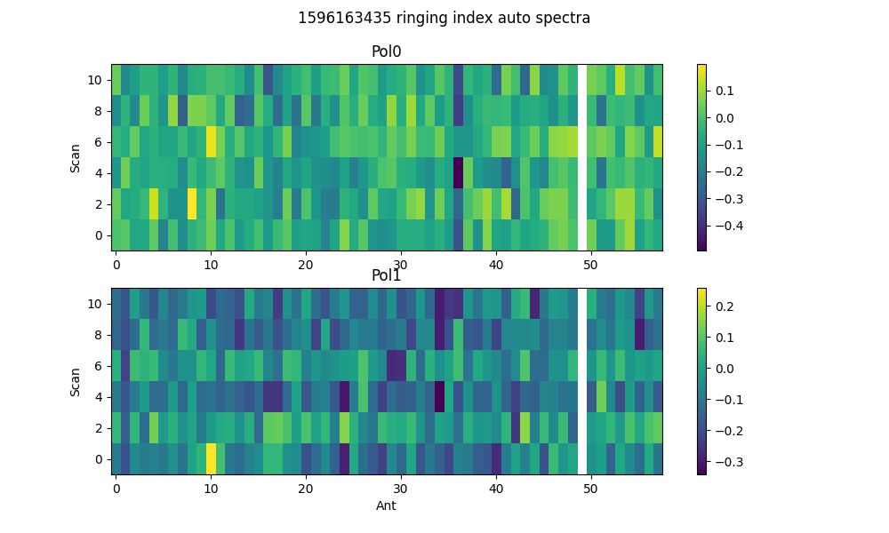

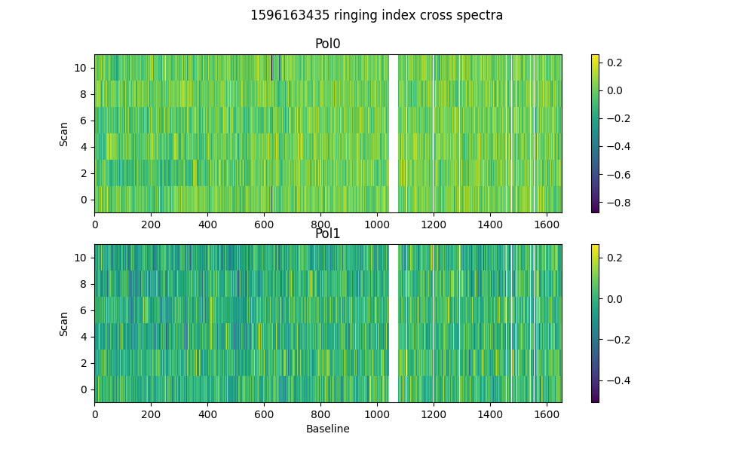

# 2-dump ringing in DC

Threshold = 0.67  
Plotting for scans >20dumps)

* Num of bad auto is 0
* Num of bad cross is 0

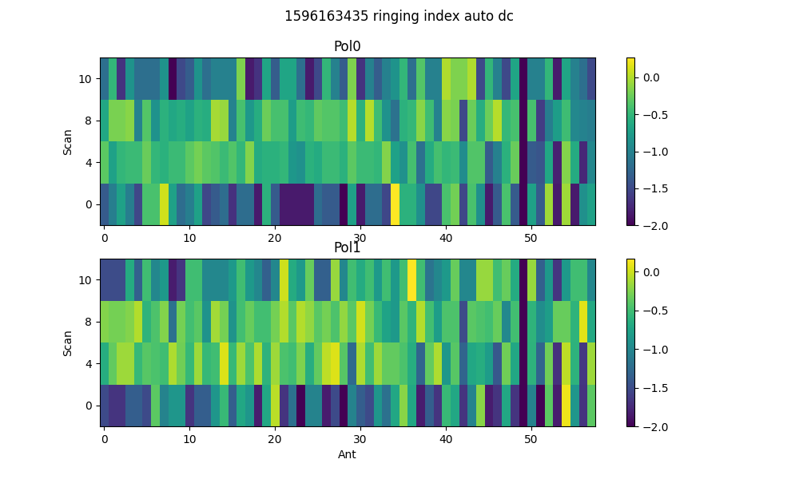

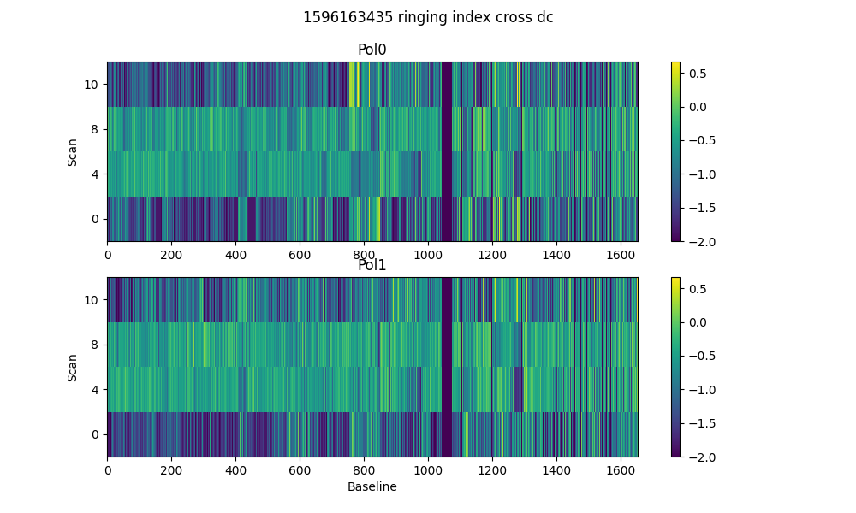

# Spectral periodicities

Using threshold of 10.0 sigma  
after detrending by polyfit(51)

* Found 19 bad spectra in auto in band0
* Found 3 bad spectra in auto in band1
* Found 1800 bad spectra in cross in band0
* Found 408 bad spectra in cross in band1

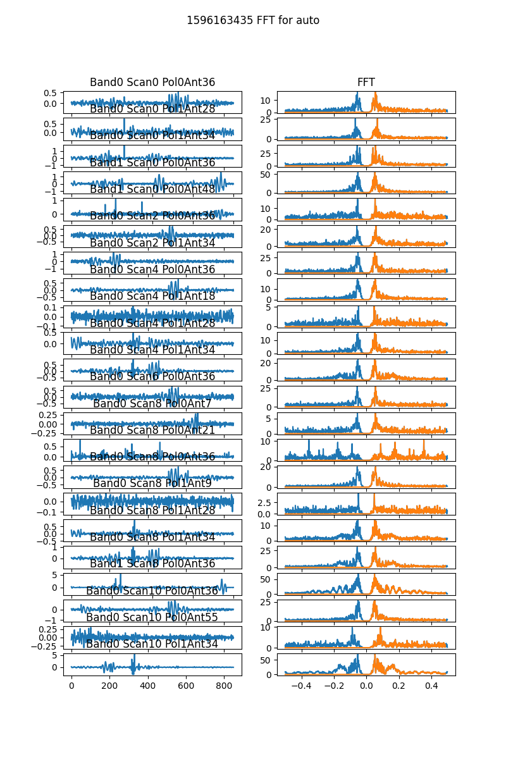

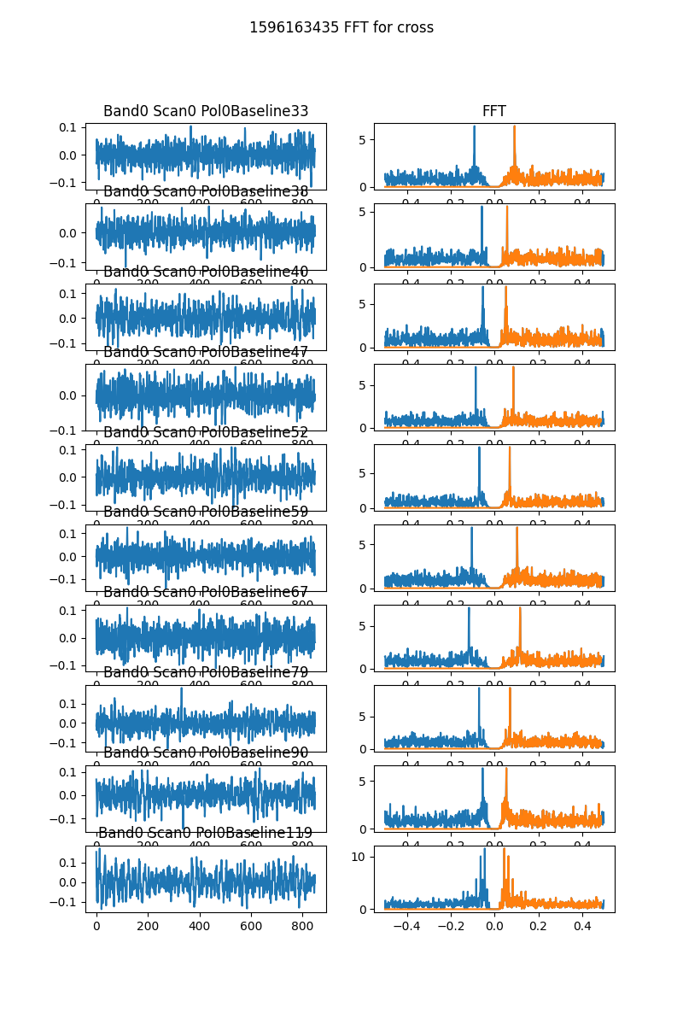

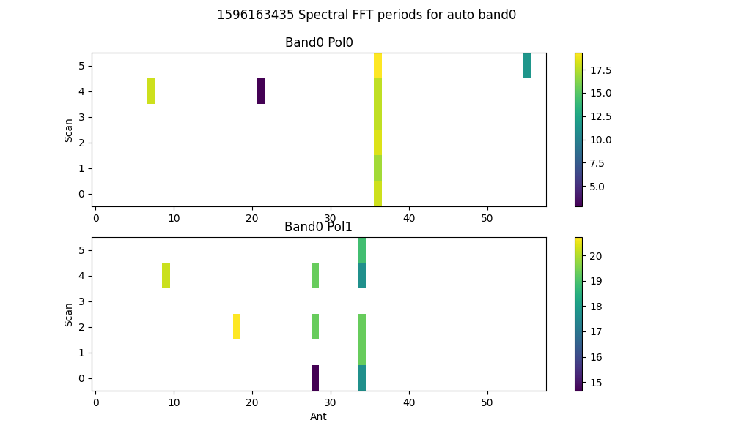

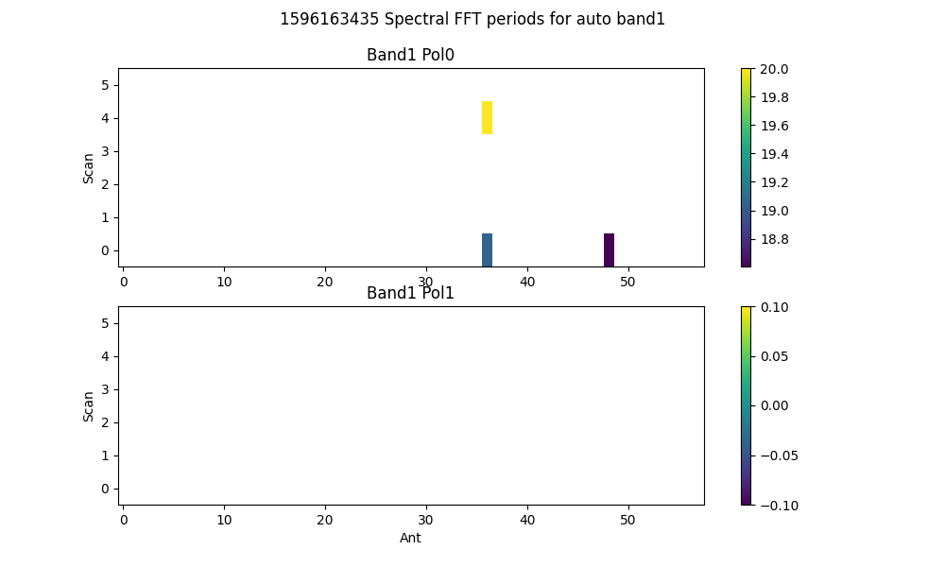

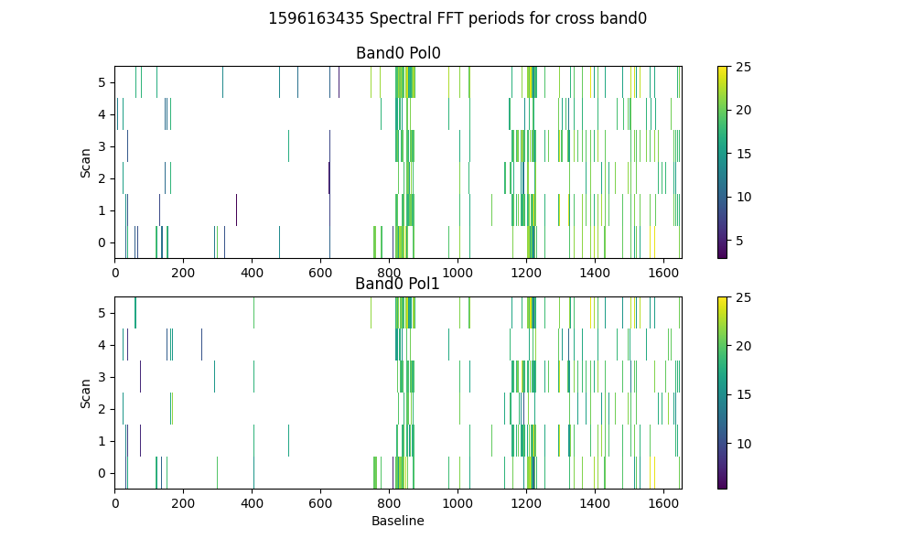

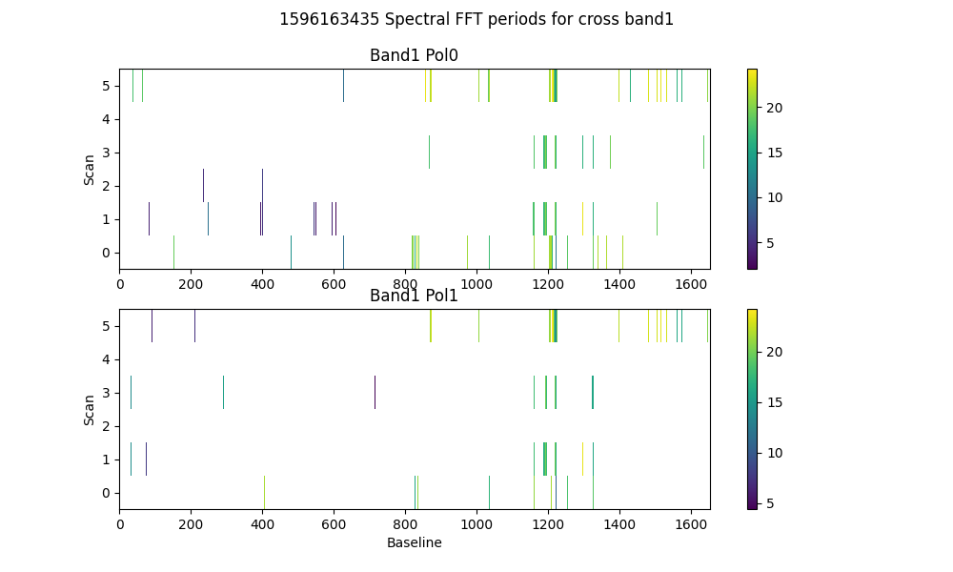

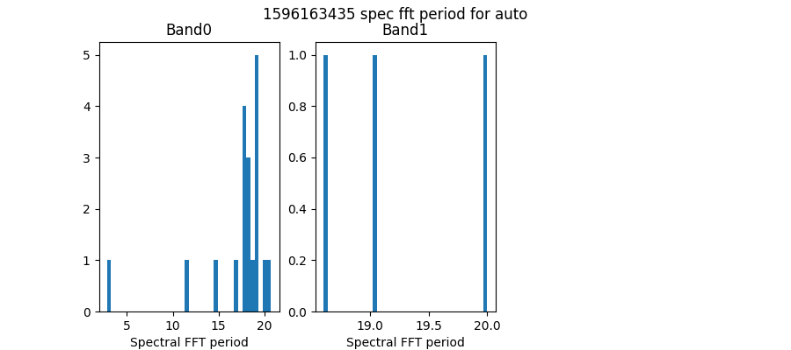

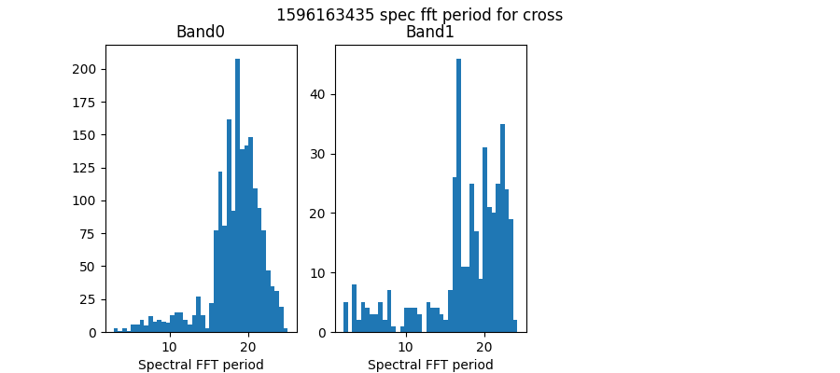

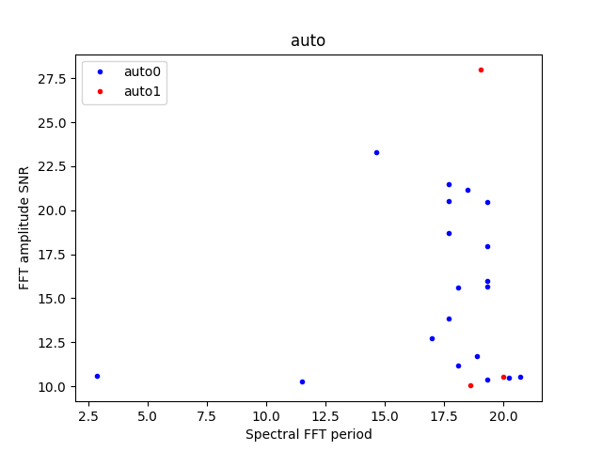

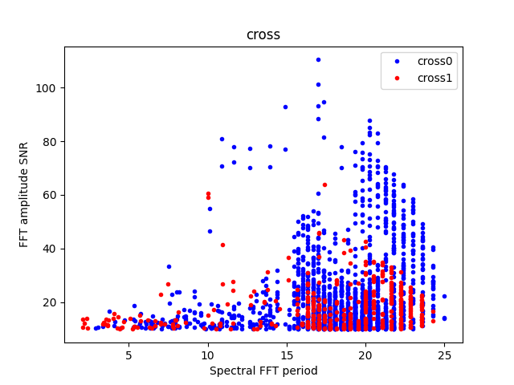

# Detrending

Applying polynomial filter with window 31 channels

# 2-chan ringing in average detrended spectrum

* Ringing index for auto pol 0 is -0.21
* Ringing index for auto pol 1 is -0.27
* Ringing index for cross pol 0 is -0.07
* Ringing index for cross pol 1 is 0.02

# X-Y pol correlation in spectra

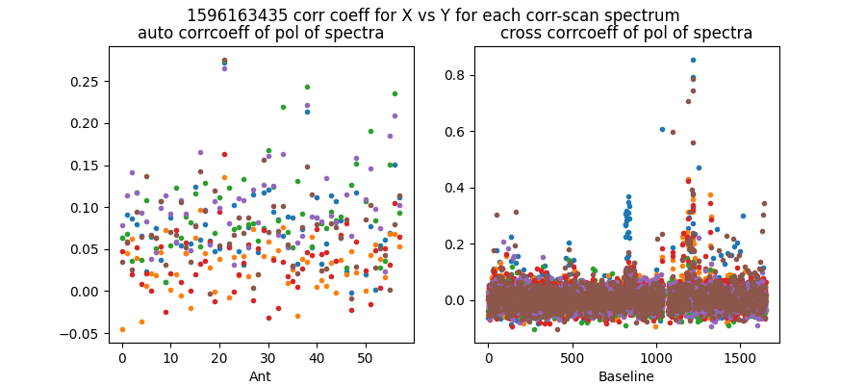

Mean and median corrcoeff for auto is 0.07 0.06

Mean and median corrcoeff for cross is 0.01 0.01

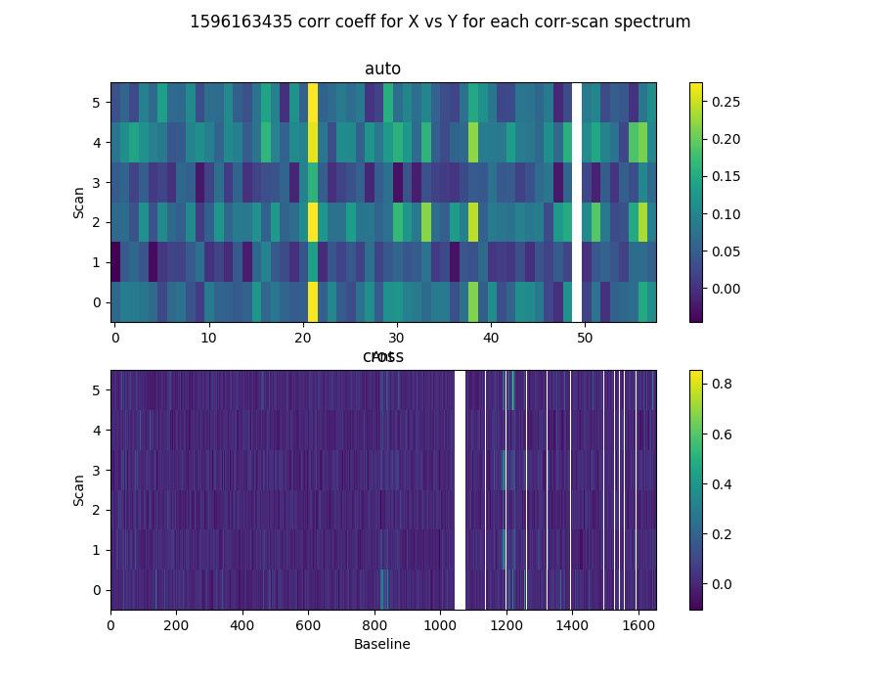

* Corr coeff for auto av spectrum X vx Y is 0.68
* Corr coeff for auto folded av spec X vx Y is 0.91
* Corr coeff for cross av spectrum X vx Y is 0.07
* Corr coeff for cross folded av spec X vx Y is 0.34

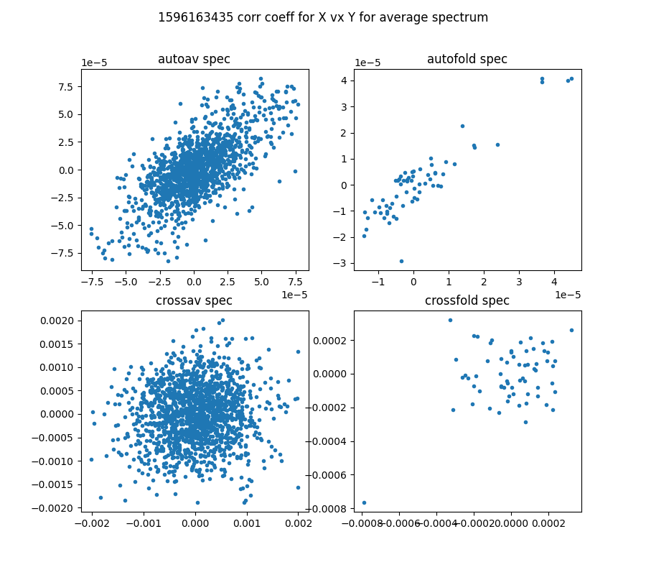

# 64-channel folded spectra

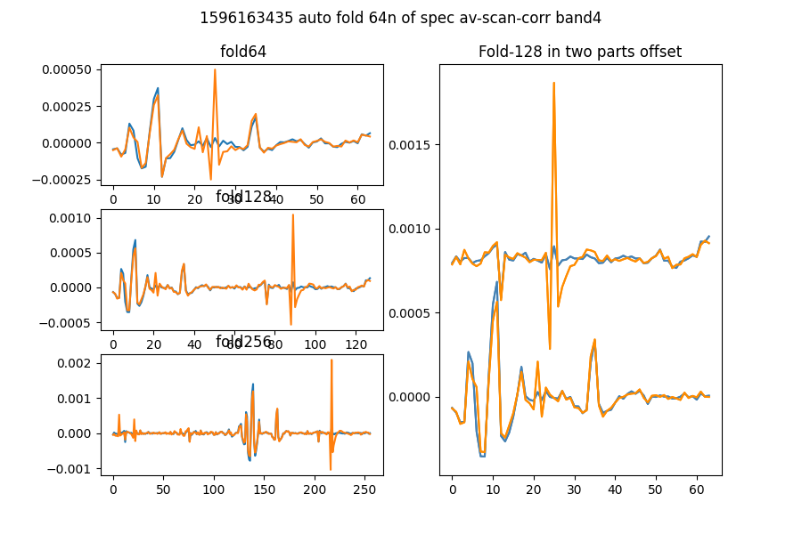

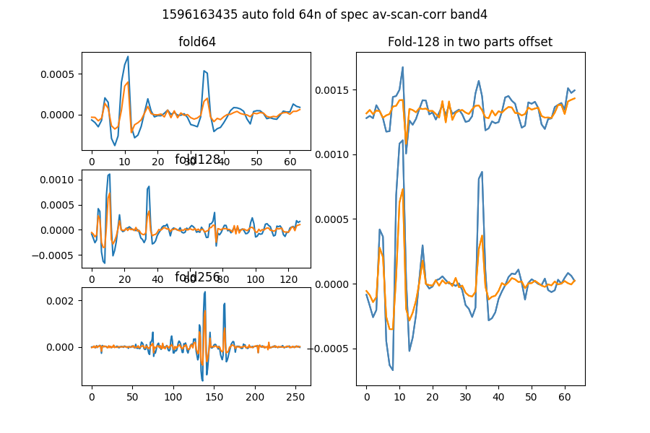

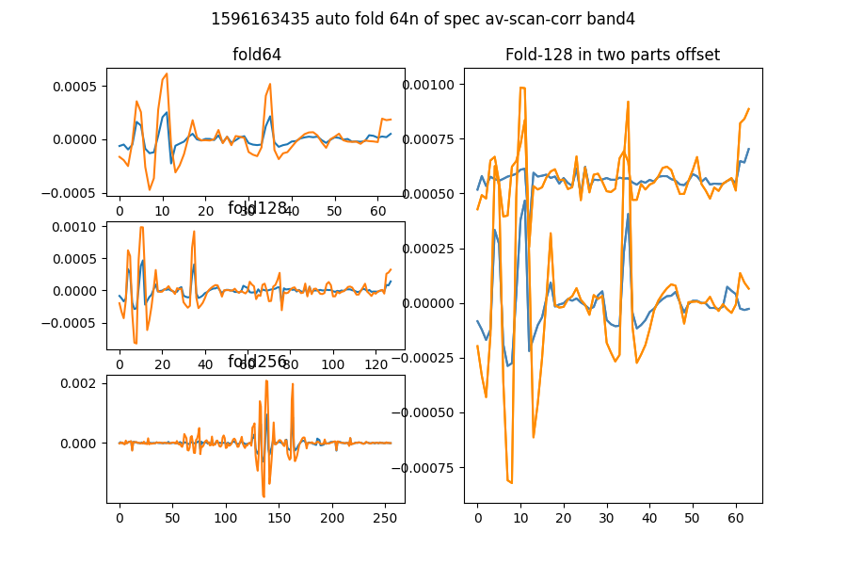

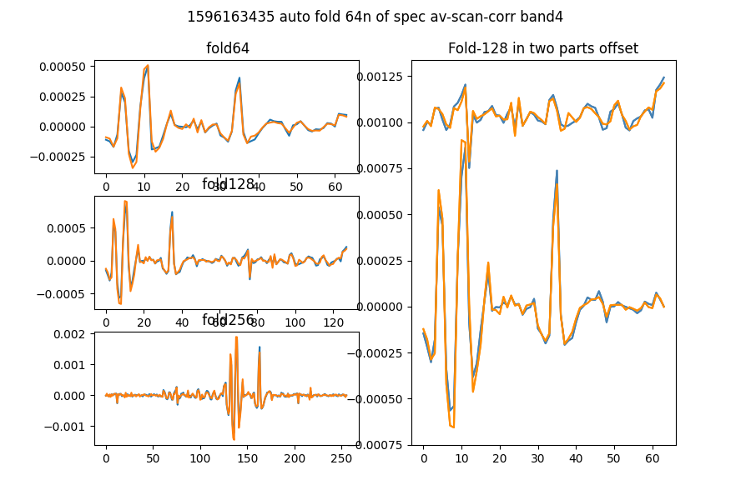

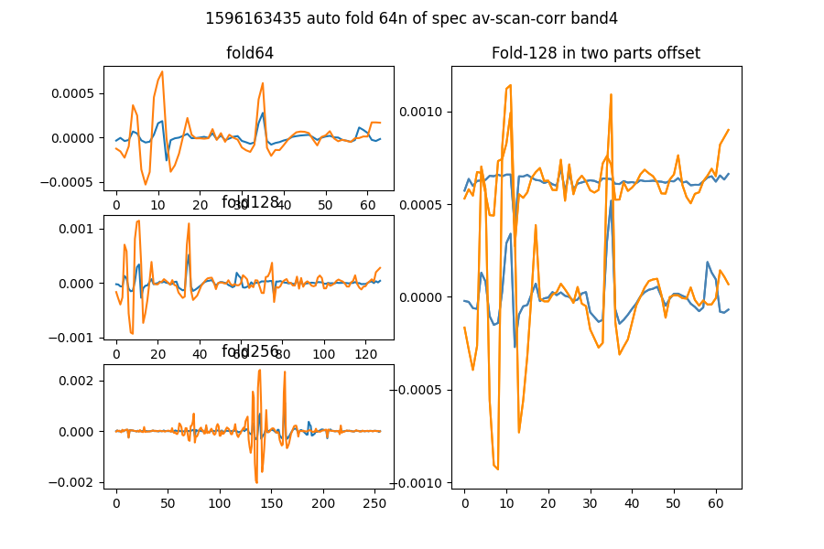

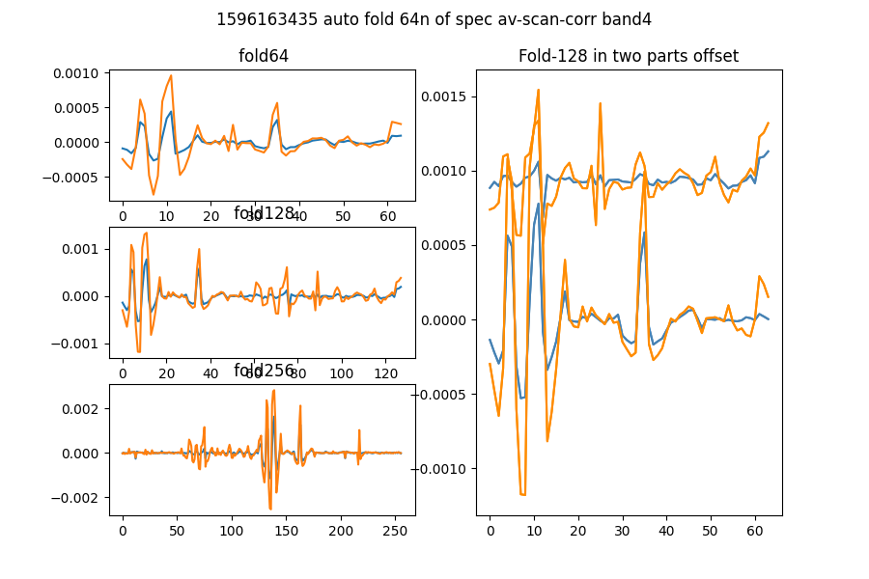

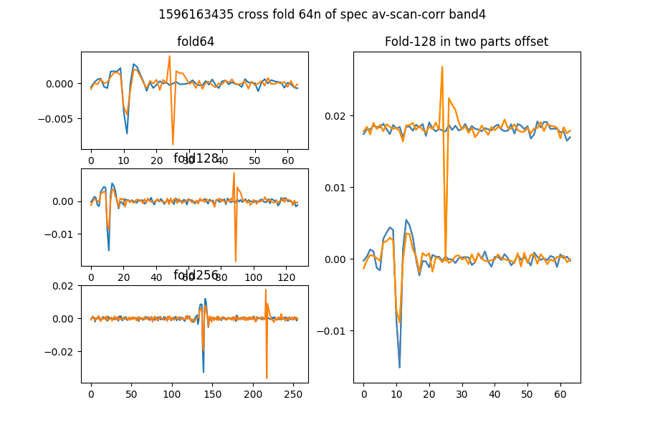

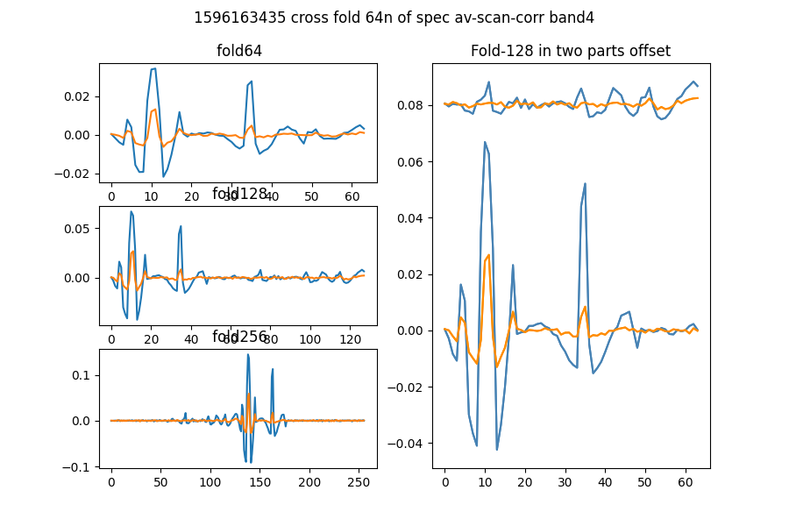

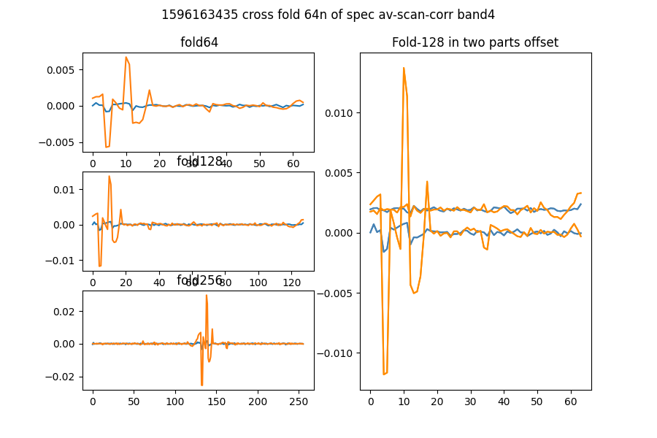

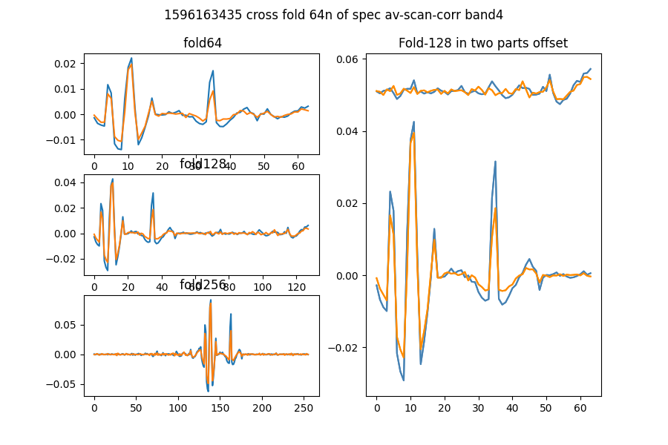

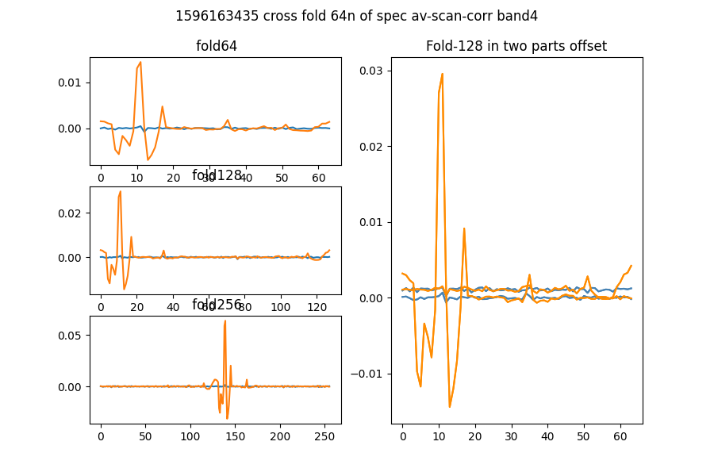

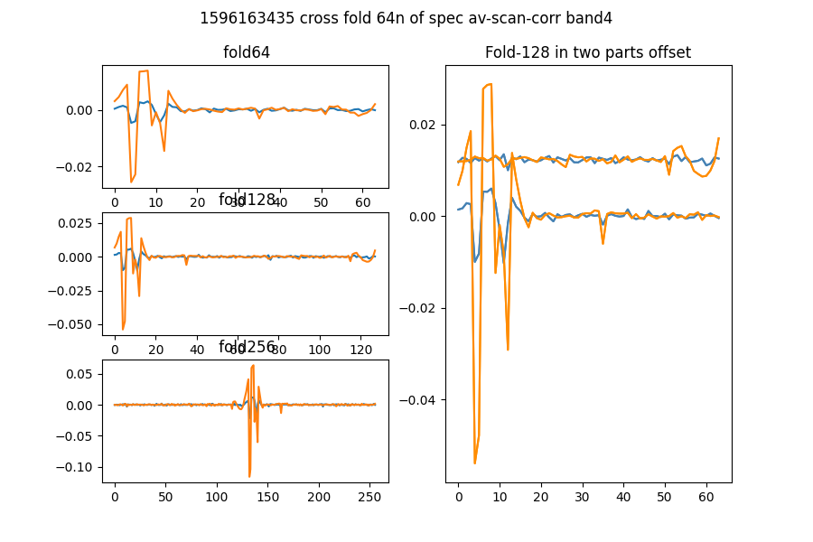

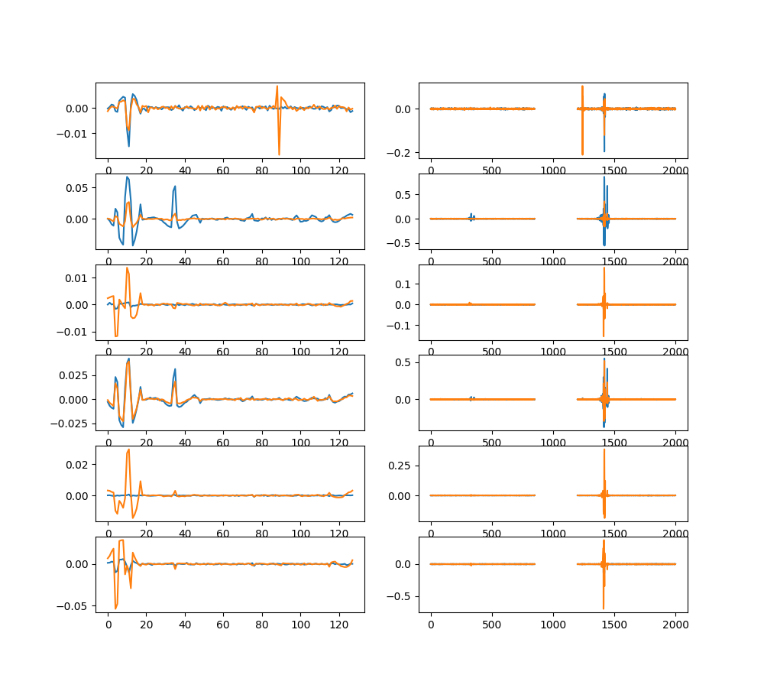

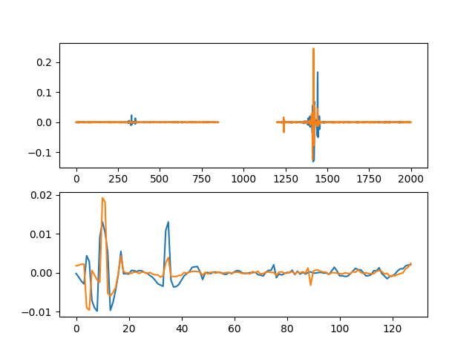

# Comb function analysis

Using nsearch=1; minfold=5; thresh=5.0

* Max (fold,start) [99, 33] with snr 9.45

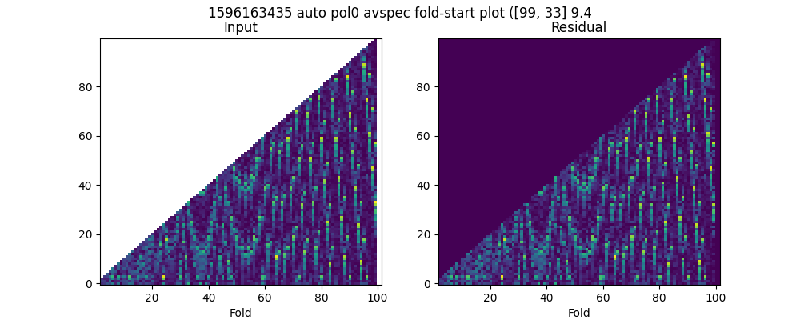

* Max (fold,start) [89, 84] with snr 9.46

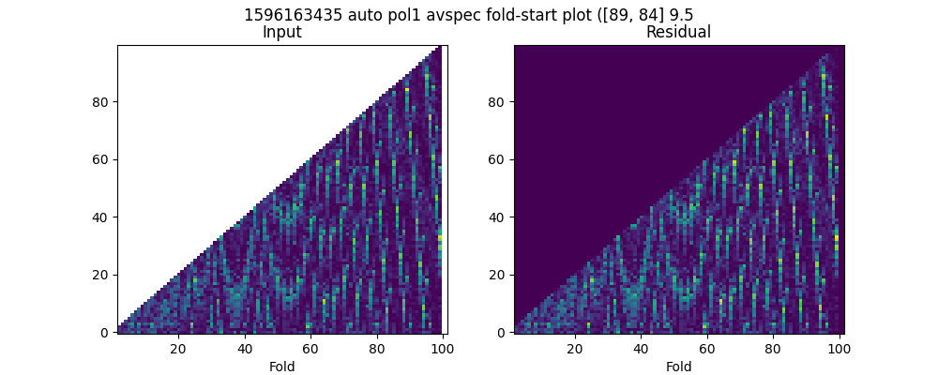

* Max (fold,start) [99, 57] with snr 9.57

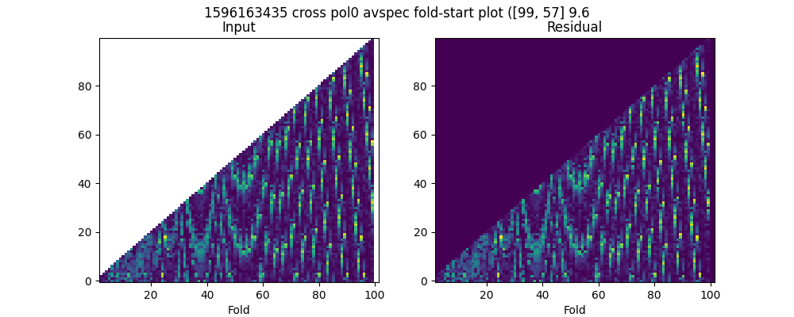

* Max (fold,start) [89, 83] with snr 30.42

