1596172238 - full report

# Data parameters

* Shape : (1352, 4096, 6160)
* Num of ants 55
* Num of corr 6160
* Num of chans 4096
* Num of scans 20

# CONTENTS

===============================================================================  
Name: file:///data/mohan//1596172238/1596172238_sdp_l0.rdb | 1596172238-sdp-l0 (version 4.0)  
===============================================================================  
Observer: Operator Experiment ID: 20200731-0008  
Description: 'Upgrade Tests: Stability Track'  
Observed from 2020-07-31 07:10:44.669 SAST to 2020-07-31 10:10:44.015 SAST  
Dump rate / period: 0.12519 Hz / 7.988 s  
Subarrays: 1  
 ID Antennas Inputs Corrprods  
 0 m000,m001,m002,m003,m008,m009,m010,m011,m012,m013,m014,m015,m016,m017,m018,m019,m020,m021,m022,m023,m024,m026,m027,m028,m029,m030,m031,m033,m034,m035,m037,m038,m040,m041,m042,m043,m044,m045,m046,m047,m048,m049,m050,m051,m052,m053,m054,m056,m057,m058,m059,m060,m061,m062,m063 110 6160  
Spectral Windows: 1  
 ID Band Product CentreFreq(MHz) Bandwidth(MHz) Channels ChannelWidth(kHz)  
 0 UHF c544M4k 816.000 544.000 4096 132.812  
-------------------------------------------------------------------------------  
Data selected according to the following criteria:  
 spw=0  
 subarray=0  
-------------------------------------------------------------------------------  
Shape: (1352 dumps, 4096 channels, 6160 correlation products) => Size: 272.902 GB  
Antennas: m000,m001,m002,m003,m008,m009,m010,m011,m012,m013,m014,m015,m016,m017,m018,m019,m020,m021,m022,m023,m024,m026,m027,m028,m029,m030,m031,m033,m034,m035,m037,m038,m040,m041,m042,m043,m044,m045,m046,m047,m048,m049,m050,m051,m052,m053,m054,m056,m057,m058,m059,m060,m061,m062,m063 Inputs: 110 Autocorr: yes Crosscorr: yes  
Channels: 4096 (index 0 - 4095, 544.000 MHz - 1087.867 MHz), each 132.812 kHz wide  
Targets: 1 selected out of 1 in catalogue  
 ID Name Type RA(J2000) DEC(J2000) Tags Dumps ModelFlux(Jy)  
 0 J0408-6545 radec 4:08:20.38 -65:45:09.1 bpcal delaycal 1352   
Scans: 20 selected out of 20 total Compscans: 18 selected out of 18 total  
 Date Timerange(UTC) ScanState CompScanLabel Dumps Target  
 31-Jul-2020/05:10:48 - 05:10:56 0:slew 0:track 2 0:J0408-6545  
 05:11:04 - 05:20:47 1:track 0:track 74 0:J0408-6545  
 05:20:55 - 05:30:46 2:track 1:track 75 0:J0408-6545  
 05:30:54 - 05:40:45 3:track 2:track 75 0:J0408-6545  
 05:40:53 - 05:50:52 4:track 3:track 76 0:J0408-6545  
 05:51:00 - 06:00:52 5:track 4:track 75 0:J0408-6545  
 06:01:00 - 06:10:51 6:track 5:track 75 0:J0408-6545  
 06:10:59 - 06:20:50 7:track 6:track 75 0:J0408-6545  
 06:20:58 - 06:30:57 8:track 7:track 76 0:J0408-6545  
 06:31:05 - 06:40:56 9:track 8:track 75 0:J0408-6545  
 06:41:04 - 06:50:55 10:track 9:track 75 0:J0408-6545  
 06:51:03 - 07:00:54 11:track 10:track 75 0:J0408-6545  
 07:01:02 - 07:11:01 12:track 11:track 76 0:J0408-6545  
 07:11:09 - 07:21:00 13:track 12:track 75 0:J0408-6545  
 07:21:08 - 07:30:59 14:track 13:track 75 0:J0408-6545  
 07:31:07 - 07:40:58 15:track 14:track 75 0:J0408-6545  
 07:41:06 - 07:51:05 16:track 15:track 76 0:J0408-6545  
 07:51:13 - 08:01:04 17:track 16:track 75 0:J0408-6545  
 08:01:12 - 08:10:32 18:track 17:track 71 0:J0408-6545  
 08:10:40 - 08:10:40 19:stop 17:track 1 0:J0408-6545

Bands used

* Band chs 0: 500-1350
* Band chs 1: 1700-2500
* Full band chs : 500-2500
* Percentage of auto flags in pol 0 is 4.7 %
* Percentage of auto flags in pol 1 is 4.8 %
* Percentage of cross flags in pol 0 is 8.1 %
* Percentage of cross flags in pol 1 is 8.1 %

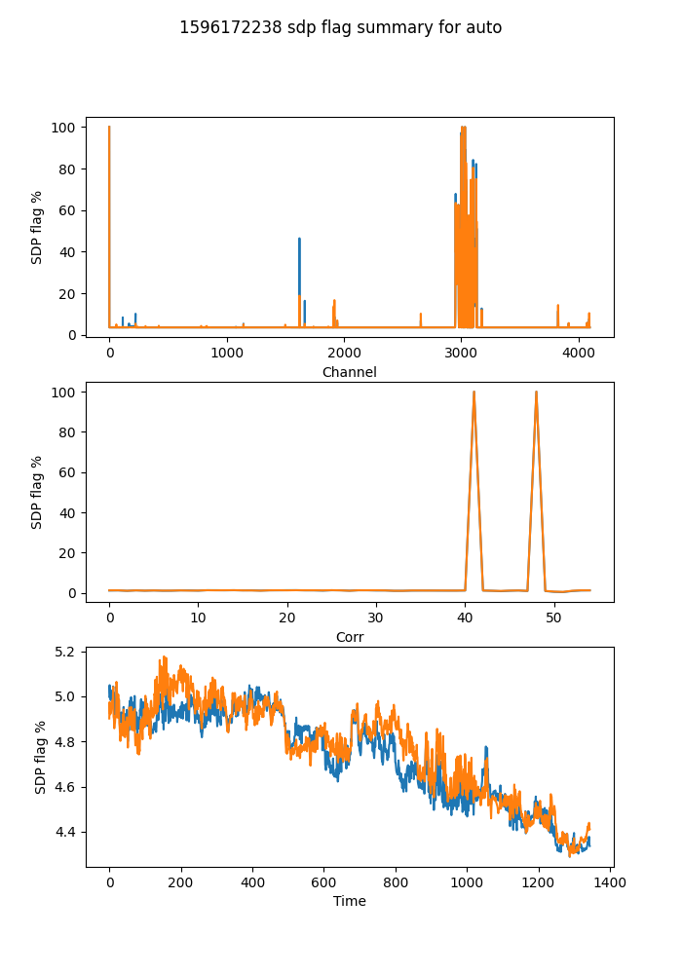

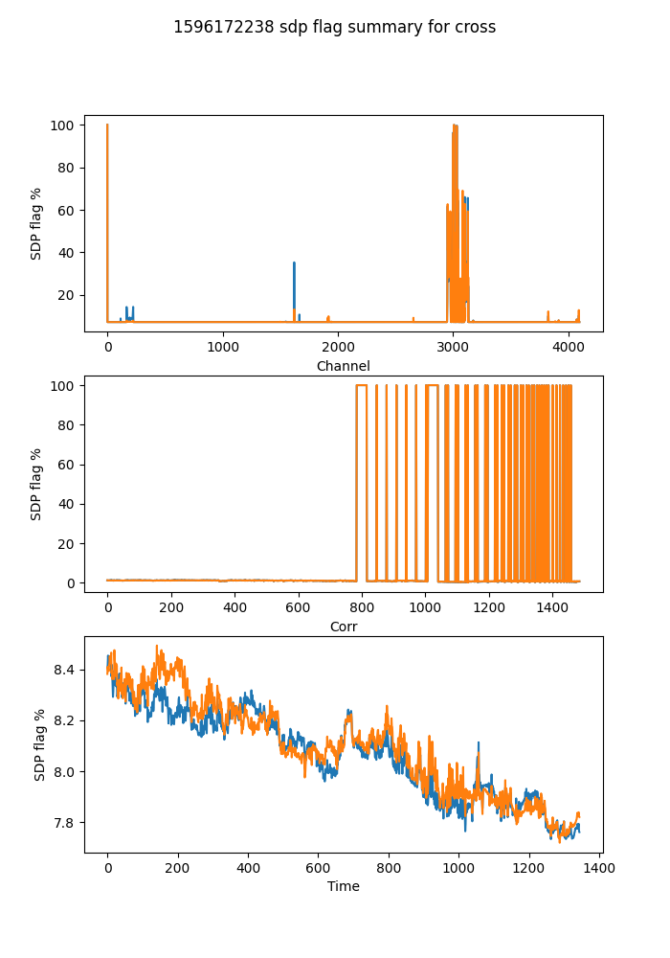

## Spectral mean and variance

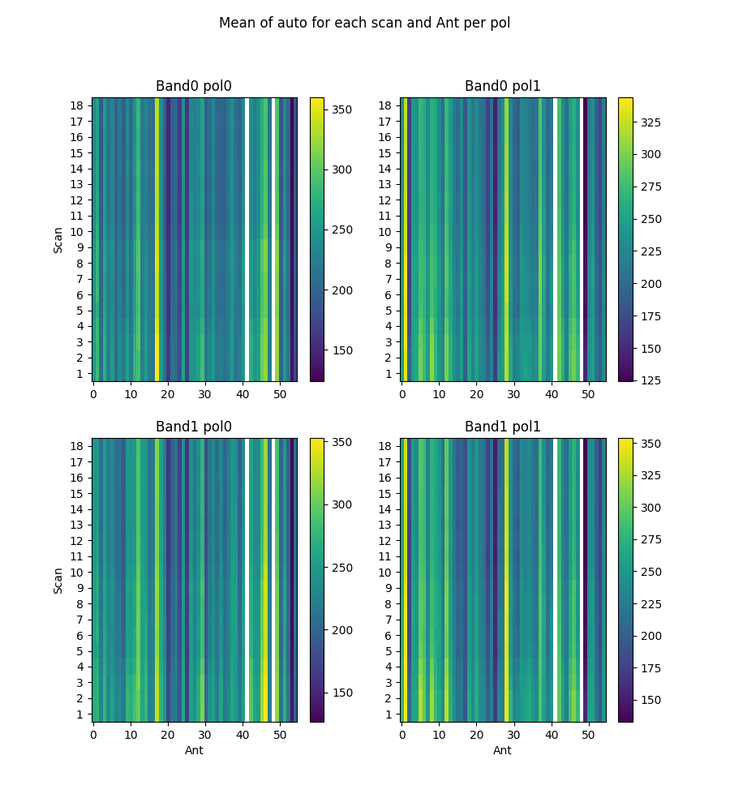

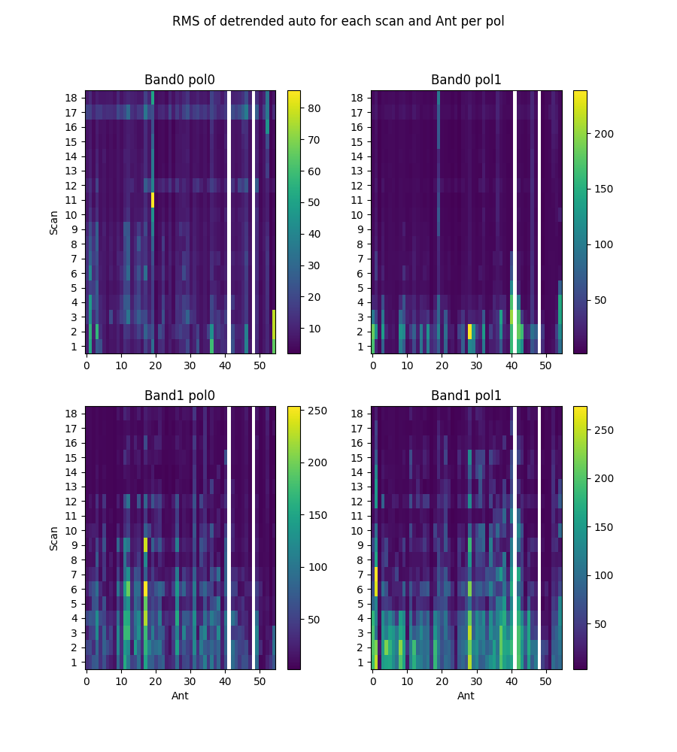

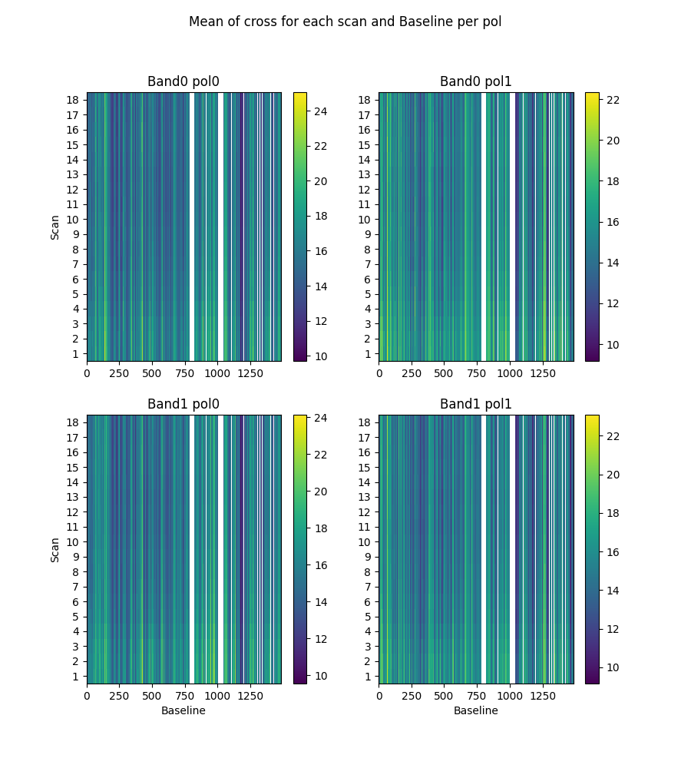

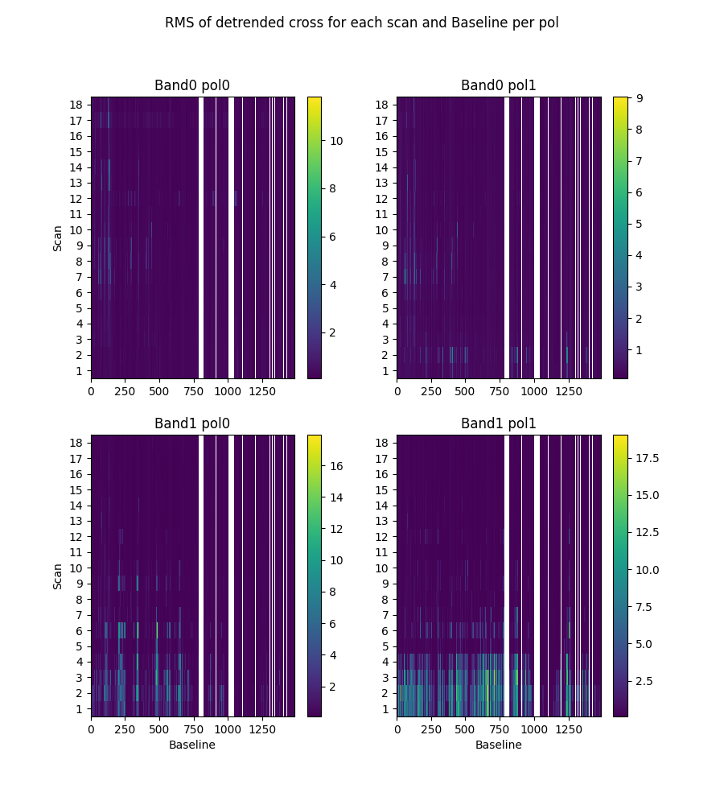

# 2-channel ringing

Using threshold of ringing index of 0.67  
(1->perfect ringing, 0-> none, neg->higher periods)

* Num of bad auto is 0
* Num of bad cross is 0

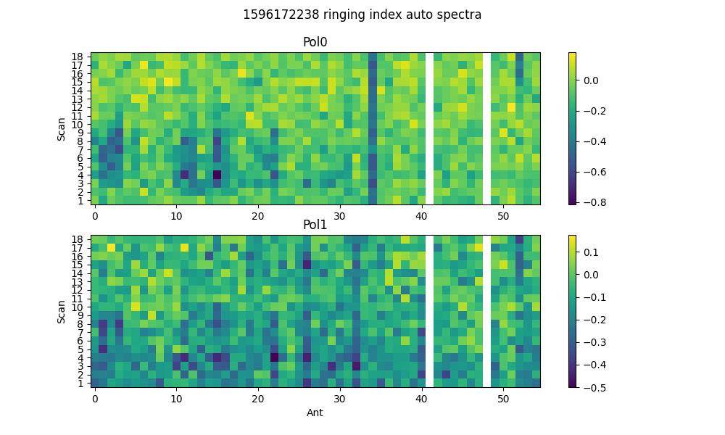

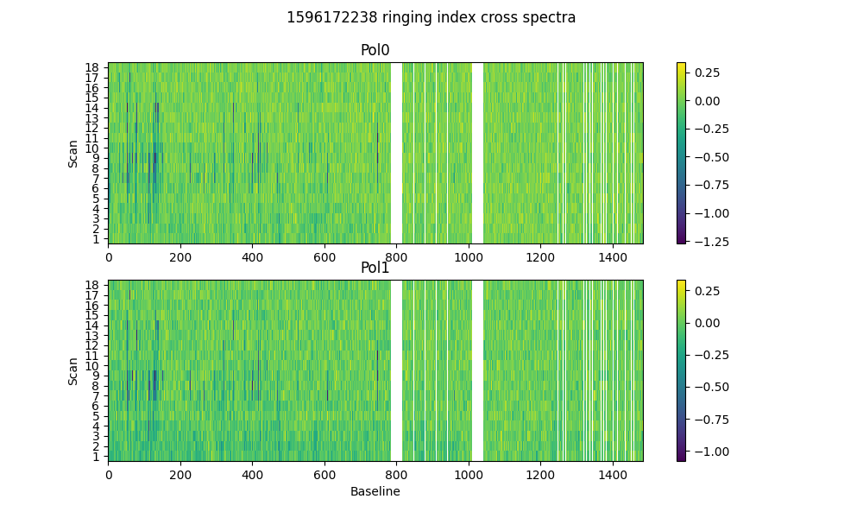

# 2-dump ringing in DC

Threshold = 0.67  
Plotting for scans >20dumps)

* Num of bad auto is 0
* Num of bad cross is 36

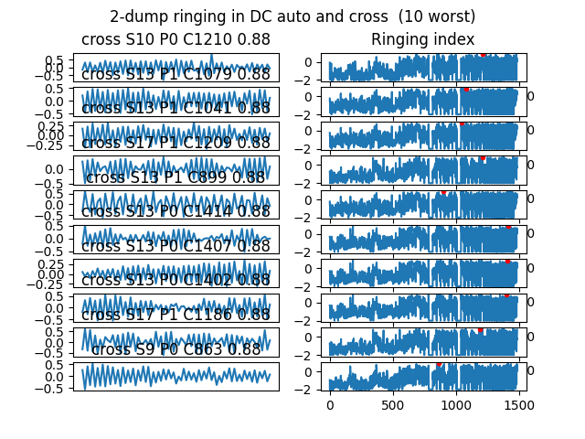

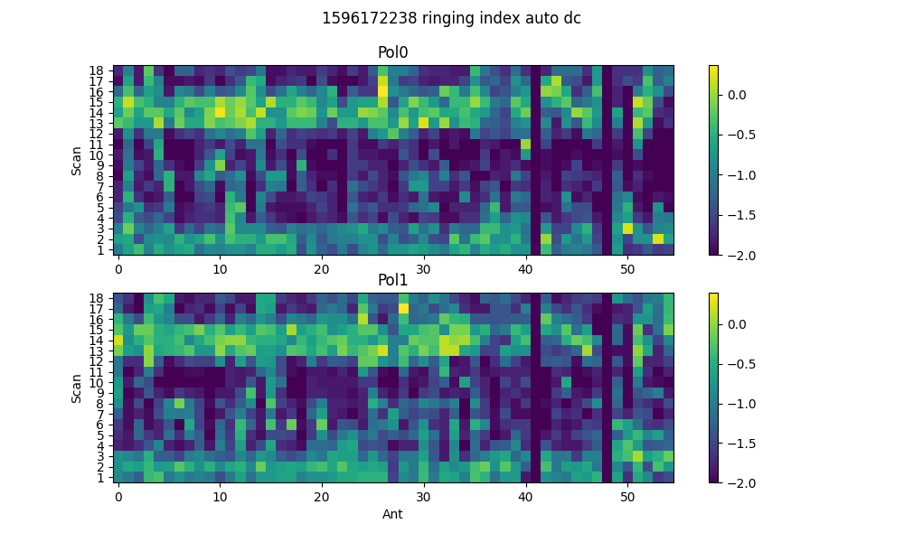

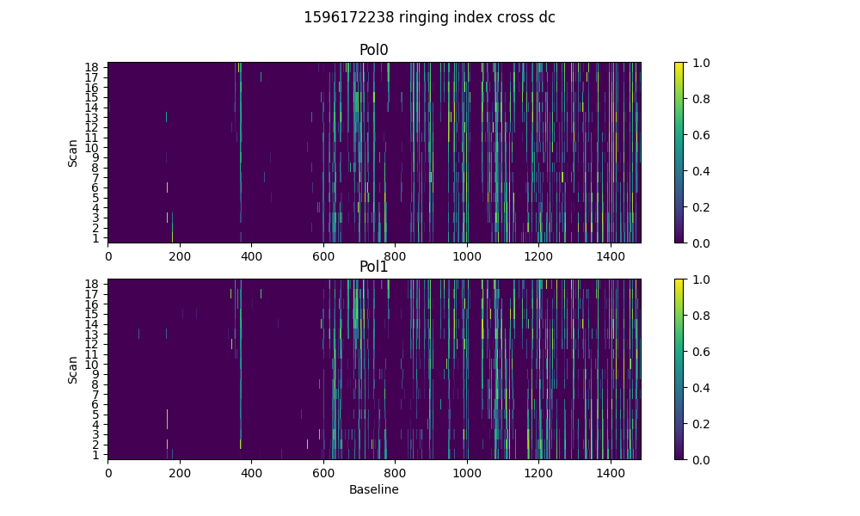

# Spectral periodicities

Using threshold of 10.0 sigma  
after detrending by polyfit(51)

* Found 328 bad spectra in auto in band0
* Found 59 bad spectra in auto in band1
* Found 6574 bad spectra in cross in band0
* Found 2166 bad spectra in cross in band1

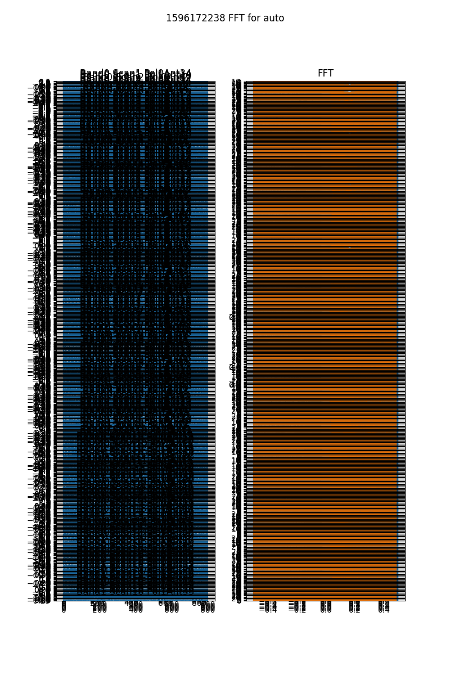

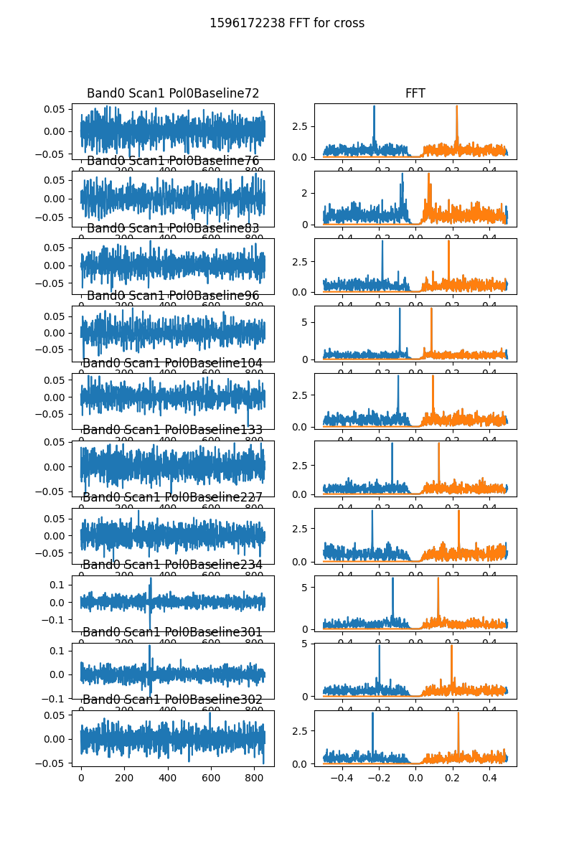

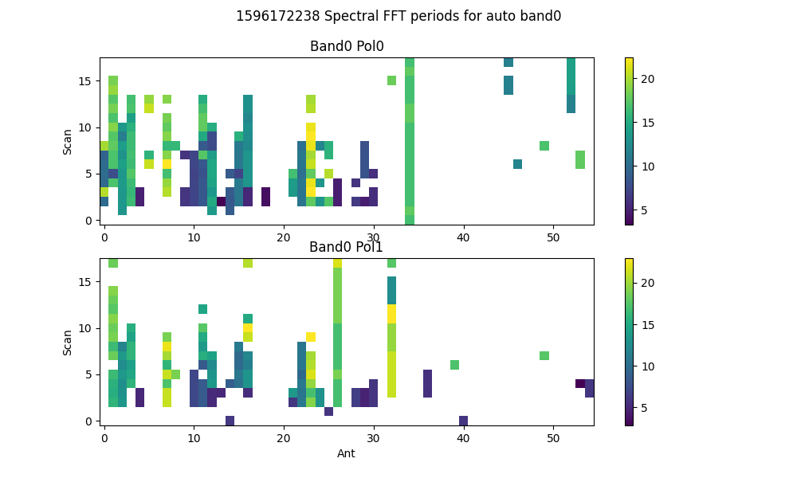

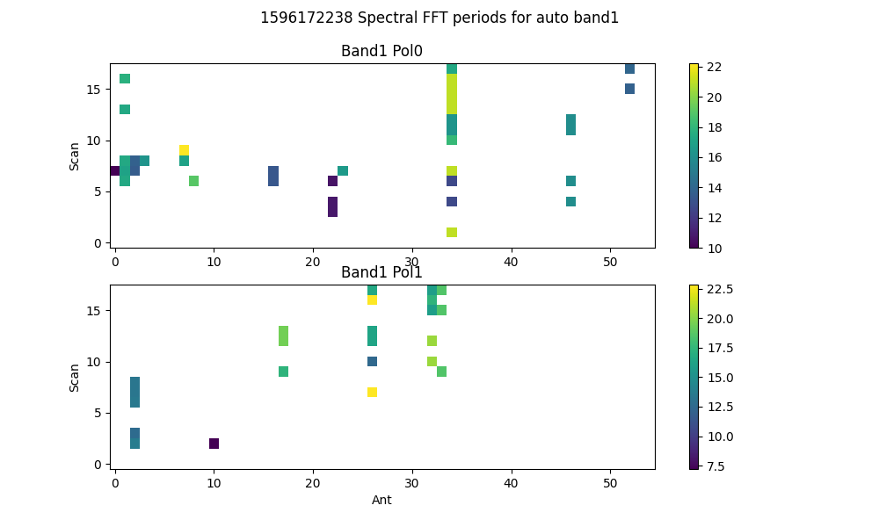

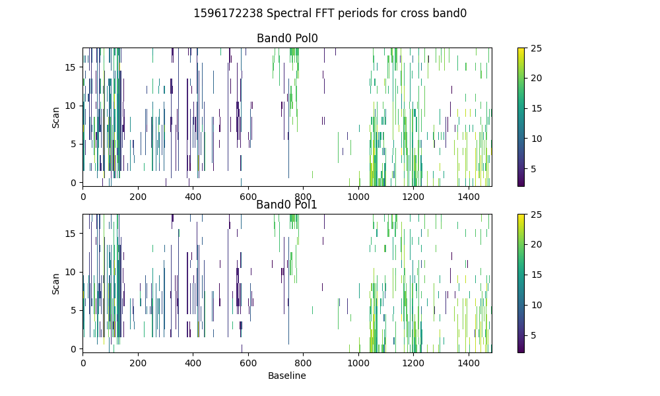

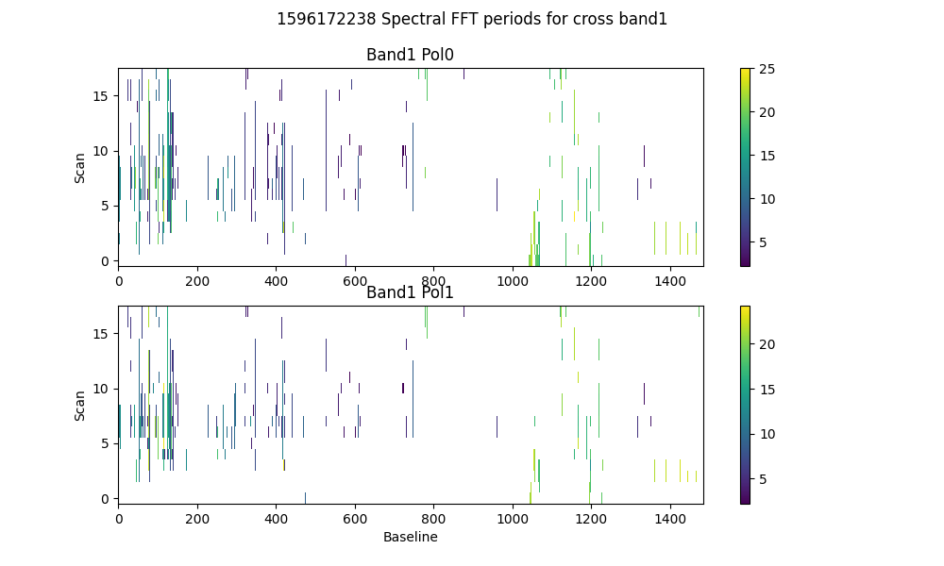

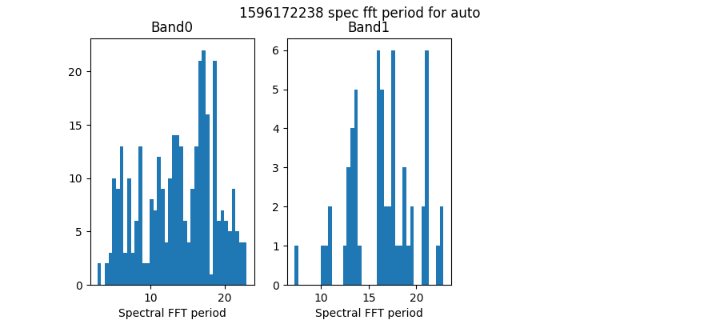

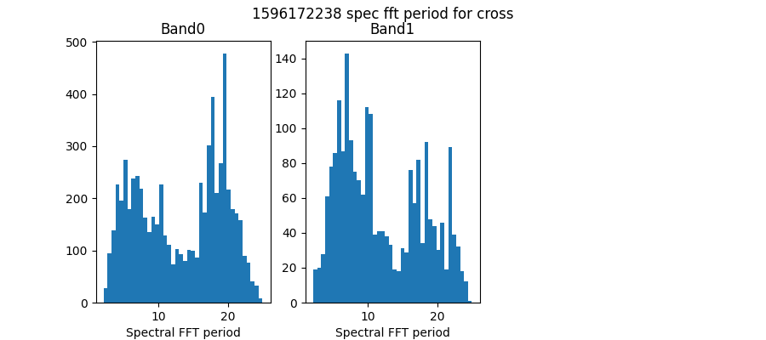

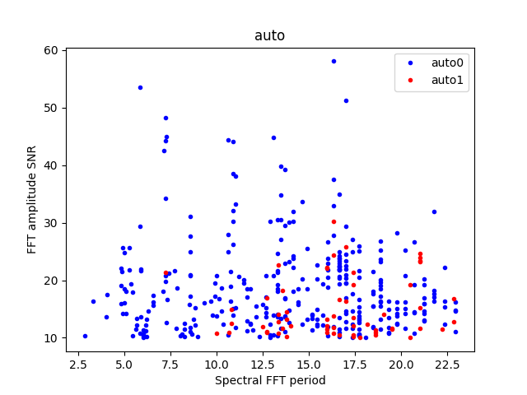

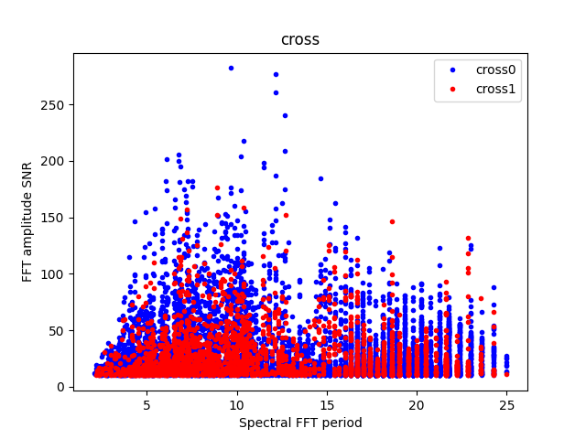

# Detrending

Applying polynomial filter with window 31 channels

# 2-chan ringing in average detrended spectrum

* Ringing index for auto pol 0 is -0.31
* Ringing index for auto pol 1 is -0.36
* Ringing index for cross pol 0 is -0.05
* Ringing index for cross pol 1 is 0.01

# X-Y pol correlation in spectra

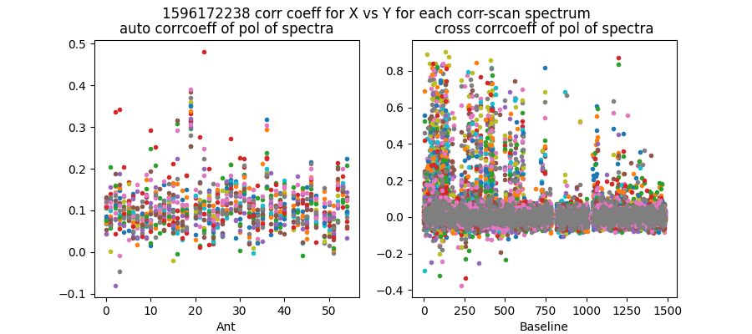

Mean and median corrcoeff for auto is 0.11 0.10

Mean and median corrcoeff for cross is 0.02 0.01

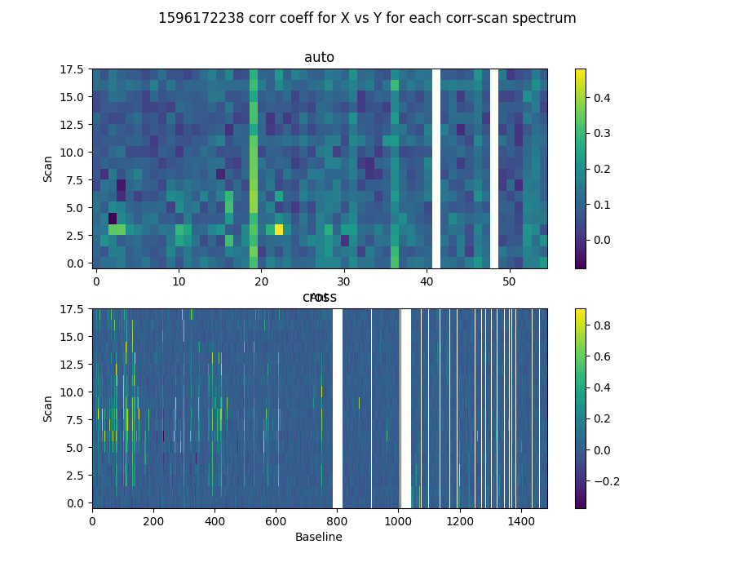

* Corr coeff for auto av spectrum X vx Y is 0.79
* Corr coeff for auto folded av spec X vx Y is 0.94
* Corr coeff for cross av spectrum X vx Y is 0.27
* Corr coeff for cross folded av spec X vx Y is 0.86

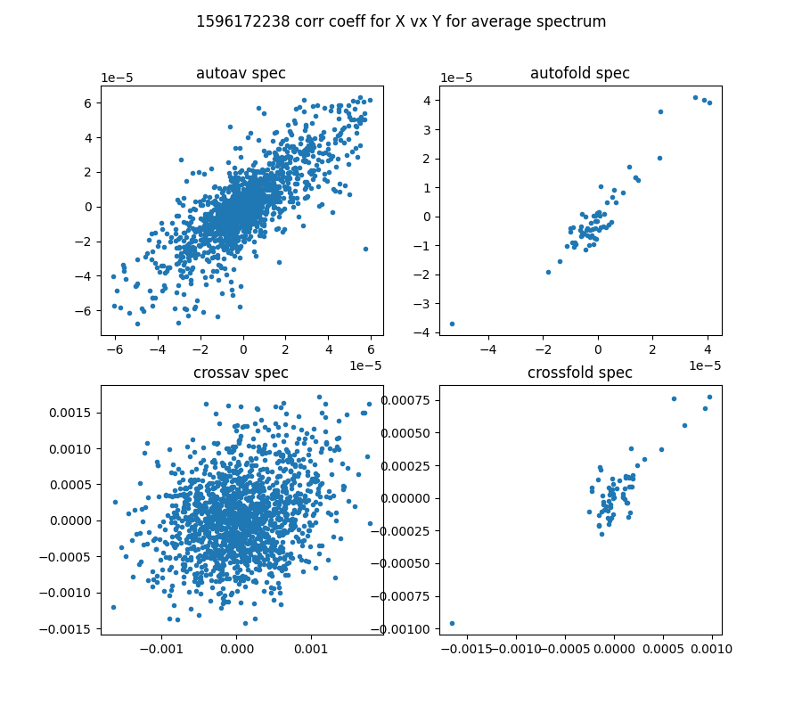

# 64-channel folded spectra

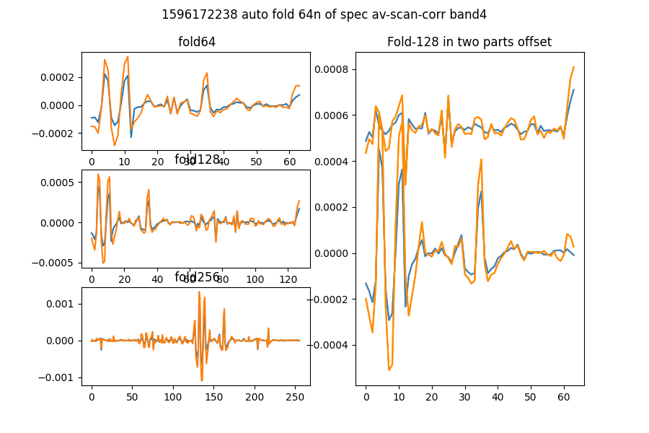

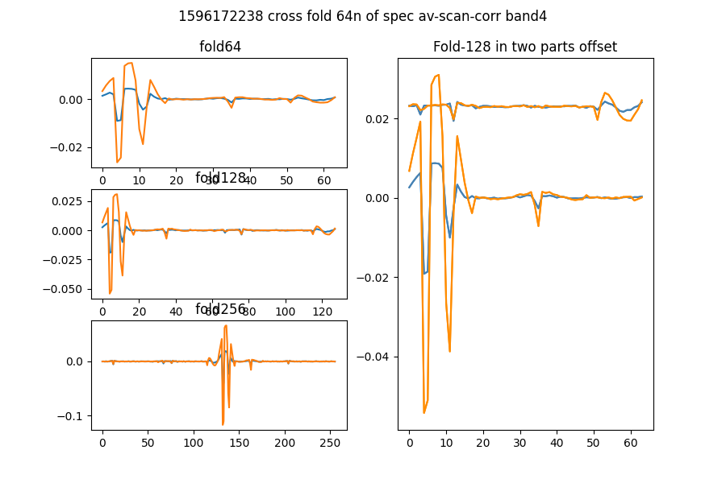

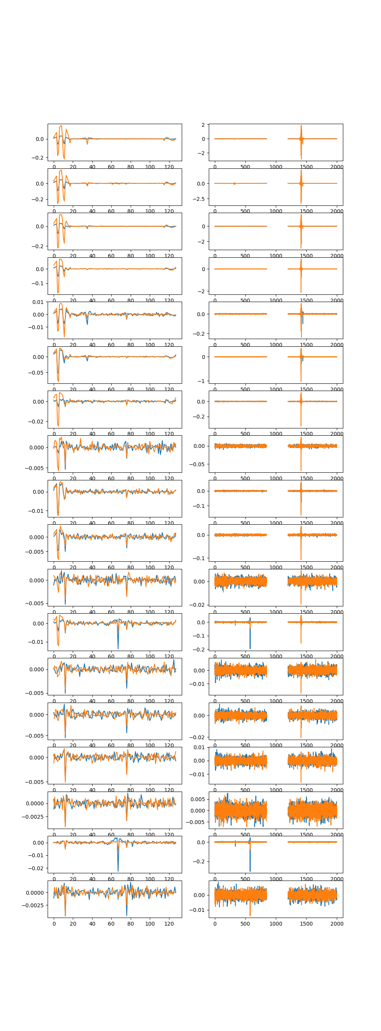

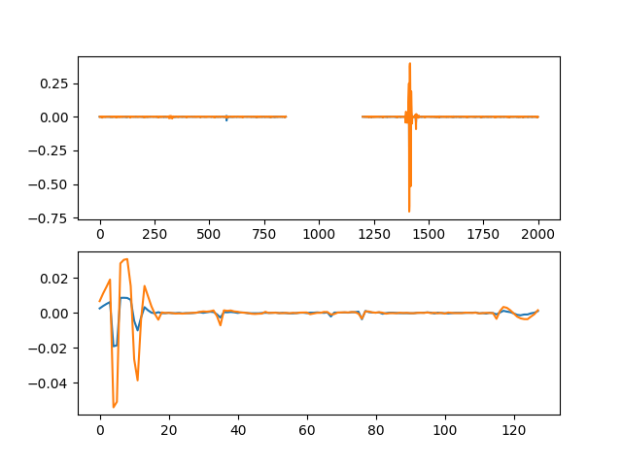

# Comb function analysis

Using nsearch=1; minfold=5; thresh=5.0

* Max (fold,start) [86, 37] with snr 10.44

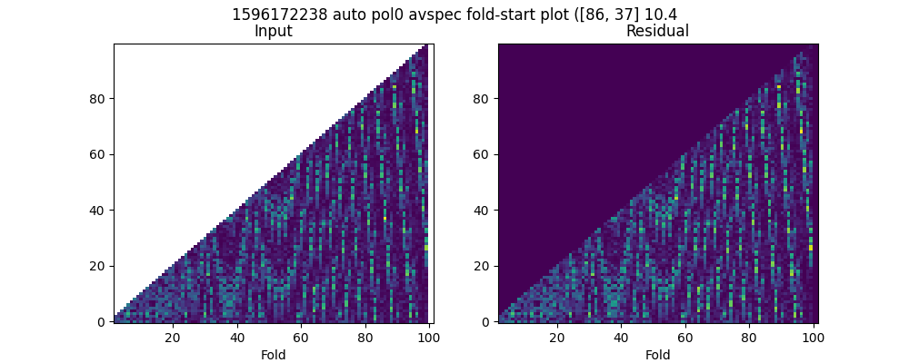

* Max (fold,start) [86, 37] with snr 8.03

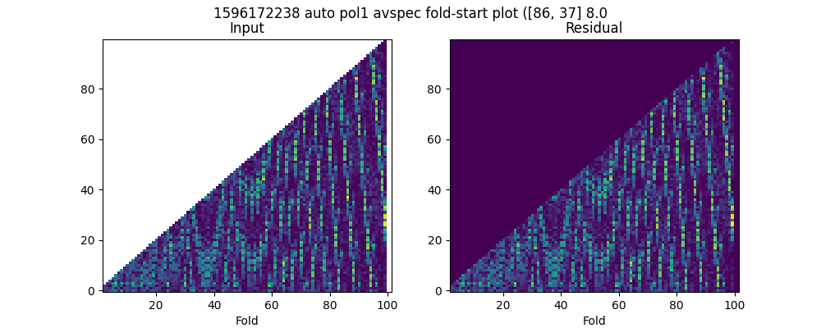

* Max (fold,start) [98, 40] with snr 36.45

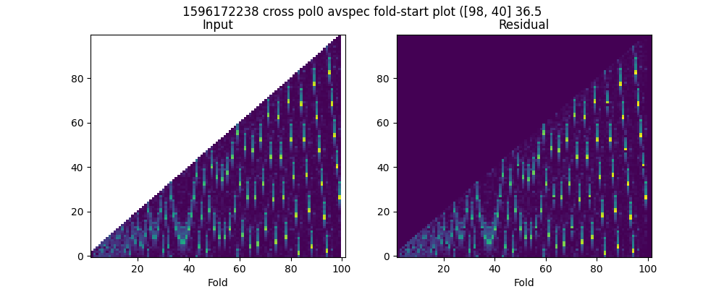

* Max (fold,start) [98, 40] with snr 37.94

