คู่มือสำหรับนักพัฒนาโปรแกรม
ระบบซ่อมแจ้งซ่อมคอมพิวเตอร์ ออนไลน์

จอ
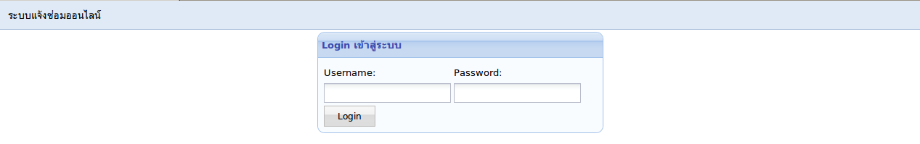
controller: user
action: index
controller: user/index
class User_Controller extends Template_Controller {
function index() {
$content = new View("user/index");
$content->set("user_username", "");

$this->template->content = $content;
}
}
view: user/index
<script type="text/javascript">
$(function() {
$("#user_username").focus();
});
</script>

<table width="400px" align="center" class="login">
<tr>
<td>
<form method="post" action="<?php echo Kohana::config("config.site_name"); ?>user/login">
<div class="panel">
<div class="panel_header">Login เข้าสู่ระบบ</div>
<div class="panel_body">
<table>
<tr>
<td>Username:</td>
<td>Password:</td>
</tr>
<tr>
<td><input type="text" name="user_username" id="user_username" value="<?php echo $user_username; ?>" /></td>
<td><input type="password" name="user_password" /></td>
</tr>
<tr>
<td><input type="submit" value="Login" class="app_button" /></td>
</tr>
</table>
</div>
</div>
</form>
</td>
</tr>
</table>
controller: user/login
class User_Controller extends Template_Controller {
....
function login() {
$user = ORM::factory("user")
->where("user_username", $this->input->post("user_username"))
->where("user_password", $this->input->post("user_password"))
->find();

if (!empty($user->id)) {
// pass
Session::instance()->set("user_id", $user->id);
Session::instance()->set("user_level", $user->user_level);

url::redirect("user/home");
} else {
// fail
Session::instance()->set_flash("message", "username invalid");

$content = new View("user/index");
$content->set("user_username", $this->input->post("user_username"));

$this->template->content = $content;
}
}
}
controller: user/home
class User_Controller extends Template_Controller {
....
function home() {
$content = new View("user/home");
$this->template->content = $content;
}
}
controller: user/logout
class User_Controller extends Template_Controller {
....
function logout() {
Session::instance()->delete("user_id");
url::redirect("user/index");
}
}

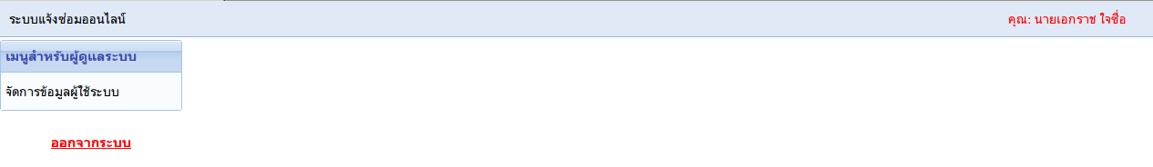
controller: user
action: home
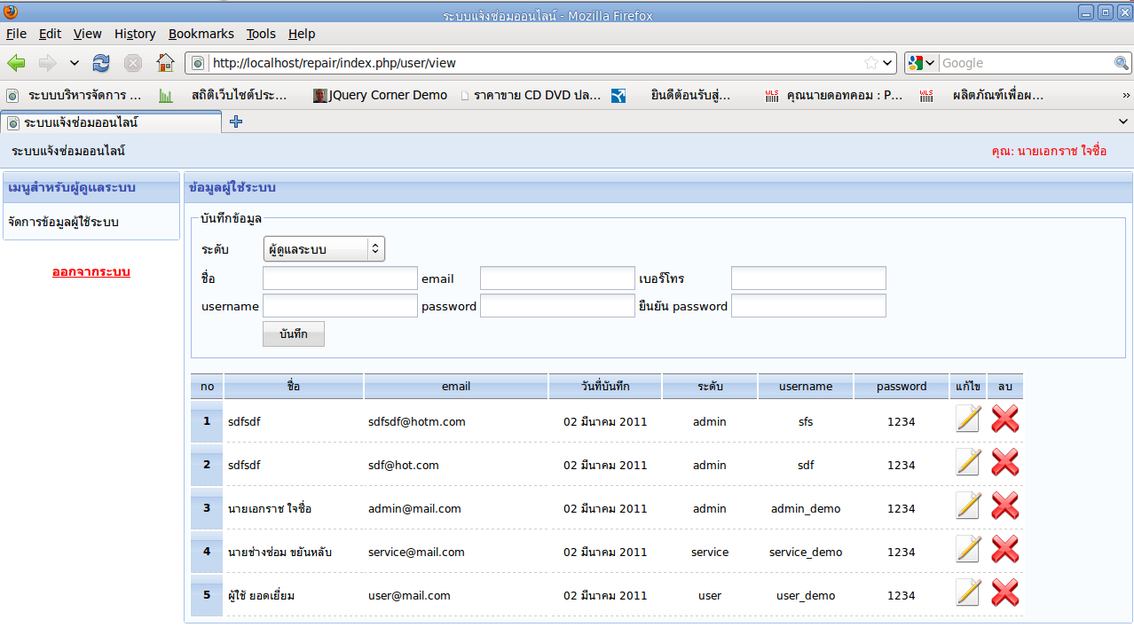
controller: user
action: view
controller: user/view
class User_Controller extends Template_Controller {
....
function view($id = null) {
$content = new View("user/view");

if (!empty($id)) {
$content->user = User_Model::findById($id);
}

$content->users = User_Model::findAll();
$content->n = 1;

$this->template->content = $content;
}
}
view: user/view
<div class="panel">
<div class="panel_header">ข้อมูลผู้ใช้ระบบ</div>
<div class="panel_body">
<!-- form -->
<form method="post" action="<?php echo Kohana::config("config.site_name"); ?>user/save">
<fieldset>
<legend>บันทึกข้อมูล</legend>
<table>
<tr>
<td>ระดับ</td>
<td><?php echo form::dropdown("user_level", enum::getUserLevel()); ?></td>
</tr>
<tr>
<td>ชื่อ</td>
<td><input type="text" name="user_name" value="<?php echo @$user->user_name; ?>" /></td>
<td>email</td>
<td><input type="text" name="user_email" value="<?php echo @$user->user_email; ?>" /></td>
<td>เบอร์โทร</td>
<td><input type="text" name="user_tel" value="<?php echo @$user->user_tel; ?>" /></td>
</tr>
<tr>
<td>username</td>
<td><input type="text" name="user_username" value="<?php echo @$user->user_username; ?>" /></td>
<td>password</td>
<td><input type="password" name="user_password" /></td>
<td>ยืนยัน password</td>
<td><input type="password" name="user_password_confirm" /></td>
</tr>
<tr>
<td></td>
<td><input type="submit" value="บันทึก" class="app_button" /></td>
</tr>
</table>
</fieldset>
<input type="hidden" name="id" value="<?php echo @$user->id; ?>" />
</form>

<!-- data -->
<table class="grid">
<thead>
<tr>
<td width="30px">no</td>
<td width="150px">ชื่อ</td>
<td width="200px">email</td>
<td width="120px">วันที่บันทึก</td>
<td width="100px">ระดับ</td>
<td width="100px">username</td>
<td width="100px">password</td>
<td width="25px">แก้ไข</td>
<td width="25px">ลบ</td>
</tr>
</thead>
<tbody>
<?php foreach ($users as $user): ?>
<tr>
<td align="right" class="grid_left"><?php echo $n++; ?></td>
<td><?php echo $user->user_name; ?></td>
<td><?php echo $user->user_email; ?></td>
<td align="center"><?php echo kdate::to_thai_day($user->user_created_date); ?></td>
<td align="center"><?php echo $user->user_level; ?></td>
<td align="center"><?php echo $user->user_username; ?></td>
<td align="center"><?php echo $user->user_password; ?></td>
<td align="center">
<a href="<?php echo Kohana::config("config.site_name"); ?>user/view/<?php echo $user->id; ?>">
<img src="<?php echo url::base(); ?>images/actions/edit.png" />
</a>
</td>
<td align="center">
<a href="<?php echo Kohana::config("config.site_name"); ?>user/delete/<?php echo $user->id; ?>" onclick="return confirm('ยืนยันการลบ')">
<img src="<?php echo url::base(); ?>images/actions/button_cancel.png" />
</a>
</td>
</tr>
<?php endforeach ?>
</tbody>
</table>
</div>
</div>
controller: user/save
class User_Controller extends Template_Controller {
....
function save() {
$fail = false;
$id = $this->input->post("id");

// validator
if (empty($id)) {
$post = Validation::factory($_POST)
->add_rules("user_name", "required")
->add_rules("user_email", "required", "email")
->add_rules("user_tel", "required")
->add_rules("user_username", "required")
->add_rules("user_password", "required")
->add_rules("user_password_confirm", "required");
} else {
$post = Validation::factory($_POST)
->add_rules("user_name", "required")
->add_rules("user_email", "required", "email")
->add_rules("user_tel", "required")
->add_rules("user_username", "required");
}

if ($post->validate()) {
// pass
if ($this->input->post("user_password") == $this->input->post("user_password_confirm")) {

if (empty($id)) {
$user = new User_Model();
$user->user_created_date = kdate::now();
$user->user_password = $this->input->post("user_password");
} else {
$user = User_Model::findById($id);
if ($this->input->post("user_password") != "") {
$user->user_password = $this->input->post("user_password");
}
}
$user->user_name = $this->input->post("user_name");
$user->user_email = $this->input->post("user_email");
$user->user_username = $this->input->post("user_username");
$user->user_level = $this->input->post("user_level");
$user->user_tel = $this->input->post("user_tel");
$user->save();

url::redirect("user/view");
} else {
$fail = true;
}
} else {
$fail = true;
}

if ($fail) {
// fail
Session::instance()->set_flash("message", "โปรดกรอกข้อมูลให้ครบด้วย");

$fields = array(
"n" => 1,
"users" => User_Model::findAll(),
"user_name" => $this->input->post("user_name")
);
$content = new View("user/view");
$content->set($fields);

$this->template->content = $content;
}
}
}
controller: user/delete
class User_Controller extends Template_Controller {
....
function delete($id) {
ORM::factory("user")->delete($id);
url::redirect("user/view");
}
}

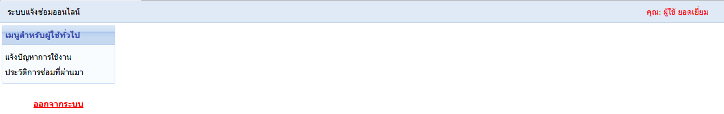
controller: user
action: home
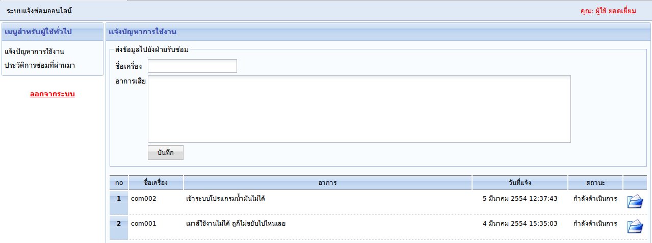
controller: order_repair
action: form
controller: order_repair/form
class Order_Repair_Controller extends Template_Controller {
function form($id = null) {
$user_id = Session::instance()->get("user_id");

$content = new View("order_repair/form");
$content->order_repairs = Order_Repair_Model::findNoCompleteByUserId($user_id);
$content->n = 1;

if (!empty($id)) {
$content->order_repair = Order_Repair_Model::findById($id);
}

$this->template->content = $content;
}
}
view: order_repair/form
<div class="panel">
<div class="panel_header">แจ้งปัญหาการใช้งาน</div>
<div class="panel_body">
<form method="post" action="<?php echo Kohana::config("config.site_name"); ?>order_repair/save">
<fieldset>
<legend>ส่งข้อมูลไปยังฝ่ายรับซ่อม</legend>
<table>
<tr>
<td>ชื่อเครื่อง</td>
<td><input type="text" name="order_repair_computer_name" value="<?php echo @$order_repair->order_repair_computer_name; ?>" /></td>
</tr>
<tr valign="top">
<td>อาการเสีย</td>
<td><textarea name="order_repair_detail" cols="100" rows="5"><?php echo @$order_repair->order_repair_detail; ?></textarea></td>
</tr>
<tr>
<td></td>
<td><input type="submit" value="บันทึก" class="app_button" /></td>
</tr>
</table>
</fieldset>
<input type="hidden" name="id" value="<?php echo @$order_repair->id; ?>" />
</form>

<table class="grid" width="100%">
<thead>
<tr>
<td width="30px">no</td>
<td width="100px">ชื่อเครื่อง</td>
<td>อาการ</td>
<td width="180px">วันที่แจ้ง</td>
<td width="100px">สถานะ</td>
<td width="40px">&nbsp;</td>
</tr>
</thead>
<tbody>
<?php $order_status = enum::getOrderStatus(); ?>
<?php foreach ($order_repairs as $order_repair): ?>
<tr valign="top">
<td align="right" class="grid_left"><?php echo $n++; ?></td>
<td><?php echo $order_repair->order_repair_computer_name; ?></td>
<td><?php echo $order_repair->order_repair_detail; ?></td>
<td align="center"><?php echo kdate::to_thai_date($order_repair->order_repair_created_date); ?></td>
<td align="center"><?php echo $order_status[$order_repair->order_repair_status]; ?></td>
<td align="center">
<?php if ($order_repair->service_id == 0): ?>
<a title="แก้ไขเพิ่มเติม" href="<?php echo Kohana::config("config.site_name"); ?>order_repair/form/<?php echo $order_repair->id; ?>">
<img src="<?php echo url::base(); ?>images/actions/edit.png" />
</a>
<?php else: ?>
<a target="_blank" title="เปิดดูรายละเอียดความคืบหน้า" href="<?php echo Kohana::config("config.site_name"); ?>order_repair/detail/<?php echo $order_repair->id; ?>" >
<img src="<?php echo url::base(); ?>images/actions/fileopen.png" />
</a>
<?php endif ?>
</td>
</tr>
<?php endforeach ?>
</tbody>
</table>
</div>
</div>
controller: order_repair/save
class Order_Repair_Controller extends Template_Controller {
....
function save() {
$user_id = Session::instance()->get("user_id");
$id = $this->input->post("id");

// validate
$post = Validation::factory($_POST)
->add_rules("order_repair_computer_name", "required")
->add_rules("order_repair_detail", "required");

if ($post->validate()) {
// insert
if (empty($id)) {
$order_repair = new Order_Repair_Model();
$order_repair->order_repair_status = "wait";
$order_repair->order_repair_created_date = kdate::now();
} else {
$order_repair = Order_Repair_Model::findById($id);
}
$order_repair->order_repair_computer_name = $this->input->post("order_repair_computer_name");
$order_repair->order_repair_detail = $this->input->post("order_repair_detail");
$order_repair->user_id = $user_id;
$order_repair->save();

url::redirect("order_repair/form");
} else {
// fail
Session::instance()->set_flash("message", "โปรดกรอกข้อมูลให้ครบด้วย");

$content = new View("order_repair/form");
$content->order_repairs = Order_Repair_Model::findNoCompleteByUserId($user_id);
$content->n = 1;

$this->template->content = $content;
}
}
}

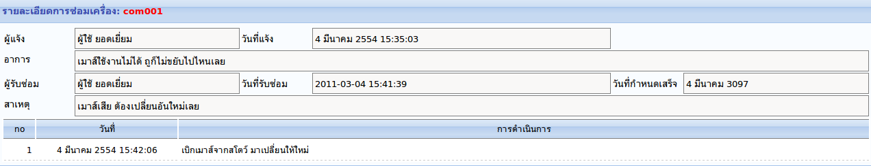
controller: order_repair
action: detail
controller: order_repair/detail
class Order_Repair_Controller extends Template_Controller {
....
function detail($id, $render_template = true) {
$content = new View("order_repair/detail");
$content->order_repair = Order_Repair_Model::findById($id);
$content->service = User_Model::findById($content->order_repair->service_id);
$content->repair_records = Repair_Record_Model::findByOrderRepairId($id);
$content->n = 1;

if ($render_template == "false") {
$content->render(true);
} else {
$this->template->content = $content;
}
}
}
view: order_repair/detail
<div class="panel">
<div class="panel_header">
รายละเอียดการซ่อมเครื่อง:
<font color="red"><?php echo $order_repair->order_repair_computer_name; ?></font>
</div>
<div class="panel_body">
<table width="100%">
<tr>
<td width="100px">ผู้แจ้ง</td>
<td class="read_only"><?php echo $order_repair->user->user_name; ?></td>
<td width="100px">วันที่แจ้ง</td>
<td class="read_only"><?php echo kdate::to_thai_date($order_repair->order_repair_created_date); ?></td>
<td width="100px"></td>
<td></td>
</tr>
<tr valign="top">
<td>อาการ</td>
<td colspan="5" class="read_only"><?php echo $order_repair->order_repair_detail; ?></td>
</tr>
<tr>
<td>ผู้รับซ่อม</td>
<td class="read_only"><?php echo $service->user_name; ?></td>
<td>วันที่รับซ่อม</td>
<td class="read_only"><?php echo $order_repair->order_repair_get_date; ?></td>
<td>วันที่กำหนดเสร็จ</td>
<td class="read_only"><?php echo kdate::to_thai_date($order_repair->order_repair_will_complete_date); ?></td>
</tr>
<tr valign="top">
<td>สาเหตุ</td>
<td colspan="5" class="read_only"><?php echo $order_repair->order_repair_reason; ?></td>
</tr>
</table>

<table class="grid" width="100%">
<thead>
<tr>
<td width="40px">no</td>
<td width="200px">วันที่</td>
<td>การดำเนินการ</td>
</tr>
</thead>
<tbody>
<?php foreach ($repair_records as $repair_record): ?>
<tr>
<td align="right"><?php echo $n++; ?></td>
<td align="center"><?php echo kdate::to_thai_date($repair_record->repair_record_created_date); ?></td>
<td><?php echo $repair_record->repair_record_detail; ?></td>
</tr>
<?php endforeach ?>
</tbody>
</table>
</div>
</div>

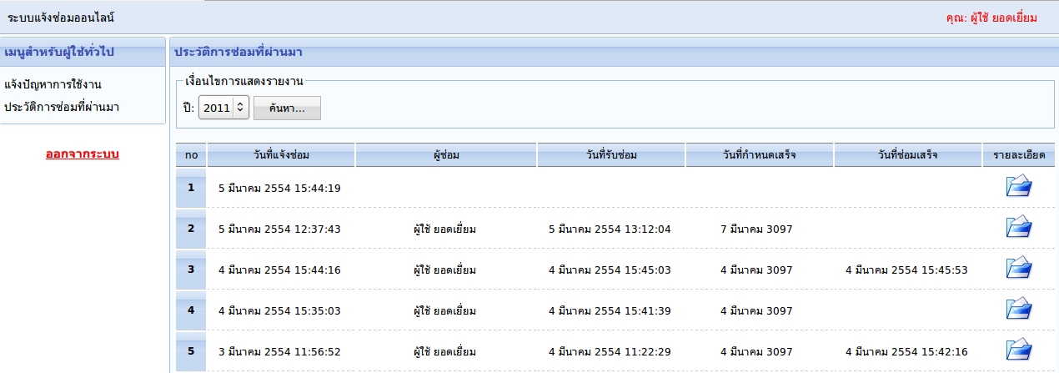
controller: order_repair
action: history_user
controller: order_repair/history_user
class Order_Repair_Controller extends Template_Controller {
...
function history_user() {
$user_id = Session::instance()->get("user_id");
$year = $this->input->post("search_year");

if (empty($year)) {
$year = date("Y");
}

$order_repairs = Order_Repair_Model::findByUserIdAndYear($user_id, $year);
$content = new View("order_repair/history_user");
$content->n = 1;
$content->order_repairs = $order_repairs;

$this->template->content = $content;
}
}
view: order_repair/history_user
<div class="panel">
<div class="panel_header">ประวัติการซ่อมที่ผ่านมา</div>
<div class="panel_body">
<?php echo form::open("order_repair/history_user"); ?>
<fieldset>
<legend>เงื่อนไขการแสดงรายงาน</legend>
ปี: <?php echo kdate::ddl_year("search_year"); ?>
<input type="submit" value="ค้นหา..." class="app_button" />
</fieldset>
<?php echo form::close(); ?>

<table class="grid" width="100%">
<thead>
<tr>
<td width="30px">no</td>
<td width="170px">วันที่แจ้งซ่อม</td>
<td>ผู้ซ่อม</td>
<td width="170px">วันที่รับซ่อม</td>
<td width="170px">วันที่กำหนดเสร็จ</td>
<td width="170px">วันที่ซ่อมเสร็จ</td>
<td width="80px">รายละเอียด</td>
</tr>
</thead>
<tbody>
<?php foreach ($order_repairs as $order_repair): ?>
<tr>
<td align="right" class="grid_left"><?php echo $n++; ?></td>
<td align="center"><?php echo kdate::to_thai_date($order_repair->order_repair_created_date); ?>&nbsp;</td>
<td align="center"><?php echo User_Model::findById($order_repair->service_id)->user_name; ?>&nbsp;</td>
<td align="center"><?php echo kdate::to_thai_date($order_repair->order_repair_get_date); ?>&nbsp;</td>
<td align="center"><?php echo kdate::to_thai_date($order_repair->order_repair_will_complete_date); ?>&nbsp;</td>
<td align="center"><?php echo kdate::to_thai_date($order_repair->order_repair_complete_date); ?>&nbsp;</td>
<td align="center">
<a target="_blank" href="<?php echo Kohana::config("config.site_name"); ?>order_repair/detail/<?php echo $order_repair->id; ?>/false">
<img src="<?php echo url::base(); ?>images/actions/fileopen.png" />
</a>
</td>
</tr>
<?php endforeach ?>
</tbody>
</table>
</div>
</div>

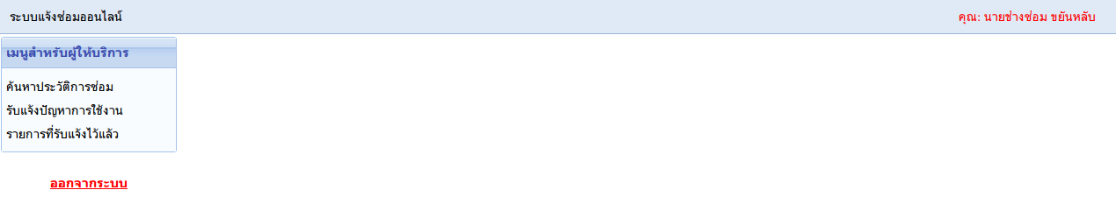
controller: user
action: home
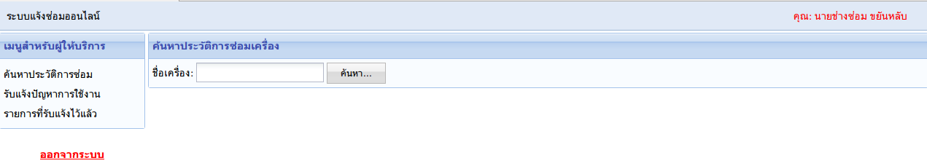
controller: order_repair
action: search_by_computer_name
controller: order_repair/search_by_computer_name
class Order_Repair_Controller extends Template_Controller {
....
function search_by_computer_name() {
$order_repair_computer_name = $this->input->post("order_repair_computer_name");

$content = new View("order_repair/search_by_computer_name");
if (!empty($order_repair_computer_name)) {
$content->order_repairs = Order_Repair_Model::findByComputerName($order_repair_computer_name);
$content->n = 1;
}
$content->order_repair_computer_name = $order_repair_computer_name;

$this->template->content = $content;
}
}
view: order_repair/search_by_computer_name
<div class="panel">
<div class="panel_header">ค้นหาประวัติการซ่อมเครื่อง</div>
<div class="panel_body">
<form method="post" action="<?php echo Kohana::config("config.site_name"); ?>order_repair/search_by_computer_name">
ชื่อเครื่อง: <input type="text" name="order_repair_computer_name" value="<?php echo $order_repair_computer_name; ?>" />
<input type="submit" value="ค้นหา..." class="app_button" />
</form>

<?php if (!empty($order_repairs)): ?>
<table class="grid" width="100%">
<thead>
<tr>
<td width="30px">no</td>
<td>ผู้แจ้งซ่อม</td>
<td width="200px">ผู้รับซ่อม</td>
<td width="120px">วันที่แจ้ง</td>
<td width="120px">วันที่รับซ่อม</td>
<td width="120px">วันที่กำหนดเสร็จ</td>
<td width="120px">วันที่ซ่อมเสร็จ</td>
<td width="70px">รายละเอียด</td>
</tr>
</thead>
<tbody>
<?php foreach ($order_repairs as $order_repair): ?>
<tr>
<td align="right" class="grid_left"><?php echo $n++; ?></td>
<td><?php echo $order_repair->user->user_name; ?></td>
<td><?php echo User_Model::findById($order_repair->service_id)->user_name; ?></td>
<td align="center"><?php echo kdate::to_thai_day($order_repair->order_repair_created_date); ?></td>
<td align="center"><?php echo kdate::to_thai_day($order_repair->order_repair_get_date); ?></td>
<td align="center"><?php echo kdate::to_thai_day($order_repair->order_repair_will_complete_date); ?></td>
<td align="center"><?php echo kdate::to_thai_day($order_repair->order_repair_complete_date); ?></td>
<td align="center">
<a target="_blank" href="<?php echo Kohana::config("config.site_name"); ?>order_repair/detail/<?php echo $order_repair->id; ?>/false">
<img src="<?php echo url::base(); ?>images/actions/fileopen.png" />
</a>
</td>
</tr>
<?php endforeach ?>
</tbody>
</table>
<?php endif ?>
</div>
</div>

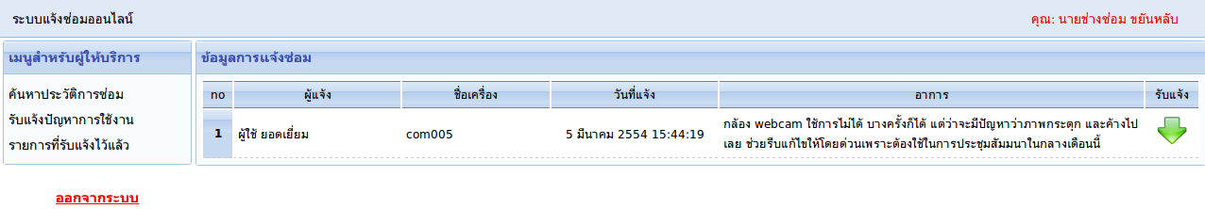
controller: order_repair
action: get_order
controller: order_repair/get_order
class Order_Repair_Controller extends Template_Controller {
....
function get_order() {
$content = new View("order_repair/get_order");
$content->order_repairs = Order_Repair_Model::findNoComplete();
$content->n = 1;

$this->template->content = $content;
}
}
view: order_repair/get_order
<div class="panel">
<div class="panel_header">ข้อมูลการแจ้งซ่อม</div>
<div class="panel_body">
<table class="grid" width="100%">
<thead>
<tr>
<td width="25px">no</td>
<td width="170px">ผู้แจ้ง</td>
<td width="150px">ชื่อเครื่อง</td>
<td width="170px">วันที่แจ้ง</td>
<td>อาการ</td>
<td width="50px">รับแจ้ง</td>
</tr>
</thead>
<tbody>
<?php foreach ($order_repairs as $order_repair): ?>
<tr>
<td align="right" class="grid_left"><?php echo $n++; ?></td>
<td><?php echo $order_repair->user->user_name; ?></td>
<td><?php echo $order_repair->order_repair_computer_name; ?></td>
<td align="center"><?php echo kdate::to_thai_date($order_repair->order_repair_created_date); ?></td>
<td><?php echo $order_repair->order_repair_detail; ?></td>
<td align="center">
<a href="<?php echo Kohana::config("config.site_name"); ?>order_repair/get_order_form/<?php echo $order_repair->id; ?>">
<img src="<?php echo url::base(); ?>images/actions/agt_update_misc.png" />
</a>
</td>
</tr>
<?php endforeach ?>
</tbody>
</table>
</div>
</div>

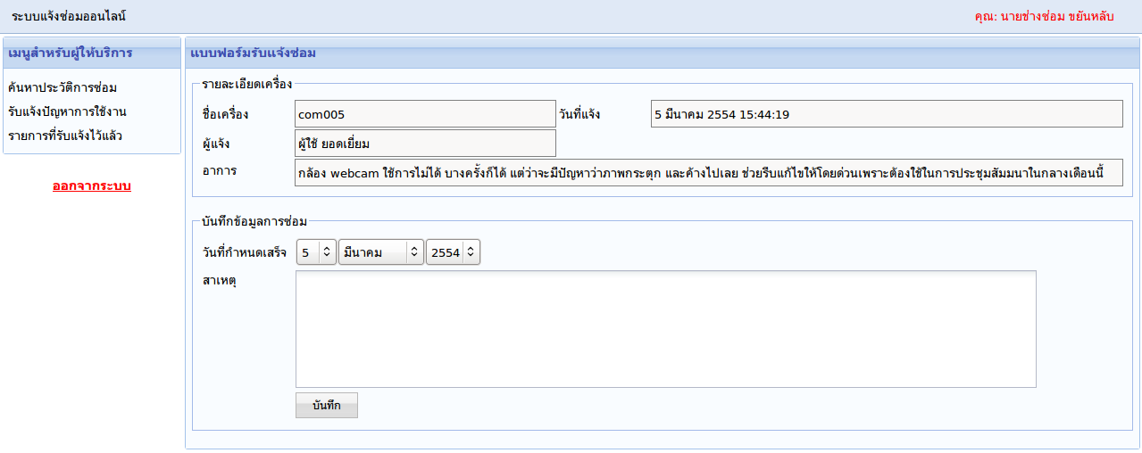
controller: order_repair
action: get_order_form
controller: order_repair/get_order_form
class Order_Repair_Controller extends Template_Controller {
....
function get_order_form($id) {
$content = new View("order_repair/get_order_form");
$content->order_repair = Order_Repair_Model::findById($id);

$this->template->content = $content;
}
}
view: order_repair/get_order_form
<div class="panel">
<div class="panel_header">แบบฟอร์มรับแจ้งซ่อม</div>
<div class="panel_body">
<fieldset>
<legend>รายละเอียดเครื่อง</legend>
<table width="100%">
<tr>
<td width="100px">ชื่อเครื่อง</td>
<td class="read_only"><?php echo $order_repair->order_repair_computer_name; ?></td>
<td width="100px">วันที่แจ้ง</td>
<td class="read_only"><?php echo kdate::to_thai_date($order_repair->order_repair_created_date); ?></td>
</tr>
<tr>
<td>ผู้แจ้ง</td>
<td class="read_only"><?php echo $order_repair->user->user_name; ?></td>
</tr>
<tr valign="top">
<td>อาการ</td>
<td class="read_only" colspan="3"><?php echo $order_repair->order_repair_detail; ?></td>
</tr>
</table>
</fieldset>

<form method="post" action="<?php echo Kohana::config("config.site_name"); ?>order_repair/get_order_save">
<fieldset>
<legend>บันทึกข้อมูลการซ่อม</legend>
<table>
<tr>
<td width="100px">วันที่กำหนดเสร็จ</td>
<td><?php echo kdate::dropdown("order_repair_will_complete_date"); ?></td>
</tr>
<tr valign="top">
<td>สาเหตุ</td>
<td><textarea name="order_repair_reason" cols="100" rows="5"></textarea></td>
</tr>
<tr>
<td></td>
<td><input type="submit" value="บันทึก" class="app_button" /></td>
</tr>
</table>
</fieldset>
<input type="hidden" name="id" value="<?php echo $order_repair->id; ?>" />
</form>
</div>
</div>
controller: order_repair/get_order_save
class Order_Repair_Controller extends Template_Controller {
....
function get_order_save() {
$id = $this->input->post("id");

$order_repair = Order_Repair_Model::findById($id);
$order_repair->order_repair_reason = $this->input->post("order_repair_reason");
$order_repair->order_repair_will_complete_date = kdate::input_from_dropdown("order_repair_will_complete_date");
$order_repair->order_repair_get_date = kdate::now();
$order_repair->order_repair_status = "repair";
$order_repair->service_id = Session::instance()->get("user_id");
$order_repair->save();

url::redirect("order_repair/get_order");
}
}

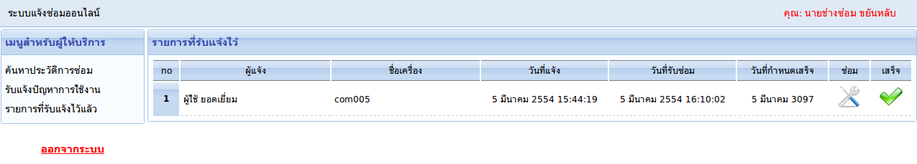
controller: order_repair
action: my_order
controller: order_repair/my_order
class Order_Repair_Controller extends Template_Controller {
....
function my_order() {
$content = new View("order_repair/my_order");
$content->order_repairs = Order_Repair_Model::findRepair(Session::instance()->get("user_id"));
$content->n = 1;

$this->template->content = $content;
}
}
view: order_repair/my_order
<div class="panel">
<div class="panel_header">รายการที่รับแจ้งไว้</div>
<div class="panel_body">
<table width="100%" class="grid">
<thead>
<tr>
<td width="30px">no</td>
<td>ผู้แจ้ง</td>
<td width="200px">ชื่อเครื่อง</td>
<td width="170px">วันที่แจ้ง</td>
<td width="170px">วันที่รับซ่อม</td>
<td width="120px">วันที่กำหนดเสร็จ</td>
<td width="50px">ซ่อม</td>
<td width="50px">เสร็จ</td>
</tr>
</thead>
<tbody>
<?php foreach ($order_repairs as $order_repair): ?>
<tr <?php if (date("d") == kdate::convert_to_day($order_repair->order_repair_will_complete_date)): ?> style="background-color: #ffffcc" <?php endif ?>>
<td align="right" class="grid_left"><?php echo $n++; ?></td>
<td><?php echo $order_repair->user->user_name; ?></td>
<td><?php echo $order_repair->order_repair_computer_name; ?></td>
<td align="center"><?php echo kdate::to_thai_date($order_repair->order_repair_created_date); ?></td>
<td align="center"><?php echo kdate::to_thai_date($order_repair->order_repair_get_date); ?></td>
<td align="center"><?php echo kdate::to_thai_date($order_repair->order_repair_will_complete_date); ?></td>
<td align="center">
<a href="<?php echo Kohana::config("config.site_name"); ?>order_repair/record/<?php echo $order_repair->id; ?>">
<img src="<?php echo url::base(); ?>images/actions/configure.png" />
</a>
</td>
<td align="center">
<a onclick="return confirm('ยืนยันการซ่อมเสร็จ คุณจะไม่สามารถเพิ่มเติมข้อมูลใด ๆ ได้อีก')" href="<?php echo Kohana::config("config.site_name"); ?>order_repair/complete/<?php echo $order_repair->id; ?>">
<img src="<?php echo url::base(); ?>images/actions/apply.png" />
</a>
</td>
</tr>
<?php endforeach ?>
</tbody>
</table>
</div>
</div>
controller: order_repair/complete
class Order_Repair_Controller extends Template_Controller {
....
function complete($id) {
$order_repair = Order_Repair_Model::findById($id);
$order_repair->order_repair_status = "complete";
$order_repair->order_repair_complete_date = kdate::now();
$order_repair->save();

url::redirect("order_repair/my_order");
}
}
controller: order_repair/record
class Order_Repair_Controller extends Template_Controller {
....
function record($id) {
$content = new View("order_repair/record");
$content->order_repair = Order_Repair_Model::findById($id);
$content->service = User_Model::findById($content->order_repair->service_id);
$content->repair_records = Repair_Record_Model::findByOrderRepairId($id);
$content->n = 1;

$this->template->content = $content;
}
}
view: order_repair/record
<div class="panel">
<div class="panel_header">บันทึกการซ่อมเครื่อง</div>
<div class="panel_body">
<form method="post" action="<?php echo Kohana::config("config.site_name"); ?>order_repair/record_save">
<table width="100%">
<tr>
<td width="150px">ผู้แจ้ง</td>
<td class="read_only"><?php echo $order_repair->user->user_name; ?></td>
<td width="150px">วันที่แจ้ง</td>
<td class="read_only" width="180px"><?php echo kdate::to_thai_date($order_repair->order_repair_created_date); ?></td>
<td width="150px"></td>
<td width="150px"></td>
</tr>
<tr valign="top">
<td>อาการ</td>
<td class="read_only" colspan="5"><?php echo $order_repair->order_repair_detail; ?></td>
</tr>
<tr>
<td>ผู้รับแจ้ง</td>
<td class="read_only"><?php echo $service->user_name; ?></td>
<td>วันที่รับแจ้ง</td>
<td class="read_only"><?php echo kdate::to_thai_date($order_repair->order_repair_get_date); ?></td>
<td>วันที่กำหนดเสร็จ</td>
<td class="read_only"><?php echo kdate::to_thai_date($order_repair->order_repair_will_complete_date); ?></td>
</tr>
<tr valign="top">
<td>สาเหตุ</td>
<td class="read_only" colspan="5"><?php echo $order_repair->order_repair_reason; ?>&nbsp;</td>
</tr>
<tr valign="top">
<td>บันทึกการดำเนินการ</td>
<td colspan="5"><textarea name="repair_record_detail" rows="3" style="width: 100%"></textarea></td>
</tr>
<tr>
<td></td>
<td><input type="submit" class="app_button" value="บันทึก" /></td>
</tr>
</table>
<input type="hidden" name="order_repair_id" value="<?php echo $order_repair->id; ?>" />
</form>

<table class="grid" width="100%">
<thead>
<tr>
<td width="40px">no</td>
<td width="200px">วันที่</td>
<td>การดำเนินการ</td>
</tr>
</thead>
<tbody>
<?php foreach ($repair_records as $repair_record): ?>
<tr>
<td align="right"><?php echo $n++; ?></td>
<td align="center"><?php echo kdate::to_thai_date($repair_record->repair_record_created_date); ?></td>
<td><?php echo $repair_record->repair_record_detail; ?></td>
</tr>
<?php endforeach ?>
</tbody>
</table>
</div>
</div>
controller: order_repair/record_save
class Order_Repair_Controller extends Template_Controller {
....
function record_save() {
$order_repair_id = $this->input->post("order_repair_id");

$post = Validation::factory($_POST)
->add_rules("repair_record_detail", "required");

if ($post->validate()) {
$repair_record = new Repair_Record_Model();
$repair_record->order_repair_id = $order_repair_id;
$repair_record->repair_record_created_date = kdate::now();
$repair_record->repair_record_detail = $this->input->post("repair_record_detail");
$repair_record->save();
} else {
Session::instance()->set_flash("message", "โปรดกรอกข้อมูลให้ครบด้วย");
}
url::redirect("order_repair/record/$order_repair_id");
}
}

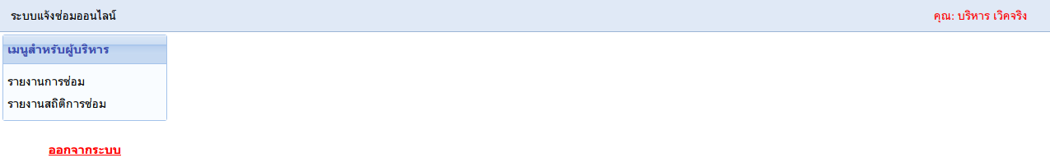
controller: user
action: home
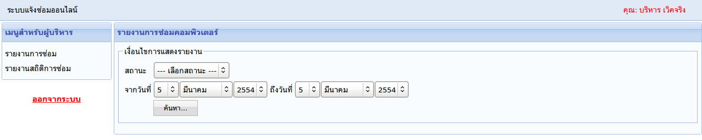
controller: order_repair
action: report_repair
controller: order_repair/report_repair
class Order_Repair_Controller extends Template_Controller {
....
function report_repair() {
$search_status = $this->input->post("search_status");

$content = new View("order_repair/report_repair");

if (!empty($_POST)) {
$_POST["from_date_year"] -= 543;
$_POST["to_date_year"] -= 543;

$from_date = "{$_POST['from_date_year']}-{$_POST['from_date_month']}-{$_POST['from_date_day']}";
$to_date = "{$_POST['to_date_year']}-{$_POST['to_date_month']}-{$_POST['to_date_day']}";

$sql = "
SELECT
order_repairs.*,
u.user_name AS user_name,
s.user_name AS service_name
FROM order_repairs
INNER JOIN users u ON u.id = order_repairs.user_id
LEFT JOIN users s ON s.id = order_repairs.service_id
WHERE 1 > 0";

if (!empty($search_status)) {
$sql .= " AND order_repair_status = '{$search_status}'";
}
if (!empty($from_date)) {
$sql .= " AND order_repair_created_date BETWEEN '{$from_date}' AND '{$to_date}'";
}
$sql .= " ORDER BY id DESC";
$content->order_repairs = Database::instance()->query($sql);
}
$content->search_status = $search_status;
$content->n = 1;

$this->template->content = $content;
}
}
view: order_repair/report_repair
<div class="panel">
<div class="panel_header">รายงานการซ่อมคอมพิวเตอร์</div>
<div class="panel_body">
<?php echo form::open("order_repair/report_repair"); ?>
<fieldset>
<legend>เงื่อนไขการแสดงรายงาน</legend>
<table>
<tr>
<td>สถานะ</td>
<td><?php echo form::dropdown("search_status", enum::getOrderStatus(true), $search_status); ?></td>
</tr>
<tr>
<td>จากวันที่</td>
<td><?php echo kdate::dropdown("from_date"); ?></td>
<td>ถึงวันที่</td>
<td><?php echo kdate::dropdown("to_date"); ?></td>
</tr>
<tr>
<td></td>
<td><input type="submit" value="ค้นหา..." class="app_button" /></td>
</tr>
</table>
</fieldset>
<?php echo form::close(); ?>

<?php if (!empty($order_repairs)): ?>
<table width="100%" class="grid">
<thead>
<tr>
<td width="30px">no</td>
<td>ผู้แจ้งซ่อม</td>
<td width="100px">ชื่อเครื่อง</td>
<td width="150px">วันที่แจ้งซ่อม</td>
<td width="120px">ผู้รับซ่อม</td>
<td width="150px">วันที่รับซ่อม</td>
<td width="100px">วันที่กำหนดเสร็จ</td>
<td width="170px">วันที่ซ่อมเสร็จ</td>
<td width="70px">รายละเอียด</td>
</tr>
</thead>
<tbody>
<?php foreach ($order_repairs as $order_repair): ?>
<tr>
<td align="right" class="grid_left"><?php echo $n++; ?></td>
<td><?php echo $order_repair->user_name; ?></td>
<td align="center"><?php echo $order_repair->order_repair_computer_name; ?></td>
<td align="center"><?php echo kdate::to_thai_date($order_repair->order_repair_created_date); ?></td>
<td><?php echo $order_repair->service_name; ?></td>
<td align="center"><?php echo kdate::to_thai_date($order_repair->order_repair_get_date); ?></td>
<td align="center"><?php echo kdate::to_thai_date($order_repair->order_repair_will_complete_date); ?>&nbsp;</td>
<td align="center"><?php echo kdate::to_thai_date($order_repair->order_repair_complete_date); ?>&nbsp;</td>
<td align="center">
<a target="_blank" href="<?php echo Kohana::config("config.site_name"); ?>order_repair/detail/<?php echo $order_repair->id; ?>/false">
<img src="<?php echo url::base(); ?>images/actions/fileopen.png" />
</a>
</td>
</tr>
<?php endforeach ?>
</tbody>
</table>
<?php endif ?>
</div>
</div>

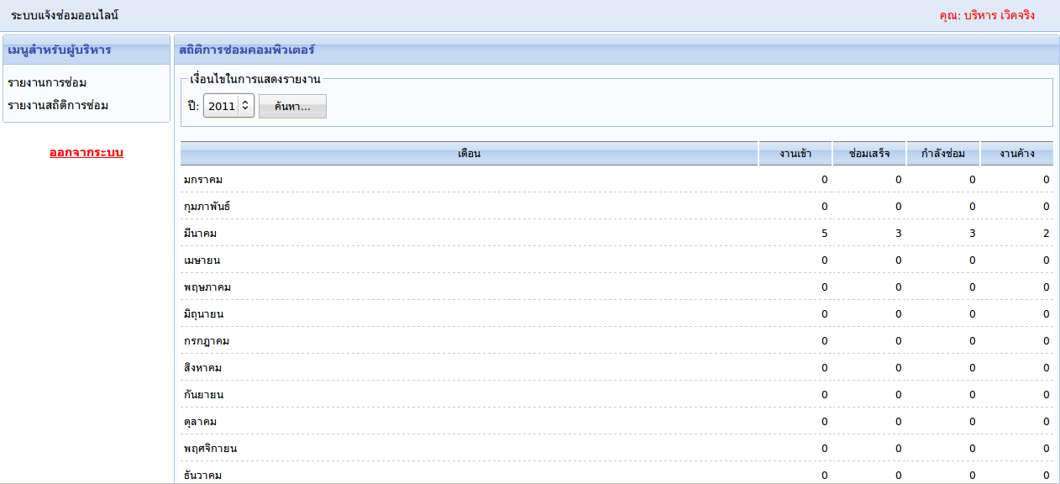
controller: order_repair
action: state_repair
controller: order_repair/state_repair
class Order_Repair_Controller extends Template_Controller {
....
function state_repair() {
$search_year = $this->input->post("year");

if (empty($search_year)) {
$search_year = date("Y");
}

$content = new View("order_repair/state_repair");
$content->months = kdate::get_month_name();
$content->search_year = $search_year;
$content->month_index = 1;

$this->template->content = $content;
}
}
view: order_repair/state_repair
<div class="panel">
<div class="panel_header">สถิติการซ่อมคอมพิวเตอร์</div>
<div class="panel_body">
<fieldset>
<legend>เงื่อนไขในการแสดงรายงาน</legend>
ปี: <?php echo kdate::ddl_year("search_year"); ?>
<input type="submit" value="ค้นหา..." class="app_button" />
</fieldset>

<table class="grid" width="100%">
<thead>
<tr>
<td>เดือน</td>
<td width="80px">งานเข้า</td>
<td width="80px">ซ่อมเสร็จ</td>
<td width="80px">กำลังซ่อม</td>
<td width="80px">งานค้าง</td>
</tr>
</thead>
<tbody>
<?php foreach ($months as $month): ?>
<tr>
<td><?php echo $month; ?></td>
<td align="right"><?php echo number_format(Order_Repair_Model::countByMonth($month_index)); ?></td>
<td align="right"><?php echo number_format(Order_Repair_Model::countCompleteByMonth($month_index)); ?></td>
<td align="right"><?php echo number_format(Order_Repair_Model::countRepairByMonth($month_index)); ?></td>
<td align="right"><?php echo number_format(Order_Repair_Model::countNoCompleteByMonth($month_index)); ?></td>
</tr>
<?php $month_index++; ?>
<?php endforeach ?>
</tbody>
</table>
</div>
</div>

