- Install MySQL Community Server on your computer and take a screenshot of the MySQL installer completion window.

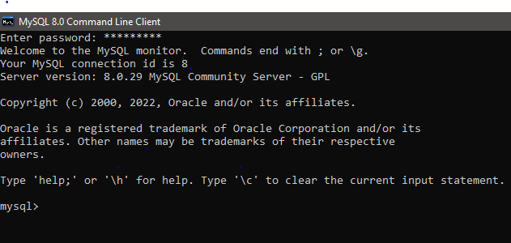

- Open MySQL Workbench or DB Browser, connect to your local MySQL server, and create a new database called music_streaming_db.

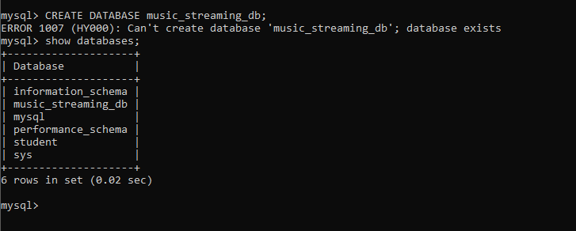

- List 3 differences between MySQL and PostgreSQL in terms of features or use cases, and give one example of a popular app or company that uses each.
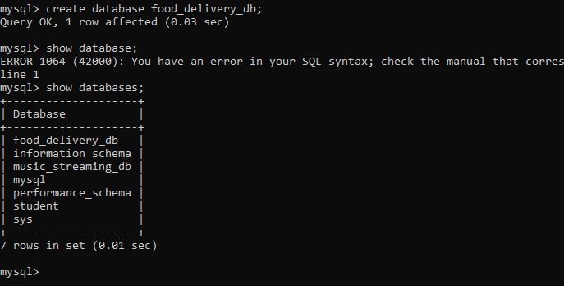

- List 3 differences between MySQL and PostgreSQL in terms of features or use cases, and give one example of a popular app or company that uses each.

:- | MySQL |  | PostgreSQL
Mostly used for web applications and websites. |  | Used for complex applications, analytics, and large databases.
Simple, fast, and easy to use. |  | Provides advanced SQL features and complex data types.
Good for read-heavy and simple database operations. |  | Good for complex queries and advanced data processing.
Facebook uses MySQL. |  | Instagram uses PostgreSQL.

