Assignment – 1

**Q-1 What is software? What is software engineering?**

* [Software is a program or set of programs containing instructions that provide desired functionality](https://www.bing.com/ck/a?!&&p=36e09c87d39452d4JmltdHM9MTY5MTEwNzIwMCZpZ3VpZD0yMDUwYzZkMy01NGZjLTY2MWUtMTE2YS1kNDlkNTU0ZTY3NDImaW5zaWQ9NTc5MA&ptn=3&hsh=3&fclid=2050c6d3-54fc-661e-116a-d49d554e6742&psq=+What+is+software%3f+What+is+software+engineering%3f&u=a1aHR0cHM6Ly93d3cuZ2Vla3Nmb3JnZWVrcy5vcmcvc29mdHdhcmUtZW5naW5lZXJpbmctaW50cm9kdWN0aW9uLXRvLXNvZnR3YXJlLWVuZ2luZWVyaW5nLw&ntb=1).
* [Software engineering is the process of designing, developing, testing, and maintaining software](https://www.bing.com/ck/a?!&&p=2731bcc82a86e8c2JmltdHM9MTY5MTEwNzIwMCZpZ3VpZD0yMDUwYzZkMy01NGZjLTY2MWUtMTE2YS1kNDlkNTU0ZTY3NDImaW5zaWQ9NTc5Mg&ptn=3&hsh=3&fclid=2050c6d3-54fc-661e-116a-d49d554e6742&psq=+What+is+software%3f+What+is+software+engineering%3f&u=a1aHR0cHM6Ly93d3cuZ2Vla3Nmb3JnZWVrcy5vcmcvc29mdHdhcmUtZW5naW5lZXJpbmctaW50cm9kdWN0aW9uLXRvLXNvZnR3YXJlLWVuZ2luZWVyaW5nLw&ntb=1)
* [It is the application of engineering principles to software development](https://www.bing.com/ck/a?!&&p=5297886e29e87b04JmltdHM9MTY5MTEwNzIwMCZpZ3VpZD0yMDUwYzZkMy01NGZjLTY2MWUtMTE2YS1kNDlkNTU0ZTY3NDImaW5zaWQ9NTc5OA&ptn=3&hsh=3&fclid=2050c6d3-54fc-661e-116a-d49d554e6742&psq=+What+is+software%3f+What+is+software+engineering%3f&u=a1aHR0cHM6Ly93d3cudGVjaG9wZWRpYS5jb20vZGVmaW5pdGlvbi8xMzI5Ni9zb2Z0d2FyZS1lbmdpbmVlcmluZw&ntb=1)[.](https://www.bing.com/ck/a?!&&p=8ebc67c12e9ca655JmltdHM9MTY5MTEwNzIwMCZpZ3VpZD0yMDUwYzZkMy01NGZjLTY2MWUtMTE2YS1kNDlkNTU0ZTY3NDImaW5zaWQ9NTc5OQ&ptn=3&hsh=3&fclid=2050c6d3-54fc-661e-116a-d49d554e6742&psq=+What+is+software%3f+What+is+software+engineering%3f&u=a1aHR0cHM6Ly93d3cudGVjaG9wZWRpYS5jb20vZGVmaW5pdGlvbi8xMzI5Ni9zb2Z0d2FyZS1lbmdpbmVlcmluZw&ntb=1)
* [Software engineers apply engineering principles and knowledge of programming languages to build software solutions for end users](https://www.bing.com/ck/a?!&&p=378c4d68a7e97761JmltdHM9MTY5MTEwNzIwMCZpZ3VpZD0yMDUwYzZkMy01NGZjLTY2MWUtMTE2YS1kNDlkNTU0ZTY3NDImaW5zaWQ9NTgwMA&ptn=3&hsh=3&fclid=2050c6d3-54fc-661e-116a-d49d554e6742&psq=+What+is+software%3f+What+is+software+engineering%3f&u=a1aHR0cHM6Ly93d3cubXR1LmVkdS9jcy91bmRlcmdyYWR1YXRlL3NvZnR3YXJlL3doYXQv&ntb=1).

**Q-2 Explain types of software?**

* In a computer system, the software is basically a set of instructions or commands that tells a computer what to do. Or in other words, the software is a computer program that provides a set of instructions to execute a user’s commands and tell the computer what to do. For example like MS-Word, MS-Excel, PowerPoint, etc. The chart below describes the types of software.

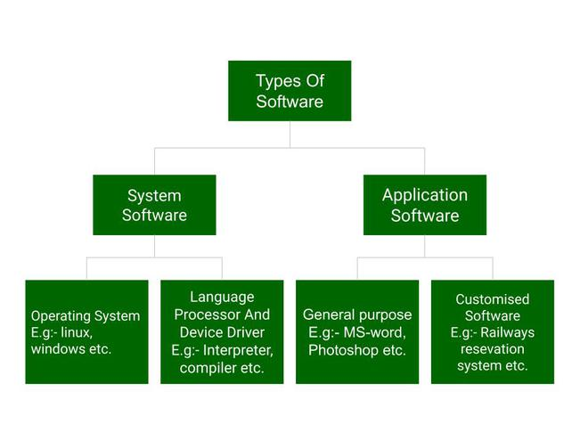

* **System software:**

System software is software that directly operates the computer hardware and provides the basic functionality to the users as well as to the other software to operate smoothly. Or in other words, system software basically controls a computer’s internal functioning and also controls hardware devices such as monitors, printers, and storage devices, etc. It is like an interface between hardware and user applications, it helps them to communicate with each other because hardware understands machine language(i.e. 1 or 0) whereas user applications are work in human-readable languages like English, Hindi, German, etc. so system software converts the human-readable language into machine language and vice versa.

**Features of system software:**

Let us discuss some of the features of System Software:

1. System Software is closer to the computer system.
2. System Software is written in a low-level language in general.
3. System software is difficult to design and understand.
4. System software is fast in speed(working speed).
5. System software is less interactive for the users in comparison to application software.

**Types of system software:**

It has two subtypes which are:

1. **Operating System:** It is the main program of a computer system. When the computer system ON it is the first software that loads into the computer’s memory. Basically, it manages all the resources such as memory, CPU, printer, hard disk, etc., and provides an interface to the user, which helps the user to interact with the computer system. It also provides various services to other computer software. Examples of operating systems are Linux, Apple macOS, Microsoft Windows, etc.
2. **Language Processor:**As we know that system software converts the human-readable language into a machine language and vice versa. So, the conversion is done by the language processor. It converts programs written in high-level programming languages like Java, C, C++, Python, etc(known as source code), into sets of instructions that are easily readable by machines(known as object code or machine code).
3. **Device Driver:**A device driver is a program or software that controls a device and helps that device to perform its functions. Every device like a printer, mouse, modem, etc. needs a driver to connect with the computer system eternally. So, when you connect a new device with your computer system, first you need to install the driver of that device so that your operating system knows how to control or manage that device.

**Application Software**

Software that performs special functions or provides functions that are much more than the basic operation of the computer is known as application software. Or in other words, application software is designed to perform a specific task for end-users. It is a product or a program that is designed only to fulfill end-users’ requirements. It includes word processors, spreadsheets, database management, inventory, payroll programs, etc.

**Features of application software:**

Let us discuss some of the features of Application Software:

1. An important feature of application software is it performs more specialized tasks like word processing, spreadsheets, email, etc.
2. Mostly, the size of the software is big, so it requires more storage space.
3. Application software is more interactive for the users, so it is easy to use and design.
4. The application software is easy to design and understand.
5. Application software is written in a high-level language in general.

**Types of application software:**

There are different types of application software and those are:

1. **General Purpose Software:**This type of application software is used for a variety of tasks and it is not limited to performing a specific task only. For example, MS-Word, MS-Excel, PowerPoint, etc.
2. **Customized Software:**This type of application software is used or designed to perform specific tasks or functions or designed for specific organizations. For example, railway reservation system, airline reservation system, invoice management system, etc.
3. **Utility Software:**This type of application software is used to support the computer infrastructure. It is designed to analyze, configure, optimize and maintains the system, and take care of its requirements as well. For example, antivirus, disk fragmenter, memory tester, disk repair, disk cleaners, registry cleaners, disk space analyzer, etc.

**Q-3 What is SDLC? Explain each face of SDLC.**

* The software development life cycle (SDLC) is the process of planning, writing, modifying, and maintaining software. Developers use the methodology as they design and write modern software for computers, cloud deployment, mobile phones, video games, and more. Adhering to the SDLC methodology helps to optimize the final outcome.
* In IT, the term "life cycle" was first used in the 1950s and 1960s to describe the stages involved in developing a new computer system, but it is now commonly used to refer to all stages in the production of any type of software.

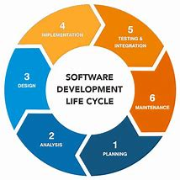

* Each stage in the SDLC has its own set of activities that need to be performed by the team members involved in the development project. While the process timeline will vary from project to project, the SDLC generally follows the seven stages outlined below.

### Stage 1: Plan and brainstorm.

* The first step in the software development life cycle is planning. It's when you gather the team to brainstorm, set goals, and identify risks. At this stage, the team will work together to devise a set of business goals, requirements, specifications, and any high-level risks that might hinder the project's success.

### Stage 2: Analyze requirements.

* Once you've come up with some ideas, it's time to organize them into a cohesive plan and design. This requires a lot of research and planning to ensure that your final product meets your expectations (and those of your customers). The big step is creating a detailed project plan document and work breakdown structure that outlines the requirements.

### Stage 3: Design the mockups.

* Once you've got your design plans in front of you, it's time for wireframing and mockups. This step builds upon the planning stage, building out the tasks you need to do in the work breakdown schedule. There are plenty of tools available, such as Adobe XD or InVision, that make this process much easier than ever before.

### Stage 4: Develop the code.

* The development phase is where coding begins to take place. It is one of the most time-consuming phases in the SDLC. This phase often requires extensive programming skills and knowledge of databases. The team will build functionality for the product or service, which includes creating a [user interface](https://www.coursera.org/articles/ui-design) and building the database so users can store information in your system.

### Stage 5: Test the product.

* Before releasing the mockups into final production, you'll need to test it to ensure it is free of bugs and errors. Any issues need to be fixed before moving forward with deployment. You'll also need to manage how the system will integrate into existing systems, software, and processes.

### Stage 6: Implement and launch the product.

* Once you've completed all testing phases, it's time to deploy your new application for customers to use. After deployment, the launch may involve marketing your new product or service so people know about its existence. If the software is in-house, it may mean implementing the change management process to ensure user training and acceptance.

### Stage 7: Set up maintenance and operations.

* The final stage of the software development life cycle is maintenance and operations. This is one of the most critical stages because it's when your hard work gets put to the test.
* Maintenance involves updating an existing software product to fix bugs and ensure reliability. It can also include adding new features or functionality to a current product. Operations refer to the day-to-day running of a software product or service, such as performing backups and other administrative tasks.

**Q-4 What is DFD? Create DFD diagram on flipkart?**

* **DFD** is the abbreviation for **Data Flow Diagram**. The flow of data of a system or a process is represented by DFD. It also gives insight into the inputs and outputs of each entity and the process itself.
* 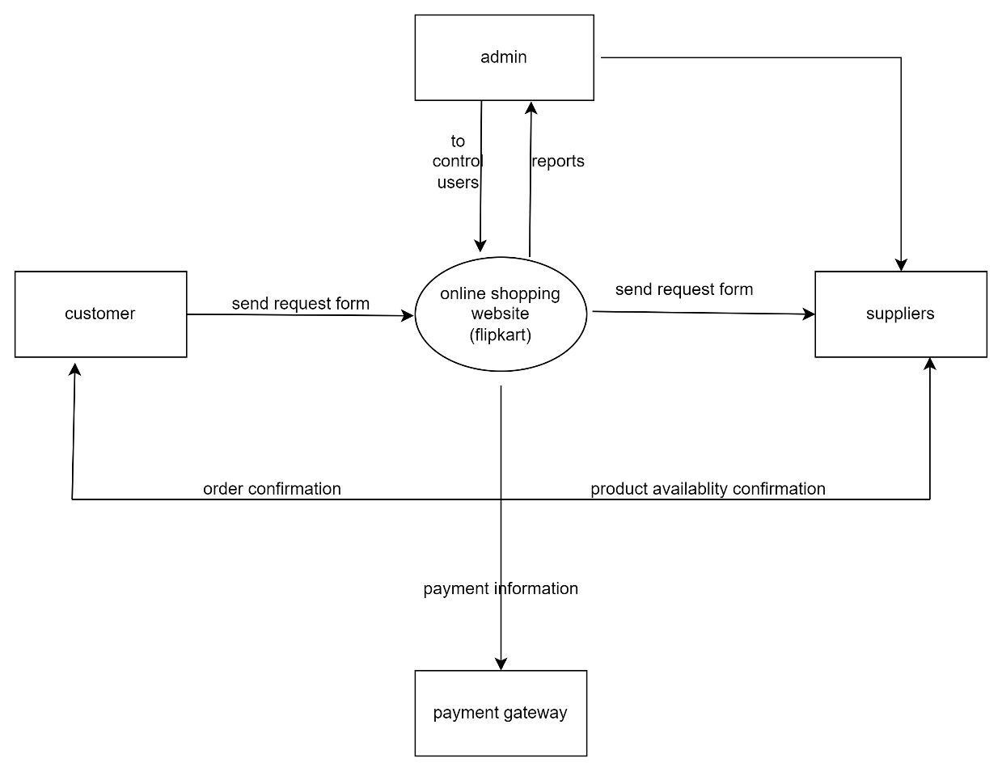

**Q-5 What is Flow chart? Create a flowchart to make addition of two numbers.**

* **A flowchart is a graphical representation of a procedure or algorithm in the form of a diagram. You can convert a complex process into a bright and straightforward method using a flowchart and make it understandable. Besides, if you need to frame a flowchart, you do not need a professional. Instead, you can create it in your way. Flowchart symbols like a diamond, round, parallelogram, give life to a dead diagram. So, let us move forward to know the types of flowcharts and how to make a flowchart in the upcoming sections.**
* 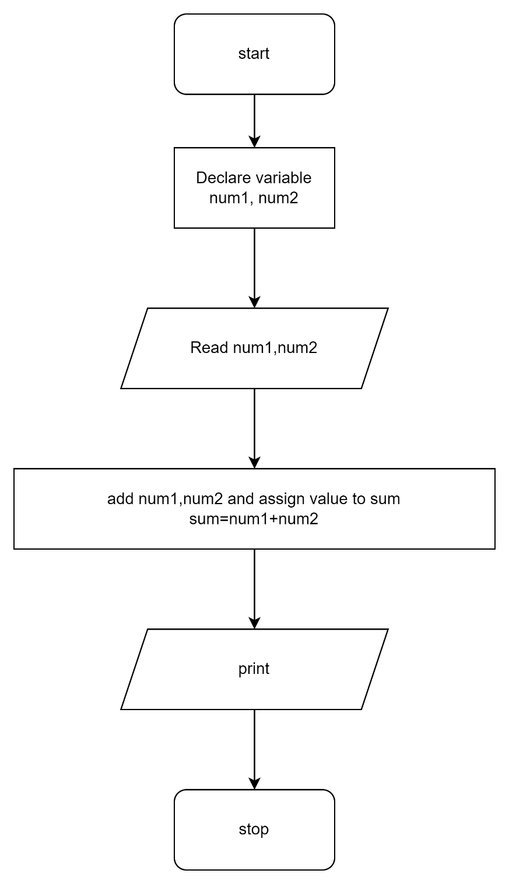

**Q-6 What is Use case Diagram? Create a use-case on bill payment on paytm.**

* A use case diagram is a graphical depiction of a user’s possible interactions with a system. It shows the different types of users (actors) and the functions (use cases) they can perform with the system.
* 