Strategy pattern define family of algorithms ,encapsulate each one and makes them interchangeable and strategy lets the algorithms vary independently that client uses them.

Without Strategy Pattern

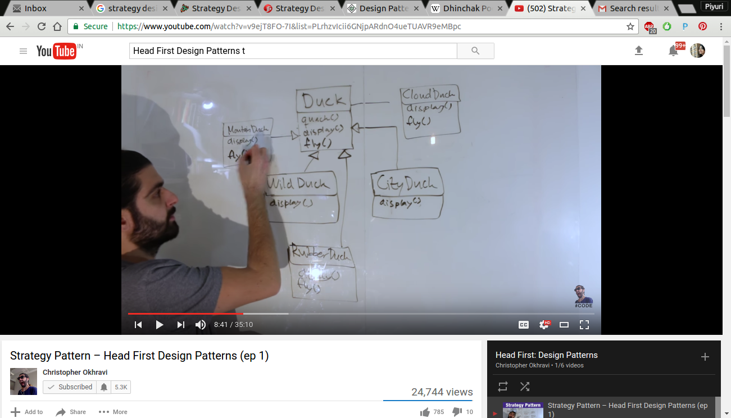

With Strategy Pattern

