Assignment No. 2
Create a database named college
show databases;

Create a table name student in college database with following structure
roll,name,class,marks,age with respective datatypes.
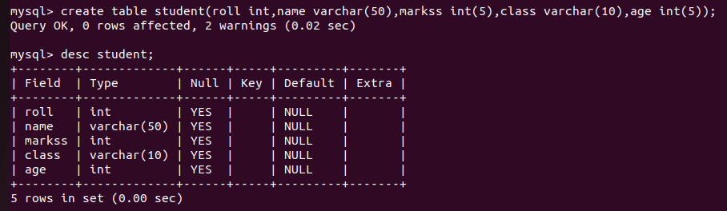
Check the structure of the table.
Alter the datatype of marks from float to integer
ALTER TABLE student modify COLUMN marks float;
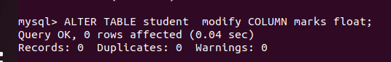
Alter the table to remove the column age
alter table student drop column age;
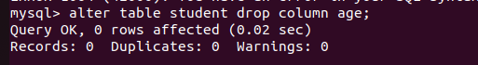
Show all the tables in database college.


Truncate the table student


Drop the table and database also.

