Assignment No. 3
Create a database named college
Create a table name student in college database with following structure
roll,name,class,marks,age with respective datatypes.
Insert at least 5 rows in the table.
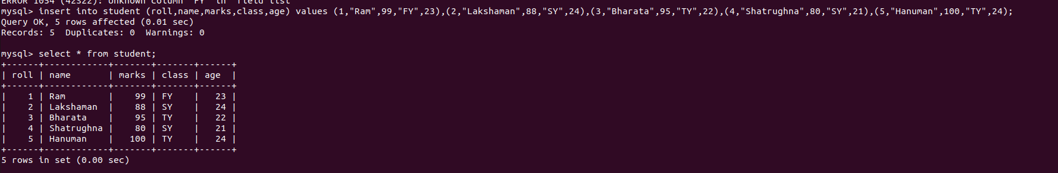
Delete the entry of roll number 4
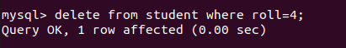

Update the marks of roll number 3
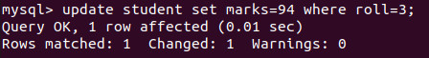

Give additional grace marks of 0.5 to all students.


Truncate the table


Insert the data again using multi-insert statement.

