**Assignment Of Session No-8**

**Answer No – 1**

Mean (µ) = 33.27133333

Standard Deviation(s) = 16.9454

Variance(s^2) = 287.1466

Outlier = 91.36

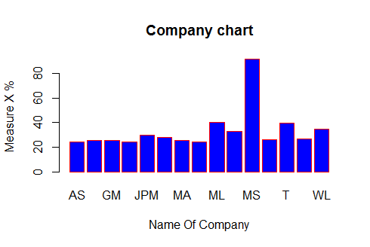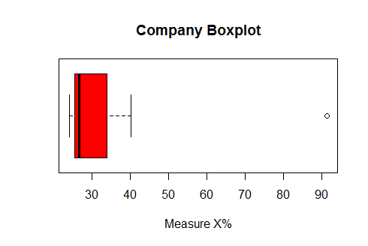

**Answer No – 2**

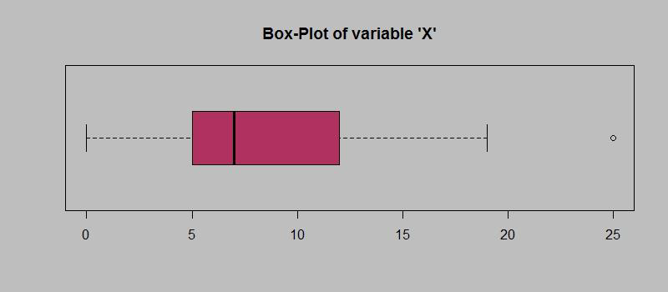

1. Inter Quartile Range of the data set = upper whisker - lower whisker= 12 - 5 = 7 ( This shows the difference between 3rd quartile and 1st quartile)
2. The dataset is positively skewed because most of the data is concentrated before the mean.
3. For the new box plot , lower quartile becomes less than 5, median also decreases , upper quartile also decreases, outlier changes.

**Answer No – 3**



1. Mode of this dataset is 5 or 6 where the frequency value is highest.
2. The dataset is positively skewed because most of the data is concentrated before the mean.
3. Both the graphs help in showing how the data is distributed , where the most of the data lies , skewness , outliers.

**Answer No – 4**

Probability that one long-distance telephone calls is misdirected,

P(Misdirected call) = 1/200   
  
Probability that at least one in five attempted telephone calls reaches the wrong number =  
1 - probability that none of the five calls are misdirected   
= 1-(1-p)^5  
= 1 - (1-1/200)^5

= 0.02475

**Answer No - 5**

**i)** The most likely monetary outcome of the business venture: = 2,000with the highest probability of 0.3.

**ii)** The venture is likely to be successful, because the probability values of non negative value when summed up is greater than 0.5. P(1000)P(2000)+P(3000) = 0.2 + 0.3 + 0.1 = 0.6 which is greater than 0.5.

**iii)** The long-term average earning of business venture of this kind:

µ= (0.1)(−2,000) + (0.1)(−1,000) + (0.2)(0) + (0.2)(1,000) + (0.3)(1,000) + (0,1)(3,000)= 800 ( Expected Value).

**iv)** The good measure of the risk involved in a venture of this kind is standard deviation.