**Introduction:-**

It is a desktop application which can merge two CSVs. It allows user to specify merge type options and common key column name while merging. This application has a beautiful GUI, libraries which I have used are Tkinter and Pandas. Pandas data frame I have used for this application in order to merge the CSV files.

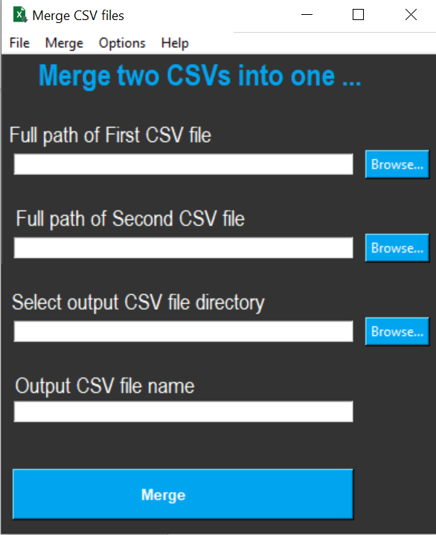

**How to use:-**

**Specifying input** – There are two ways to specify the input. One way is by clicking on the browse button for first csv and second csv. Another way is through the menu options, user can click on ‘File’->’Load first CSV’ for the input of first CSV and ‘File’->’Load second CSV’ for the input of second CSV.

**Specifying Output** – User can click on browse button for specifying output directory path and output file name path. Output directory can also be selected by clicking on ‘File’->’Select Output Directory’.

Also Output file name can be given without file name extension, this application will automatically add .csv file name extension when saving the output CSV file.

**Additional** **Options** –

1. **Key Column Name -** There are some merging options which can be selected by end user. User can specify common key column name for merging, it should be common in both CSVs file. If user will specify this key column name then merging will be performed as per this column. This column can be specified by clicking on ‘Options’->’Key Column Name’, new window will pop up in which user can specify the column name and then click on submit button.

By default application will try to find the column name which is common in both CSVs and will consider that column as key column. Below are some screenshots and some steps which user can follow.

Step1- Click on Options->’Key Column Name’

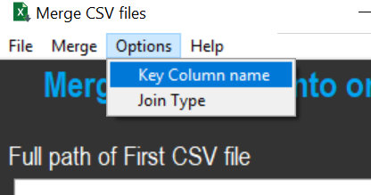

Step2 – Type the name of key column. Suppose if the column name is ‘Id’ which is common in both CSVs then it can be typed as mentioned in below highlighted screenshot and then user can click on Submit button.

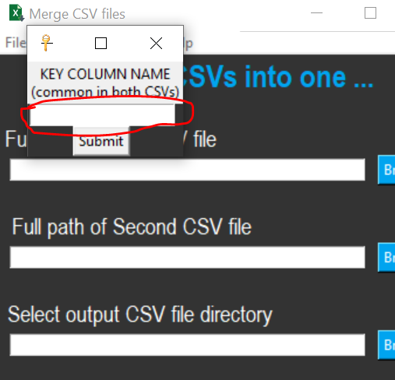

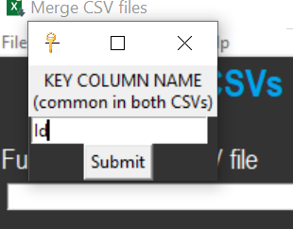

2.**Join Type** – By default it’s value is Outer/Full. Outer/Full join type is the union of all the records in both CSVs file. If any record is common as per the key column then it will be considered as single record and this single record will be written into output csv file. If user want to change this default Join Type then user can click on ‘Options’->’Join Type’, by clicking on this option a new window will appear on screen and the join type option can be selected by clicking on the drop down list.

Available options are Left, Right, Inner and Outer/Full. After selecting the join type option(which will be considered while merging), user can click on submit button. This option will be application till application runs. If user go to this option ‘Options’->’Join Type’ again then this changed value of Join type will still come in the new window.

Below are some screenshots and some steps which user can follow for specifying the join Type.

Step1 – Go to ‘Options’->’Join Type’

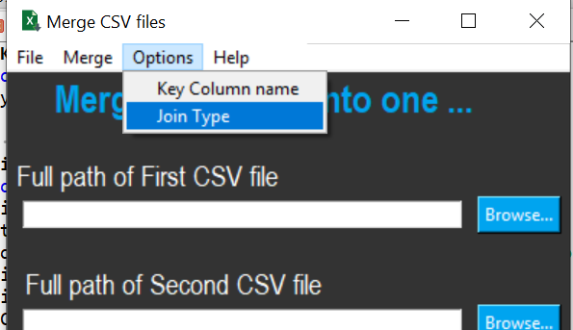

Step2 – Change the Join Type option by clicking on drop down list.

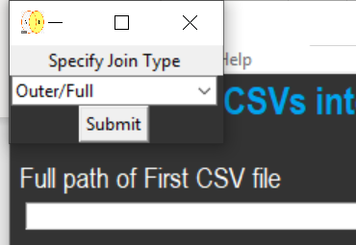

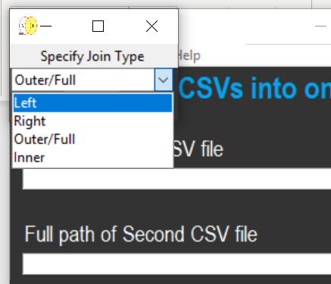

Step3 – After changing the join type option, click on Submit button.

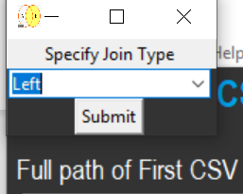

**Submit for merging** - After specifying input/output and merging options, user can click on ‘Merge’ button and the output csv file will be saved in output directory. Once it will be saved, a new MessageBox will appear which will inform to user that output has been saved successfully.

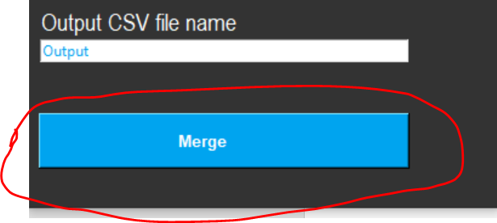

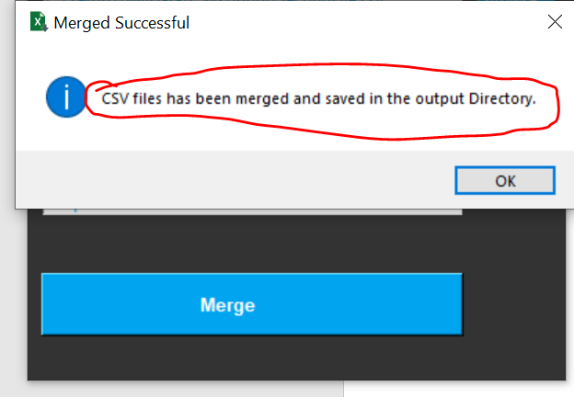

**Final Note** – This application has been developed in Python by using Tkinter and Pandas Library. It has been tested in Windows environment so it might not work in other environment or operating systems(mac, linux and unix etc.) because many functionality of Tkinter does not working in other operating system. For e.g. button Color does not work in mac operating system. While using this project for other operating system, kindly test the project before deploying it and do the necessary changes.