## **Microsoft Imagine Cup 2018**



Project Title : **FeedFilter**

Team Name : **CottonCandy**

College Name : IIT Guwahati

**Documentation**

* **Motivation behind FeedFilter**
  + Social​ ​media,​ ​today,​ ​is​ ​one​ ​of​ ​the​ ​integral​ ​part​ ​of​ ​a​ ​majority​ ​of​ ​people’s​ ​life.​ ​But sometimes,​ we see that a viral/trending content continuously occupies our feed and after a point of time, it gets frustrating. There comes a point when we want to manage the contents as per our needs.
  + Although, there are moderation options in social media sites like Facebook, but they do not give that much customized options and freedom to personally manage your content as per your need.
  + This is a very important problem to solve because anybody who uses social media extensively, may be for entertainment or some work, certainly feels that something undesirable and redundant posts are spoiling their experience.
* **How FeedFilter solves above problem ?**
  + FeedFilter is a chrome extension which currently allow people to manage their Facebook feed.
  + FeedFilter provides various options from users:

1. **Tag:** If content is related to this tag, then it is expected to be removed.
2. **User/Page/Group:** If content is posted or shared by this user/page/group then it is removed.
3. **Text moderation:** If content is having offensive/racy/adult content in form of plain text or text inside image, then it is expected to be removed.
4. **Image moderation:** If content is having offensive/racy/adult image then it is expected to be removed.

* FeedFilter suggests further tags to user to block from their feed from the data collected from various users.
* **Technologies Used :**
* Chrome extension
* Django backend server
* Python multithreading for runtime efficiency
* Cognitive Service APIs :

|  |  |  |
| --- | --- | --- |
| API | API End Point | Function |
| Microsoft Text Analytics API | text/analytics/v2.0/keyPhrases | Extracts key phrases from text of post as well as text extracted from image by vision API |
| text/analytics/v2.0/sentiment | Analyses sentiment of text of post and that extracted from image by vision API |
| Google Cloud Vision API - Image Content Analysis | Via google cloud vision pip repository | Extracts text from image  Extracts web detections from image |
| Microsoft Content Moderator API | /contentmoderator/moderate/v1.0/ProcessImage | Analyses image and find the extent to which it is racy, adult or offensive |
| /contentmoderator/moderate/v1.0/ProcessText | Analyses text of post and image and finds the extent to which it is racy, adult or offensive |

* **Salient Features:**
* We are analyzing images and the texts contained in images using above api and getting the context keywords which are then used to filter content. This is usually not done in existing filtering extensions because it is slow and time taking.
* We are using multithreading to fasten the whole process of API calls. There are many threads concurrently running, making the filtering much faster.
* We have provided tag with timer, i.e. the user can include tags with some duration. After that duration, the tag will be removed automatically from the user’s list of tags.
* We are showing user the complete analysis of their feed in dashboard to help them have an overview of the quality of content they are seeing (based on sentiment and content analysis) and suggesting them how they can improve it by suggesting the tags.
* There is provision to view blocked content, in case user wants to see it later.
* **Step-wise go through of FeedFilter :**

1. The extension will first ask to login in this popup.

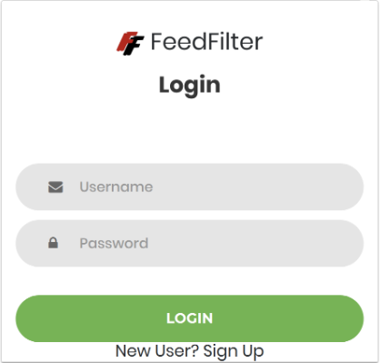

1. After logging in, the user will see this popup.

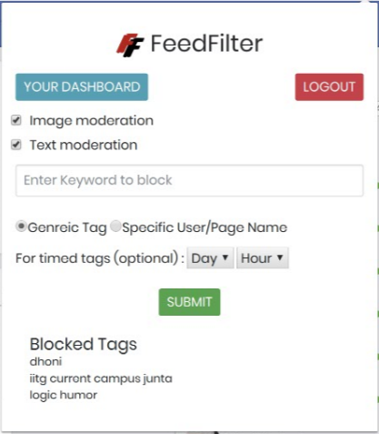

The different parts of this popup are:

● Image moderation/Text moderation options: Checkboxes to select if you want to filter some obscene/racy/adult content from your feed.

● Tag input: To add new tags here. Custom tags / group name/ account name/ page name

● Blocked Tags: List of tags currently added by user.

● Dashboard link - Link to view detailed analysis of your feed.

1. **Dashboard** – Dashboard shows all the detailed analysis of the user’s news feed.

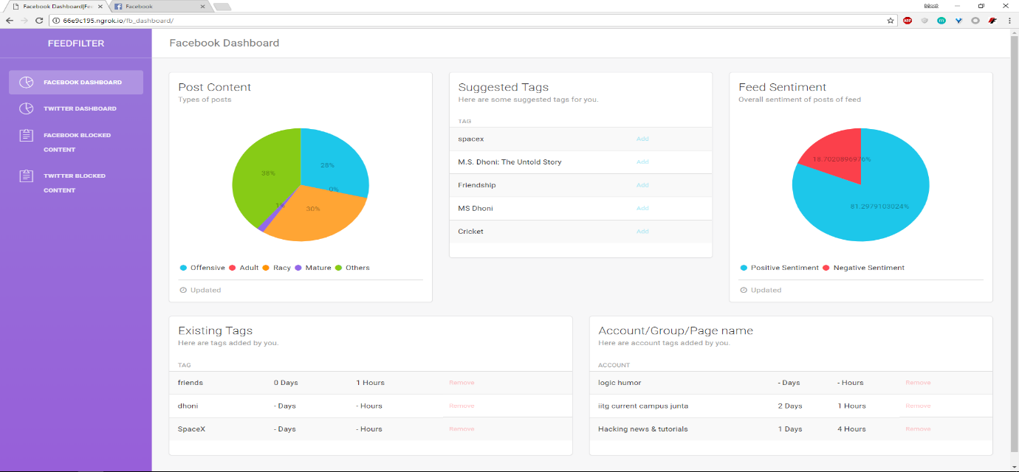

● Post types: A pie chart showing the percentage of different categories of posts which were in your feed.

● Suggested Tags: A list of tags which are suggested by the extension to the user, with an option to add it to your list of tags. There is an ‘ADD’ button

● Sentiment : A pie chart showing the percentage of positive and negative sentiments in your feed.

● Generic Tags: A list of custom tags added by the user, with an option to remove it.

● Account name/ Page name/ Group name: Tags in the form of user accounts or page names or group names whom you don't want to see. Remove button to remove it.

● **Blocked Content** : A link to see your list of blocked posts. 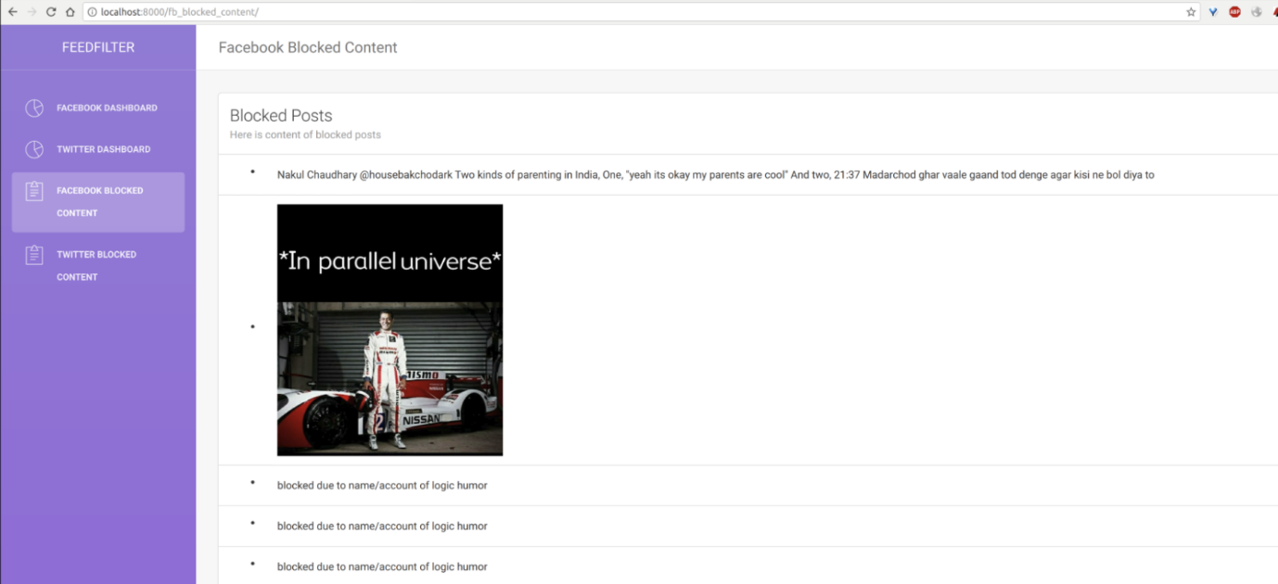

* **What’s unique about FeedFilter ?**

1. FeedFilter analyzes images and the texts contained in images, which is usually not done in filtering extensions because it is slow and time taking.
2. It uses python multithreading to fasten the whole process of API calls. There are 8 threads concurrently running, making it atleast 8 times faster than normal speed.
3. FeedFilter Dashboard shows the complete analysis (in the dashboard) of feed to help user have an overview of the quality of content they are seeing and suggesting them how they can improve it by suggesting the tags.

* **Future Challenges**

We are planning to extend the same thing for Twitter. In fact, the databse modelling and code handling has been done partially for Twitter in the current version of project. There are some challenges in case of twitter for capturing post id’s for which we are trying to find a solution. Once done, FeedFilter will be easily extendable to other social sites like LinkedIn as well.