**COLLEGE DATABASE**

Presented By:

PIYUSH JAISWAL

PRIYAMWAD PATHAK

RAJJAT CHHAJER

SHIVAM YADAV

SOMYA PAREEK

**PROBLEM STATEMENT-**

There is Student which has a unique enrollment no, name, gender, batch, mobile no. and branch.

There is Faculty which contains name of the faculty, Employment-id, gender and mobile no.

There is a House which has name, year, captain name and vice-captain name.

For every house there are points for each event, and year.

Each Faculty and Student belongs a House.

Every sports has year, event name, category, event type, participants and winner.

Both the student and the faculty can participate in sports.

There are Athletics which have year, event name, category, and 1st , 2nd and 3rd and each position has a winning value. Students participate in athletics.

Every year there is a best athlete with maximum points.

There are clubs which the student can join. Each club has a name, captain, vice-captain and coordinators for a particular year.

Every year, INGENUITY- the college’s fest is held. It has many events organized by a particular team and has coordinators as well.

Other colleges participate in INGENUITY. Each college has a name, representative, his/her contact no, accommodation no and no. of participants.

Every student and faculty can order couriers from online sites or from any other places. Every courier has a date, order no., signature and the site from whom the package has been received.

Every student and faculty is allocated a room. Every room has a room no., location, room type and rent.

Every girl has to sign against the day’s date and put in the time at which she has entered the hostel during night.

Student can take keys for various common rooms or other rooms for the corresponding activities. Every key allocated has a room no., location, date, In time, Out time and the signature.

Students can also take various sports equipment available. For every allocation there are records for date, type of sport, In time, Out time and signature.

**ER DIAGRAM**

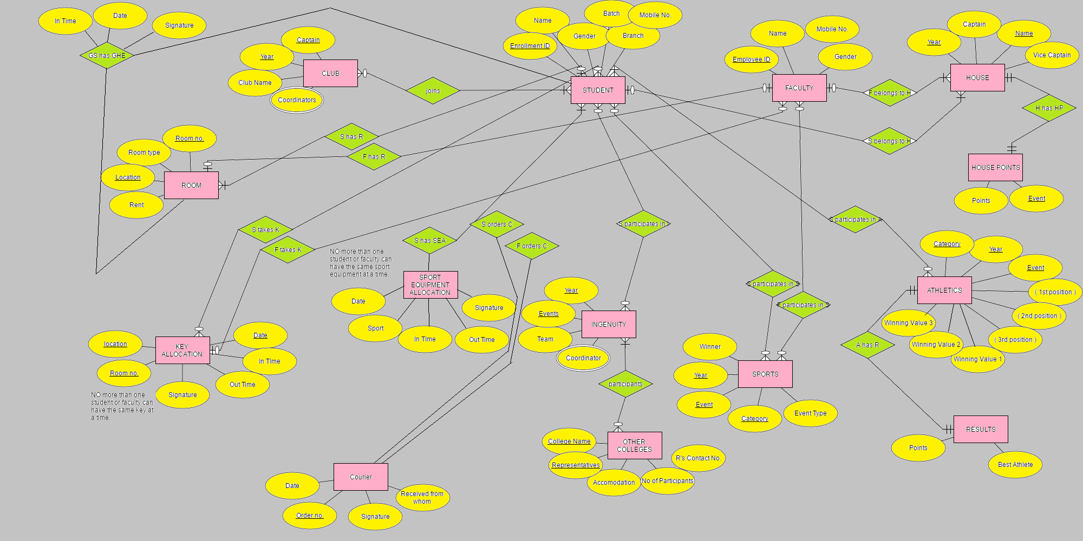

**Procedure to convert ER model of Database to Relational Tables**

Procedure:

* Separate tables are made for each entities and the attributes become the fields of the tables with their respective data types.
* Tables are made for relationships which contain the primary keys of the entities participating in the relationship and attributes of the relationship if any.
* Separate tables are made for multivalued attributes.
* Tables for relationships are only made for relationships having cardinality m: n. Relationships in which the cardinality is 1:n, the key of the entity having the 1 side cardinality is made the foreign key in the entity having the n side cardinality. The attributes of the relationships are also transferred to the n side entity.

In relationships having 1:1 cardinality, the foreign key and the attributes of the relationship can go to any entity.

STUDENT

Type: Entity

Foreign Keys: Room no, Location (CLUB);

Year, H_Name (HOUSE);

The keys of CLUB are taken in STUDENT as foreign keys because it participates in the relationship *S has R* and has the cardinality 3(m):1.

The keys of HOUSE are taken in STUDENT as foreign keys because it participates in the relationship *S belongs to H* and has the cardinality m:1.

FACULTY

Type: Entity

Foreign Keys: Room no, Location (CLUB)

Year, H_Name (HOUSE);

The keys of CLUB are taken in FACULTY as foreign keys because it participates in the relationship *F has R* and has the cardinality 1:1.

The keys of HOUSE are taken in FACULTY as foreign keys because it participates in the relationship *F belongs to H* and has the cardinality m:1.

HOUSE

Type: Entity

Foreign Keys: none.

HOUSE POINTS

Type: Entity

Foreign Keys: Year, H_Name (HOUSE)

The keys of HOUSE are taken in HOUSE POINTS as foreign keys because it participates in the relationship *H has HP* and has the cardinality 1:1.

CLUB

Type: Entity

Foreign Keys: Coordinator (CLUB_Coordinator)

CLUB_Coordinator is a multi-valued attribute of CLUB

CLUB_Coordinators

Type: Multivalued attribute (CLUB)

ROOM

Type: Entity

Foreign Keys: none

Relationship Attributes: In time, Date, Signature

ROOM participates in the relationship GS has GHE with STUDENT with cardinality 1:1. This relationship has attributes In time, Date, Signature.

KEY ALLOCATION

Type: Entity

Foreign Keys: none

SPORTS EQUIPMENT ALLOCATION

Type: Entity

Foreign Keys: none

COURIER

Type: Entity

Foreign Keys: Enrollment ID (STUDENT), Employee ID (FACULTY)

The keys of STUDENT are taken in COURIER as foreign keys because it participates in the relationship *S orders C* and has the cardinality m: 1.

The keys of FACULTY are taken in COURIER as foreign keys because it participates in the relationship *F orders C* and has the cardinality m: 1.

INGENUITY

Type: Entity

Foreign Keys: Coordinator (INGENUITY_Coordinator)

INGENUITY_Coordinator is a multi-valued attribute of INGENUITY.

INGENUITY_Coordinator

Type: Multivalued attribute (INGENUITY)

OTHER COLLEGES

Type: Entity

Foreign Keys: none

SPORTS

Type: Entity

Foreign Keys: none

ATHLETICS

Type: Entity

Foreign Keys: none

RESULTS

Type: Entity

Foreign Keys: Category, Year, Event (ATHLETICS)

The keys of ATHLETICS are taken in RESULTS as foreign keys because it participates in the relationship *A has R* and has the cardinality 1:1.

S participates in A

Type: Relationship

Entities: STUDENT, ATHLETICS

Relationship Attributes: none

S participates in I

Type: Relationship

Entities: STUDENT, INGENUITY

Relationship Attributes: none

participants

Type: Relationship

Entities: INGENUITY, OTHER COLLEGES

Relationship Attributes: none

S has SEA

Type: Relationship

Entities: STUDENT, SPORTS EQUIPMENT ALOCATION

Relationship Attributes: Date, In time, Out time, Signature

joins

Type: Relationship

Entities: STUDENT, CLUB

Relationship Attributes: none

S takes K

Type: Relationship

Entities: STUDENT, KEY ALLOCATION

Relationship Attributes: none

S participates in S

Type: Relationship

Entities: STUDENT, SPORTS

Relationship Attributes: none

F participates in S

Type: Relationship

Entities: FACULTY, SPORTS

Relationship Attributes: none

**DATABASE SCHEMA**

