Project Report: Data Analysis Application

Student Name: **Piyush Jaloniya**  UID: **24MCI10042**

Student Name: **Khushi** UID: **24MCI10059**

Branch: MCA (AIML) Section/Group:24MAM 1-B

Semester: 1st Date: 25/10/2024

Subject Name: Python Programming Subject Code: 24CAH-606

* **Title of the Project:**

Data Analysis Application Using Tkinter and Matplotlib

## Aim

The aim of this project is to develop a user-friendly data analysis application that allows users to load datasets, perform statistical calculations, and visualize data using various plot types. The application will leverage Python libraries such as Pandas for data manipulation, Matplotlib for data visualization, and Tkinter for creating the graphical user interface (GUI).

## Objective

* To create an intuitive interface that simplifies the process of data analysis for users without programming expertise.
* To facilitate the loading and exploration of datasets in CSV format.
* To provide essential statistical measures (mean and median) for selected data columns.
* To enable users to visualize data through different types of plots, aiding in better understanding and interpretation of the data.

## Tasks to be Done

1. Set Up the Development Environment:  
 - Install Python and required libraries (Pandas, Matplotlib, Tkinter).  
2. Design the GUI:  
 - Create a simple and intuitive layout using Tkinter.  
 - Implement buttons for loading datasets, plotting data, and calculating statistics.  
3. Load Dataset Functionality:  
 - Implement functionality to load CSV files and display their column names.  
4. Calculate Statistics:  
 - Create a function to calculate and display the mean and median of the selected column.  
5. Data Visualization:  
 - Implement various plotting functions (line plot, bar chart, histogram, scatter plot, and box plot).  
 - Ensure plots are displayed correctly using Matplotlib.  
6. Testing:  
 - Test the application with different datasets to ensure it works as intended.  
 - Handle any exceptions or errors gracefully.

## Code:

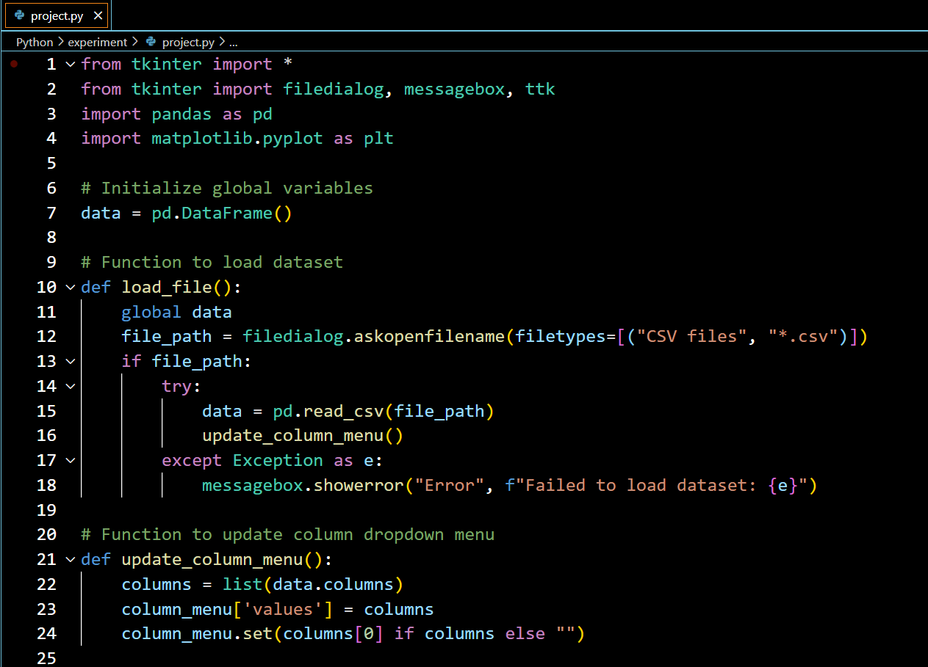

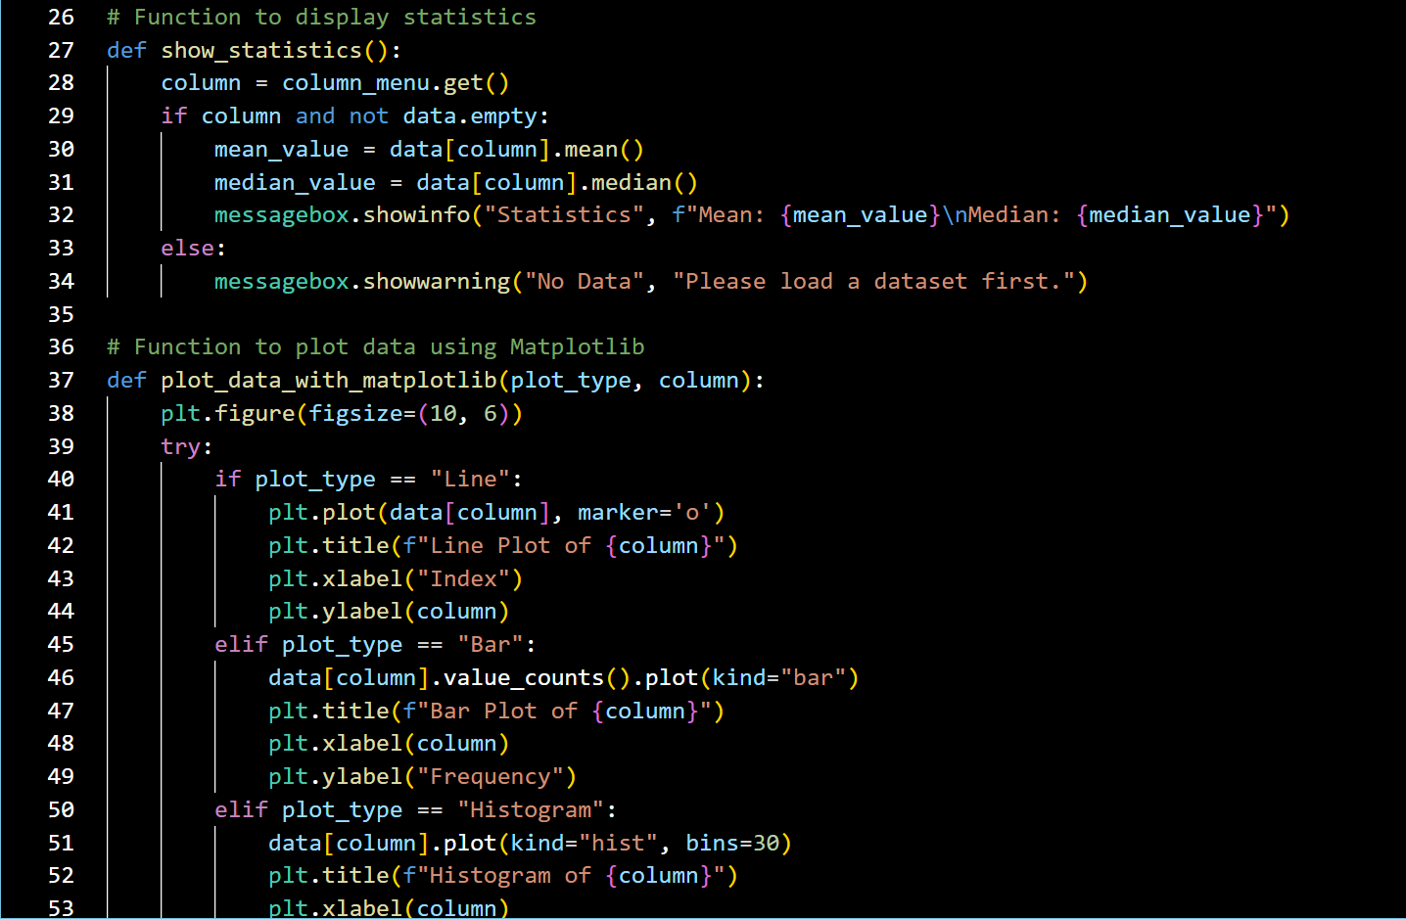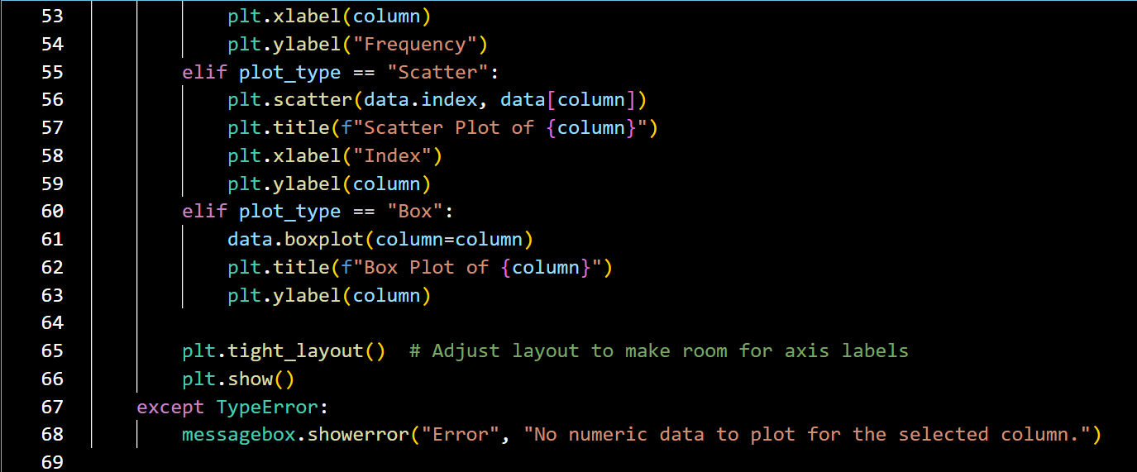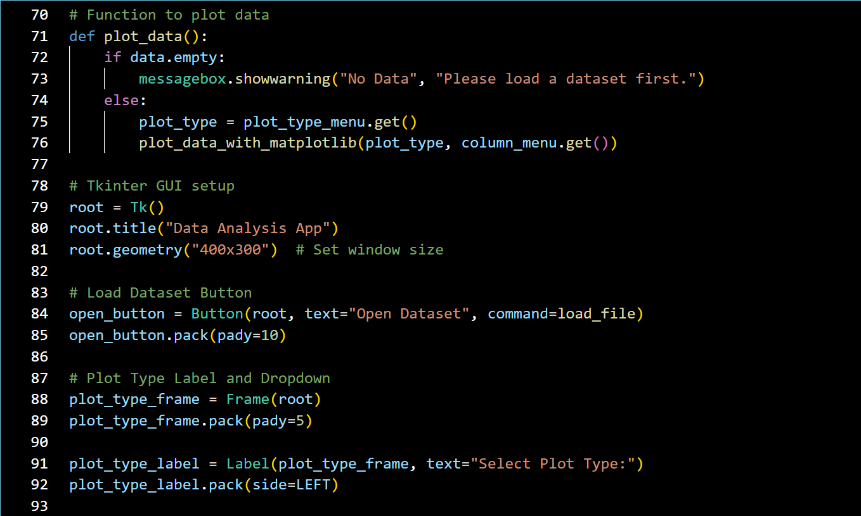

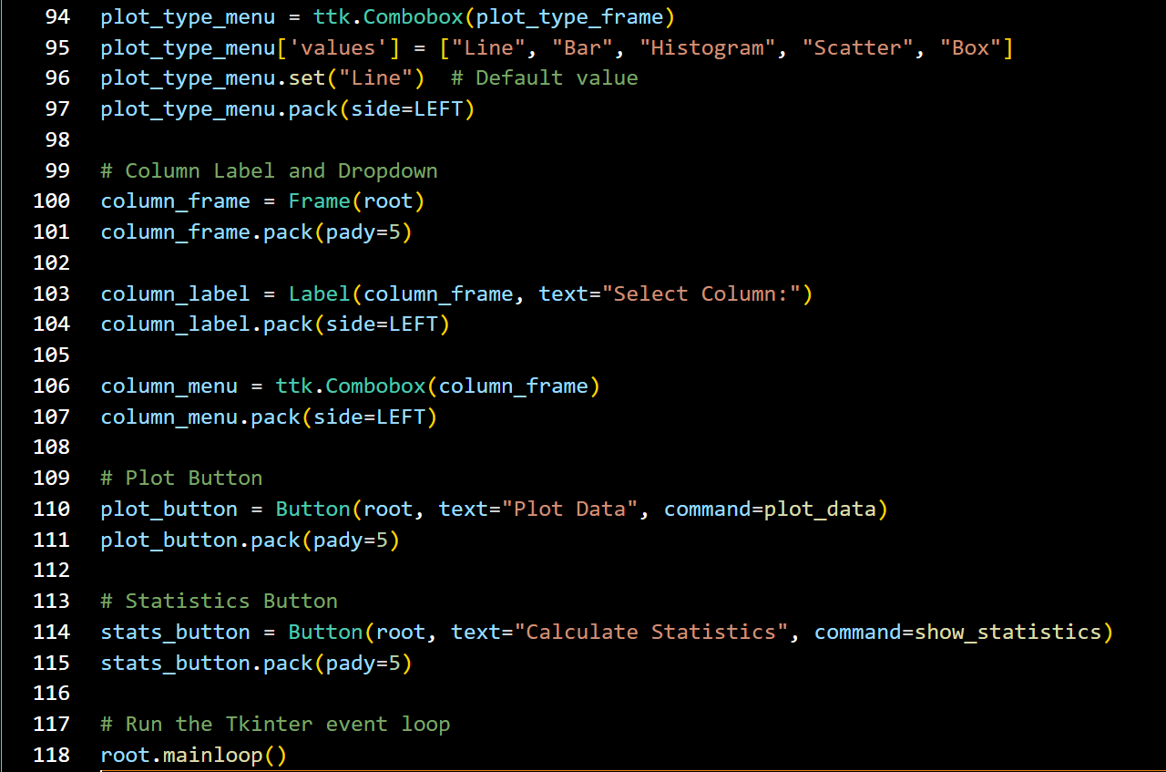

## Learning Outcomes

* **Python Programming:**
* Enhanced understanding of Python’s core programming concepts, such as functions and error handling.
* Learned how to handle CSV files and work with real-world datasets.
* **Data Manipulation with Pandas:**
* Gained experience in loading, processing, and analyzing data using Pandas.
* Implemented statistical calculations (mean, median) for selected columns in the dataset.
* **Data Visualization with Matplotlib:**
* Acquired skills in creating various plots (line, bar, histogram, scatter, box) to visualize data effectively.
* Learned how to adjust plot layout and handle errors in data visualization.
* **GUI Development with Tkinter:**
* Developed a user-friendly graphical interface to interact with the dataset.
* Gained proficiency in adding buttons, dropdowns, and message boxes for easy user interaction.
* **Error Handling:**
* Implemented error-handling mechanisms to ensure the application runs smoothly even with incorrect inputs.

## Conclusion

The Data Analysis Application project serves as an excellent foundation for further exploration into data analysis and visualization in Python. By integrating various libraries, this project not only meets its initial aims but also provides opportunities for future enhancements and learning.