How conversations are classified:

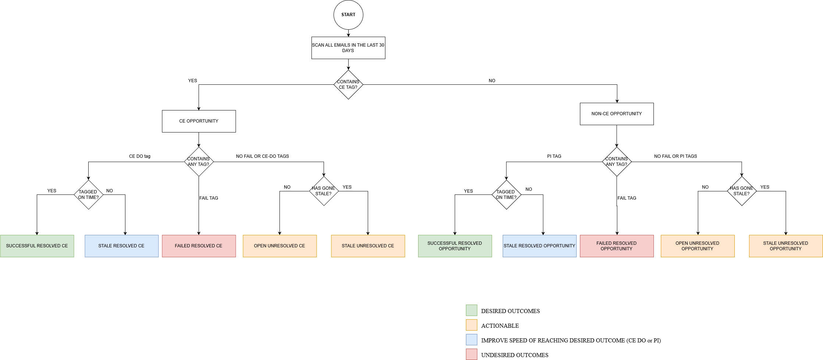

([Better resolution image](https://i.imgur.com/6p3r4bH.png))

* Unresolved opportunity (email conversation) if :
  + Either
    - Not tagged CE *and*
    - Not tagged PI *and*
    - Not tagged fail *and*
    - Irrespective of stale or not
  + Or
    - Tagged CE *and*
    - Not tagged CE DO *and*
    - Not tagged fail *and*
    - Irrespective of stale or not
* Resolved opportunity (email conversation) if:
  + Either
    - Not Tagged CE *and*
    - Tagged PI *or* fail
    - Irrespective of stale or not

Stale opportunities could be resolved or unresolved

* Open opportunities are opportunities that are actionable and need to be marked as PI or fail.
* Tagging PI to a stale conversation does not affect fields such as total PIs or last PI date. However, it does move the conversation from ‘stale unresolved opportunity’ to ‘stale resolved opportunity’. One of our goals is to have very few stale opportunities and even lower number of stale unresolved opportunities.
* Tagging a conversation as ‘fail’ works irrespective of whether the conversation is stale or not. It will affect metrics such as total failed opportunities etc. However, additionally, IF the deal has been stale, it will also move the conversation from total stale unresolved to stale resolved opportunities

|  |  |  |
| --- | --- | --- |
| **Field** | **Meaning** | **How it’s updated** |
| Total Opportunities (30 days) | Total email conversations we’ve had with the customers linked to this deal in the last 30 days. This includes all CE, Non-CE opportunities (resolved or unresolved) |  |
| Stale Opportunity (30 Days) | **Total opportunities that went stale – does not matter if this conversation has been** |  |
|  |  |  |
|  |  |  |
|  |  |  |
|  |  |  |
|  |  |  |

**Field:** Total opportunities (30 days)   
**Meaning:** Total email conversations we’ve had with the customers linked to this deal in the last 30 days  
How it is updated:

Stale opportunities (30 days)

Total PI (30 days)

Total failed opportunities (30 days)

Total opportunities (1 year)

Stale opportunities (1 year)

Total PI (1 year)

Total failed opportunities (1 year)

Total CE (30 days)

Stale CE (30 days)

Total CE DO (30 days)

Total failed CE (30 days)

Total CE (1 year)

Stale CE (1 year)

Total CE DO (1 year)

Total failed CE (1 year)

Last open contact date

Last PI date

Last open CE date

Last failed CE date

Last CE DO date

Currently open opportunities

Currently stale opportunities

Contact history

PI history

CE History

CE DO history