Coding Project – Level 0

# Compiling

Compile using the following command

csc.exe /t:exe /out:MegaDownloader.exe .\Program.cs

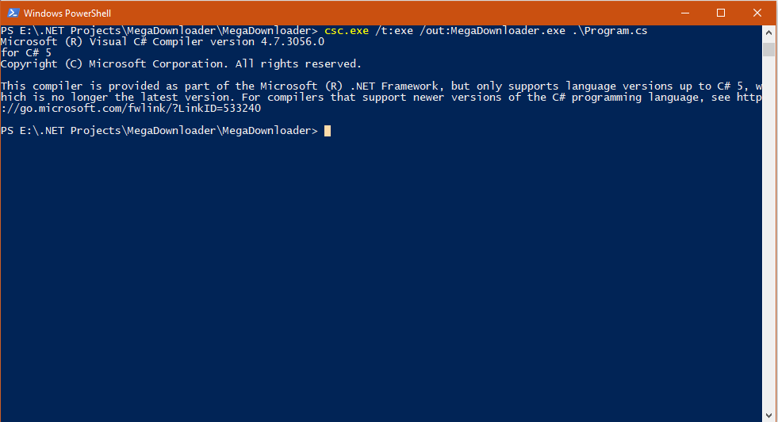

# Running the program

Run the program passing the url of the file to downloaded and the destination of the file on the local disk as shown below

.\MegaDownloader.exe "https://raw.githubusercontent.com/typo3-ter/raw/master/readme.txt" "E:\demo_data.txt"

# Execution outputs

1. Execution when
   * The url is valid
   * Local path is a valid destination
   * No duplicate file exists at that path in the system
   * Download is successful

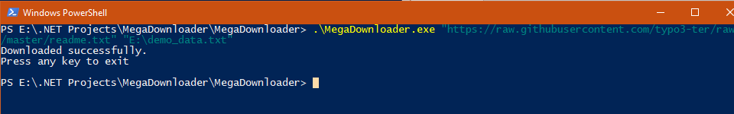

The file demo_data.txt has been created

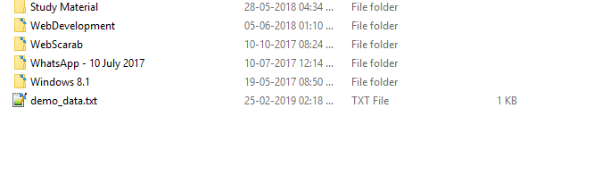

1. Execution when
   * The url is valid
   * Local path is a valid destination
   * Duplicate file exists at that path in the system
   * File is replaced and download is successful

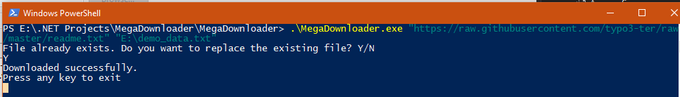

1. Execution when
   * The url is valid
   * Local path is a valid destination
   * Duplicate file exists at that path in the system
   * File is NOT replaced and download is unsuccessful

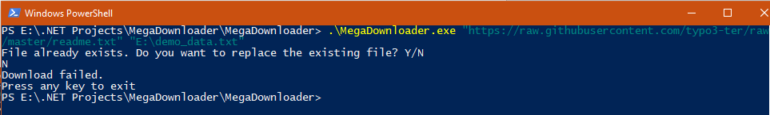

1. Execution when
   * url is not a valid url

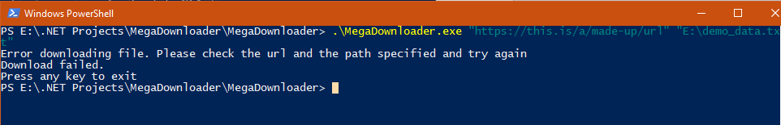

# Explanation:

Created a new class Downloader that is separate from the class containing the main method. This is done so that the code can be reused at a later point in time.

The Download method takes 2 parameters, one for the url and one for the address on the local disk. We will be using the DownloadFile function of the WebClient class. By default the DownloadFile function replaces any existing file. This might not be the best option for some users as some they might not be aware of this existing file and might lose the data contained in it.

We check the location to see if the file already exists and prompt the user if it does. We check for null urls and download errors prompting the user about the appropriate actions that can be taken.

We return true if the file was downloaded and false otherwise.